RightNow TO
A Real-Time Contextual Recommendation System
Full-Stack Technical Report
Application type: Full-stack web application
Backend: Spring Boot (Java), hosted on Render
Frontend: React (Vite), hosted on Vercel
Database: Supabase (PostgreSQL)
AI engine: Google Gemini
Live data: Open-Meteo, Google Places
Author: ____________________
Date: July 2026

Table of Contents
Abstract 3
1 Introduction 3
1.1 Background and Motivation 3
1.2 Problem Statement 3
1.3 Objectives 3
1.4 Scope 3
2 System Overview 3
2.1 Concept 3
2.2 Key Features 4
3 System Architecture 4
3.1 Component Responsibilities 4
3.2 Request Flow 4
4 Technology Stack 5
5 Backend Implementation 5
5.1 Live Weather Integration (Open-Meteo) 5
5.2 Location and Places (Google Places) 6
5.3 AI Orchestration (Gemini) 7
5.4 Vibe Checks API 8
5.5 Recommendation Endpoint 10
5.6 Configuration 10
6 Database Design 11
6.1 SQL Definitions 11
6.2 Why Supabase and PostgreSQL 11
7 Frontend Implementation 12
7.1 API Client 12
7.2 Dashboard Component 12
7.3 Vibe Feed Component 13
8 Deployment and the CORS Problem 15
8.1 Proxy Configuration 15
8.2 Local Development CORS 15
9 Challenges and Solutions 16
10 Results 16
11 Future Work 16
12 Conclusion 16
A Appendix — Environment Variables 17

Abstract
RightNow TO is a full-stack web application that recommends where to eat and drink in downtown Toronto based on the exact conditions of the moment a user opens it. Rather than ranking venues by popularity alone, the system combines three live signals — current weather, which venues are open and nearby, and the real-time atmosphere reported by other users — and passes them to an AI model that acts as a constrained decision engine. This report documents the system's objectives, architecture, and full implementation, including backend orchestration in Spring Boot, a PostgreSQL data layer on Supabase, a React frontend, and the deployment approach across Vercel and Render. Representative source code and interface mockups are included throughout.

1 Introduction

1.1 Background and Motivation
Most recommendation apps answer the question what is good near me? with a ranked list that barely changes from hour to hour. But the best real-world choice depends heavily on context. A rooftop patio is a great suggestion on a warm, clear evening and a poor one during a cold downpour; a quiet café suits a slow afternoon, while a lively bar fits a busy Friday night. RightNow TO was built to close that gap by making recommendations that reflect the current moment, not a long-run average.

1.2 Problem Statement
Given a user standing in downtown Toronto right now, produce a short list of open venues that genuinely fit the current weather and street atmosphere, with a one-line justification for each — and do so without recommending venues that are closed or do not exist.

1.3 Objectives
- Integrate multiple live data sources (weather, places, and a social feed) into a single recommendation request.
- Use an AI model as a decision engine while preventing it from inventing or suggesting closed venues.
- Return structured, machine-readable output so the interface can render results reliably.
- Deploy the frontend and backend independently and connect them securely across origins.

1.4 Scope
The project targets downtown Toronto and food-and-drink venues. Weather and open-venue data are fetched live per request; user-generated Vibe Checks are persisted. Authentication and personalisation are out of scope for this version and are discussed under Future Work.

2 System Overview

2.1 Concept
The application presents a dashboard styled as a Toronto transit arrival board that announces the user's next destination, alongside a live On the Street feed of user-submitted Vibe Checks. Behind this simple interface, a single backend request gathers live context and asks the AI model to choose and describe the best options.

2.2 Key Features
- Contextual recommendations driven by live weather and open-venue data.
- Vibe Checks — users report a venue's atmosphere as Busy, Chill, or Lively.
- AI-written blurbs — each recommendation includes a short, situation-aware reason.
- Structured JSON responses so the React board renders deterministically.

3 System Architecture
The system uses a decoupled client–server design with an AI orchestration layer in the middle. The React client never contacts third-party APIs directly; the Spring Boot backend is the single orchestrator that gathers context, calls Gemini, and returns clean JSON. This keeps API keys server-side and provides one place to enforce the rule that only open venues may be recommended.
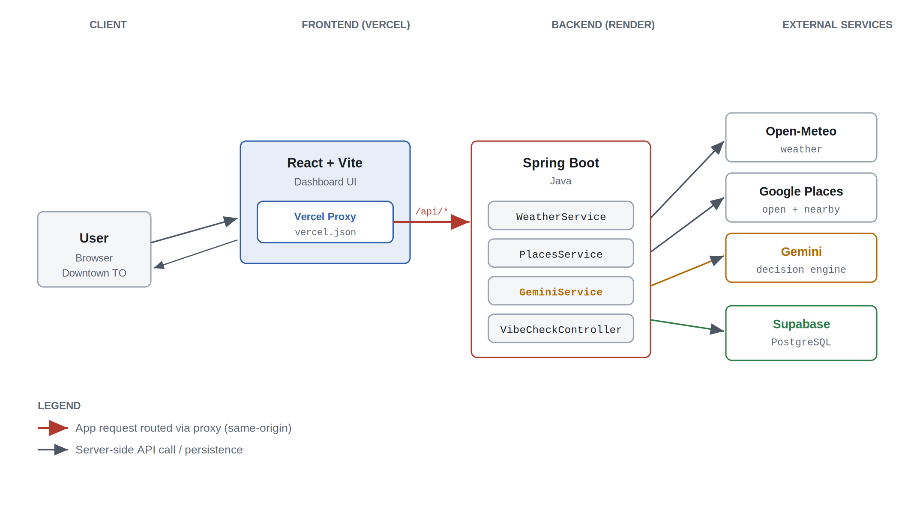
Figure 1. High-level system architecture. A single Spring Boot orchestrator fans out to live data feeds, the AI model, and PostgreSQL.

3.1 Component Responsibilities
- React frontend (Vercel) — renders the dashboard and Vibe feed; routes all API calls through a proxy.
- Spring Boot backend (Render) — orchestrates weather, places, database, and AI calls behind a small REST API.
- Supabase (PostgreSQL) — stores Vibe Checks and optional cached context.
- External services — Open-Meteo (weather), Google Places (open venues), and Gemini (ranking and copy).

3.2 Request Flow
When the user opens the app, one request triggers an ordered orchestration in which each stage adds verified context before the model is ever called.
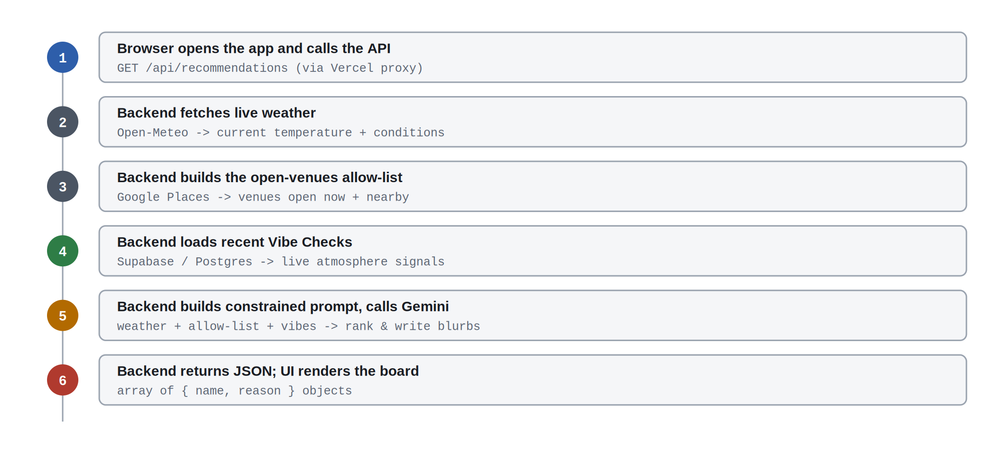
Figure 2. The recommendation request flow. Context is fully assembled and verified before the model is invoked.

4 Technology Stack
Each layer was chosen to keep orchestration logic on the server and to remain deployable on free-tier infrastructure.
Layer | Technology | Role
Frontend | React (Vite) | Component-based dashboard and live Vibe feed; bundled by Vite.
Frontend host | Vercel | Static hosting plus an edge rewrite that proxies API calls.
Backend | Spring Boot / Java | REST API, context gathering, prompt construction, orchestration.
Backend host | Render | Runs the Spring Boot service; holds API credentials as env vars.
Database | Supabase / PostgreSQL | Managed Postgres for Vibe Checks and cached context.
Weather | Open-Meteo | Current temperature and conditions; no API key required.
Places | Google Places | Real-time list of venues that are open and nearby.
AI | Google Gemini | Constrained decision engine that ranks venues and writes copy.

5 Backend Implementation
The Spring Boot service assembles a tightly-scoped context object and hands it to Gemini as a heavily constrained prompt. This constrain-then-delegate pattern is what prevents the model from inventing closed or fictional venues.
Note: the listings below are complete reference implementations consistent with the described architecture; adjust package names and helper methods to match the actual codebase.

5.1 Live Weather Integration (Open-Meteo)
A weather service calls Open-Meteo for the current temperature and conditions in downtown Toronto. Because Open-Meteo needs no API key, it is a low-friction way to inject a strong contextual signal.
package com.rightnowto.weather;

import org.springframework.stereotype.Service;
import org.springframework.web.client.RestTemplate;

@Service
public class WeatherService {

private static final double LAT = 43.6532; // downtown Toronto
private static final double LON = -79.3832;
private final RestTemplate rest = new RestTemplate();

public WeatherSnapshot getCurrent() {
String url = "https://api.open-meteo.com/v1/forecast"
+ "?latitude=" + LAT
+ "&longitude=" + LON
+ "&current=temperature_2m,weather_code";

OpenMeteoResponse res = rest.getForObject(url, OpenMeteoResponse.class);
double temp = res.current().temperature2m();
String conditions = describe(res.current().weatherCode());
return new WeatherSnapshot(temp, conditions);
}

// Map Open-Meteo WMO codes to plain-language conditions
private String describe(int code) {
if (code == 0) return "clear";
if (code <= 3) return "partly cloudy";
if (code <= 67) return "rainy";
if (code <= 77) return "snowy";
return "overcast";
}
}
Listing 1. WeatherService — fetches and interprets current conditions. [Java]

5.2 Location and Places (Google Places)
The places service queries Google Places for venues that are open now and nearby. This list becomes the allow-list for the AI step — the model may only choose from it.
package com.rightnowto.places;

import org.springframework.beans.factory.annotation.Value;
import org.springframework.stereotype.Service;
import org.springframework.web.client.RestTemplate;
import java.util.List;

@Service
public class PlacesService {

@Value("${google.places.api-key}")
private String apiKey;

private final RestTemplate rest = new RestTemplate();

/** Strict, real-time list of venues that are OPEN NOW and nearby. */
public List<Place> findOpenNearby() {
String url = "https://maps.googleapis.com/maps/api/place/nearbysearch/json"
+ "?location=43.6532,-79.3832"
+ "&radius=1200"
+ "&type=restaurant"
+ "&opennow=true"
+ "&key=" + apiKey;

PlacesResponse res = rest.getForObject(url, PlacesResponse.class);
return res.results().stream()
.map(r -> new Place(r.placeId(), r.name(), r.types()))
.toList();
}
}
Listing 2. PlacesService — builds the real-time open-venues allow-list. [Java]

5.3 AI Orchestration (Gemini)
The orchestrator builds a single prompt from the weather, the allow-list, and recent Vibe Checks, then instructs Gemini to return strict JSON. Returning structured data instead of prose is what lets the frontend render results reliably.
package com.rightnowto.ai;

import com.fasterxml.jackson.databind.ObjectMapper;
import org.springframework.beans.factory.annotation.Value;
import org.springframework.http.*;
import org.springframework.stereotype.Service;
import org.springframework.web.client.RestTemplate;
import java.util.List;

@Service
public class GeminiRecommendationService {

@Value("${gemini.api-key}")
private String apiKey;

private final RestTemplate rest = new RestTemplate();
private final ObjectMapper mapper = new ObjectMapper();

public List<Recommendation> recommend(WeatherSnapshot weather,
List<Place> openPlaces,
List<VibeCheck> vibes) throws Exception {

String prompt = buildPrompt(weather, openPlaces, vibes);
String requestBody = mapper.writeValueAsString(new GeminiRequest(prompt));

String url = "https://generativelanguage.googleapis.com/v1beta/"
+ "models/gemini-1.5-flash:generateContent?key=" + apiKey;

HttpHeaders headers = new HttpHeaders();
headers.setContentType(MediaType.APPLICATION_JSON);
ResponseEntity<String> res = rest.postForEntity(
url, new HttpEntity<>(requestBody, headers), String.class);

String jsonText = extractModelText(res.getBody()); // pull model output
return List.of(mapper.readValue(jsonText, Recommendation[].class));
}

/** The constraint that keeps the model honest: a fixed allow-list. */
private String buildPrompt(WeatherSnapshot weather,
List<Place> openPlaces,
List<VibeCheck> vibes) {
return """
You are a downtown Toronto local giving one-line suggestions.
It is currently %.0f C and %s.

You may ONLY recommend venues from this list of places that are
open right now. Do NOT invent or add any venue:
%s

Recent atmosphere reported by other users:
%s

Return STRICT JSON only: an array of objects, each with the
fields "name" and "reason". No markdown, no commentary.
""".formatted(
weather.temp(),
weather.conditions(),
formatPlaces(openPlaces),
formatVibes(vibes));
}
}
Listing 3. GeminiRecommendationService — prompt construction and JSON parsing. [Java]

5.4 Vibe Checks API
A custom social endpoint lets users submit a venue's atmosphere as Busy, Chill, or Lively. Entries are persisted to Postgres and surfaced both in the feed and as an extra signal in the prompt.
package com.rightnowto.vibes;

import jakarta.persistence.*;
import java.time.Instant;
import java.util.UUID;

@Entity
@Table(name = "vibe_checks")
public class VibeCheck {

@Id
@GeneratedValue(strategy = GenerationType.UUID)
private UUID id;

private String placeId;
private String placeName;

@Enumerated(EnumType.STRING)
private Vibe vibe; // BUSY, CHILL, LIVELY

private String note;
private Instant createdAt = Instant.now();

// getters and setters omitted for brevity
}

enum Vibe { BUSY, CHILL, LIVELY }
Listing 4. VibeCheck — the JPA entity and Vibe enum. [Java]

package com.rightnowto.vibes;

import org.springframework.data.jpa.repository.JpaRepository;
import org.springframework.web.bind.annotation.*;
import java.util.List;
import java.util.UUID;

public interface VibeCheckRepository
extends JpaRepository<VibeCheck, UUID> {

// Powers the live "On the Street" feed
List<VibeCheck> findTop20ByOrderByCreatedAtDesc();
}

@RestController
@RequestMapping("/api/vibes")
class VibeCheckController {

private final VibeCheckRepository repo;
VibeCheckController(VibeCheckRepository repo) { this.repo = repo; }

@GetMapping
List<VibeCheck> recent() {
return repo.findTop20ByOrderByCreatedAtDesc();
}

@PostMapping
VibeCheck submit(@RequestBody VibeCheck vibe) {
return repo.save(vibe);
}
}
Listing 5. Repository and REST controller for Vibe Checks. [Java]

5.5 Recommendation Endpoint
The recommendation controller ties the pieces together. Note the ordering: context and the allow-list are gathered first, and only then is the model invoked.
package com.rightnowto.recommend;

import org.springframework.web.bind.annotation.*;
import java.util.List;

@RestController
@RequestMapping("/api/recommendations")
public class RecommendationController {

private final WeatherService weather;
private final PlacesService places;
private final VibeCheckRepository vibes;
private final GeminiRecommendationService gemini;

// constructor injection omitted for brevity

@GetMapping
public List<Recommendation> get() throws Exception {
var snapshot = weather.getCurrent();
var openPlaces = places.findOpenNearby(); // the allow-list
var recentVibes = vibes.findTop20ByOrderByCreatedAtDesc();
return gemini.recommend(snapshot, openPlaces, recentVibes);
}
}
Listing 6. RecommendationController — the orchestration entry point. [Java]

5.6 Configuration
Database credentials and API keys are supplied through environment variables on Render, never hard-coded.
# --- Supabase / PostgreSQL ---
spring.datasource.url=${SUPABASE_DB_URL}
spring.datasource.username=${SUPABASE_DB_USER}
spring.datasource.password=${SUPABASE_DB_PASSWORD}
spring.jpa.hibernate.ddl-auto=validate
spring.jpa.properties.hibernate.dialect=org.hibernate.dialect.PostgreSQLDialect

# --- External API keys (set as environment variables on Render) ---
google.places.api-key=${GOOGLE_PLACES_KEY}
gemini.api-key=${GEMINI_KEY}
Listing 7. application.properties — datasource and API-key configuration. [properties]

6 Database Design
Persistence is handled by Supabase, a managed PostgreSQL platform. The primary persistent entity is the Vibe Check; weather and places are fetched live per request, with an optional cache table to reduce third-party calls.
The schema below is a representative model consistent with the described behaviour; adjust column names and types to match the actual migrations.
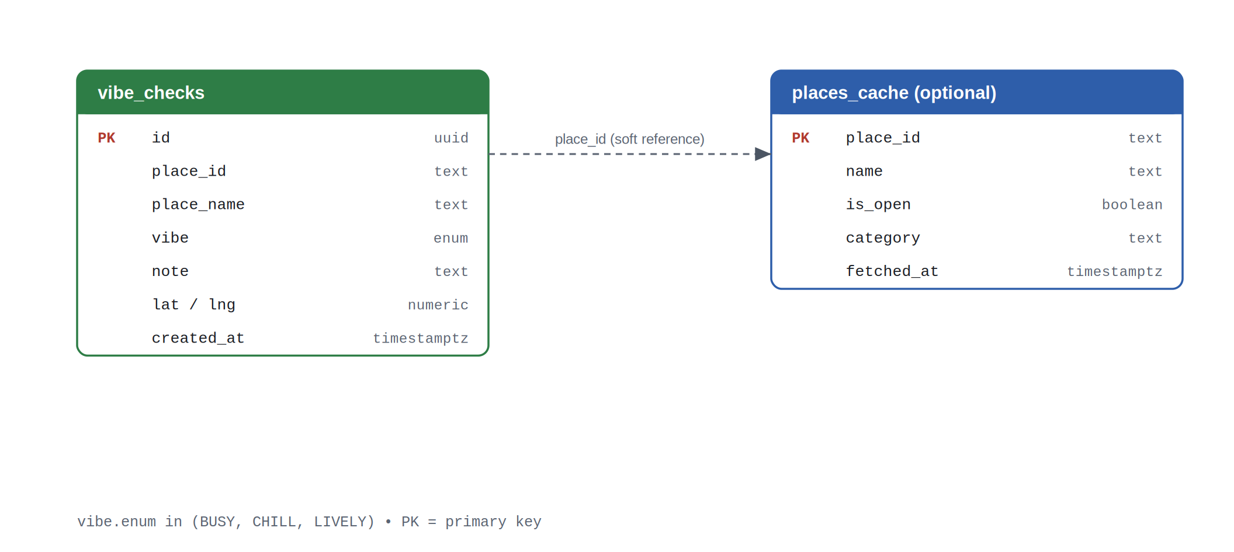
Figure 3. Entity model. vibe_checks is the source of truth for the social feed; places_cache is optional.

6.1 SQL Definitions
create table vibe_checks (
id uuid primary key default gen_random_uuid(),
place_id text not null,
place_name text not null,
vibe text not null
check (vibe in ('BUSY', 'CHILL', 'LIVELY')),
note text,
lat numeric,
lng numeric,
created_at timestamptz not null default now()
);

-- Fast lookups for the "recent 20" feed query
create index idx_vibe_checks_created_at
on vibe_checks (created_at desc);
Listing 8. Table definition and index for vibe_checks (PostgreSQL). [SQL]

6.2 Why Supabase and PostgreSQL
- Managed Postgres — a real relational database with SQL, indexes, and constraints, with no server to run.
- Fast to ship — instant provisioning and a generous free tier suit a Render + Vercel deployment.
- Room to grow — row-level security, authentication, and realtime subscriptions are available as the feed expands.

7 Frontend Implementation
The client is a React application bundled with Vite, built around one memorable metaphor: a transit arrival board that announces the user's next destination.

7.1 API Client
All network calls target /api so the browser stays same-origin; the Vercel proxy forwards them to the backend (Section 8).
// All calls go to /api so the browser stays same-origin.
// Vercel rewrites /api/* to the Render backend (see vercel.json).
const API = "/api";

export async function getRecommendations() {
const res = await fetch(`${API}/recommendations`);
if (!res.ok) throw new Error("Could not load recommendations");
return res.json();
}

export async function getVibes() {
const res = await fetch(`${API}/vibes`);
return res.json();
}

export async function postVibe(vibe) {
const res = await fetch(`${API}/vibes`, {
method: "POST",
headers: { "Content-Type": "application/json" },
body: JSON.stringify(vibe),
});
return res.json();
}
Listing 9. api.js — a small proxy-aware fetch client. [JavaScript]

7.2 Dashboard Component
The dashboard fetches recommendations on mount and renders each as an arrival on the board. Because the backend returns structured JSON, the component stays simple.
import { useEffect, useState } from "react";
import { getRecommendations } from "./api";

export default function Dashboard() {
const [recs, setRecs] = useState([]);
const [loading, setLoading] = useState(true);
const [error, setError] = useState(null);

useEffect(() => {
getRecommendations()
.then(setRecs)
.catch((e) => setError(e.message))
.finally(() => setLoading(false));
}, []);

if (loading) return <p className="status">Reading the street...</p>;
if (error) return <p className="status">{error}</p>;

return (
<div className="board">
<h1>Next Stop: Main Character Energy</h1>
{recs.map((r) => (
<article className="arrival" key={r.name}>
<h2>{r.name}</h2>
<p>{r.reason}</p>
</article>
))}
</div>
);
}
Listing 10. Dashboard.jsx — fetches and renders recommendations. [React]

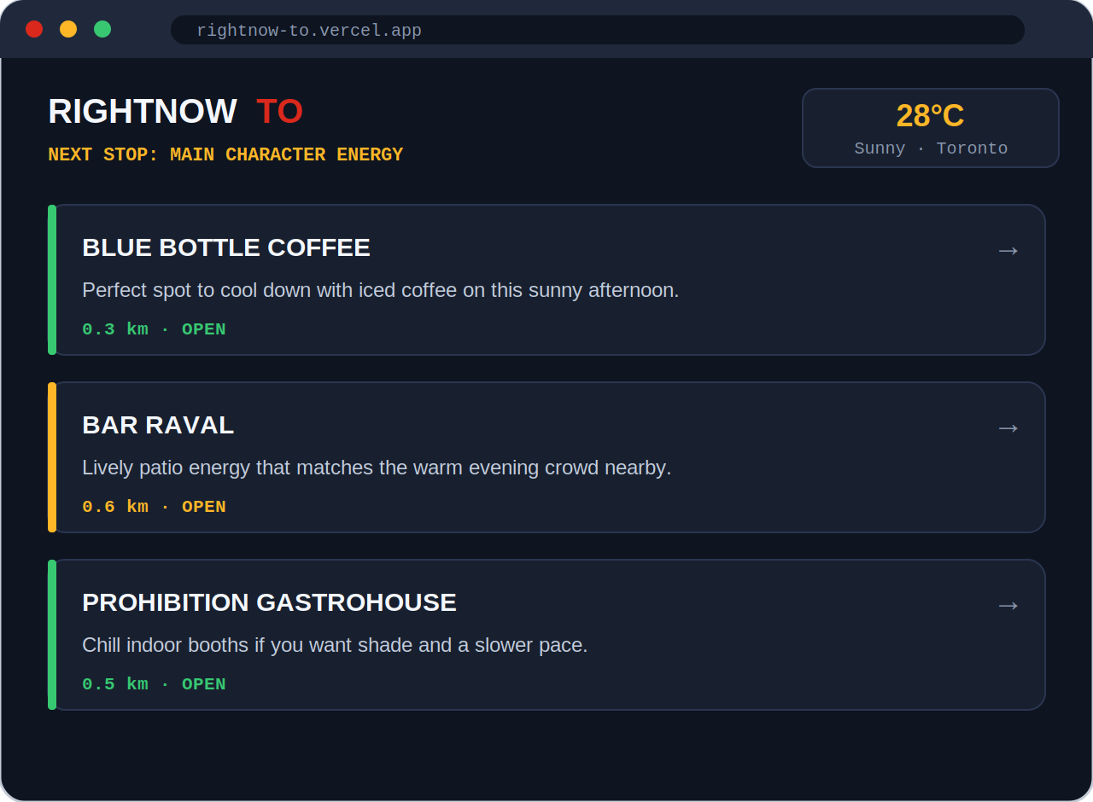
Figure 4. Representative UI mockup of the recommendation dashboard. Replace with an actual screenshot of the running app.

7.3 Vibe Feed Component
The Vibe feed lists recent atmosphere reports and lets users drop their own, prepending new entries optimistically for a responsive feel.
import { useEffect, useState } from "react";
import { getVibes, postVibe } from "./api";

export default function VibeFeed() {
const [vibes, setVibes] = useState([]);

useEffect(() => { getVibes().then(setVibes); }, []);

async function drop(vibe) {
const saved = await postVibe(vibe);
setVibes((prev) => [saved, ...prev]); // optimistic prepend
}

return (
<section className="feed">
<h2>On the Street</h2>
{vibes.map((v) => (
<div className="vibe" key={v.id}>
<span className={`tag ${v.vibe.toLowerCase()}`}>{v.vibe}</span>
<strong>{v.placeName}</strong>
<p>{v.note}</p>
</div>
))}
</section>
);
}
Listing 11. VibeFeed.jsx — the live On the Street feed. [React]

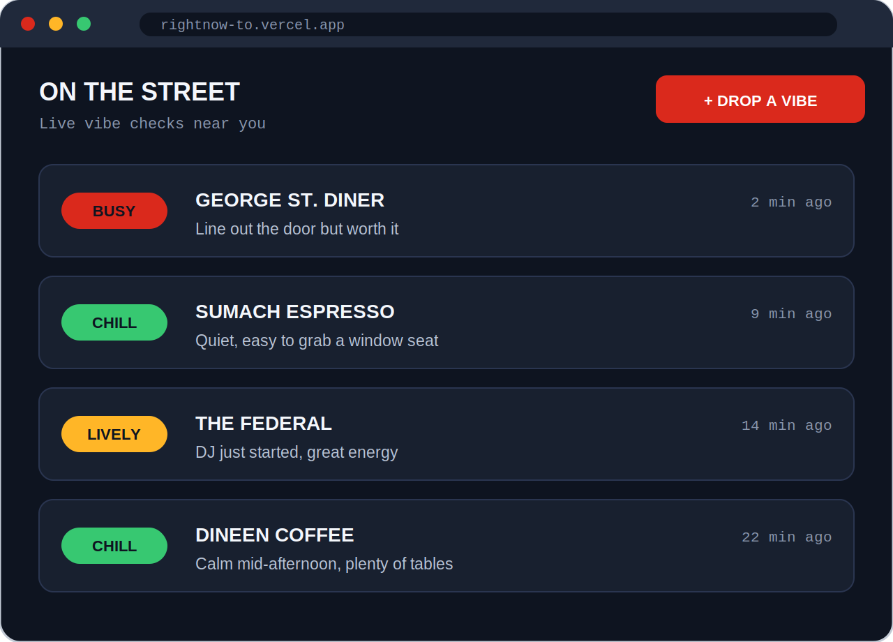
Figure 5. Representative UI mockup of the On the Street feed. Replace with an actual screenshot of the running app.

8 Deployment and the CORS Problem
The frontend is hosted on Vercel and the backend on Render — two different origins. A browser calling the Render backend directly from the Vercel domain triggers a cross-origin (CORS) block. Instead of loosening CORS on the server, the project uses a Vercel proxy that rewrites /api/* requests to the backend, so every call is same-origin from the browser's point of view.
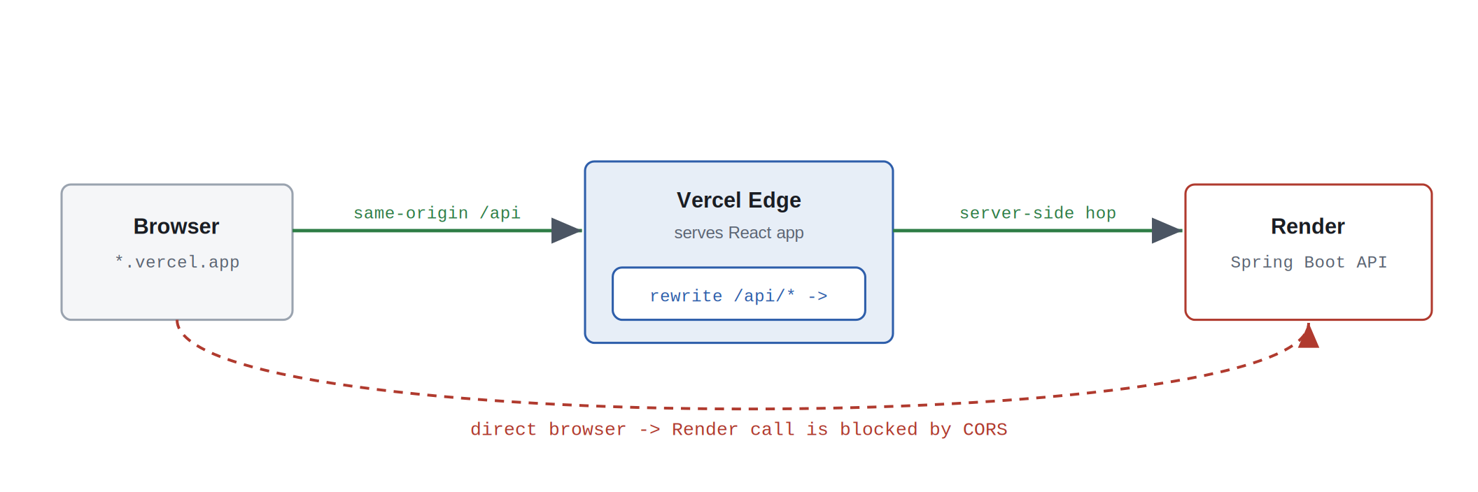
Figure 6. The Vercel proxy converts a cross-origin call into a same-origin one, sidestepping the CORS block.

8.1 Proxy Configuration
The rewrite lives in vercel.json at the project root.
{
"rewrites": [
{
"source": "/api/:path*",
"destination": "https://rightnow-api.onrender.com/api/:path*"
}
]
}
Listing 12. vercel.json — rewrites frontend /api/* calls to the Render backend. [JSON]

8.2 Local Development CORS
During local development the frontend runs on the Vite dev server, so a small CORS mapping is enabled for that origin only. In production the proxy makes this unnecessary.
@Configuration
public class WebConfig implements WebMvcConfigurer {

// Only needed for local development against the Vite dev server;
// in production the Vercel proxy makes every call same-origin.
@Override
public void addCorsMappings(CorsRegistry registry) {
registry.addMapping("/api/**")
.allowedOrigins("http://localhost:5173")
.allowedMethods("GET", "POST");
}
}
Listing 13. WebConfig — CORS mapping used only for local development. [Java]

9 Challenges and Solutions

Keeping the AI honest
Language models readily invent plausible-sounding venues. The solution was to never let the model source facts: it sees only a verified allow-list of open places and is instructed to choose strictly from it. The model ranks and writes copy; it does not retrieve.

Structured, renderable output
Free-form prose is hard to render reliably. Prompting Gemini for strict JSON let the React board map results directly to UI elements without brittle parsing.

Cross-deployment CORS
Splitting the frontend (Vercel) and backend (Render) across origins created browser security blocks. The Vercel rewrite proxy resolved this without weakening backend security.

Orchestrating multiple live feeds
A single request fans out to weather, places, the database, and the model. Sequencing these calls and handling a slow or empty feed is the real backend complexity behind a one-line recommendation.

10 Results
The completed system delivers on its objectives: a single request returns a short list of open, context-appropriate venues, each with an AI-written justification, and the live feed gives the app a social pulse. The constrain-then-delegate pattern reliably prevents closed or invented venues from appearing, and the proxy architecture allows the frontend and backend to be deployed and scaled independently.

11 Future Work
- Caching layer — persist weather and places results briefly in places_cache to cut third-party calls and latency.
- Vibe decay — weight recent Vibe Checks more heavily so the social signal reflects the last hour, not the last week.
- Accounts and profiles — use Supabase authentication to personalise results and save favourites.
- Realtime feed — Supabase realtime subscriptions so the feed updates without polling.
- Wider coverage — parameterise the location so the same engine serves other neighbourhoods and cities.

12 Conclusion
RightNow TO shows how live external data and an AI model can be combined into a genuinely contextual product. The key engineering insight is architectural rather than model-specific: by treating the AI as a ranker and copywriter over verified data — never as a source of truth — the system stays both useful and trustworthy. The same pattern of gathering constrained context and delegating the final judgement generalises well beyond restaurant recommendations.

A Appendix — Environment Variables
The following variables are configured on Render (backend) and are never committed to source control:
- SUPABASE_DB_URL, SUPABASE_DB_USER, SUPABASE_DB_PASSWORD — PostgreSQL connection.
- GOOGLE_PLACES_KEY — Google Places API key.
- GEMINI_KEY — Google Gemini API key.

