**Screenshots of example run (Positive and Negative)**

Below is the screenshot of the output showing the relevant answers (**POSITIVE** response) for the specific relevant questions.

It includes some of the modifications compared to previous ones like asking the input from the user for the Name and Age. This will store user-specific information and preferences to provide a more personalized experience to users.

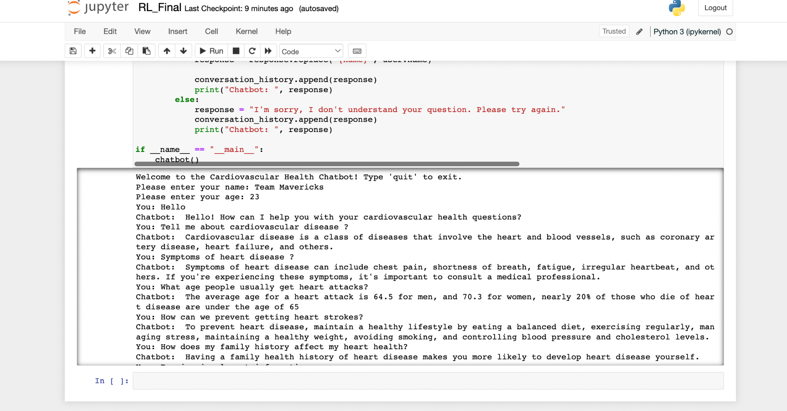

Below is the screenshot of the output showing the irrelevant answers (**NEGATIVE** response) for the specific relevant questions.

