**Instructions**

**Required Software Installation  
Installation of Anaconda**

* Navigate to the Anaconda website and download the anaconda installer from the mentioned link[**https://www.anaconda.com/products/distribution#windows**](https://www.anaconda.com/products/distribution#windows)andchoose a Python installer and download the same.
* Follow the on-screen instructions for the successful installation of the anaconda**.**
* **Jupyter** Notebook comes pre-installed with Anaconda.
* The Python version which is currently being used in this project is “**3.10.9**”

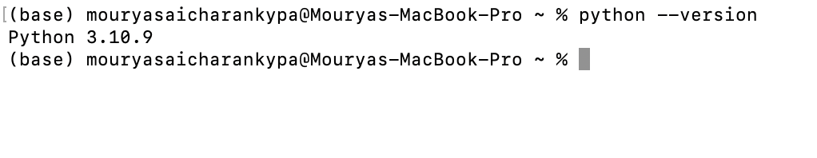

**Install the following required packages:**

* NumPy
* TensorFlow
* nltk
* scikit-learn

Install these packages using the following command:

**pip install numpy tensorflow nltk scikit-learn**

This can also be done in other ways by installing the individual packages as mentioned below.

* pip install numpy
* pip install tensorflow
* pip install nltk
* pip install scikit-learn

Either of the above cases work for installing the required packages.

**Download NLTK data:**

* Download the NLTK data for tokenization using the following command.

**import nltk**

**nltk.download('punkt')**

Make sure that the "**intents.json**" file is in the same directory as where our rl_chatbot Jupyter Notebook file is present.

**Execution:**

* Execute each block of code in rl_chatbot_final Jupyter Notebook one at a time and wait for that block of code to complete execution.
* After reaching the following code block, wait for the model to get trained for 2 mins after executing it. Then stop the training or else **it will take a lot of time to train completely**.
* We tried executing the code for a long time (testing purpose) and we observed below is the snapshot of the end of the code (but is not necessary to wait for long time).

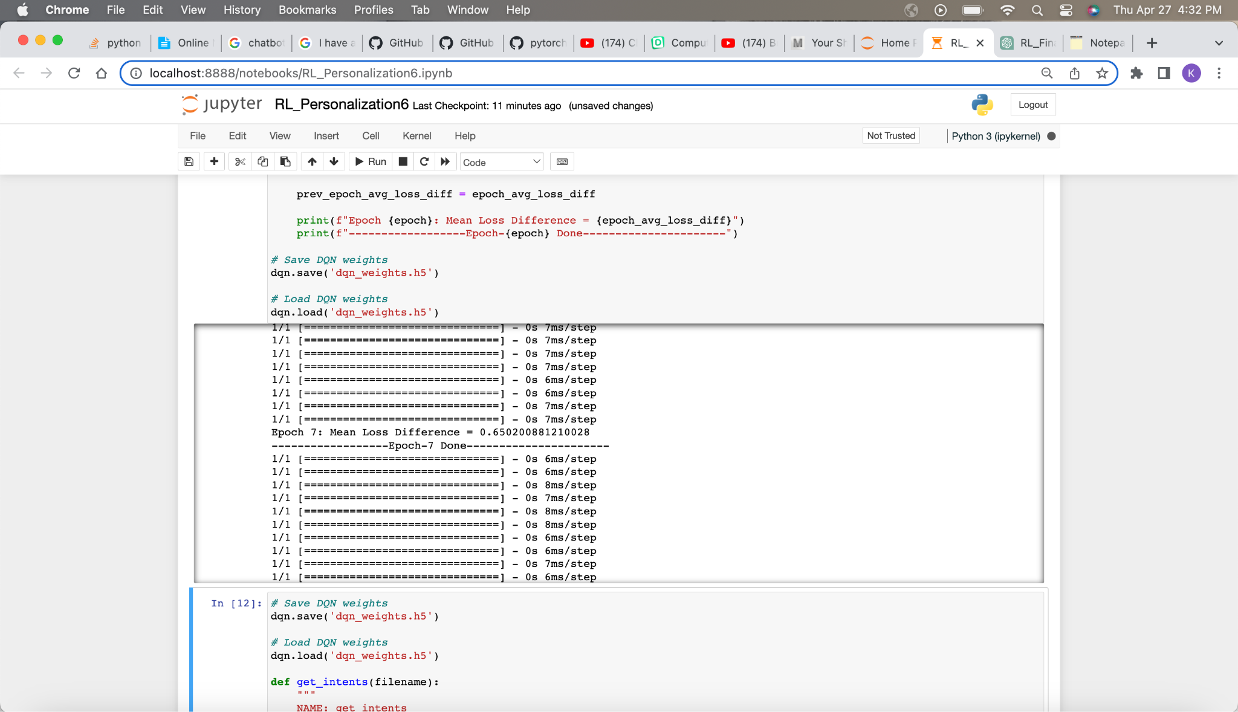

* Once the code block execution is done, we can see the value of Mean loss difference along with the Epoch iteration number. This is shown in the below snapshot.

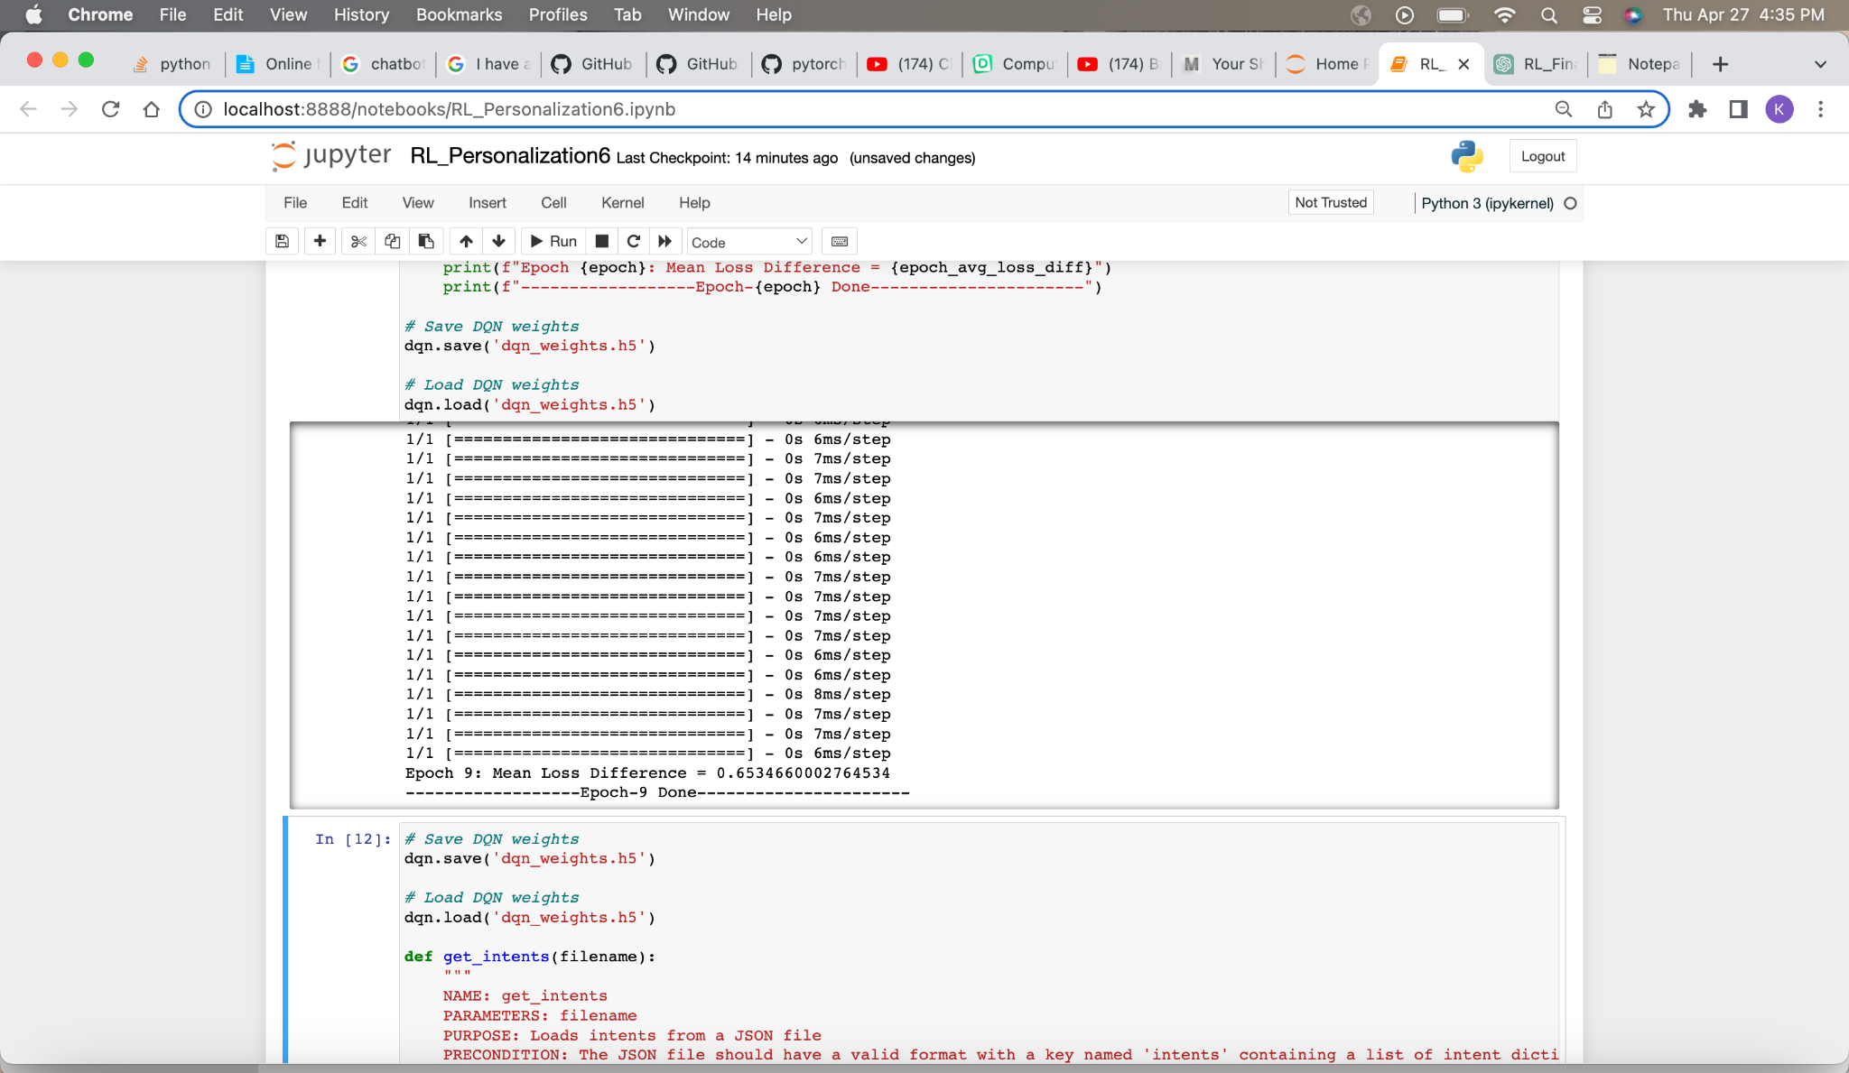

* Continue executing other blocks of codes one at a time and wait till each gets finished before proceeding to another block.
* After the final block of code is executed, a chatbot is generated and prompts for user input where you can interact with it regarding cardiovascular disease.
* Below snapshots shows the sample run of the chatbot which shows the positive response of the chatbot for the very relevant questions related to the cardiovascular disease (Also known as Heart disease)
  + Below is the first one for the POSITIVE response of the chatbot.

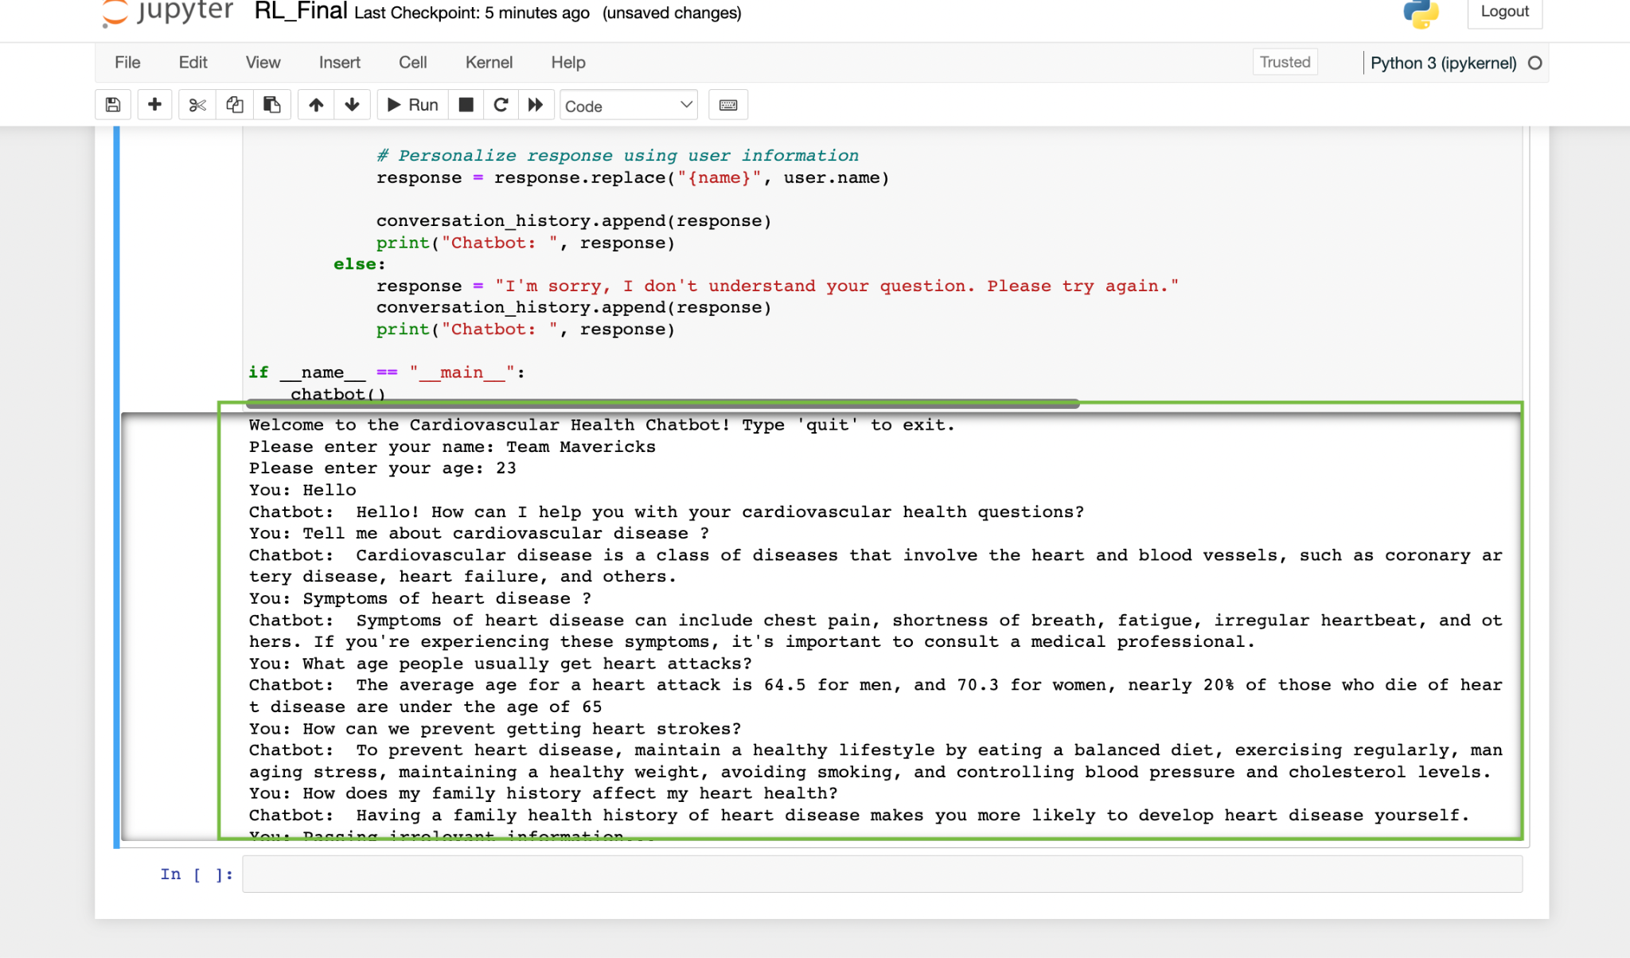

* In the above image, the content which is highlighted in the green color is the positive response of the code.
* Chatbot, first takes the user details like Name and age to store user-specific information (not specifically in any kind of database).
* All questions related to Cardiovascular or Heart disease are answered by the chatbot starting from what is cardiovascular through at what age people get heart attacks more in both men and women.
  + Below is the second one for the NEGATIVE response of the chatbot.

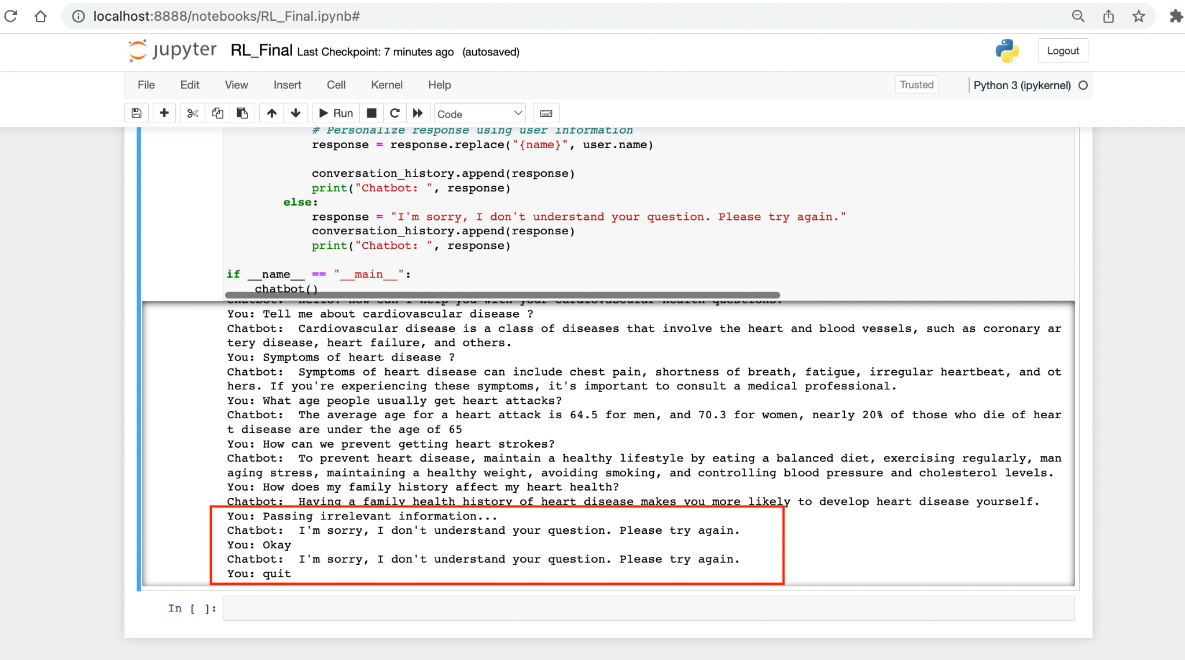

**Example Test Cases to run:**

What is cardiovascular disease?

What are the symptoms of heart disease?

Symptoms? (It can answer single-word questions as well based on the amount of data trained the model)

What causes heart problems?

heart problems?

What can I do to reduce my risk of heart problems?

What are the treatment options for heart disease?

What should I do if I think I'm having a heart attack?

What type of exercise is best for cardiovascular health?

What should I eat for a healthy heart?

What is high blood pressure and how does it affect my heart?

How does stress affect my heart?

Is heart disease hereditary?

What medications are commonly prescribed for heart disease?

Family_risks

* How does my family history affect my heart health?
* Does family history affect heart disease?
* How can family history damage the heart?

Age related

* At what age do people see cardiovascular disease?
* What age do people get cardiovascular disease?
* What age do men get cardiovascular disease?
* What age do women get cardiovascular disease?

**Limitations:**

The Chatbot cannot answer general questions or questions that are not related to cardiovascular disease. The current version of the chatbot is trained on a limited amount of data and hence it is prone to give inappropriate answers if it misinterprets questions.

Examples of what chatbot **cannot** answer:

* Passing irrelevant information
* Who is the current president of the USA?
* Diet? (Sometimes, a single word may not be interpreted appropriately)
* What can you do?

Anything that is not relevant to cardiovascular disease or heart disease will be considered irrelevant and will not be answered properly by the chatbot.