Data Analysis of Montreal

1. Introduction
   1. Background

Montreal is the second-most populous in Canada. It has total population 1704694 and population density of 3889/km^2. As a residence in this city, I would like to explore it more in this project.

Recent years, Montreal is growing fast, and it has attracted many investors. The most important factors of investing are the price of estates and the location of their business.

Therefore to conclude, we need to create a map to show the venue density in Montreal and as well as the estate price in each region.

* 1. Data Description and Data Cleaning

The city of Montreal is divided into 19 boroughs, I am going to scrape the data from Wikipedia(source: <https://en.wikipedia.org/wiki/Boroughs_of_Montreal>).

Then I am using the average price in each borough from this website (source: <https://news.shupilov.com/blog/montreal-boroughs-ranked-according-to-5-year-appreciation/>).

After cleaning the data and merge the tables, the result dataframe will be as following:

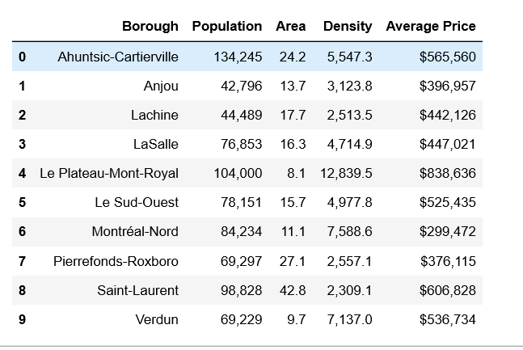

Next, I will use the FourSquare API to find the most common venue in Montreal and use the information to perform further analysis.