|  |  |  |  |  |
| --- | --- | --- | --- | --- |
| logo | Commercial services | Industrial services | Contact us | Search bar |

https://tmcontrols.com/

https://www.voltasg.com/consulting/

https://iteclv.com/

main photo is

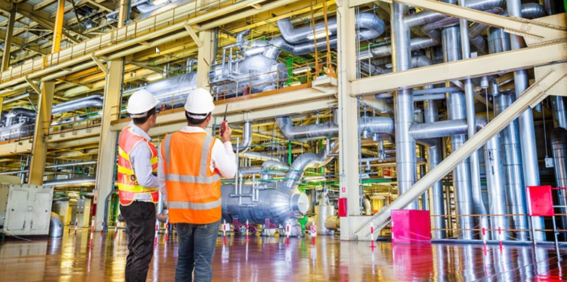Main page has main brands and main customers

brands we can fully Handle

Allen Bradely

Danfoss

Cuttler hammer

Wago

BR

**Contact us**

Address:

[**Address**](https://www.google.com/search?rlz=1C1GCEA_enUS971US971&sxsrf=APwXEdcJKKGjK-SdOUYHjLvRR5RWRJamUA:1682056775894&q=st+rose+executive+suites+and+virtual+offices+address&ludocid=7943077189676533787&sa=X&ved=2ahUKEwih3_nkpbr-AhXxJ0QIHVprDUsQ6BN6BAhoEAI)**:**2831 St Rose Pkwy #200, Henderson, NV 89052

[**Hours**](https://www.google.com/search?rlz=1C1GCEA_enUS971US971&sxsrf=APwXEdcJKKGjK-SdOUYHjLvRR5RWRJamUA:1682056775894&q=st+rose+executive+suites+and+virtual+offices+hours&ludocid=7943077189676533787&sa=X&ved=2ahUKEwih3_nkpbr-AhXxJ0QIHVprDUsQ6BN6BAhrEAI)**:**

|  |  |
| --- | --- |
| Monday | 8 AM–5 PM |
| Tuesday | 8 AM–5 PM |
| Wednesday | 8 AM–5 PM |
| **Thursday** | **8 AM–5 PM** |
| Friday | 8 AM–5 PM |
| Saturday | Closed |
| Sunday | Closed |

Phone : (702) 955- 6624