Stellar Ranger

## Game Design Document

### Kyle Rennie

### June, 2022

### Revision 1.0

The game is a vertical scrolling shooter. Stellar Ranger is inspired by many classic arcade space shooter games such as Space Invaders, Galaga, and Galaxian. Although the game appears to be a vertical scrolling shooter it could be technically said to be a fixed shooter since the background moves and the player's position is fixed giving it the illusion of movement. The player controls a fixed ship at the bottom of the screen as animated asteroids travel toward the player. The player may either shoot the asteroids or avoid them completely. A player can win the game by surviving for 2 minutes and they will lose if they collide with asteroids 5 times.

## Target System and Requirements

The game was built on and for Windows systems. Although the game was built with Allegro 4.4.2 which is cross-compatible with other systems, this has not been tested. The game uses MappAL to generate background tiles as it moves. To build the game the user will need to use Visual Studio and Allegro. Visual Studio 2013 was used to create the game and other versions were not tested.

## User Interface

The interface is simple and provides only information that is pertinent to the user. The main display is where most of the game is displayed. All of the player character sprites (ship and laser) are rendered in this area. The background, as well as the “opponents”, are displayed here as well. The asteroids that are obstacles for the player are rendered here and rotate between different frames of animation.

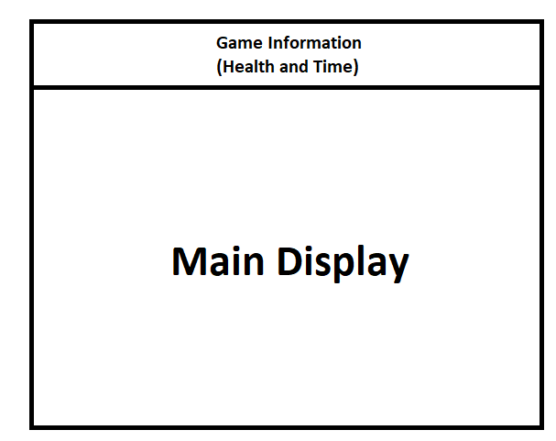

## 

## 

## Story

Before the start of the game, the player is traveling through space to reach an unknown planet for exploration. On the way to their destination, they encounter an unexpected asteroid field that is very dangerous. During the game, the player will navigate their ship through the asteroid field to attempt to reach safety and their destination.

## Theme

The game is based on a sci-fi space theme. All visuals are futuristic and in space. The background is made up of distant stars and stellar bodies. The foreground is made up of the player ship and asteroids. The midi music used is from Megaman 2 and it is Dr. Wily’s theme. The sprites and art are all pixel art to invoke a classic arcade theme.

## Menus

There are no interactable menus, they are all text-based. The initial menu gives players a brief overview of the game and its controls. The pause menu will give players slightly more detailed and specific information and the last menu displays if the player has won or lost the game. Players may toggle game music on or off with a keybinding. Players may pause the game and look at the menu to get control help.

## Playing a game

A player will first be greeted by the title screen. After the title screen, an intro screen will go over the main gameplay, controls, and keybinds. A player can press any button to begin the game. Once the game begins the user controls the spaceship sprite and tries to either avoid asteroids or shoot them. This loop continues until the player either gets hit 5 times or survives for 2 minutes and makes it through the asteroid belt. Either way, the end screen will display the outcome and ask them to exit the game.

## Characters and NPCs

The main character is a ship exploring outer space. I drew the ship and it can take 5 hits from asteroids before it will be destroyed. The ship is equipped with a forward-facing laser that can destroy asteroids in a single hit. The asteroids have 64 different frames of animation and were taken from the resources used in COMP 369. The asteroids explode on impact with a player and deal 1 point of damage out of 5 life. The speed at which the asteroids come towards the player varies so that some are almost stationary and some come quickly to add variety.

## Conclusion

This game was initially a project for the class COMP 369 from Athabasca. Although as I put some time into it I got more invested and made it my own. If I were to put more time into it I would expand the shooting and add power-ups to make the player weapon stronger or more varied. Additional levels could be added with different enemies and maybe AI. The base game can be easily changed and added to so I might come back to this project in the future.