Healthcare Cyber Threat Intelligence Brief
Actively Exploited Vulnerabilities - January through June 2026
Northstar Regional Health (fictional)

Intelligence question
Which actively exploited vulnerabilities present the greatest near-term operational risk to a midsized healthcare organization?

Key judgment
Northstar Regional Health's most consequential near-term exposure is likely concentrated in externally reachable and centrally managed infrastructure. The three highest-scoring vulnerabilities affect remote access, enterprise email, and centralized firewall management. Each could provide access to trusted systems or disrupt communications and network security across multiple sites. This judgment is made with moderate confidence because exploitation is confirmed, but the fictional organization's actual technology inventory is unknown.

Dataset findings
The assessment reviewed 146 KEV records from 69 vendors. The model classified 5 as Critical and 5 as High. 19 records were marked as associated with known ransomware campaigns.
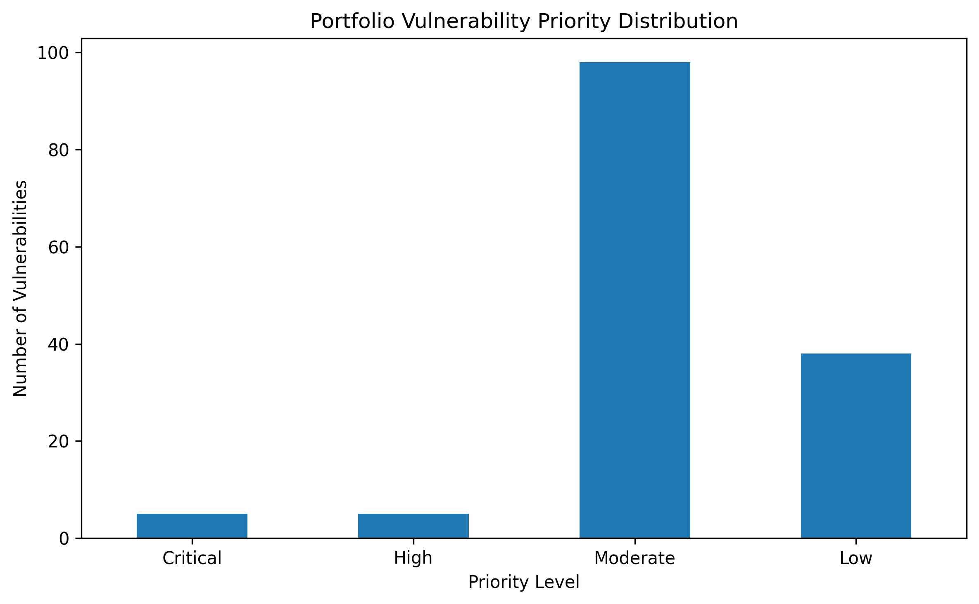

Priority vulnerabilities
Rank | CVE | Technology | Principal concern | First action
1 | CVE-2026-0257 | PAN-OS GlobalProtect | Unauthorized VPN access | Verify exposure and upgrade
2 | CVE-2023-21529 | Exchange Server | Authenticated remote code execution | Patch and review logs
3 | CVE-2026-20131 | Cisco Secure FMC | Unauthenticated root code execution | Upgrade and restrict access

Recommended 30-day actions
- Match the three products against the authoritative asset inventory.
- Confirm installed versions and configuration-specific exposure.
- Apply vendor fixes and track remediation to closure.
- Review remote-access, Exchange, firewall-management, and identity logs.
- Restrict management interfaces to dedicated administrative networks.
- Validate segmentation and privileged accounts after remediation.
- Test contingency procedures for loss of email, remote access, or firewall management.

Confidence and limitations
The technical findings are supported by authoritative public sources. Organization-specific risk remains uncertain because no internal asset or control data were used. Product relevance is a hypothesis requiring verification, not proof of exposure.

Core sources
- CISA KEV Catalog: https://www.cisa.gov/known-exploited-vulnerabilities-catalog
- Palo Alto CVE-2026-0257: https://security.paloaltonetworks.com/CVE-2026-0257
- NIST NVD CVE-2023-21529: https://nvd.nist.gov/vuln/detail/CVE-2023-21529
- Cisco CVE-2026-20131: https://sec.cloudapps.cisco.com/security/center/content/CiscoSecurityAdvisory/cisco-sa-fmc-rce-NKhnULJh

