Healthcare Threat Intelligence Technical Analysis
Northstar Regional Health (fictional) | 2026 H1 CISA KEV assessment

Executive summary
This analysis reviewed 146 CISA KEV records from 69 vendors and selected three Critical vulnerabilities for deeper research. The selected cases affect remote access, enterprise email, and centralized firewall management.

Methodology
Factor | Maximum points
Healthcare relevance | 3
Internet-facing or remote-access relevance | 2
Known ransomware association | 3
Technical impact | 3
Remediation urgency | 2
Operational impact | 3
Priority thresholds: Critical 13-16; High 9-12; Moderate 5-8; Low 0-4.

Dataset overview
Measure | Result
Records | 146
Unique vendors | 69
Critical | 5
High | 5
Moderate | 98
Low | 38
Known ransomware association | 19
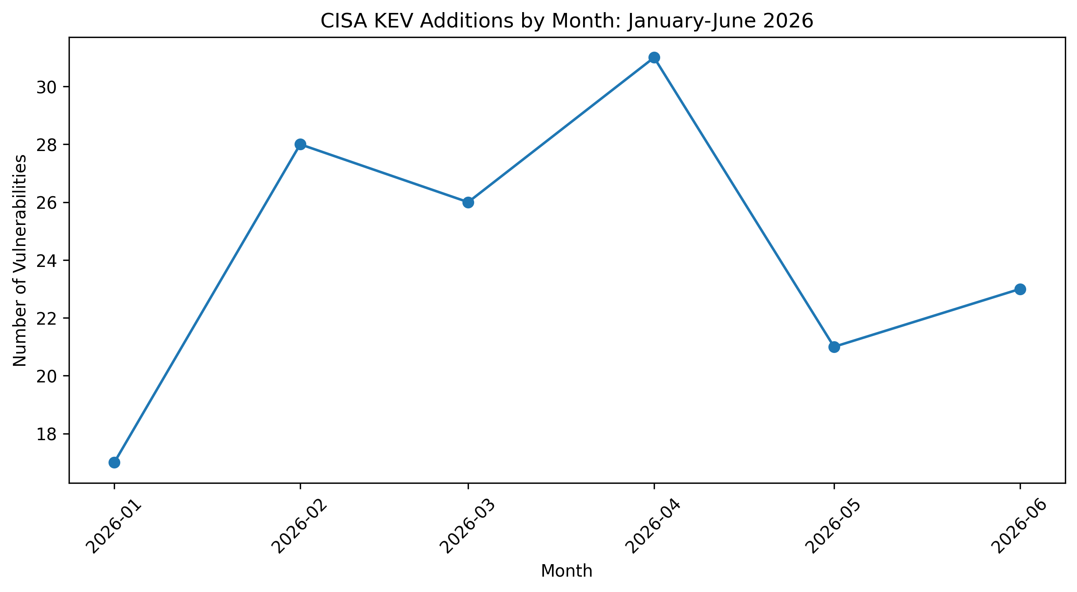
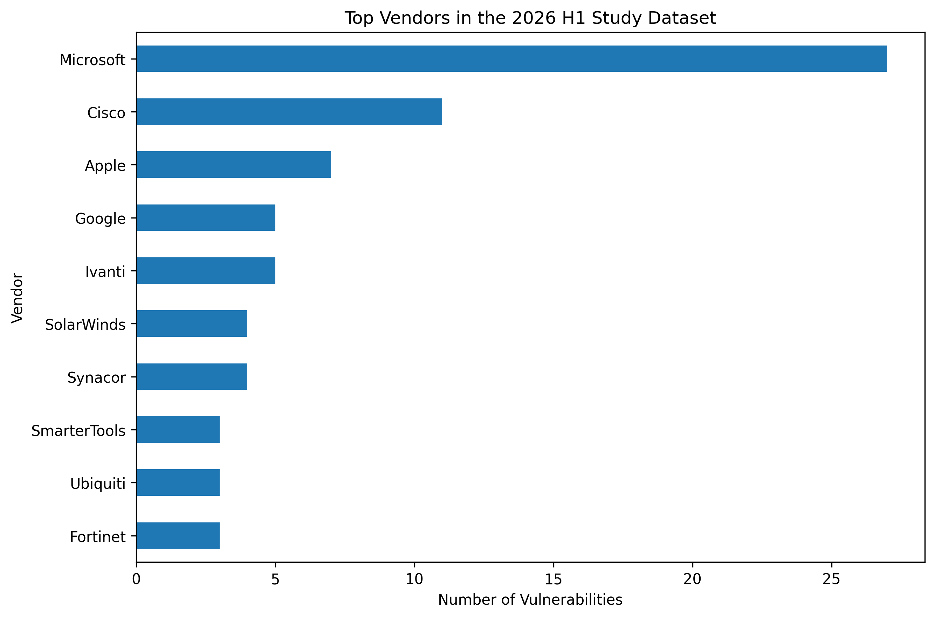

Priority profile 1

CVE-2026-0257 - PAN-OS GlobalProtect Authentication Bypass

Key judgment
An unauthenticated attacker can establish an unauthorized VPN connection when vulnerable configuration conditions are present.

Authoritative findings
- Limited exploitation attempts were reported by Palo Alto Networks.
- The attack is network-based and requires no privileges or user interaction.
- The vendor provides fixed releases and configuration checks.

Potential healthcare impact
Possible bypass of a perimeter access control, unauthorized internal connectivity, remote-access disruption, and follow-on compromise.

MITRE ATT&CK mapping
Tactic | Technique | Evidence status | Rationale
Initial Access | T1190 | Assessed - High | Externally reachable GlobalProtect service exploited for unauthorized access.

Recommended defensive actions
- Confirm product, version, and configuration.
- Upgrade to a fixed release.
- Review authentication and VPN logs.
- Investigate suspicious sessions.

Confidence
High technical confidence; moderate organization-specific confidence.

Sources
- https://security.paloaltonetworks.com/CVE-2026-0257
- https://www.cisa.gov/news-events/alerts/2026/05/29/cisa-adds-one-known-exploited-vulnerability-catalog
- https://attack.mitre.org/techniques/T1190/

Priority profile 2

CVE-2023-21529 - Exchange Server Deserialization Remote Code Execution

Key judgment
An authenticated attacker with network access can exploit unsafe deserialization to execute code on vulnerable Exchange Server systems.

Authoritative findings
- CISA added the vulnerability to KEV on April 13, 2026.
- NVD records CVSS 8.8, low attack complexity, low privileges, and no user interaction.
- Affected Exchange product families and fixed builds are documented.

Potential healthcare impact
Possible email disruption, exposure of communications, code execution on a trusted server, and lateral movement.

MITRE ATT&CK mapping
Tactic | Technique | Evidence status | Rationale
Lateral Movement | T1210 | Assessed - Moderate | Authenticated network exploitation of a remote Exchange service.

Recommended defensive actions
- Inventory Exchange systems.
- Apply Microsoft updates.
- Review Exchange, Windows, identity, and management logs.
- Reset credentials and isolate systems if needed.

Confidence
High confidence in RCE and active exploitation; moderate deployment-specific confidence.

Sources
- https://msrc.microsoft.com/update-guide/en-US/vulnerability/CVE-2023-21529
- https://nvd.nist.gov/vuln/detail/CVE-2023-21529
- https://www.cisa.gov/news-events/alerts/2026/04/13/cisa-adds-seven-known-exploited-vulnerabilities-catalog
- https://attack.mitre.org/techniques/T1210/

Priority profile 3

CVE-2026-20131 - Cisco Secure FMC Remote Code Execution

Key judgment
An unauthenticated remote attacker can execute arbitrary Java code as root through the web management interface.

Authoritative findings
- Cisco attributes the flaw to insecure deserialization.
- Cisco PSIRT reported attempted exploitation in March 2026.
- Cisco states that no workaround addresses the issue.

Potential healthcare impact
Possible root compromise of firewall management, policy manipulation, reduced visibility, weakened segmentation, and broad recovery work.

MITRE ATT&CK mapping
Tactic | Technique | Evidence status | Rationale
Initial Access | T1190 | Conditional | Applies when the web management interface is internet-facing.
Lateral Movement | T1210 | Assessed | Applies when the service is reachable only internally.

Recommended defensive actions
- Identify installations and versions.
- Upgrade using Cisco guidance.
- Remove public management access.
- Review logs and validate policies and accounts.

Confidence
High technical confidence; moderate organization-specific confidence.

Sources
- https://sec.cloudapps.cisco.com/security/center/content/CiscoSecurityAdvisory/cisco-sa-fmc-rce-NKhnULJh
- https://attack.mitre.org/techniques/T1190/
- https://attack.mitre.org/techniques/T1210/

Limitations
- The organization is fictional.
- No real asset inventory, scanner output, logs, or architecture were used.
- The scoring model is educational and not independently validated.
- KEV addition dates do not necessarily represent exploitation start dates.
- Unknown ransomware status was not treated as absence of ransomware use.

