**EE 551 Python: Neural Network on MNIST dataset**

**Nan Xu**

**Background:** Machine learning (ML) and Deep learning (DL) are the raising topic in recent five year. It deals with the problem of finding a predictive function based on the given data. My research interested focus on use machine learning approaches to solve real-world applications. Deep convolutional neural network (CNN) is one of the most efficient algorithms in dealing with big datasets, and image-based datasets. Python language is the most widely-used computational language in DL area and solving the MNIST problems by using Python packages is a great start project of Deep learning & Python.

**Goal:** In this project, we developed a convolutional neural network to recognize the hand-written digits.

**Dataset & Method:** *Datasets:* We used the MNIST dataset [1] for training and testing the proposed algorithms. MNIST dataset has 70000 hand-written digits samples in size of 28*28 pixels. There are 60000 samples in the training set; and 10000 samples in the testing set. *Methods:* The proposed neural network is a two-layer convolutional neural network. The first and the second layers both are the size of 3×3 filter with 32 components. Then the network follow by a 128 features dense layer and a softmax layer for outputting the 10 digits. The algorithm trained by using Stochastic gradient decent optimization [2] algorithms. The proposed CNN is a shallow network, we are not using a deep CNN because the limitation of our computation power.

**Method Implantation:** The proposed CNN algorithm is implemented by using *Keras* package in Python. *Keras* is one of the most widely-used package in Deep learning which is built upon the Google *Tensorlfow*. Also, we use the *Matplotlib* to visualize the dataset, the training process and the predicted results.

**Results:** We use the classification accuracy to evaluate the proposed CNN architecture. The accuracy performance is valided on the 10000 test samples, and the accuracy on the MNIST dataset achieves 98.57%. It is a promising result on MNIST test set.

**Discussion:** *Why CNN*: Deep convolutional neural network is one of the state-of-the-art approaches in solving learning-based problems and pattern recognition problems. It achieved the promising results in many real-world applications and datasets, e.g., autonomous driving, face recognition, medical image processing.

*Limitation of the CNN*: the limitation of CNN is that the algorithm is black-box algorithms, which is finding the best predictive function based on the validation results and back-ward optimization. We don’t know how does the mechanism works on the forward side. As a result, it’s hard to design an accurate model by using professional knowledge.

**Code:** In the attached jupyter-notebook PDF files, ‘Project_codes.pdf’.

**Reference:** [1] Fisher,R.A. "The use of multiple measurements in taxonomic problems" Annual Eugenics, 7, Part II, 179-188 (1936)

[2] Robbins, Herbert, and Sutton Monro. "A stochastic approximation method." The annals of mathematical statistics (1951): 400-407.

**Appendix:**

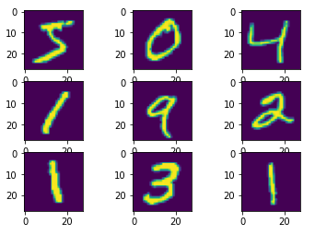

Figure 1 Nine samples of MNIST dataset

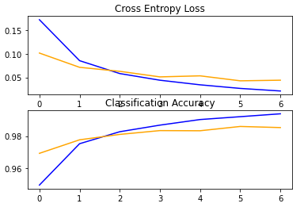

Figure 2 Training and Validation Accuracy & Loss

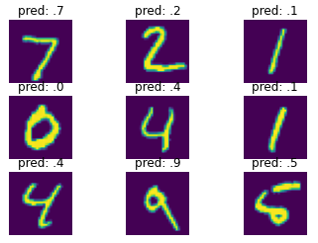

Figure 3 CNN Prediction results