MOBILE APP DEVELOPMENT 700
SMART PANTRY MANAGER
A Java Android application that suggests recipes strictly from leftover ingredients to cut food waste
Practical Assignment | Portfolio of Evidence | Written Report

App name | Smart Pantry Manager
Student name | Kyle Razawo
Student number | 402311608
Qualification | BSc in Information Technology
Module | Mobile App Development 700
Institution | Richfield Graduate Institute of Technology
Date | 22 October 2026
GitHub repository | https://github.com/kyrie1481-art/smart-pantry-manager

Faculty of Information Technology | Individual Assignment | Total: 100 Marks

Contents
1. Introduction 4
1.1 The problem 4
1.2 The solution 4
1.3 Who it is for 4
1.4 Scope and technology 4
2. System Design 6
2.1 Screens and navigation 6
2.2 Data model 7
2.3 The strict-matching rule 7
2.4 Activity lifecycle in the app 9
3. Screenshots of Every Output 10
3.1 Pantry management 10
3.2 Recipe suggestions 12
3.3 Settings and persistence 13
4. Key Code Snippets 15
4.1 Snippet 1: the strict-matching check (RecipeMatcher.java) 15
4.2 Snippet 2: plural to singular (RecipeMatcher.java) 15
4.3 Snippet 3: updating a record in SQLite (DatabaseHelper.java) 16
4.4 Snippet 4: filling a RecyclerView card (PantryAdapter.java) 16
4.5 Snippet 5: passing data between screens with an Intent 17
5. Challenges and Solutions 18
5.1 Challenge 1: matching names and units 18
5.2 Challenge 2: the list showed old data 18
5.3 Challenge 3: content hidden behind the system bars 18
6. Conclusion and Reflection 19
6.1 What I learned 19
6.2 What I would improve with more time 19
7. Reference List 20

1. Introduction

1.1 The problem
Many households throw away food that was still perfectly good. Ingredients sit at the back of a cupboard until they expire, and when it is time to cook, most recipe apps suggest dishes that need a shopping trip for one or two missing items. The result is wasted food, wasted money and an extra trip to the shop.

1.2 The solution
Smart Pantry Manager is an Android application that helps a user cook with what they already have. The user records the ingredients in their pantry (name, quantity, unit and an optional expiry date). The app then suggests recipes that can be cooked using strictly those ingredients.
The core value of the app is its strict-matching rule: a recipe is only suggested when every single ingredient it needs is in the pantry in at least the required quantity. A recipe with four out of five ingredients is never shown, so the user never has to go shopping to follow a suggestion.

1.3 Who it is for
The app is aimed at students, families and anyone trying to stretch a tight grocery budget and reduce food waste. It is simple enough to use every day: a quick update after shopping, and a glance at the Recipes tab when deciding what to cook.

1.4 Scope and technology
The application was built entirely in Java using Android Studio, with a minimum SDK of 24. Persistent data is stored in a local SQLite database accessed through SQLiteOpenHelper (Google, n.d.f). SQLite was chosen because it is built into Android, works fully offline, needs no server or account, and fits the persistent-data approach covered in the module. The app has five screens and the following features:
- Pantry management: add, edit and delete ingredients, with input validation.
- A pantry list screen that displays the database content in a RecyclerView with a custom adapter.
- A collection of 20 recipes, pre-loaded into the database on first run.
- A Suggested Recipes screen that applies the strict-matching rule, with a clear message when nothing matches.
- An optional Almost There tab that lists recipes missing exactly one ingredient, kept completely separate from the strict list.
- A Recipe Detail screen showing the full ingredient list and method.
- JUnit unit tests that check the matching logic automatically.
- A Settings screen with an expiring-soon alert toggle and a default-unit preference, saved with SharedPreferences (Google, n.d.g).
The interface is built with the Material Components library (Google, n.d.e). In line with the assignment brief, the app does not use Google Maps, any mapping SDK, GPS or location services, and it contains no payment features.

2. System Design

2.1 Screens and navigation
The app has five screens. The Pantry List is the home screen; the Suggested Recipes and Settings screens are reached from a bottom navigation bar, and the Add/Edit and Recipe Detail screens are opened with Intents (Google, n.d.d).
Screen | Class | Purpose
Pantry List | MainActivity | Shows all ingredients in a RecyclerView; add, edit and delete
Add / Edit Ingredient | AddEditItemActivity | Validated form used to create or update an ingredient
Suggested Recipes | SuggestedRecipesActivity | Lists only the recipes that pass the strict-matching rule
Recipe Detail | RecipeDetailActivity | Full ingredient list and method of one recipe
Settings | SettingsActivity | Expiry alerts switch and default unit (SharedPreferences)

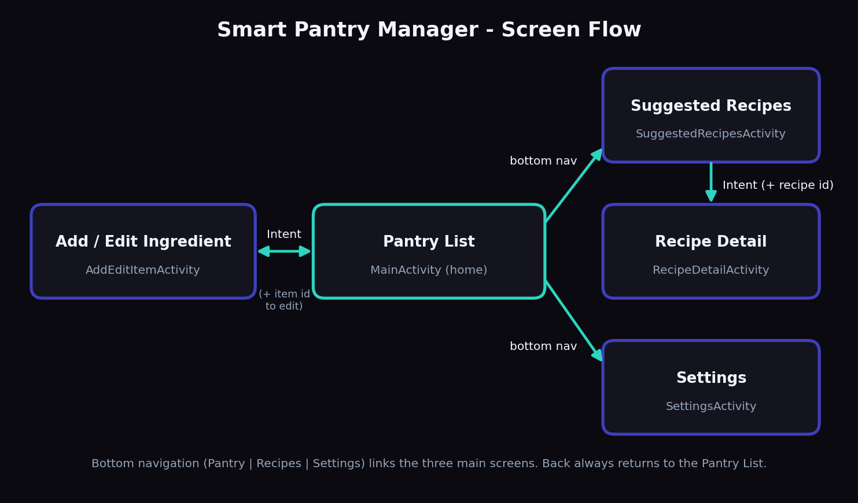
Figure 1: Screen flow of Smart Pantry Manager
When the user taps an ingredient card, the Pantry List sends the ingredient's id to the Add/Edit screen inside the Intent. When there is no id, the same screen works as an Add form. In the same way, tapping a recipe sends the recipe's id to the Recipe Detail screen, which loads that recipe from the database. The Pantry List is treated as the home screen: the other main screens sit on top of it, so pressing Back always returns the user to the pantry.

2.2 Data model
The data is stored in three SQLite tables (Figure 2). The pantry table holds what the user owns. The recipes table and the recipe_ingredients table hold the recipe collection, which is seeded on the first run. A recipe has many ingredient lines, so ingredients are stored in their own table linked by recipe_id (a one-to-many relationship), which avoids repeating recipe data.
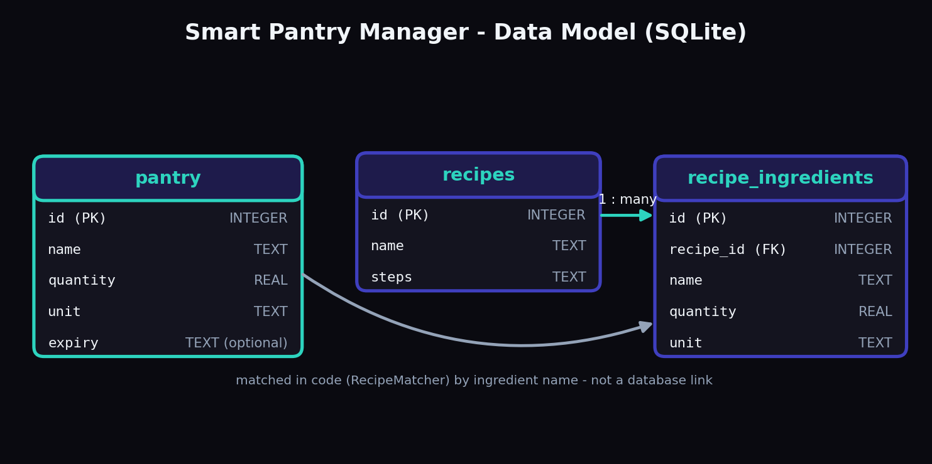
Figure 2: Data model (ER diagram) of the SQLite database
The pantry table is deliberately not linked to the recipe tables by a key. Instead the RecipeMatcher compares ingredient names in code, because a user may type names in many ways (for example Tomato or tomatoes) and a strict database key would not tolerate that.

2.3 The strict-matching rule
The strict-matching rule is the most important piece of business logic in the application. It is implemented in the RecipeMatcher class and works in four steps:
- Normalise every name: convert to lower case, remove symbols and change each word to its singular form, so that tomatoes and tomato are treated as the same ingredient.
- Convert units before comparing: weights are compared in grams (1 kg = 1000 g) and volumes in millilitres (1 l = 1000 ml, 1 cup = 240 ml, 1 tbsp = 15 ml, 1 tsp = 5 ml).
- Add up the quantity of each ingredient if the user entered it more than once.
- Apply the all-or-nothing rule: if any single ingredient is missing or the quantity is too small, the recipe is rejected.
If the recipe and pantry use units that cannot be converted into each other (for example a recipe needs 1 tsp of salt and the pantry holds 500 g of salt), the app accepts the ingredient as long as the user owns some of it. The design tests used to check the rule are listed below.
Test | Pantry contents | Expected result
1 | Cheese Toast needs bread 2 pcs, cheese 40 g, butter 10 g. Pantry: bread 4 pcs, cheese 200 g (butter missing) | NOT suggested (2 of 3 ingredients)
2 | Same as test 1, then add butter 250 g | Cheese Toast appears in the list
3 | Recipe says tomato; pantry has Tomatoes | Matches (plural handled)
4 | Recipe needs cheese 40 g; pantry has cheese 0.2 kg | Matches (unit conversion)
5 | Recipe needs bread 2 pcs; pantry has bread 1 pcs | NOT suggested (quantity too small)
6 | Pantry is empty | Message: No recipes match your pantry yet - add more ingredients
7 | Same as test 1 (butter missing), Almost there tab | Cheese Toast listed with the note Missing: butter, and still absent from the Ready list

These cases were also written as automatic JUnit tests in the RecipeMatcherTest and RecipeMatcherAlmostThereTest classes, which run on the computer without a phone (Google, n.d.b). In addition to the cases above they check duplicate entries, zero quantities, units that cannot be converted, and name cleaning. Every test passes.
The bonus Almost There tab uses the same checking code. getMissingIngredients returns the names of the ingredients the pantry cannot cover, and a recipe is placed in the Almost There list only when exactly one name is returned. The two lists are shown on separate tabs, so an almost-ready recipe can never appear among the strict suggestions.

2.4 Activity lifecycle in the app
Each screen is an Activity. The screens set up their views once in onCreate, but they reload their data in onResume. This matters because onResume runs every time a screen returns to the foreground, for example when the user comes back from the Add/Edit screen, so the pantry list and the suggestions always reflect the latest database content (Google, n.d.a).

3. Screenshots of Every Output

a3.1 Pantry management
REPLACE WITH YOUR REAL SCREENSHOT
Pantry List with several ingredients added (e.g. Egg, Butter, Cheese, Bread)
Figure 3: Pantry List screen showing the ingredients stored in the database, displayed in a RecyclerView.
REPLACE WITH YOUR REAL SCREENSHOT
Pantry List with no ingredients (fresh install)
Figure 4: Empty state: a friendly message is shown instead of a blank screen.
REPLACE WITH YOUR REAL SCREENSHOT
Add Ingredient form filled in (name, quantity, unit, expiry date)
Figure 5: Add Ingredient screen: the Create part of CRUD, including the unit drop-down and date picker.
REPLACE WITH YOUR REAL SCREENSHOT
Add Ingredient form showing red validation errors (empty name, quantity 0)
Figure 6: Input validation: error messages appear under the fields and nothing is saved until they are fixed.
REPLACE WITH YOUR REAL SCREENSHOT
Edit Ingredient screen with values pre-filled
Figure 7: Edit screen: the Update part of CRUD, opened by tapping a card; the ingredient id travels in the Intent.
REPLACE WITH YOUR REAL SCREENSHOT
Delete confirmation dialog
Figure 8: Delete: a confirmation dialog protects against accidental deletion (Delete part of CRUD).
REPLACE WITH YOUR REAL SCREENSHOT
Pantry List with an item highlighted as Expiring soon or Expired
Figure 9: Expiring-soon alert: items expiring within 3 days are highlighted and a banner counts them.

3.2 Recipe suggestions
REPLACE WITH YOUR REAL SCREENSHOT
Suggested Recipes list with at least one recipe shown
Figure 10: Suggested Recipes screen: only recipes whose ingredients are all in the pantry are listed.
REPLACE WITH YOUR REAL SCREENSHOT
Suggested Recipes BEFORE adding butter - Cheese Toast is NOT in the list
Figure 11: Strict-matching proof (1/2): with one ingredient missing, the recipe does not appear.
REPLACE WITH YOUR REAL SCREENSHOT
Suggested Recipes AFTER adding butter - Cheese Toast appears
Figure 12: Strict-matching proof (2/2): after adding the missing ingredient, the recipe appears.
REPLACE WITH YOUR REAL SCREENSHOT
Suggested Recipes, Almost there tab, showing a recipe with Missing: butter
Figure 13: Bonus Almost There tab: recipes missing exactly one ingredient, shown separately from the strict list.
REPLACE WITH YOUR REAL SCREENSHOT
Suggested Recipes with the message No recipes match your pantry yet
Figure 14: Feedback when zero recipes match the pantry.
REPLACE WITH YOUR REAL SCREENSHOT
Recipe Detail screen (ingredients and method)
Figure 15: Recipe Detail screen opened with an Intent carrying the recipe id.

3.3 Settings and persistence
REPLACE WITH YOUR REAL SCREENSHOT
Settings screen (alerts switch and default unit)
Figure 16: Settings screen: preferences are saved with SharedPreferences.
REPLACE WITH YOUR REAL SCREENSHOT
Pantry List after fully closing and reopening the app
Figure 17: Persistence: the data is still present after the app is closed and reopened.
REPLACE WITH YOUR REAL SCREENSHOT
Android Studio Run window showing all unit tests passed (green ticks)
Figure 18: Unit tests: all RecipeMatcher tests pass.
REPLACE WITH YOUR REAL SCREENSHOT
GitHub commit history page
Figure 19: GitHub repository showing the incremental commit history.

4. Key Code Snippets
Five short snippets from the project are explained below. The full source code is in the submitted ZIP file and on GitHub.

4.1 Snippet 1: the strict-matching check (RecipeMatcher.java)
private static boolean hasEnough(RecipeIngredient needed, List<PantryItem> pantry) {
String neededName = normalizeName(needed.getName());
int neededCategory = unitCategory(needed.getUnit());
double neededBase = toBaseQuantity(needed.getQuantity(), needed.getUnit());

double totalBase = 0; // how much of it the pantry holds (in base units)
boolean incompatibleUnitFound = false; // e.g. recipe says "1 tsp salt", pantry says "500 g salt"

for (PantryItem item : pantry) {
if (item.getQuantity() <= 0) {
continue; // an empty item does not count
}
if (!normalizeName(item.getName()).equals(neededName)) {
continue; // different ingredient
}
if (unitCategory(item.getUnit()) == neededCategory) {
totalBase += toBaseQuantity(item.getQuantity(), item.getUnit());
} else {
incompatibleUnitFound = true;
}
}

// Enough in compatible units?
if (totalBase + 0.000001 >= neededBase) {
return true;
}
// Units cannot be compared (weight vs spoons): accept the ingredient if the user owns some
return totalBase == 0 && incompatibleUnitFound;
}

This method checks one recipe ingredient against the whole pantry. It normalises the ingredient name, then loops through every pantry item with the same name and adds up the quantity in base units (grams, millilitres or pieces) so that 1 kg correctly covers 250 g. The method returns true only if the total is at least the amount the recipe needs. It was written this way, instead of a simple name comparison, so that the rule stays strict but still works despite plurals, different units and duplicate entries. The canMake method calls it for every ingredient and rejects the recipe as soon as one call returns false.

4.2 Snippet 2: plural to singular (RecipeMatcher.java)
private static String singularize(String word) {
if (word.length() <= 3) {
return word;
}
if (word.equals("leaves")) return "leaf";
if (word.equals("loaves")) return "loaf";

if (word.endsWith("ies") && word.length() > 4) {
return word.substring(0, word.length() - 3) + "y"; // berries -> berry
}
if (word.endsWith("sses") || word.endsWith("ches") || word.endsWith("shes")
|| word.endsWith("xes") || word.endsWith("oes")) {
return word.substring(0, word.length() - 2); // tomatoes -> tomato
}
if (word.endsWith("ss") || word.endsWith("us") || word.endsWith("is")) {
return word; // hummus, swiss stay the same
}
if (word.endsWith("s")) {
return word.substring(0, word.length() - 1); // eggs -> egg
}
return word;
}

A naive exact-string match would treat tomato and tomatoes as different ingredients. This method applies simple English rules (for example oes becomes o, ies becomes y, and a trailing s is removed) after checking special words such as leaves. The same method is applied to both the pantry name and the recipe name, so both sides always end up in the same form. A full natural-language solution is not needed for this scope.

4.3 Snippet 3: updating a record in SQLite (DatabaseHelper.java)
public int updatePantryItem(PantryItem item) {
SQLiteDatabase db = getWritableDatabase();
ContentValues values = new ContentValues();
values.put("name", item.getName());
values.put("quantity", item.getQuantity());
values.put("unit", item.getUnit());
values.put("expiry", item.getExpiryDate());
return db.update(TABLE_PANTRY, values, "id = ?",
new String[]{String.valueOf(item.getId())});
}

This is the Update part of CRUD. The values are placed in a ContentValues object and written with db.update, which targets the row using the id and a ? placeholder. Using a placeholder with a String array passes the id as a parameter instead of joining it into the SQL text, which is safer and avoids quoting errors (Google, n.d.f). The Create, Read and Delete methods follow the same pattern.

4.4 Snippet 4: filling a RecyclerView card (PantryAdapter.java)
@Override
public void onBindViewHolder(@NonNull PantryViewHolder holder, int position) {
final PantryItem item = items.get(position);

holder.tvName.setText(item.getName());
holder.tvQuantity.setText(AppUtils.formatQuantity(item.getQuantity()) + " " + item.getUnit());

int secondary = ContextCompat.getColor(holder.itemView.getContext(), R.color.text_secondary);
int warning = ContextCompat.getColor(holder.itemView.getContext(), R.color.warning_amber);
int error = ContextCompat.getColor(holder.itemView.getContext(), R.color.error_red);

String expiry = item.getExpiryDate();
if (expiry == null || expiry.isEmpty()) {
holder.tvExpiry.setText("No expiry date");
holder.tvExpiry.setTextColor(secondary);
} else {
int days = AppUtils.daysUntilExpiry(expiry);
if (showExpiryAlerts && days < 0 && days != AppUtils.NO_EXPIRY) {
holder.tvExpiry.setText("Expired: " + expiry);
holder.tvExpiry.setTextColor(error);
} else if (showExpiryAlerts && AppUtils.isExpiringSoon(expiry)) {
holder.tvExpiry.setText("Expires soon: " + expiry);
holder.tvExpiry.setTextColor(warning);
} else {
holder.tvExpiry.setText("Expires: " + expiry);
holder.tvExpiry.setTextColor(secondary);
}
}

holder.itemView.setOnClickListener(v -> listener.onEdit(item));
holder.btnDelete.setOnClickListener(v -> listener.onDelete(item));
}

The adapter connects the list data to the RecyclerView. For each visible position the RecyclerView calls onBindViewHolder, which copies the item's values into the card's views, chooses the expiry colour, and sets the click listeners. The RecyclerView re-uses a small pool of card views as the user scrolls, which keeps long lists fast (Google, n.d.c).

4.5 Snippet 5: passing data between screens with an Intent
// MainActivity.java - the sender
@Override
public void onEdit(PantryItem item) {
Intent intent = new Intent(this, AddEditItemActivity.class);
intent.putExtra(AddEditItemActivity.EXTRA_ITEM_ID, item.getId());
startActivity(intent);
}

// AddEditItemActivity.java - the receiver
editingItemId = getIntent().getIntExtra(EXTRA_ITEM_ID, -1);
if (editingItemId != -1) {
loadItemForEditing(); // edit mode: fill the form from the database
}

When a pantry card is tapped, an explicit Intent is created for the Add/Edit screen and the item's id is attached with putExtra (Google, n.d.d). The receiving screen reads the id with getIntExtra and a default of -1. If the id is -1 no item was sent, so the screen runs in add mode; otherwise it loads that item from the database and runs in edit mode. This lets one screen and one layout do two jobs.

5. Challenges and Solutions
[Check these against what really happened to you while building. Keep the ones you truly met, and replace any that did not happen. Then delete this line.]

5.1 Challenge 1: matching names and units
Problem: in early testing a recipe that needed tomato did not appear even though the pantry contained Tomatoes, and a recipe needing 40 g of cheese was rejected when the user stored 0.2 kg. An exact-string match and a plain number comparison were too fragile.
Solution: I added normalizeName and singularize to compare names in a standard lower-case singular form, and a unit-conversion step that changes every quantity to grams, millilitres or pieces before comparing. I also summed duplicate entries of the same ingredient.

5.2 Challenge 2: the list showed old data
Problem: after adding an ingredient and pressing Save, the pantry list still showed the old data until the app was restarted.
Solution: the data was only being loaded in onCreate, which does not run again when the user returns to a screen. I moved the loading code into a loadPantry method that is called from onResume, so the list refreshes every time the screen comes back to the foreground (Google, n.d.a).

5.3 Challenge 3: content hidden behind the system bars
Problem: on a newer Android phone the app drew underneath the status bar and the system navigation bar, so the titles and the bottom navigation were partly covered.
Solution: I wrote an applyInsets method in NavigationHelper that reads the system-bar and keyboard sizes using WindowInsetsCompat and adds them as padding to the screen's root layout. Every screen calls it in onCreate.

6. Conclusion and Reflection

6.1 What I learned
Building Smart Pantry Manager showed me how the main parts of an Android application fit together. I learned how the Activity lifecycle decides when to create views and when to refresh data, how a RecyclerView and a custom adapter turn database rows into a scrolling list, and how Intents carry data from one screen to another. I also practised designing a small relational database with SQLite, writing full CRUD methods, and checking that the data persists after the app is closed. I also learned to write JUnit tests so the most important rule can be checked automatically.
The most valuable lesson was that the most important feature is often plain logic rather than visuals. The strict-matching rule needed careful design (normalising names, converting units and summing quantities) and a list of test cases, which taught me to think about real-world messy input. Using Git also showed me how small, well-described commits make a project easier to follow and to fix (Chacon and Straub, 2014).

6.2 What I would improve with more time
- Add a search box and filters to the pantry list.
- Migrate the database code to the Room library to reduce boilerplate and get compile-time query checks.
- Add automated user-interface tests (Espresso) in addition to the existing unit tests.
- Let users add their own recipes and search or filter the pantry.
- Send a notification when an ingredient is about to expire.
- Offer cloud backup, for example with Firebase, so the pantry survives a lost phone.

7. Reference List
Chacon, S. and Straub, B. (2014) Pro Git. 2nd edn. New York: Apress. Available at: https://git-scm.com/book/en/v2 (Accessed: 22 October 2026).
Google (n.d.a) Activity lifecycle. Android Developers. Available at: https://developer.android.com/guide/components/activities/activity-lifecycle (Accessed: 22 October 2026).
Google (n.d.b) Build local unit tests. Android Developers. Available at: https://developer.android.com/training/testing/local-tests (Accessed: 22 October 2026).
Google (n.d.c) Create dynamic lists with RecyclerView. Android Developers. Available at: https://developer.android.com/develop/ui/views/layout/recyclerview (Accessed: 22 October 2026).
Google (n.d.d) Intents and intent filters. Android Developers. Available at: https://developer.android.com/guide/components/intents-filters (Accessed: 22 October 2026).
Google (n.d.e) Material Components for Android. GitHub. Available at: https://github.com/material-components/material-components-android (Accessed: 22 October 2026).
Google (n.d.f) Save data using SQLite. Android Developers. Available at: https://developer.android.com/training/data-storage/sqlite (Accessed: 22 October 2026).
Google (n.d.g) Save key-value data. Android Developers. Available at: https://developer.android.com/training/data-storage/shared-preferences (Accessed: 22 October 2026).

