Summary for Video # 20

The video mainly talks about the settings of Revenue Centers, see the items below.

1. POS Buttons, all kinds of button color settings for POS Buttons

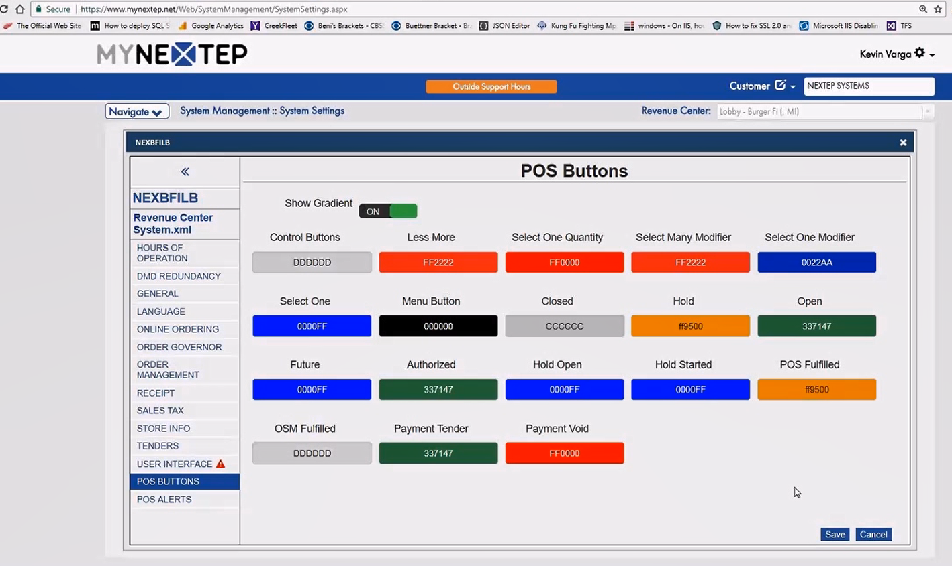

1. POS Alerts, settings for POS Alerts

