**Exploring the Trends in the Suicide Rate of Demographic Groups in the United States**

Presented by:

Christopher Kalfas, Daniel Bowen, Jason Chicatelli, and Kyriaki Karalis

* **Determine suicide rates for different demographic groups in the US and what percentage of the suicides are by gun.** 
  + The vast majority of gun deaths in the United States are suicide rather than homicide.

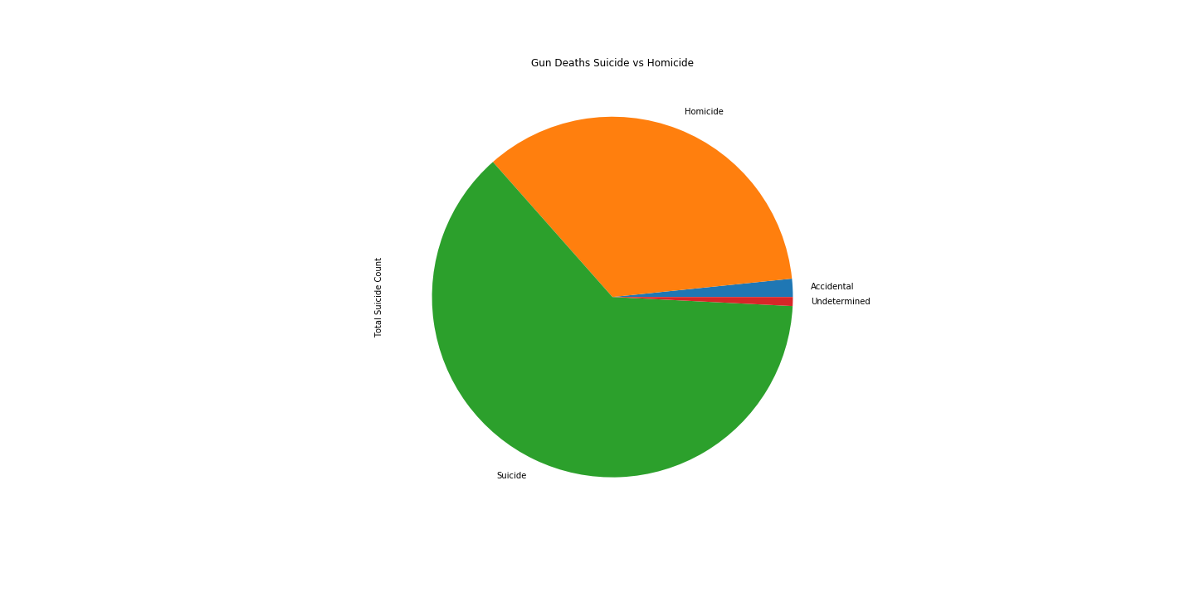

* **The proximity of poverty to increased suicide rate** 
  + As poverty rates increase, so does the suicide rate.

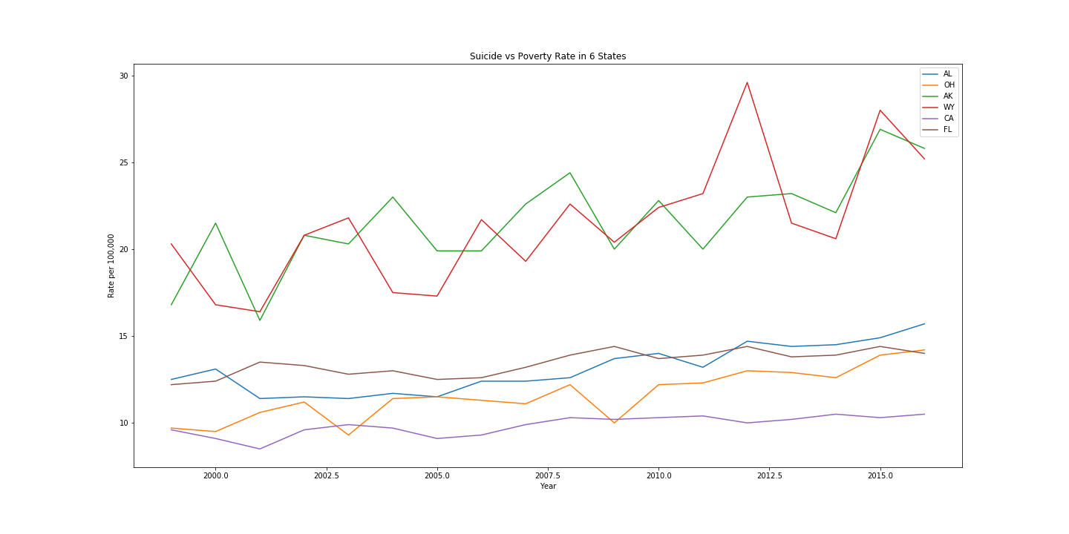

* **What are the suicide rates for different demographic groups in the US?**
  + White males are by far the most likely to commit suicide.

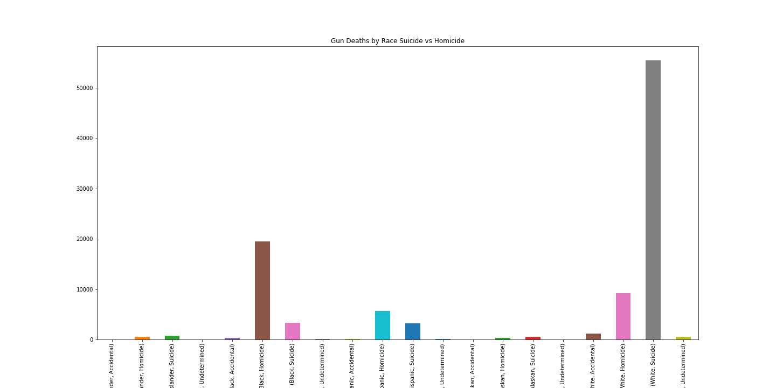

* **Then compare the suicides to proximity to a gun dealer** 
  + Regardless of local population differences, as the number of gun dealers increases, so does the suicide rate by gun.

