# SQL/Data Handling:

Below you will find a dummy snapshot of Orders data for January 2021 (excluding the big cities of Athens and Thessaloniki). For this period of time, we would like to focus on the "Breakfast" cuisine_parent and see how it differs from other cuisines. "Breakfast" stands for restaurants that mainly offer coffee and beverages and create additional habits to efood users.

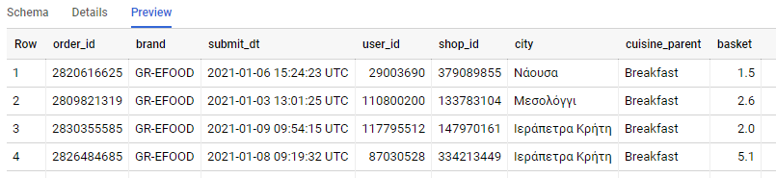

For every city that exceeds the 500 orders we would like to know:

- how many orders are placed in the "Breakfast" cuisine (Breakfast_Orders)?

- how many users ordered from the "Breakfast" cuisine (Breakfast_Users)?

- what is the Average Basket of the Breakfast_Users that we defined before?

Order your findings, showing us the 10 cities with the most Breakfast Orders.

We are mainly using the [Standard SQL of BigQuery](https://cloud.google.com/bigquery/docs/reference/standard-sql/functions-and-operators).

You can find the table and the available SQL Editor here: [Link to BQ](https://console.cloud.google.com/bigquery?project=bi-2019-test&authuser=1&p=bi-2019-test&d=ad_hoc&t=orders_jan2021&page=table).

Please note that you need to be logged in with your **gmail** account in order to access it.

*------------------------------------------------------ MY ANSWER -----------------------------------------------------*

*You could reply in these requests either separately or combined.*

*The only table you have to use in the FROM clause is `bi-2019-test.ad_hoc.orders_jan2021`.*

*Please, paste here:*

*1. screenshot(s) from the editor’s Query Results, showing your answer.*

*2. your SQL query/queries*

SELECT orders.city

    , count(distinct orders.order_id) as Total_Orders

    , COUNT(DISTINCT IF(orders.cuisine_parent = 'Breakfast', order_id, NULL)) as Breakfast_Orders

    , COUNT(DISTINCT IF(orders.cuisine_parent = 'Breakfast', user_id, NULL)) as Breakfast_Users

    , round(avg(cust.Average_Basket), 2) as Average_Basket

FROM `bi-2019-test.ad_hoc.orders_jan2021` orders

left join (select city, sum(basket)/count(user_id) as Average_Basket

            from `bi-2019-test.ad_hoc.orders_jan2021`

            where user_id in (select user_id from `bi-2019-test.ad_hoc.orders_jan2021` where cuisine_parent = 'Breakfast' )

            group by city) cust

on orders.city = cust.city

group by orders.city

having Total_Orders > 500

order by Breakfast_Orders desc

LIMIT 10

*Feel free to write your comments before delivering.*

*--------------------------------------------------------- THE END -------------------------------------------------------*