Senior Business Intelligence Analyst

Main Assessment

horizontal line

03/21

# Part I

Below you will find a dummy snapshot of Orders data for January 2021 (excluding the big cities of Athens and Thessaloniki).

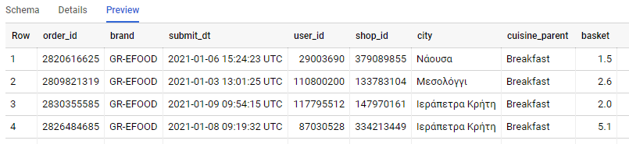

We are mainly using the Standard SQL of BigQuery.

You can find the table and the available SQL Editor here: [Link to BQ](https://console.cloud.google.com/bigquery?project=bi-2019-test&authuser=1&p=bi-2019-test&d=ad_hoc&t=orders_jan2021&page=table).

Please note that you need to be logged in with your **gmail** account to access it.

* We need to segment existing customers based on their *frequency* and *order* value.
* Ordering Coffee via efood is a quite new habit that Marketing thinks could create more loyal customers. Which segment could be a valuable target group for a Marketing campaign about Coffee (“Breakfast” cuisine_parent)?

Use the provided table, create user segments, answer to the business question, and prepare your findings for sharing with the C-Level and Business Intelligence team members. Your findings could be presented in a Visualization tool of your choice, or though Power Point or Excel etc.

## Submitting a solution

Please, create a public Github repo that will contain:

* *all* the *code* and
* the *instructions* to *run* it

Within efood (and Delivery Hero in general) we use **Python** (3.x), **R** and **SQL** so we suggest preferring them before using another programming stack; still, you can use ***whatever*** suits you but due to our knowledge limitations we will only be able to verify if it works 100% or it fails.

Reply via email sharing your code and presentation/visuals/comments.

## How we will evaluate the answer

Do the exercise at your own pace, and take into account that we value:

* *methodology*
* *structure*
* *simplicity* of the code (using well-known libraries to achieve this is allowed and encouraged)
* that the project looks as a real-world one

# Part II

During the Mini Assessment you submitted one or several queries in your deliverable. Please add the SQL snippet(s) in a folder in the repo you created for the Part I and review it as a pull request in the Github repository or just comment in the repo. Please notethatin this context, *review* means that you spot your mistakes (if any), comment & suggest changes.

# Contact

You can send an email to [d.kouvari@e-food.gr](mailto:d.kouvari@e-food.gr), [m.parzakonis@e-food.gr](mailto:m.parzakonis@e-food.gr), [gmouratos@e-food.gr](mailto:gmouratos@e-food.gr) with any questions you have. It goes without saying that this assessment is handed over as a real case so you are expected to work as you would in your normal work life (eg search the Nets, reference books etc); as always keep in mind to **cite** anything that is considered a “loan”.