This Certificate is awarded to

Nefeli Farm

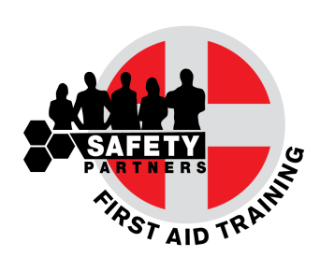
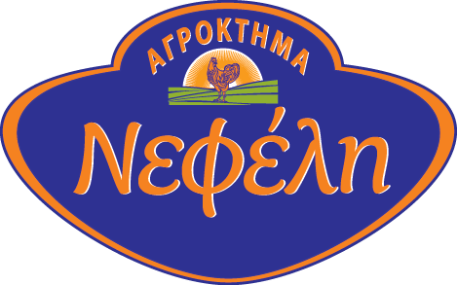

For the completion of
First Aid at Work Training Course
which has taken place in June 2017, in cooperation with
- S. Safety Partners Ltd

This course took place in accordance with the provisions of the Safety and Health at Work Laws
(First Aid) ΚΔΠ 198/2009

___________________________
Antonis Siamailas
Director

Safety Partners is an approved First Aid at Work Training Provider by the Cyprus Republic Ministry of Labour Inspection.
Company Approval Certificate No.: 21.1.6.3.32.26/2016. First Aid Scientific Support by Nuco Training UK

