{{{{{{{{{{{{{{{{{{{{{{{{{{{{{{{{{{{{{{{{{{{{{{{{{{{{{{}}}}}}}}}

**FastReport VCL 5**

**User's Manual**

* 1998-2014 Fast Reports Inc.

*Manual Version 5.0.0*

**I**

**FastReport VCL 5 User's Manual**

**Table of contents**

**Chapter I Designer**

**2**

**Control keys**

**................................................................................................................................... 31**

**Mouse control**

**................................................................................................................................... 32**

**Toolbars**

**................................................................................................................................... 43**

**esigner mode bar**

**......................................................................................................................................................... 4D**

**tandard toolbar**

**......................................................................................................................................................... 4S**

**ext toolbar**

**......................................................................................................................................................... 5T**

**rame toolbar**

**......................................................................................................................................................... 6F**

**lign toolbar**

**......................................................................................................................................................... 7A**

**Designer options**

**................................................................................................................................... 84**

**Report settings**

**................................................................................................................................... 95**

**Page options**

**................................................................................................................................... 126**

**Chapter II Creating reports**

**16**

**Report objects**

**................................................................................................................................... 161**

**“Hello, World!” report example**

**................................................................................................................................... 162**

**The “Text” object**

**................................................................................................................................... 173**

**HTML-tags in the "Text" object**

**................................................................................................................................... 194**

**Displaying expressions with the help of the "Text" object**

**................................................................................................................................... 205**

**Bands in FastReport**

**................................................................................................................................... 216**

**Data bands**

**................................................................................................................................... 227**

**TfrxDBDataSet component**

**................................................................................................................................... 238**

**“Customer List” report**

**................................................................................................................................... 239**

**0Displaying DB fields with the help of the "Text" object**

**................................................................................................................................... 261**

**1Aliases**

**................................................................................................................................... 271**

**2Variables**

**................................................................................................................................... 281**

**3“Picture” object**

**................................................................................................................................... 301**

**4Report with pictures**

**................................................................................................................................... 311**

**5Multi-lined text display**

**................................................................................................................................... 331**

**6Data splitting**

**................................................................................................................................... 351**

**7Text wrap of objects**

**................................................................................................................................... 371**

**8Displaying data in the form of a table**

**................................................................................................................................... 391**

**9Printing labels**

**................................................................................................................................... 411**

**0Child-bands**

**................................................................................................................................... 432**

**1Shifting objects**

**................................................................................................................................... 452**

**2Report with two data levels (master-detail)**

**................................................................................................................................... 462**

* *1998-2014 Fast Reports Inc.*

**Table of contents**

**II**

**3Headers and footers of a data band**

**................................................................................................................................... 492**

**4Multi-page reports**

**................................................................................................................................... 512**

**5RowCount and PageCount properties**

**................................................................................................................................... 522**

**Chapter III Groups and aggregates**

**54**

**Report with groups**

**................................................................................................................................... 541**

**Other group features**

**................................................................................................................................... 562**

**Reset page numbers**

**................................................................................................................................... 583**

**Drill-down groups**

**................................................................................................................................... 584**

**Line numbering**

**................................................................................................................................... 595**

**Aggregate functions**

**................................................................................................................................... 606**

**Page and report totals**

**................................................................................................................................... 637**

**Inserting aggregate functions**

**................................................................................................................................... 648**

**Chapter IV Formatting, highlighting**

**67**

**Formatting of values**

**................................................................................................................................... 671**

**Inline formatting**

**................................................................................................................................... 682**

**Conditional highlighting**

**................................................................................................................................... 693**

**Coloring alternate data rows**

**................................................................................................................................... 724**

**Chapter V Nested reports (subreports)**

**75**

**Nested reports (subreports)**

**................................................................................................................................... 751**

**Side-by-side subreports**

**................................................................................................................................... 752**

**Limitations on use of subreports**

**................................................................................................................................... 763**

**PrintOnParent option**

**................................................................................................................................... 774**

**Chapter VI Script**

**79**

**A Taste of Script**

**................................................................................................................................... 791**

**Structure of a script**

**................................................................................................................................... 822**

**"Hello, World!" script**

**................................................................................................................................... 843**

**Using objects in the script**

**................................................................................................................................... 844**

**Calling the variables from the report’s variables list**

**................................................................................................................................... 855**

**Referencing the DB fields**

**................................................................................................................................... 866**

**Using aggregate functions in the script**

**................................................................................................................................... 877**

**Displaying a variable’s value in a report**

**................................................................................................................................... 878**

**Events**

**................................................................................................................................... 879**

**0Example of using the “OnBeforePrint” event**

**................................................................................................................................... 891**

**1Printing a group sum in the group header**

**................................................................................................................................... 911**

**2“OnAfterData” event**

**................................................................................................................................... 951**

**3Service objects**

**................................................................................................................................... 961**

**Report” object**

**......................................................................................................................................................... 96“**

* *1998-2014 Fast Reports Inc.*

**III**

**FastReport VCL 5 User's Manual**

**Engine” object**

**......................................................................................................................................................... 97 “**

**Outline” object**

**......................................................................................................................................................... 98 “**

**4Using the “Engine” object**

**................................................................................................................................... 991**

**5Anchors**

**................................................................................................................................... 1021**

**6Using the “Outline” object**

**................................................................................................................................... 1031**

**7“OnManualBuild” page event**

**................................................................................................................................... 1071**

**8Creation of objects in the script**

**................................................................................................................................... 1111**

**Chapter VII Cross-tab reports**

**114**

**Constructing a cross-tab report**

**................................................................................................................................... 1151**

**Changing the appearance**

**................................................................................................................................... 1182**

**Using functions**

**................................................................................................................................... 1203**

**Sorting values**

**................................................................................................................................... 1214**

**Tables with composite headers**

**................................................................................................................................... 1215**

**Adjusting cell width**

**................................................................................................................................... 1236**

**Font colors and highlighting**

**................................................................................................................................... 1257**

**Managing a cross-tab in script**

**................................................................................................................................... 1268**

**Adjusting row/column size**

**................................................................................................................................... 1309**

**0Filling a table manually**

**................................................................................................................................... 1311**

**1Adding external objects to the table**

**................................................................................................................................... 1331**

**2Some useful settings**

**................................................................................................................................... 1361**

**Chapter VIII Charts**

**140**

**Limiting the number of chart values**

**................................................................................................................................... 1441**

**Some useful settings**

**................................................................................................................................... 1452**

**Chart with manually entered values**

**................................................................................................................................... 1453**

**Chart completion from Script**

**................................................................................................................................... 1464**

**Printing a chart built in Delphi**

**................................................................................................................................... 1475**

**Chapter IX Interactive reports**

**149**

**Hyperlink**

**................................................................................................................................... 1491**

**Hyperlink configuration**

**................................................................................................................................... 1502**

**Link to the URL**

**................................................................................................................................... 1503**

**Link to the page number**

**................................................................................................................................... 1514**

**Link to an anchor**

**................................................................................................................................... 1515**

**Link to a detailed report**

**................................................................................................................................... 1516**

**Link to a detailed page**

**................................................................................................................................... 1527**

**Custom link**

**................................................................................................................................... 1528**

**Chapter X Dot-Matrix reports**

**154**

**Cross-tab in dot-matrix**

**................................................................................................................................... 1571**

* *1998-2014 Fast Reports Inc.*

**Table of contents**

**IV**

**Dot-matrix report printing**

**................................................................................................................................... 1582**

**“Command” object**

**................................................................................................................................... 1593**

**Chapter XI Dialogue forms**

**162**

**Controls**

**................................................................................................................................... 1621**

**"Hello, World!" report**

**................................................................................................................................... 1632**

**Entering parameters and transferring them into a report**

**................................................................................................................................... 1643**

**Interaction with controls**

**................................................................................................................................... 1654**

**Several dialogue forms**

**................................................................................................................................... 1665**

**Managing dialogue forms**

**................................................................................................................................... 1676**

**Chapter XII Data access components**

**170**

**Component descriptions**

**................................................................................................................................... 1711**

**frxDBLookupComboBox**

**......................................................................................................................................................... 171T**

**frxADOTable**

**......................................................................................................................................................... 172T**

**frxADOQuery**

**......................................................................................................................................................... 174T**

**frxADODataBase**

**......................................................................................................................................................... 176T**

**Report designer**

**................................................................................................................................... 1762**

**Simple report of “List” type**

**................................................................................................................................... 1773**

**Report with parametric query**

**................................................................................................................................... 1784**

**Other useful features**

**................................................................................................................................... 1805**

**Chapter XIII Report inheritance**

**182**

**Creating a base report**

**................................................................................................................................... 1821**

**Changing a base report**

**................................................................................................................................... 1842**

**Inheritance control**

**................................................................................................................................... 1853**

**Chapter XIV Wizards**

**188**

**New report wizard**

**................................................................................................................................... 1881**

**New connection wizard**

**................................................................................................................................... 1922**

**New table wizard**

**................................................................................................................................... 1933**

**New query wizard**

**................................................................................................................................... 1944**

**Query construction**

**................................................................................................................................... 1945**

**sing the Query constructor**

**......................................................................................................................................................... 197U**

**omplex query building**

**......................................................................................................................................................... 199C**

**Chapter XV Report viewing, printing and export**

**203**

**Control keys**

**................................................................................................................................... 2041**

**Mouse control**

**................................................................................................................................... 2052**

**Report printing**

**................................................................................................................................... 2053**

**Text search in reports**

**................................................................................................................................... 2074**

**Report Export**

**................................................................................................................................... 2085**

**xport to PDF Format**

**......................................................................................................................................................... 209E**

* *1998-2014 Fast Reports Inc.*

**V**

**FastReport VCL 5 User's Manual**

**xport to Open Document**

**......................................................................................................................................................... 210 E**

**xport to RTF Format**

**......................................................................................................................................................... 211 E**

**xport to Word 2007**

**......................................................................................................................................................... 212 E**

**xport to Excel 97/2000/XP**

**......................................................................................................................................................... 213 E**

**xport to Excel XML Format**

**......................................................................................................................................................... 215 E**

**xport to Excel 2007**

**......................................................................................................................................................... 215 E**

**xport to PowerPoint 2007**

**......................................................................................................................................................... 216 E**

**xport to CSV Format**

**......................................................................................................................................................... 217 E**

**xport into HTML Format**

**......................................................................................................................................................... 218 E**

**xport to Text Format**

**......................................................................................................................................................... 219 E**

**xport to Jpeg, BMP, Gif, Tiff Graphic Formats**

**......................................................................................................................................................... 220 E**

**Sending a Report via E-mail**

**................................................................................................................................... 2216**

**Report Design considerations**

**................................................................................................................................... 2227**

* *1998-2014 Fast Reports Inc.*

**Chapter**

**I**

**Designer**

* 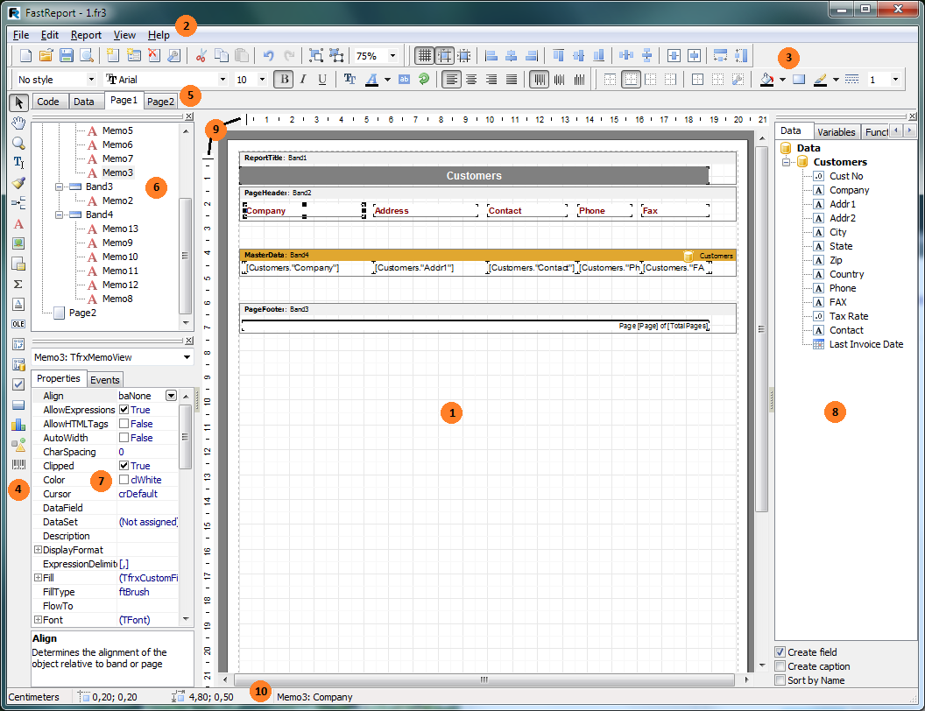 **FastReport VCL 5 User's Manual**

The report component is supplied with an embedded visual report designer, which can be opened at design-time by double-clicking on the TfrxReport component. The designer provides the user with all the tools necessary for designing and previewing reports. The designer’s interface meets current requirements. It contains several toolbars, which can be docked wherever wanted. These toolbar locations are restored every time the designer is opened. Toolbar locations, together with other designer settings, are stored in the registry or, should one be assigned, in an ini-file.

To give the end user of your project the ability to design reports, you should either place a “TfrxDesigner” component from the FastReport component palette onto a Delphi form or add the “frxDesgn” unit to the unit's Uses list (NB: spelling). Using the designer at run-time allows the user to change the report’s appearance, as well as to edit the finished report.

Note: you should also place any other Tfrx components that will be used on the Delphi form.

Key to report designer features:

* report design workspace
* menu bar
* toolbars
* object toolbar
* report page tabs

*FastReport v4 © 1998-2014 Fast Reports Inc.*

*Manual v5.0.0*

**esigner**

**3D**

* “Report tree” pane
* “Object inspector” pane
* “Data tree” pane : elements can be dragged from this pane onto a report page
* rulers : a ruler can be dragged onto a report page to create a blue guideline on the page (objects snap to nearby guidelines)

10 status bar

**1.1 Control keys**

**Keys**

**Description**

|  |  |  |
| --- | --- | --- |
| Ctrl+O | “File > Open…” menu command |  |
| Ctrl+S | “File > Save” menu command |  |
| Ctrl+P | “File > Preview” menu command |  |
| Ctrl+Z | “Edit > Undo” menu command |  |
| Ctrl+C | “Edit > Copy” menu command |  |
| Ctrl+V | “Edit > Paste” menu command |  |
| Ctrl+X | “Edit > Cut” menu command |  |
| Ctrl+A | “Edit > Select all” menu command |  |

Arrow, Tab move between objects

Del

delete selected object(s)

Enter

open editor for selected object

Shift+arrows modify sizes of selected object(s)

Ctrl+arrows move selected object(s)

Alt+arrows attach selected object to adjacent object in specified direction

**1.2 Mouse control**

|  |  |  |
| --- | --- | --- |
| **Operation** | **Description** |  |
| Left button | select object; paste new object; move or resize objects  for selected objects, zoom in and out by dragging red square  in bottom left corner of selected objects’ group |  |

Right button

selected object's contextual menu

|  |  |  |
| --- | --- | --- |
| Double-click | open editor for object  double-clicking on white space opens the “Page Settings”  dialogue |  |
| Mouse wheel | scroll report page |  |

Shift + left button toggle object selection

*FastReport v4 © 1998-2014 Fast Reports Inc.*

*Manual v5.0.0*

*  **FastReport VCL 5 User's Manual**

|  |  |  |
| --- | --- | --- |
| Ctrl + left button | create frame by moving mouse  release button to select all objects captured in the frame  can also click on blank space, and move mouse as required |  |
| Alt + left button | edit contents in place, if a “Text” object is selected |  |

**1.3 Toolbars**

**1.3.1 Designer mode bar**

The Mode toolbar is integrated with the Object toolbar at the left hand edge of the designer window and has these buttons:

**Icon**

**Name**

**Description**

Object selection standard mode of operation : mouse cursor selects object(s), modifies their sizes, etc.

Hand

allows dragging of whole report page

Zoom

allows left-clicking to zoom in

(adds 25% if already 25-75%, else adds 100%) or right-clicking to zoom out

(subtracts 25% if already 50-100%, else subtracts 100%) holding left mouse button while dragging zooms in to selected area

Text editor

allows in-place editing of “Text” object holding left mouse button and moving the cursor creates and sizes a new “Text” object and opens its editor

Format copying allows Format copying from one "Text" object to others: select a “Text” object,

click Format mode button,

select Target "Text" objects in turn

exit Format copying mode by clicking any other mode button

**1.3.2 Standard toolbar**

**Icon**

**Name**

New Report Open Report

**Description**

creates new blank report

opens existing report from file hotkey combination “Ctrl+O”

*FastReport v4 © 1998-2014 Fast Reports Inc.*

*Manual v5.0.0*



**esigner**

**5D**

|  |  |  |
| --- | --- | --- |
| Save Report | saves report to file  hotkey combination “Ctrl+S” |  |
| Preview | previews report  hotkey combination “Ctrl+P” |  |

New Report Page adds new page to report New Dialog Page adds new dialogue form to report

Delete Page

deletes current page

Page Settings opens page properties dialogue

Cut

cuts selected object(s) onto clipboard hotkey combination “Ctrl+X”

Copy

copies selected object(s) onto clipboard hotkey combination “Ctrl+C”

|  |  |  |
| --- | --- | --- |
| Paste | pastes object(s) from clipboard  hotkey combination “Ctrl+V” |  |
| Undo | undo last operation  hotkey combination “Ctrl+Z” |  |
| Redo | redo last cancelled (undone) operation  hotkey combination “Ctrl+Y” |  |

Group

groups selected objects

|  |  |  |
| --- | --- | --- |
| Ungroup | ungroups selected objects |  |
| Zoom | sets zoom factor |  |

**1.3.3 Text toolbar**

**Icon**

**Name**

**Description**

**No style**

Style

shows style of selected "Text" object select from drop-down list to change style of selected object define styles in “Report>Styles”

|  |  |  |
| --- | --- | --- |
| **Arial** | Font Name shows font of selected “Text” object  select from drop-down list to change font of selected object  shows last five fonts used at head of list |  |
| **10** | Font Size shows font size of selected “Text” object  select from drop-down list to change font size of  selected object  can also type digits directly into edit box  Bold (toggle) toggles font Bold style of “Text” object's content on/off  Italic (toggle) toggles font Italic style of “Text” object's content on/off |  |

*FastReport v4 © 1998-2014 Fast Reports Inc.*

*Manual v5.0.0*

*  **FastReport VCL 5 User's Manual**

Underline (toggle) toggles font Underline style of “Text” object's content on/off Font Settings opens Font settings dialogue

|  |  |  |
| --- | --- | --- |
| Font Color | drops down font color selection grid |  |
| Highlight | opens highlight dialogue  can set a condition for highlighting |  |

Text Rotation changes text rotation from drop-down list

Align Left

left aligns text within “Text” object's frame

Align Center centre aligns text within “Text” object's frame

|  |  |  |
| --- | --- | --- |
| Align Right | right aligns text within “Text” object's frame |  |
| Justify | justifies text within “Text” object's frame |  |
| Align Top | top aligns (vertical) text within “Text” object's frame |  |

Align Middle middle aligns (vertical) text within “Text” object's frame Align Bottom bottom aligns (vertical) text within “Text” object's frame

**1.3.4 Frame toolbar**

**Icon**

**Name**

Top Line (toggle)

**Description**

toggles top frame line of “Text” object on/off

Bottom Line (toggle) toggles bottom frame line of “Text” object on/off

Left Line (toggle)

toggles left frame line of “Text” object on/off

Right Line (toggle) toggles right frame line of “Text” object on/off

|  |  |  |
| --- | --- | --- |
| All Frame Lines | sets all four frame lines of “Text” object on |  |
| No Frame | sets all four frame lines of “Text” object off |  |
| Frame editor | invokes the frame editor dialogue |  |

Background Color sets background color from the drop-down list.

Fill editor

invokes the fill editor dialogue

|  |  |  |
| --- | --- | --- |
| Frame Color | drops down frame line color selection grid |  |
| Frame Style | drops down frame line style selection list |  |

**1**

Frame Width

sets frame line width from drop-down list can also type digits (0.1 to 10) directly into edit box

*FastReport v4 © 1998-2014 Fast Reports Inc.*

*Manual v5.0.0*



**esigner**

**7D**

**1.3.5 Align toolbar**

Note that some buttons will be active when more than one object is selected.

**Icon**

**Description**

show Grid (toggles on/off)

align to Grid (toggles on/off)

fit to Grid

align left edges (to first selected object) align horizontal centres (to first selected object) align right edges (to first selected object)

align top edges (to first selected object) align vertical centres (to first selected object) align bottom edges (to first selected object) space equally in horizontal direction

space equally in vertical direction individually centre each object horizontally in band individually centre each object vertically in band set equal widths (same as first selected object) set equal heights (same as first selected object)

*FastReport v4 © 1998-2014 Fast Reports Inc.*

*Manual v5.0.0*

* 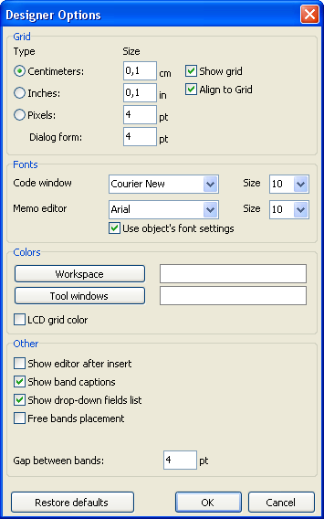 **FastReport VCL 5 User's Manual**

**1.4 Designer options**

Set the designer options via the “View>Options...” menu command.

Here you can set the preferred units (centimetres, inches, pixels) and grid spacing. Tip: you can also cycle through the units from within the designer by double-clicking on the left part of the status bar where the current units are displayed.

You can set grid visibility and alignment to grid. This can also be done via buttons in the “Standard” toolbar from within the designer.

You can set a font for the code editor window and for the “Text” object editor. If the “Use object's font settings” option is enabled, the font in the text editor window matches the font of the object being edited.

The default white background of the designer workspace and tool windows can be modified via the “Workspace” and the “Tool windows” buttons.

*FastReport v4 © 1998-2014 Fast Reports Inc.*

*Manual v5.0.0*

**esigner**

**9D**

The “LCD grid color” option increases contrast of the grid lines a little and improves their visibility on LCD monitors.

The “Show editor after insert” option controls what happens when new objects are inserted. If the option is enabled, its editor will be displayed each time an object is inserted. When creating a large number of blank objects, it is recommended to temporarily disable the option.

Disabling the “Show band captions” option hides band captions, so saving some space on a design page. When disabled, the band captions are shown inside the band workspace.

The “Show drop-down list of fields” option controls whether the drop-down list is accessible when pointing with the mouse to “Text” objects which are connected to data fields. This may be necessary if there are many narrow “Text” objects in a band

The “Free band placement” option disables snapping of bands to the page. This option is disabled by default and bands are automatically grouped on the page according to their function. The gap between bands is set in the “Gap between bands” field.

**1.5 Report settings**

The Report Settings dialogue is available from the “Report>Options...” menu. The dialogue has three pages.

On the first page you can see the general settings for the report:

*FastReport v4 © 1998-2014 Fast Reports Inc.*

*Manual v5.0.0*

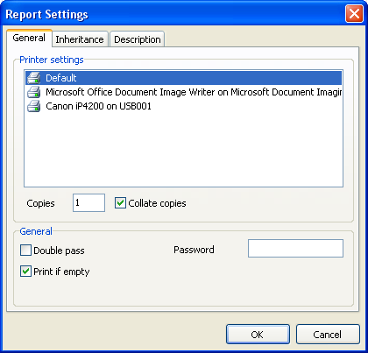**10 FastReport VCL 5 User's Manual**

You can tie a report to one of the printers installed in the system. This means that the selected printer will become the default when printing that report. This might be useful in cases where there are several different printers in the system; e.g. text documents can be tied to monochrome printers, while documents with graphics tied to color capable ones. “Default” is listed in Printer settings - when this is selected, the report will not be tied to any particular printer but will be printed on the system's default printer.

You can also set the number of report copies to be printed and whether to collate the output. The value set in this dialogue will be shown in the “Print” dialogue when printing the report.

If the “Double pass” flag is checked report generation will be performed in two steps. During the first pass a draft report is created and divided into pages, but is not available for preview. In the second pass the draft report is converted to a standard report which is then saved in the preview stream.

Why are two passes necessary? Mostly this option is used in cases where a report needs access to the total number of pages in the report, i.e. for use as “Page 1 of 15”. The total number of pages is calculated during the first pass and is made available via the “TOTALPAGES” system variable. The most frequent mistake is to attempt to use this variable in a single-pass report, when the variable will return 0.

Another use for two passes is to perform some calculations in the first pass and display the results in the second pass. For example, when a sum is to be displayed in a group header instead of in the usual group footer. Calculations of this type are accomplished by writing report script code in the “OnBeforePrint” event of an object.

The “Print if empty” flag allows creation of a report containing no data lines. If this option is

*FastReport v4 © 1998-2014 Fast Reports Inc.*

*Manual v5.0.0*

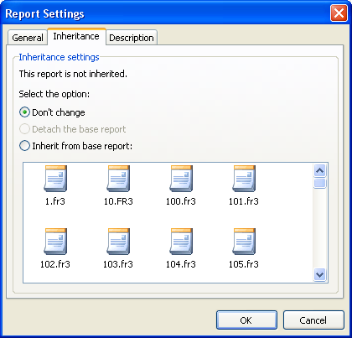

**esigner**

**11D**

disabled blank reports will not be created.

The “Password” field enables the setting of a password, which must be entered before a report can be opened.

On the second page you can set up the report inheritance options:

You will learn about inheritance later in the “Report inheritance” chapter. In this dialogue you can see the base report's name (if the report is inherited), detach the base report (in which case your report will be standalone and non-inherited) or inherit the report from one of the available base reports.

The third page of the dialogue allows you to set descriptive properties for the report:

*FastReport v4 © 1998-2014 Fast Reports Inc.*

*Manual v5.0.0*

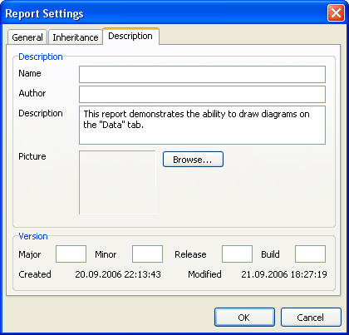**12 FastReport VCL 5 User's Manual**

All fields on this page are for information purposes only and are not printable.

**1.6 Page options**

The “Page Options” are available via either the “File>Page settings...” menu or by double- clicking on blank space on the page. The dialogue has two pages:

*FastReport v4 © 1998-2014 Fast Reports Inc.*

*Manual v5.0.0*

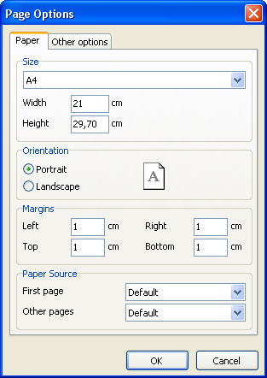

**esigner**

**13D**

On the first dialogue page, you can set the size and alignment of the paper as well as the margins. In “Paper source” the drop-down lists allow selection of printer tray for the first page and for the rest of the report pages.

*FastReport v4 © 1998-2014 Fast Reports Inc.*

*Manual v5.0.0*

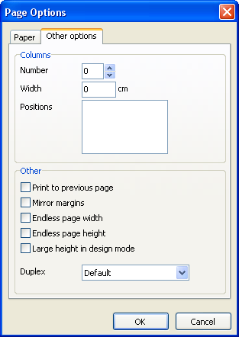**14 FastReport VCL 5 User's Manual**

On the second dialogue page, you can set the number of columns for multi-column reports. The current settings are also displayed in the designer.

The “Print to previous page” flag allows you to print pages without starting a new page, instead beginning in any blank space on the previous page. This option can be useful when a report template consists of several pages or when printing batch (composite) reports.

The “Mirror margins” option switches the right and left margins of even-numbered pages during previewing or printing of a report.

The “Endless page width & height” options increase page sizes depending on the number of data records on the page (when the report is run). When set the report will appear on one big page in the preview window instead of on several standard size pages.

The “Large height in design mode” option increases the page height in the designer. This feature can be useful if there are many bands on a page: it must be used when working with overlayed bands. It only effects the page height in design mode.

*FastReport v4 © 1998-2014 Fast Reports Inc.*

*Manual v5.0.0*

**Chapter**

**II**

**Creating reports**

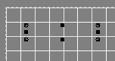**16 FastReport VCL 5 User's Manual**

**2.1 Report objects**

The FastReport Designer represents reports as a collection of schematic pages. Objects are placed anywhere on the report pages and are used to define the report's appearance and to display various information, such as text and graphics. FastReport objects which are included in the standard package are:

* “Band” object : an area on a design page which behaves according to its type (e.g. Header band, Data band)
* “Text” object : displays one or more lines of text within a rectangular area
* “Picture” object : displays a graphic file in “BMP,” “JPEG,” “ICO,” “WMF” or “EMF” format
* “Line” object : displays a horizontal or vertical line
* “System text” object : displays either system information (date, time, page number, etc) or aggregate values
* “Subreport” object : allows insertion of another report design page within the host page
* “Draw” category objects : displays various geometrical shapes

(diagonal line, rectangle, rounded rectangle, ellipse, triangle and diamond)

* “Chart” object : displays data in various chart formats (pie chart, histogram, etc.)
* “RichText” object : displays text in Rich Text Format (RTF)
* “CheckBox” object : displays a checkbox with either a tick or a cross
* “Barcode” object : displays data as one of several barcode types
* “OLE” object : displays any object using OLE technology.

The basic objects most commonly used are the “Band” and “Text” objects. You will learn about their capabilities in detail later in this chapter.

**2.2 “Hello, World!” report example**

The example report will contain just one piece of information : “Hello, World!”. Open the report designer and click on the “Text” button in the Object toolbar. Move the mouse cursor over the page and click again. The object is inserted at the mouse position.

The text editor window will be opened right away; if it does not appear automatically then double- click the object. Text editor opening can be configured in the designer settings - see later on. Type in “Hello, World!” and then click the ΞΚ button.

*FastReport v4 © 1998-2014 Fast Reports Inc.*

*Manual v5.0.0*

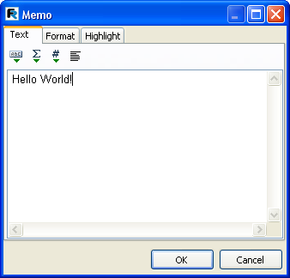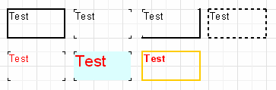

**reating reports**

**17C**

The report design is finished. To preview the report either select the “File>Preview” menu item or click the corresponding button in the toolbar. The preview window containing a report page with the “Hello, World!” text will appear. This report can be printed out, saved to a file (*.fp3), or exported to one of the supported export formats.

**2.3 The “Text” object**

The “Text” object has many features. It can display text in a frame and be filled with a color. The text can be displayed using any font of any size and style. All the properties can be set visually with the help of the toolbars.

Here are some examples of text design:

Now let’s look at other features of this basic object. As an example, let's create a new "Text" object to display two lines of text:

*This is a very, very, very long text line. And this is another line, the shorter one.*

Enable the object frame from the toolbar and re-size the object up to 9x3 cm using the mouse. We see that the object can display not only a single line but also several lines of text. Now

*FastReport v4 © 1998-2014 Fast Reports Inc.*

*Manual v5.0.0*

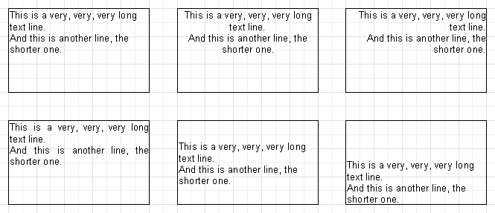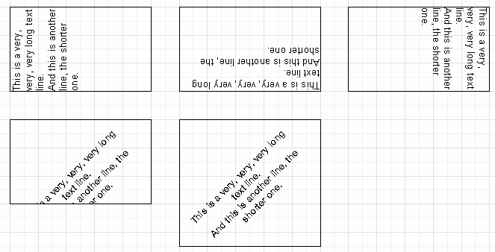**18 FastReport VCL 5 User's Manual**

reduce the object width to 5cm. It is obvious that long lines did not fit across the object and were

therefore wrapped. This is controlled by the “WordWrap” object property. If it is disabled (either

in the object inspector or via the object context menu) any long lines will be simply cut short.

Now let’s see how text alignment inside the object works. Alignment buttons are located in the “Text” toolbar and control horizontal or vertical text alignment. Note the “Justify” button which lets you align paragraphs to both object edges - to do this “WordWrap” must be enabled.

All the text in the object can be rotated to any angle in the range 0..360°. The button in the “Text” toolbar allows you to quickly rotate the text to pre-sets of 0, 45, 90, 180 or 270°. For any other value set the required angle in the “Rotation” property of the object inspector. When rotating text to angles other than 90, 180 or 270° the text may be cut off by the frame of the object, as shown below. To cure this increase the object height a little so that all the text fits within the object.

*FastReport v4 © 1998-2014 Fast Reports Inc.*

*Manual v5.0.0*

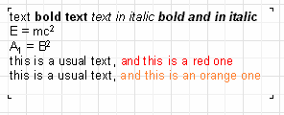

**reating reports**

**19C**

Let's briefly look at some other “Text” object properties which influence its appearance. Most of these properties are available only in the object inspector:

* BrushStyle : type of object filling
* CharSpacing : s?aning between characters, in pixels
* GapX, GapY : text indents from left and top edges, in pixels
* LineSpacing : spacing between lines, in pixels
* ParagraphGap : first line indent for the paragraph, in pixels

**2.4 HTML-tags in the "Text" object**

The “Text” object does understand some simple HTML tags. Tags can be located within the text of the object. Tags are disabled by default, but to enable them either select “Allow HTML tags” in the object context menu or enable the “AllowHTMLTags” property in the object inspector. Here is the list of supported tags:

<b> : bold text

<i> : italic text

<u> : underlined text

<sub> : subscript

<sup> : superscript

<font color> : font color

<nowrap> : text which is not split when "WordWrap" is enabled, the whole text is shifted to the next line

Please note that only a few tags are supported, but this should be enough for the majority of applications. It is not possible to modify the font size or name by means of HTML tags.

The following examples show how these tags can be used.

*text <b>bold text</b> <i>text in italic</i> <b><i>bold and in italic</b></i> E = mc<sup>2</sup>*

*A<sub>1</sub> = B<sup>2</sup>*

*this is a usual text, <font color=red>and this is a red one</font>*

*this is a usual text, <font color="#FF8030">and this is an orange one</font>*

*FastReport v4 © 1998-2014 Fast Reports Inc.*

*Manual v5.0.0*

**20 FastReport VCL 5 User's Manual**

**2.5 Displaying expressions with the help of the "Text" object**

One of the most important features of this basic object is its ability to display not only a static text but expressions as well. Expressions can be located within the object mixed in with normal text. Let's see a simple example of how this works. Type the following into the object:

*Hello, World! Today is [DATE].*

When the report is run we can get something like this:

*Hello, World! Today is 01.01.2004.*

How does this happen? When FastReport creates the report and encounters an expression enclosed in square brackets the report engine calculates the expression's value and inserts this value into the text in place of the expression. “Text” objects can contain any number of expressions mixed in with the normal text. Complex expressions can contain brackets (for example [1+2*(3+4)]). Constants, variables, functions and DB fields can all be used in expressions. We will learn more about these later in the chapter.

FastReport automatically recognizes expressions enclosed in square brackets in the text. But what happens if our normal text contains square brackets which we do not want to be considered as expressions? For example, if we need to display the following:

*a[1] := 10*

FastReport would consider [1] as an expression and display the text as:

*a1 := 10*

which is not what we want, of course. One way to avoid this happening is to disable expression recognition. Disable the “AllowExpressions” property (or “Allow Expressions” in the context menu) and all expressions in the text will be ignored. In our example, FastReport would then display exactly what we need:

*a[1] := 10*

But sometimes text is required to contain both an expression and normal text with square brackets, for example:

*a[1] := [myVar]*

Disabling “AllowExpressions” lets us display square brackets in the required places, but it also disables handling of expression. In this situation FastReport allows you to use an alternative set of symbols to designate expressions. The “ExpressionDelimiters” property, “[,]” by default, is responsible for this. In our example we can use angular brackets for the expressions instead of square ones:

*a[1] := <myVar>*

The “<,>” value must be set in the “ExpressionDelimiters” property, where the comma is

*FastReport v4 © 1998-2014 Fast Reports Inc.*

*Manual v5.0.0*

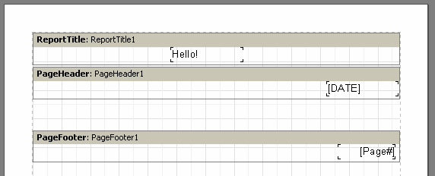

**reating reports**

**21C**

required to separate the opening and closing symbols. Another requirement is that the opening and closing symbols cannot be identical, so “%,%” will not work. Complex symbols can be used, for example “<%,%>”. So our example could look like this:

*a[1] := <%myVar%>*

**2.6 Bands in FastReport**

Bands are used for placing the objects they contain at particular locations on the output page. When placing an object in the “PageHeader” band we tell the report engine that the given object must be displayed at the top of each page in the finished report. Similarly, objects in the “PageFooter” band are displayed at the bottom of each page. Let's demonstrate this with an example. We’ll create a report containing “Hello!” at the top of the page, the current date to the right of it and the page number at the foot of the page on the right hand side.

Open the FastReport designer and click the “New report” button in the toolbar. You will see a report template which already contains three bands: “ReportTitle”, “MasterData”, and “PageFooter”. Let's remove the “MasterData” band for a while (click either on any free space inside the band or on its header and remove it with the “Delete” key or "Delete" in the context menu). Now let's add a new band (“PageHeader”). Click the “Add band” button on the object toolbar and select “PageHeader” from the drop-down list. We see that a new band is added to the page. At the same time the existing bands are moved down. FastReport designer automatically positions bands on the page - header bands at the top, data bands in the middle and footer bands at the bottom.

Now let’s add some objects. Add a “System text” object to the “PageHeader” band and in its editor select “[DATE]” from the System variable drop-down list (you should remember that the current date can also be displayed in a “Text” object by typing “[DATE]” in its editor). Next add a “Text” object containing “Hello!” to the “ReportTitle” band. A “Text” object displaying the page number has already been automatically added to the “PageFooter” band.

When running the report you will see that the objects in the finished report are printed in the proper positions on the page.

*FastReport v4 © 1998-2014 Fast Reports Inc.*

*Manual v5.0.0*

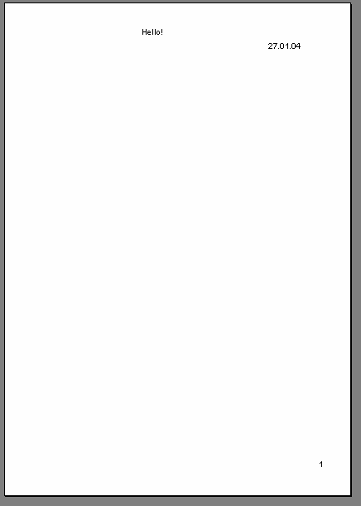**22 FastReport VCL 5 User's Manual**

So, bands are responsible for positioning objects on the page. Depending on the type of band, we can print objects at the top or the bottom of a page and on the first or the last page. The basic bands needed in most reports work as follows:

* “PageHeader” band : displayed at the very top of each page
* “PageFooter” band : displayed at the very bottom of each page
* “ReportTitle” band : displayed at the top of the first page - this can be before or after the “PageHeader” band, depending on the page's “TitleBeforeHeader” property (found in the object inspector after clicking on any free space on the page)
* “ReportSummary” band : displayed in the free space at the very end of the report

**2.7 Data bands**

Now we will learn how to print data from DB tables or from queries. What is considered to be a 'table' or a 'query'? They consist of data organized into lines (records or rows) which contain one or more columns (fields). To print this sort of data FastReport uses a special type of band, the various bands which are named "...Data". To print a whole table or just some of its rows and fields, you must add one or more of these bands to the report, connect them to the table and place field objects within them. When FastReport builds the report, the bands will be printed on the output page, once for each record in the table. If there is no free space left on the output page for a band, a new output page will be created by the report engine before continuing.

*FastReport v4 © 1998-2014 Fast Reports Inc.*

*Manual v5.0.0*



**reating reports**

**23C**

**2.8 TfrxDBDataSet component**

The “TfrxDBDataSet” connector component from the Delphi FastReport component palette is used to connect a table (or any other data source) to FastReport. This component acts as the messenger between the data source and the FastReport core. The component is responsible for record navigation and field reference. This allows the FastReport core to be independent of any data access library. FastReport can simultaneously work with “BDE”, “IB_Objects” (which have a non-standard implementation, incompatible with TDataSet) and other libraries, as well as with data from sources not connected to a DB, for example arrays or files. The "TfrxDBDataSet"

component is intended for working with data sources compatible with TDataSet (such as BDE,

ADO, IBX and the majority of other libraries). The “TfrxIBODataSet” component is intended for

working with IB_Objects. The “TfrxUserDataSet” component works with other data sources (arrays, files, etc.).

It is very easy to use the “TfrxDBDataSet” component. Connect it to the data source by setting the “DataSet” property (for direct connection to a table or a query) or the “DataSource” property (for connection via a “TDataSource” component). The two methods are equivalent and mutually exclusive, though the first does allow data management without requiring a “TDataSource” component.

To make the Delphi component (and the data connected to it) available to the report, any dataset used in the report must be enabled. Do this through the “Report>Data...” menu item in the FastReport designer, selecting the required datasets in the opened dialogue.

**2.9 “Customer List” report**

Our second report will be much more complicated than the first one (it will contain a DB table of company clients). To produce this report let’s use the demonstration database DBDEMOS that is included in the Delphi distribution kit. Create a new project in Delphi, place a “TTable”

component on the form and set some of its properties :

*FastReport v4 © 1998-2014 Fast Reports Inc.*

*Manual v5.0.0*

**24 FastReport VCL 5 User's Manual**

*DatabaseName = 'DBDEMOS'*

*TableName = 'Customer.db'*

To make the table’s data available for use in FastReport add a “TfrxDBDataSet” component to the form and then set one property:

*DataSet = Table1*

Finally, add a “TfrxReport” (the basic component of FastReport) to the form, double-click it to open the FastReport designer and click the “New report” button there to automatically create a basic report design with three bands (“Report title,” “Master data” and “Page footer”). To make our table useable we must enable it in FastReport. Do this by clicking the “Report>Data...” menu item, checking frxDBDataset1 (it is the only dataset listed at the moment) and clicking OK. After the dialogue has closed, the DBDataset and the table fields to which it is connected become visible in the “Data tree” pane in the IDE.

Now let’s design the report. First, add a “Text” object containing “List of clients” to the “ReportTitle” band.

Next, connect the “MasterData” band to our dataset. This can done in any of three ways:

* double-click on the band
* select “Edit...” in the band’s contextual menu
* or click on the “DataSet” property of the band in the object inspector

Now place four “Text” objects (which will display the client number, customer name, phone and fax fields from the dataset) on the band. Let’s do this in several different ways to demonstrate some features of the FastReport designer.

The first way is to place a “Text” object on the band and type "[frxDBDataSet1."CustNo"]" into it. This is the least convenient way, since the field link has to be entered manually, with the possibility of incorrectly typing the text. Somewhat easier is to use the expression designer - double-click the “Text” object and click the leftmost button on the “Text” tab of the editor window which opens. To insert our field double-click the field name in the expression designer. Click the

OK button to close the dialogue and see the field link inserted into the “Text” object.

The second way of adding the DB field to the “Text” object is by setting two properties in the object inspector. Place a second “Text” object on the band, without writing anything in the editor window. Set the object’s properties using the object inspector:

*DataSet = frxDBDataSet1*

*DataField = 'Company'*

Both of these properties are presented as a list, so just select the required value from the drop- down using the mouse.

The third way is to “drag and drop” the required field from the “Data tree” pane into the report. This is the simplest and easiest way, but before doing it uncheck the “Create header” checkbox at the bottom of the “Data tree” pane, otherwise a second “Text” object, containing the field’s name, is created in addition to the field link object itself. In this way select the “Phone” field and drag it onto the band.

*FastReport v4 © 1998-2014 Fast Reports Inc.*

*Manual v5.0.0*

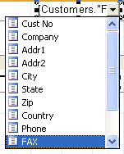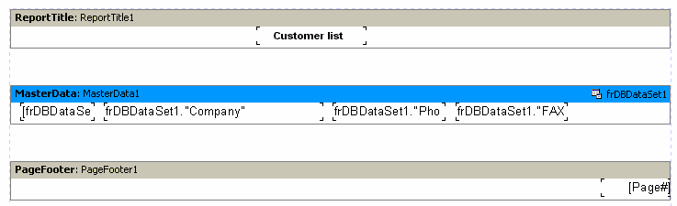

**reating reports**

**25C**

The fourth way requires the designer option “Show drop-down fields list” flag to be set (via main menu : “View>Options”) and the band to be already connected to the dataset. Place a blank “Text” object on the band and hover the cursor over the object a drop-down button will appear at the right hand end. Click this button to open the list of DB fields and select the ”FAX” field.

Our report design is complete.

Click on the “Preview” button to see the result.

*FastReport v4 © 1998-2014 Fast Reports Inc.*

*Manual v5.0.0*

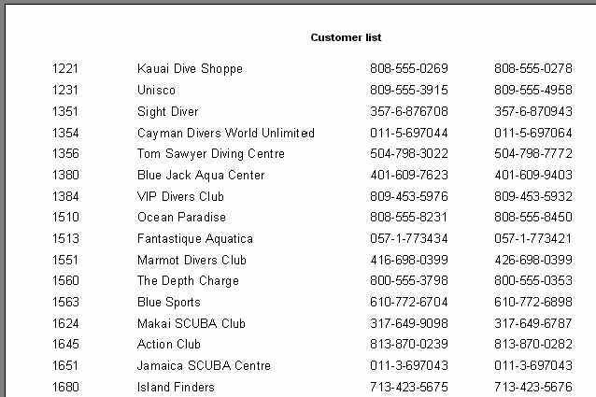**26 FastReport VCL 5 User's Manual**

**2.10 Displaying DB fields with the help of the "Text" object**

As you have seen, “Text” objects can display data from a DB as well as static text and expressions. We have also seen that it can be done in two ways: either by placing a link to the DB field into the object text, or by connecting the object to the required field through its “DataSet” and “DataField” properties. The first way is suitable for displaying both field contents and qualifying text in the same object. For example:

*Contact person: [frxDBDataSet1."Contact_Person"]*

Special syntax is required for links to the DB field: [datasetname.“fieldname”]. The field name (as well as the dataset name) can contain spaces but there must not be any space between the “point” and “quote” symbols.

Furthermore, we can also apply computing operations to a field in the expression, as shown here:

*Length (cm): [<frxDBDataSet1."Length_in"> * 2.54]*

Note how square and angle brackets have to be used. Remember that square brackets are used by default for delimiting expressions in the object’s text. Where required, the square brackets can be replaced by any other opening/closing character pairs (see the section “Displaying expression with the help of the “Text” object”). Angle brackets are used inside expressions for delineating the FastReport variables or DB fields. Logically we should write:

*Contact person: [<frxDBDataSet1."Contact_Person">]*

*FastReport v4 © 1998-2014 Fast Reports Inc.*

*Manual v5.0.0*

**reating reports**

**27C**

instead of

*Contact person: [frxDBDataSet1."Contact_Person"]*

However, both these notations are correct, as FastReport does not require angle brackets where the expression contains only a variable or only a DB field. In all other cases the angle brackets are required, as in:

*Length (cm): [<frxDBDataSet1."Length_in"> * 2.54]*

**2.11 Aliases**

In the previous report the data source was named frxDBDataSet1, the fields were named “CustNo,” “Company,” “Phone,” and “FAX” and we referred to them in the report using something like "[frxDBDataSet1.“CustNo"”]". Is this easy to understand? Not really. It would be clearer if the data source and the field were named “Our clients” and “Number” respectively. There is a problem, “frxDBDataSet1” is the name of the component, within which spaces are not supported and “CustNo” is the name of the field in the database, which cannot be changed without database restructure. However there is a way around this. We can use pseudonyms or aliases for these items. In FastReport both the dataset and its fields possess a second name property known as UserName, i.e. an alias, which can easily be changed. Whenever a component has been given an alias (i.e. UserName changed from its default), this alias must be used in FastReport - the component's Name property will not be recognized.

It is very easy to set aliases for a data source and its fields in FastReport. It is done in the Delphi environment. To open the alias editor, double-click on the frxDBDataSet1 component or use its context menu. You can modify the dataset and field aliases in the editor, and also specify which fields are needed in the report. Let's rename the dataset and fields as below:

*FastReport v4 © 1998-2014 Fast Reports Inc.*

*Manual v5.0.0*

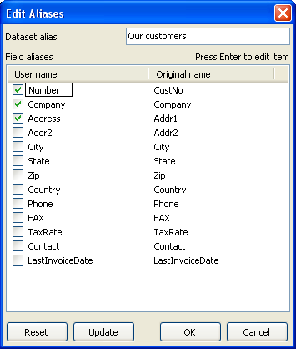**28 FastReport VCL 5 User's Manual**

The alias for the dataset can also be modified without using the alias editor, changing the “UserName” property of the frxDBDataSet1 component.

Having done this we now need to modify the report, as the names of the dataset and fields have been changed. To modify the field names in report objects, it is easiest to use the fourth method described in the ""Customer List" report" section. Move the mouse cursor over the “Text” object so that the button in the right hand end of the object appears, click on the button and select the field from the list. Following this the origin of the data in the dataset and its fields is more apparent.

**Note** : It is better to assign aliases at the very beginning of report design to avoid having to later

rename all the fields within a report.

**2.12 Variables**

As well as aliases, there is another way to help the report designer set more understandable names for DB fields and other information elements. A DB field name or any expression can be associated with a variable. To create and work with variables in FastReport, select the “Report/ Variables...” menu item.

The list of variables in FastReport has a two-level structure. The first level simply contains the category and the second level contains the variable itself. This categorization of variables is convenient when the list of variables is very long. A variable list must contain at least one

*FastReport v4 © 1998-2014 Fast Reports Inc.*

*Manual v5.0.0*

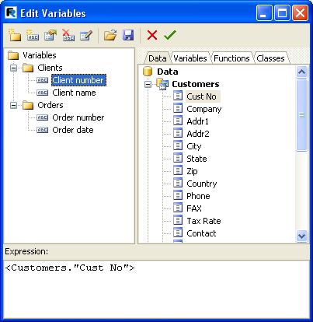

**reating reports**

**29C**

category, which means that variables cannot be located at the top level. Furthermore, category names cannot be included in reports, so each name within the list must be unique.

Let's illustrate the use of variables with the following example. Assume we have two data sources: the first is “frxDBDataSet1” with “CustNo” and “Name” fields and the second is “frxDBDataSet2” with “OrderNo” and “Date” fields. We can associate the following list of variables with the fields:

*Clients*

*Client number*

*Client name*

*Orders*

*Order number*

*Order date*

where “Clients” and “Orders” are two categories. Open the variables editor and create this structure by using of the “New category”, “New variable”, and “Edit” buttons. To link the variables to the DB fields select a variable and double-click on the required DB field in the right hand pane. The link to the DB field will be shown in the bottom pane. The variable is now associated with this expression so the value of the variable becomes the value of the expression. If necessary, the expression can be edited or modified manually and any FR functions or other variables can be used within it. Remember that categories must not be associated with any expression.

After the list of variables has been created, close the variables editor. Now we can insert the variables into the report. In contrast to DB fields, there are fewer insertion methods. We can either insert a variable into the object text manually by typing “[Client number]”, or we can drag a

*FastReport v4 © 1998-2014 Fast Reports Inc.*

*Manual v5.0.0*

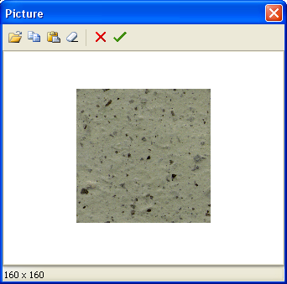**30 FastReport VCL 5 User's Manual**

variable from the “Data tree” pane onto the report page, in which case switch to the “Variables” tab in this pane.

Let’s review what we have learnt so far

* A report design is composed of design pages
* Pages may contain FR objects, either placed on the page or within a band
* Bands are placeholders on the design page and control where the objects they contain appear on the output page(s) according to the band type
* “Text” objects contain the text we want to output in a given position, they can be multi-lined and may contain static text, data fields, variables, expressions or a combination of all of these
* Data type bands (Master, Detail, Subdetail etc.), when connected to a TfrxDbDataset, control the number of times these bands appear (rows) and, together with the report engine, determine the number of finished pages output by the report. Note: even though these data bands may have types like Master, Detail etc., this is only a place relationship of the bands' hierarchical position on the output pages(s). The actual data relationships are dependent on the table/query relationships within the connected frxdbdatasets. Each data band level requires a separate “TfrxDbDataset” or equivalent association.

**2.13 “Picture” object**

The next object to look at is the “Picture” object. It is also frequently used in reports. Using this object you can insert logos, photos (e.g. of an employee) or any other pictorial information. The object can display graphics in “BMP”, “JPEG”, “ICO”, “WMF” or “EMF” format.

Let’s look at the capabilities of this object. Create a blank report and place a “Picture” object on the report page. If the picture editor does not open automatically then double-click on the "Picture" object. You can load any picture from a graphic file or clear the existing picture and close the editor by clicking on the green Tick.

*FastReport v4 © 1998-2014 Fast Reports Inc.*

*Manual v5.0.0*

**reating reports**

**31C**

Some of the object's properties are available on the context menu as well as in the object inspector:

* AutoSize
* Stretch : enabled by default
* Center
* KeepAspectRatio : enabled by default

When “AutoSize” is enabled the object is re-sized up to the size of the picture it contains. Sometimes this can be useful if database pictures of differing size are being displayed. “AutoSize” is disabled by default.

“Stretch” is enabled by default. This property stretches the picture within the object. Change the object’s size using the mouse and you will see that the whole picture is always displayed within the object’s frame. If “Stretch” is disabled the picture (or only part of it) is displayed at its original size. This behaviour differs from “AutoSize” in that you have control of the object's frame size, which can be larger or smaller than the picture it contains. With “AutoSize” enabled you have no control over the object's frame size.

The “Center” property aligns the picture within the object.

“KeepAspectRatio” is enabled by default : it keeps the picture from distorting when the object’s size is changed. This property is only effective when “Stretch” is also enabled. With “KeepAspectRatio” enabled a drawn circle remains a circle without turning into an oval, whatever the “Picture” object's size. The stretched picture occupies only that part of the internal space of the object needed to display it with the correct aspect ratio. When disabled, the picture will be stretched to fill the object's frame and will be distorted if the frame’s aspect ratio is not the same as the picture's aspect ratio.

Another useful property available only in the object inspector is "FileLink". Entering a filename, such as c:\picture.bmp, or a variable which contains a filename, such as [picture_file], will load the picture from the named file when you run the report.

**2.14 Report with pictures**

The “Picture” object, like many objects in FastReport, can display data from a DB. This object

can be connected to a DB field by setting the “DataSet” and “DataField” properties in the object

inspector. In contrast to the “Text” object, this is the only way to connect this object to its data.

Let's demonstrate this with a report giving the names and images of some fish. We will again need the “DBDEMOS” database that is included in the Delphi distribution kit.

Create a blank project in Delphi, place a “TTable” component on the form and set some properties:

*DatabaseName = 'DBDEMOS'*

*TableName = 'Biolife.db'*

*FastReport v4 © 1998-2014 Fast Reports Inc.*

*Manual v5.0.0*

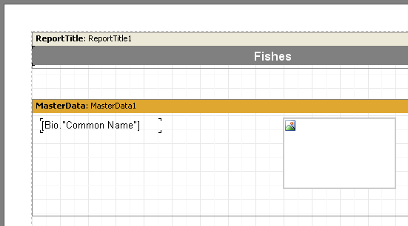**32 FastReport VCL 5 User's Manual**

To work with this table in FastReport add a “TfrxDBDataSet” component and set these properties:

*DataSet = Table1 UserName = 'Bio'*

Finally, add a “TfrxReport” component to the form. Open the report designer and click the “New report” button to create a basic design in FastReport. Now enable the use of the frxDBDataset and its connected table in the report - from the Menu select “Report>Data”, select the “Bio” dataset and click OK.

Now we’ll add objects to the report page. Place a “Text” object containing “Fish” in the “ReportTitle” band. Connect the “Master data” band to the data source (double-click on the band and select “Bio” from the list). Increase the band’s height to 5 cm by dragging the bottom of the band down or by using the object inspector. Place a “Text” object in the band and connect it to the “CommonName” field using any of the methods previously described. After that, drop the “Picture” object alongside, and connect it to the “Graphic” field by setting its properties in the object inspector:

*DataSet = Bio*

*DataField = 'Graphic'*

Note that both of these properties are of the “List” type, and can be set to the required values using the mouse. To make room for the picture, stretch the object to 4 x 2.5cm.

The report design is now finished and it produces the report shown here:

*FastReport v4 © 1998-2014 Fast Reports Inc.*

*Manual v5.0.0*

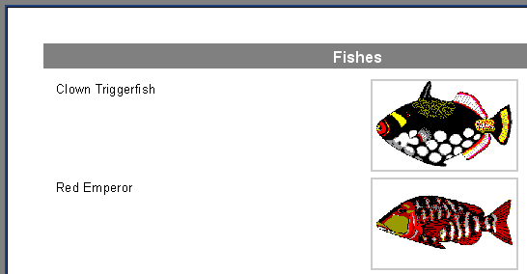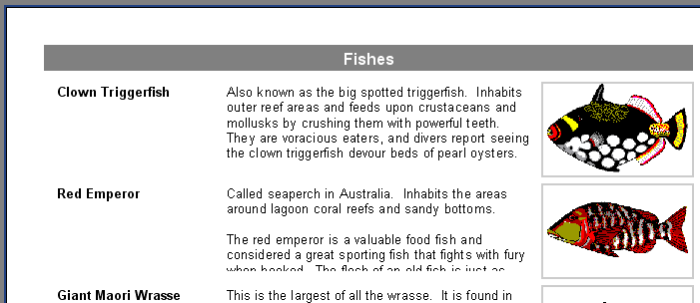

**reating reports**

**33C**

**2.15 Multi-lined text display**

We’ll improve the previous example The “Biolife” table has a “Notes” field, which contains a detailed description of each fish. Update our report by adding this field to it.

At first glance, this would seem to be easy - add a “Text” object to the data band between the existing objects, connect it to the “Notes” field and set the object’s size to 8 x 2.5 cm. However, the report preview is not exactly what we want:

FastReport performed exactly what it was instructed to do. The “Notes” field contains multi-lined text of varying length but the “Text” object displaying the information from this field has a fixed size. This is why some lines appear to be cut off. What can be done about this?

Of course, either the size of the object could be increased or its font size could be reduced.

*FastReport v4 © 1998-2014 Fast Reports Inc.*

*Manual v5.0.0*

**34 FastReport VCL 5 User's Manual**

However, this may lead to wastage of space on the output page as some fish have long descriptions, while others have short ones. FastReport has some properties which allow us to resolve this problem.

These properties allow a band or an object to automatically adjust its height to create the necessary space for a given record (row). To achieve this, we just need to enable the “Stretch” property of both the band and the “Text” object. However, that is not quite all, because a “Text” object with longer text should be able to stretch by itself we’ll need to set some of its other properties too.

The “Text” object can automatically set its height and width to make space for its contents. “AutoWidth” and “StretchMode” can be used for this. “AutoWidth” allows the “Text” object to vary its width so that all the lines make space without splitting any words. This mode is useful when an object has a single text line and when growth to the right will not effect other objects. The

“Stretch” property allows the object’s height to grow to accommodate the text without changing

the object's width. "Stretch" has several modes which can be selected in the object inspector: smDontStretch don't stretch the object (the default)

smActualHeight stretch the object so it makes room for the whole text smMaxHeight stretch the object so that its bottom reaches the bottom of the band in which it is placed - we'll look at this mode later on

Here we are interested in the “Stretch” property of the “Text” object. Enable it using the object's context menu or by setting "StretchMode" to smActualHeight. Also enable the band's “Stretch” property. Preview the report and make sure that everything is now as expected.

*FastReport v4 © 1998-2014 Fast Reports Inc.*

*Manual v5.0.0*

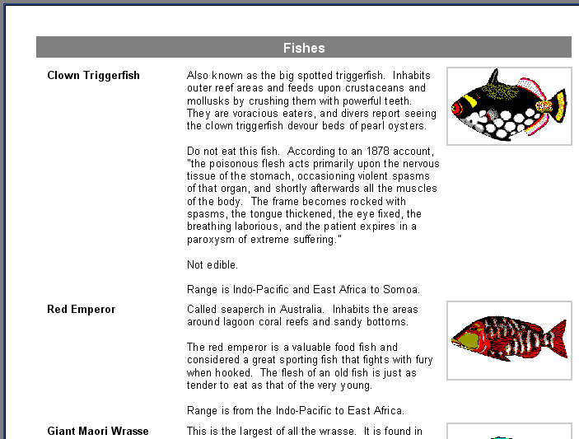

**reating reports**

**35C**

As you can see, when constructing the report FastReport fills objects with data and stretches them if “Stretch” is enabled. It then computes the band’s height so each object has enough room. If the band's “Stretch” property is disabled, this height adjustment is not performed and the band is displayed at the height set in the design. In this case we would see that the objects with longer text would still be stretched but the band would not, which leads to overlaying of text, since the following band is displayed immediately after the previous one.

**2.16 Data splitting**

Let's look at a peculiarity of this report: There is a lot of blank space at bottom of the pages. Why is this? When a report is created the FastReport engine fills the white space of the page with the bands. After displaying each band the current position shifts down. When FastReport finds that there is not enough white space left to display the next band (its height is larger than the white space left on the page) FastReport creates a new page and carries on with band display from there. This sequence continues for as many times as there are records in the dataset.

Our report contains an object with large text, which is why the band height is quite large. Furthermore, if a large band does not have enough room on a page it is shifted to the next one leaving a lot of unused space remaining at the bottom of the page, as shown here:

*FastReport v4 © 1998-2014 Fast Reports Inc.*

*Manual v5.0.0*

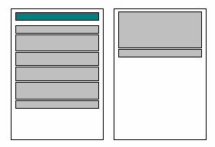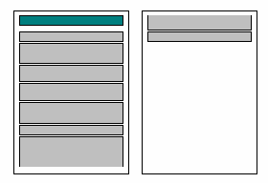**36 FastReport VCL 5 User's Manual**

To limit paper wastage, let's use a FastReport feature that makes paragraphs from a band’s contents. All we need do is enable the “AllowSplit” property of the “First level data” band. You will see that there is now less white space at the bottom of the report pages:

How does this band splitting work? There are some objects in FastReport which support this feature. They are the “Text”, “Line” and “RichEdit” objects. They can be “split”, while other objects cannot. When FastReport needs to split a band, it does it in the following way:

* displays the non-splittable objects which have room in the white space
* partially displays splittable objects (“Text” objects are displayed in a way that all lines have space in the object)
* creates a new page and continues with object display in the band
* if a non-splittable object does not have room in the white space, it is shifted to the next page; at the same time all the objects located beneath it are shifted as required
* the process continues until all of the band objects are fully displayed. The splitting algorithm will become clearer by looking at this example:

*FastReport v4 © 1998-2014 Fast Reports Inc.*

*Manual v5.0.0*

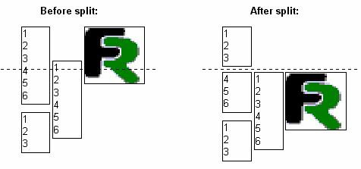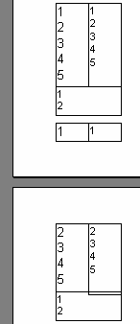

**reating reports**

**37C**

It should be noted, that the splitting algorithm is not perfect and the final output may not be quite as expected. You should use this option very carefully in cases where objects on the split band are grouped in a complicated way, and/or their font sizes differ. Here is an example of what could be generated:

**2.17 Text wrap of objects**

In some report designs text may be required to wrap around other objects (often when using pictures). Let's demonstrate how FastReport can do this in our current example.

Add one more “Text” object to the data band below the Bio.“Notes” object, as shown here:

*FastReport v4 © 1998-2014 Fast Reports Inc.*

*Manual v5.0.0*

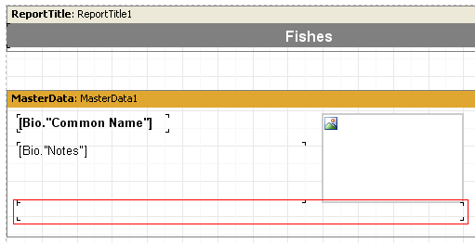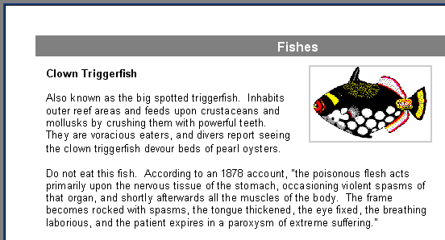**38 FastReport VCL 5 User's Manual**

We will disable stretching for the Bio.“Notes” object and enable it for the bottom object. To make the text “flow” from the Bio.“Notes” object into the bottom one, set the “FlowTo” property of the Bio.“Notes” object in the object inspector - it is a drop-down list. Select the bottom object’s name from this list. The resulting report will look like this:

When the report is generated, if the text does not fit into the top object the excess part is shifted to the bottom object. With the arrangement of the two objects around the picture the effect of text wrapping is achieved.

**Please note** : the main object must be inserted in the report before inserting the linked one,

otherwise text flow may not function correctly! If this occurs, select the linked object and bring it to the front using the “Edit>Bring to front menu item.

*FastReport v4 © 1998-2014 Fast Reports Inc.*

*Manual v5.0.0*

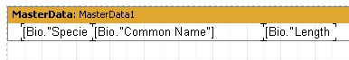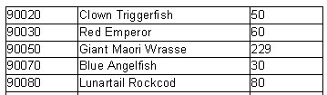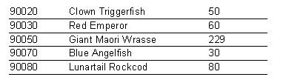

**reating reports**

**39C**

**2.18 Displaying data in the form of a table**

Sometimes it is necessary to display data in the form of a framed table. An example of this type of report might be a price list. To create this type of report in FastReport just requires the enabling of frames for the objects located in the data band. Let's demonstrate several variants of frames with an example.

Create a report similar to this:

Place the “Text” objects side by side on the band and minimize the band’s height.

The first and the simplest type of table has full cell framing. To achieve this enable all frame lines (found in Frame.Typ property) for every object:

The next type of framing draws only horizontal or only vertical cell lines, again through the Frame.Typ property:

Finally, to draw only an external frame to the table the report needs a modification:

*FastReport v4 © 1998-2014 Fast Reports Inc.*

*Manual v5.0.0*

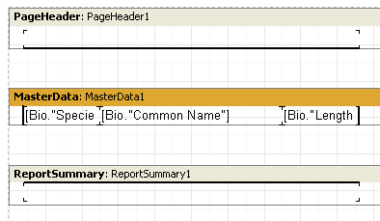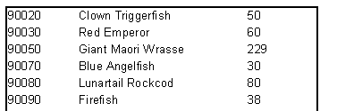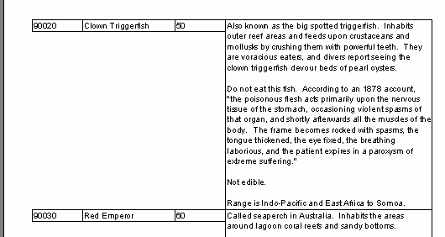**40 FastReport VCL 5 User's Manual**

You can see that we have added two “Text” objects, one in the pageheader and one in the pagefooter bands. The appropriate frame lines for the objects along the edges of the data band have been enabled, resulting in the report looking like this:

All these examples contained bands which had fixed sizes. How is it possible to display a table when the band is stretched? Let's explain how, by means of an example. Add a new field (multi- lined text from Bio.“Notes”) to our report. As you have already learnt, the “Stretch” property must be enabled both for this object and for the band in which the object is located so that the band height is altered, dependent on the size of the text in the “Text” object. The generated report looks like this:

This is a bit different from what we need - it looks nicer if the frames of the neighboring objects stretch as well. FastReport can solve this problem easily. Set the “StretchMode” property to smMaxHeight in the object inspector for all objects which are to be stretched and the FastReport

*FastReport v4 © 1998-2014 Fast Reports Inc.*

*Manual v5.0.0*

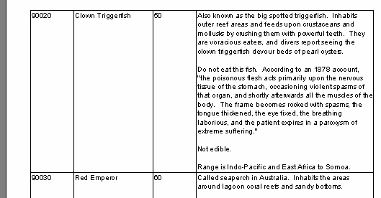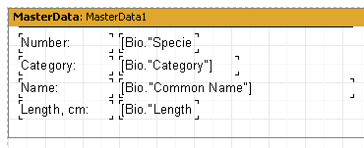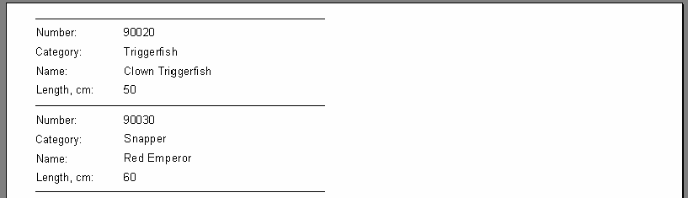

**reating reports**

**41C**

core will first calculate the maximum band height and then “stretch” objects with stretch enabled to the bottom edge of the band. Because object frames stretch together with the object the report’s appearance changes:

**2.19 Printing labels**

In contrast to table-type reports, other reports (such as label printing reports) may have the data arranged one field under another. Let's look at an example of this kind of report which displays data about fish, as in the previous example. The report data is presented as a label and has the following structure:

When previewed we would see the following output:

Notice there is a lot of blank space on the right side of the page. To make use of the whole page the number of columns in which data is displayed can be set in the report page settings. To do

*FastReport v4 © 1998-2014 Fast Reports Inc.*

*Manual v5.0.0*

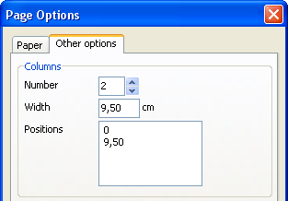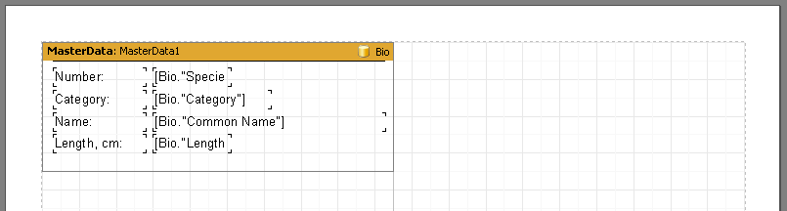**42 FastReport VCL 5 User's Manual**

this either double-click on the white space on the design page or use “File>Page Settings...” on the menu.

The column count, width and positions are set on the "Other options" tab in the dialogue. In our example only the Number needs to be set at 2, as FastReport adjusts the other options automatically. The column frame is displayed in the designer as a thin vertical line:

The report is now created in the following way. FastReport repeats the “First level data” band as long as there is white space at the bottom of the page. After that, a new column on the same page is created and data bands continue repeating from the top of the new column : this contrasts with simple reports, where a new page is created instead of a new column. When the second column has been filled then a third column is created, and so on - our example only has two columns though. When all of the columns have been filled then FastReport creates a new page and continues displaying data starting in the first column again.

Our two column report should look like this:

*FastReport v4 © 1998-2014 Fast Reports Inc.*

*Manual v5.0.0*

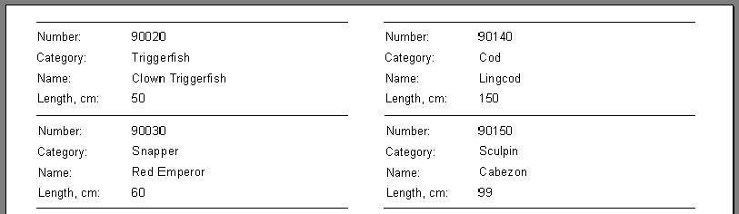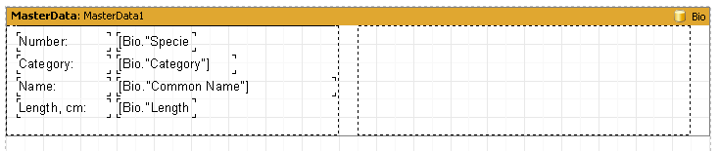

**reating reports**

**43C**

The “Columns” property, available in the object inspector for all data bands, is another way to set the number of columns. If this property is changed from zero however, the number of columns is set only for the selected databand and not for the whole page (as in the previous example). The effect is to display data firstly from 'left-to-right then top-to-bottom', in contrast to the 'top-to- bottom then left-to-the right' output shown above.

Disable the columns in the Page Options dialogue (set Column Number to 1) and enter 2 in the databand “Columns” property. Note that the “ColumnWidth” property must also be changed from the default zero to prevent column 2 overlaying column 1; optionally the “Column Gap” property can also be changed. FastReport then shows the column frames as dotted lines :

This design displays data in 'left-to-right then top-to-bottom' order.

**2.20 Child-bands**

There can be a problem when one field in a label-type report has content of variable length. To simulate this in our example, let's reduce the width of the Bio.“Common Name” object to 2.5 cm and enable the “Stretch” property for this object and also for the “First level data” band. Enable all the frame lines for all the objects so that the effects of the stretching function are clear to see. The design now outputs a report like this:

*FastReport v4 © 1998-2014 Fast Reports Inc.*

*Manual v5.0.0*

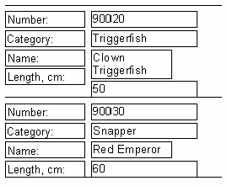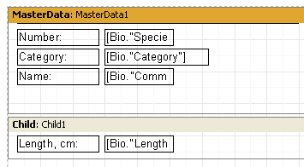**44 FastReport VCL 5 User's Manual**

Here the first Bio.“Common Name” field object contains a lot of text and is stretched into two lines. This causes the Bio.“Length (cm)” field object, located beneath it, to be shifted downwards. This happens because all the objects have their “ShiftMode” property set to smAlways by default, meaning they shift downwards if there is a stretchable object (a “Text” object with the “Stretch” property enabled) above them. The distance shifted depends on how much the object above is stretched.

But this is not want we want to happen on our label - we want the “Length, cm.” object also to be shifted by the same amount. This can be achieved by using a special FastReport band type called the “Child” band. A “Child” band is linked to (and displayed after) its parent band. Add a “Child” band to the design and drag the two “Text” objects into it, as shown here:

Link the MasterData band to the Child band, by setting its “Child” property to “Child1” in the object inspector. Now, each time the MasterData band prints, the Child band is printed immediately after it:

*FastReport v4 © 1998-2014 Fast Reports Inc.*

*Manual v5.0.0*

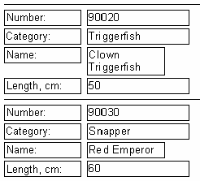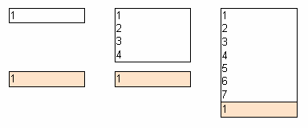

**reating reports**

**45C**

The “Length, cm:” title now lines up exactly with its value field “50”. To prevent a child band from being moved to the next page if there is insufficient white space on the page (and becoming so- called 'orphaned' from its parent band), enable the “KeepChild” property of the parent band in the object inspector.

**2.21 Shifting objects**

You have already seen how 'smAlways' works for the “ShiftMode” property. Let's look at the next mode of shifting, 'smWhenOverlapped'. In this mode object shifting occurs when the object above stretches and overlaps the object below. Here are two secenarios:

1. the three top objects have “Stretch” enabled and the three bottom objects have “ShiftMode” set to 'smAlways'. The bottom objects only shift far enough to allow space for the stretched object above it:

1. the three top objects have “Stretch” enabled and the three bottom objects have “ShiftMode” set to 'smWhenOverlapped'. The bottom objects shift to allow space for the stretched object and also to maintain the designed separation of the two objects:

*FastReport v4 © 1998-2014 Fast Reports Inc.*

*Manual v5.0.0*

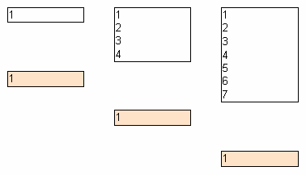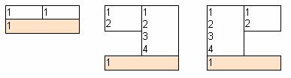**46 FastReport VCL 5 User's Manual**

This allows the creation of complicated reports, in particular where an object could overlap several other objects above it at the same time. In the example below all the upper objects contain stretchable text and all the lower ones are in 'smWhenOverlapped' mode. The lower objects will always be displayed close to the object above, irrespective of text length in the objects above:

**2.22 Report with two data levels (master-detail)**

So far our example reports have used only one data band (“First level data” or ”MasterData”) to control data output. This was adequate for the output of data from one DB table. FastReport also allows reports to be designed having up to six data levels, all on the one design page. Furthermore, an unlimited number of data levels in reports can be achieved by the use of the “Subreport” object - this object is covered later on. Most reports in general need only one, two or three data levels, larger numbers of data levels are rare.

Let's look at how to design a two data level report. The report will output data from the demo

tables: “Customer” and “Orders”. The first table is a list of customers and the second one is a

list of orders placed by those customers. The tables contain data in the following fields: Customer:

|  |  |  |
| --- | --- | --- |
| CustNo | Company |  |
| 1221 | Kauai Dive Shoppe |  |
| 1231 | Unisco |  |
| 1351 | Sight Diver |  |
| …. |  |  |

Orders:

*FastReport v4 © 1998-2014 Fast Reports Inc.*

*Manual v5.0.0*

**reating reports**

**47C**

|  |  |  |  |
| --- | --- | --- | --- |
| OrderNo | CustNo | SaleDate |  |
| 1003 | 1351 | 12.04.1988 |  |
| 1023 | 1221 | 01.07.1988 |  |
| 1052 | 1351 | 06.01.1989 |  |
| 1055 | 1351 | 04.02.1989 |  |
| 1060 | 1231 | 28.02.1989 |  |
| 1123 | 1221 | 24.08.1993 |  |
| …. |  |  |  |

As you can see, the second table contains the list of all the orders placed by all the customers. To view the orders from the Orders table which are placed by one customer in the Customers table, the two tables are linked on the “CustNo” field, which is common to both tables. The report output from this data should appear as follows:

|  |  |  |  |
| --- | --- | --- | --- |
| 1221 | Kauai Dive Shoppe | |  |
| 1023 | 01.07.1988 | |  |
| 1123 | 24.08.1993 | |  |
| 1231 | Unisco |  |
| 1060 | 28.02.1989 |  |
| 1351 | Sight Diver |  |
| 1003 | 12.04.1988 |  |
| 1052 | 06.01.1989 |  |
| 1055 | 04.02.1989 |  |

Let's design the report. Create a new project in Delphi, place two “TTable”, one "TDataSource", two “TfrxDBDataSet” and one “TfrxReport” components on the form. Set the component properties as shown here:

Table1:

*DatabaseName = 'DBDEMOS'*

*TableName = 'Customer.db'*

Table2:

*DatabaseName = 'DBDEMOS'*

*TableName = 'Orders.db'*

DataSource1:

*DataSet = Table1*

frxDBDataSet1:

*DataSet = Table1*

*UserName = 'Customers'*

frxDBDataSet2:

*DataSet = Table2*

*UserName = 'Orders'*

In the report designer, enable the data sources in the “Report>Data...” dialogue. Now add a

*FastReport v4 © 1998-2014 Fast Reports Inc.*

*Manual v5.0.0*

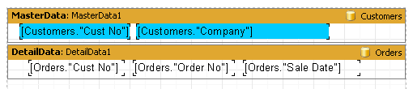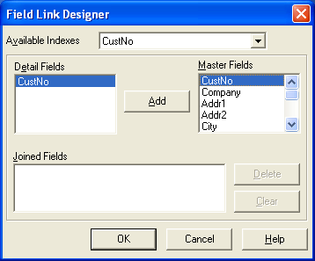**48 FastReport VCL 5 User's Manual**

“MasterData” and a “DetailData” band to the page:

Note that the “MasterData” band must be placed above the “DetailData” band! Drag it there if necessary. If the Master is placed under the Detail, FastReport will generate an error message when you preview the report.

If you previewed the report now, you would see that the list of orders remains the same for every customer and contains all the records from the “Orders” table. This would be because we have not set the MasterSource property of the “Orders” table. Set “MasterSource = DataSource1” for

the “Table2” component on the Delphi form. Now we have set a 'master-detail' relationship. After

that, we select the fields to link on. Set the “MasterFields” property of the “Table2” component:

We need to link together the “CustNo” fields in the two sources. To do this, select the desired fields and click the “Add” button. The Field link will appear in the bottom pane. Finish by closing the editor using ΞΚ.

When creating the preview FastReport does the following. After a record is output from the master table (Customer), it sets the filter on the detail table (Orders). Only those records which meet the 'Orders.CustNo = Customer.CustNo' condition will remain in the table. This means that for each customer only those orders which belong to the current customer will be displayed in the detail band. This is an important concept to grasp. Even though data bands may be of master or of detail type, they only control the positioning of the data on the output page (order and number of times displayed). The data displayed by the objects in the bands is dependent on which fields the objects are linked to and on the external linking of the two tables.

*FastReport v4 © 1998-2014 Fast Reports Inc.*

*Manual v5.0.0*

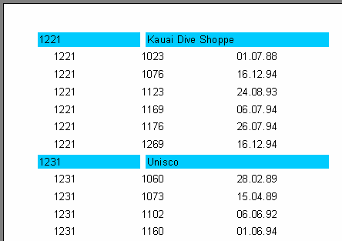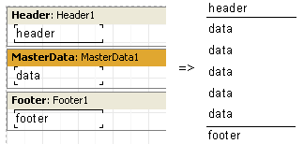

**reating reports**

**49C**

This is the final output:

Reports containing up to 6 data levels can be constructed in a similar manner.

**2.23 Headers and footers of a data band**

Each data band may have a header and a footer. Headers are output first, then all the records in the data band, and finally the footers. Here is an example of how the headers and footers work in a simple report:

Let's look at a more complex example using two data levels - master and detail:

*FastReport v4 © 1998-2014 Fast Reports Inc.*

*Manual v5.0.0*

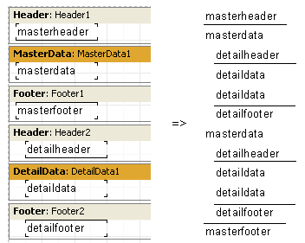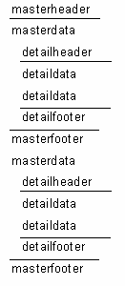**50 FastReport VCL 5 User's Manual**

As you can see, the header is output before all data band records. So the master data header is output once at the beginning of the report and a detail data header is output before each group of detail bands belonging to the current master record band. The detail footer is output after the

group of detail bands belonging to the master record band and the master footer is  **not output**

until after all the master data band records have been output.

Using the FooterAfterEach property of the data band, we can override this behavior. Setting this property to True (you may also use the context menu for the data band - "Footer After Each Row") causes footer output after each data row. This may be useful in the design of some master-detail reports. If FooterAfterEach for the master data band is set to True the report will look like this:

*FastReport v4 © 1998-2014 Fast Reports Inc.*

*Manual v5.0.0*

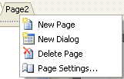

**reating reports**

**51C**

**2.24 Multi-page reports**

A FastReport report can consist of several design pages. Multi-page designs allow for the adjustment of properties such as size and orientation of each page, as well as allowing variation in the placement of objects and bands on the pages. When this type of report is output all bands from the first design page are be displayed, then bands from the second page, and so on.

When a new report is created in the designer it contains one page by default. You can add a new page by clicking on the button in the toolbar or by selecting the “File>New page” menu command. Then you would see that a new page tab appears in the designer:

You can easily switch between pages by clicking on the page tabs. Page tabs can be dragged (“drag&drop”) to easily change their printing order. An unnecessary page can be deleted using the button in the toolbar or by selecting the “Edit>Delete page" menu command. You can also call the context menu by right-clicking on the page tab:

The number of design pages in a report is unlimited. As a rule additional pages are used either for title pages or, in more complicated reports, for data coming from many data sources.

Here is a simple example of creating a title page. Let's use our previous report having one data level. Add a new page to it, it will be added as a second page. Move it to the front of the report by grabbing the page2 tab with the mouse and dragging it over the first page tab, page1. This changes the page order. Select the new page and place a “Text” object containing “Our report” in the middle of the page. That is all that is needed. The report with a title page is complete:

*FastReport v4 © 1998-2014 Fast Reports Inc.*

*Manual v5.0.0*

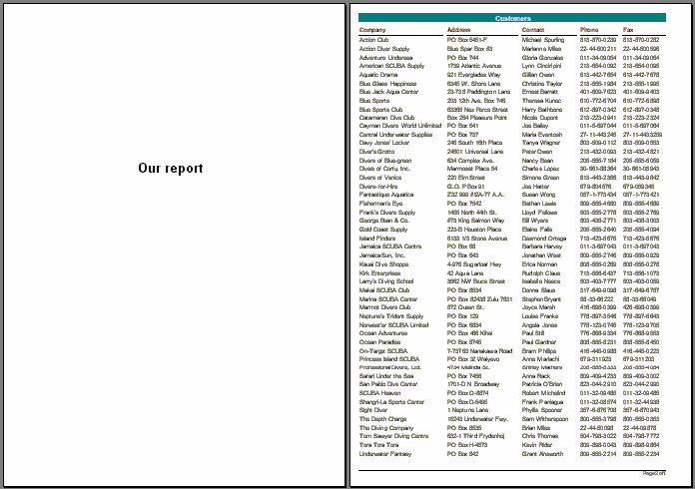**52 FastReport VCL 5 User's Manual**

Pay attention to one feature of multi-page reports, however. If the “PrintOnPreviousPage” property is enabled in the object inspector for the second output page, then the second output page's objects will start printing on the white space of the first output page, and not on the new output page.

**2.25 RowCount and PageCount properties**

Sometimes the need arises to show static data several times over, for example when printing “Blank” business cards or post cards. For this purpose data bands have the “RowCount” property, and the report page has the “PageCount” property.

These two properties control the degree of band/page repetition in the report, without being influenced by the report data.

*FastReport v4 © 1998-2014 Fast Reports Inc.*

*Manual v5.0.0*

**Chapter**

**III**

**Groups and**

**aggregates**

**54 FastReport VCL 5 User's Manual**

**3.1 Report with groups**

In the previous example we constructed a two-level report based on the data from two tables. Another report which looks the same can be constructed in FastReport, this time based on a dataset obtained from a joined query.

To do this, an SQL query is needed which returns data from both tables and sorted in a particular way. In our example, the tables will be joined on the “CustNo” fields present in both tables. The query might be:

**select** *  **from** customer, orders

**where** orders.CustNo = customer.CustNo

**order**  **by** customer.CustNo

The "order by" line is required to sort the records on the “CustNo” field. This query returns a dataset like:

CustNo

Company

OrderNo

SaleDate

|  |  |  |  |
| --- | --- | --- | --- |
| 1221 | Kauai Dive Shoppe 1023 | 01.07.1988 |  |
| 1221 | Kauai Dive Shoppe 1123 | 24.08.1993 |  |
| 1231 | Unisco 1060 | 28.02.1989 |  |
| 1351 | Sight Diver 1003 | 12.04.1988 |  |
| 1351 | Sight Diver 1052 | 06.01.1989 |  |
| 1351 | Sight Diver 1055 | 04.02.1989 |  |

How can a multi-level report be designed using this data? In FastReport there is a special band,

the “Group Header”. A condition (a DB field value or an expression) is specifed for the band; the

band is output every time the condition's value changes. The following example illustrates this.

Let's create a new project in Delphi and place “TQuery”, “TfrxReport” and “TfrxDBDataSet” components on the form. Set their properties as shown here:

Query1:

*DatabaseName = 'DBDEMOS'*

*SQL =*

*select * from customer, orders*

*where orders.CustNo = customer.CustNo*

*order by customer.CustNo*

frxDBDataSet1:

*DataSet = Query1*

*UserName = 'Group'*

Open the report designer and create a new report. Connect our data source to the report. After that, add a “Group header” band to the report. Set a condition (in this case the “Group.CustNo” data field) in the “Group header” band editor:

*FastReport v4 © 1998-2014 Fast Reports Inc.*

*Manual v5.0.0*

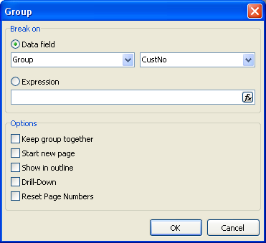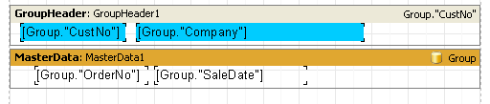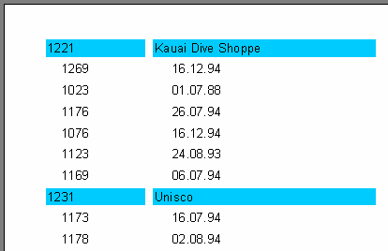

**roups and aggregates**

**55G**

Also link the data band to the “Group” data source and arrange some objects as shown (note that the group header must be placed above the data band):

On previewing the report, we obtain output similar to this:

As you can see, the “Group header” band is output only when the field to which it is linked

*FastReport v4 © 1998-2014 Fast Reports Inc.*

*Manual v5.0.0*

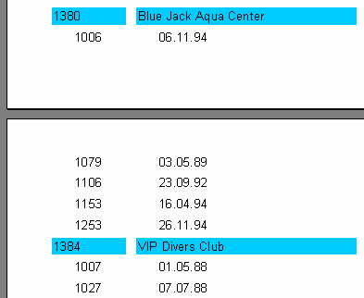**56 FastReport VCL 5 User's Manual**

changes in value. Otherwise the data band connected to the “Group” dataset is displayed. If we compare this report to the master-detail report constructed earlier, it is obvious that order numbers are not sorted at all. This can be easily corrected by changing the SQL query’s 'order by' clause:

**select** *  **from** customer, orders

**where** orders.CustNo = customer.CustNo

**order**  **by** customer.CustNo, orders.OrderNo

Reports having nested groups can be designed in a similar way. The depth of nesting of groups is unlimited. Reports which use groups have some advantages over reports of the master-detail type:

* the whole report needs only one dataset (query)
* the number of data grouping levels is unlimited
* data sorting becomes possible
* more optimal usage of the DB resources (the query returns only one dataset for output, with filtering done by the query).

The only disadvantage is the need to write queries in the SQL language. However, a basic knowledge of SQL is virtually obligatory for any programmer working with databases.

**3.2 Other group features**

Let’s look at how the group is output when the report calls for a new page:

Looking at the report, it is unclear to which client the list of orders at the top of the second page

refers. FastReport allows the group header to be output on the new page (which in our case

*FastReport v4 © 1998-2014 Fast Reports Inc.*

*Manual v5.0.0*

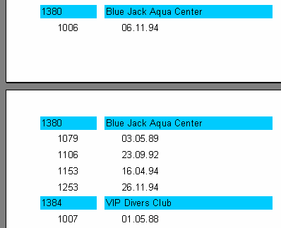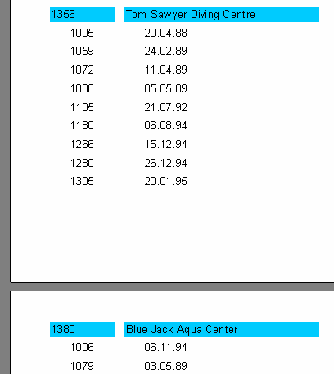

**roups and aggregates**

**57G**

identifies the client). To do this, enable the “ReprintOnNewPage” property for the “Group header” band using the object inspector or the context menu . This will alter the report as shown:

There is another way to avoid breaking groups at page boundaries. This is to enable the “KeepTogether” property for the group header in the object inspector or context menu. Then, if the whole group doesn't fit into the free space on the output page, it is moved as a whole to a new page. In our example, appearing like this:

*FastReport v4 © 1998-2014 Fast Reports Inc.*

*Manual v5.0.0*

**58 FastReport VCL 5 User's Manual**

A lot of blank space may be left on some pages but, if possible, the group is displayed complete on one page.

The “StartNewPage” group header property allows the output of groups on separate pages. It possibly will lead to a wastage of paper but might be useful in some situations.

**3.3 Reset page numbers**

The “Group header” band has a “ResetPageNumbers” property which allows us to reset page numbers when printing a group. What is it for?

Here's an example : you have created a report which puts the customer name in a group header and customer orders in the data band. Now you need to print the report and send it to all your customers, each customer getting only the pages of the report which refer to them. Unfortunately, the page numbering in the report is continuous, so a customer getting the pages numbered 50 to 52 will ask "where are the first 49 pages?". To avoid this situation you have to number to each customer's pages with its own sequence. Inside the report each group will have pages numbered from 1.

Please note: if you set “ResetPageNumbers” to True, you should also set “StartNewPage” to True, so that each group will start on a new page. To print the page number or total pages, you should use the [Page] and [TotalPages] system variables and not [Page#] and [TotalPages#].

**3.4 Drill-down groups**

The group header has a property called DrillDown. If you set it to True, the group becomes interactive. This means you can click on the group header in the preview window and the group will expand (display all records in the group) or collapse (display only the header and, if ShowFooterIfDrillDown is True, the footer).

Here is an example of such a group with one expanded header:

*FastReport v4 © 1998-2014 Fast Reports Inc.*

*Manual v5.0.0*

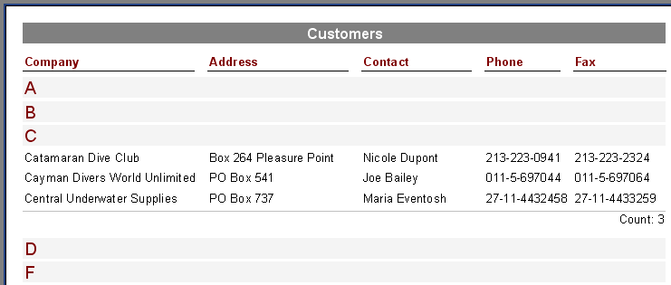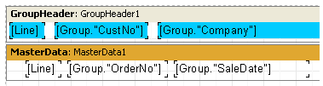

**roups and aggregates**

**59G**

You can control whether all groups are collapsed or expanded when the report first runs. By default a group is collapsed but you can set ExpandDrillDown to True if you want it expanded. You can also use the preview's context menu to expand or collapse all groups at once.

**3.5 Line numbering**

Let's use our example to show how to number the lines in a group. To do this, we add a “Text” object containing a system variable [Line] to both of our bands (this is most easily done by dragging & dropping from the “Variables” tab of the “Data Tree” pane).

When previewing the report, we can see that both the data levels now have their own line numbers:

*FastReport v4 © 1998-2014 Fast Reports Inc.*

*Manual v5.0.0*

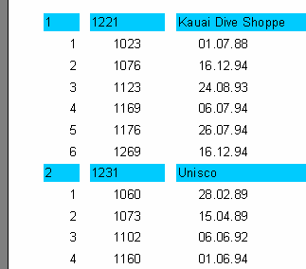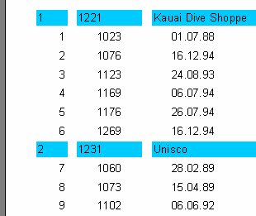**60 FastReport VCL 5 User's Manual**

To continuously number the second level data lines, use the [Line#] variable instead of [Line] in the “Text” object on the data band. The result will then look like:

**3.6 Aggregate functions**

In most cases group reports need to display some summary information (such as: “total of a group”, “number of group elements” etc). FastReport provides aggregate functions for calculating aggregate values over some data span. The aggregate functions are:

|  |  |  |  |
| --- | --- | --- | --- |
| SUM | returns the total of an expression |  |  |
| MIN | returns the minimal value of an expression |  |  |
| MAX | returns the maximal value of an expression |  |  |
| AVG | returns the average value of an expression |  |  |
| COUNT | returns the number of lines (rows) in the data span |  |  |

*FastReport v4 © 1998-2014 Fast Reports Inc.*

*Manual v5.0.0*

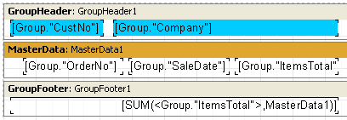

**roups and aggregates**

**61G**

The syntax of all aggregate functions (except COUNT) is similar to that of the SUM function: SUM(expression, band, flags)

SUM(expression, band)

SUM(expression)

The parameters are:

expression the expression to be calculated

band the name of the data band within which the calculation is performed flags a bit field, with values

* : include invisible bands in calculation
* : accumulate the aggregate as a running total

(do not reset the aggregate when the current data span resets)

* : (both of the two previous options)

An expression is the only mandatory parameter, the other two are optional. Nevertheless, to avoid making mistakes it is recommended that band parameters are always given.

The “COUNT” aggregate function has the following syntax:

COUNT(band, flags)

COUNT(band)

where the parameters have the same meaning as above.

There is a general rule for all aggregate functions: an aggregate can only be calculated over a data band and can only be used in that band’s footer, which can be one of : footer, page footer, group footer, column footer or report footer (summary band).

How do aggregate functions work? We will look at this using our group report example. Let's add some new elements to the report:

The Group.“ItemsTotal” field in the data band displays the current order total. Place a “Text” object in the group footer containing the aggregate SUM shown above. It will display the total of all orders placed by the given customer. Using a calculator, we can check that the result is correct:

*FastReport v4 © 1998-2014 Fast Reports Inc.*

*Manual v5.0.0*

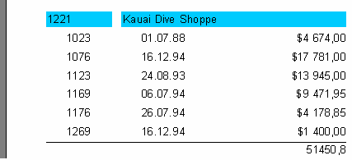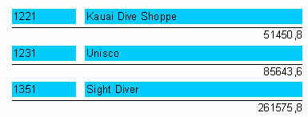**62 FastReport VCL 5 User's Manual**

Aggregate functions work like this : before outputting a report, FastReport scans the “Text” object contents to find any aggregate functions. The aggregates found are linked to the data bands in their parameters (in our example “SUM” is linked to the “MasterData1” band). During report output (when the data band is displayed) the values of the aggregates linked to it are calculated. In our case the Group.“ItemsTotal” field values are accumulated. Once the group footer displaying the aggregate has been output the aggregate value is reset to zero, and the cycle is repeated for the next group, and so on.

What is the purpose of the optional “Flags” parameter in aggregate functions? Reports may have some, or all, of the data bands hidden. We may, however, need to calculate aggregates over all the data bands, whether visible or not. In our example, set the “Visible” property of the data band to false, so preventing its display. To still have this hidden data band included in the calculations, we have to set the third, optional parameter in the function call to the figure 1, i.e.:

*[SUM(<Group."ItemsTotal">,MasterData1,1)]*

This produces a report looking like tis:

When the “Flags” parameter value is set to 2, the aggregate value is not reset immediately after it is displayed : the aggregate becomes a “running” calculation for each successive output. Let’s modify the function call as shown here:

*[SUM(<Group."ItemsTotal">,MasterData1,3)]*

The value “3” is a bit combination of “1” and “2”, meaning that we need to include the invisible bands, without resetting the total after each group. As a result, we have:

*FastReport v4 © 1998-2014 Fast Reports Inc.*

*Manual v5.0.0*

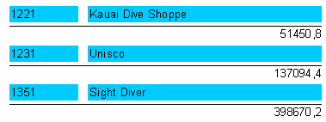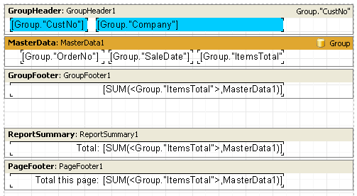

**roups and aggregates**

**63G**

**3.7 Page and report totals**

Quite often, we need to display summary totals for a page or for a whole report. We can use the aggregate functions in this situation as well. We’ll show this by making some changes to our example:

As you can see, we have added a “Report Summary” band containing a “Text” object with the aggregate SUM to both the “Report Summary” band and the “Page Footer” band. That is all that is needed:

*FastReport v4 © 1998-2014 Fast Reports Inc.*

*Manual v5.0.0*

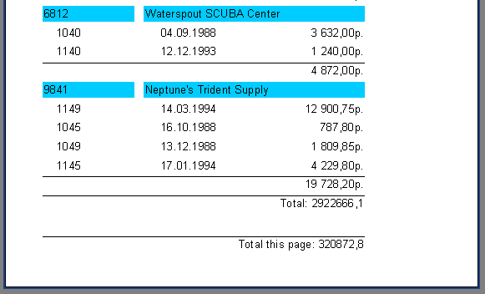**64 FastReport VCL 5 User's Manual**

**3.8 Inserting aggregate functions**

So far we have manually inserted the aggregate functions into “Text” objects. Now we will look at other ways to insert aggregate functions.

Firstly, we can use the “System text” object to output an aggregate. In fact this object is similar to a “Text” object with its own special editor for more easily specifying system variables or aggregate functions:

*FastReport v4 © 1998-2014 Fast Reports Inc.*

*Manual v5.0.0*

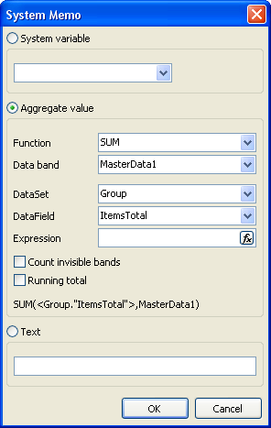

**roups and aggregates**

**65G**

Select a function type, then a data band (over which the aggregate is to be calculated) and finally a DB field or an expression whose value is to be calculated. You can also set the “Count invisible bands” and “Running totals” flags, if required.

The second method is to use a “Text” object and click the button in its editor : this opens a dialogue similar to the “System text” object editor. When the OK button is clicked a call to the aggregate function is inserted into the object's text.

*FastReport v4 © 1998-2014 Fast Reports Inc.*

*Manual v5.0.0*

**Chapter**

**IV**

**Formatting,**

**highlighting**

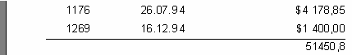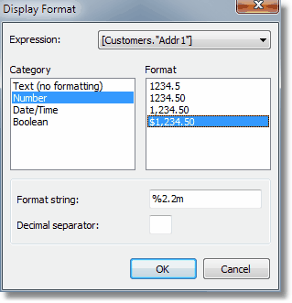

**ormatting, highlighting**

**67F**

**4.1 Formatting of values**

A feature of aggregate functions is that the returned numerical values are not formatted, as shown by the first example, which uses “SUM”:

Data fields usually return a formatted value, which is simply displayed by the “Text” object without any change. To apply formatting to the “SUM” result, let's use the value formatting tools in FastReport.

Select the object containing the Sum and open the format editor either from 'Display Format...' in its context menu or through the “DisplayFormat” property in the object inspector.

This editor lists the format categories on the left, the corresponding formats on the right and the format string and decimal separator for the selected category and format below. We’ll select the “Number” category and "$1,234.50" format. The format string is an argument for the Delphi "Format" function, which FastReport uses to implement number formatting. The format string and decimal separator can be changed. If the decimal separator is left blank then the current regional setup value is used.

After clicking ΞΚ and previewing the report you will see that the Sum in the report is now formatted correctly:

*FastReport v4 © 1998-2014 Fast Reports Inc.*

*Manual v5.0.0*

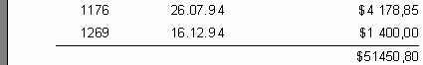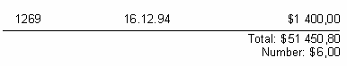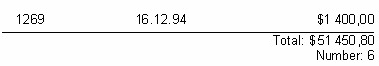**68 FastReport VCL 5 User's Manual**

Note the combobox at the top of the dialogue form. If we have more than one expression in an object, we may set different formatting for each expression.

**4.2 Inline formatting**

Inline formatting allows you to set different formatting for each expression contained in the object. It was used in previous versions of FastReport. Now it is obsolete (use the formatting dialogue to set different formatting for each expression).

Using the example, re-size the footer and its object and change the object text to this:

*Total: [SUM(<Group."ItemsTotal">,MasterData1)]*

*Number: [COUNT(MasterData1)]*

The total and the number of orders will be displayed in the object.

In the report preview both of these values are shown in monetary format, which we had previously set. This is incorrect:

To display each value in its correct format they need to be formatted individually. To do this we use format tags, which are placed just before the closing square bracket of the expression. In our example, disable formatting for the object (select “Text (no formatting)” category in the format editor). Now we need to specify the format for just the first expression, as the second one will be displayed correctly by default (i.e. as an integer). Change the object text as follows:

*Sum: [SUM(<Group."ItemsTotal">,MasterData1) #n%2,2m]*

*Number: [COUNT(MasterData1)]*

Preview the report to make sure that the object is displayed correctly:

The general syntax of format tags is:

*[expression #formattag]*

*FastReport v4 © 1998-2014 Fast Reports Inc.*

*Manual v5.0.0*



**ormatting, highlighting**

**69F**

Note that the space character between the expression and the “#” symbol is mandatory! The format tag itself might look like:

* n*format_string* numerical format
* d*format_string* date/time format

#bFalse,True boolean format

*Format_string* in each case is the argument to the function used for formatting. So, for

numerical formatting the Delphi Format function is used, and for date/time the FormatDateTime function. The syntax for these functions can be found in the Delphi help system. Below are several values used in FastReport:

for numerical formatting:

%g number with the minimal places after the decimal point

%2.2f number with a fixed number of places after the decimal point %2.2n as previous, but with thousands separator

%2.2m monetary format, accepted by the Windows OS, dependent on the regional settings in the control panel

for date/time formatting:

dd.mm.yyyy date as '23.12.2003'

dd mmm yyyy date as '23 Nov 2003'

dd mmmm yyyy date as '23 November 2003'

hh:mm time as '23:12'

hh:mm:ss time as '23:12:00'

dd mmmm yyyy, hh:mm date and time as '23 November 2003, 23:12'

A comma or a dash can be used instead of the dot in the  *format_string* for numerical formatting.

This symbol is used as the separator between the integer and the fractional parts of the value. Any other character is not allowed.

For formatting with the “#b” type (boolean), the  *format_string* is entered as two values separated

by a comma. The first value corresponds to “False” and the second to “True”.

**4.3 Conditional highlighting**

There is a possibility to change the "Text" object's appearance depending on the given

conditions. For example, an object can be highlighted with red color if it has a negative value.

This feature is called "conditional highlighting". To set up it, select the "Text" object and click the button on the "Text" toolbar.You will see the following dialog window:

*FastReport v4 © 1998-2014 Fast Reports Inc.*

*Manual v5.0.0*

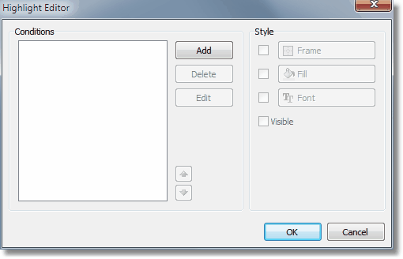**70 FastReport VCL 5 User's Manual**

It is possible to define one or several conditions and set up the style for every condition. Style can contain one or several settings:

frame;

fill;

font;

object's visibility.

You can indicate, which settings need to be changed when the condition is met. For this, check the needed setting using the checkbox.

In order to create a new condition, click the "Add" button. You will see an expression editor. Here, it is possible to write any expression which returns a boolean result. In many cases you will use the "Value" variable, which contains the currently printing value.

Let us look at the following example: we have a "Text" object, in which we print the amount of products in stock:

*[Products."UnitsInStock"]*

We want to paint the object red, if the amount of products = 0. For this, we create the following condition:

*Value = 0*

**Attention: if you have selected C++Script as a script language (see more details in the "Script" chapter), you should write the condition using C++Script:**

*Value == 0*

*FastReport v4 © 1998-2014 Fast Reports Inc.*

*Manual v5.0.0*

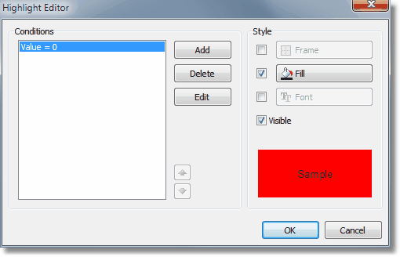

**ormatting, highlighting**

**71F**

In the given case, we used the "Value" variable, which has got a printed value. If there are several expressions in an object, then this variable will have the value of the last expression. Instead of "Value", you can use a data column:

*<Products."UnitsInStock"> = 0*

Configure the style for the given condition in such a way that only fill can be used, and choose the red color:

When printing an object which has a zero value, it will be red. Let us make our example more complex, we will add another condition. If the units in stock is less than 10, it must be printed yellow. To do this, open the condition editor and click the "Add" button. The second condition will be like this:

*Value < 10*

In case where several conditions have been indicated, FastReport checks all the conditions, starting from the first one. If a certain condition is met, FastReport applies its style settings to the object, and the process stops. It is important to put the conditions in a correct order. The order which we have seen in this example is correct:

1. Value = 0
2. Value < 10

If we swap conditions, then the highlighting will work wrongly.

1. Value < 10
2. Value = 0

In the given case, the "Value = 0" will not be executed, because when the value is zero, then the

first condition will be met. In order to change the order of the conditions, use the and buttons.

*FastReport v4 © 1998-2014 Fast Reports Inc.*

*Manual v5.0.0*

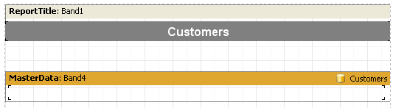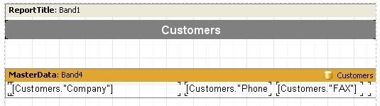**72 FastReport VCL 5 User's Manual**

**4.4 Coloring alternate data rows**

Using conditional highlighting, it is easy to create reports having a "banded" look, where data lines are alternately colored. To save some effort, let's use the “Customer List” example that we designed previously.

Remove all the “Text” objects from the “MasterData” band. Place a “Text” object on the data band and stretch it to cover almost all of the band space:

This object will change its color dependent on the data line number. Select the object and set the following conditional expression in the Highlight tab of the object editor:

*<Line> mod 2 = 1*

**Note: if you have selected C++Script as the script language (see more details in the "Script" chapter), you should write the condition using C++Script as:**

*<Line> % 2 == 1*

Select a gray as the color for highlighting, not too saturated a color, but closer to white. Now the other objects can be added to the data-band on top of the first empty “Text” object:

On preview the report produces this output:

*FastReport v4 © 1998-2014 Fast Reports Inc.*

*Manual v5.0.0*

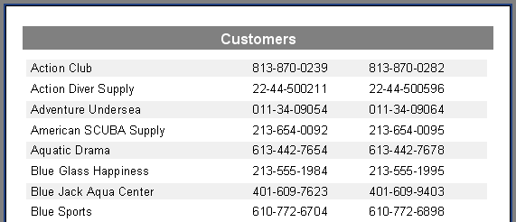

**ormatting, highlighting**

**73F**

*FastReport v4 © 1998-2014 Fast Reports Inc.*

*Manual v5.0.0*

**Chapter**

**V**

**Nested reports**

**(subreports)**

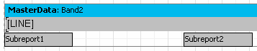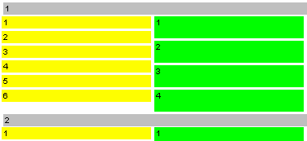

**ested reports (subreports)**

**75N**

**5.1 Nested reports (subreports)**

Sometimes very complex report are needed which contain blocks of additional data inserted at particular points in the design. Although many of these reports can be designed using an arrangement of FastReport bands, sometimes it just becomes too complicated. In these circumstances it is necessary to use the “Subreport” object .

When a “Subreport” object is inserted into a design FastReport automatically adds a new page, which is connected to the “Subreport”. Such a nested report resembles a multi-page report in terms of design structure. The only difference is that the nested report is displayed in a specific location on the basic design page, and not after it. When this report is output, as soon as the “Subreport” object is encountered the report engine outputs the connected subreport page in its entirety. After that output continues with the rest of the basic design page.

Further “Subreport” objects can be inserted into a subreport design page, so increasing the depth of nesting. An example of a nested report can be found in the demo program - the “Subreports” report.

It is worth noting that FastReport’s ability to use subreports enables deep nesting of data. Remember that the number of data levels in FastReport is limited to only six when Detail data bands are used instead of the “Subreport” object.

**5.2 Side-by-side subreports**

Two or more “Subreport” objects can be placed side-by-side on the same data band:

This design allows reports where the data output of each “Subreport” has varying lengths of

rows/records, or varying heights or degree of stretching :

*FastReport v4 © 1998-2014 Fast Reports Inc.*

*Manual v5.0.0*

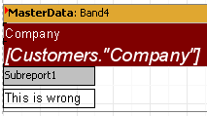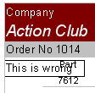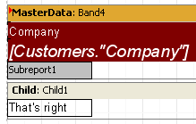**76 FastReport VCL 5 User's Manual**

As illustrated, FastReport continues to output the basic design page only after the longest Subreport has finished. The Vertical Alignment property can also be used to adjust “Text” object alignment within each subreport.

**5.3 Limitations on use of subreports**

Since subreports are placed on the basic design page, they  **cannot** contain any of the following

bands: “ReportTitle/ReportFooter”, “PageTitle/PageFooter/PageBackground” or “ColumnTitle/ ColumnFooter”. If any of these bands are placed on a nested report page they will not be recognised. For the same reason there is no point in changing any nested report page options, as the options of the basic report page override those of any nested pages.

**Do not place objects below the “Subreport” object:**

If this is done then the objects created in the subreport will overlay everything placed below the subreport object on the main design page, and the output will be something like this:

To display objects below or after a nested report, use a child band:

This method is also used when several Subreports must be placed one below the other. Use a child band for each Subreport and chain them together, setting the child property of Child1 to Child2, and so on.

*FastReport v4 © 1998-2014 Fast Reports Inc.*

*Manual v5.0.0*

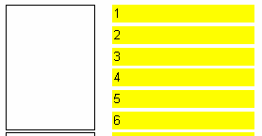

**ested reports (subreports)**

**77N**

**5.4 PrintOnParent option**

The "Subreport" object has a "PrintOnParent" property which can sometimes be useful. This property is False by default.

Usually a subreport is output as a set of bands on the basic report page. When this is so, the height of the parent band containing the "Subreport" object is not controlled by the bands in the subreport, i.e. it cannot be stretched. If the subreport "PrintOnParent" property is set to True, either in the object inspector or the context menu, the objects in the subreport are physically printed on the band which contains the "Subreport" object. This band can be made to stretch and can have stretched objects placed on it:

*FastReport v4 © 1998-2014 Fast Reports Inc.*

*Manual v5.0.0*

**Chapter**

**VI**

**Script**

**cript**

**79S**

A script is a program, written in a high-level language, which is part of a report. As the report runs, the script runs as well. A script can handle data in ways that are not possible just using the normal operations of the FastReport core; for example, a script can hide redundant data depending on a predefined condition. A script can also be used for controlling the properties of dialogue forms which are part of a report.

A script is written in one of the languages supported by the script engine (FastScript). Currently, these are:

* PascalScript
* C++Script
* BasicScript
* JScript

The following features are supported by the FastScript engine:

* standard language set : variables, constants, procedures, functions (which may be nested and having variables, constants, default parameters), all standard operators (including case, try, finally, except, with), types (integral, fractional, logical, character, line, multi-dimensional arrays, variant), classes (with methods, events, properties, indexes and default properties)
* type compatibility checking
* access to any of the report’s objects

FastScript, however does not support the following:

* declarations of these types : records, classes
* pointers, sets (but the 'IN' operator can be used in expressions such as "a in ['a'..'c','d']")
* shortstring type
* unconditional jumps (GOTO)

Scripts can be created in the FastReport designer, which contains a script editor with syntax highlighting. There is also an embedded debugger which has the following functions: “Step”, “Breakpoint”, “Run to cursor” and “Evaluate”.

**6.1 A Taste of Script**

The tools for working with scripts are located in the “Code” tab of the FastReport designer. When switching to this tab, the IDE looks like this:

*FastReport v4 © 1998-2014 Fast Reports Inc.*

*Manual v5.0.0*

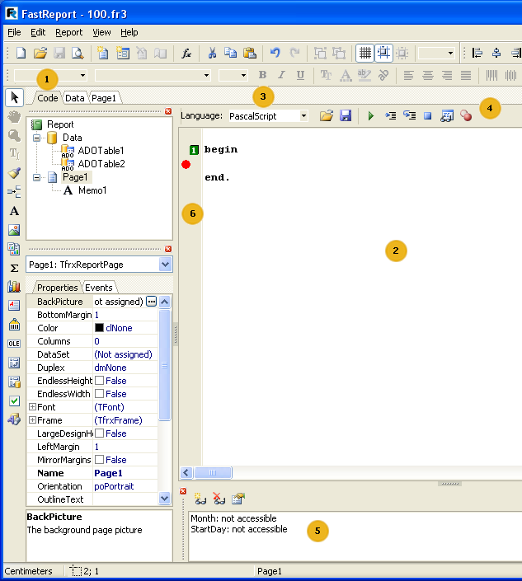**80 FastReport VCL 5 User's Manual**

Key to the labelling above:

* “Code” tab
* script editor pane
* drop-down list for selecting the language in which the script is written
* debugger toolbar
* run report in debugging mode (F9)
* run to cursor (F4)
* execute the regular code line (Step into, F7)

*FastReport v4 © 1998-2014 Fast Reports Inc.*

*Manual v5.0.0*



**cript**

**81S**

* interrupt running script (Ctrl+F2)
* preview value of expression (Evaluate, Ctrl+F7)
* toggle breakpoint (F5)
* - “Watches” pane
* bookmarks and breakpoints are displayed in this column; also, line of executing code highlighted here

List of the shortcut keys which can be used in the script editor:

**Key**

**Meaning**

|  |  |  |
| --- | --- | --- |
| Cursor arrows | move cursor |  |
| PageUp, PageDown | go to previous/next page |  |
| Ctrl+PageUp | go to beginning of the text |  |
| Ctrl+PageDown | go to end of the text |  |
| Home | go to beginning of the line |  |
| End | go to end of the line |  |
| Enter | go to next line |  |
| Delete | delete symbol at cursor position; delete selected text |  |
| Backspace | delete symbol to the left of the cursor |  |
| Ctrl+Y | delete current line |  |
| Ctrl+Z | undo last action (up to 32 events) |  |
| Shift+Cursor arrows | select a text block |  |
| Ctrl+A | select whole text |  |
| Ctrl+U | shift selected block by 2 symbols to the left |  |
| Ctrl+I | shift selected block by 2 symbols to the right |  |
| Ctrl+C, Ctrl+Insert | copy selected block to the clipboard |  |
| Ctrl+V, Shift+Insert | paste text from the clipboard |  |
| Ctrl+X, Shift+Delete | cut selected block to the clipboard |  |
| Ctrl+Shift+<number> | set bookmark with <number> 0..9 on the current line |  |
| Ctrl+<number> | jump to bookmark <number> |  |
| Ctrl+F | search a line | |  |  |
| Ctrl+R | replace a line | |  |  |
| F3 | repeated search/replacement from the cursor position | |  |  |
| F4 | set breakpoint for script to run to (Run to cursor) | |  |  |
| Ctrl+F2 | reset the script | |  |  |
| Ctrl+F7 | preview value of variable (Evaluate) | |  |  |
| F9 | run the script (Run) | |  |  |

*FastReport v4 © 1998-2014 Fast Reports Inc.*

*Manual v5.0.0*

**82 FastReport VCL 5 User's Manual**

|  |  |  |
| --- | --- | --- |
| F7 or F8 | execute code line (Step into) |  |
| Ctrl + Space | show list of methods and properties of object |  |
| Ctrl+Shift+Delete | delete word to right of cursor |  |

Ctrl+Shift+Backspace delete word to left of cursor

**6.2 Structure of a script**

The structure of a script depends on the language used; however there are some elements common to each language. These are the script’s title and body, and the main procedure which will be executed when the report runs. Below are examples of scripts in all four of the supported languages:

*PascalScript structure:*

#language PascalScript  *// optional*

**program** MyProgram;  *// optional*

*// the “uses” chapter should be located before any other chapter*

**uses** 'unit1.pas' , 'unit2.pas' ;

**var**  *// the “variables” chapter can be placed anywhere*

1. j: Integer;

**const**  *// “constants” chapter*

pi = 3 . 14159 ;

**procedure** p1;  *// procedures and functions*

**var**

1. Integer;

**procedure** p2;  *// nested procedure*

**begin**

**end** ;

**begin**

**end** ;

**begin**  *// main procedure.*

**end** .

*C++Script structure:*

#language Ρ++Script  *// optional*

*// the “include” chapter should be placed before any other chapter*

#include "unit1.cpp" , "unit2.cpp"

*FastReport v4 © 1998-2014 Fast Reports Inc.*

*Manual v5.0.0*

**cript**

**83S**

**int** i, j = 0 ;  *// the “variables” chapter can be placed anywhere*

#DEFINE pi = 3.14159  *// “constants” chapter*

**void** p1()  *// functions*

* *// no nested procedures*

}

* *// main procedure.*

}

*JScript structure:*

#language JScript  *// optionally*

*// the “import” chapter should be before any other chapter*

**import** "unit1.js" , "unit2.js"

**var** i, j = 0 ;  *// the “variables” chapter can be located anywhere*

**function** p1()  *// functions*

* *//*

}

*// main procedure.*

p1();

**for** (i = 0 ; i < 10 ; i++) j++;

*BasicScript structure:*

#language BasicScript ' optionally

* the “imports” chapter should be located before Any other chapter imports "unit1.vb", "unit2.vb"

Dim i, j = 0 ' the “variables” chapter can be placed anywhere

Function p1() ' functions

* '

}

* main procedure.

For i = 0 To 10

p1()

Next

A more detailed description of the FastScript engine can be found in its documentation. This information is not repeated here in this user manual:

* syntactic charts for each of the supported languages
* supported data types
* operations with classes, properties, methods and events
* nested functions

*FastReport v4 © 1998-2014 Fast Reports Inc.*

*Manual v5.0.0*

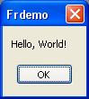**84 FastReport VCL 5 User's Manual**

* enumerations and sets

Later we will look at examples of scripts written in the “PascalScript” language. When a new report is created this language is selected by default.

**6.3 "Hello, World!" script**

We have already seen an example of a “Hello, World!” report; now let's see how to create a simple script which displays a window with the same greeting.

Open the designer and click on the “New report” button so that FastReport automatically creates a basic template. Switch to the “Code” tab and write the following script:

*PascalScript:*

**begin**

ShowMessage( 'Hello, World!' );

**end** .

*C++ Script:*

{

ShowMessage( "Hello, World!" );

}

After that run the report. As expected, FastReport displays a little dialogue with a greeting:

Let's explain some details. We created a script consisting of a single “begin..end” block. So our

script has a very simple structure; it consists only of a main procedure (see the “Structure of a script” section above). The main procedure is executed as soon as the report runs. In this case it displayed a greeting dialogue; the procedure ends right after the dialogue is closed. After the main procedure has finished running, the normal report construction begins.

**6.4 Using objects in the script**

Any report object can be accessed from a script. So, if there are for example the “Page1” page and a “Memo1” object, they can be used in the script, calling them by their names:

*PascalScript:*

*FastReport v4 © 1998-2014 Fast Reports Inc.*

*Manual v5.0.0*

**cript**

**85S**

Memo1.Color := clRed

*C++Script:*

Memo1.Color = clRed

The list of report objects accessible from the script is shown in the “Report tree” pane. What object properties are available to a script? The answer is simple: all those that are visible in the object inspector. The object inspector also shows hints for each property at the bottom. Both panes (report tree and object inspector) are available while working with a script. To get detailed help on object properties and methods use the FastReport help file which is included in the distribution kit.

Here's a simple example. Place a “Text” object named “MyTextObject” and containing “Test” onto the report design page. Then write this script:

*PascalScript:*

**begin**

MyTextObject.Color := clRed

**end** .

*C++Script:*

{

MyTextObject.Color = clRed

}

Run the report and see that the object’s color is red.

**6.5 Calling the variables from the report’s variables list**

Any variable that is defined in the list of the report variables (“Report>Variables...” menu item) can be referenced in a script. The variable’s name should be enclosed in angle brackets:

*PascalScript:*

**if** <my variable> = 10  **then** ...

*C++ Script:*

**if** (<my variable> == 10 ) { ... }

An alternative way is to use the “Get” function:

*PascalScript:*

**if** Get( 'my variable' ) = 10  **then** ...

*FastReport v4 © 1998-2014 Fast Reports Inc.*

*Manual v5.0.0*

**86 FastReport VCL 5 User's Manual**

*C++ Script:*

**if** (Get( "my variable" ) == 10 ) { ... }

A variable’s value is changed only via the “Set” procedure:

*PascalScript:*

Set( 'my variable' , 10 );

*C++ Script:*

Set(" my variable" , 10 );

It is worth noting that to assign a string value to the variable you must add quotes around the value:

*PascalScript:*

Set('my variable', '''' + 'String' + '''');

*C++ Script:*

Set("my variable", "\"String\"");

System variables, such as “Page#,” should be referenced in exactly the same way:

*PascalScript:*

**if** <Page#> = 1  **then** ...

*C++ Script:*

**if** (<Page#> == 1 ) { ... }

**6.6 Referencing the DB fields**

Just as with variables, angle brackets should be used when referencing DB fields in a report:

*PascalScript:*

**if** <Table1."Field1"> = Null  **then** ...

*C++ Script:*

**if** (<Table1."Field1"> == Null) { ... }

*FastReport v4 © 1998-2014 Fast Reports Inc.*

*Manual v5.0.0*

**cript**

**87S**

Alternatively the “Get” function can be used for accessing DB fields (in fact, this function is used implicitly by FastReport when calculating expressions enclosed in angle brackets).

**6.7 Using aggregate functions in the script**

An idiosyncrasy of aggregate functions is that they must be used inside “Text” objects; once used in this manner they can then be used in the script itself. If an aggregate function only appears in a script (without appearing in a “Text” object) an error message is generated. This happens because an aggregate function must be connected to a specific band; once so connected it will work correctly.

**6.8 Displaying a variable’s value in a report**

Variables can be declared and used locally within a script. Once declared a script variable can have a value assigned to it. Here is a simple example of a script variable in use:

*PascalScript:*

**var**

MyVariable:  **String** ;

**begin**

MyVariable := 'Hello!' ;

**end** .

*C++ Script:*

string MyVariable;

{

MyVariable = "Hello!" ;

}

The variable’s value can be displayed in a “Text” object, for example, by typing '[MyVariable]' into the object.

A variable’s name must be unique. This means the name must not duplicate the name of any other report object, standard function or constant. If there is an error in a script, a message will be displayed when the report is run and report construction will be stopped.

**6.9 Events**

So far we have looked at scripts with only a main procedure, which is executed when a report starts running. In the main procedure initial settings can be made and variables initialized. However this is not enough for total control over the process of report generation. To enable as much control as possible over report generation every object has several events to which

*FastReport v4 © 1998-2014 Fast Reports Inc.*

*Manual v5.0.0*

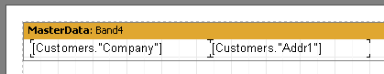**88 FastReport VCL 5 User's Manual**

handlers (i.e. procedures in the script) can be assigned. For example, connecting a handler to the data band enables records to be filtered, such that the band can be hidden or revealed according to specific conditions being met.

Let's demonstrate the process of report creation and the events triggered by means of a simple report containing one page and having one “MasterData” band, with two “Text” objects on the band:

As described above, the script's main procedure is called at the very start of running the report. After that the essentials of report construction begin. Firstly the “OnStartReport” event of the "Report" object is called. Then, before an output page is created, the “OnBeforePrint” page event is called. This event is called once for each design page in the report template (design pages should not be confused with the output pages of a report!). In our example the event is called once, as the report design consists of only one design page.

Then the events of the data bands are called in the following order:

1. the band's “OnBeforePrint” event is called
2. the “OnBeforePrint” event of each object contained in the band is called
3. each object is filled with data (in our example with values of the “Company” and “Addr1" DB fields)
4. the “OnAfterData” event of each object is called
5. actions such as positioning objects on the band (if there are stretchable objects among them), calculating band height and stretching it (if it is stretchable) are performed
6. the band's “OnAfterCalcHeight” event is called
7. a new output page is created if the band hasn't enough room in the page's white space
8. the band and all of its objects are displayed on the output page
9. the “OnAfterPrint” event of each band object is called
10. the “OnAfterPrint” event of the band itself is called

Bands continue to be printed as long as the source connected to the band has data. After that report printing stops, the report page's “OnAfterPrint” event is called and finally the “Report” object's “OnStopReport” event.

So by using the events of different objects practically every step of the report creation process can be managed. The key to using events is a thorough understanding of the band output process, which is discussed in the next nine sections. Most of the actions can be performed using the band's “OnBeforePrint” event only; any modifications made to an object are displayed immediately. However, if the band is stretchable, it is impossible to say in this event on which page the band will be printed, since calculation of the band's height is performed in step 5. It can be done, however, either in the “OnAfterCalcHeight” event in step 6 or in the “OnAfterPrint” event in step 9. Note that in the last event the band will already have been output so modification to objects will not have any visible effect.

It is essential to clearly understand “where and when” the bands are output and to understand the timing (calling order) of each of their events. Likewise for each of the objects contained in the

*FastReport v4 © 1998-2014 Fast Reports Inc.*

*Manual v5.0.0*

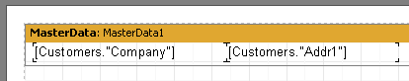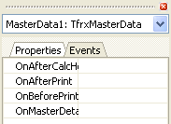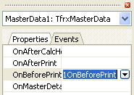

**cript**

**89S**

bands.

**6.10 Example of using the “OnBeforePrint” event**

To demonstrate this event create a report representing a list of clients. This report will include only those companies whose name begins with the letter “A”.

Let's create a new project in Delphi, place “TTable”, “TfrxDBDataSet” and “TfrxReport” components on the form and set these properties:

Table1:

*DatabaseName = 'DBDEMOS'*

*TableName = 'customer.db'*

frxDBDataSet1:

*DataSet = Table1*

*UserName = 'Customers'*

Open the report designer and create a report like this:

Select the data band and switch to the “Events” tab in the object inspector:

To create an “OnBeforePrint” event handler (which is the most appropriate for us) double-click

on the blank field to the right of the event’s name:

*FastReport v4 © 1998-2014 Fast Reports Inc.*

*Manual v5.0.0*

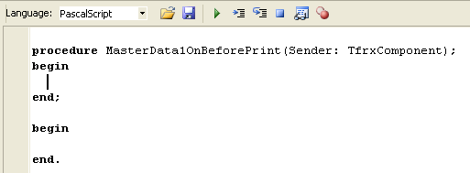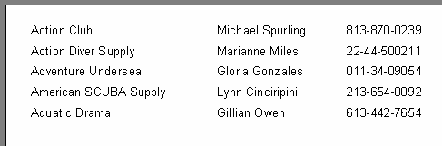**90 FastReport VCL 5 User's Manual**

This adds a blank handler to the script and the designer switches to the “Code” tab.

All that is needed now is to type the following code in the handler’s body:

*PascalScript:*

**if** Copy(<Customers."Company">, 1 , 1 ) = 'A'  **then**

MasterData1.Visible := True

**else**

MasterData1.Visible := False;

*C++Script:*

**if** (Copy(<Customers. "Company" >, 1 , 1 ) == "A" )

MasterData1.Visible =  **true** ;

**else**

MasterData1.Visible =  **false** ;

Run the report and make sure that the script works correctly:

Let's explain several things. One handler can be assigned to the events of more than one object

* the “Sender” parameter shows which object has initiated the event. To assign an existing handler to an event, either type it directly into the object inspector, or select it from the drop- down list:

*FastReport v4 © 1998-2014 Fast Reports Inc.*

*Manual v5.0.0*

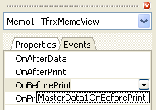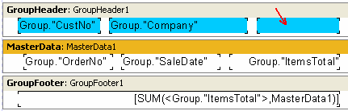

**cript**

**91S**

A link to a handler can easily be deleted - select the assigned handler in the object inspector and press the “Delete” key.

**6.11 Printing a group sum in the group header**

This method is used quite often and requires the use of a script because the value of a group sum is only known after all the records in the group have been processed. To display the sum in the group header (i.e. before the group is output to the report) the following algorithm is used:

* turn on the two-pass report option (“Report > Options...” menu item)
* in the first pass, calculate the sums for each group and save them in an array
* in the second pass, extract the values from the array and display them in the group headers

Let's show two methods for performing this task. First create a new project in Delphi, place “TQuery”, “TfrxReport” and “TfrxDBDataSet” components on the form and set them up as follows:

Query1:

*DatabaseName = 'DBDEMOS'*

*SQL =*

*select * from customer, orders*

*where orders.CustNo = customer.CustNo*

*order by customer.CustNo, orders.OrderNo*

frxDBDataSet1:

*DataSet = Query1*

*UserName = 'Group'*

Open the designer and connect the data source to the report. Enable double-pass in the report's settings (“Report > Options...” menu item). Add two bands to the report: “GroupHeader” and “MasterData”. In the “GroupHeader” band's editor, enter the Group.“CustNo” data field. Connect the data band to the “Group” data source and then arrange some objects in the following way:

*FastReport v4 © 1998-2014 Fast Reports Inc.*

*Manual v5.0.0*

**92 FastReport VCL 5 User's Manual**

To display the sum we use the arrowed object in the design (in our example it is named “Memo8”).

**The first method.**

We will use the “TStringList" class as an array for storing the sums - we will be storing the numeric values as strings. The first item in the StringList will correspond to the sum of the first group, as so on. An integer variable (which we will increment after printing each group) is used to calculate the group's index number.

So our script will look like this:

*PascalScript:*

**var**

List: TStringList;

1. Integer;

**procedure** frReport1OnStartReport(Sender: TfrxComponent);

**begin**

List := TStringList.Create;

**end** ;

**procedure** frReport1OnStopReport(Sender: TfrxComponent);

**begin**

List.Free;

**end** ;

**procedure** Page1OnBeforePrint(Sender: TfrxComponent);

**begin**

i := 0 ;

**end** ;

**procedure** GroupHeader1OnBeforePrint(Sender: TfrxComponent);

**begin**

**if** Engine.FinalPass  **then**

Memo8.Text := 'Sum: ' + List[i];

**end** ;

**procedure** GroupFooter1OnBeforePrint(Sender: TfrxComponent);

**begin**

**if**  **not** Engine.FinalPass  **then**

List.Add(FloatToStr(SUM(<Group."ItemsTotal">,MasterData1))); Inc(i);

**end** ;

**begin**

**end** .

*FastReport v4 © 1998-2014 Fast Reports Inc.*

*Manual v5.0.0*

**cript**

**93S**

*C++ Script:*

TStringList List;

**int** i;

**void** frReport1OnStartReport(TfrxComponent Sender)

{

List = TStringList.Create();

}

**void** frReport1OnStopReport(TfrxComponent Sender)

{

List.Free();

}

**void** Page1OnBeforePrint(TfrxComponent Sender)

{

i = 0 ;

}

**void** GroupHeader1OnBeforePrint(TfrxComponent Sender)

{

**if** (Engine.FinalPass)

Memo8.Text = "Sum: " + List[i];

}

**void** GroupFooter1OnBeforePrint(TfrxComponent Sender)

{

List.Add(FloatToStr(SUM(<Group. "ItemsTotal" >,MasterData1)));

i++;

}

{ }

The procedure names in the script show which events we have used. They are: “Report. OnStartReport”, “Report.OnStopReport”, “Page1.OnBeforePrint”, “GroupHeader1. OnBeforePrint” and “GroupFooter1.OnBeforePrint”. The first two events are called at the beginning and the end of the report respectively. To create handlers for these two events select

the “Report” object in the object inspector's drop-down list and its properties will appear in the

object inspector. Then switch to the object inspector's “Events” tab and create the handlers.

Why didn't we create the “List” variable in the script's main procedure ? We created it in the “OnStartReport” event because dynamically created variables should be destroyed after the report has been finished. It is logical to create dynamic variables in the “OnStartReport” event and destroy them in the “OnStopReport” event. In other cases (when memory does not need to be freed on completion of the script) one can use the script's main procedure for initialization of variables.

The creation and destruction of the “List” variable is straight forward. Now let's see how the script works. At the start of the page the counter for the current group (the variable “i”) is reset to zero and it is incremented after each group has been printed (in the “GroupFooter1. OnBeforePrint” event). The calculated sum is added to “List” in this event before the counter is

*FastReport v4 © 1998-2014 Fast Reports Inc.*

*Manual v5.0.0*

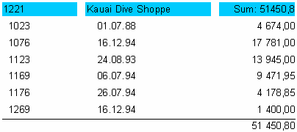**94 FastReport VCL 5 User's Manual**

incremented. The “GroupHeader1.OnBeforePrint” event does nothing during the first pass (If “Engine.FinalPass” condition) but during the second pass (when “List” has been filled with values) the sum corresponding to the current group is retrieved from “List” and is output to the “Memo8” object to display the sum in the group header. In the finished report, it appears as follows:

This algorithm is quite straight forward. However, it can be simplified.

**The second method.**

We will use the collection of report variables as an array for storing the group sums. Remember that report variables are accessed via the “Get” and “Set” functions. Using these functions also saves us from having to explicitly create and destroy these variables. Our script will look as follows:

*PascalScript:*

**procedure** GroupHeader1OnBeforePrint(Sender: TfrxComponent);

**begin**

**if** Engine.FinalPass  **then**

Memo8.Text := 'Sum: ' + Get(<Group."CustNo">);

**end** ;

**procedure** GroupFooter1OnBeforePrint(Sender: TfrxComponent);

**begin**

Set(<Group."CustNo">,

FloatToStr(SUM(<Group."ItemsTotal">,MasterData1)));

**end** ;

**begin**

**end** .

*C++ Script:*

**void** GroupHeader1OnBeforePrint(TfrxComponent Sender)

{

**if** (Engine.FinalPass)

Memo8.Text = "Sum:" + Get(<Group. "CustNo" >);

}

*FastReport v4 © 1998-2014 Fast Reports Inc.*

*Manual v5.0.0*

**cript**

**95S**

**void** GroupFooter1OnBeforePrint(TfrxComponent Sender)

{

Set(<Group. "CustNo" >,

FloatToStr(SUM(<Group. "ItemsTotal" >,MasterData1)));

}

{ }

As you can see, this script is somewhat simpler. Code in the “GroupFooter1.OnBeforePrint” handler sets the value of a variable having a name derived from the client number (or any other identifier which unambiguously identifies the client could be used, for example <Group."Company">). If there isn't a variable with that name already existing then the script automatically creates it; otherwise if it does exist then its value is updated. In the “GroupHeader1.OnBeforePrint” handler the value of the appropriate variable is retrieved.

**6.12 “OnAfterData” event**

This event is triggered after a report object has been filled with the data from the source to which it is connected. Use this event for accessing either a DB field value or an expression contained in the object. This value is placed in the “Value” system variable which is available only in this event. So if two “Text” objects contain the expressions [Table1.“Field1”] and [<Table2.“Field1”>

* 10] the values of these expressions can be used by referring to the “Value” variable for the objects:

*PascalScript:*

**if** Value > 3000  **then**

Memo1.Color := clRed

*C++ Script:*

**if** (Value > 3000 )

Memo1.Color = clRed;

which is simpler than writing something like this:

*PascalScript:*

**if** <Table1."Field1"> > 3000  **then**

Memo1.Color := clRed

*C++ Script:*

**if** (<Table1. "Field1" > > 3000 )

Memo1.Color = clRed;

Using “Value” instead of an expression enables you to write one multi-purpose handler for the

*FastReport v4 © 1998-2014 Fast Reports Inc.*

*Manual v5.0.0*

**96 FastReport VCL 5 User's Manual**

“OnAfterData” event which can be connected to several objects.

Please note something else - if an object contains several expressions (for example '[expr1] [expr2]') it is the value of the last expression that is transferred to the “Value” variable.

The “OnAfterData” event is ideal for calculating the height and width of objects such as “Text”. That is, if the exact height of a stretched “Text” object containing an expression is needed in a script you can use this code in the “OnAfterData” event:

*PascalScript:*

**var**

MemoHeight: Extended;

**begin**

MemoHeight := TfrxMemoView(Sender).CalcHeight;

**end** ;

*C++ Script:*

float MemoHeight;

MemoHeight = TfrxMemoView(Sender).CalcHeight;

If this code were used in the “OnBeforePrint” event the result will be the height of the object containing the expression before the expression is evaluated, and not its actual value on printing.

**6.13 Service objects**

There are some other system objects which can be used in scripts, in addition to the normal report objects like pages, bands, “Text” and other objects. They may be useful in the management of report construction. The “Engine” object, used in the previous chapter, is one such object and all of them are listed here:

* Report : the “Report” object
* Engine : the link to the report “Engine”
* Outline : the link to the “Report tree” element in a previewed report

Let's look at each of these objects.

**6.13.1 “Report” object**

This object represents a link to the current report. The properties of this object can be seen when selecting the “Report” element in the “Report tree” window.

Methods:

**Method Description**

*FastReport v4 © 1998-2014 Fast Reports Inc.*

*Manual v5.0.0*

**cript**

**97S**

function Calc

(const Expr: String): Variant function GetDataSet

(const Alias: String): TfrxDataSet

returns the value of “Expr”, which is an expression for example, Report.Calc('1+2') returns “3”

any valid fastReport expression can be passed in the parameter

returns the dataset having the specified name the dataset must appear in the report's dataset list (“Report>Data...” dialogue)

**6.13.2 “Engine” object**

This is the most useful and interesting object, it represents a link to the engine (FastReport’s core, which manages report construction). By using the engine’s properties and methods really exotic report design layouts can be created

The methods and properties of this object.

**Property**

**Type**

**Description**

CurColumn

Integer

the index of the current column in a multi-columned report a value can be assigned to this property.

|  |  |  |
| --- | --- | --- |
| CurX | Extended the current print position on the X-axis  a value can be assigned to this property. |  |
| CurY | Extended the current print position on the Y-axis  a value can be assigned to this property. |  |
| DoublePass | Boolean equals “True” if the report is a two-pass one  analogous to Report.EngineOptions.DoublePass. |  |
| FinalPass | Boolean equals “True” when in last pass of a two-pass report |  |
| PageHeight | Extended printable region’s height, in pixels |  |
| PageWidth | Extended printable region’s width, in pixels |  |
| StartDate | TDateTime time of report running  the same as the <Date> system variable |  |
| StartTime | TDateTime time of report running  the same as the <Time> system variable |  |
| TotalPages | Integer the number of pages in a report  the same as the < TotalPages> system variable  the report should be a two-pass one, if this variable is used |  |

SecondScriptcall Boolean

flag returning 'repeat-call' status of an event (in some cases an event can be called repeatedly during grouping)

if True then the script has already been called

Methods:

*FastReport v4 © 1998-2014 Fast Reports Inc.*

*Manual v5.0.0*

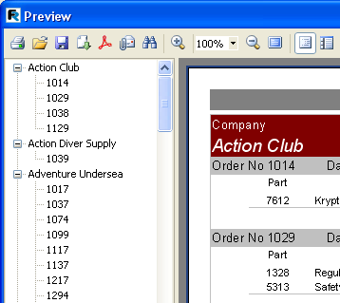**98 FastReport VCL 5 User's Manual**

**Method**

**Description**

|  |  |  |
| --- | --- | --- |
| procedure AddAnchor  (const Text: String) | adds “Text” to the list of anchors  see more below |  |
| procedure NewColumn | creates a new column in a multi-column report  after the last column a page break is automatically  inserted |  |
| procedure NewPage | creates a new page (page break) |  |
| procedure ShowBand  (Band: TfrxBand) | displays a band with a specified name  after displaying the band the “CurY” position is  automatically incremented |  |

function FreeSpace: Extended returns height of the white space left on page in pixels.

function GetAnchorPage (const Text: String): Integer

returns the page number where the specified anchor has been placed

**6.13.3 “Outline” object**

This object represents the "Report tree" control element in a previewed report.

The “Outline” displays a tree-like structure of the finished report. When any tree node is clicked

the preview pane jumps to the page displaying this node. To display the “Outline” it should be

enabled either by clicking the button in the toolbar of the preview window or by setting the “Report.PreviewOptions.OutlineVisible” property to True. The “Outline's” width in pixels can be set there as well : “Report.PreviewOptions.OutlineWidth”.

*FastReport v4 © 1998-2014 Fast Reports Inc.*

*Manual v5.0.0*

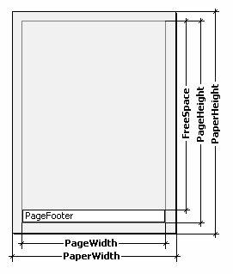

**cript**

**99S**

The “Outline” methods are:

**Method**

**Description**

|  |  |  |
| --- | --- | --- |
| procedure AddItem  (const Text: String) | adds an element having “Text” name at the current tree position  the current report page and position on the page are linked  to the element |  |
| procedure LevelRoot | moves the current position in the tree to the root level |  |
| procedure LevelUp | moves the current position in the tree up one level |  |

**6.14 Using the “Engine” object**

We have already said that the “Engine” object represents the report's engine, which manages report construction. The process of arranging band(s) on a page can be managed by using the engine's properties and methods. First some theory.

The diagram below shows various dimensions of the report page.

The physical dimensions of the page are the “PaperWidth” and “PaperHeight” properties, visible

in the object inspector when the page is selected. So the size of an A4 page is 210 x 297mm.

“PageWidth” and “PageHeight” are the dimensions of the printable region, which is usually less than the physical dimensions of the page. The size of the printable region is dependent on the report page properties “LeftMargin”, “TopMargin”, “RightMargin” and “BottomMargin”. The printable region’s size in pixels is returned by the “Engine.PageWidth” and “Engine.PageHeight” functions.

Finally, “FreeSpace” is the height of the free space on a page. If there is a "Page Footer" band

*FastReport v4 © 1998-2014 Fast Reports Inc.*

*Manual v5.0.0*

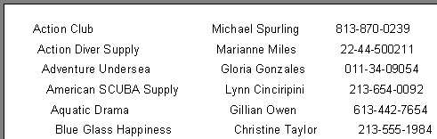**100 FastReport VCL 5 User's Manual**

on the page, its height is taken into account when calculating the “FreeSpace”. This height is returned in pixels by the “Engine.FreeSpace” function. Note that after displaying the next band the free space is reduced on the page, this is taken into account when calculating the “FreeSpace”.

How are report pages constructed? The FastReport core displays bands on a page as long as there is enough free space. When there is no more free space left the “Page Footer" band is printed (if required) and a new blank page is created. As already said, after displaying the next band the height of free space is reduced. Moreover, display of the next band begins from the current position, which is defined by coordinates on the X-axis and the Y-axis. The current position is returned by “Engine.CurX” and “Engine.CurY” respectively. After printing the next band, CurY automatically increases by the height of the printed band. After a new page is created “CurY” equals “0.” “CurX” is changed when printing multi-column reports.

“Engine.CurX” and “Engine.CurY” are available not only for reading but also for writing. This means that bands can be shifted by incrementing or decrementing these values. For example, in a report resembling this:

it can be printed in the following way:

This is achieved by writing a handler for the band's “OnBeforePrint” event:

*PascalScript:*

**procedure** MasterData1OnBeforePrint(Sender: TfrxComponent);

**begin**

Engine.CurX := Engine.CurX + 5 ;

**end** ;

*C++ Script:*

**void** MasterData1OnBeforePrint(TfrxComponent Sender)

{

Engine.CurX = Engine.CurX + 5 ;

}

*FastReport v4 © 1998-2014 Fast Reports Inc.*

*Manual v5.0.0*

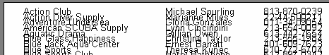

**cript**

**101S**

Changing “CurY” can make bands overlap, for example:

Achieved by this script:

*PascalScript:*

**procedure** MasterData1OnBeforePrint(Sender: TfrxComponent);

**begin**

Engine.CurY := Engine.CurY - 15 ;

**end** ;

*C++ Script:*

**void** MasterData1OnBeforePrint(TfrxComponent Sender)

{

Engine.CurY = Engine.CurY - 15 ;

}

The “Engine.NewPage” method inserts a page break at any required point in a report, following which printing continues from the top of the new output page. In our example a break can be inserted after printing the second record:

*PascalScript:*

**procedure** MasterData1OnAfterPrint(Sender: TfrxComponent);

**begin**

**if** <Line> = 2  **then**

Engine.NewPage;

**end** ;

*C++ Script:*

**void** MasterData1OnAfterPrint(TfrxComponent Sender)

{

**if** (<Line> == 2 )

Engine.NewPage();

}

Note that we used the “OnAfterPrint” event (that is to say, after the band has been printed). Also note that the “Line” system variable returns the sequential number of the record.

The “Engine.NewColumn” method inserts a column break in multi-columned reports. If there are no more free columns left on the page then a new page is created.

*FastReport v4 © 1998-2014 Fast Reports Inc.*

*Manual v5.0.0*

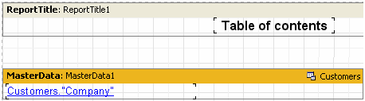**102 FastReport VCL 5 User's Manual**

**6.15 Anchors**

An Anchor is one of the elements in the hyperlink system which enables jumping to any element connected to the finished report’s object by clicking on it (in the preview window).

Anchor can be set via the “Engine.AddAnchor” method. Anchor has a name and a position within a report page. To jump to an anchor with a specified name, type the following line into the URL property of any report object:

*#AnchorName*

or

*#[AnchorName]*

In the second case FastReport substitutes a value for the expression.

Clicking on the object executes a jump to that part of the report where the anchor was added.

Use anchors when constructing a “Contents” table, for example with links to corresponding chapters. Let's illustrate this in the following example. First we need the familiar “Customer” table.

Our report will be a multi-page one (with two design pages). We will place the “Contents” table on the first page and the list of clients on the second page. Clicking on any Content line executes a jump to the corresponding report element.

The first design page:

Place the following text in the URL property of the “Text” object contained in the data-band

*#[Customers."Company"]*

and set the font properties to blue and underlined, to simulate the look of a hyperlink. The second design page:

*FastReport v4 © 1998-2014 Fast Reports Inc.*

*Manual v5.0.0*

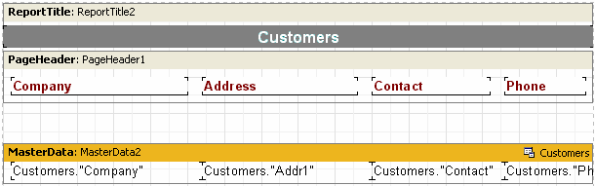

**cript**

**103S**

To add an anchor, create a “MasterData2.OnBeforePrint” event handler in the script:

*PascalScript:*

**procedure** MasterData2OnBeforePrint(Sender: TfrxComponent);

**begin**

Engine.AddAnchor(<Customers."Company">);

**end** ;

*C++ Script:*

**void** MasterData2OnBeforePrint(TfrxComponent Sender)

{

Engine.AddAnchor(<Customers. "Company" >);

}

That is all that is needed. Preview the report and make sure that the “hyperlinks” work.

The last thing to be mentioned is the “Engine.GetAnchorPage” function. This function returns the number of the page on which the corresponding anchor was added and is useful when creating the “Contents” table. The report must be a two-pass one, otherwise this function cannot be used.

**6.16 Using the “Outline” object**

The “Outline” object, as previously stated, represents a report tree which can be displayed in a preview window. Clicking on an element in the tree executes a jump to the report’s output page that contains the corresponding element. It is not necessary to use a script to work with an “Outline” as some bands can automatically create a tree. Let's look at two examples showing how an “Outline” can be used with the help of bands and a script.

Almost all bands have the “OutlineText” property to contain a text expression which automatically creates the tree. The expression is evaluated when creating a report and its value is added to the tree when the band is printed. So the hierarchy of elements in the tree is similar to the hierarchy of bands in the report, meaning that the tree will have main and subordinate elements which correspond to the main and subordinate bands in the report (for example where the report has two levels of data or has groups). We will use our previous example to show the

*FastReport v4 © 1998-2014 Fast Reports Inc.*

*Manual v5.0.0*

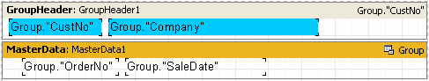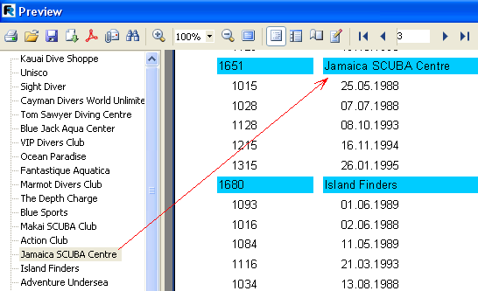**104 FastReport VCL 5 User's Manual**

operation of a tree in a report having groups.

Set the value of the “GroupHeader1.OutlineText” band property to “<Group."Company">.” To make the tree visible as soon as the preview window opens set the “PreviewOptions. OutlineVisible” property of the “Report” object to True. On previewing the report you will now see the following:

Clicking on any element in the tree executes a jump to the corresponding page in the report with the selected element at the top of the window.

Let's add the second level to the report tree. Just set the “OutlineText” property of the “MasterData” band to “<Group.“OrderNo”>” and the tree will change to this:

*FastReport v4 © 1998-2014 Fast Reports Inc.*

*Manual v5.0.0*

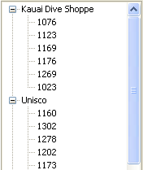

**cript**

**105S**

It is evident that navigation right down to order numbers is possible, and that the hierarchy of the elements in the tree resembles that in the report.

Now we will create a similar tree, but using a script instead of the “OutlineText” property. In the report clear the “OutlineText” properties of both of the bands and create two event handlers: “GroupHeader1.OnBeforePrint” and “MasterData1.OnBeforePrint”:

*PascalScript:*

**procedure** GroupHeader1OnBeforePrint(Sender: TfrxComponent);

**begin**

Outline.LevelRoot;

Outline.AddItem(<Group."Company">);

**end** ;

**procedure** MasterData1OnBeforePrint(Sender: TfrxComponent);

**begin**

Outline.AddItem(<Group."OrderNo">);

Outline.LevelUp;

**end** ;

**begin**

**end** .

*C++ Script:*

**void** GroupHeader1OnBeforePrint(TfrxComponent Sender)

{

Outline.LevelRoot;

Outline.AddItem(<Group. "Company" >);

}

**void** MasterData1OnBeforePrint(TfrxComponent Sender)

{

Outline.AddItem(<Group. "OrderNo" >);

Outline.LevelUp;

}

*FastReport v4 © 1998-2014 Fast Reports Inc.*

*Manual v5.0.0*

**106 FastReport VCL 5 User's Manual**

{

}

Preview the report to make sure that it works in the same way as previously, where the tree was created automatically. Let's see how the tree is created by the script.

The “Outline.AddItem” method adds a child node to the current tree node and then makes the child node the current one. So if “AddItem” were called several times in a row it would create the “ladder” shown here:

*Item1*

*Item2*

*Item3*

*...*

The “LevelUp” and “LevelRoot” Outline methods are used to control which element is the current one. The first method moves the cursor to the element located one level up. So this script:

Outline.AddItem( 'Item1' );

Outline.AddItem( 'Item2' );

Outline.AddItem( 'Item3' );

Outline.LevelUp;

Outline.AddItem( 'Item4' );

constructs a tree like this:

*Item1*

*Item2*

*Item3 Item4*

This shows that “Item4” is a child element of the “Item2” element. The “LevelRoot” method on the other hand moves the cursor up to the root of the tree. For example, the script:

Outline.AddItem( 'Item1' );

Outline.AddItem( 'Item2' );

Outline.AddItem( 'Item3' );

Outline.LevelRoot;

Outline.AddItem( 'Item4' );

constructs this tree:

*Item1*

*Item2*

*Item3*

*Item4*

Knowing this it is clear how the report works. Before every group title (company name) is output the root of the tree is made the current element. After that, the list of orders is output, each order being added as a child element of the company. To ensure that all the orders are located on one

*FastReport v4 © 1998-2014 Fast Reports Inc.*

*Manual v5.0.0*

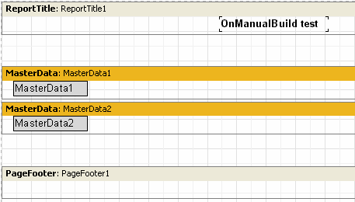

**cript**

**107S**

level and not displayed as a “ladder”, the “Outline.LevelUp” method is called after each order addition to shift the cursor back to the company level.

**6.17 “OnManualBuild” page event**

The FastReport core is usually responsible for report construction. It displays the report bands in a specific order, as many times as required by the data, thus creating a complete report. Sometimes it is necessary to display a report in a non-standard form which the FastReport core is unable to accomplish. In this case it is possible to construct a report manually using the “OnManualBuild” event of the report's design page. If the handler for this event is defined then the FastReport core transfers control to it when data output is required. At the same time the FastReport core automatically handles the display of those bands which are located on the page, such as “Report title”, “Page title”, “Column title”, “Report footer”, “Page footer”, “Column footer” and “Background”. The core also handles the creation of new pages and columns. The purpose of the “OnManualBuild” event handler is to display data bands, their titles and their footers in a user controlled order.

That is to say the essence of the “OnManualBuild” handler is to give commands to the FastReport core for displaying bands at particular times. The core does the rest itself : it creates new pages as soon as there is no free space on the current one, handles scripts attached to events, etc.

Let's demonstrate a handler using a simple example. This report has two master data bands which are not connected to data:

The handler will display these bands in alternate order (six times for each one). After six bands have been displayed a small gap will be inserted.

*PascalScript:*

**procedure** Page1OnManualBuild(Sender: TfrxComponent);

**var**

1. Integer;

*FastReport v4 © 1998-2014 Fast Reports Inc.*

*Manual v5.0.0*

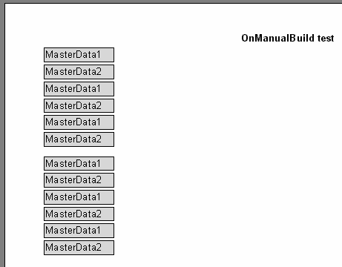**108 FastReport VCL 5 User's Manual**

**begin**

**for** i := 1  **to** 6  **do**

**begin**

* *show two bands }*

Engine.ShowBand(MasterData1); Engine.ShowBand(MasterData2);

* *make a gap }*

**if** i = 3  **then**

Engine.CurY := Engine.CurY + 10 ;

**end** ;

**end** ;

*C++ Script:*

**void** Page1OnManualBuild(TfrxComponent Sender)

{

**int** i;

**for** (i = 1 ; i <= 6 ; i++)

{

*// show two bands*

Engine.ShowBand(MasterData1); Engine.ShowBand(MasterData2);

*// make a gap*

**if** (i == 3 )

Engine.CurY = Engine.CurY + 10 ;

}

}

The following example displays the same bands, with a second copy shifted to the right.

*FastReport v4 © 1998-2014 Fast Reports Inc.*

*Manual v5.0.0*

**cript**

**109S**

*PascalScript:*

**procedure** Page1OnManualBuild(Sender: TfrxComponent);

**var**

1. j: Integer;

SaveY: Extended;

**begin**

SaveY := Engine.CurY;

**for** j := 1  **to** 2  **do**

**begin**

**for** i := 1  **to** 6  **do**

**begin**

Engine.ShowBand(MasterData1); Engine.ShowBand(MasterData2);

**if** i = 3  **then**

Engine.CurY := Engine.CurY + 10 ;

**end** ;

Engine.CurY := SaveY;

Engine.CurX := Engine.CurX + 200 ;

**end** ;

**end** ;

*C++Script:*

**void** Page1OnManualBuild(TfrxComponent Sender)

{

**int** i, j;

Extended SaveY;

SaveY = Engine.CurY;

**for** (j = 1 ; j <= 2 ; j++)

{

**for** (i = 1 ; i <= 6 ; i++)

{

Engine.ShowBand(MasterData1); Engine.ShowBand(MasterData2);

**if** (i == 3 )

Engine.CurY = Engine.CurY + 10 ;

}

Engine.CurY = SaveY;

Engine.CurX = Engine.CurX + 200 ;

}

}

*FastReport v4 © 1998-2014 Fast Reports Inc.*

*Manual v5.0.0*

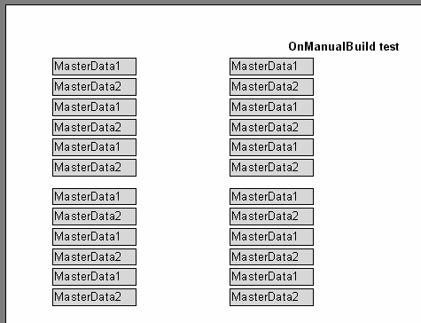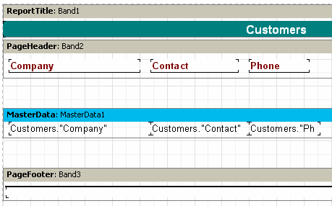**110 FastReport VCL 5 User's Manual**

As you can see, in these examples we controlled only the output of data bands. The rest of the bands (in our case the “Report title”) were output automatically.

Finally we will show how to construct a report with a “List of clients” (we have shown several versions before) using the “OnManualBuild” event. This time connect the data band to the data source.

And use this script:

*PascalScript:*

*FastReport v4 © 1998-2014 Fast Reports Inc.*

*Manual v5.0.0*

**cript**

**111S**

**procedure** Page1OnManualBuild(Sender: TfrxComponent); **var**

DataSet: TfrxDataSet;

**begin**

DataSet := MasterData1.DataSet;

DataSet.First;

**while**  **not** DataSet.Eof  **do**

**begin**

Engine.ShowBand(MasterData1);

DataSet.Next;

**end** ;

**end** ;

*C++Script:*

**void** Page1OnManualBuild(TfrxComponent Sender)

{

TfrxDataSet DataSet;

DataSet = MasterData1.DataSet;

DataSet.First();

**while** (!DataSet.Eof)

{

Engine.ShowBand(MasterData1);

DataSet.Next();

}

}

Preview the report to make sure that the script produces a report identical to the standard report. Note how we got a link to the Dataset - we connected a dataset variable to the data source using this code:

DataSet := MasterData1.DataSet;

If the MasterData band is not connected to a data source then the link to the required data source can be made in the following way:

DataSet := Report.GetDataSet( 'Customers' );

Of course, the data source we are interested in must be enabled in the menu “Report > Data…” dialogue.

**6.18 Creation of objects in the script**

New objects can be added to a report using a script. Let's show how this is done with a simple example. Create a blank report and enter this code in the script’s main procedure:

*PascalScript:*

**var**

Band: TfrxReportTitle;

*FastReport v4 © 1998-2014 Fast Reports Inc.*

*Manual v5.0.0*

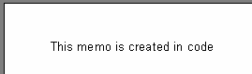**112 FastReport VCL 5 User's Manual**

Memo: TfrxMemoView;

**begin**

Band := TfrxReportTitle.Create(Page1);

Band.Height := 20 ;

Memo := TfrxMemoView.Create(Band);

Memo.SetBounds( 10 , 0 , 100 , 20 );

Memo.Text := 'This memo is created in code' ;

**end** .

*C++ Script:*

TfrxReportTitle Band;

TfrxMemoView Memo;

{

Band = TfrxReportTitle.Create(Page1);

Band.Height = 20 ;

Memo = TfrxMemoView.Create(Band);

Memo.SetBounds( 10 , 0 , 100 , 20 );

Memo.Text = "This memo is created in code" ;

}

Preview the report:

Note that we did not destroy the FastReport objects we created in this example. This is not required as FastReport objects are automatically destroyed by the Delphi application after the report is completed. Also note that when we create standard Delphi objects in a script (such as TStringLists) we also have to destroy them in the script, as this will not be done automatically by the application.

*FastReport v4 © 1998-2014 Fast Reports Inc.*

*Manual v5.0.0*

**Chapter**

**VII**

**Cross-tab**

**reports**

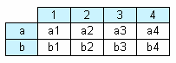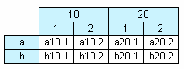**114 FastReport VCL 5 User's Manual**

This kind of report has a tabular structure, which means that it consists of rows and columns. At design time it is not known how many lines and columns the output table will have. This is why a report grows not only downwards (as in the types of report previously described) but also sideways. A typical example of a cross-tab report is shown below.

Let's look at the elements in the table:

In the illustration we see a table with two lines (rows) and four columns, where “a” and “b” are line titles, “1”, “2”, “3” and “4” are column titles, and “a1”..”a4” and “b1”..”b4” are cells. To construct a report like this we need just one set of data (from a query or a table) which has three fields and contains the following values:

|  |  |  |  |
| --- | --- | --- | --- |
| a | 1 | a1 |  |
| a | 2 | a2 |  |
| a | 3 | a3 |  |
| a | 4 | a4 |  |
| b | 1 | b1 |  |
| b | 2 | b2 |  |
| b | 3 | b3 |  |
| b | 4 | b4 |  |

You can see that the first field contains a line letter, the second a column number and the third the contents of the cell at the intersection of the specified line and column. When outputting the report FastReport creates a table in memory and fills it with data. So the table expands dynamically, creating lines and columns where they do not already exist.

Titles can occur at more than one level, as illustrated here:

In this example the number, or index, of the column is composite, i.e. it consists of two values. This report is generated from the following data:

|  |  |  |  |  |
| --- | --- | --- | --- | --- |
| a | 10 1 | a10.1 |  |  |
| a | 10 2 | a10.2 |  |  |
| a | 20 1 | a20.1 |  |  |
| a | 20 2 | a20.2 |  |  |
| b | 10 1 | b10.1 |  |  |
| b | 10 2 | b10.2 |  |  |

*FastReport v4 © 1998-2014 Fast Reports Inc.*

*Manual v5.0.0*

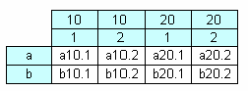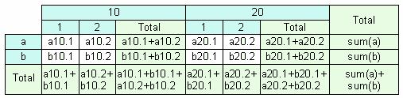

**ross-tab reports**

**115C**

|  |  |  |  |
| --- | --- | --- | --- |
| b | 20 1 | b20.1 |  |
| b | 20 2 | b20.2 |  |

Here the first field contains the line index, as before, the second and third fields contain column indexes and the last field contains the cell value. Look at how FastReport constructs the memory table when handling cross-tab data with complex titles:

When outputting the report from this memory table FastReport joins those title cells which have the same value and are located at the same level.

Here is a more complex cross-tab report, incorporating intermediate and grand totals:

This report is derived from the same data as before. The values in the cells highlighted in the

new color are automatically calculated and are not present in the original data set.

**7.1 Constructing a cross-tab report**

Now let's turn from theory to practice. We will construct a simple cross-tab report displaying employees’ salaries over four years. To do this we need the “crosstest” table, which is located in the FastReport “DEMOS\MAIN” folder. The table contains data like:

Name Year Salary

Ann 1999 3300 Ben 2002 2000

….

Create a new project in Delphi, place “TTable”, “TfrxDBDataSet” and “TfrxReport” components on the form and set their properties:

Table1:

*DatabaseName = 'c:\Program Files\FastReport 4\Demos\Main'*

*TableName = 'crosstest.db'*

the DatabaseName property, of course, must correspond to the path of your FastReport

*FastReport v4 © 1998-2014 Fast Reports Inc.*

*Manual v5.0.0*

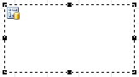**116 FastReport VCL 5 User's Manual**

installation folder!

frxDBDataSet1:

*DataSet = Table1*

*UserName = 'SimpleCross'*

The “TfrxCrossObject” component from the FastReport component palette is used to design a cross-tab report. Just place it on the Delphi form, it does not need any properties to be changed. The “frxCross” unit, containing the cross-tab functionality, is added to the “uses” list when the Delphi application is compiled.

Open the report designer. Firstly connect the data source using the “Report > Data…” menu item. Then select the “DB cross-tab” object from the designer's object toolbar and click on the design page to place the object there:

All settings are made using the cross-tab editor. Open it by double-clicking on the object:

*FastReport v4 © 1998-2014 Fast Reports Inc.*

*Manual v5.0.0*

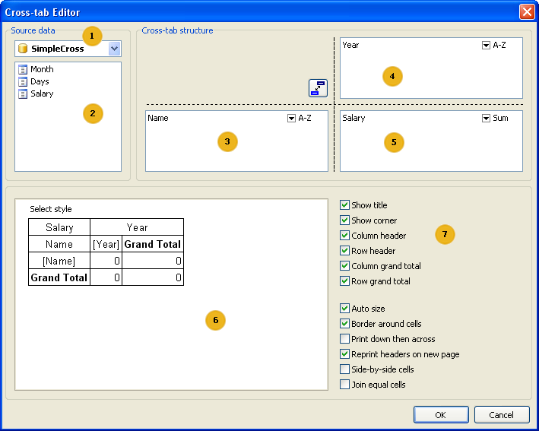

**ross-tab reports**

**117C**

Key to the items shown above:

* a drop-down list of available data sources
* the list of fields in the selected data source; the fields from this list can be dragged to the lists numbered 3, 4 or 5
* the list of fields which generate line (row) headers
* the list of fields which generate column headers
* the list of fields which generate table cells
* table structure preview
* structure options : display of titles, totals, etc

You can only use the mouse in this editor to make changes. For our example it is only necessary to drag fields from the list 2 to lists 3, 4 and 5 (in the diagram above). After that close the editor by clicking the ΞΚ button. The cross-tab object now shows its structure:

*FastReport v4 © 1998-2014 Fast Reports Inc.*

*Manual v5.0.0*

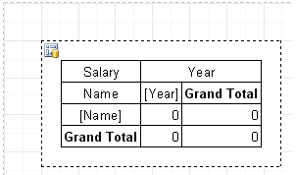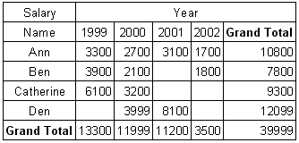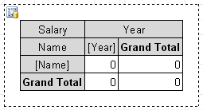**118 FastReport VCL 5 User's Manual**

When the report is previewed you will see a table resembling this:

**7.2 Changing the appearance**

Let’s modify the cross-tab object’s appearance. The first thing we want to do is to change the title colors and display “Total” instead of “Grand total”. This is very easy - to change the title color to gray click on the “Year”, “Name” and “Grand Total” cells in turn and select gray using the background button on the toolbar.

We can also use a set of predefined styles. These are available in the cross-tab editor - click “Select style” and choose one.

*FastReport v4 © 1998-2014 Fast Reports Inc.*

*Manual v5.0.0*

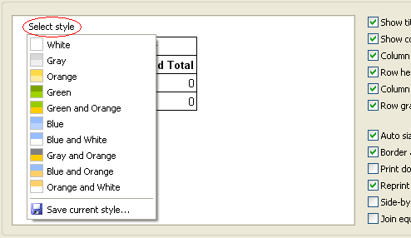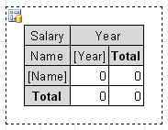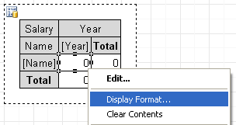

**ross-tab reports**

**119C**

To change the two “Grand Total” texts double-click on each cell, which opens the familiar text editor where we can type “Total”:

To format the currency values select the first cell (intersection of [Name] and [Year] in our example), right-click to display the context menu and select “Display Format...”:

Select the required format and close the format editor. All this produces the report:

*FastReport v4 © 1998-2014 Fast Reports Inc.*

*Manual v5.0.0*

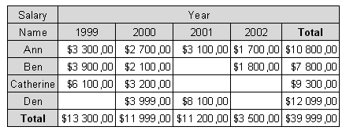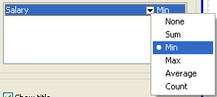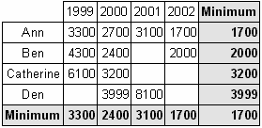**120 FastReport VCL 5 User's Manual**

**7.3 Using functions**

In our example we see the sum of each employee’s salary over four years in the “Total” line. Any of the following aggregate functions can be used:

SUM sum of values

MIN minimal value

MAX maximal value AVG average value

COUNT number of values

Let’s use the “MIN” function in our example. Open the cross-tab editor and in list 5 (the “Salary” field item) click the down arrow.

Select the “MIN” function from the drop-down list. Now we can change the text in the total cells from “Total” to “Minimum.” The finished report looks like this:

*FastReport v4 © 1998-2014 Fast Reports Inc.*

*Manual v5.0.0*

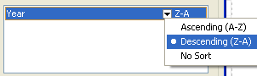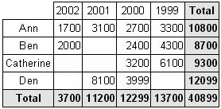

**ross-tab reports**

**121C**

**7.4 Sorting values**

Lines and columns by default are arranged in ascending order, either numerically or alphabetically depending on the type of the data. Sort modes can be set independently for lines and columns. The sort modes are : “arrange in ascending order”, “arrange in descending order” and “perform no sorting”. With no sorting the lines/columns are displayed in default database order.

Let's change the column sorting in our example. Let the years be arranged in decreasing order. To do this, open the cross-tab editor, select the “Year” column element and change the sorting mode by clicking on the down arrow and selecting Descending:

Close the editor and preview the report. It will look like this:

**7.5 Tables with composite headers**

Our previous example contained a single value per line and single column headers. Let's look at a cross-tab design having a composite header with more than one value. The source data has data in the following format:

Name Year Month Days Salary

|  |  |  |  |
| --- | --- | --- | --- |
| Ann 1999 2 | 3 | 1000 |  |
| Ben 2002 1 | 5 | 2000 |  |
| …. |  |  |  |

We have added the “Month” and “Days” fields containing the month number and the number of working days respectively. Several different reports can be constructed from this data, for example : salaries of employees over each year, broken down in months.

What kind of a report will we get? It must resemble the report from the previous example but having the annual data subdivided by month. The cross-tab object must be set up in the same manner as before. This time we will also drag the “Month” field into the column header list, as shown here:

*FastReport v4 © 1998-2014 Fast Reports Inc.*

*Manual v5.0.0*

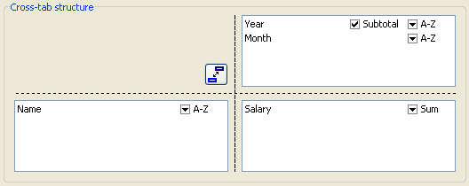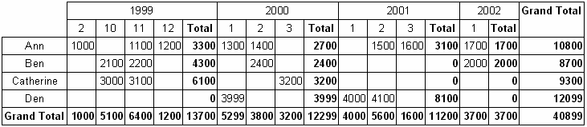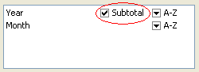**122 FastReport VCL 5 User's Manual**

On preview we see the following report:

Note that FastReport has automatically added a column of intermediate totals, displayed after each year. This can be turned off in the cross-tab editor by de-selecting the “Subtotal” flag of the “Year” column element:

Also note that the last column element in the column header list never has a “Subtotal” flag (including the case of a single element). In our example we do not need intermediate totals for each month, so the “Subtotal” flag can be turned off.

There is another feature of intermediate totals, if they are used: it might be preferable to head the intermediate total as “Year + year total” instead of “Total”. In the cross-tab object on the report page double-click the intermediate total cell and in the text editor type:

*Total for [Value]*

On report construction the “[Value]” expression is replaced by the actual value of the column header in the cell above:

*FastReport v4 © 1998-2014 Fast Reports Inc.*

*Manual v5.0.0*

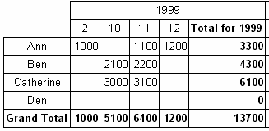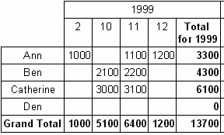

**ross-tab reports**

**123C**

**7.6 Adjusting cell width**

Looking at the previous illustration it is obvious that FastReport automatically adjusts cell widths so that larger cell values do actually fit within the cells. This may not be desirable in some cases, however, as extra wide columns can appear ugly. What can be done about this? Let's look at three methods of controlling cell width.

The simplest method of controlling cell width is to add line breaks to the text of intermediate totals, i.e.:

*Total*

*for[Value]*

The resulting table is more compact:

However, there are circumstances where it is difficult or impossible to sensibly break lines manually. The cross-tab object has therefore been given both “MinWidth” and “MaxWidth” properties (referring to cell widths). Both of these properties are only accessible via the object inspector.

By default “MinWidth” is 0 and “MaxWidth” is 200, which is adequate in most cases. The second method of controlling cell width is to alter these values according to special requirements.

So in our example we can set both “MinWidth” and “MaxWidth” to 50. This means that a data cell must be at least 50 pixels wide, even if the cell value would fit into fewer pixels. For large cell values the cell width is limited to the “MaxWidth” value and the text in the cell is broken as required. So our example now looks like this:

*FastReport v4 © 1998-2014 Fast Reports Inc.*

*Manual v5.0.0*

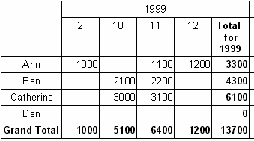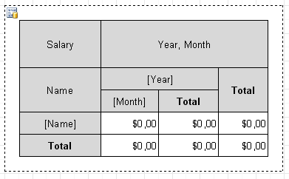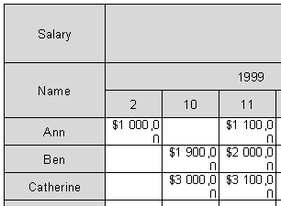**124 FastReport VCL 5 User's Manual**

The third method of controlling cell width is to change cell widths manually. To be able to do this the AutoSize property must be set to False. The cross-tab cell width can then be changed using

the mouse. In the report page cross-tab object, the mouse cursor changes shape over cell

borders so allowing the borders to be dragged. Here is an example of what can be achieved:

Remember that if auto-size is turned off then the cross-tab will not automatically adjust the cell widths and heights and you may see something like this in the report preview:

If so then just increase the cell widths a little.

*FastReport v4 © 1998-2014 Fast Reports Inc.*

*Manual v5.0.0*

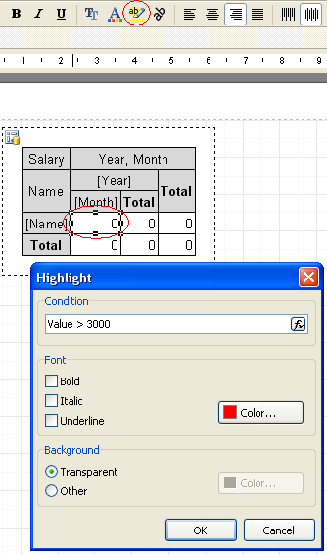

**ross-tab reports**

**125C**

**7.7 Font colors and highlighting**

Sometimes it is necessary to highlight values and/or change the font color. We have looked at this in the group report example, where we used conditional highlighting for “Text” objects. Conditional highlighting can also be useful for us here.

To add highlighting to our example report, assuming we need to change the font color for values greater than 3000 - select the object representing the table cell and set the highlighting parameters by clicking the highlight button on the toolbar. The familiar highlighting editor window will open where this condition can be set:

*Value > 3000*

and the font color set to red:

*FastReport v4 © 1998-2014 Fast Reports Inc.*

*Manual v5.0.0*

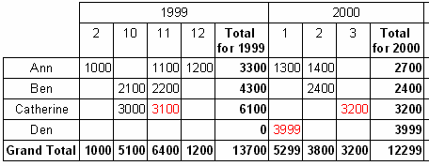**126 FastReport VCL 5 User's Manual**

This is all that is required. Close the editor by clicking on the OK button and preview the report:

Likewise total values can be highlighted, if required, and also cells and lines using the

background and frame color buttons.

**7.8 Managing a cross-tab in script**

If any of the methods shown above do not achieve the required report look then a report script can be used instead. The “Cross-tab” object has the following events:

**Event**

**Description**

|  |  |  |
| --- | --- | --- |
| OnAfterPrint | event is called after printing a table |  |
| OnBeforePrint | event is called before printing a table |  |
| OnCalcHeight | event is called before calculating height of a row in the table  the event handler can be set to either the required height  or to “0” if the row needs to be hidden | |  |
| OnCalcWidth | event is called before calculating column width in a table  the event handler can be set to either the required width  or to “0” if the column needs to be hidden | |  |
| OnPrintCell | event is called before displaying a table cell  the event handler can modify the cell design or its contents | |  |
| OnPrintColumnHeader | event is called before displaying the column title  the event handler can modify the design or content of the title cell | |  |
| OnPrintRowHeader | event is called before displaying the row title  the event handler can modify the design or content of the title cell | |  |

We can use the following methods of the “Cross-tab” object in these events:

**Method Description**

*FastReport v4 © 1998-2014 Fast Reports Inc.*

*Manual v5.0.0*

**ross-tab reports**

**127C**

|  |  |  |
| --- | --- | --- |
| function ColCount: Integer | returns the number of columns in the table |  |
| function RowCount: Integer | returns the number of rows in the table |  |

function IsGrandTotalColumn

(Index: Integer): Boolean

function IsGrandTotalRow

(Index: Integer): Boolean

function IsTotalColumn

(Index: Integer): Boolean

function IsTotalRow

(Index: Integer): Boolean

procedure AddValue (const Rows, Columns, Cells

* array of Variant)

returns “True” if the 'Index' column is a total returns “True” if the 'Index' row is a total returns “True” if the 'Index' column is a sub- total returns “True” if the 'Index' row is sub-total

adds a value to the table

Let's show how to highlight the third column (in our example the “November 1999” date). Select the cross-tab object on the report design page, in the object inspector click on the events tab, locate the “OnPrintCell” event and create a handler on the code page by double-clicking in the empty list to the right of the event name. The script editor will appear with the basic declaration created for you, then add the code required in the empty 'begin...end' block of the declaration:

*Pascal script:*

**procedure** Cross1OnPrintCell(Memo: TfrxMemoView;

RowIndex, ColumnIndex, CellIndex: Integer;

RowValues, ColumnValues, Value: Variant);

**begin**

**if** ColumnIndex = 2  **then**

Memo.Color := clRed;

**end** ;

*C++ Script:*

**void** Cross1OnPrintCell(

TfrxMemoView Memo,

**int** RowIndex,

**int** ColumnIndex,

**int** CellIndex,

Variant RowValues,

Variant ColumnValues,

Variant Value)

{

**if** (ColumnIndex == 2 ) { Memo.Color = clRed; }

}

We will see the following when the report is previewed:

*FastReport v4 © 1998-2014 Fast Reports Inc.*

*Manual v5.0.0*

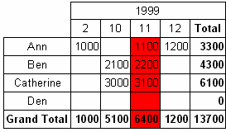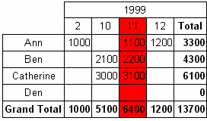**128 FastReport VCL 5 User's Manual**

To highlight a column title, create an “OnPrintColumnHeader” event handler in a similar way :

*Pascal script:*

**procedure** Cross1OnPrintColumnHeader(Memo: TfrxMemoView;

HeaderIndexes, HeaderValues, Value: Variant);

**begin**

**if** (VarToStr(HeaderValues[ 0 ]) = '1999' )  **and**

(VarToStr(HeaderValues[ 1 ]) = '11' )  **then**

Memo.Color := clRed;

**end** ;

*C++ Script:*

**void** Cross1OnPrintColumnHeader(

TfrxMemoView Memo,

Variant HeaderIndexes,

Variant HeaderValues,

Variant Value)

{

**if** ((VarToStr(HeaderValues[ 0 ]) == "1999" ) &&

(VarToStr(HeaderValues[ 1 ]) == "11" ))

{

Memo.Color = clRed;

}

}

The report preview is now:

This is how the script works: the “OnPrintCell” event handler is called before printing a cell in the table’s data area (note that cells in the table titles call either the “OnPrintColumnHeader” or the “OnPrintRowHeader” handler). The “OnPrintCell” handler parameters include: a link to the “Text”

*FastReport v4 © 1998-2014 Fast Reports Inc.*

*Manual v5.0.0*

**ross-tab reports**

**129C**

object which represents the table cell (the “Memo” parameter) and the cell’s “address” as the location of the row, column and cell (cell is relevant if your cross-tab contains multi-leveled cells) as the “RowIndex”, “ColumnIndex”, and “CellIndex” parameters respectively. The parameter list also has the header's values specified as Variants (the “RowValues” and “ColumnValues” parameters) and the “Value” Variant parameter which holds the cell contents.

In our example it is easier to specify the “address” using the “RowIndex” and “ColumnIndex”. Numbering of columns and rows begins at “0” so “ColumnIndex = 2” refers to the third column. We could also specify the correct column by looking at its data content (we need the 11th month of 1999):

*Pascal script:*

**procedure** Cross1OnPrintCell(Memo: TfrxMemoView;

RowIndex, ColumnIndex, CellIndex: Integer;

RowValues, ColumnValues, Value: Variant);

**begin**

**if** (VarToStr(ColumnValues[ 0 ]) = '1999' )  **and**

(VarToStr(ColumnValues[ 1 ]) = '11' )  **then**

Memo.Color := clRed;

**end** ;

*C++ Script:*

**void** Cross1OnPrintCell(

TfrxMemoView Memo,

**int** RowIndex,

**int** ColumnIndex,

**int** CellIndex,

Variant RowValues,

Variant ColumnValues,

Variant Value)

{

**if** ((VarToStr(ColumnValues[ 0 ]) == "1999" ) &&

(VarToStr(ColumnValues[ 1 ]) == "11" ))

{

Memo.Color = clRed;

}

}

The “RowValues” and “ColumnValues” parameters are arrays of the Variant type, having a zero

base. The “0” element is at the highest level of the table title, the “1” element is at the next level,

etc. In our example “ColumnValues[0]” contains years and “ColumnValues[1]” contains months.

Why is the “VarToStr” function required? This prevents errors during type conversion. When working with the Variant type FastReport tries to automatically cast strings to number format, which in turn can lead to errors when casting the “Total” and “Grand Total'” column values.

The “OnPrintColumnHeader” event handler is called during output of the column title cells. The parameter list is similar to that of the “OnPrintCell” handler, though in this case the cell's “address” (“HeaderIndexes” and “HeaderValues” parameters) is in a different form. The “HeaderValues” parameter holds the same values as the “ColumnValues” and “RowValues” in

*FastReport v4 © 1998-2014 Fast Reports Inc.*

*Manual v5.0.0*

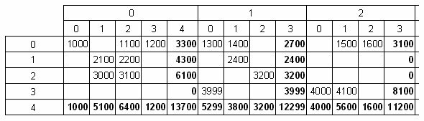**130 FastReport VCL 5 User's Manual**

the “OnPrintCell” handler. The “HeaderIndexes” parameter is also an array of values of Variant type, and contains the address of the title cell in a different form: the “0” element is the index at the highest level in the table title, the “1” one is at the next level, etc. To clarify the principle of cell numbering refer to the picture below:

In our example it was easier to use the “HeaderValues” parameter, but the following handler could be used instead:

*Pascal script:*

**procedure** Cross1OnPrintColumnHeader(Memo: TfrxMemoView;

HeaderIndexes, HeaderValues, Value: Variant);

**begin**

**if** (HeaderIndexes[ 0 ] = 0 )  **and** (HeaderIndexes[ 1 ] = 2 )  **then**

Memo.Color := clRed;

**end** ;

*C++ Script:*

**void** Cross1OnPrintColumnHeader(

TfrxMemoView Memo,

Variant HeaderIndexes,

Variant HeaderValues,

Variant Value)

{

**if** ((HeaderIndexes[ 0 ] == 0 ) && (HeaderIndexes[ 1 ] == 2 )) { Memo.Color =

clRed; }

}

**7.9 Adjusting row/column size**

The width and height of the table columns and rows can be adjusted by using the “OnCalcWidth” and “OnCalcHeight:” event handlers. Let's see how to increase the width of the column holding the 11th month of 1999 with the following example. Create an “OnCalcWidth” event handler:

*Pascal script:*

*FastReport v4 © 1998-2014 Fast Reports Inc.*

*Manual v5.0.0*

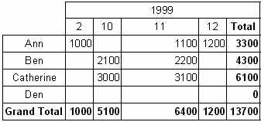

**ross-tab reports**

**131C**

**procedure** Cross1OnCalcWidth(ColumnIndex: Integer;

ColumnValues: Variant;  **var** Width: Extended);

**begin**

**if** (VarToStr(ColumnValues[ 0 ]) = '1999' )  **and**

(VarToStr(ColumnValues[ 1 ]) = '11' )  **then**

Width := 100 ;

**end** ;

*C++ Script:*

**void** Cross1OnCalcWidth(

**int** ColumnIndex,

variant ColumnValues,

Extended &Width)

{

**if** ((VarToStr(ColumnValues[ 0 ]) == "1999" ) &&

(VarToStr(ColumnValues[ 1 ]) = "11" ))

{

Width = 100 ;

}

And the report becomes:

To hide a column in our example just set the Width to zero. Note that the totals are not recalculated as the table is already filled with values at this point.

**7.10 Filling a table manually**

There are two versions of the cross-tab object, “DB cross-tab” and “Cross-tab”. So far we have worked with the first object, attached to data from a DB table. The object fills itself automatically as soon as the report runs. Let's look at the second object, “Cross-tab”.

The “Cross-tab” object is not attached to a DB table. Therefore it has to be filled with data manually. The “Cross-tab” object has a similar editor to the “DB cross-tab” object, though it differs in that the dimensions of the table’s titles and cells have to be specified, instead of being set by the DB fields:

*FastReport v4 © 1998-2014 Fast Reports Inc.*

*Manual v5.0.0*

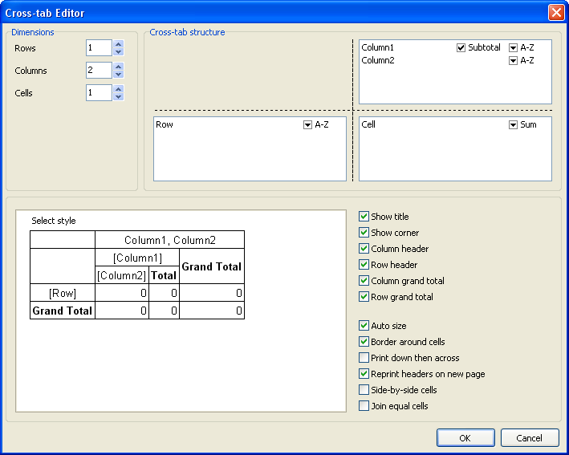**132 FastReport VCL 5 User's Manual**

Let's show the use of a “Cross-tab” object with an example. Place a “Cross-tab” object on the report design page and set its properties as shown above : the number of levels in the rows title is 1, in the columns title is 2 and in the cells is 1. Let's fill the table with data using the “OnBeforePrint” event handler:

*PascalScript:*

**procedure** Cross1OnBeforePrint(Sender: TfrxComponent);

**begin**

**with** Cross1  **do**

**begin**

AddValue([ 'Ann' ], [ 2001 , 2 ], [ 1500 ]);

AddValue([ 'Ann' ], [ 2001 , 3 ], [ 1600 ]);

AddValue([ 'Ann' ], [ 2002 , 1 ], [ 1700 ]);

AddValue([ 'Ben' ], [ 2002 , 1 ], [ 2000 ]);

AddValue([ 'Den' ], [ 2001 , 1 ], [ 4000 ]);

AddValue([ 'Den' ], [ 2001 , 2 ], [ 4100 ]);

**end** ;

**end** ;

*FastReport v4 © 1998-2014 Fast Reports Inc.*

*Manual v5.0.0*

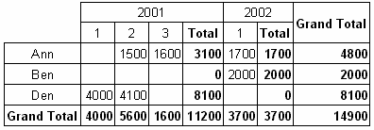

**ross-tab reports**

**133C**

*C++ Script:*

**void** Cross1OnBeforePrint(TfrxComponent Sender)

{

Cross1.AddValue([ "Ann" ], [ 2001 , 2 ], [ 1500 ]);

Cross1.AddValue([ "Ann" ], [ 2001 , 3 ], [ 1600 ]);

Cross1.AddValue([ "Ann" ], [ 2002 , 1 ], [ 1700 ]);

Cross1.AddValue([ "Ben" ], [ 2002 , 1 ], [ 2000 ]);

Cross1.AddValue([ "Den" ], [ 2001 , 1 ], [ 4000 ]);

Cross1.AddValue([ "Den" ], [ 2001 , 2 ], [ 4100 ]);

}

In the handler, data is added to the table through the “TfrxCrossView.AddValue” method. This method has three parameters, each of them an array of Variant type. The first parameter is the row value, the second the column value and the third the cell value. Note that the number of values in each array must match the settings for the object! In our example the object has one level in the row title, two levels in the column title and one level of cells, so the AddValue method's Variant array parameters need one value for the rows, two values for the columns and one value for the cells.

On preview the report output is:

The “AddValue” method can also be used for the “DB cross-tab” object. This allows the insertion of data which is not derived from the data source attached to the object. If any data is added in this way it is also summarized with the data from the data source.

**7.11 Adding external objects to the table**

External objects (such as lines, shapes, pictures) can be placed in the cross-tab. You may need to show, for example, some data in a graphical form. Let's look at an example that uses shapes to display a rudimentary progress bar:

*FastReport v4 © 1998-2014 Fast Reports Inc.*

*Manual v5.0.0*

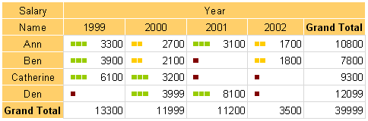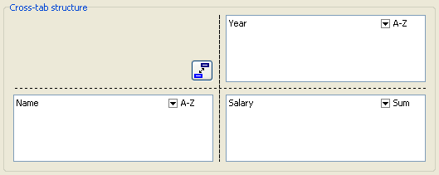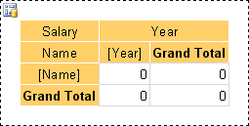**134 FastReport VCL 5 User's Manual**

A dark red bar is displayed if the cell value is less than 100, yellow if less than 3000 or green if more that 3000.

Let's start with our report. Place a "DB Cross-tab" object on the report page and set its properties like this:

Turn off the “Auto-Size” property and set the column widths as shown below:

Now add the shape object to our table by selecting the “Rectangle” object on the object toolbar

and placing it inside the cell:

*FastReport v4 © 1998-2014 Fast Reports Inc.*

*Manual v5.0.0*

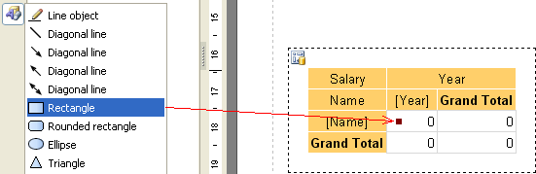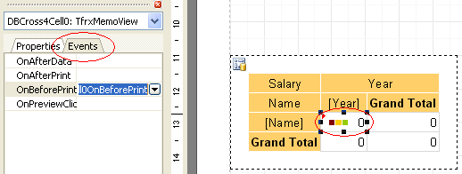

**ross-tab reports**

**135C**

Change its height and width to 0.2cm and set its top and left properties. Add two more similar rectangles.

Now create a script that will show the correct number of colored shapes (depending on the cell value). To do this select the cell and create an “OnBeforePrint” event handler:

Write the following code in the event handler (pay attention to the shape names, so that they match your objects):

**procedure** DBCross1Cell0OnBeforePrint(Sender: TfrxComponent);

**begin**

*// 'Value' is the current cell's value*

**if** Value < 100  **then**

**begin**

*// first shape object*

DBCross1Object1.Color := clMaroon;  *// dark red*

*// second shape object*

DBCross1Object2.Color := clWhite;

*// third shape object*

DBCross1Object3.Color := clWhite;

**end**

**else**  **if** Value < 3000  **then**

**begin**

DBCross1Object1.Color := $00CCFF ;  *// yellow*

DBCross1Object2.Color := $00CCFF ;

DBCross1Object3.Color := clWhite;

**end**

*FastReport v4 © 1998-2014 Fast Reports Inc.*

*Manual v5.0.0*

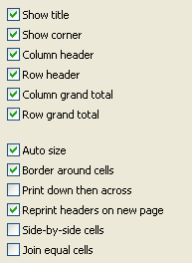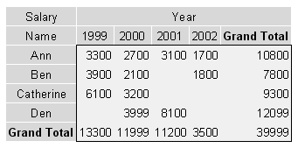**136 FastReport VCL 5 User's Manual**

**else**

**begin**

DBCross1Object1.Color := $00CC98 ;  *// green*

DBCross1Object2.Color := $00CC98 ;

DBCross1Object3.Color := $00CC98 ;

**end** ;

**end** ;

That's all - preview the report, which will be similar to that shown at the top of this section.

**7.12 Some useful settings**

Let's look at some other settings available in the cross-tab editor.

The first six options allow you to show or hide various table elements.

The “Auto size” option is already well known. It allows us to set the table width and height manually.

The “Border around cells” option allows the drawing of a frame around the cell elements. Here is an example table with a border (note that the cells themselves don't have borders):

*FastReport v4 © 1998-2014 Fast Reports Inc.*

*Manual v5.0.0*

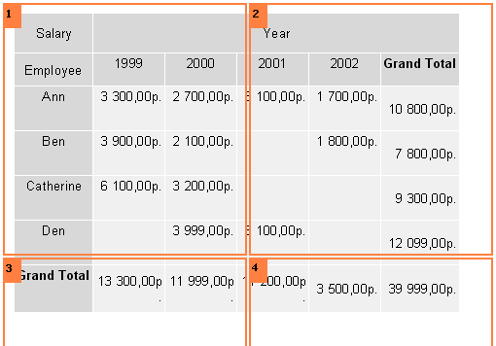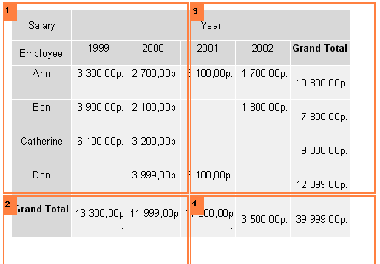

**ross-tab reports**

**137C**

The “Print down then across” option determines how a table is printed across several pages. Here are two examples showing how this option works (note the page order):

1. “Print down then across” is off:

1. “Print down then across" is on:

*FastReport v4 © 1998-2014 Fast Reports Inc.*

*Manual v5.0.0*

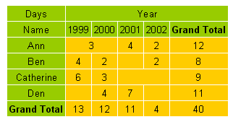**138 FastReport VCL 5 User's Manual**

The “Reprint headers on new page” option determines whether table headers are printed on each new preview page.

The “Side-by-side cells” option is used if you have two or more values in a table cell. It determines if these cell values are printed side-by-side or stacked one above the other (the default).

The “Join equal cells” option merges cells horizontally if they contain the same value:

Some other properties are also available in the object inspector:

* AddWidth, AddHeight : adds a specified amount of space to the cell width or height. It is taken into account when the FastReport engine calculates the cell size (the “Auto size” option must be on)
* NextCross : a pointer to another cross-tab object that will be printed to the side of this one
* NextCrossGap : the gap between the two adjacent cross-tab objects

*FastReport v4 © 1998-2014 Fast Reports Inc.*

*Manual v5.0.0*

**Chapter**

**VIII**

**Charts**

**140 FastReport VCL 5 User's Manual**

FastReport can insert charts into a report. The “TfrxChartObject”

object from the

FastReport component palette in Delphi is used for this purpoae. The component is based on the “TeeChart” library which is included in Delphi distribution kit. Alternatively the “TeeChartPro” library can be purchased separately.

Let's make an example report with a simple chart. The chart will use the “Country” table from the “DBDEMOS” database that comes with Delphi . The table contains data about countries, their areas and populations:

Name

Area

Population

|  |  |  |
| --- | --- | --- |
| Argentina | 2 777 815 32 300 003 |  |
| Bolivia | 1 098 575 7 300 000 |  |
| …. |  |  |

Create a new project in Delphi. Place “TTable”, “TfrxDBDataSet”, “TfrxChart” and “TfrxReport” components on the form and set these properties:

Table1:

*DatabaseName = 'DBDEMOS'*

*TableName = 'country.db'*

frxDBDataSet1:

*DataSet = Table1*

*UserName = 'Country'*

Open the report designer, create a new report and connect the data source in the “Report >

Data…” dialogue. Add a “Chart” object to the report design page and set its size to 18 cm wide x 8 cm high. Open its object editor by double-clicking on it.

*FastReport v4 © 1998-2014 Fast Reports Inc.*

*Manual v5.0.0*

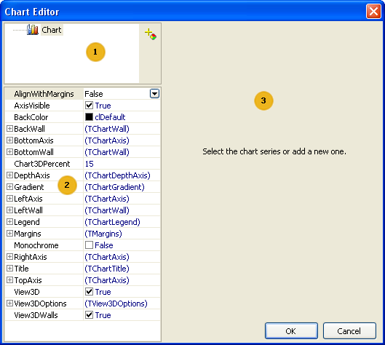

**harts**

**141C**

Key to the chart editor above:

* chart structure; a chart can contain one or more series
* object inspector showing the properties of the element selected in the window; set the chart properties here
* options area for connection of the series to data; it is activated once a series in area 1 has been selected

When first opened the chart editor will appear as in the image shown above. The first task is to

add one or more series to the chart (just one series in our example). Do this by clicking the add button and selecting the pie chart in the Gallery:

*FastReport v4 © 1998-2014 Fast Reports Inc.*

*Manual v5.0.0*

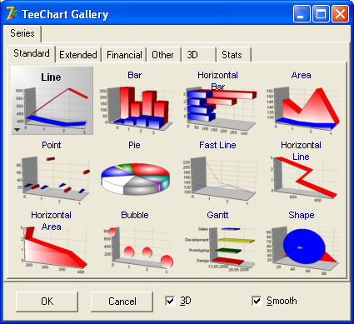**142 FastReport VCL 5 User's Manual**

The vertical arrows change the order of the series in the list. To change the name of a series

select the series, then one second later click on it again (note that this is not a double-click).

There are many different types of series available. After a series has been added the options area 3 becomes active. Here you specify which data should be used for plotting the chart. First let's choose the dataset in the “DataSet” drop-down list. Then choose the “Label” and “Pie” fields using their respective drop-down lists, as shown below:

*FastReport v4 © 1998-2014 Fast Reports Inc.*

*Manual v5.0.0*

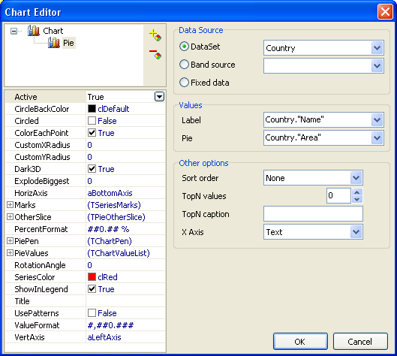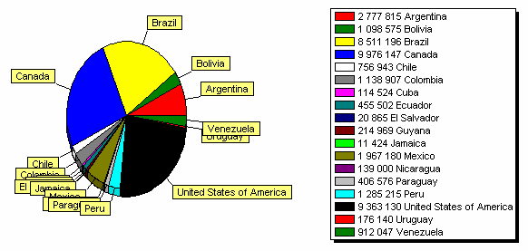

**harts**

**143C**

Click OK to close the editor and preview the report:

What can be improved in this report? It would be nice to sort the populations in descending

order. Open the chart editor again, select the series in the chart structure and change the sort order from None to Descending:

*FastReport v4 © 1998-2014 Fast Reports Inc.*

*Manual v5.0.0*

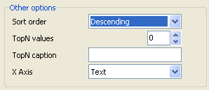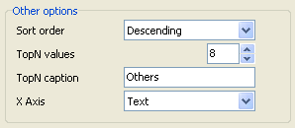**144 FastReport VCL 5 User's Manual**

If we previewed the report now, we would see that the data in the legend table has been sorted in descending order.

**8.1 Limiting the number of chart values**

Our chart is over-crowded with many small values, which has resulted in many becoming invisible. FastReport allows you to limit the number of values displayed in the chart. All the values in excess of a set number are displayed as a single composite value, consisting of the sum of all these values.

In our example the chart has 18 values but practically only 8 of them can be seen. Open the chart editor and set the limit to 8:

If “TopN” is set to zero then there will be no limitation. A name should be entered in “TopN caption” so that the aggregated values are identified correctly in the legend list. The Sort mode is irrelevant as the values will always be sorted descending by default.

The report will look like this:

*FastReport v4 © 1998-2014 Fast Reports Inc.*

*Manual v5.0.0*

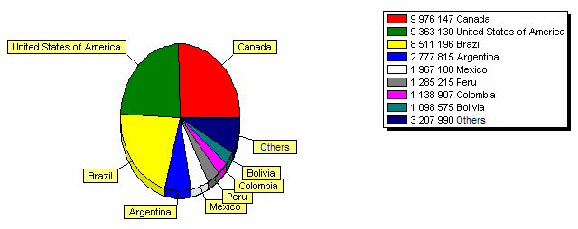

**harts**

**145C**

**8.2 Some useful settings**

Let's look at some useful settings for controlling the chart's appearance. These settings can only be accessed through the object inspector of the chart editor.

These basic properties are available when 'Chart' is selected in the Chart Structure:

* Gradient : settings for gradient background fill. Enable the “Gradient.Visible” property to show gradients
* Legend : settings for the Legend List. The List can be hidden through the “Legend.Visible” property and its position set through the “Legend.Alignment” property.

The following properties are available when a series has been selected:

* ColorEachPoint : color each value with a different color
* ExplodeBiggest : outset the largest value (only works for pie charts)
* Marks : settings for the look of chart labels
* ValueFormat : the line for formatting values

Note that all charting capabilities are accessible in the TeeChart Pro library (which can be bought separately from www.teechart.com). This library contains many types of chart and inludes a convenient chart and series editor.

**8.3 Chart with manually entered values**

In the previous example we created a chart using data from a DB table. A chart can also be created from manually entered data. This method can be convenient if the chart is small.

Let's demonstrate how this works with a simple example. Place a chart on the report design page and open the chart editor. Add a series of “Bar chart” type and set these properties, using semi-colons to separate individual values:

*FastReport v4 © 1998-2014 Fast Reports Inc.*

*Manual v5.0.0*

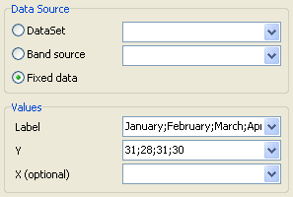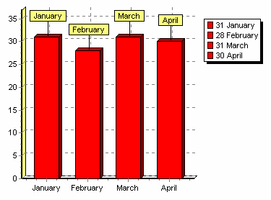**146 FastReport VCL 5 User's Manual**

The resulting chart is:

**8.4 Chart completion from Script**

Let's look at how to construct the previous chart using a script. Leave the Label and Y fields empty in the chart editor. In the report script enter the following code:

*PascalScript:*

**begin**

Chart1.SeriesData[ 0 ].XSource := 'Jan;Feb;Mar;Apr' ;

Chart1.SeriesData[ 0 ].YSource := '31;28;31;30' ;

**end** .

*C++Script:*

{

Chart1.SeriesData[ 0 ].XSource = "Jan;Feb;Mar;Apr" ;

Chart1.SeriesData[ 0 ].YSource = "31;28;31;30" ;

*FastReport v4 © 1998-2014 Fast Reports Inc.*

*Manual v5.0.0*

**harts**

**147C**

}

SeriesData[0] in this case allows us to set parameters for the first series in the chart. If the chart has more than one series then refer to them with SeriesData[1], etc.

**8.5 Printing a chart built in Delphi**

If you have already built a chart in your Delphi code and want to print it in the report you need to use a “Picture” object from the FastReport object toolbar. Place the object in the required place on the report design page and create the following “TfrxReport.OnBeforePrint” event handler in the Delphi application:

**procedure** TForm1.frxReport1BeforePrint(Sender: TfrxReportComponent);

**begin**

**if** Sender. **Name** = 'Picture1'  **then**

TfrxPictureView(Sender).Picture.Assign(

Chart1.TeeCreateMetafile(False,

Rect( 0 , 0 , Round(Sender.Width), Round(Sender.Height))));

**end** ;

where Picture1 is the “Picture” object's name and Chart1 is your Delphi chart.

**Note** : When you have code assigned to the event handlers of the TfrxReport component within

a Delphi application you must preview the report by running the compiled Delphi application. You cannot preview the report from within the FastReport report designer.

*FastReport v4 © 1998-2014 Fast Reports Inc.*

*Manual v5.0.0*

**Chapter**

**IX**

**Interactive**

**reports**

**nteractive reports**

**149I**

A FastReport's prepared report can be made interactive. This means that, it will react to the user's actions in the preview window. You can use the following interaction:

when clicking on the report object, some kind of operation is performed. For example, you can run detailed report and show it in a separate window;

preview window can show the report outline, which can be used for navigating on the report.

**9.1 Hyperlink**

Almost all report objects have the "Hyperlink" property. Using this property, you can define an object's reaction to the mouse click in the preview window.

When clicking such an object, one of the following can occur:

navigate to the URL address;

send e-mail;

execute any kind of system command;

navigate to the report page with the indicated number;

navigate to the anchor, added in a script;

run detailed report in a separate preview window;

custom action, defined in a script.

*FastReport v4 © 1998-2014 Fast Reports Inc.*

*Manual v5.0.0*

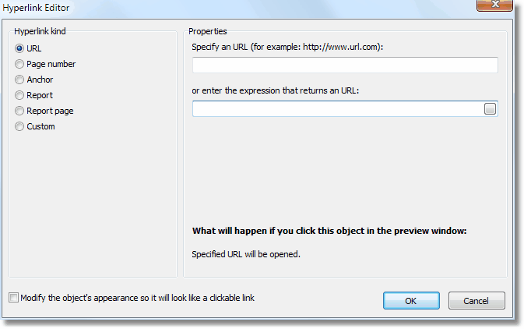**150 FastReport VCL 5 User's Manual**

**9.2 Hyperlink configuration**

To configure a hyperlink, select the object which you want to make interactive, and right click on

it. In the context menu, select the "Hyperlink..." item. The hyperlink editor window will open:

Choose the type of hyperlink by selecting the radiobutton in the left side of the window. After you have done, you may click the "Modify the object's appearance..." checkbox at the bottom of the window. The appearance of the object will change in the following way:

blue color will be set for the text and it will underlined;

a hand cursor form will be set.

In some cases hyperlink needs to be shown in the preview window, but there is no need to print it. This is easy to do, if you configure the "Visibility" object property. This can be done in the "Object Inspector" window.

**9.3 Link to the URL**

Using this type of link, you can:

navigate to the given internet address;

execute some kind of system commands, for example, "mailto:" for sending an email. You can indicate the value of the link by using two methods:

indicate the value directly, for example, "http://www.fast-report.com"; indicate an expression, which returns the value of the link. This expression will be calculated

*FastReport v4 © 1998-2014 Fast Reports Inc.*

*Manual v5.0.0*

**nteractive reports**

**151I**

when you run the report.

**9.4 Link to the page number**

By using this link type, you can organize navigation on the pages of a prepared report. Most often, navigation to the first page is used. For this, indicate the page number (1 in the given case) as a link value.

You can indicate the page number by using two methods:

indicate the number directly, for example,1;

indicate an expression, which returns the page number. This expression will be calculated when you run the report.

**9.5 Link to an anchor**

By using this type of link, you can navigate to an anchor, added in a script. An anchor has got a name and a definite position in a prepared report (page number and position on the page). When moving to an anchor by its name, you navigate onto the indicated position.

In order to use this link type, you first need to define an anchor. In order to do this, use the script

and Engine.AddAnchor method (see more in the "Script/Anchors" topic). Now you can indicate

its name in the hyperlink configurations window. This can be done by using two methods: indicate the name of the anchor directly;

indicate an expression which returns the name of the anchor. For example, this can be a data column. This expression will be calculated when the report is run.

**9.6 Link to a detailed report**

Using this link type, you can execute another report and show it in a separate preview window. You must set the following parameters for this type of hyperlink:

detailed report's name;

name of the report's variable, which will take the hyperlink's value;

hyperlink value.

When the link is clicked, the following will take place:

the indicated report will be loaded;

the report's variable will be set to the hyperlink's value;

the report will be built and run in a separate preview window. Report variable's value can be indicated by using two methods:

indicate the value directly;

indicate an expression, which returns the value. This expression will be calculated when the report is run.

*FastReport v4 © 1998-2014 Fast Reports Inc.*

*Manual v5.0.0*

**152 FastReport VCL 5 User's Manual**

**9.7 Link to a detailed page**

This link type works in the same way, except that, another page in the current report is used as a detailed report. For this, your report must contain at least two pages: one with the main report, another with detailed one.

You must set the following parameters for this type of hyperlink:

page name in that report;

name of the report's variable, which will take the hyperlink's value;

hyperlink value.

When the link is clicked, the following will take place:

the report's variable will be set to the hyperlink's value;

the indicated report page will be built and shown in a separate preview window. Report variable's value can be indicated by using two methods:

indicate the value directly;

indicate an expression, which returns the value. This expression will be calculated when the report is run.

When you choose a report page, its "Visible" property resets to false. This means that, when the main report will be built, this page will be skipped.

**9.8 Custom link**

Using this type of link you can define own reaction to the clicking of the mouse. For this, use the "OnClick" event handler of the object.

*FastReport v4 © 1998-2014 Fast Reports Inc.*

*Manual v5.0.0*

**Chapter**

**X**

**Dot-Matrix**

**reports**

**154 FastReport VCL 5 User's Manual**

Earlier we looked at reports intended for printing on standard modern printers (stylus, laser,etc.). A report sent to a dot-matrix printer will be printed very slowly. FastReport allows the creation of special reports intended for dot-matrix printers, where only standard font symbols and no graphic elements are output; this results in a faster printing speed.

Let's see how to build a report of “List” type intended for dot-matrix printing. Earlier we created this kind of report, see the ”List of clients” report. We will use the same data for the report.

So, start a new project in Delphi, place “TTable”, “TfrxDBDataSet”, “TfrxReport” and “TfrxDotMatrixExport” components on the form and set their properties:

TTable:

*DatabaseName = 'DBDEMOS'*

*TableName = 'Customer.db'*

TfrxDBDataSet:

*DataSet = Table1*

*UserName = ‘Customers’*

Open the report designer. Select “File > New…” to open the report wizard dialogue and select the “Dot-Matrix Report” item:

On clicking ΞΚ an empty design page is shown, marked out for a dot-matrix font:

*FastReport v4 © 1998-2014 Fast Reports Inc.*

*Manual v5.0.0*

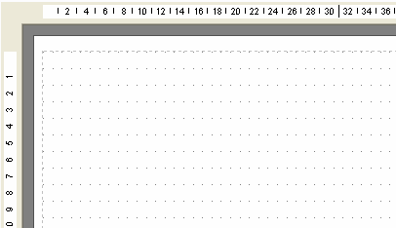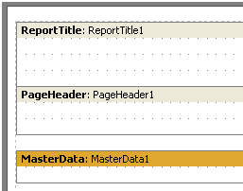

**ot-Matrix reports**

**155D**

The object toolbar also changes to show the objects available for dot-matrix printing, these are “Band”, “Text”, “Line”, “ESC-Command”, “Subreport”, “Cross-tab” and “DBCross-tab” objects. Other objects cannot be used on a dot-matrix printer.

Place “Report Title”, “Page Header” and “Master Data” bands on the report page:

Place “Text” objects on the bands as follows:

*FastReport v4 © 1998-2014 Fast Reports Inc.*

*Manual v5.0.0*

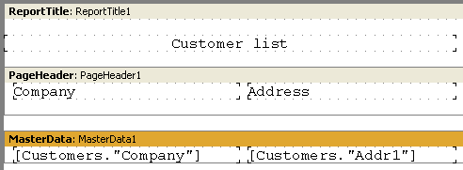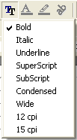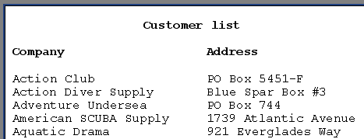**156 FastReport VCL 5 User's Manual**

The placement of Dot-matrix objects is similar to that in ordinary reports. However, these objects are strictly limited in position and appearance. The objects snap to the grid, the font size (height) cannot be changed and they cannot be colored. But some font attributes can be modified by selecting the “Text” object and clicking the “Tt” button on the toolbar:

These font attributes are specific to dot-matrix printing. The report page and all the dot-matrix objects, excepting bands, have these attributes.

**Note: in the designer and in the preview only “Bold”, “Italic” and “Underline” attributes are implemented on screen. The whole set of attributes is implemented only when printing.**

Let's modify our report using the “Bold” style for the headings. The report is finished and ready for previewing:

*FastReport v4 © 1998-2014 Fast Reports Inc.*

*Manual v5.0.0*

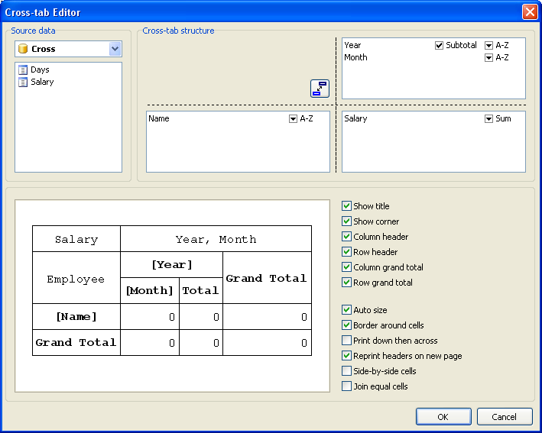

**ot-Matrix reports**

**157D**

**10.1 Cross-tab in dot-matrix**

The range of objects usable in dot-matrix reports is restricted to those that can be displayed in a textual form. Among these are the two “Cross-tab” objects. Let's look at a simple cross-tab report similar to the one built earlier in the “Tables with composite headers” section.

Create a dot-matrix report as in the previous section, choosing a “Dot-Matrix Report”. Place a “DB cross-tab” object on the report page and open its editor:

The cross-tab editor shows the structure of the output table in dot-matrix mode. The cell font attributes can be set using the “Tt” button in the toolbar. In all other respects the cross-tab objects behave as previously described. The previewed report looks like this:

*FastReport v4 © 1998-2014 Fast Reports Inc.*

*Manual v5.0.0*

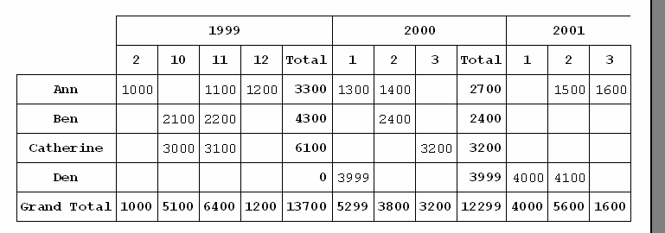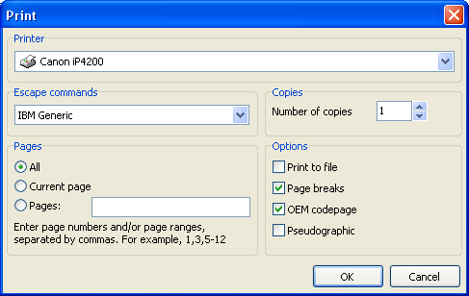**158 FastReport VCL 5 User's Manual**

**10.2 Dot-matrix report printing**

To enable the actual printing of a previewed dot-matrix report it is necessary to first place a

TfrxDotMatrixExport

component from the “FastReport” component palette on your Delphi

project form. This component handles the conversion of the preview report into the text format required by dot-matrix printers. It also replaces the normal printer dialogue with a special one for dot-matrix printers:

The printer dialogue is similar to the normal one, but has dot-matrix printer specifics. The printer's commands system must be chosen from the following list before printing (the ESC- commands):

*FastReport v4 © 1998-2014 Fast Reports Inc.*

*Manual v5.0.0*

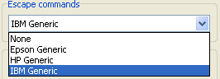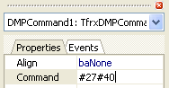

**ot-Matrix reports**

**159D**

There are also some other options for dot-matrix printing:

* Print to file : whether to send the print stream to a file on the hard disk. If enabled then the normal 'Save As...' dialogue appears
* Page breaks : whether a “Page break” control command is sent on reaching the bottom of the page. If disabled then printing is unbroken on continuous stationery
* IAI-codepage : whether to perform symbol conversion
* Pseudographic : specifies how to draw vertical and horizontal lines. If disabled then lines are drawn using -, | and + symbols

**10.3 “Command” object**

As described earlier, these attributes can be set for dot-matrix report objects:

This is a standard set that is understood by all models of dot-matrix printer. Certain printer

models can support other commands that are not present in the standard set, for example printing at 20 character per inch resolution. To be able to send these extra attributes to the printer use the “ESC-Command” object in the report.

Place the “ESC-Command” object at the correct place on the report page, before any objects which use the non-standard attributes (e.g. in the top left corner of the page). To set a command edit the Command property of the object in the object inspector:

*FastReport v4 © 1998-2014 Fast Reports Inc.*

*Manual v5.0.0*

**160 FastReport VCL 5 User's Manual**

The property can be set using one of the two formats : decimal (e.g. #27#40) or hexadecimal (e.g. 1B28).

*FastReport v4 © 1998-2014 Fast Reports Inc.*

*Manual v5.0.0*

**Chapter**

**XI**

**Dialogue forms**

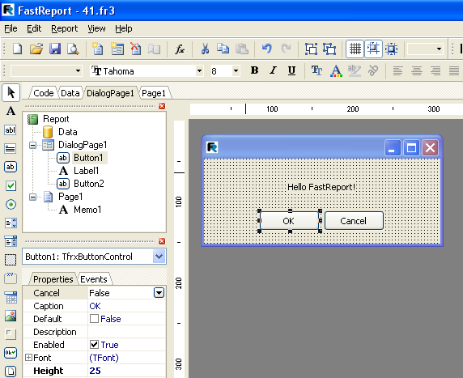**162 FastReport VCL 5 User's Manual**

As well as the usual report design pages, you can use dialogue forms in a report. Dialogue forms are created in the usual report designer using the button in the designer toolbar : the button adds a new dialogue page tab to the report. When switching to the dialogue page tab the designer workspace changes to show the form, and the object toolbar changes to show the control objects which can be placed on the form:

**11.1 Controls**

To use Dialogue form controls in a report place a “TfrxDialogControls” component from the FastReport component palette on the Delphi project form. Alternatively add “frxDCtrl” to the “Uses” list. The following controls then become available for use in the report:

**Element**

**Name**

TfrxLabelControl TfrxEditControl

**Description**

control for displaying fixed texts on the dialogue form control for entering text using the keyboard

*FastReport v4 © 1998-2014 Fast Reports Inc.*

*Manual v5.0.0*



**ialogue forms**

**163D**

|  |  |  |
| --- | --- | --- |
| TfrxMemoControl | control for entering multiple lines of text using the  keyboard |  |
| TfrxButtonControl | control representing a button |  |
| TfrxCheckBoxControl | control representing a flag, having two states - enabled  or disabled; has an adjacent label |  |

TfrxRadioButtonControl control representing a radio button. There must be more than one radio button control on the form

|  |  |  |
| --- | --- | --- |
| TfrxListBoxControl | control representing a list of items from which one can  be selected |  |
| TfrxComboBoxControl | control representing a drop-down list of items from  which one can be selected |  |
| TfrxDateEditControl | control representing a field with a drop-down calendar  for date entry |  |
| TfrxGroupBoxControl | control representing a labelled box that can contain  other objects |  |
| TfrxPanelControl | control representing a panel which can contain other  objects |  |
| TfrxBitBtnControl | control representing a button containing a picture |  |

TfrxSpeedButtonControl control representing a speed button containing a picture

TfrxMaskEditControl

control for entering text using the keyboard and conforming to a template

TfrxCheckListBoxControl control representing a list of items, selected by means of a checkbox

|  |  |  |
| --- | --- | --- |
| TfrxBevelControl | control used for showing lines and frames on the form |  |
| TfrxImageControl | control representing a picture in “BMP”, “ICO”, “WMF”  or “EMF” format |  |

All the controls are similar to those used in Delphi. See the FastReport component help for information on the properties, events and methods of each control.

**11.2 "Hello, World!" report**

In this example we will create a report which, before creating the preview, displays a greeting window using a dialogue form. Create a new project in Delphi and place “TfrxReport” and “TfrxDialogControls” components on the form. Open the FastReport designer by double-clicking on the “TfrxReport” component and add a dialogue form to the report. Place “TfrxLabelControl” and “TfrxButtonControl” objects on the form:

*FastReport v4 © 1998-2014 Fast Reports Inc.*

*Manual v5.0.0*

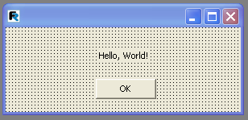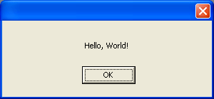**164 FastReport VCL 5 User's Manual**

Set the object properties:

TfrxLabelControl:

*Caption = 'Hello, World!'*

TfrxButtonControl:

*Caption = 'OK' Default = True*

*ModalResult = mrOk*

Set the “BorderStyle = bsDialog” property for the form. Both the controls and the form have the same set of properties as for the corresponding Delphi controls.

When the dialogue form design is complete return to the report design Page1 tab and place a “Text” object containing the greeting on the page. Preview the report and you will see the dialogue form:

After clicking on the OK button the dialogue closes and the report is constructed and displayed. If the dialogue is closed by clicking the system menu “Υ” button then the report will not be constructed. FastReport works like this : if there are dialogue forms in a report, the report is only constructed after each dialogue has been closed with ModalResult = mrOk, i.e. in this example by clicking the ΞΚ button,. That is why the “ModalResult” property of the button had to be set to “mrOk.”

**11.3 Entering parameters and transferring them into a report**

Let's make this example more complicated, to show how to transfer values entered in the dialogue to the report. Modify the dialogue as here:

*FastReport v4 © 1998-2014 Fast Reports Inc.*

*Manual v5.0.0*

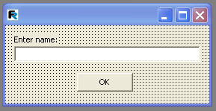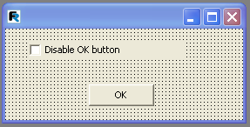

**ialogue forms**

**165D**

Place a “Text” object containing this text on the report Page1, and set its “AutoWidth” to True:

*You entered: [Edit1.Text]*

Preview the report and make sure that the text typed in is successfully displayed in the report. Other objects in the dialogue can be accessed in a similar way. Since each object has a name that is unique within the whole report it can be used anywhere within the same report.

**11.4 Interaction with controls**

By using a script, complex logic can be incorporated into a dialogue's operation. Let's illustrate this with a simple example : modify the form like this:

Double-click on the “CheckBox” object to create an “OnClick” event handler and enter the following script:

*PascalScript:*

**procedure** CheckBox1OnClick(Sender: TfrxComponent);

**begin**

Button1.Enabled :=  **not** CheckBox1.Checked;

**end** ;

*C++ Script:*

**void** CheckBox1OnClick(TfrxComponent Sender)

{

Button1.Enabled = !CheckBox1.Checked;

}

*FastReport v4 © 1998-2014 Fast Reports Inc.*

*Manual v5.0.0*

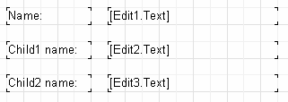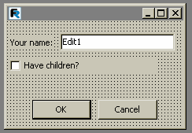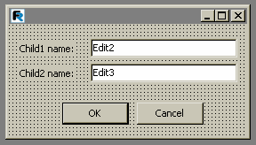**166 FastReport VCL 5 User's Manual**

This code is the same as is used in Delphi. On running the report the button responds to the state of the check box.

**11.5 Several dialogue forms**

Let's see how a report with two dialogues works. Create a report with two dialogues and one design page:

Set the “ModalResult” property for the OK and Cancel buttons to mrOk and mrCancel respectively. Now run the report. First of all the user will be asked to answer questions from the first dialogue (name, any children), then after clicking ΞΚ, from the second one (childrens’ names). After clicking ΞΚ in the second dialogue the report will be built. FastReport handles multiple dialogues in this way : the dialogues are displayed in their creation order; each dialogue is displayed only after the previous one has been closed with “ModalResult = mrOk” (in this example by clicking each OK button). If any dialogue is closed using the Cancel button or the system menu “Υ” button then building of the report is prevented.

*FastReport v4 © 1998-2014 Fast Reports Inc.*

*Manual v5.0.0*

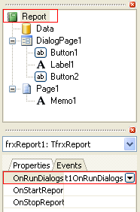

**ialogue forms**

**167D**

**11.6 Managing dialogue forms**

In the previous example the second dialogue is displayed irrespective of whether "Have children" was checked. Let's show how to hide the second dialogue when this flag is unchecked. Create an “OnClick” handler for the ΞΚ button on the first dialogue (double-click on the button to create the handler):

*PascalScript:*

**procedure** Button1OnClick(Sender: TfrxComponent);

**begin**

DialogPage2.Visible := CheckBox1.Checked;

**end** ;

*C++Script:*

**void** Button1OnClick(TfrxComponent Sender)

{

DialogPage2.Visible = CheckBox1.Checked;

}

This code hides the second dialogue (DialogPage2) if the flag is not checked. Preview the report to see that this works correctly.

Another way of managing the forms is to use the “OnRunDialogs” report event. To create this event handler select the Report object in the report tree or object inspector and switch to the “Events” tab in the object inspector. Double-click on the “OnRunDialogs” event to create a handler:

Write the following code in the handler:

*PascalScript:*

*FastReport v4 © 1998-2014 Fast Reports Inc.*

*Manual v5.0.0*

**168 FastReport VCL 5 User's Manual**

**procedure** frxReport1OnRunDialogs( **var** Result: Boolean);

**begin**

Result := DialogPage1.ShowModal = mrOk;

**if** Result  **then**

**begin**

**if** CheckBox1.Checked  **then**

Result := DialogPage2.ShowModal = mrOk;

**end** ;

**end** ;

*C++Script:*

**void** frxReport1OnRunDialogs( **bool** &Result);

{

Result = DialogPage1.ShowModal == mrOk;

**if** (Result)

{

**if** (CheckBox1.Checked)

Result = DialogPage2.ShowModal == mrOk;

}

}

The handler works like this : the first dialogue is shown : if it is closed via the ΞΚ button then look at the state of CheckBox1 : if this state is Checked then show the second dialogue : if the second dialogue is closed via the ΞΚ button then set Result to True. If the handler returns Result

* True then the preview is built : if Result = False then the report stops running without building a preview.

*FastReport v4 © 1998-2014 Fast Reports Inc.*

*Manual v5.0.0*

**Chapter**

**XII**

**Data access**

**components**

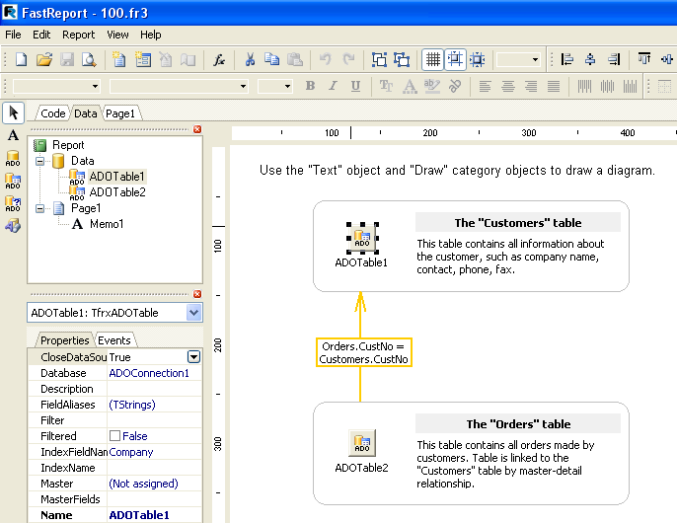**170 FastReport VCL 5 User's Manual**

As a rule most reports are based on data sourced from a DB. Delphi provides a variety of components for linking to DB data and FastReport makes use of these links. Here we discuss the use of “TTable” and “TQuery” components as data sources for reports, but in general any TDataSet descendant can be used.

As well as the data access components of Delphi projects, such as the “TfrxDBDataset” that we have used in our examples so far, there are several specific DB components in FastReport that can be used in reports, which ones are used being dependent on the choices made during installation. The principles of data access in FastReport are much the same as those used in the Delphi environment. Just as in Delphi a component is placed on a dialogue form and its properties are set in the object inspector. Component design is very flexible and new components to support different database engines can easily be created (see the Developers Manual). With the support of the “TfrxDesigner” component, they give end users of an application the ability to design reports at runtime.

*FastReport v4 © 1998-2014 Fast Reports Inc.*

*Manual v5.0.0*

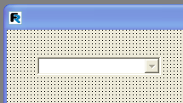

**ata access components**

**171D**

**12.1 Component descriptions**

Let's see how components are used for data access via ADO. They are made available in

FastReport by adding the “TfrxADOComponents” component from the Delphi FastReport palette to the project form. The following objects then appear on the object toolbar when you switch to the “Data” tab in the report designer : “TfrxADOTable”, “TfrxADOQuery” and “TfrxADODataBase”. These components are similar to the corresponding Delphi components (“TADOTable”, “TADOQuery” and “TADOConnection”) in terms of their functionality. There is also a “TfrxDBLookupComboBox” control which can be used in dialogue forms.

**Icon**

**Name**

TfrxDBLookupComboB ox

TfrxADOTable TfrxADOQuery TfrxADODataBase

**Description**

control used for selecting a value from a directory

control used for accessing a DB table control used for executing a SQL query control used for connecting to a DB

**Used in**

dialogue

forms “Data” tab “Data” tab “Data” tab

Let's look at each component.

**12.1.1 TfrxDBLookupComboBox**

This component is used for selecting a value from a look-up dataset.

The component has the following properties:

**Property**

**Description**

|  |  |  |
| --- | --- | --- |
| DataSet | data source to which the control is connected |  |
| ListField | name of DB field displayed in the control |  |
| KeyField | name of DB key field identifying the selected record |  |
| KeyValue | value of DB key field returned by the selection from the list |  |
| Text | value of DB list field displayed in the list |  |

AutoOpenDataSet when True the connected data source is opened automatically after the dialogue's OnActivate event

*FastReport v4 © 1998-2014 Fast Reports Inc.*

*Manual v5.0.0*

**172 FastReport VCL 5 User's Manual**

To connect the control to the look-up dataset enter values for the three properties : “DataSet”, “ListField” and “KeyField”.

Note that the returned value is available via either the “Text” or the “KeyValue” properties, neither of which appears in the object inspector. They are accessible only through code. The initial position of the cursor in the look-up dataset can be set in code using “KeyValue”.

**12.1.2 TfrxADOTable**

This component is used for accessing a DB table using ADO. The component has the following properties:

**Property**

**Description**

|  |  |  |
| --- | --- | --- |
| DatabaseName | connection name (name of the TfrxADODatabase component) |  |
| FieldAliases | enables aliases to be set for the dataset fields |  |
| Filter | expression for filtering records |  |
| Filtered | whether filtered or not |  |

IndexFieldNames names of index fields (for sorting)

|  |  |  |
| --- | --- | --- |
| IndexName | secondary index name |  |
| MasterFields | fields connected with master dataset |  |
| Master | master dataset |  |
| TableName | DB table name |  |
| UserName | alias for the dataset, used in code |  |

These properties are similar to those of Delphi's “TADOTable” component. To connect the component to a DB table just set the “DatabaseName” and “TableName” properties. The Table is opened either by setting “Active” property to True or by calling the “Open” method.

The “FieldAliases” property editor is opened from the object inspector or by double-clicking on the component. The editor allows the selection of which fields will become available for use in code and the setting of aliases for these fields and for the dataset as a whole.

*FastReport v4 © 1998-2014 Fast Reports Inc.*

*Manual v5.0.0*

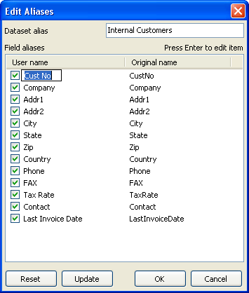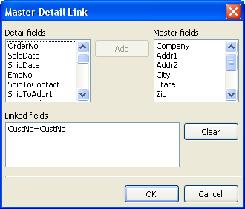

**ata access components**

**173D**

The “MasterFields” property editor is used for creating master-detail connections between two tables. To connect two tables with the master-detail relation a second table must be set in the “Master” property of the dependent table and the “MasterFields” property editor opened. If the table has secondary indexes which are to be used then set the “IndexName” property beforehand.

The editor visually binds the “master” and the “detail” fields of the datasets. When two datasets are connected in a “Master-Detail” relationship movement within the master dataset

*FastReport v4 © 1998-2014 Fast Reports Inc.*

*Manual v5.0.0*

**174 FastReport VCL 5 User's Manual**

automatically filters the detail dataset so that only records belonging to the current record of the master dataset are shown.

To connect fields in the two datasets select a field from the list on the left (the detail dataset) then a field from the list on the right (the master dataset) and click the Add button. The link between the two fields is then displayed in the bottom list. To clear the bottom list use the Clear button. The linked fields must of compatible type and be indexed.

**12.1.3 TfrxADOQuery**

This component executes SQL queries on a DB. It has the following properties:

**Property**

**Description**

|  |  |  |
| --- | --- | --- |
| DatabaseName | connection name (name of the TfrxADODatabase component) |  |
| FieldAliases | enables aliases to be set for the dataset fields |  |
| Filter | expression for filtering records |  |
| Filtered | whether filtered or not |  |
| Master | master dataset |  |
| Params | list of query parameters |  |
| SQL | Query text |  |
| UserName | alias for the dataset, used in code |  |

IgnoreDupParams when True allows parameters with duplicate names. The name of the Query parameters will not be edited in the parameter

editor

The “Active”, “DatabaseName”, “FieldAliases”, “Filter”, “Filtered” and “Master” properties are similar to those of the “TfrxADOTable” component described above. The “SQL” property has its own editor for entering the SQL query.

*FastReport v4 © 1998-2014 Fast Reports Inc.*

*Manual v5.0.0*

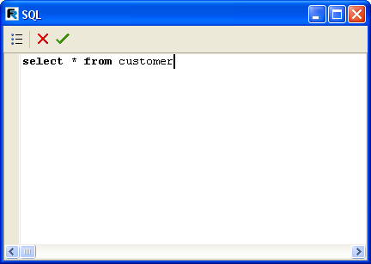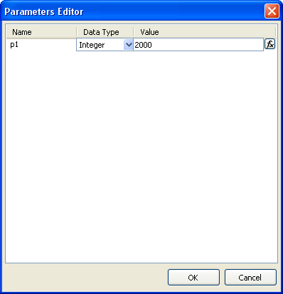

**ata access components**

**175D**

The “Params” property also has its own editor. It is enabled when a Query text contains parameters.

A parameter can be one of two types : its value either derived from the master-source or set as a discrete value (either an absolute value, as shown above, or linked to a variable or to an object property).

*FastReport v4 © 1998-2014 Fast Reports Inc.*

*Manual v5.0.0*

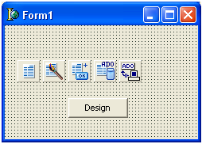**176 FastReport VCL 5 User's Manual**

When a parameter is derived from the data master-set the “TfrxADOQuery.Master” property has to be set. This dataset must contain a field of the same name as the parameter. Neither the parameter type nor its value has to be specified.

**12.1.4 TfrxADODataBase**

This component is used to connect to a database. Its function is similar to the “TADOConnection” Delphi component. The component has the following properties:

**Property**

**Description**

|  |  |  |
| --- | --- | --- |
| Connected | when True the connection is activated |  |
| DatabaseName | the ADO connection string |  |
| LoginPrompt | whether to prompt for the password when connecting to the DB |  |

The “LoginPrompt” property defines whether to prompt for the password when connecting to the DB. When “LoginPrompt” is False a user name and password must be included in the ADO connection string.

**12.2 Report designer**

Let's look at the design of a simple report using data access components at runtime. It will use the Demo.mdb database that comes with FastReport as the data source - {FR} \Demos\Main\demo.mdb.

Create a new Delphi project and add one each of “TfrxReport”, “TfrxDesigner”, “TfrxDialogControls”, “TfrxADOComponents”, "TADOConnection" and "TButton” components to the form.

Setup the database connection by double-clicking on the “TADOConnection”, and choosing "Build connection string", the provider ("Microsoft Jet 4.0 OLE DB Provider") and the database ({FR}\Demos\Main\demo.mdb). Close the connection dialogue with OK and set the component properties here:

*FastReport v4 © 1998-2014 Fast Reports Inc.*

*Manual v5.0.0*

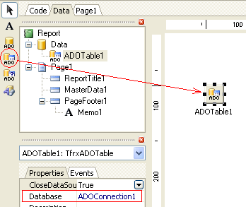

**ata access components**

**177D**

ADOConnection1:

*LoginPrompt = False*

frxADOComponents1:

*DefaultDatabase = ADOConnection1*

Define the following handler for the “Design” button:

**procedure** TForm1.Button1Click(Sender: TObject);

**begin**

frxReport1.DesignReport;

**end** ;

After that, compile and run the project. This is all you need to do to create an end-user runtime reports designer.

When the “Design” button is clicked the FR report designer opens, containing a blank report. Let's look at the design of a simple report in this environment.

**12.3 Simple report of “List” type**

This report will contain data from a single DB table. To construct the report, take these steps:

Click on the “New report” button on the designer toolbar - FastReport creates an empty report containing “Code”, “Data” and “Page1” tabs. Switch to the “Data” tab and place an

“ADO Table” component on page :

Note that the “Database” property is already connected to our database, because this was specified in the “TfrxADOComponents.DefaultDatabase” property. But the table name has to be

*FastReport v4 © 1998-2014 Fast Reports Inc.*

*Manual v5.0.0*

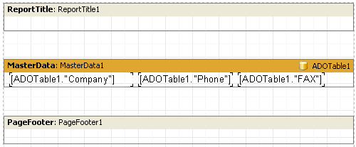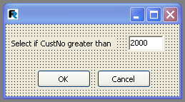**178 FastReport VCL 5 User's Manual**

set now:

*TableName = 'Customer'*

Switch to the Page1 tab. Connect the “MasterData” band to the table by double-clicking on it and selecting “ADOTable1” in the dialogue.

Drag the fields shown below from the “Data tree” window to the report page, which will then look roughly like this:

Preview the report with the “Preview” button on the toolbar.

**12.4 Report with parametric query**

Let's design a more complicated report in which the query parameters are requested in a dialogue before the report is created. Use the same project as in the previous section, and click the New Report button in the report designer to clear the old one.

Switch to the “Data” tab and place an “ADO Query” component on the page. Double-click on it to open its editor and enter the following SQL text:

**select** *  **from** Customer  **where** CustNo > :p1

Add a dialogue form to the report and place a “Label”, an “Edit” and two “Button” components on the dialogue form:

*FastReport v4 © 1998-2014 Fast Reports Inc.*

*Manual v5.0.0*

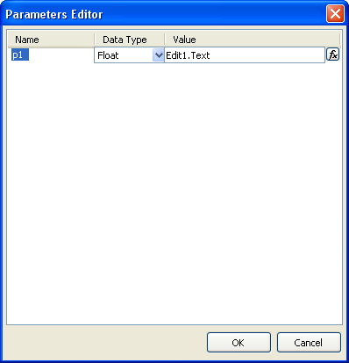

**ata access components**

**179D**

Set the component properties:

Label1:

*Caption = 'Select if CustNo greater than'*

Edit1:

*Text = '2000'*

Button1:

*Caption = 'OK'*

*ModalResult = mrOk*

Button2:

*Caption = 'Cancel'*

*ModalResult = mrCancel*

Open the “Params” property editor of the “Query” component and set the parameter:

After that switch to the report design Page1 and create the report as in the previous example:

When the report is previewed the dialogue prompting for a customer number is displayed. After

*FastReport v4 © 1998-2014 Fast Reports Inc.*

*Manual v5.0.0*

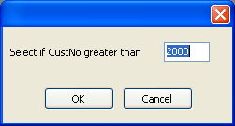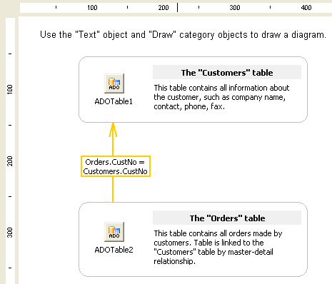**180 FastReport VCL 5 User's Manual**

a figure is entered and the dialogue has been closed with the ΞΚ button the report is created. All customers with CustNos larger than that entered are shown.

**12.5 Other useful features**

“Text” and “Draw” elements can be placed on the “Data” page. Using these elements simple explanatory diagrams can be drawn, as shown below:

*FastReport v4 © 1998-2014 Fast Reports Inc.*

*Manual v5.0.0*

**Chapter**

**XIII**

**Report**

**inheritance**

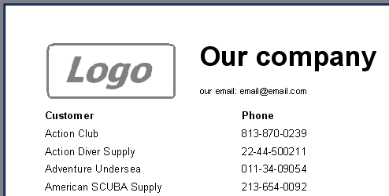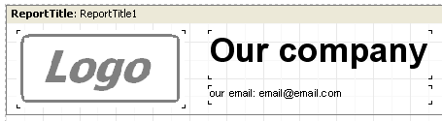**182 FastReport VCL 5 User's Manual**

Often a group of reports share some common data - for example, the header/footer with company logo or other data, like email or address etc. Should the situation arise that some of this company data needs changing, for example the email address, then it would have to be done in each report! To avoid this tedious task, report inheritance can be used. What is report inheritance?

As an example, reports commonly have elements (logo, company name, email etc) typically

placed in the report title and/or page header. A  *base report* can be designed that contains only

these common elements. All other reports can then use the base report and thus contain all of the common elements, as well as other elements specifically added to each report.

Should something (e.g. logo or email) need changing then the base report would be opened and the necessary changes made there. All reports inheriting from the base report would then be amended automatically. In fact, when a report based on inheritance is opened the base report is opened first of all, followed by the derived one.

**13.1 Creating a base report**

Let's create a simple report that uses inheritance. Our finished report should look like this:

First the base report has to be created. Which elements must it contain? They are the logo

bitmap, "Our company" title and email address. Create a new report and place the common objects in the “ReportTitle”:

*FastReport v4 © 1998-2014 Fast Reports Inc.*

*Manual v5.0.0*

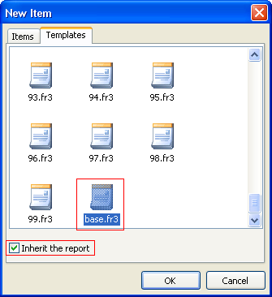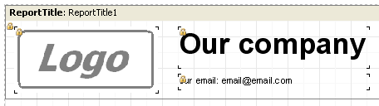

**eport inheritance**

**183R**

Save the report as "base.fr3". In which folder? This depends on how you setup the “TfrxDesigner” component. By default FastReport searches for base reports in the folder that contains the application's .exe file. Alternatively a folder for templates can be specified in the “TfrxDesigner.TemplateDir” property.

Now create the derived report. To do this use “File > New”, select the “Templates” tab in the dialogue and search for the base report ("base.fr3"). Click the "Inherit the report" checkbox and press OK:

FastReport will create a report containing all of the objects from the base report. They are tagged with the "lock" symbol:

What does "lock" symbol mean? It means that these objects cannot be renamed or deleted, nor can they be moved to another band. Changes to any other property (such as text, color or frame) can be made. Note that if you change some property of a locked object (for example color) this change will be stored in the derived report. If you subsequently change the color of this object in the base report the change will be ignored by the derived report. For example: open the derived report, change the color of "Our company" to red and save the report. Now open the base report and set the color for "Our company" to green. When the derived report is opened

*FastReport v4 © 1998-2014 Fast Reports Inc.*

*Manual v5.0.0*

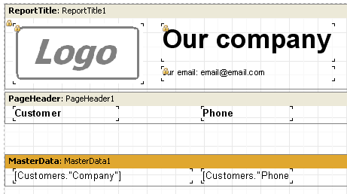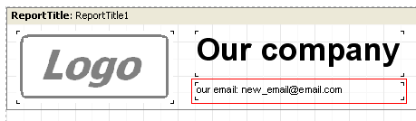**184 FastReport VCL 5 User's Manual**

again the color of "Our company" is still red. It is therefore preferable to change the properties of objects having the "lock" symbol back in the base report and not in the derived report.

Let's finish our report. All that is needed is to add page header and master data bands:

And the report is finished.

**13.2 Changing a base report**

Let's look at changing a base report. Open the base report ('base.fr3' in our example) and change some fields. Let's alter the email address:

Save the report. Now open the derived report and see that the email address has been changed in this report as well:

*FastReport v4 © 1998-2014 Fast Reports Inc.*

*Manual v5.0.0*

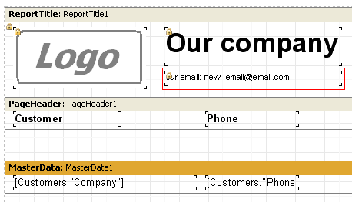

**eport inheritance**

**185R**

What if some objects have to be added to the base report? There is a simple rule : the base and derived reports cannot contain any objects having the same name. While changing base reports, it may not be known how many reports use the base report, nor what object names have been used in these derived reports. So a simple strategy is: when adding objects to base reports name the objects using a template like 'ReportName_ObjectName'. In our example add a “Text” object to our report and set its name to 'BaseMemo3'.

There is no restriction on deleting objects from a base report nor on moving them.

**13.3 Inheritance control**

We have followed the creation of a derived report from scratch. What happens if an existing report is to be changed to inherit from a different report? To do this, open the report and from “Report > Options...” choose the “Inheritance” tab:

*FastReport v4 © 1998-2014 Fast Reports Inc.*

*Manual v5.0.0*

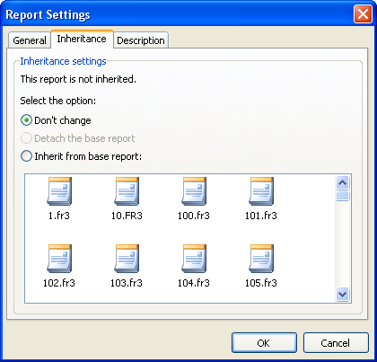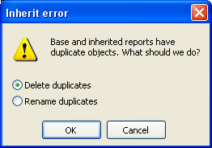**186 FastReport VCL 5 User's Manual**

Select the "Inherit from base report" option and choose the base report from the list. If necessary change the Template path to see a different set of templates. Press OK and FastReport will combine the two reports. The following error message may appear:

This happens if the two reports contain objects having the same name. Objects with duplicated names can be deleted from the derived report or can be renamed in the derived report.

*FastReport v4 © 1998-2014 Fast Reports Inc.*

*Manual v5.0.0*

**Chapter**

**XIV**

**Wizards**

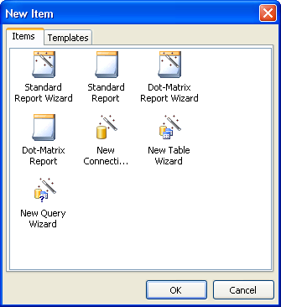**188 FastReport VCL 5 User's Manual**

FastReport provides some wizards that simplify the report creation process. Wizards are found under “File > New...”:

**14.1 New report wizard**

There are two icons for wizards helping to create new reports and two icons for the straight forward creation of new reports:

* Standard report wizard
* Dot-matrix report wizard
* Standard report
* Dot-matrix report

Icons of type "Standard report" and "Dot-matrix report" create the empty standard and dot-matrix reports respectively (there is more about dot-matrix reports in previous sections). These new reports contain one empty page.

Icons of type "Standard report wizard" and "Dot-matrix report wizard" guide the process of choosing the dataset and fields required for the report, the optional creation of groups and the selection of data layout. Let's look at a report created with the help of the "Standard report wizard".

Choose "File > New..." and the "Standard report wizard" icon. The report wizard dialogue appears:

*FastReport v4 © 1998-2014 Fast Reports Inc.*

*Manual v5.0.0*

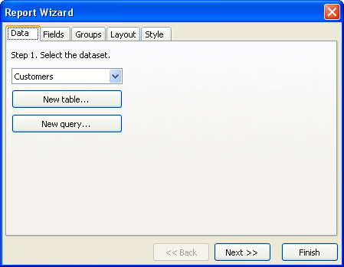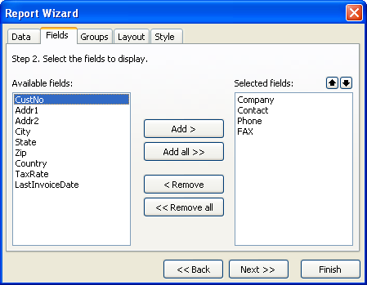

**izards**

**189W**

The dialogue has several tabs. On the first tab choose the data source for the report. All data sources available in your application are listed here (TfrxDBDataSet components). New data sources can be created, either tables or queries, using the "New table" or "New query" buttons. These buttons open the "New table/query" wizard (described later in this chapter). Let's choose the Customers table. Then press the "Next >>" button.

On the next tab select the fields to be displayed in the report:

*FastReport v4 © 1998-2014 Fast Reports Inc.*

*Manual v5.0.0*

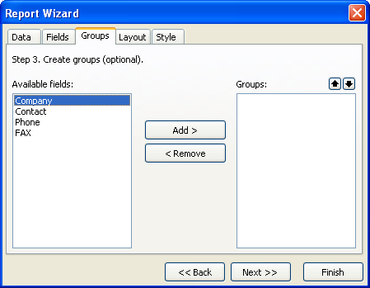**190 FastReport VCL 5 User's Manual**

On the left side is a list of available fields; on the right side a list of fields already selected to appear in the report. Use the "Add >", "Add all >>", "< Remove" and "<< Remove all" buttons to

move fields from one list to another. Use the

buttons to move selected fields up or down in

the list. Let's add the "Company", "Contact", "Phone" and "FAX" fields to the selected fields list and press the "Next >>" button.

On the next tab one or more groups can be created. FastReport will add the Group header and Group footer bands to the report.

Group creation is optional. Skip it here by pressing the "Next >>" button. The next tab sets the page orientation and one of two data layouts - tabular and columnar:

*FastReport v4 © 1998-2014 Fast Reports Inc.*

*Manual v5.0.0*

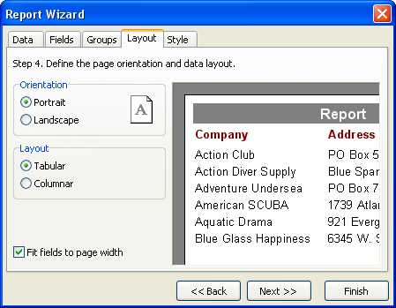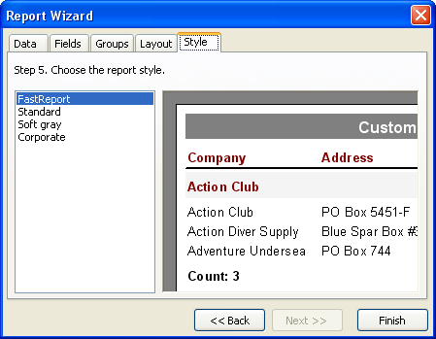

**izards**

**191W**

The chosen layout is illustrated on the right side of the dialogue.

Finally, the last tab lists the available color schemes for your report, again illustrated on the right side of the dialogue..

When the "Finish" button is pressed the wizard will create the following report:

*FastReport v4 © 1998-2014 Fast Reports Inc.*

*Manual v5.0.0*

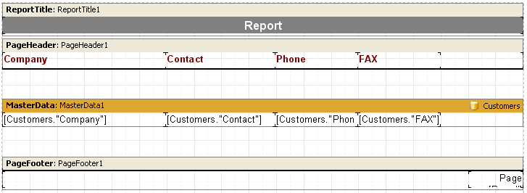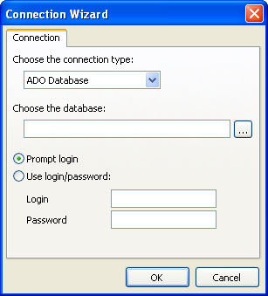**192 FastReport VCL 5 User's Manual**

The report can now be previewed.

**14.2 New connection wizard**

This wizard adds a new database connection to an existing report. Two or more connections may be needed if data from two or more databases is to appear in the report. The wizard adds the database component (for example “TfrxADODatabase”) to your report.

The connection string must be created using the button which opens the standard Windows connection dialogue for setting the database and connection parameters. After this the user name and password can be set, if necessary.

Note: a new connection can be made manually - just place a “TfrxADODatabase” component on

*FastReport v4 © 1998-2014 Fast Reports Inc.*

*Manual v5.0.0*

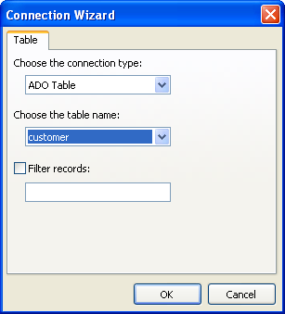

**izards**

**193W**

the report's Data tab.

**14.3 New table wizard**

This wizard adds a new database table to an existing report.

Select the table name. If required, a filter can also be defined, for example:

*(CustNo > 2000) and (CustNo < 3000)*

NB: a new table can be created manually by placing a “TfrxADOTable” component on the report's Data tab.

*FastReport v4 © 1998-2014 Fast Reports Inc.*

*Manual v5.0.0*

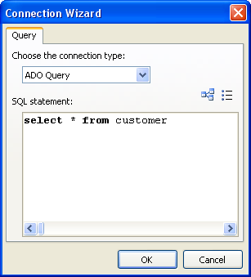**194 FastReport VCL 5 User's Manual**

**14.4 New query wizard**

This wizard adds a new SQL query to an existing report.

The SQL query must be composed here. The visual query builder can be used to do this - click the button. The query builder is described later in this chapter.

NB: a new query can be created manually by placing a “TfrxADOQuery” component on the report's Data tab.

**14.5 Query construction**

FastQueryBuilder can be used to compose queries visually. FastQueryBuilder is included in FastReport Professional and Enterprise editions, or alternatively it can be purchased as an independent product. The query builder builds queries visually in the SQL language. The builder is illustrated below:

*FastReport v4 © 1998-2014 Fast Reports Inc.*

*Manual v5.0.0*

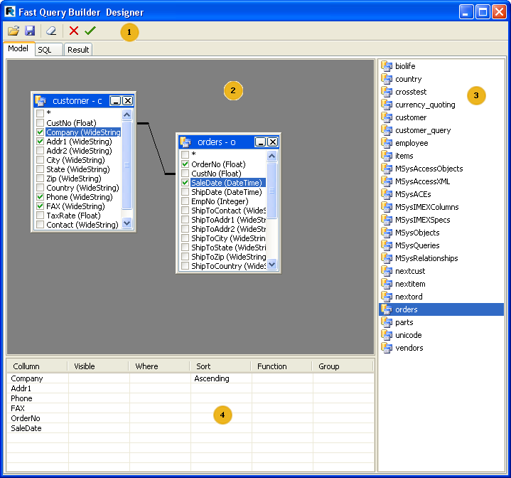

**izards**

**195W**

* - toolbar
* builder workspace
* list of available tables
* selected table field properties

Toolbar:

* open SQL file
* save query to file (query diagram is also saved in the file)
* clear builder workspace
* IK button : save and exit builder
* Cancel button : exit builder without saving

The builder's workspace and the list of available tables support Drag&Drop, i.e. tables can be dragged onto the workspace with the mouse. Alternatively double-click on a table in the list of available tables.

*FastReport v4 © 1998-2014 Fast Reports Inc.*

*Manual v5.0.0*

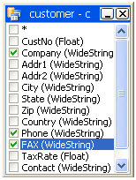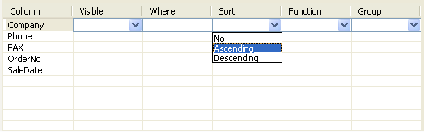**196 FastReport VCL 5 User's Manual**

To include a field from the table in the query select it in the list:

Selected fields appear in the field properties space (4):

* Visible : whether field appears in the output
* Where : field selection condition, e.g. '> 5'
* Sort : sorting direction for field
* Function : function applied to field
* Group : grouping on the field

By “dragging” fields between the tables in the workspace (2) “Join lines” appear. When fields are joined the compatibility of the types of the joined fields is checked. The builder prevents joins between type-incompatible fields. To change the join parameters hold the cursor over the “join line”, right-click and select the Options item. The Link Options dialogue will open, where the join can be configured, as below:

*FastReport v4 © 1998-2014 Fast Reports Inc.*

*Manual v5.0.0*

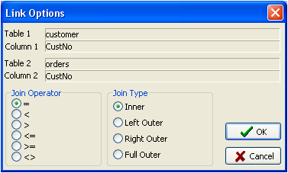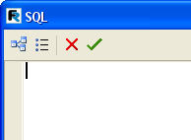

**izards**

**197W**

**14.5.1 Using the Query constructor**

Let's create a simple report using the query builder.

Click “New report” on the designer toolbar to create a report page having “Report header”, “First level data” and “Page footer” bands.

Place an “ADO Query” component on the “Data” tab. Double-click on the component to open the query editor.

Click the button in the query editor to open the query builder window. Select the Customer table in the list of tables (3) and drag it onto the workspace (alternatively double-click on the table). Select the CustNo, Company and Phone fields:

*FastReport v4 © 1998-2014 Fast Reports Inc.*

*Manual v5.0.0*

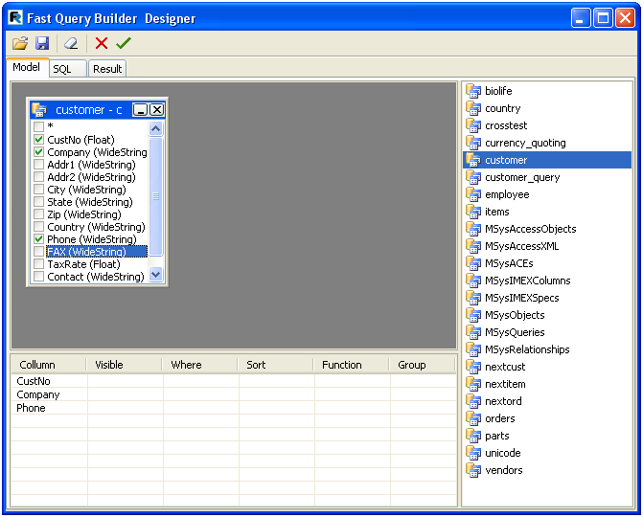**198 FastReport VCL 5 User's Manual**

That is all that is required for query building. The query text appears on the SQL tab and the Result tab shows the data returned by the query. Click to close the builder and to return to the query editor, where the query text is now displayed:

*FastReport v4 © 1998-2014 Fast Reports Inc.*

*Manual v5.0.0*

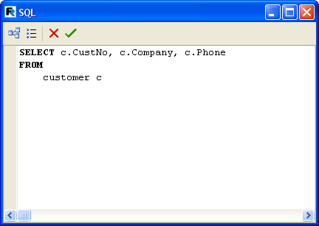

**izards**

**199W**

**Please Note** ! If the query text is altered in the query editor then the query diagram of tables and

joins will be lost. Do not alter the query text manually, always open the query builder and modify the diagram visually.

Clicking in the query editor returns to the report designer. All that is left to do is to connect the “MasterData” band to the data source and place the required fields on the “MasterData” band.

**14.5.2 Complex query building**

In the last example we built a report based on one table. Let's now look at query building where data comes from two tables.

Earlier we looked at a report working with groups. Let's build a query for this report using the query builder. We need to compose a query in SQL which will return data from both tables, with the data grouped on a specific condition. In our example the condition will be CustNo fields in both tables.

As in the previous example, create a new report and put a “TADOQuery” component on the page. Open the query editor and then the query builder.

Drag two tables to the work area Customers and Orders. Both tables have a CustNo field which we will use to join them. Drag the CustNo field from one table to the other table to create a join between the two tables:

*FastReport v4 © 1998-2014 Fast Reports Inc.*

*Manual v5.0.0*

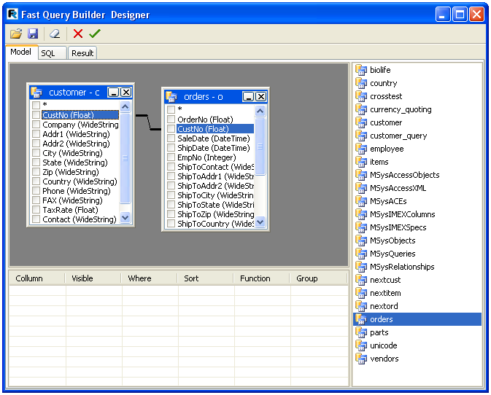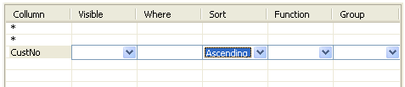**200 FastReport VCL 5 User's Manual**

Now the fields to be displayed and the sort field need to be set. Check the "*" field in both tables and check the CustNo field in the Customer table. The selected fields appear in the field parameters list. Select the sort order for the CustNo field:

That is all that is needed to complete the Query. The SQL code looks like this:

*FastReport v4 © 1998-2014 Fast Reports Inc.*

*Manual v5.0.0*

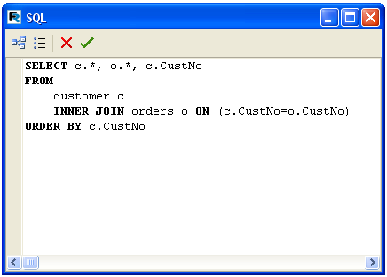

**izards**

**201W**

*FastReport v4 © 1998-2014 Fast Reports Inc.*

*Manual v5.0.0*

**Chapter**

**XV**

**Report viewing,**

**printing and**

**export**

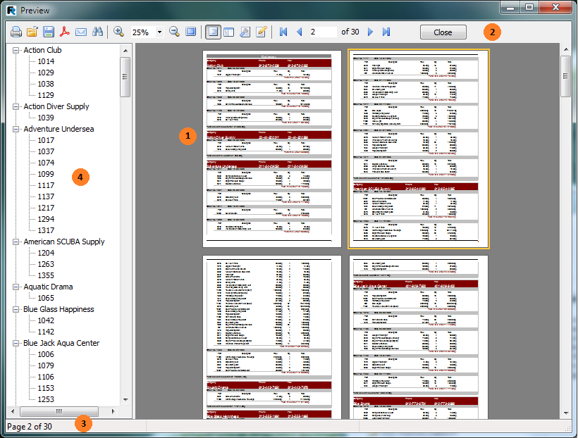

**eport viewing, printing and export**

**203R**

A built report can be displayed and printed or exported into one of the supported formats. Everything can be done in the preview window.

Key:

* finished report pages
* toolbar
* status bar
* outline space for either the outline tree (as shown above) or for thumbnails The toolbar has these buttons:

**Icon**

**Name**

Print report Open report Save report

**Description**

prints report - Hotkey : Ctrl+P opens file containing finished report (*.fp3) saves report to file (*.fp3) or exports report to one

*FastReport v4 © 1998-2014 Fast Reports Inc.*

*Manual v5.0.0*

**204 FastReport VCL 5 User's Manual**

of the supported formats

|  |  |  |
| --- | --- | --- |
| Export to PDF | exports report to Adobe Acrobat file (*.pdf) visible if  corresponding export filter is installed |  |
| Send via e-mail | exports report to one of the supported formats and  sends it via e-mail as enclosure visible if  corresponding export filter is installed |  |
| Text search | text search in report - Hotkey : Ctrl+F |  |
| Zoom in | zooms in on the preview |  |
| Scale | selects arbitrary scale for zoom |  |
| Zoom out | zooms out of the preview |  |
| Full screen | displays report as full screen  return to normal size by double-clicking on report |  |
| Outline | shows or hides report outline |  |
| Thumbnails | shows or hides thumbnail view |  |
| Page properties | opens dialogue with page settings |  |
| Edit page | edits current page |  |
| To beginning | jump to first report page |  |
| Previous page | jump to previous report page |  |
| Page number | jump to report page number  type number and press Enter |  |
| Next page | jump to next report page |  |
| To end | jump to last report page |  |
| Close window | close preview |  |

**15.1 Control keys**

**Keys**

**Description**

|  |  |  |
| --- | --- | --- |
| Ctrl+S | save report to *.fp3 file |  |
| Ctrl+P | print report |  |
| Ctrl+F | text search |  |
| F3 | search again |  |
| Arrows | smooth report scrolling |  |
| PageUp, PageDown | up/down report scrolling |  |

Ctrl+PageUp, PageDown next/previous page report scrolling

|  |  |  |  |
| --- | --- | --- | --- |
| Home | report beginning |  |  |
| End | report end |  |  |

*FastReport v4 © 1998-2014 Fast Reports Inc.*

*Manual v5.0.0*

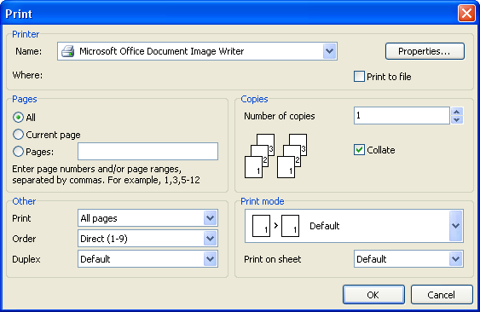

**eport viewing, printing and export**

**205R**

**15.2 Mouse control**

**Action**

**Description**

|  |  |  |
| --- | --- | --- |
| Left button | click on selected object (in interactive report)  report scrolling in “hand” mode (move mouse with button held down)  zoom in when in “magnifier” mode |  |
| Right button | context menu  zoom out in “magnifier” mode |  |
| Double-click | return to normal size when in full-screen mode |  |
| Mouse wheel | report scrolling |  |

**15.3 Report printing**

To print a report click on the button (or Ctrl+P hotkey). The standard print dialogue opens.

Let's look at the options available in this dialogue.

Printer” panel : select printer on which to print the report; set printer properties, for example printing quality; choose to print to file.

*FastReport v4 © 1998-2014 Fast Reports Inc.*

*Manual v5.0.0*

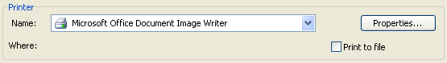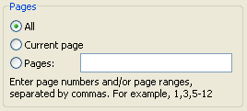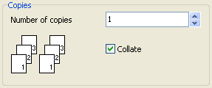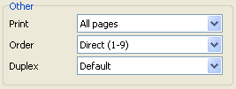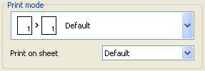**206 FastReport VCL 5 User's Manual**

Pages” panel : select which pages to print (all, current or selected range).

Copies” panel : set number of copies to print. If printing more than one copy and Collate is

checked then the first copy is printed in full, then the second in full, etc. If Collate is not checked then all copies of the first page are printed followed by all copies of the second page, etc.

Other” panel :

* Print : select which pages to print (All pages, Even pages, Odd pages)
* Order : print pages in direct or reverse order (first page to last, last page to first)
* Duplex : handle duplex by default (report settings are used) or choose one of duplex options: vertical, horizontal, simplex

Print mode” panel : select the printing mode.

*FastReport v4 © 1998-2014 Fast Reports Inc.*

*Manual v5.0.0*

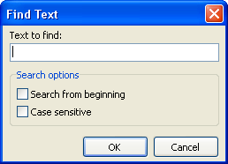

**eport viewing, printing and export**

**207R**

* Default mode : prints on the sheet defined in the report. One preview page is printed on each sheet

* Split big pages : this mode is useful if printing an A3 report on an A4 sheet. One preview page is printed on more than one sheet. When this mode is chosen the sheet size (“Print on sheet”) must also be specified.

* Join small pages : this mode is useful if printing an A4 report on an A3 sheet. Two or more preview pages are printed on one sheet. When this mode is chosen the sheet size (“Print on sheet”) must also be specified.

* Scale mode : report is printed on specified size of sheet. All report output is scaled. One preview page is printed on one sheet. When this mode is chosen the sheet size (“Print on sheet”) must also be specified.

When ΞΚ is clicked the report printing begins. If “Print to file” is checked then the standard “Save As...” dialogue opens. The report is saved to this file with *.prn extension. The file contains a copy of the information sent to the printer.

**15.4 Text search in reports**

FastReport can search for a given phrase within the text of a previewed report. Search using the button on the toolbar (or Ctrl+F hotkey). The search dialogue opens:

Enter the phrase to be searched for and select options if required:

* Search from beginning : search report from the beginning; otherwise searching is from current page on
* Case sensitive : match the case of the search phrase (lower or upper) when searching

*FastReport v4 © 1998-2014 Fast Reports Inc.*

*Manual v5.0.0*

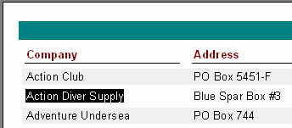**208 FastReport VCL 5 User's Manual**

On clicking ΞΚ the search is started and the first occurrence (if any) is highlighted:

To continue searching click F3. The next occurrence (if any) will be highlighted

**15.5 Report Export**

FastReport can export a previewed report to various formats for further editing, archiving or sending by e-mail, etc.. To enable export the appropriate FR export components must be added to the Delphi form.

FastReport can export to the following formats: PDF, Open Document Spreadsheet, Open Document Text, Excel 97/2000/XP, Excel XML, Excel 2007, RTF, Word 2007, PowerPoint 2007, HTML, text, CSV, BMP, Jpeg, Tiff, and Gif. Also, reports can be sent by e-mail in any of these listed formats.

*FastReport v4 © 1998-2014 Fast Reports Inc.*

*Manual v5.0.0*

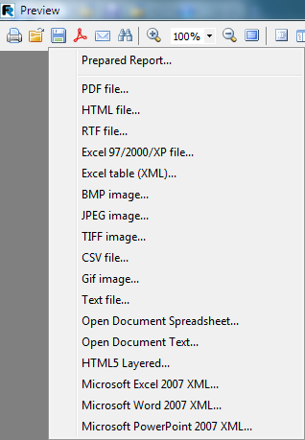

**eport viewing, printing and export**

**209R**

FastReport uses one of the three following methods to export reports:

* 'Layer' : each report object is exported to a separate layer. The exported output approximates to the original preview.
* 'Table' : export of objects to the output file is by creation of a transitional grid in memory and then output of this grid. The exported output closely matches the original preview, based on the assumption that the principles of good report design were followed (see “Report Design considerations” chapter).
* 'Drawing' : exported objects are captured from the page image. The exported output is a direct copy of the preview. This method is used when exporting to graphic formats.

**15.5.1 Export to PDF Format**

PDF (Portable Document Format): a platform-independent format of electronic documents created by Adobe Systems. The free Adobe Reader package is used for viewing. This format is flexible it allows inclusion of required fonts, vector and bitmapped images; it is a means to distribute and store documents intended for viewing and/or printing.

The Export method is 'layer-by-layer'.

When exporting to PDF format a dialogue opens requesting output file settings.

*FastReport v4 © 1998-2014 Fast Reports Inc.*

*Manual v5.0.0*

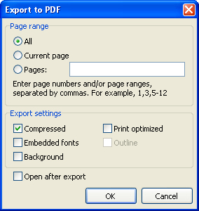**210 FastReport VCL 5 User's Manual**

Export settings:

* Compressed : output file is compressed, file-size is reduced but export time is increased
* Embedded fonts : all fonts used in report are contained in the PDF output file, allows accurate rendering on computers where the fonts are absent; output file size is considerably increased
* Background : graphic image assigned to page background is exported to PDF file; output file size is considerably increased
* Print optimized : graphic images output in high resolution for accurate printing; this option is only necessary when a document contains graphics and will be printed; output file size is considerably increased
* Outline : option is enabled only when report contains an outline; outline is exported to PDF file
* Open after export : exported file is opened immediately after export using default PDF viewer installed on the computer (for example, Adobe Reader).

Export feature : RichText objects are exported as graphics.

**15.5.2 Export to Open Document**

Open Document Format (ODF, OASIS Open Document Format for Office Application) was designed by OASIS and based on the XML format used in OpenOffice.

FastReport supports export to table (.ods) and text (.odt) files. These files can be opened in OpenOffice.

The Export method is 'table'.

When exporting to ODF format a dialogue opens requesting output file settings.

*FastReport v4 © 1998-2014 Fast Reports Inc.*

*Manual v5.0.0*

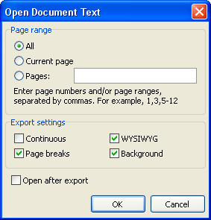

**eport viewing, printing and export**

**211R**

Export settings:

* Continuous : export as a continuous document, without page breaks and without page headers/footers
* Page breaks : enables page breaks in the document
* WYSIWYG : accurate rendition of previewed report; when disabled optimization is allowed, reducing the number of lines and columns in the export file
* Background : graphic image assigned to page background(s) is exported to ODF file; output file size is considerably increased
* Open after export : exported file is opened immediately after export.

Export feature : RichText objects are exported as simple text, export of graphic images is supported.

**15.5.3 Export to RTF Format**

RTF (Rich Text Format) was developed by Microsoft as a standard for the interchange of text documents. RTF documents are supported by many modern text editors and operating systems.

The Export method is 'table'.

When exporting to RTF format a dialogue opens requesting output file settings.

*FastReport v4 © 1998-2014 Fast Reports Inc.*

*Manual v5.0.0*

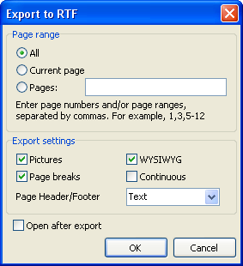**212 FastReport VCL 5 User's Manual**

Export settings:

* Pictures : enables export of graphic images to file
* Page breaks : enables page breaks in the document
* WYSIWYG accurate rendition of previewed report; when disabled optimization is allowed, reducing the number of lines and columns in the export file
* Continuous : export as a continuous document, without page breaks and without page headers/footers
* Page header/footer : header/footer export mode; modes are: Text (h/f exported as normal text), Header/Footer (h/f exported) and None (h/f not exported)
* Open after export : exported file is opened immediately after export using default RTF viewer installed on the computer (for example, Microsoft WordPad)

Export feature : RichText objects are fully integrated in RTF format; accuracy of rendering and file-size depend on how the report was designed, see the “Report Design considerations” chapter.

**15.5.4 Export to Word 2007**

Word 2007 is an application for working with text documents. It is included into Microsoft Office 2007.

The export method is 'table'.

When exporting to Word 2007 format a dialogue opens requesting output file settings.

*FastReport v4 © 1998-2014 Fast Reports Inc.*

*Manual v5.0.0*

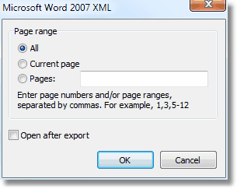

**eport viewing, printing and export**

**213R**

Export settings:

* Open after export output file will be opened immediately after export.

**15.5.5 Export to Excel 97/2000/XP**

Excel application for working with electronic spreadsheets. It is included in Microsoft Office. The Export method is 'table'.

When exporting to Excel format a dialogue opens requesting output file settings.

*FastReport v4 © 1998-2014 Fast Reports Inc.*

*Manual v5.0.0*

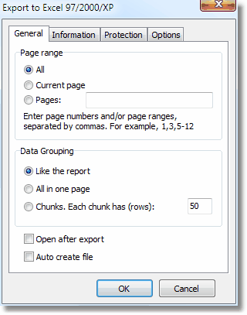**214 FastReport VCL 5 User's Manual**

Data grouping:

* Like the report - each page of prepared report is exported on a separate Excel sheet;
* All in one page - generate continuous document without page breaks and page headers/ footers;
* Chunks. Each chunk has (rows) - each chunk is exported on a separate Excel sheet. Export settings:
* WYSIWYG : full compliance to report appearance; when disabled optimization is allowed, reducing the number of lines and columns in the export file
* Pictures includes graphic images export into output table;
* Grid lines - turns on/off Excel grid lines;
* Adjust page size - adjusts cell size to fit the content;
* Delete empty rows - deletes empty rows from the output table;
* Export formulas - if a cell text starts with "=" symbol, it is exported as an Excel formula.
* Open Excel after export : exported file is opened immediately after export.

Export features: RichText objects are transferred as simple text, graphic image transfer is supported.

*FastReport v4 © 1998-2014 Fast Reports Inc.*

*Manual v5.0.0*

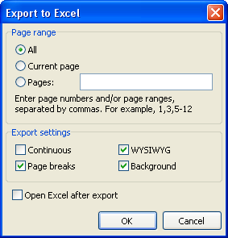

**eport viewing, printing and export**

**215R**

**15.5.6 Export to Excel XML Format**

XML (Extensible Markup Language) is an extendable markup language. XML is intended for structured data storage and also for information exchange between different programs. FastReport uses XML format for data transfer into Excel ver. 2003 and later.

Export method is 'table'.

On exporting to XML format the dialogue box for output file parameter settings appears.

Export parameters:

* Continuous - generate continuous document without page breaks and page headers/footers
* Page breaks enables page breaks in the document
* WYSIWYG accurate rendition of previewed report; when disabled optimization is allowed, reducing the number of lines and columns in the export file
* Background : background color of report page(s) exported to spreadsheet
* Open Excel after export : exported file is opened immediately after export.

Export features : RichText objects are exported as simple text; graphic images are not supported.

**15.5.7 Export to Excel 2007**

Excel 2007 is an application for working with electronic worksheets. It is included into Microsoft Office 2007.

The export method is 'table'.

When exporting to Excel format a dialogue opens requesting output file settings.

*FastReport v4 © 1998-2014 Fast Reports Inc.*

*Manual v5.0.0*

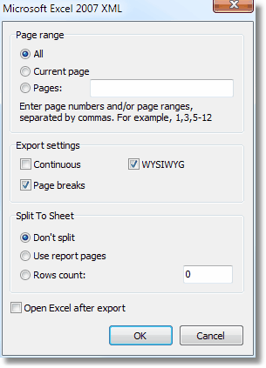**216 FastReport VCL 5 User's Manual**

Split to sheet:

* Don't split - all report pages are exported to a single Excel sheet;
* Use report pages - each page of prepared report is exported on a separate Excel sheet;
* Rows count - each set of rows is exported on a separate Excel sheet.

Export parameters:

* Continuous - generate continuous document without page breaks and page headers/footers;
* Page breaks includes page breaks in resulting document;
* WYSIWYG accurate rendition of previewed report; when disabled optimization is allowed, reducing the number of lines and columns in the export file;
* Open Excel after export - exported file is opened immediately after export. Export features: RichText objects are transferred as simple text, graphic images are supported.

**15.5.8 Export to PowerPoint 2007**

PowerPoint 2007 is an application for working with electronic presentations. It is included into Microsoft Office 2007.

Export method is a layered one.

When exporting to PowerPoint format a dialogue opens requesting output file settings.

*FastReport v4 © 1998-2014 Fast Reports Inc.*

*Manual v5.0.0*

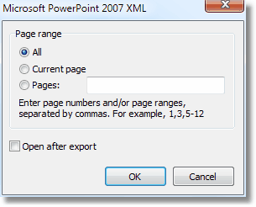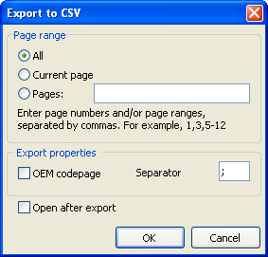

**eport viewing, printing and export**

**217R**

Export settings:

* Open after export exported file will be opened immediately after export.

**15.5.9 Export to CSV Format**

CSV files contain tabular data (numbers and text) in plain-text form. A specified separator is inserted between column values and each row starts on a new line. This format can be opened by various table/diagram editors.

The Export method is 'table'.

When exporting to CSV format a dialogue opens requesting output file settings.

Export settings:

* OEM codepage : OEM coding for exported file

*FastReport v4 © 1998-2014 Fast Reports Inc.*

*Manual v5.0.0*

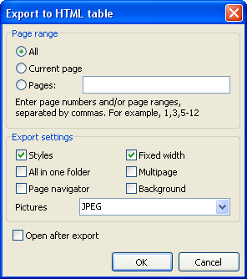**218 FastReport VCL 5 User's Manual**

* Separator : separator used between columns
* Open after export : exported file is opened immediately after export using default CSV viewer installed on the computer.

Export features : no layout information (i.e. report design) is included in the export file; graphic images are not supported.

**15.5.10Export into HTML Format**

HTML (Hypertext Markup Language) is regarded as the standard language for documents on the Internet. It is used for creating relatively simple but well designed documents. HTML supports hypertext linking as well as simple document layout.

The Export method is 'table'.

When exporting to HTML format a dialogue opens requesting output file settings.

Export settings:

* Styles : design styles for text objects exported; when disabled exporting speed is increased, but detracts from spreadsheet appearance
* All in one folder : all additional files are saved in the same folder as the main file
* Page navigator : special navigator for fast jumping between pages created
* Fixed width : blocks automatic table/diagram width adjustment when changing display window size
* Multipage : each page exported as a separate file
* Background : graphic image assigned to page background is exported to HTML file
* Pictures : graphic image exported to HTML file

*FastReport v4 © 1998-2014 Fast Reports Inc.*

*Manual v5.0.0*

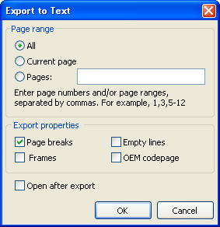

**eport viewing, printing and export**

**219R**

* Open after export : exported file is opened immediately after export using default HTML viewer installed on the computer.

Export features : export may consist of several files; each graphic image exported to its own file; RichText objects are exported as simple text; accuracy of rendering and file-size depend on how the report was designed, see the “Report Design considerations” chapter.

**15.5.11Export to Text Format**

Normal plain text file without any graphics.

The Export method is 'table'.

When exporting to Text format a dialogue opens requesting output file settings.

Export settings:

* Page breaks : export of page breaks to resulting file
* Empty lines : enables page breaks in the document
* Frames : enables text object frame export
* OEM codepage : OEM coding for exported file
* Open after export : exported file is opened immediately after export using default text viewer installed on the computer.

Export features: no layout information (i.e. report design) is included in the export file; graphic images are not supported: page width is automatically set dependent on the type of text objects on report page.

*FastReport v4 © 1998-2014 Fast Reports Inc.*

*Manual v5.0.0*

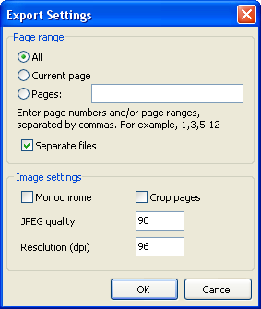**220 FastReport VCL 5 User's Manual**

**15.5.12Export to Jpeg, BMP, Gif, Tiff Graphic Formats**

FastReport exports to graphic formats.

* JPEG (Joint Photographic Experts Group) : a compressed format based on an algorithm that records differences between pixels. It is characterized by high compression at the expense of graphic accuracy.

* BMP (Windows Device Independent Bitmap) : used for storage of bitmap images used in Windows. A standard file format for computers under Windows control.

* GIF (Graphics Interchange Format) : hardware independent format was developed for transmission of bitmap images through networks. Well suited for compressing homogeneous content (logos, inscriptions, schemes).
* TIFF, TIF (Target Image File Format) : hardware independent format. Today it is one of the most widespread and reliable in polygraphy and facsimile transmission.

The Export method is 'enveloping'.

When exporting in the above graphic formats a dialogue opens requesting output file settings.

Export settings:

* Separate files : when enabled each report page is exported to a separate file; filenames are derived from the specified filename by suffixing an underscore + page number
* Monochrome : exports as a monochrome image
* Crop pages : blank space round the page edges are cropped
* JPEG quality : JPEG compression ratio; only enabled when exporting to JPEG format
* Resolution : graphic resolution of exported image

*FastReport v4 © 1998-2014 Fast Reports Inc.*

*Manual v5.0.0*

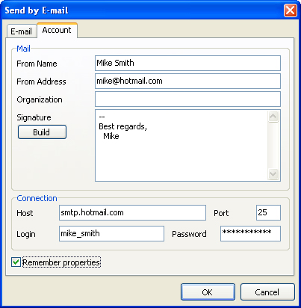

**eport viewing, printing and export**

**221R**

Export features: when the Separate files is disabled one very large file is created.

**15.6 Sending a Report via E-mail**

FastReport can send a finished report by e-mail in any format required without the need for a separate mail application.

When exporting by e-mail the E-mail setup dialogue is opened. Before exporting begins the sender's email account details should be set on the “Account” tab:

* From Name :– sender’s name
* From Address : sender’s e-mail address
* Organization : sender’s organization
* Signature : signature for e-mail; it can be generated by clicking on the “Build” button once the earlier fields have been filled in
* Host : SMTP server service
* Port : SMTP server port
* Login : access name for authorization on SMTP server, if required by the specified SMTP server
* Password : authorization password, if required by the specified SMTP server
* Remember properties : remember all fields for further usage

After filling in the necessary fields on the “Account” tab, the message fields on the "E-mail” tab

*FastReport v4 © 1998-2014 Fast Reports Inc.*

*Manual v5.0.0*

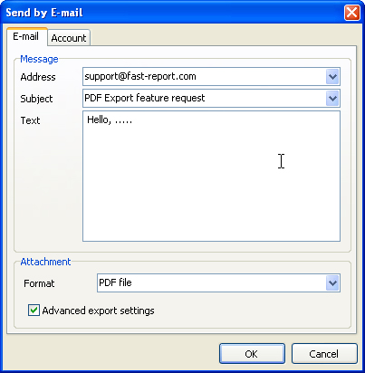**222 FastReport VCL 5 User's Manual**

must be completed:

* Address : e-mail address of recipient; previously used addresses can be selected from the drop-down list
* Subject : message subject; previously used subjects can be selected from the drop-down list
* Text : message text
* Format : format of exported report attached to the e-mail; select one of the available export formats; the FastReport (FR3) format is also available for selection
* Advanced export settings : when enabled the OK button opens the appropriate export format settings dialogue; when disabled default export settings are used

Export via e-mail features: only plain authentication on SMTP servers is supported. If authentication is not required then it is not necessary to enter “Login” and “Password”.

**15.7 Report Design considerations**

The quality of the export output in any format is highly dependent on the quality of the original report design. FastReport can manipulate objects in a large number of ways during report creation. This has the advantage of fast development of reports and subsequent printing. Printed documents look just as previewed. This is the primary objective of the FastReport report engine. The downside of this development freedom is the complexity of exporting FastReport documents to different data formats, each of which has its own, sometimes complex, requirements and limitations. In this chapter, special design requirements for reports intended for export will be discussed.

*FastReport v4 © 1998-2014 Fast Reports Inc.*

*Manual v5.0.0*

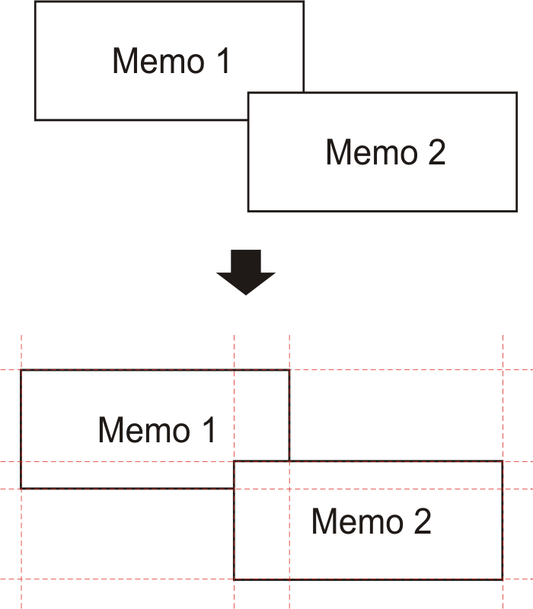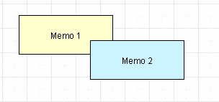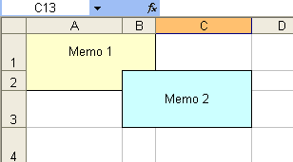

**eport viewing, printing and export**

**223R**

Many formats use tabular data presentation, such as HTML, XLS, XML, RTF and CSV. In contrast to the freedom allowed in FastReport page design, when exporting to these formats the output cells created for these tables cannot intersect or be arranged in layers. Export filters, as a rule, take into account these requirements when objects are exported by FastReport, by the use of special algorithms dealing with intersections and the optimal placing of cells. At object intersections new columns and lines are created in the output table. This is necessary to enable FastReport to position objects exactly and to obtain the best correspondence with the original preview page. A large number of intersecting objects in a report design leads to a large number of additional columns and rows in the output table. This in turn can lead to the need for editing of the exported file in its own editor before suitable for further use.

For example, take a report where the design has a slight overlap of two objects in the same band and the number of records in the report is 150. On export to RTF format 450 lines will be created (150 rows for each object and 150 rows for the intersection). If we remove the overlap there would only be 300 rows. For large reports with a large number of objects the difference would be much greater. This, of course, affects the size of the output file.

*Objects in the report*

*Export to Excel - result*

Bear this in mind when designing reports intended for export to any of the formats that use the 'table' output method.

When designing tables in reports be aware of the borders of neighboring cells. It is important that cells do not overlap and are not arranged in layers. The export algorithm may deal with the cells in an unexpected way and give a result far from that intended. It is best to arrange objects in such a way that they are placed in line both vertically and horizontally. Guidelines can help to achieve this.

*FastReport v4 © 1998-2014 Fast Reports Inc.*

*Manual v5.0.0*

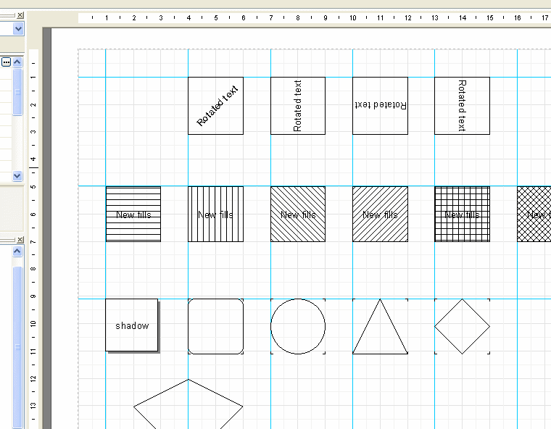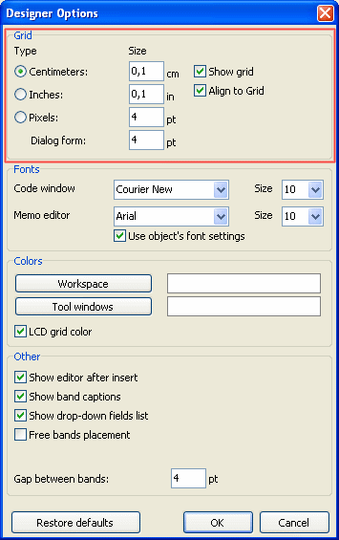**224 FastReport VCL 5 User's Manual**

*Using guidelines in the designer*

To use guidelines in FastReport designer just click on the horizontal or vertical ruler at the top or left edge of the report page and drag the ruler to the required position on the page, where a guideline will be displayed. You will then be able to place objects aligning to these horizontal and vertical guidelines.

Grid alignment can also be helpful in placing “Text” objects to avoid them overlapping. The grid is enabled in the designer Options, where the pitch can also be adjusted : “View > Options > Grid”.

*FastReport v4 © 1998-2014 Fast Reports Inc.*

*Manual v5.0.0*

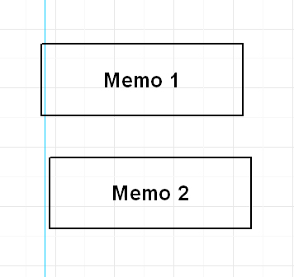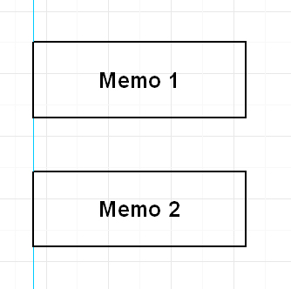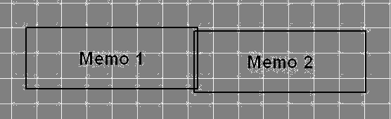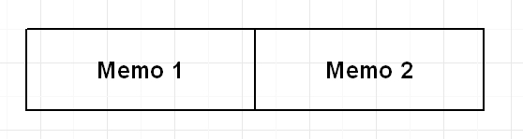

**eport viewing, printing and export**

**225R**

When using frames around “Text” objects it is best to use the object's frame properties, rather than adding graphic objects like lines and rectangles around the text. Also, try not to use objects in the background beneath transparent text objects.

Keeping these simple rules in mind will help you to create a report which will look perfect after export to any format that uses the table-based output method.

Below are some examples of good and bad arrangement of objects.

*Bad*

*Good*

The objects are displaced horizontally - they do not line up horizontally with the vertical guideline.

*Bad*

*Good*

The objects are overlapping - on export to a table/diagram format additional unnecessary rows and columns and also three additional cells in the overlap zone are created.

Study of the demo reports included in the FastReport installation is recommended, to help master the basic principles of good report design.

*FastReport v4 © 1998-2014 Fast Reports Inc.*

*Manual v5.0.0*