# QA-CRUD-Project

Why are we doing this?
we are doing this project to consolidate the learning of using Spring Boot to create an API with CRUD functionality that is connected to a working database(H2/MySQL)

How I expected the challenge to go.
I expect the challenge to go relatively smoothly asides for the testing aspect

What went well? / What didn't go as planned?
the testing didn’t go as planned.
connecting to the h2 and MySQL was troublesome but got there in the end.
testing on postman and seeing results in database went well
creating API went well
using GitHub feature branching went well

Possible improvements for future revisions of the project.
complete the testing section

Screenshots showing your postman requests and the output from the API.

post/create request:

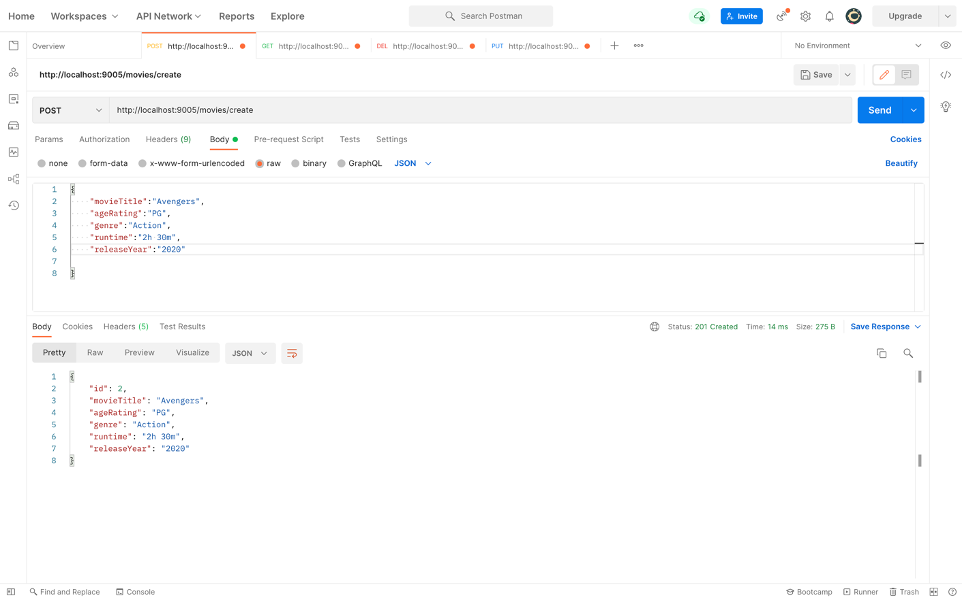

get/read request:
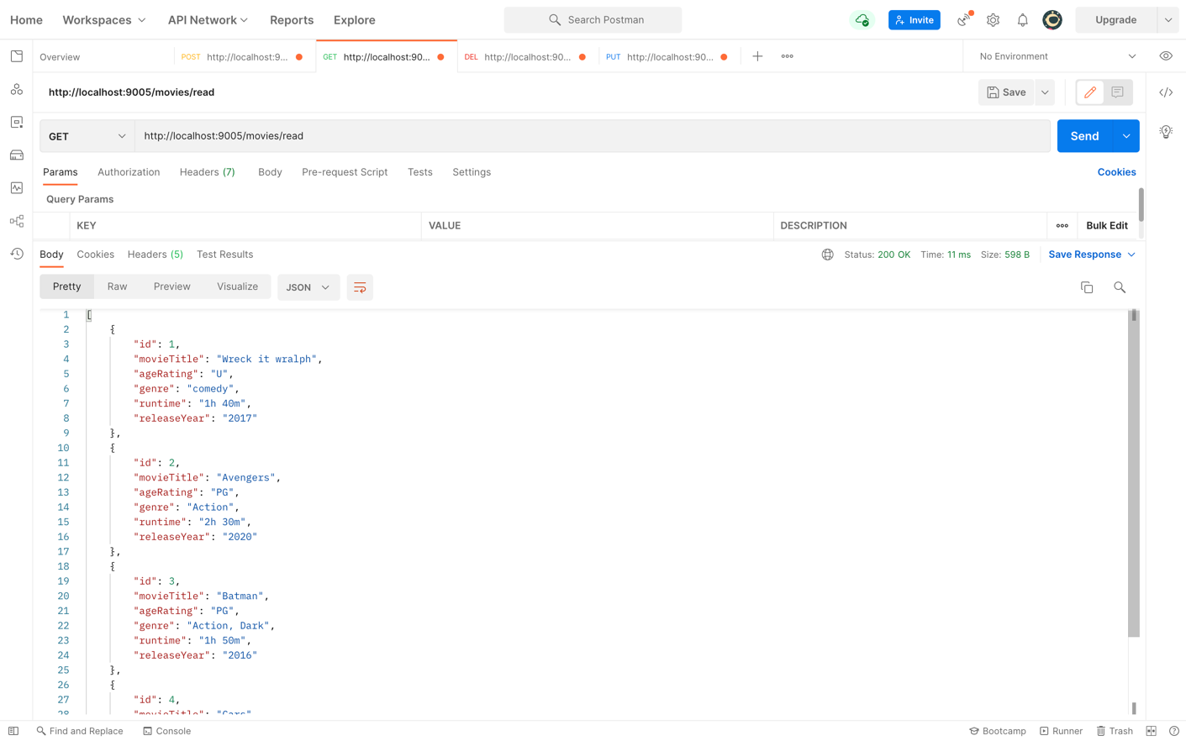

delete request: I removed the first movie:
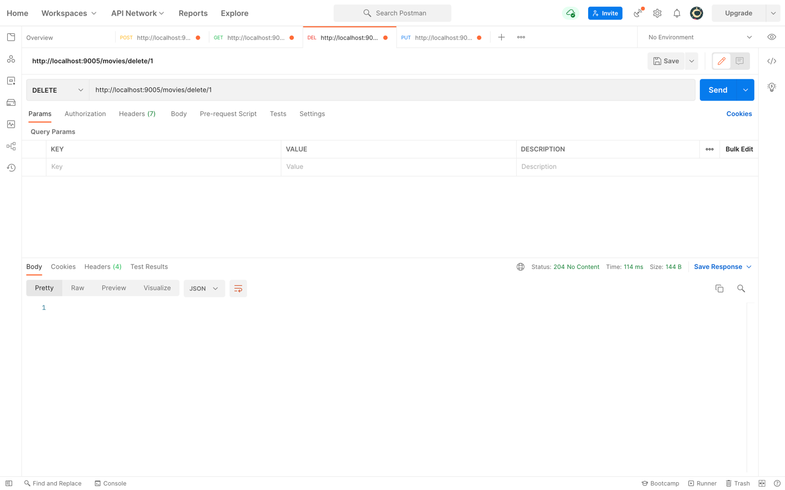

shows first movie removal when I use read all
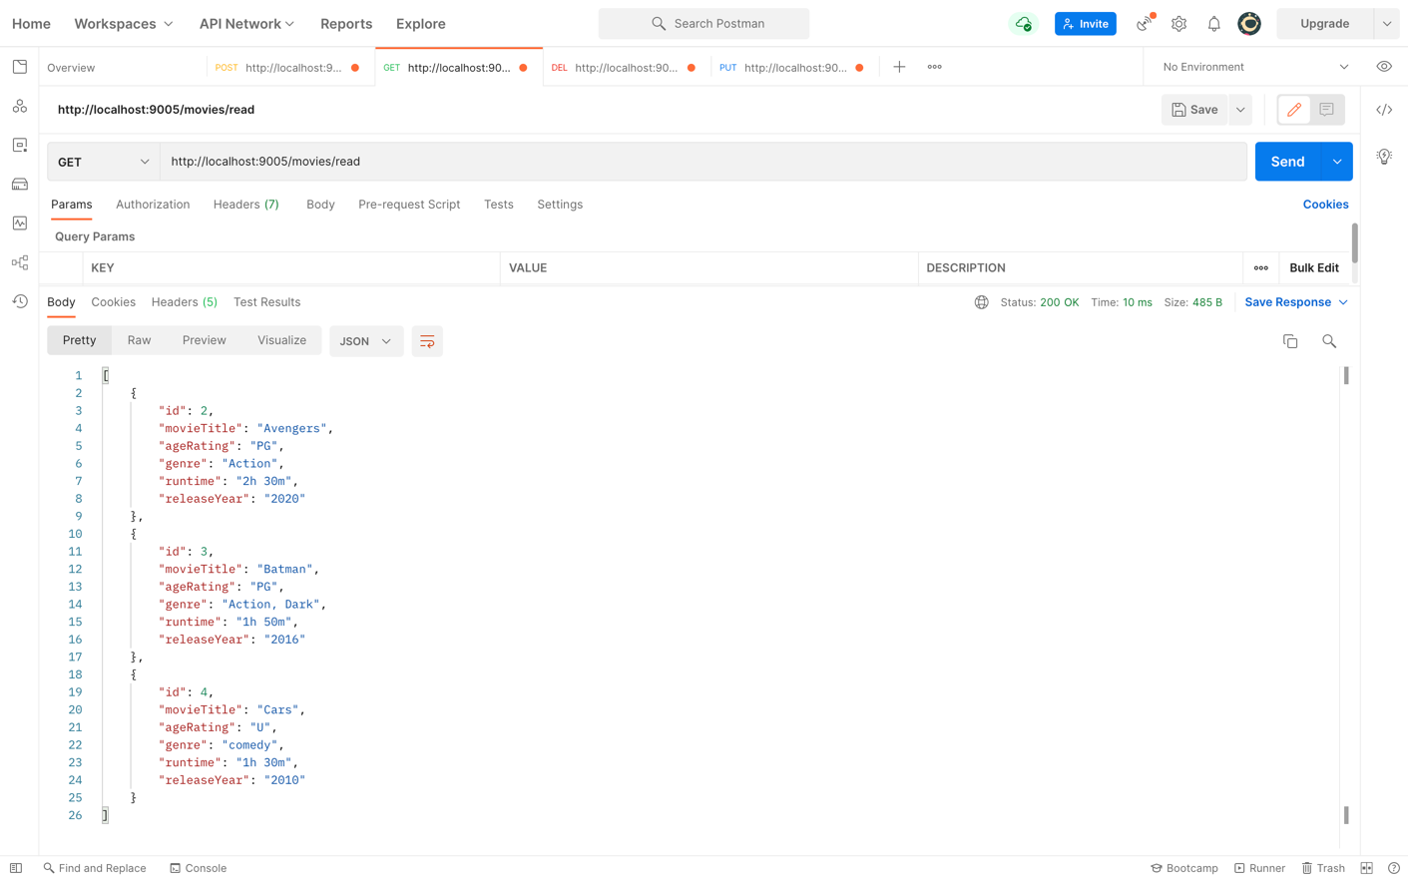

changing data in last movie entry using update:

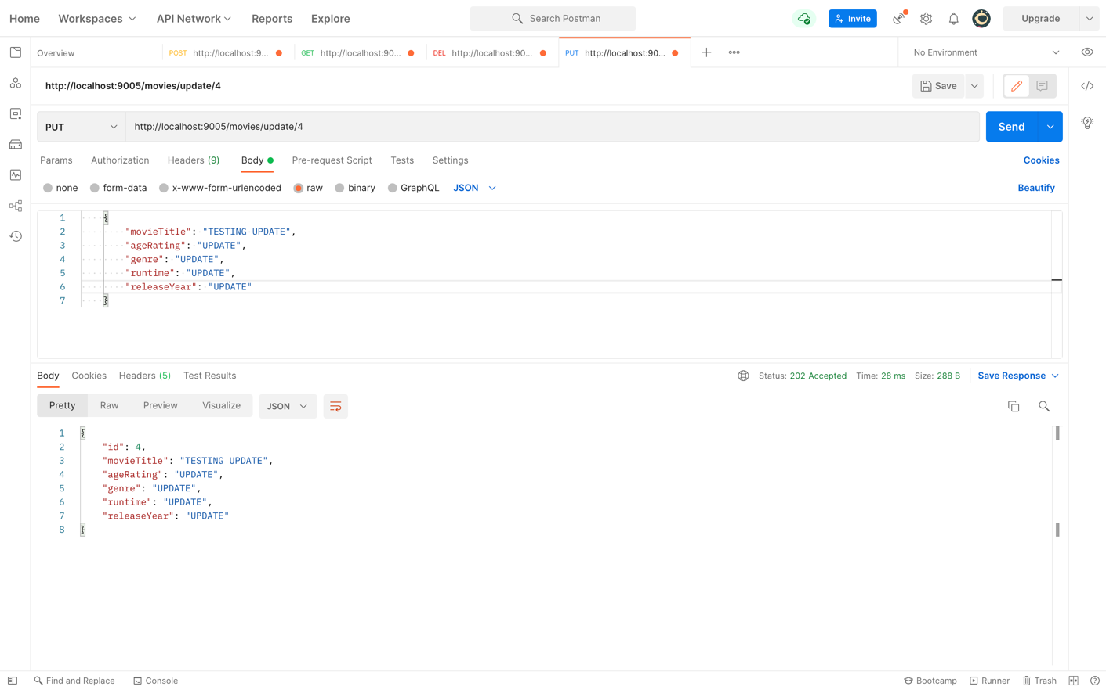

showing the change once I use readall:

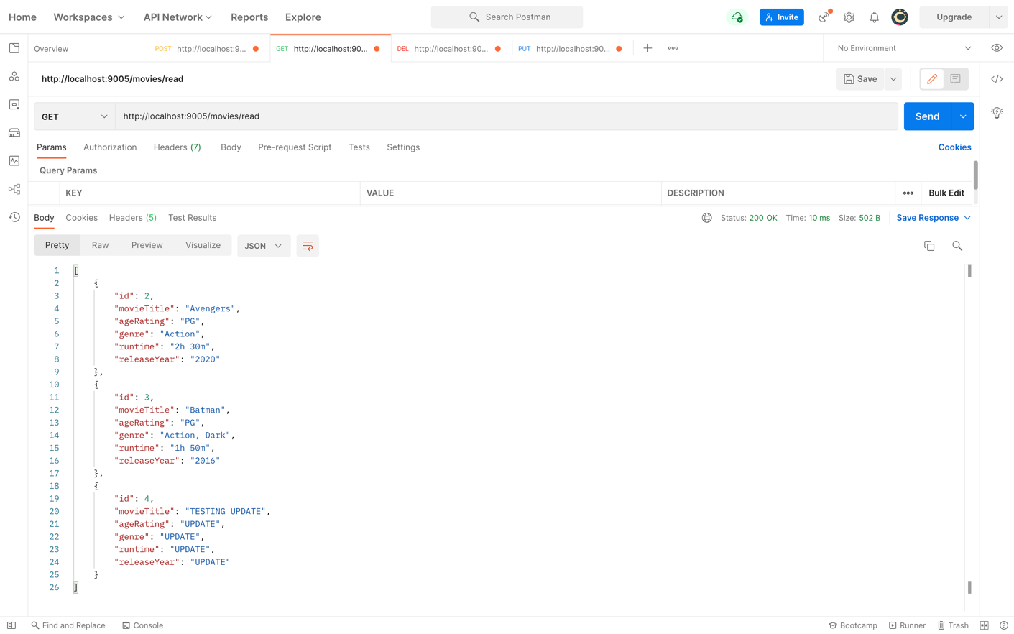

Screenshots of your database to prove that data is being persisted.

H2 database after files have been added in postman:
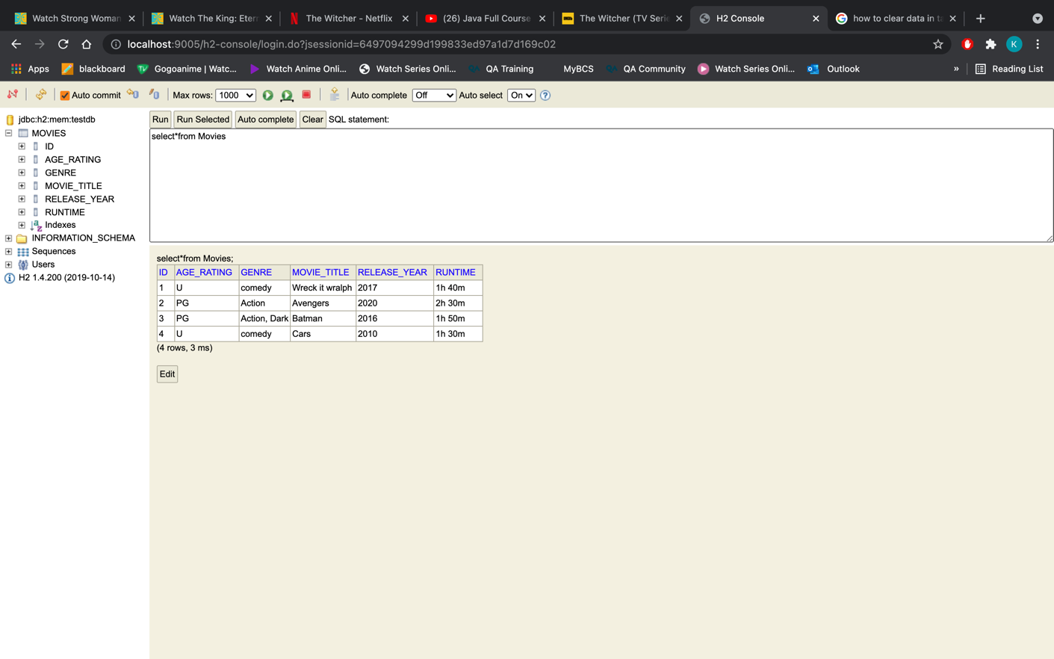

After I use a delete request to remove the first movie:
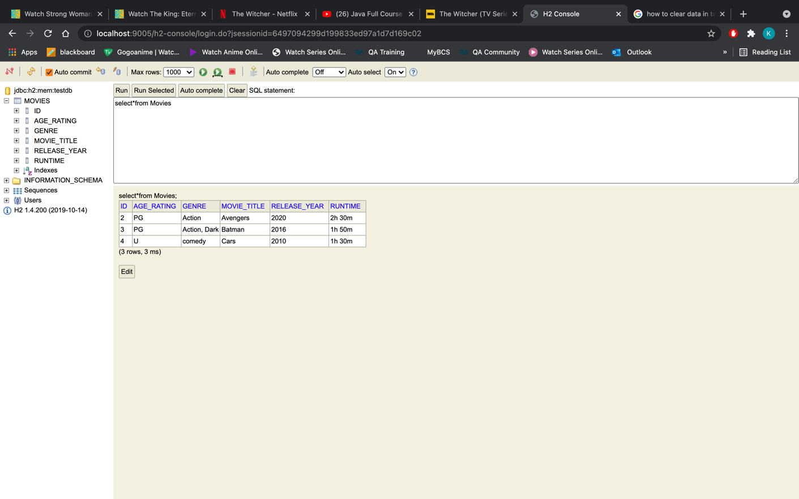

reflecting change in database after using update in postman:
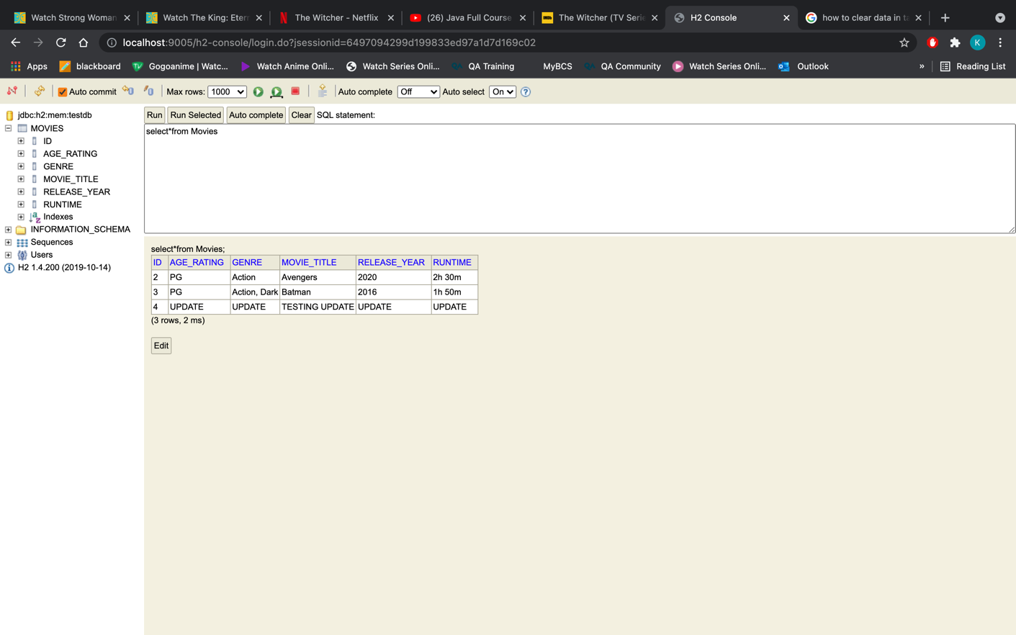

added my jar file:
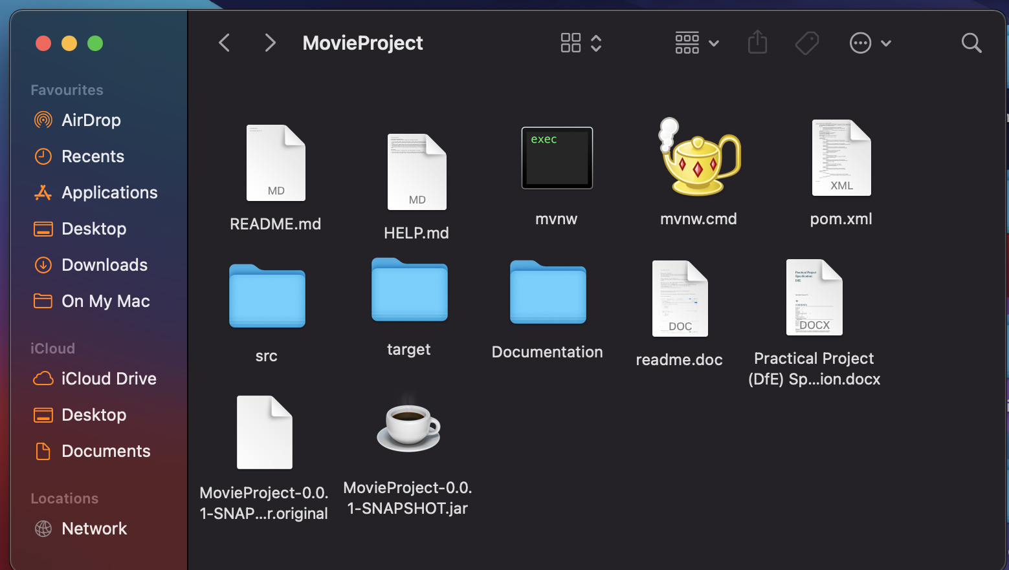

Screenshot of your test results, including coverage report.

NA

Link to Jira Board - You must add both Pawel and Anoush as collaborators also.

Link to Jira:
https://kyrone.atlassian.net/jira/software/projects/CRUD/boards/1

