COLLEGE OF ENGINERING AND COMPUTER STUDIES

**OUTCOMES EVALUATION #** 2

IPTL Integrative Programming and Technologies Lab

E-Commerce Product Upload and Management System: A Front-End Development with HTML, CSS,

and JavaScript

Submitted By

Fajardo, Mark Tranquilino G. IV

Garcia, Kristian Keneth M

Course & Section

BSIT, 3-1

Date

January 16, 2025

**OUTCOMES OUTLINE**

1. **DESCRIPTION**

This activity involves developing a functional e-commerce product management interface using HTML, CSS, and JavaScript. The task focuses on creating a dynamic and interactive user interface that simulates an online product management system commonly seen in e-commerce platforms. Implement features that facilitate the upload, display, editing, deletion, and organization of product data in a client-side web application.

1. **OBJECTIVES**

• Create interactive web applications using HTML, CSS, and JavaScript.

• Validate user inputs, including image file types and sizes, to ensure proper product uploads.

• Implement dynamic features such as editing and deleting products using JavaScript.

• Design user interfaces that focus on usability, responsiveness, and interactivity.

• Manage a product list by integrating features such as sorting, searching, and filtering.

• Integrate a product rating system that allows users to rate products from 1 to 5 stars.

• Demonstrate the ability to handle user actions and provide immediate visual feedback on the interface

1. **THEORETICAL FRAMEWORK**

|  |  |  |
| --- | --- | --- |
| **INPUT** | **PROCESS** | **OUPUT** |
|  |  |  |

1. **RESULTS AND DISCUSSION** (screenshots of I/O, essential codes, logic with brief discussions)

**INITIAL**

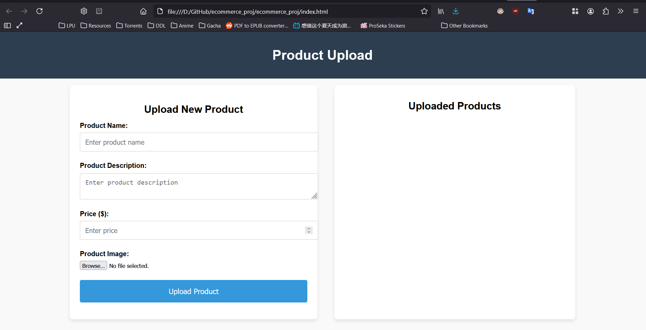

Fig. 1.0, Initial UI

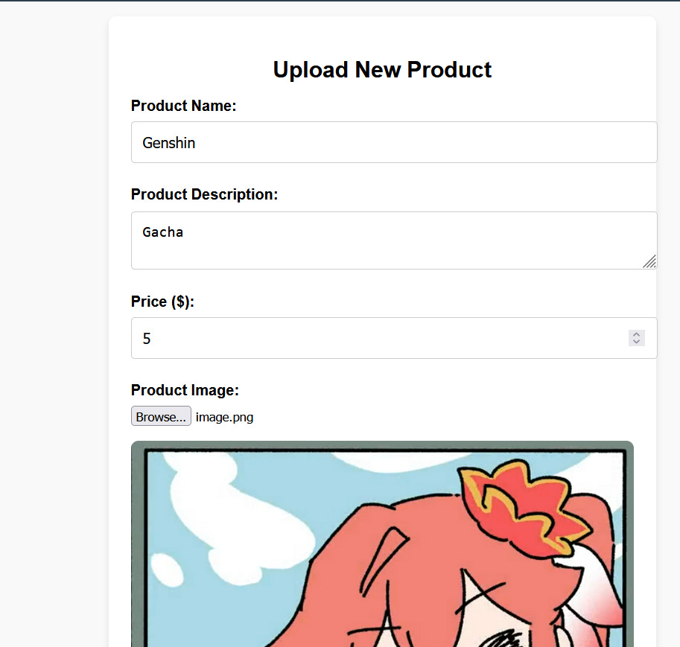

Fig. 1.1, Sample Upload

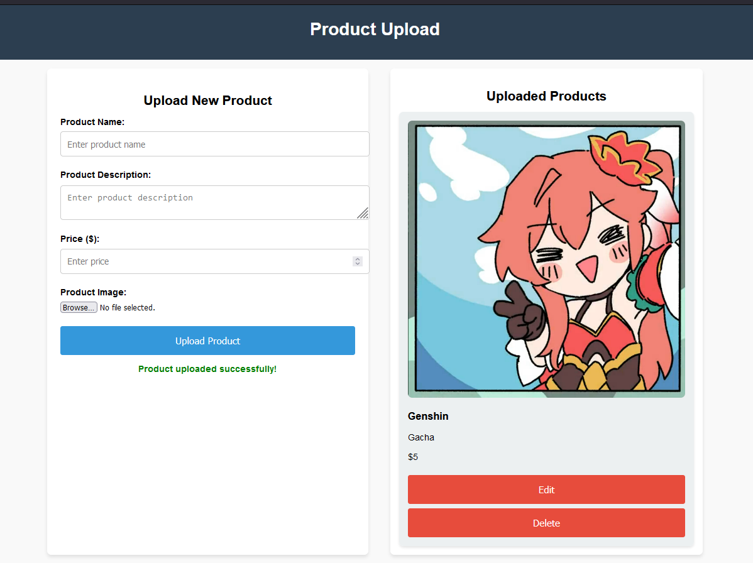

Fig 1.2, Uploaded Products

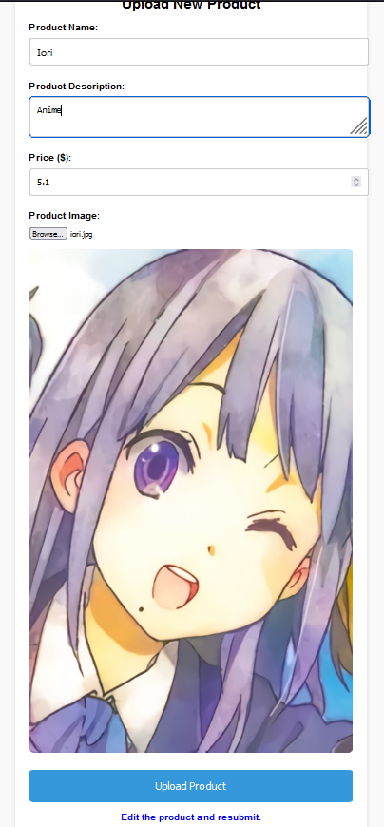

Fig. 1.3, Edited Product (Zoomed)

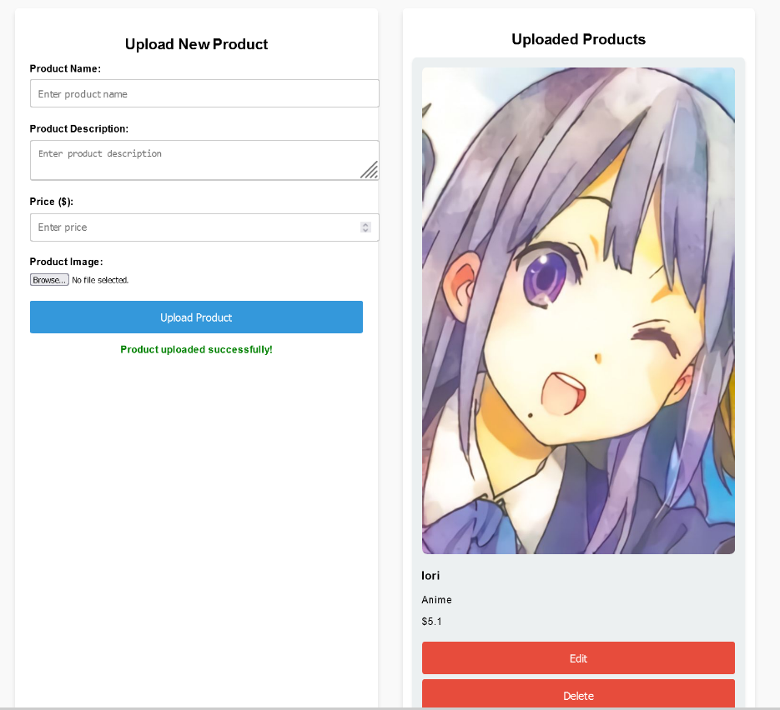

Fig. 1.4, Updated Product

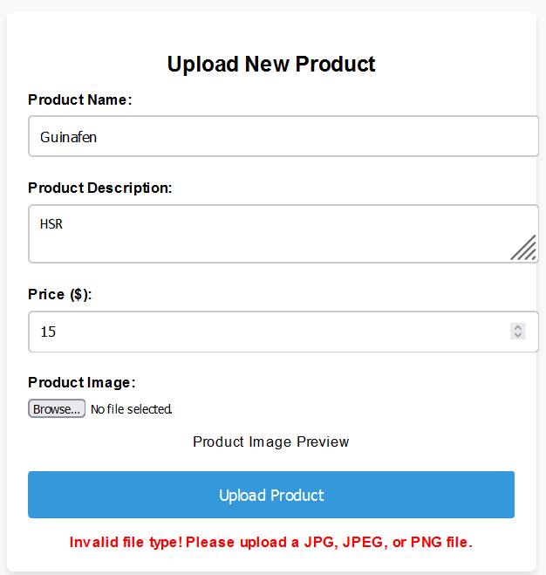

Fig. 2.0, File Validation

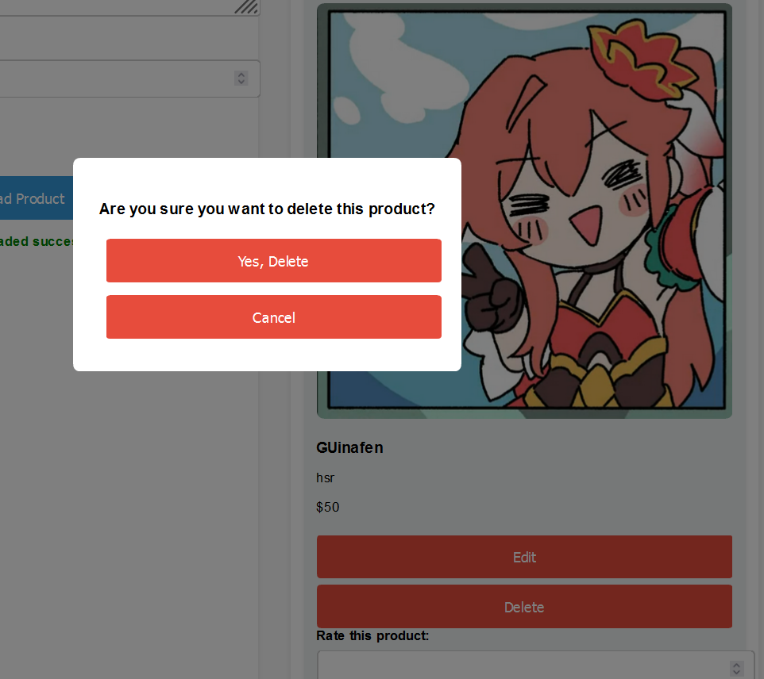

Fig. 2.1, Delete Confirmation

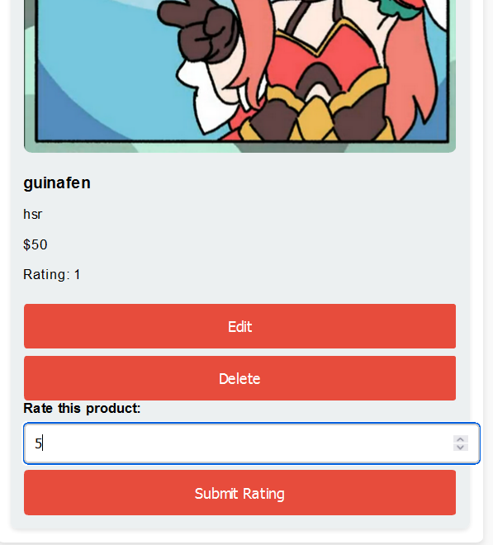

Fig. 2.2, Rating System

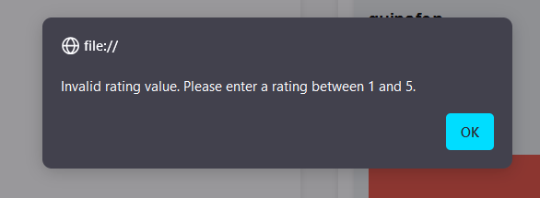

Fig. 2.2.1, Rating System Validation

1. **CODES**
2. **LEARNING OUTCOMES**
3. **REFERENCES**