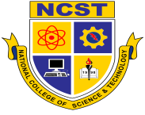**NATIONAL COLLEGE OF SCIENCE & TECHNOLOGY**

Amafel Building, Aguinaldo Highway, Dasmariñas, Cavite

Tel. No.: (046)416-6278 ● Telefax: (046)416-0166 ● Mobile No.:+63918-888-6278

[**www.ncst.edu.ph**](http://www.ncst.edu.ph)

researchdept@ncst.edu.ph

CERTIFICATE OF TECHNICAL ADVISORSHIP

This is to certify that the technical aspects of the thesis entitled THE DEVELOPMENT ANTI-PLAGIARISM SOFTWARE ON RESEARCH DOCUMENT FOR NATIONAL COLLEGE OF SCIENCE AND TECHNOLOGY from the BS IN COMPUTER SCIENCE program has been examined and given appropriate technical recommendations as needed by the study.

MR. JOHN CHRISTIAN OAB

Technical Adviser

January 17, 2018

Date