**Chapter 3**

**TECHNICAL BACKROUND**

This chapter represents the technical background of the project. This chapter also represents the background development of the system and its flow. The chapter will also represent the proponents of the project development

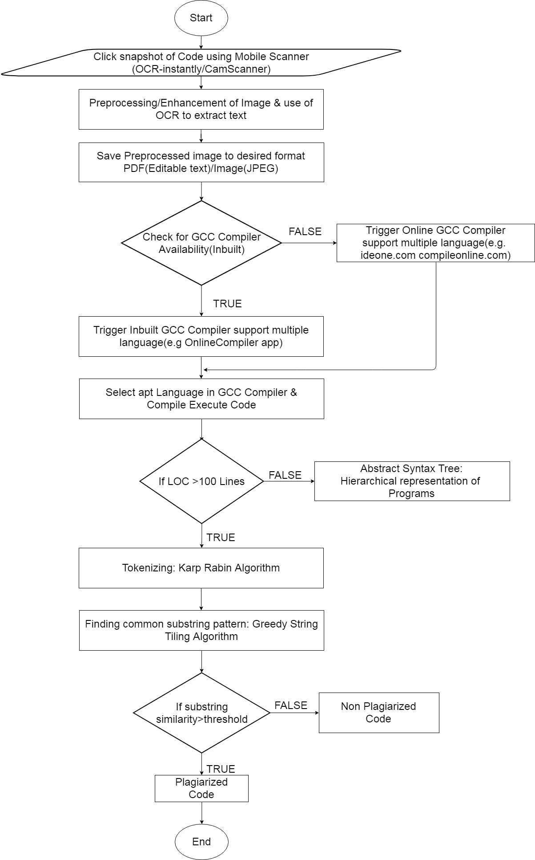**Existing System Flow**

**Figure 1.** Existing System Flow (Hawkeye: Anti-Plagiarism Software)

Figure 1show the System flow of the Hawkeye Anti-Plagiarism Software to detect the plagiarized content the user must input the image on the system. This application is used on Mobile phones since most students are using mobile devices to plagiarized source codes. This software detects cloned software codes. The system use a compiler called Multi Language OCR compiler once the input image is on the system the software will now convert the image into relevant text file and then the software use multiple compilers to detect any plagiarized software codes. As seen on the System flow the software use different algorithms to detect any form of plagiarized content on the system.

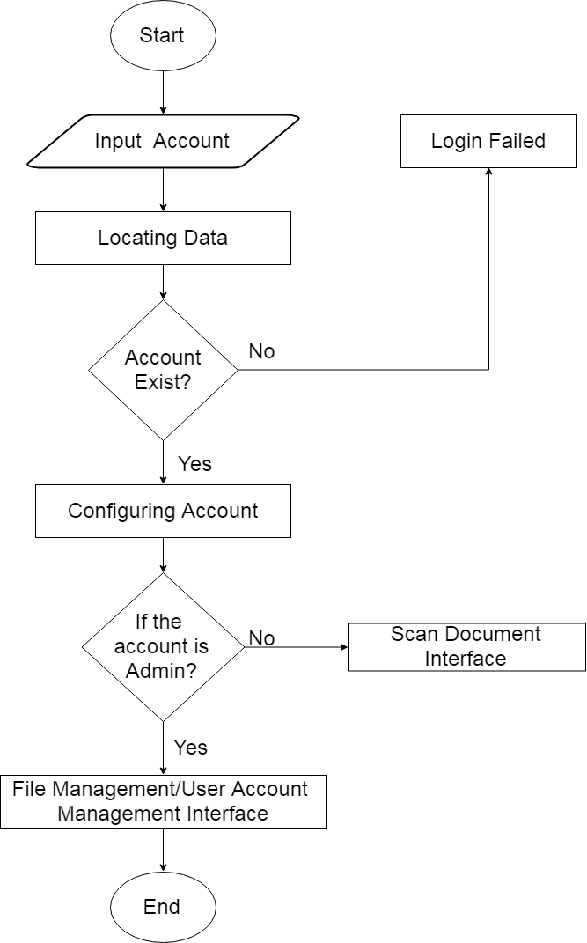**Proposed System Flow**

**Figure 2.**Login System Flow

Figure 2 shows how the flow of login system flows on the system the user must login on the system for security purposes. Once the input account is now on the system it will now locate the input account on the database however if the account is not existed or located on the database the user is forbidden to access the system and it will redirect on the Input Account.

Once the user is login the system will configure whether it’s a common user or Administrator. There is a different path on the system depending on the account status if the system configure that the account is a common user the system will redirect the account on the Scan Document Interface, This Interface is for scanning plagiarized contents while on Administrators Interface is different, the interface has a File Management and User Management. The File Management and User Management contains all data within the system it contains the uploaded documents and the accounts of all registered users within the system.

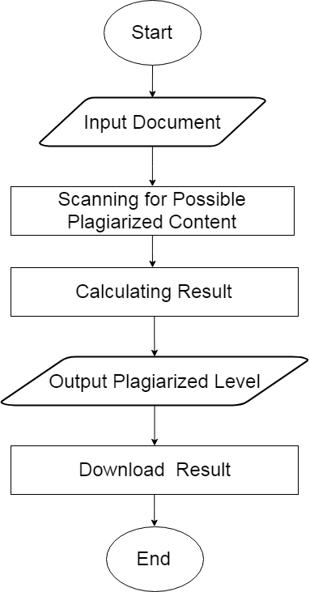

**Figure 3**.Common User System Flow

Figure 3illustrate the system flow of the common user on the system. The system flow of this is to input documents, once the document is input the system will scan the documents and calculate its plagiarism level once the plagiarism level is calculated the system will show the output and the result of the scanned document and also download the result.

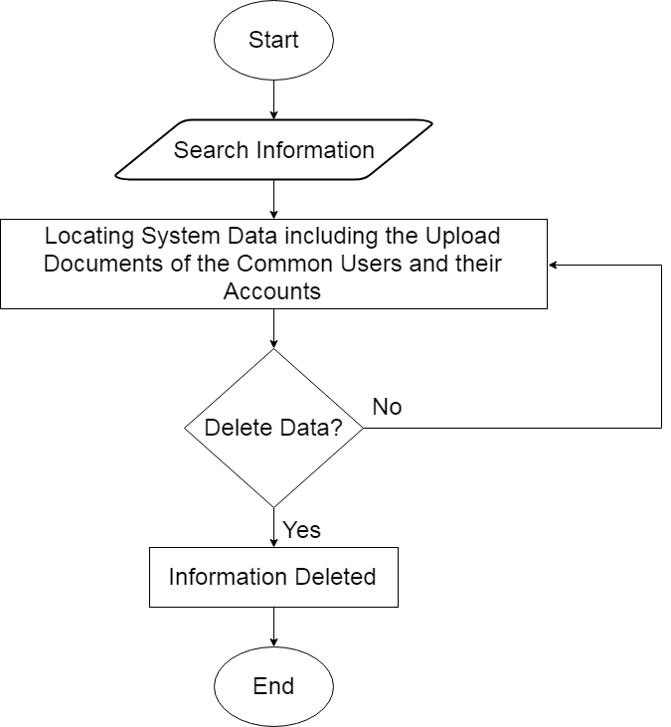

**Figure 4.**Administrator System Flow

Figure 4 shows the system flow of the Administrator account. The administrator has the authority to manipulate the stored data on the system. The administrator locates data by searching the Information. Once the information has been located the administrator has a freedom to delete the data of stored documents on the system including also the common users account.

**System Architecture**



Internet

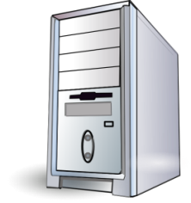

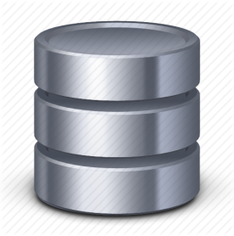

System Unit

NCST Document Storage User Account Storage



Anti-Plagiarism Software Application



User/Administrator

**Figure 5.**System Architecture

On Figure 5shows the System Architecture of the software. The users and administrator are the one who use the Anti-Plagiarism Software Application. The software application needs a system unit to operate. The system Unit is connected to 2 Database the account database and the NCST document storage. The account storage holds the accounts of the user and administrator to access the system while on the NCST storage holds the uploaded documents of NCST research office. The system is connected on the Internet for detecting online sources to detect plagiarized content.

**Operational Definition of Terms**

**Account-** The Identification of the user to access the system

**Administrator-** The authorized personnel that can manipulate the data of the system including authority to manage the common users account on the system.

**Application Software –** A type of software that has GUI based functions.

**Common User-** A user of the system but has limitation on accessing data within the system.

**Delete-** is a function for removing data on the system.

**Download Result-** A function to transfer data to other purpose.

**Flask-** is a web framework that is written in python programming language.

**Login -** isan act or function for accessing the system.

**Python-** is a high-level programming language.

**Scan-** a function that can analyzeforplagiarized content.

**Search-** a tool on the system to locate data recorded on the systems.