Documentation for using ChatGPT for study

Asking ChatGPT to help me come out with CSS stylesheet tempate and I modified it accordingly to assignment needs.

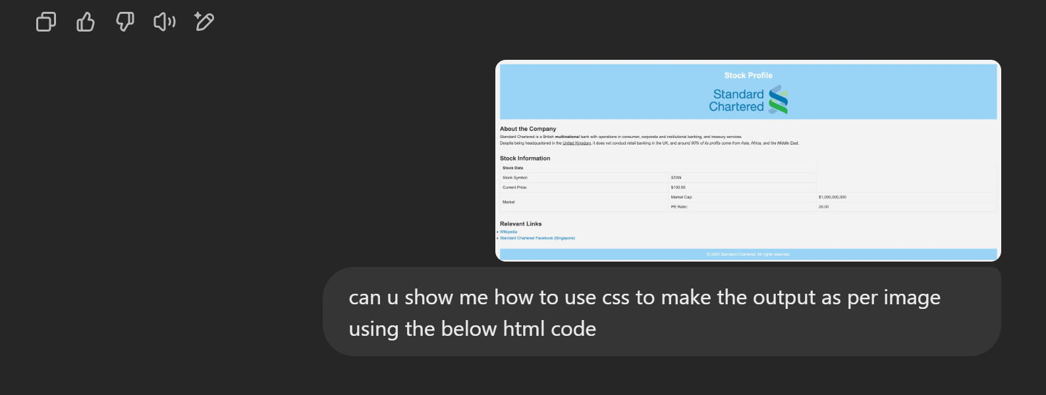

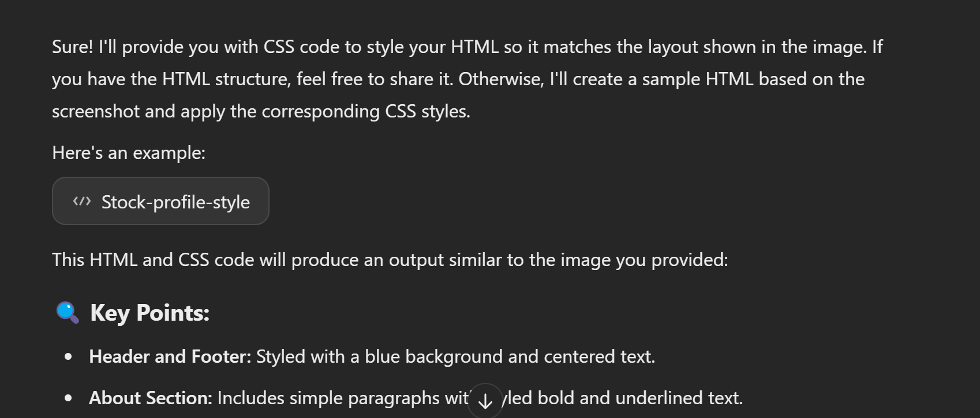

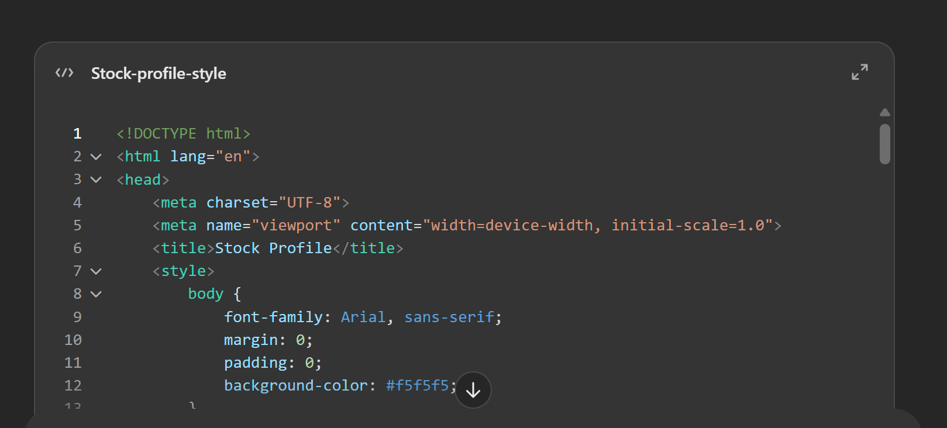

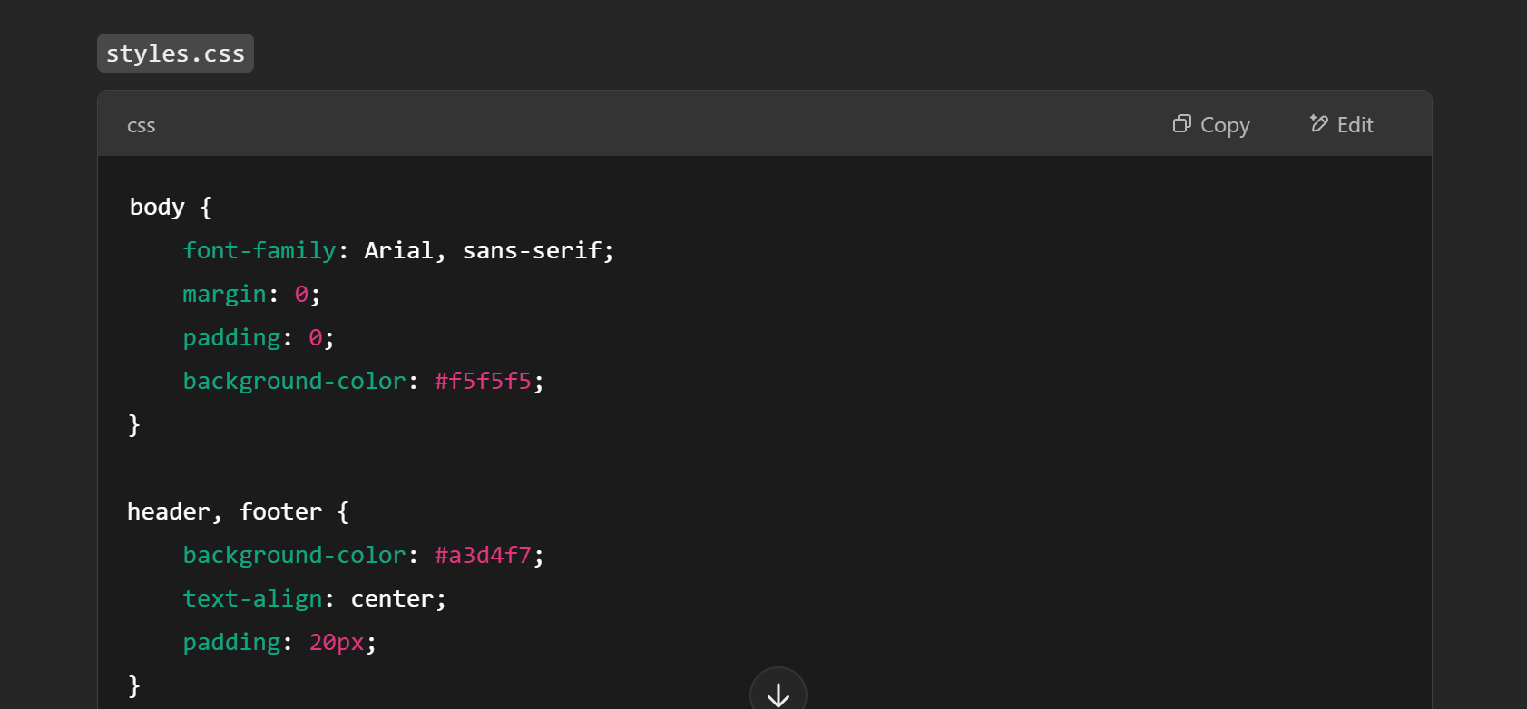
Asking ChatGPT to teach me Grid basic:

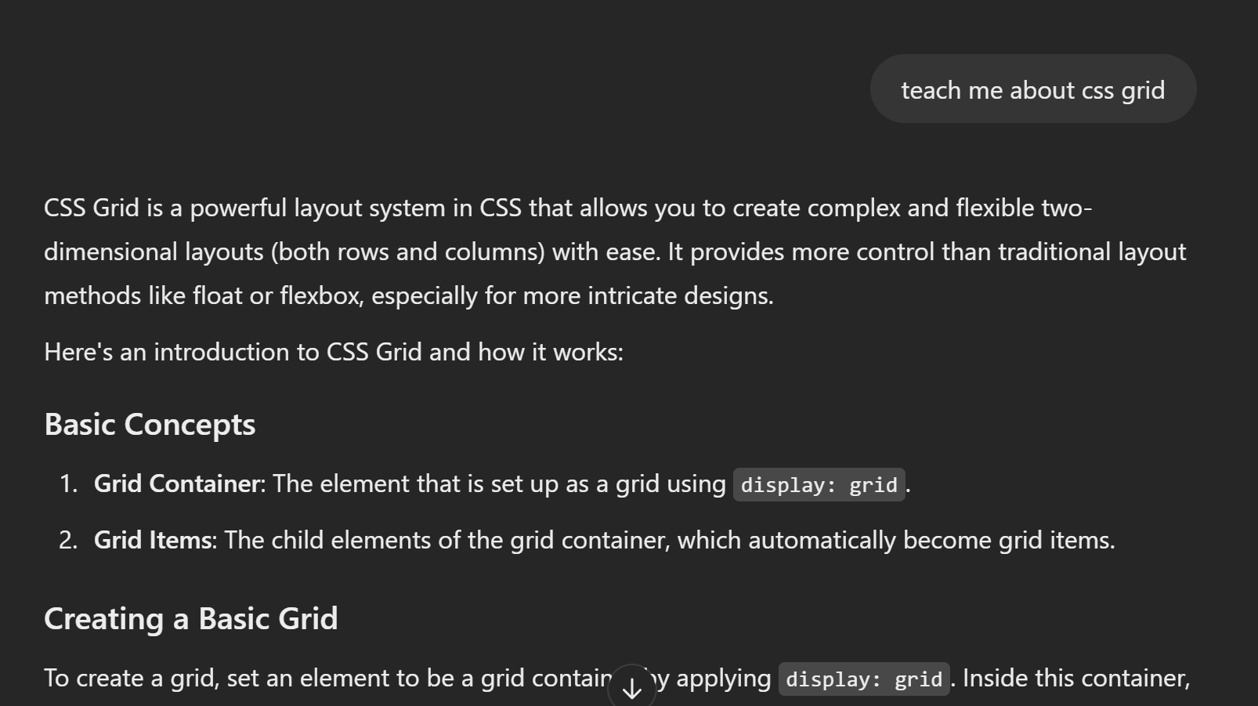

Asking ChatGPT to teach me Flexbox basic:

