**Hospital Project Prototype Version 1**

Kyuhee Jo (kjo3@jhu.edu)

1. Install JAVA

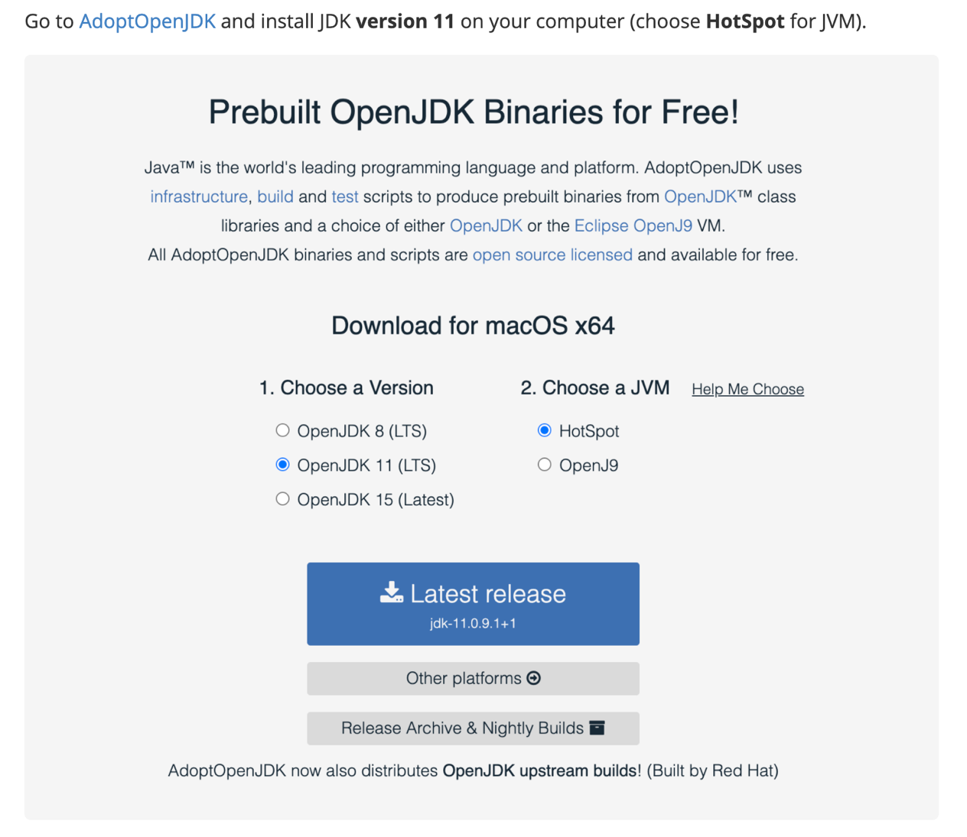

1. Install IntelliJ

I’ve used IntelliJ, a modern IDE (Integrated development environment) for this project.

IntelliJ has two versions: a free **community** edition and a proprietary version which requires purchasing a license, the **Ultimate** Edition. For this purpose, either version is fine, but you may create a "student account" (with an .edu email) to get a license to use the "Ultimate Edition". Click [here](https://www.jetbrains.com/student/) to apply for student license.

Download and install IntelliJ (**Version: 2020.3**) by following the instructions [here](https://www.jetbrains.com/help/idea/installation-guide.html). I recommend [Install using the Toolbox App](https://www.jetbrains.com/help/idea/installation-guide.html). When installing, accept all the default settings.

Refer to this [link](https://www.jetbrains.com/help/idea/run-for-the-first-time.html) for a rundown of what you will see when you run IntelliJ for the first time.

1. Using & Running the program
2. Open IntellieJ > Open > Navigate to hospital-project folder > Open

1. Navigate to Project > src > Search > Main and double click to open main

1. Set input (1) /output (2) file path (Input path should be the path to existing excel file, but output could be either existing file or arbitrary name/filepath that doesn’t exist yet)

1. Run the program and provide input

1. You should see the output below. Furthermore, if you open the excel in output filepath (that you set above), you should see excel sheet filled with output values. You can run multiple times to get different results.

1. Please inspect the results and keep record of bugs/ feedbacks arises along the process. For example, if the output does not abide by the rule structure, the output produces unreasonable value, the program crashes etc. It’d be very helpful if you keep record of the specific input files/ value that produced the bug/error. (I haven’t been able to test with real-life data and the program may be incomplete/contain bugs)