Growth Quality and Churn Risk in a B2B SaaS Acquisition
Diligence at close, underwriting test and post-close monitoring of a $113m-ARR software book
Prepared by Qiuli Lai | September 2026 | Data as of 31 July 2026
Scope. Customer-level data is synthetic (seed 42), generated from written rules because account-level usage, billing and support data is never public. The book's retention in the year before close was calibrated to SaaS Capital's 2025 survey, which measured the same window, so agreement in that window is by design and is never used as evidence. Everything from January 2025 onward is out of sample. Benchmarks are published surveys and SEC filings, each cited with its measurement window. Numbers describe a method under test, not a real company.
Part | Contents
1 Executive summary | Situation, headline metrics, findings, answers to the owner's questions, recommendations, pipeline
2 Metrics and techniques | Definition of every financial and technical term, and what each one measures
3 End-to-end analysis | 3.1 Evidence boundary · 3.2 Synthetic book and calibration · 3.3 Data quality · 3.4 Revenue bridge · 3.5 Growth quality · 3.6 Retention vs peers · 3.7 Loss composition · 3.8 Segment strategy · 3.9 NRR drivers · 3.10 Concentration · 3.11 Revenue to cash · 3.12 Underwriting test · 3.13 Post-close monitoring · 3.14 Renewals and value of retention · 3.15 Churn model · 3.16 Retention economics · 3.17 Forward forecast · 3.18 Workbook · 3.19 Corrections · 3.20 Limitations

Part 1 Executive summary

1.1 Situation
A formerly bootstrapped B2B software company selling to three customer segments (SMB, Mid-Market, Enterprise) is acquired in December 2024 at $112.8m of list ARR and 2,875 active accounts. By July 2026 the book has grown to $146.6m and 3,505 accounts. The report answers three questions an owner would ask in sequence. What could a buyer know about revenue quality at close? Did the forecast made at close hold over the following nineteen months? Where do revenue quality and churn risk sit today, and what should be done about them?

1.2 Headline metrics
Metric | At close (Dec 2024) | Now (Jul 2026) | Reference point
List ARR | $112.8m | $146.6m | Scale; SaaS Capital surveys private companies above $1m ARR, most likely far smaller than this book
List ARR growth, trailing 12 months | 21.2% | 18.0% | SaaS Capital medians: 23% bootstrapped and 25% equity-backed for 2024; 20% and 25% for 2025
12-month GRR (cohort) | 90.9% | 92.1% | SaaS Capital 2025 median 91%
12-month NRR (cohort) | 102.7% | 103.1% | SaaS Capital 2025 medians 101% all, 104% bootstrapped
Active accounts | 2,875 | 3,505 | Enterprise 325 at close, 391 now
Expansion share of gross new ARR | 51% (2024) | 55% (4 quarters to Jun 2026) | Benchmarkit 2026 median 40% (denominator not stated)
Quick ratio | 2.31 (2024) | 2.26 (4 quarters to Jun 2026) | Above 1 means gross additions exceed gross losses
Top 10 customers, share of ARR | 3.7% | 3.7% | Low; a design consequence (Section 3.10)
Cash conversion, latest quarter | n/a | 97.2% | Failed collections 1.4% of revenue
ARR renewing in next 12 months | n/a | $91.8m committed | Plus $12.5m on monthly contracts

1.3 Key findings
# | Finding | Evidence | Implication
1 | Retention at close sat at the peer median | GRR 90.9% and NRR 102.7% vs SaaS Capital 91% and 101% to 104%; 95% range 89.2% to 92.7% for GRR | Underwrite retention as a band of about two points, not a point
2 | Growth was not bought with discounts | 2024 billed ARR grew 21.6% vs list 21.2%; discounted share fell from 5.9% to 5.6% | Price realisation is stable; watch partner expansion (21.8% written above 15% discount)
3 | Growth is decelerating and leaning on expansion | Growth 27% (2023), 21% (2024), 20% (2025); new-logo ARR flat at $17m to $19m a year; expansion share 41% to 58% | A fixed new-logo engine on a larger base slows growth mechanically; the plan should not extrapolate past growth
4 | The underwriting case held | Base case 1.0% below actual after 19 months, never more than 1.7% off; inside the 90% band in 19 of 19 months | The forecast method is fit for a plan; its band is too narrow, most of all at long horizons
5 | SMB loses revenue through lost logos, not down-sell | SMB churn loss 10.1% vs contraction 1.4% of starting ARR; GRR 88.5%, NRR 99.7% | SMB retention work is about renewal saves, not usage expansion
6 | Enterprise is small in count but carries half the book | 391 accounts, 50% of ARR, NRR 104.2%; 49% of 2025 net new ARR | Growth is balanced across segments; no single segment carries it
7 | Expansion does not rise with contract size | About 61% of accounts expand in a year by a median 14%, flat across ACV bands; NRR trails peers in the $50k to $100k band by 2.9 points | In a real book this is the test for a product-scalability ceiling; here it is a generator limitation
8 | Risk is concentrated on renewal dates | 88% of post-close churn fell in the 46% of account-months inside a renewal window | Run retention off the renewal calendar
9 | A simple penalised logistic model is the right scorer | L2 logistic holdout AUC 0.809 vs boosted trees 0.800 and oracle 0.816; +0.054 over the operating rule | Promote the L2 logistic; keep trees as a monitored challenger
10 | Retention outreach pays only with a good list | Break-even save rate 17% (value-ranked logistic) vs 37% (operating rule) and 137% (random) | Fund a pilot pooled across portfolio companies; on one book a pilot sized on the L2 list needs about 68 months

1.4 Answers to the owner's questions
Question | Answer | Confidence and what would change it
Is retention at close in line with comparable companies? | Yes. Portfolio GRR and NRR sit at the SaaS Capital 2025 median for the same window. Band-level gaps are within about three points (GRR −2.4 to +1.9, NRR −2.9 to +3.2) except the >$250k band, which has only 25 accounts. | Calibrated by design, so this is a check of method. Real data would make it evidence.
Was growth bought with discounts? | No. Billed growth kept pace with list growth and the discounted share of revenue edged down. About 13% of new and expansion revenue was written above a 15% discount in both 2024 and the latest year. | Descriptive only. A causal price effect needs a pricing test.
Did the forecast made at close hold? | Yes. The base case ended 1.0% below actual after 19 months, and was never more than 1.7% off in any month. A rolling test shows the 90% band is too narrow: it covers 84% of outcomes overall and 70% to 79% ten to twelve months out. | Strong for the point path; the band should be widened, most of all at long horizons.
Is SMB strategic, or should its share fall? | The retention data does not justify shrinking SMB: its NRR is 99.7%, so the base roughly holds its value, and it supplied 16% of 2025 net new ARR, in line with its 16% share of ARR. The case against SMB rests on cost to serve: it raises about 11 times more support tickets per dollar of ARR than Enterprise. | The decision turns on CAC payback and support cost by segment, which the data does not contain. Request both before changing mix.
Is SMB churn logo churn or contraction? | Logo churn. Lost customers removed 10.1% of SMB starting ARR in the latest twelve months; down-sell removed 1.4%. | High for this book. The generator has modest down-sell, so real books may show more contraction.
How many Enterprise accounts, and can they carry growth? | 391 accounts (325 at close), average ACV $177k. Enterprise ARR grew 19% in 2025 and delivered 49% of net new ARR. It keeps pace with the company but cannot carry it alone. | Moderate. Fifty to sixty-five new Enterprise logos a year is a small sample; a few large wins or losses move the segment.
Is NRR below benchmark a motion or a product problem? | It depends on the band. In the $50k to $100k band, the largest shortfall (2.9 points), almost the whole gap is expansion; in the $12k to $25k band and on multi-year contracts the gap comes mainly from losses. Breadth and depth of expansion are flat across contract sizes, which in a real company would point to a seat or product ceiling rather than a weak sales motion. | Low for this book: flat expansion by size is a generator rule. Seat penetration and whitespace data would settle it.
Are the benchmarks comparable in definition? | SaaS Capital's 2025 figures use the same twelve-month cohort definition as this report, include price increases in NRR and exclude them from GRR. No reactivations occur in this book, so their treatment does not matter here. Benchmarkit does not disclose its definition and is used for direction only. | High for SaaS Capital. Its sample is likely much smaller companies, a size mismatch that cannot be measured.
Which churn model should run, and why? | The L2 (ridge) logistic. All penalties tie on accuracy and agree on the strong features. With about 96 churn events per feature there is no need to drop features, and L1's selection of the weak ones changes with the sample, so L2 wins the pre-set tie-break. Boosted trees do not beat it because the simulated churn process has no interaction for them to find. | High on this data; rerun the same comparison on real data before relying on it.
Is a retention programme worth funding? | Only on a good list and only as a pooled pilot. On the value-ranked list, outreach breaks even if it saves 17% of the listed accounts that would otherwise churn. A pilot sized on the L2 list would take about 68 months on one book, and longer on the smaller value-ranked list. | The save rate is unknown until a randomised pilot runs.

1.5 Recommendations
- Underwrite retention at the benchmark median with a band of about two points either way. One year's GRR for a book of this size moves that much by chance.
- Plan growth from its components (new-logo ARR, expansion, contraction and churn rates), not from last year's growth rate. The book decelerates by construction as the base outgrows a flat new-logo engine.
- Run churn outreach on the L2 logistic score ranked by expected ARR loss, reviewed monthly against the renewal calendar. Keep the boosted trees as a challenger and rerun the comparison each quarter.
- Before changing segment mix, obtain CAC, payback and cost-to-serve by segment. Retention alone does not argue for shrinking SMB.
- Fund a retention pilot only if the same protocol runs across several portfolio companies, or restrict it to accounts inside a renewal window where churn is concentrated.
- Widen forecast bands by the measured coverage shortfall at each horizon before they are used in a plan or covenant test.

1.6 Pipeline
The analysis runs end to end from one command. Each stage has a control, and 23 unit tests cover the most important of them.
Stage | What it does | Main output | Control
1 Generate | Simulates 4,547 customers over 55 months from written rules; plants eight classes of data defects | Six raw tables, defect log, true churn probability | Fixed seed; assumption register (Section 3.2)
2 Data quality | Runs rule checks, writes a row-level issue ledger, repairs or quarantines | Clean tables, issue ledger, cleaning manifest | Recall on planted defects; no identity violations after cleaning
3 SQL marts | Builds account-month, cohort retention, MRR bridge and discount dependence tables | Four marts in SQLite | Bridge identity ties to the cent; churn matches an independent pandas computation
4 Diligence and monitoring | Cohort GRR and NRR by cut; benchmark matching; bootstrap ranges; plan vs actual | Benchmark and monitoring tables | Same measurement window as the benchmark
5 Forecast | Underwriting base case and band at close; forward scenarios | Forecast paths and coverage tests | Unit test: post-close data cannot move the underwriting forecast
6 Features | Trailing three-month signals and a three-month forward churn label for every account-month | Customer-month feature table | Tests for label maturity and no look-ahead
7 Models | Grid search, penalty diagnostics, holdout scoring, customer-cluster bootstrap | Model comparison, coefficients, stability, paired differences | Promotion rule fixed before the holdout
8 Economics | Break-even save rate and pilot size for each list | Retention economics table | Each account worked once
9 Reporting | Brief, dashboard, Excel workbook with live formulas, this report | reports/ and dashboard/ | Workbook recalculated with zero formula errors
Context | Quarterly revenue, margin and growth for 11 listed SaaS companies from SEC EDGAR | Public comparables panel | Fiscal quarters aligned to calendar quarters

REFLECTION
Why might this be? The pipeline's strength is that every stage is testable because the truth is known: planted defects, the true churn probability, and a close date that splits known from unknown. The same design is its weakness, because a synthetic book can only confirm what its rules allow.
Did we resolve it? Partly. Every conclusion in this report is labelled as calibrated, out of sample, or a property of the generator. The method transfers to real data unchanged; the numbers do not.

Part 2 Metrics and techniques
Each term is defined in words, followed by what it measures and why an owner or analyst uses it. Formulas are in the code and the workbook. Terms appear in the order the analysis uses them.

2.1 Recurring revenue and growth
Term | Definition | What it measures and why it matters
MRR | Monthly recurring revenue: the subscription revenue customers are contracted to pay each month, excluding one-off fees. | The run-rate of the subscription business and the base unit of every other revenue metric.
ARR | Annual recurring revenue: twelve times month-end MRR. | Annualised scale at a point in time; the figure buyers and lenders value and compare across companies.
List ARR | Recurring revenue at list price, before any discount. | Volume sold independent of pricing concessions. Used for the bridge and retention so that a discount change is not mistaken for churn or expansion.
Billed ARR | Recurring revenue actually invoiced after discounts. | What customers really pay; the basis for recognised revenue and cash.
Discounted MRR share | Share of list MRR given away as discount at a point in time. | Price realisation. A rising share means growth is being bought with concessions.
Discount dependence | Share of new-logo or expansion revenue written while the customer carried a discount above 15%. | How exposed growth is to heavy discounting. Descriptive: it does not say discounts caused the growth.
New-logo ARR | ARR from customers in their first paying month. | Output of the acquisition engine; the only growth source that does not depend on the existing base.
Expansion ARR | Increase in ARR from existing customers: more seats, more usage, price uplift or new modules. | Output of the installed-base engine; usually cheaper to win than new logos.
Contraction ARR | Decrease in ARR from customers who stay: fewer seats, lower usage or a concession. | Partial loss and often an early warning before full churn.
Churned ARR | ARR lost from customers who leave entirely. | Outright loss of relationships.
Net new ARR | Change in ARR over a period: additions less losses. | Absolute growth delivered in the period.
ARR bridge | Roll-forward from opening to closing ARR through new, expansion, contraction and churn. | Shows where growth came from and where it leaked. It must tie exactly, otherwise the data is wrong.
ARR growth | Closing ARR relative to opening ARR over twelve months. | Headline growth; comparable with growth benchmarks only when measured on the same basis.
Quick ratio | Gross additions (new plus expansion) relative to gross losses (contraction plus churn). | Growth efficiency: dollars added per dollar lost. Above one the book grows; a falling ratio means losses are catching up with sales.
Expansion share | Expansion as a share of gross additions. | Reliance on the installed base. A high share can mean a strong land-and-expand motion or a weakening new-logo engine.

2.2 Retention
Term | Definition | What it measures and why it matters
Cohort | The customers active at the start of a twelve-month window, followed to its end. | Fixes the population so that new customers cannot hide losses from existing ones.
GRR (gross revenue retention) | Share of a starting cohort's recurring revenue still billed to the same customers twelve months later, counting churn and down-sell but giving no credit for upsell. Each customer is capped at its starting value. | Evaluates how much revenue the existing customer base keeps on its own. It is the floor under future revenue and the most direct read on product stickiness. It cannot exceed 100%, and it cannot be bought back with sales spend.
NRR (net revenue retention) | The same cohort comparison with expansion, cross-sell and price increases included. | Evaluates whether the existing base grows by itself. Above 100%, the company grows even with no new customers; the gap between NRR and GRR is the expansion engine.
Logo churn rate | Share of starting customers who left entirely within the window. | Relationship loss by count. It weights a $5k customer like a $500k one, so it is read beside revenue measures.
Churn loss, contraction loss | Revenue lost from departures, and revenue lost from down-sell by customers who stayed, each as a share of starting ARR. | Splits GRR into its two causes and tells whether retention work should target renewals or usage.
Monthly-compounded GRR | A monthly retention rate raised to the twelfth power. | Not interchangeable with cohort GRR. When churn clusters at annual renewals, compounding a monthly average overstates annual loss.
Non-renewal rate | Share of contracts reaching their end date in the past year that did not renew. | The historical loss rate at renewal, used to price upcoming renewals.
Renewal exposure | ARR whose contracts come up for renewal in a period. | Where and when revenue is at risk; retention effort should follow this calendar.
Renewal window | An account-month in which the contract can end within three months, or the contract is monthly. | Where almost all churn occurs: 88% of post-close churn fell inside a window, and outside it only a small early-exit risk remains.
Reactivation | A customer who leaves and later returns. | Definitions differ on whether returners count as retained, which can inflate retention if they do.
Expansion breadth and depth | Breadth: share of starting accounts whose ARR rose. Depth: the median percentage increase among them. | Separates how widely the base expands from how far. Depth that does not rise with contract size points to a ceiling.

2.3 Customers, contracts and pricing
Term | Definition | What it measures and why it matters
ACV | Annual contract value: what a customer pays per year after discount. | Customer size. Retention and expansion norms differ strongly by size.
ACV band | Grouping of customers by ACV (under $12k, $12k to $25k, and so on). | Allows like-for-like comparison with benchmarks that are reported by band.
Segment | SMB, Mid-Market and Enterprise, assigned at signup. | Different buying processes, churn behaviour and cost to serve.
Contract term | Month-to-month, annual or multi-year commitment. | Determines when a customer can leave. Longer terms defer churn risk to renewal; they do not remove it.
Pricing model | Seat (price per user), usage (price per unit consumed) or hybrid. | How revenue responds to customer activity. Usage pricing moves revenue in both directions.
Acquisition channel | Inbound, outbound, paid, partner or self-serve. | Acquisition cost and discount practice differ by channel.
Bootstrapped, equity-backed | Funded mainly from own revenue, or by outside equity. | Benchmark groups differ: bootstrapped companies tend to grow more slowly and retain slightly better.
Cost to serve (proxy) | Support tickets per $1m of ARR. | Relative service burden per revenue dollar. A proxy, because the cost of a ticket is not observed.

2.4 Quality of revenue and cash
Term | Definition | What it measures and why it matters
Quality of revenue | Diligence work that tests whether reported recurring revenue is recurring, collectible, diversified and not propped up by concessions. | Separates revenue that will survive a change of ownership from revenue that will not.
Top-N concentration | Share of ARR held by the largest N customers. | Dependence on a few relationships; one loss can move the whole book.
HHI | Herfindahl-Hirschman Index of customer ARR shares on a 0 to 10,000 scale. 10,000 divided by the HHI equals the number of equal-sized customers with the same concentration. | Concentration across the whole book in one number.
Recognised revenue | Revenue earned in the period under accrual accounting; here, billed MRR summed over the months of the period. | The income-statement view of the business.
Cash conversion | Cash collected as a share of recognised revenue in the period. | Whether revenue turns into cash.
Accounts receivable | Revenue billed but not yet collected. | Working capital tied up in customers.
DSO (days sales outstanding) | Receivables expressed in days of revenue. | Collection speed.
Failed collections | Invoices that are never paid. | Leakage between billing and cash; a bad-debt proxy.
Deferred revenue | Cash received for service not yet delivered. | A prepayment cushion. Absent here because every account is billed monthly.
Gross margin | Revenue less cost of revenue, as a share of revenue. | Converts ARR into gross profit; used to value a point of retention.
Value of a GRR point | ARR, and the gross profit on it, preserved by one percentage point higher GRR. | Puts retention in money terms so it can be prioritised against other uses of capital.
EV / revenue multiple | Enterprise value divided by trailing twelve-month revenue. | The market price of a revenue dollar; used here only to illustrate what retained ARR is worth.

2.5 Deal, benchmarks and forecasting
Term | Definition | What it measures and why it matters
Diligence | Investigation of a target before committing capital. | What a buyer can know at close.
Close | Completion date of the acquisition, December 2024. | Splits known from unknown data. Everything after it is out of sample.
Benchmark median | The middle value of a metric across surveyed companies. | A reference point: half of peers do better, half worse.
Measurement window | The period a benchmark actually measured. | A comparison is fair only if both sides cover the same window.
Calibration | Setting a simulation's parameters so a chosen window reproduces known figures. | Agreement after calibration is by design and is not evidence.
Out of sample | Data not used to build or tune the analysis. | The only kind of evidence this report relies on.
Underwriting | The forecast a buyer commits to at close. | Basis for price, plan and financing; judged by how well it held.
Base case | The central forecast path. | Most likely outcome if current rates persist.
Forecast band | Range of plausible outcomes around the base case, for example 90%. | How much to trust the point forecast.
Coverage | Share of actual outcomes that fall inside a band. | Honesty of the band: a 90% band should contain the outcome about nine times in ten.
Rolling-origin backtest | Rebuilding the forecast at many past start dates using only earlier data, and scoring each. | Tests the method rather than one lucky path.
Resampled-month band | Band built by redrawing whole historical months of new, expansion, contraction and churn together. | Keeps the components' historical co-movement.
Plan vs actual | Comparison of underwritten with realised figures. | Early warning when the investment thesis drifts.
Scenario | Forecast under changed assumptions; run-off assumes no new customers. | Planning range. Run-off isolates what the existing base does alone.
Sampling noise | Variation in a measured rate that arises only because a finite group of customers was observed. | Sets the size of a difference worth acting on.
Bootstrap range | Range obtained by repeatedly resampling customers and recomputing the metric; 95% unless stated. | Quantifies sampling noise without distributional assumptions.
Public comparables | Reported quarterly financials of listed SaaS companies, from SEC filings. | Market context for margin and growth assumptions.

2.6 Data engineering and quality
Term | Definition | What it measures and why it matters
Synthetic panel | Monthly data generated from written rules. | Every result traces to an assumption; it cannot prove real-world effects.
Planted defect | An error inserted on purpose at a known rate. | Makes detection measurable.
Detection recall | Share of planted defects the checks found. | Effectiveness of the checks.
Issue ledger | Row-level record of every problem found, written before anything is changed. | Audit trail for every repair.
Identity-based repair | Fixing a value only when an accounting identity reconstructs it exactly. | Repairs without guessing.
Quarantine | Setting a record aside with a reason instead of deleting it. | Keeps the audit trail and customer histories intact.
Reconciliation | Computing the same figure two independent ways and requiring agreement. | Catches errors whatever their cause, including ones nobody anticipated.
SQL mart | A curated analytical table built by SQL from cleaned data. | Single source of truth for everything downstream.

2.7 Churn modelling
Term | Definition | What it measures and why it matters
Churn label | Whether an active account churns in any of the next three months. | The outcome the model ranks accounts on.
Feature | An input signal the model sees, such as the usage ratio. | What information the model can use.
Trailing window | Features use only the three months up to the scoring month. | Prevents the use of future information.
Leakage | Information from after the scoring date reaching the model. | Makes backtests look better than real use.
Label maturity | A label is usable only once all three following months have been observed. | Avoids treating unknown outcomes as non-churn.
Chronological holdout | Training on earlier months and testing on later ones. | Mimics how a model is actually used.
Purge gap | Months dropped between training and test because their labels straddle the boundary. | Prevents overlap leakage.
Forward folds | Validation months each scored by a model trained only on earlier, matured months. | Tunes settings without looking ahead.
Hyperparameter, grid search | Settings chosen before fitting, such as penalty strength, searched systematically. | Controls model complexity.
Rule score | Hand-weighted score of usage, discount, payment delay, tickets and revenue change. | Auditable baseline that needs no fitting.
Rule x renewal exposure | The rule score scaled down for accounts that cannot leave within the window. | The operating baseline; it encodes contract mechanics.
Logistic regression | A linear model of the log-odds of churn. | Readable coefficients and probability estimates.
Regularisation | A penalty on large coefficients. | Limits overfitting and stabilises estimates.
L1 (lasso) | Penalty that can shrink coefficients exactly to zero. | Selects features; unstable when features are correlated.
L2 (ridge) | Penalty that shrinks all coefficients smoothly toward zero. | Stable when features are correlated; keeps every feature.
Elastic Net | A mix of the L1 and L2 penalties. | Selection with some of L2's stability.
C | Inverse penalty strength; a smaller C means stronger shrinkage. | How cautious the model is.
One-standard-error rule | Among settings whose score is within one standard error of the best, choose the simplest or most stable. | Avoids choosing on noise.
Correlation | How closely two features move together, from −1 to 1. | First screen for redundant features.
Multicollinearity | Features that move together so the model cannot separate their effects. | Makes individual coefficients unstable even when predictions are fine.
VIF | Variance inflation factor: how much a coefficient's uncertainty is inflated by correlation with other features. Above about 5 is a warning. | Locates collinearity feature by feature.
Condition number | Summary of how close the whole feature set is to redundancy. | Large values signal an unstable design.
Events per variable | Churn events per feature. | Overfitting risk; above about 20 is comfortable.
Selection stability | How often each feature is kept, with the same sign, across customer resamples. | Whether an interpretation would survive new data.
Gradient boosted trees | An ensemble of small decision trees added in sequence, each correcting the errors of the last. | Captures thresholds and interactions automatically, at the cost of transparency.
Interaction effect | When the impact of one factor depends on another. | For example, falling usage mattering more near renewal.
Permutation importance | Drop in accuracy when one feature is shuffled. | Which features a model actually relies on.
Oracle | The simulator's true churn probability. | Ceiling for any model on the observable features.
Probability calibration | Whether predicted probabilities match observed rates. | Needed when probabilities feed economics, not only rankings.
Promotion rule | Criteria, set before the holdout, that a challenger must meet to replace the operating model. | Prevents choosing after seeing the results.

2.8 Model evaluation and statistics
Term | Definition | What it measures and why it matters
ROC-AUC | Probability that a randomly chosen churner is ranked above a randomly chosen non-churner; 0.5 is chance. | Ranking quality across all thresholds.
Average precision | How pure the ranked list stays as it grows. | More informative than AUC when churn is rare.
Brier score, Brier skill | Accuracy of predicted probabilities; skill compares it with always predicting the average rate. | Whether the probabilities can be trusted. Zero skill means no better than the average.
Monthly AUC standard deviation | Spread of AUC across holdout months. | Stability over time.
Top-10% churn rate, lift | Churn rate among the highest-scored tenth of accounts each month; lift divides it by the average rate. | Value of the list a team would actually work.
Precision, recall, F1 | At the top 10%: share of flagged accounts that churn; share of churners flagged; their balance. | List quality at a fixed capacity.
Accuracy | Share of predictions that are correct. | Misleading when churn is rare: predicting no churn scores about 98%.
Customer-cluster bootstrap | Resampling whole customers, with all their months together. | Respects that one customer's months are related.
Paired difference | Difference between two models measured on the same resampled customers. | The right test of whether one model beats another.
95% interval | Range expected to contain the true value in 95% of repeated samples. | Precision of an estimate.

2.9 Economics and experiments
Term | Definition | What it measures and why it matters
Save rate | Share of at-risk customers an intervention keeps. | The unknown that decides whether outreach pays.
Break-even save rate | Save rate at which a list's outreach cost equals the gross profit it protects. | The hurdle a programme must clear; lower is better.
Margin at risk | Gross profit the listed churners would take with them. | The prize a retention programme competes for.
Value-ranked list | Accounts ordered by churn probability times ARR, the expected loss. | Targets dollars rather than headcount.
Randomised pilot | The intervention goes to a random half of eligible accounts; the other half is the control. | The only clean way to measure the save rate.
Power, minimum detectable effect | Chance a pilot detects a real effect; the smallest effect it can reliably detect at a given size. | Whether a pilot is worth running at all.
Pooled pilot | The same protocol run across several portfolio companies. | Reaches a sample size one company cannot.

Part 3 End-to-end analysis
Each section follows the same order: the question, the method step by step, the result, what it means for the owner, and a reflection on why the result may look the way it does and whether the issue was resolved.

3.1 Deal scenario and evidence boundary
Question. Which data could a buyer have seen at close, and which data tests the buyer's judgement afterwards?
Method. The acquisition date splits the panel. Everything up to December 2024 is available to diligence and to model training; everything after it is used only to test what was decided at close. The diligence window is set to December 2023 to December 2024 because that is the window SaaS Capital's 2025 retention survey measured; the survey reports private-company retention by contract size, contract length and funding type.
Period | Months | Role | Used for
Jan 2022 to Nov 2023 | 23 | Pre-diligence history | Trends, cohort context, model training
Dec 2023 to Dec 2024 | 13 | Diligence window (calibrated) | Benchmark comparison, model training
Dec 2024 | (in window) | Close | Underwriting forecast made with data to this month
Jan 2025 to Jul 2026 | 19 | Post-close, out of sample | Forecast test, churn-model holdout, check against benchmarks published in 2026
Aug 2026 to Jul 2027 | 12 | Forward | Scenario forecast

Result. The churn model trains on 66,904 account-months with 1,533 churn events and is tested on 48,800 post-close account-months with 1,059 events. The underwriting forecast is tested on 19 post-close months, and 2025 retention is compared with benchmarks that were published only in 2026.
Interpretation. Every number in this report is either calibrated (agreement by design, never cited as evidence), out of sample (evidence), or a property of the generator (reported, not interpreted).

REFLECTION
Why might this be? A synthetic book can reproduce any benchmark it is tuned to, so without a hard boundary the analysis would validate itself.
Did we resolve it? Yes, by design. The boundary is enforced in code: a unit test changes post-close data and confirms the underwriting forecast does not move, and training labels end before the holdout begins.

3.2 The synthetic book and its calibration
Question. What does the book contain, and which of its parameters come from evidence rather than assumption?
Method. The generator simulates 4,547 customers over 55 months (January 2022 to July 2026) in three segments, seven industries, five acquisition channels and three pricing models, on monthly, annual or multi-year contracts. Each account carries a hidden health score that drives its usage, support tickets, NPS and module adoption. The churn decision depends on health, discount, late payment, severe tickets and promotion expiry; committed contracts can be lost only at renewal apart from a small early-exit risk, while monthly contracts can be lost in any month. Price uplifts and seat changes happen at commercial reviews, usage-priced revenue follows consumption, and some accounts about to leave are saved with an extra discount. The output is six tables (customers, subscriptions, usage, payments, events, contracts) with eight classes of defects planted at a known rate. Parameters were then tuned so the December 2023 to December 2024 cohort reproduces SaaS Capital's 2025 medians.
Parameter | Target | Evidence type | Source or rationale | Realised
panel window | Jan 2022 to Jul 2026 | design choice | Three years of pre-close history for diligence; close in Dec 2024; 19 post-close months out of sample | 4,547 accounts
acquisition close | Dec 2024 | design choice | Aligns the diligence window with the window SaaS Capital's 2025 survey measured | list ARR $113m at close
portfolio grr | about 91% | benchmark calibration | SaaS Capital 2025 median 91% (bootstrapped 92%; equity-backed 90%) | 90.9%
portfolio nrr | 102% to 104% | benchmark calibration | SaaS Capital 2025 median 101% (bootstrapped 104%); target set between the two because the company was bootstrapped before close | 102.7%
grr by acv band | 90% to 91% by band | benchmark calibration | SaaS Capital 2025 ACV bands (<$12k 90%; $12k-$25k 91%; $25k-$50k 91%; $50k-$100k 90%; $100k-$250k 91%) | 89.2% / 89.6% / 91.2% / 89.7% / 92.9%
grr by contract term | M2M 89%; annual 90%; multi-year 94% | benchmark calibration | SaaS Capital 2025 contract-length cut | 90.3% / 90.4% / 91.6%
list arr growth 2024 | 20% to 25% | benchmark calibration | SaaS Capital 2026 growth report: 2024 medians 23% bootstrapped and 25% equity-backed (2025: 20% and 25%) | 21.2%
usage minus seat nrr | positive | benchmark direction | Benchmarkit 2026 usage 108% vs seat 98% (definition not disclosed) | +4.8 pts
churn timing | committed contracts churn at renewal plus a small early-exit hazard | design choice | Contract mechanics; the size of the effect is an assumption | renewal_in_3m is the largest coefficient
churn mechanism | additive on the log-odds scale in latent health plus renewal gating | design choice | No explicit usage-decline x ticket-surge x renewal interaction is simulated; the tree-model test is therefore not evidence about real data | n/a
discount effect on churn | +1.2 logit per 100pp discount at renewal | design choice | Assumption; not identified from any source | n/a
save offer | 35% of would-be churners with price sensitivity >0.25 retained with +10pp discount | design choice | Assumption; creates reverse causality between discount and churn | n/a
parameters after close | held fixed | design choice | No market-level drift is simulated after Dec 2024; post-close differences from 2026 benchmarks reflect this | calendar-2025 GRR 92.5%
defect rate | 0.1% per customer and 0.02% per subscription row | design choice | Test fixture | all 8 classes detected exactly
customer size distribution | log-uniform within segment | design choice | No reliable public concentration benchmark found; concentration results follow from this choice | top 10 = 3.7% of ARR at close

Evidence type: benchmark calibration means the parameter was tuned to a published figure; benchmark direction means only the sign was matched; design choice means an assumption stated openly.
Result. The calibrated window reproduces portfolio GRR of 90.9% against a 91% target and NRR of 102.7% against 102% to 104%. The five ACV bands with calibration targets land within 1.9 points of them, and the largest miss among targeted cuts is multi-year contracts, at 91.6% against 94%. The >$250k band was not targeted; with 25 accounts it sits 7.4 points below SaaS Capital's 95%. List ARR grew 21.2% in 2024, inside the 20% to 25% target but below the 2024 bootstrapped median of 23%.
Interpretation. The register makes every result traceable to either a cited figure or a stated assumption. Anything that depends on a design choice, such as the absence of interaction effects in the churn decision, is flagged where it matters in later sections.

REFLECTION
Why might this be? The multi-year shortfall arises because the generator gives multi-year contracts fewer renewal events but no extra stickiness at renewal, and a group of about 450 accounts has a standard error of about two points in one year's GRR.
Did we resolve it? Partly. The gap was left visible rather than tuned away, because chasing every band would fit the generator to a survey of much smaller companies. No conclusion in the report rests on the calibrated window.

3.3 Data quality and cleaning
Question. Can the raw tables be trusted, and does cleaning keep every customer's history intact?
Method. Eight rule checks run on the raw tables and write every problem, row by row, into an issue ledger before anything is changed. Treatment follows one rule: a value is repaired only when an accounting identity reconstructs it exactly (billed MRR equals list MRR less the discount); otherwise the record is quarantined with a reason. Repair matters because deleting a single month would open a hole in a customer's history and corrupt every three-month feature that spans it. Because the defects were planted, detection is scored against the truth. Two further controls do not depend on knowing the defects: the monthly revenue bridge must tie (opening plus components equals closing) and its churn component must match an independent pandas computation, and the receivables roll-forward must balance (Section 3.11). A contamination test reran the checks at 0.1%, 1% and 5% defect rates.
Defect class | Planted | Detected | Treatment
duplicate customer id | 5 | 5 | keep first
missing industry | 5 | 5 | label unknown
future signup | 5 | 5 | quarantine customer
negative mrr | 34 | 34 | repair sign from identity
duplicate subscription month | 34 | 34 | drop exact duplicate
discount out of range | 34 | 34 | repair from identity
orphan foreign key | 5 | 5 | quarantine row
contract date inversion | 5 | 5 | swap dates

Table | Raw rows | Clean rows | Change | Reason
customers | 4,557 | 4,547 | -10 | 5 duplicate IDs and 5 future signups removed
subscriptions | 168,370 | 168,336 | -34 | 34 duplicate subscription months removed
payments | 143,008 | 143,003 | -5 | 5 orphan rows with no matching customer quarantined
usage, events, contracts | 224,052 | 224,052 | 0 | No row-level change; 5 contract date inversions repaired

Result. All eight defect classes were detected exactly, with no false alarms. 127 issues were recorded; 73 values were repaired (34 negative MRR, 34 out-of-range discounts, 5 inverted contract dates); none was left unresolved, and no identity violation or duplicate key remained. The bridge identity holds to within a fraction of a cent in every month (largest gap 2.6e-8 dollars, floating-point rounding), and the SQL churn component matches the independent computation to the cent. Recall stayed at 100% in the contamination test.
Interpretation. The cleaned tables can carry the analysis. The controls that matter for real data are the reconciliations, because they catch inconsistency whatever its cause.

REFLECTION
Why might this be? Detection is perfect because the checks were written knowing what had been planted. The test shows the rules work; it does not show the data is clean.
Did we resolve it? Partly. Reconciliations protect against errors nobody anticipated, and they are the part that carries over to real data. Defect types outside the eight planted classes remain untested.

3.4 Revenue model: the SQL marts and the ARR bridge
Question. How does ARR move from year to year, and where does growth come from?
Method. Four SQL scripts build the marts that every later step reads. The account-month mart holds one row per customer per month with status, list and billed MRR, contract and usage fields. The cohort mart follows signup cohorts. The MRR bridge classifies each customer's month-on-month change as new (first paying month), expansion, contraction or churn (last paying month) and sums them; opening MRR plus the four components must equal closing MRR every month. The discount-dependence mart tags each new or expansion dollar with the discount the customer carried. The table below annualises the monthly bridge (twelve times MRR) and sums it by calendar year. A segment-level rebuild from the account-month mart (Section 3.8) reproduces all four 2025 components to within $0.1m.
Year | Opening ARR | New logos | Expansion | Contraction | Churn | Closing ARR | Growth | Quick ratio | Expansion share
2022 (Feb-Dec) | $57.8m | $14.1m | $10.0m | −$4.1m | −$4.6m | $73.2m | 26.7% | 2.78 | 41%
2023 | $73.2m | $17.7m | $13.9m | −$5.5m | −$6.3m | $93.0m | 27.0% | 2.68 | 44%
2024 | $93.0m | $17.2m | $17.6m | −$7.5m | −$7.5m | $112.8m | 21.2% | 2.31 | 51%
2025 | $112.8m | $18.9m | $20.4m | −$9.7m | −$7.2m | $135.3m | 19.9% | 2.33 | 52%
2026 (Jan-Jul) | $135.3m | $9.8m | $13.3m | −$6.2m | −$5.5m | $146.6m | 8.4% | 1.97 | 58%

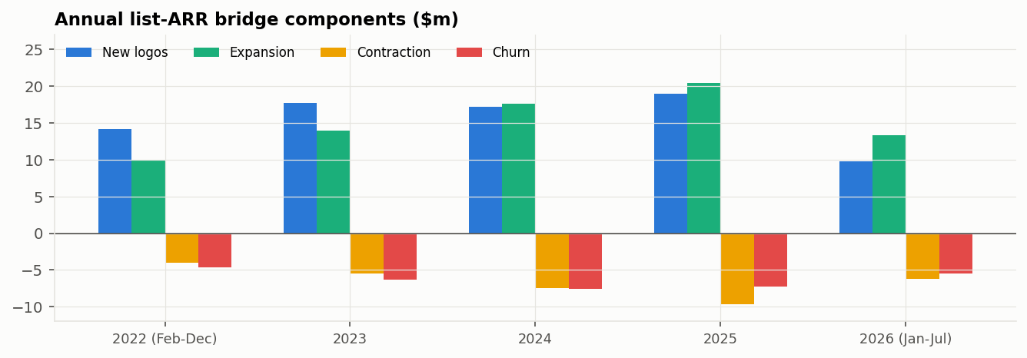
Figure 1. Annual list-ARR bridge components
Result. List ARR grew from $57.8m to $146.6m. Annual growth slowed from 27.0% in 2023 to 21.2% in 2024 and 19.9% in 2025; January to July 2026 added 8.4%, about 15% annualised. New-logo ARR stayed between $17m and $19m a year, so its contribution to growth fell from 24% of opening ARR in 2023 to 18% in 2024 and 17% in 2025. The existing base contributed a steady 2.9%, 2.8% and 3.1% (expansion less contraction and churn). Expansion rose from 41% to 58% of gross additions, and the quick ratio fell from 2.78 to 1.97.
Interpretation. Growth decelerates for an arithmetic reason: a new-logo engine that grows slowly adds a shrinking share of a base that grows at about 20%. The base itself adds about three points a year. A plan that extrapolates last year's growth rate will overshoot; a plan built from the components will not. The quick ratio fell from 2.78 in 2022 to 2.31 in 2024, held at 2.33 in 2025, and dropped to 1.97 in the first seven months of 2026, when churn ran at an annualised $9.5m against $7.2m in 2025 and new-logo ARR slowed to an annualised $16.8m.

REFLECTION
Why might this be? New-logo counts in the generator grew from 584 in 2022 to 703 in 2025, about 6% a year, while the base compounds at about 20%, so deceleration is built in. The 2026 dip in the quick ratio comes from a heavy first quarter for churn and a weak second quarter for new logos (Section 3.13.4).
Did we resolve it? Yes for planning: the underwriting and forward forecasts are built from component rates, not from growth rates (Sections 3.12 and 3.17). The underlying cause is a generator property; in a real company the next question would be sales capacity and pipeline coverage.

3.5 Growth quality: price realisation and discount dependence
Question. Was growth bought with discounts?
Method. Three measures are compared. First, year-on-year growth of list ARR against billed ARR: if billed grows more slowly, a widening discount mix is absorbing growth. Second, the discounted share of list MRR over time. Third, discount dependence: the share of new and expansion revenue written while the customer carried a discount above 15%, cut by channel and contract length.
Month | List ARR growth, YoY | Billed ARR growth, YoY | Discounted share of list MRR
2023-12 | 27.0% | 27.1% | 5.9%
2024-12 | 21.2% | 21.6% | 5.6%
2025-12 | 19.9% | 20.1% | 5.5%
2026-07 | 18.0% | 18.1% | 5.4%

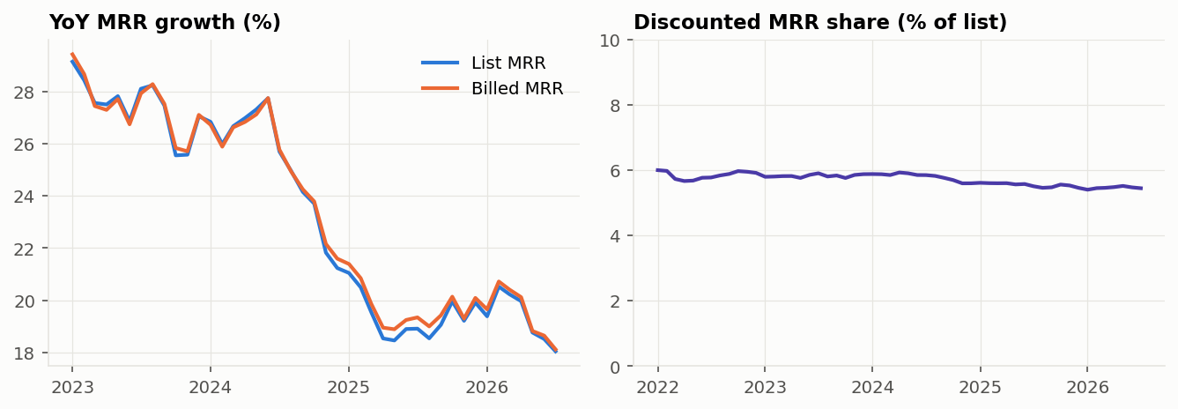
Figure 2. List vs billed growth, and the discounted share of list revenue
Cut (2024) | New-logo revenue above 15% discount | Expansion revenue above 15% discount
Channel: Inbound | 10.4% | 14.5%
Channel: Outbound | 14.8% | 9.2%
Channel: Paid | 13.4% | 13.9%
Channel: Partner | 14.4% | 21.8%
Channel: Self-serve | 10.3% | 5.5%
Contract: monthly | 6.7% | 9.5%
Contract: 12 months | 11.4% | 14.0%
Contract: 24 months | 21.0% | 13.4%
Contract: 36 months | 5.8% | 10.0%
Portfolio, 2024 | 13.2% | 13.0%
Portfolio, latest 12 months | 13.1% | 13.1%

Result. In 2024 billed ARR grew 21.6% against 21.2% for list; the discounted share fell from 5.9% to 5.6% and has since held near 5.4%. About 13% of new and expansion revenue carried a discount above 15% in both 2024 and the latest year. The pockets are partner-sourced expansion (21.8%), 24-month new contracts (21.0%) and outbound new logos (14.8%).
Interpretation. Price realisation is stable and growth was not bought with a widening discount mix. The pockets are where a deal-desk review would start. For context, SBI's 2025 pricing survey found that 48% of companies with a strict discount-approval process keep discounts under 10%, against 22% of those with flexible guidelines; the figure describes other companies and is not a target for this one.

REFLECTION
Why might this be? The generator gives outbound and paid accounts, 24-month contracts and Enterprise a higher chance of an initial discount, a rule that mirrors common practice; heavy discounts on new logos are most common in outbound (14.8%) and partner (14.4%), and on expansion in partner (21.8%). Outbound accounts retain best (GRR 94.2%) while paid accounts are among the weakest (90.6%), and save offers add discounts to accounts that were about to leave. Discount therefore sits with both low-risk and high-risk accounts, which hides any price effect.
Did we resolve it? No causal claim is made. Measuring a price effect needs a pricing test, or a change in approval policy used as a natural experiment. Diligence can conclude only the narrower point, which still matters: the discount mix did not flatter 2024 growth.

3.6 Retention at close against peers
Question. Is the customer base as durable as comparable companies' at the same point in time?
Method. The cohort is every customer active in December 2023, followed to December 2024. GRR counts churn and down-sell with each customer capped at its starting value; NRR adds expansion and price increases. Customers are grouped by their own billed ACV and contract term and compared with SaaS Capital's matching bands; the portfolio is compared with the all-company, bootstrapped and equity-backed medians. A customer bootstrap (1,000 resamples) gives the 95% range of the portfolio figures. Before comparing, the definitions were checked against each source.
Dimension | SaaS Capital 2025 | Benchmarkit 2026 | This report
Measurement window | Dec 2023 to Dec 2024 | Not disclosed | Dec 2023 to Dec 2024 (diligence); Jul 2025 to Jul 2026 (monitoring)
Unit | Median across more than 1,000 private B2B companies above $1m ARR | Median across surveyed companies; sample not disclosed | One company's customer base
Cohort basis | Customers present at the start; their MRR twelve months later | Not disclosed | Same as SaaS Capital
Price increases | Included in NRR, excluded from GRR | Not disclosed | Included in NRR; GRR capped per customer
Reactivations | Not stated | Not disclosed | None occur (0 of 4,547 customers)
Size and banding | Bands by each company's typical ACV; size mix not published by band | Not disclosed | $113m ARR; bands by each customer's own ACV
Funding split | Bootstrapped and equity-backed reported separately | Not split | Formerly bootstrapped
Use here | Primary benchmark | Direction only (usage vs seat NRR, expansion share)

Cut | Accounts | Our GRR | Median GRR | Gap | Our NRR | Median NRR | Gap
All private B2B SaaS >$1M ARR | 2,462 | 90.9% | 91% | −0.1 | 102.7% | 101% | +1.7
Bootstrapped | 2,462 | 90.9% | 92% | −1.1 | 102.7% | 104% | −1.3
Equity-backed | 2,462 | 90.9% | 90% | +0.9 | 102.7% | 101% | +1.7
ACV <$12k | 1,059 | 89.2% | 90% | −0.8 | 100.9% | 98% | +2.9
ACV $12k-$25k | 520 | 89.6% | 91% | −1.4 | 101.5% | 103% | −1.5
ACV $25k-$50k | 426 | 91.2% | 91% | +0.2 | 102.2% | 102% | +0.2
ACV $50k-$100k | 225 | 89.7% | 90% | −0.3 | 101.1% | 104% | −2.9
ACV $100k-$250k | 207 | 92.9% | 91% | +1.9 | 105.1% | 102% | +3.1
ACV >$250k (too small) | 25 | 87.6% | 95% | −7.4 | 99.8% | 106% | −6.2
Annual contracts | 1,223 | 90.4% | 90% | +0.4 | 104.2% | 101% | +3.2
Month-to-month contracts | 783 | 90.3% | 89% | +1.3 | 102.7% | 100% | +2.7
Multi-year contracts | 456 | 91.6% | 94% | −2.4 | 101.1% | 103% | −1.9

Benchmark: SaaS Capital 2025 B2B SaaS retention benchmarks, measured December 2023 to December 2024. The first three rows compare the whole portfolio with different benchmark groups. Gaps in percentage points.
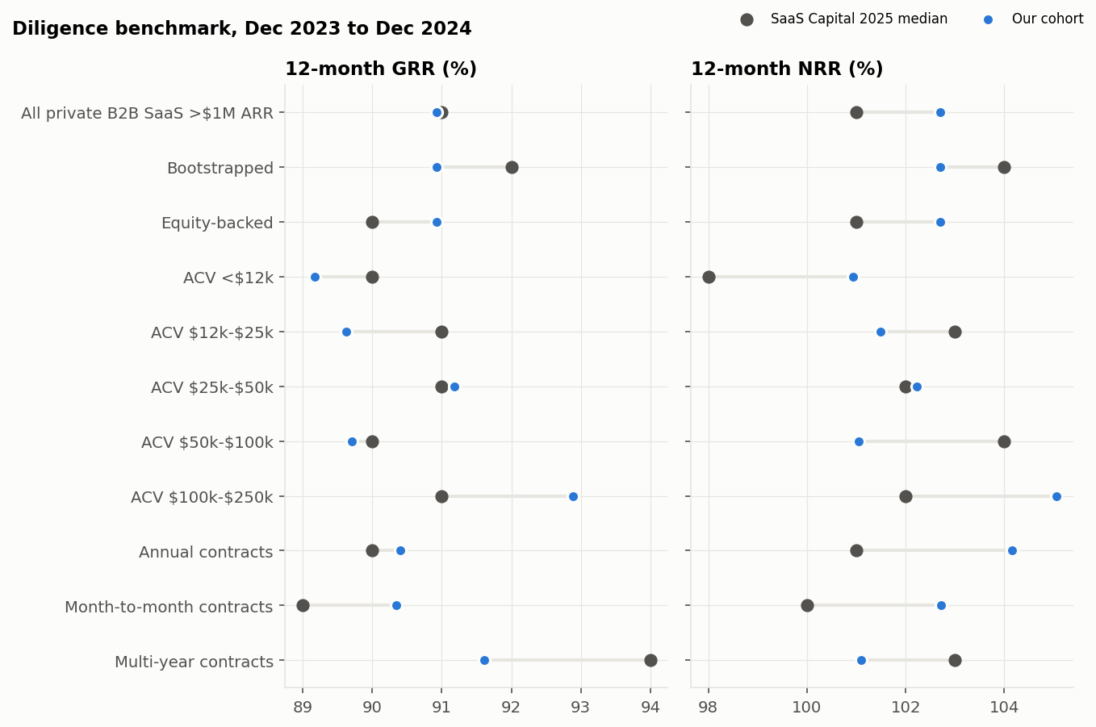
Figure 3. Diligence cohort vs SaaS Capital 2025 medians on matched cuts
Result. Portfolio GRR was 90.9% (95% range 89.2% to 92.7%) against a 91% median, and NRR 102.7% (100.5% to 105.0%) against 101% for all companies and 104% for bootstrapped ones. Excluding the >$250k band, GRR gaps by contract size and term run from −2.4 to +1.9 points and NRR gaps from −2.9 to +3.2 points. The >$250k band shows −7.4 points on GRR but contains 25 accounts, so one lost customer moves it by several points.
Interpretation. At close the base looked like a median private SaaS company on the same window and definition. A buyer should underwrite retention as a range of about two points either way, because that is how much one year's figure for a book of about 2,500 starting accounts moves by chance.

REFLECTION
Why might this be? Band-level gaps of up to three points arise because SaaS Capital classifies companies by their typical contract, while this report classifies customers inside one company; because groups of 200 to 500 accounts carry a standard error of two to three points; and because the generator's expansion rules do not change with contract size, so NRR does not rise with ACV as the survey shows.
Did we resolve it? The first two are handled by reading gaps of about three points or less as noise. The third is a generator limitation, left visible and examined in Section 3.9. None of this is evidence either way, because the window was calibrated.

3.7 Where revenue is lost: logo churn or contraction
Question. Is lost revenue driven by customers leaving or by customers paying less, and does the answer differ by segment?
Method. For each cohort, the revenue lost is split into churn loss (starting ARR of customers who left) and contraction loss (reduction in ARR of customers who stayed), both as a share of starting ARR; expansion is shown beside them. Logo retention curves follow signup cohorts month by month. The monthly bridge offers a second view of contraction, discussed in the reflection.
Segment and window | Accounts | Starting ARR | GRR | NRR | Logo churn | Churn loss | Contraction loss | Expansion
Enterprise, diligence | 293 | $48.6m | 92.1% | 104.0% | 6.1% | 6.6% | 1.3% | 11.9%
Mid-Market, diligence | 750 | $30.4m | 90.0% | 101.5% | 7.9% | 8.3% | 1.7% | 11.5%
SMB, diligence | 1,419 | $14.0m | 88.9% | 100.7% | 9.4% | 9.5% | 1.6% | 11.8%
Portfolio, diligence | 2,462 | $93.0m | 90.9% | 102.7% | 8.5% | 7.6% | 1.4% | 11.8%
Enterprise, Jul 2025 to Jul 2026 | 352 | $63.5m | 93.6% | 104.2% | 4.5% | 4.5% | 1.9% | 10.6%
Mid-Market, Jul 2025 to Jul 2026 | 939 | $41.5m | 91.5% | 102.9% | 7.2% | 7.0% | 1.5% | 11.4%
SMB, Jul 2025 to Jul 2026 | 1,786 | $19.2m | 88.5% | 99.7% | 10.2% | 10.1% | 1.4% | 11.1%
Portfolio, Jul 2025 to Jul 2026 | 3,077 | $124.2m | 92.1% | 103.1% | 8.7% | 6.2% | 1.7% | 10.9%

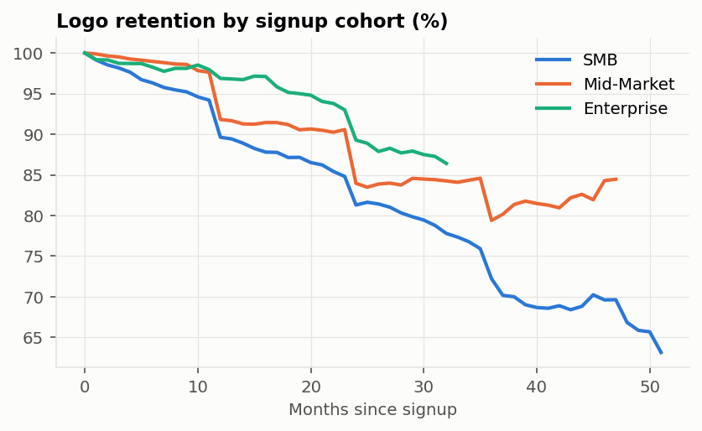
Figure 4. Logo retention by signup cohort and segment
Signup year | Cohort size | Logo retention at 12 months | At 24 months | At 36 months
2022 | 584 | 92% | 83% | 76%
2023 | 587 | 92% | 84% | 74%
2024 | 643 | 89% | 80% | not yet
2025 | 703 | 92% | not yet | not yet

Cohorts are counted only where every member has reached the stated age; the 36-month figure for 2023, the 24-month figure for 2024 and the 12-month figure for 2025 (367 of 703 accounts) cover the earlier-signing part of those years.
Result. In the latest twelve months SMB lost 10.1% of starting ARR to departures and only 1.4% to down-sell; Enterprise lost 4.5% and 1.9%. Across the portfolio, churn loss (6.2%) is almost four times contraction loss (1.7%). SMB logo retention falls to about 90% after the first annual renewal, 81% after the second and 72% after the third; Enterprise holds 97% at 12 months and 89% at 24. Signup-year cohorts retain 89% to 92% of logos at 12 months and 80% to 84% at 24 months. The 2024 cohort sits two to three points below the others at 12 months and three to four points below at 24, and the 2025 cohort is back at 92%.
Interpretation. SMB revenue loss is a logo-churn problem, concentrated at renewal dates. The lever is saving renewals, through outreach before the renewal window or longer contract terms, not driving usage expansion. The 2024 cohort's dip is at the edge of sampling noise for a cohort of about 600 accounts (roughly ±2.4 points), so it is a watch item rather than evidence that newer customers are weaker.

REFLECTION
Why might this be? Churn dominates partly because in the generator a churn decision removes the whole account and down-sell at renewal is modest. The monthly bridge shows the opposite picture for Enterprise: −$5.9m of contraction against −$2.1m of churn in 2025. The two views differ by construction. The bridge counts every monthly decrease, including usage dips that reverse within the year, while the cohort nets each customer's ups and downs over twelve months.
Did we resolve it? Partly. The report uses the cohort view for retention and the bridge view for monthly flow, and says which is which. With real data, renewal outcomes should also be split into renewed flat, renewed smaller, renewed larger and lost.

3.8 Segment strategy: SMB and Enterprise
Question. Is SMB strategic or a segment whose share should fall, and is the Enterprise base large enough to support growth?
Method. Four views are combined: the mix of accounts and ARR by segment over time; a segment-level ARR bridge for 2024 and 2025 built from the account-month mart with the same classification as the SQL bridge; new-logo counts by segment and year; and a cost-to-serve proxy, support tickets per $1m of ARR over the latest twelve months. Retention by segment comes from Section 3.7.
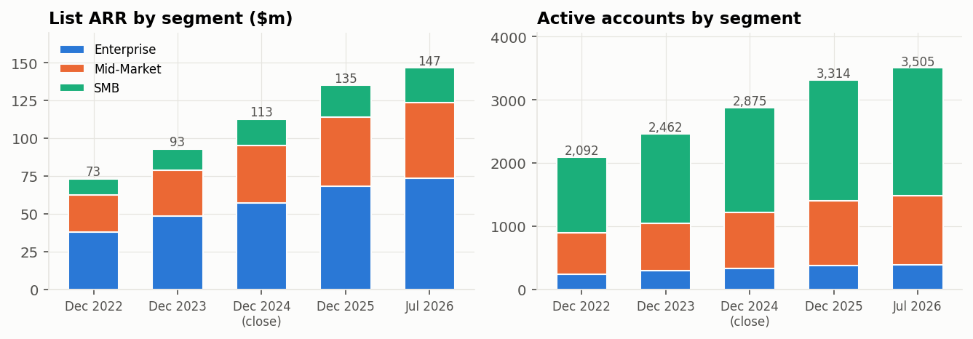
Figure 5. List ARR and active accounts by segment
Segment | Accounts at close | Accounts now | ARR at close | ARR now | Share of ARR now | Average ACV now
Enterprise | 325 | 391 | $57.3m | $73.4m | 50% | $177k
Mid-Market | 887 | 1,095 | $37.9m | $50.4m | 34% | $44k
SMB | 1,663 | 2,019 | $17.5m | $22.8m | 16% | $11k

Segment, 2025 | New logos | Expansion | Contraction | Churn | Net new ARR | Share of net new | ARR growth | Net new 2024
Enterprise | $7.9m | $11.1m | −$5.9m | −$2.1m | $10.9m | 49% | 19.0% | $8.8m
Mid-Market | $7.5m | $6.5m | −$2.7m | −$3.4m | $8.0m | 36% | 21.1% | $7.5m
SMB | $3.6m | $2.8m | −$1.1m | −$1.8m | $3.5m | 16% | 20.2% | $3.5m

Segment | New logos 2023 | 2024 | 2025 | Tickets per account per year | Tickets per $1m ARR | Non-renewal rate, last year
Enterprise | 64 | 50 | 62 | 29.3 | 160 | 3.5%
Mid-Market | 166 | 200 | 221 | 24.5 | 542 | 6.7%
SMB | 357 | 393 | 420 | 19.6 | 1,770 | 10.4%

Result. SMB is 58% of accounts and 16% of ARR. Its base roughly holds value (NRR 99.7%), it grows through about 400 new logos a year, and it supplied 16% of 2025 net new ARR, in line with its share of ARR. Per dollar of ARR it raises about 11 times as many support tickets as Enterprise, and its contracts fail to renew about three times as often (10.4% against 3.5%). Enterprise has 391 accounts (325 at close), holds 50% of ARR at an average ACV of $177k, grew ARR 19% in 2025 and delivered 49% of net new ARR, from 50 to 65 new logos a year.
Interpretation. On retention evidence alone SMB is not dilutive enough to shrink: it neither drags NRR far below the portfolio nor contributes less growth than its weight. The argument against SMB is cost to serve and churn at renewal, and that argument needs CAC, payback and support cost by segment, which the data does not contain. A reasonable interim stance is to keep SMB on low-touch, self-serve acquisition and avoid scaling paid acquisition into it until payback is measured. Enterprise keeps pace with the company; its $10.9m of 2025 net new ARR came from $7.9m of new logos and $3.1m of net growth in the existing base. But with about 60 new logos a year it cannot carry company growth alone: each Enterprise win or loss moves the segment, and Mid-Market supplies over a third of net new ARR.

REFLECTION
Why might this be? The ticket gap is largely mechanical: the generator draws tickets per account with only a mild link to size, so small accounts generate far more tickets per dollar. Segment growth rates end up similar although retention differs: SMB's 2025 new-logo ARR equalled about 20% of its opening ARR against about 14% for Enterprise, which offsets SMB's flat base.
Did we resolve it? Partly. The answer to the SMB question is framed as what the retention data can and cannot support, and the missing inputs are named. Ticket cost per segment and CAC by channel are the diligence requests that would settle it.

3.9 NRR drivers: expansion motion or product scalability
Question. Where NRR trails the benchmark, is the cause losses or expansion, and if expansion, is it the sales motion or a ceiling in the product?
Method. NRR equals GRR plus expansion, so each benchmark gap is first split into a loss part and an expansion part. Expansion is then separated into breadth (share of starting accounts that grew) and depth (median increase among them), by ACV band and pricing model. For accounts that expanded, the increase is split into seat growth (more users at the old price per seat) and price (the remainder: uplifts, modules and usage). A weak motion shows up as low breadth; a scalability ceiling shows up as depth that does not rise, or falls, with account size.
Group (diligence window) | Accounts | Expanded (breadth) | Median increase (depth) | Contracted | Churned | Expansion, % of ARR
Portfolio | 2,462 | 61% | 14.0% | 13% | 8.5% | 11.8%
ACV <$12k | 1,059 | 62% | 14.2% | 11% | 9.3% | 11.8%
ACV $12k-$25k | 520 | 61% | 13.3% | 14% | 8.7% | 11.9%
ACV $25k-$50k | 426 | 60% | 12.3% | 15% | 7.3% | 11.1%
ACV $50k-$100k | 225 | 61% | 14.1% | 19% | 8.9% | 11.3%
ACV $100k-$250k | 207 | 64% | 14.0% | 16% | 5.8% | 12.2%
ACV >$250k | 25 | 68% | 15.1% | 12% | 12.0% | 12.3%
Pricing: hybrid | 638 | 71% | 10.6% | 21% | 8.6% | 10.3%
Pricing: seat | 1,370 | 56% | 14.0% | 5% | 8.7% | 9.5%
Pricing: usage | 454 | 62% | 19.3% | 30% | 7.9% | 17.4%

Expanding accounts | Accounts | Expansion ARR | From seat growth | From price, modules, usage | Median seat growth
All | 1,509 | $11.0m | 65% | 35% | 9.7%
Pricing: hybrid | 452 | $3.3m | 73% | 27% | 6.5%
Pricing: seat | 774 | $3.6m | 87% | 13% | 12.5%
Pricing: usage | 283 | $4.0m | 40% | 60% | 0.0%

Result. NRR trails the benchmark in the $12k to $25k band (−1.5 points), the $50k to $100k band (−2.9), multi-year contracts (−1.9) and against the bootstrapped median (−1.3). In the $50k to $100k band GRR is only 0.3 points short, so almost the whole gap is expansion; in the $12k to $25k band (GRR −1.4) and on multi-year contracts (GRR −2.4) the gap comes mainly from losses. Breadth (about 60%) and depth (12% to 15%) are flat across ACV bands: a $150k account expands by the same proportion as a $10k one. About two thirds of expansion comes from seat growth and one third from price, modules and usage; for seat-priced accounts seat growth is 87% of expansion.
Interpretation. The largest shortfall is in expansion; the smaller ones are retention. In a real company, flat depth across contract sizes would point to a scalability ceiling (large customers cannot add proportionally more seats or modules) rather than a weak motion, because breadth is healthy everywhere. The diligence requests that separate the two are seat penetration (seats bought relative to addressable users), module whitespace by account, and account-manager coverage of the top bands.

REFLECTION
Why might this be? In this simulation the expansion rules do not depend on account size, so flat depth is a generator property rather than a finding about the company.
Did we resolve it? No, and it cannot be on this data. The method is in place and the data it needs is named; on real data the same tables would answer the question.

3.10 Customer concentration
Question. How dependent is revenue on a few customers?
Method. Customers are ranked by billed ARR at close and today. The table reports the share of ARR held by the largest 1, 10, 20 and 50 customers and by the largest 10% of customers, and the HHI with its equivalent number of equal-sized customers.
Measure | At close (Dec 2024) | Now (Jul 2026)
Active customers | 2,875 | 3,505
Largest customer | 0.47% | 0.60%
Top 10 customers | 3.7% | 3.7%
Top 20 customers | 6.8% | 6.4%
Top 50 customers | 14.4% | 13.1%
Top 10% of customers | 48.2% | 48.6%
HHI (0 to 10,000) | 11.4 | 9.7
Equivalent equal-sized customers | 881 | 1,026

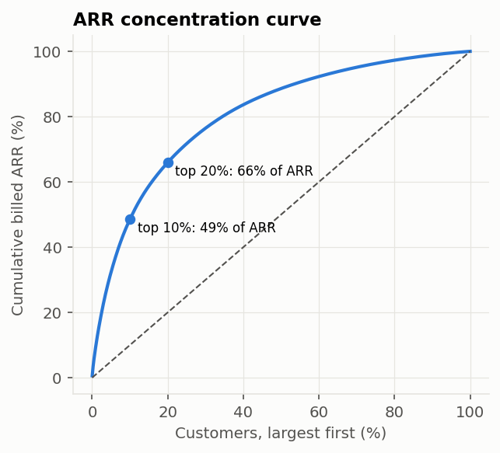
Figure 6. Cumulative share of ARR by customer, largest first (July 2026)
Result. At close the top 10 customers held 3.7% of ARR and the largest 0.47%; the top 10% of customers held 48%. The HHI is equivalent to about 1,026 equal-sized customers today. Concentration is broadly unchanged since close: the HHI fell as the customer count grew, while the largest customer's share rose from 0.47% to 0.60%.
Interpretation. No single relationship can move the book. Revenue is concentrated in the sense that matters for operations (the top tenth of customers carries about half of ARR, which is where account management should sit), but not in the sense that matters for valuation.

REFLECTION
Why might this be? Concentration is low because the generator draws contract sizes from bounded ranges within each segment, so no customer can become very large. Real software books are usually more skewed, and concentration is often the first diligence finding.
Did we resolve it? No. The result is reported as a consequence of a design choice, and a heavier-tailed size distribution is listed as a next step (Section 3.20).

3.11 Revenue to cash
Question. Does recognised revenue turn into cash, and how fast?
Method. Recognised revenue is billed MRR summed over the months of each quarter, because billing is monthly and recognition ratable. Each invoice is dated the first of the month; cash arrives after one month of payment terms plus the customer's recorded days late, and failed invoices are never collected. Receivables must roll forward exactly: opening balance plus collectible invoices less cash equals the closing balance.
Quarter | Revenue | Invoiced | Cash collected | Never collected | Receivables | Cash conversion | DSO (days)
2025 Q3 | $29.8m | $29.8m | $28.9m | $0.57m | $10.5m | 96.8% | 32
2025 Q4 | $31.4m | $31.4m | $30.3m | $0.55m | $10.9m | 96.7% | 32
2026 Q1 | $32.8m | $32.8m | $31.9m | $0.48m | $11.4m | 97.3% | 32
2026 Q2 | $33.9m | $33.9m | $32.9m | $0.49m | $11.8m | 97.2% | 32

Result. Invoices equal recognised revenue in every quarter and receivables roll forward exactly. Cash conversion runs between 96.7% and 97.3%, failed collections between 1.4% and 1.9% of revenue, and DSO at about 32 days.
Interpretation. Revenue converts to cash at about 97%. Invoices never paid account for 1.4% to 1.9% of revenue; the rest of the gap is timing, as receivables grow with the book. The leakage figure is the one to test against a real book's receivables ageing and bad-debt history.

REFLECTION
Why might this be? DSO of about 32 days mostly restates an assumption: the data has no payment-terms field, so one-month terms were assumed. Every account is billed monthly, so there is no deferred revenue, which in real SaaS books sits between ARR and cash when customers prepay annually.
Did we resolve it? No. With real data, receivables ageing and contract billing terms replace the assumption, and annual upfront billing adds a deferred-revenue line to the bridge.

3.12 Underwriting forecast against actual
Question. Would a forecast made at close, with only pre-close data, have held over the next nineteen months?
Method. Using months up to December 2024 only, the base case applies the trailing twelve-month averages of new-logo MRR and of the expansion, contraction and churn rates from the SQL bridge, month by month. The band comes from 4,000 simulated paths, each built by drawing whole pre-close months at random from the last 24 and rescaling new-logo MRR to the trailing level, so the four components move together as they did historically. A unit test changes post-close data and confirms the forecast does not move. Because one path landing inside its band is weak evidence, a rolling-origin test rebuilds the band at 29 earlier start dates and scores the next twelve months each time.
Month | Base case | 90% band | Actual | Error (base vs actual) | Inside 90% band
2025-01 | $114.5m | $113.8m to $115.1m | $114.6m | −0.1 | Yes
2025-03 | $117.8m | $116.6m to $119.3m | $116.6m | +1.1 | Yes
2025-06 | $122.9m | $121.0m to $124.9m | $122.7m | +0.2 | Yes
2025-09 | $128.0m | $125.7m to $130.5m | $128.1m | −0.1 | Yes
2025-12 | $133.1m | $130.5m to $136.0m | $135.3m | −1.6 | Yes
2026-03 | $138.2m | $135.2m to $141.6m | $140.2m | −1.4 | Yes
2026-06 | $143.4m | $140.1m to $147.2m | $145.4m | −1.3 | Yes
2026-07 | $145.2m | $141.7m to $149.1m | $146.6m | −1.0 | Yes

List ARR. A positive error means the base case was above actual.
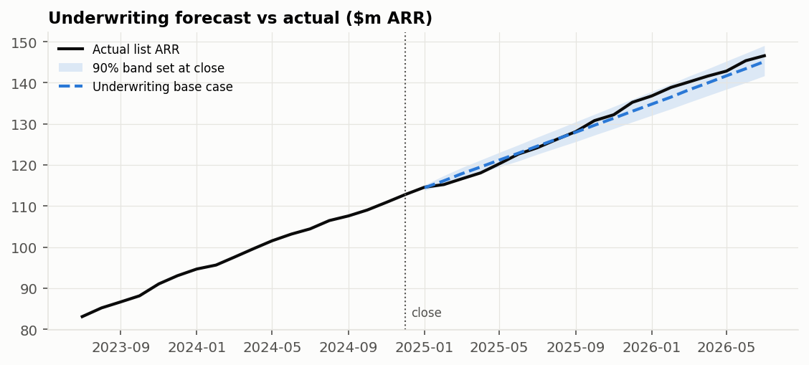
Figure 7. Underwriting base case and 90% band set at close, against actual list ARR
Months ahead | 1 | 2 | 3 | 4 | 5 | 6 | 7 | 8 | 9 | 10 | 11 | 12
Coverage of 90% band | 79% | 93% | 86% | 96% | 88% | 88% | 83% | 83% | 82% | 71% | 70% | 79%
Band width, % of ARR | 1.3% | 2.1% | 2.6% | 2.9% | 3.3% | 3.6% | 3.8% | 4.1% | 4.3% | 4.5% | 4.7% | 4.9%
Median error, % | −0.01 | −0.02 | +0.01 | +0.01 | +0.00 | −0.04 | −0.08 | −0.14 | −0.15 | −0.21 | −0.24 | −0.22

Result. After 19 months the base case was $145.2m against actual $146.6m, 1.0% low. The base ran up to 1.2% above actual in the first half of 2025, crossed in late summer, and ran up to 1.7% below from late 2025. Actual ARR stayed inside the 90% band in all 19 months and inside the 50% band in 8 of them (42%). Across the rolling test, the 90% band covered 84% of outcomes overall. Coverage is below 90% at ten of twelve horizons. Up to nine months ahead it averages about 86% and is uneven (79% one month ahead, 96% four months ahead); at ten to twelve months it falls to 70% to 79%.
Interpretation. The forecast method is fit for underwriting a point path: the realised miss is small and changes sign. Its band is too narrow at most horizons and most of all at ten to twelve months, so a range from this method understates risk.

REFLECTION
Why might this be? The band is too narrow, most of all at long horizons, for two reasons. New-logo arrivals trend upward slowly, which a trailing average lags, so the base drifts low as the horizon lengthens; this matches the late-2025 undershoot. And drawing months independently ignores the way good and bad months cluster, which understates the spread of twelve-month outcomes.
Did we resolve it? Diagnosed, not fixed. Two fixes are available: a trend term on new-logo revenue, or widening each horizon's band by its measured coverage shortfall. Until one is in place, the band should be read as a lower bound on uncertainty, especially beyond nine months.

3.13 Post-close monitoring

3.13.1 Retention plan against actual
Method. The retention plan holds the diligence GRR and NRR flat. The actual is the rolling twelve-month cohort measured at each month-end, starting December 2025, the first month with a full post-close year.
Period ending | Plan GRR | Actual GRR | Variance | Plan NRR | Actual NRR | Variance
2025-12 | 90.9% | 92.5% | +1.6 | 102.7% | 103.2% | +0.5
2026-01 | 90.9% | 92.5% | +1.6 | 102.7% | 103.2% | +0.5
2026-02 | 90.9% | 93.1% | +2.2 | 102.7% | 104.3% | +1.6
2026-03 | 90.9% | 92.9% | +1.9 | 102.7% | 104.2% | +1.5
2026-04 | 90.9% | 92.9% | +1.9 | 102.7% | 103.9% | +1.2
2026-05 | 90.9% | 92.6% | +1.7 | 102.7% | 103.8% | +1.1
2026-06 | 90.9% | 92.6% | +1.6 | 102.7% | 103.8% | +1.1
2026-07 | 90.9% | 92.1% | +1.2 | 102.7% | 103.1% | +0.4

Result. Actual GRR ran 1.2 to 2.2 points above plan and NRR 0.4 to 1.6 points above. The bootstrap range for one year's portfolio GRR is about ±1.3 to ±1.8 points.

REFLECTION
Why might this be? The simulator holds its parameters fixed after close, so the beat is cohort mix and chance, not improvement. Variances of this size sit at the edge of one year's sampling noise.
Did we resolve it? Partly. The monitoring rule is to treat a variance inside the bootstrap range as noise and to review one that persists for two quarters or exceeds the range. By that rule this variance qualifies for review: it has been positive for eight months and briefly exceeded the range. Because it is favourable and the simulator's parameters are fixed, the review conclusion is that the plan was conservative; the action is to re-base the retention plan at about 92%, not to change operations.

3.13.2 Calendar 2025 against benchmarks published in 2026
Method. Calendar 2025 retention (December 2024 cohort to December 2025) is compared with SaaS Capital figures published in 2026, the first out-of-sample benchmark test. The 2026 bootstrapped page covers companies of $3m to $20m ARR only and does not state its window; 2025 is inferred.
Measure | Ours 2024 | Ours 2025 | 95% range 2025 | Benchmark 2024 | Benchmark 2025 | Benchmark scope
GRR | 90.9% | 92.5% | 91.1% to 93.7% | 92% | 91% | SaaS Capital bootstrapped; 2025 figure for $3m to $20m ARR
NRR | 102.7% | 103.2% | 101.3% to 104.8% | 104% | 103% | Same
List ARR growth | 21.2% | 19.9% |  | 23% / 25% | 20% / 25% | SaaS Capital revenue growth, bootstrapped / equity-backed, all sizes

Result. 2025 GRR of 92.5% sits 1.5 points above the 2026 bootstrapped median of 91%, and NRR of 103.2% matches its 103%. Growth of 19.9% sits at the bootstrapped median and below the equity-backed one.

REFLECTION
Why might this be? SaaS Capital describes its bootstrapped median as essentially flat year on year; the 92% and 91% figures are not directly comparable because the 2026 figure covers $3m to $20m companies only. The simulator has no market-wide drift after close, and the benchmark covers much smaller companies. The benchmark's growth figure is revenue growth, not ARR growth, so that row is context only.
Did we resolve it? Partly. The comparison is read as at or slightly above the benchmark (the 91% median sits just below our 95% range of 91.1% to 93.7%), not as outperformance given the size mismatch. No public 2026 retention figure for equity-backed companies was found, so the funding mismatch after the sale remains.

3.13.3 Retention by contract size, pricing and channel today
Method. The same cohort measure is applied to July 2025 to July 2026 and cut by ACV band, contract term, pricing model and acquisition channel. Segment results are in Section 3.7.
Cut | Accounts | Starting ARR | GRR | NRR | Churn loss | Contraction loss | Expansion
ACV <$12k | 1,213 | $9.4m | 88.2% | 99.6% | 10.5% | 1.2% | 11.4%
ACV $12k-$25k | 723 | $12.9m | 90.4% | 101.1% | 8.4% | 1.2% | 10.7%
ACV $25k-$50k | 534 | $20.3m | 91.4% | 103.0% | 7.5% | 1.2% | 11.6%
ACV $50k-$100k | 318 | $23.6m | 92.8% | 103.0% | 5.4% | 1.8% | 10.2%
ACV $100k-$250k | 231 | $39.1m | 92.5% | 103.0% | 5.7% | 1.7% | 10.4%
ACV >$250k | 58 | $18.8m | 94.3% | 106.5% | 3.1% | 2.6% | 12.2%
Term: Annual | 1,504 | $60.5m | 92.1% | 104.7% | 6.5% | 1.4% | 12.6%
Term: Month-to-month | 1,004 | $11.0m | 89.6% | 100.9% | 8.9% | 1.5% | 11.3%
Term: Multi-year | 569 | $52.7m | 92.7% | 101.6% | 5.2% | 2.1% | 9.0%
Pricing: hybrid | 794 | $41.1m | 92.9% | 103.6% | 6.1% | 1.0% | 10.7%
Pricing: seat | 1,718 | $51.4m | 92.3% | 101.1% | 7.2% | 0.5% | 8.8%
Pricing: usage | 565 | $31.7m | 90.8% | 105.5% | 4.6% | 4.6% | 14.7%
Channel: Inbound | 809 | $30.0m | 91.5% | 103.0% | 7.6% | 0.9% | 11.5%
Channel: Outbound | 658 | $50.0m | 94.2% | 105.4% | 4.3% | 1.5% | 11.2%
Channel: Paid | 642 | $15.8m | 90.6% | 101.6% | 8.0% | 1.4% | 10.9%
Channel: Partner | 352 | $19.8m | 89.3% | 98.6% | 7.2% | 3.6% | 9.4%
Channel: Self-serve | 616 | $8.5m | 91.6% | 102.9% | 6.8% | 1.6% | 11.2%

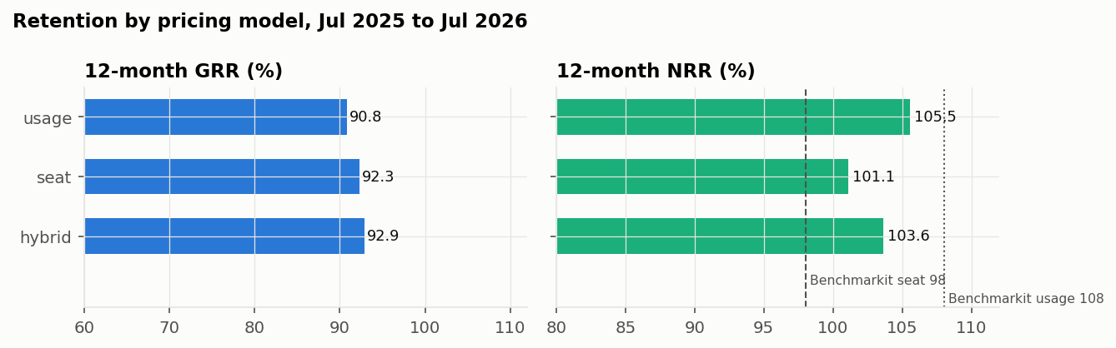
Figure 8. Twelve-month GRR and NRR by pricing model, July 2025 to July 2026
Result. GRR broadly rises with contract size, from 88.2% under $12k to 94.3% above $250k. Usage-priced accounts have the lowest GRR (90.8%) and the highest NRR (105.5%); seat-priced accounts have the lowest NRR (101.1%) with GRR of 92.3%, and hybrid accounts the highest GRR (92.9%). Partner-sourced accounts are weakest (GRR 89.3%, NRR 98.6%) with the highest contraction (3.6%); outbound accounts are strongest (94.2%, 105.4%). The >$250k band, now 58 accounts, sits at 94.3% and 106.5% against SaaS Capital's 95% and 106%.
Interpretation. Usage pricing moves revenue both ways, which matches Benchmarkit's 2026 direction (usage 108% against seat 98% NRR) with a smaller gap. The question for management would be whether usage pricing should be offered to seat customers. The large-account band that looked 7 points short at close was a small-sample artefact.

REFLECTION
Why might this be? The generator has no channel-specific churn or contraction rule. Partner accounts carry the same average discount as the book (4.7% against 4.9%) and a similar pricing and segment mix, although their expansion is written above a 15% discount more often (21.8%, Section 3.5). They were also weakest at diligence (GRR 87.2%), but the two windows share many of the same accounts, so the persistence is weaker evidence than it looks. The pricing pattern is a simulated relationship whose direction was set to match external evidence.
Did we resolve it? Partly. The partner gap is unexplained rather than attributed; in a real book it would trigger a review of partner deal terms and be tracked for two or more quarters before acting. The >$250k question was resolved by more data, which is the right way to resolve a small-sample gap.

3.13.4 Quarterly bridge and expansion mix
Quarter | Opening ARR | New logos | Expansion | Contraction | Churn | Closing ARR | Quick ratio | Expansion share
2025 Q3 | $122.7m | $4.8m | $5.0m | −$2.5m | −$1.8m | $128.1m | 2.27 | 51%
2025 Q4 | $128.1m | $5.5m | $5.9m | −$2.6m | −$1.6m | $135.3m | 2.68 | 52%
2026 Q1 | $135.3m | $4.4m | $5.8m | −$2.6m | −$2.7m | $140.2m | 1.92 | 57%
2026 Q2 | $140.2m | $3.6m | $5.9m | −$2.6m | −$1.6m | $145.4m | 2.23 | 62%

Result. Over the four quarters to June 2026 expansion was 55% of gross new ARR and the quick ratio 2.26. New-logo ARR fell to $3.6m in the second quarter of 2026 from $4.4m to $5.5m in the three before; churn peaked at $2.7m in the first quarter.
Interpretation. Benchmarkit reports a 40% median for expansion's share of new ARR without stating its denominator, so the comparison is directional only. A rising expansion share together with a weak quarter for new logos is the pipeline question a monitoring review would raise first.

REFLECTION
Why might this be? The expansion share sits above 40% partly because calibration raised expansion to reach the NRR target while new-logo flow was set separately. A single weak quarter of new logos is within the month-to-month variation seen before close.
Did we resolve it? It is a calibration side effect, not a finding. In a real book the same numbers would prompt a pipeline and sales-capacity review, and the quarter would be tracked against the forecast band.

3.14 Renewal exposure and the value of retention
Question. How much ARR is exposed in the next twelve months, and what is a point of retention worth?
Method. Committed ARR is placed in the quarter its contract ends; monthly contracts are shown separately because they can end in any month. Last year's non-renewal rates by segment are applied to committed renewals, and the SMB non-renewal rate to the monthly book, which is all SMB. The value of a GRR point is one percent of opening ARR, converted to gross profit at 75%. The margin assumption is checked against eleven listed SaaS companies from SEC filings, and an ARR sensitivity grid varies GRR and the expansion rate around today's values.
Renewal window | Enterprise | Mid-Market | SMB | Total
2026 Q3 (Aug to Sep) | $6.2m | $6.3m | $1.8m | $14.3m
2026 Q4 | $12.2m | $10.0m | $2.3m | $24.5m
2027 Q1 | $10.3m | $10.5m | $2.3m | $23.0m
2027 Q2 | $11.7m | $8.9m | $2.2m | $22.8m
2027 Q3 (Jul) | $3.8m | $2.7m | $0.7m | $7.2m
Beyond 12 months | $24.9m | $9.4m | $0.0m | $34.3m
Monthly contracts | $0.0m | $0.0m | $12.5m | $12.5m

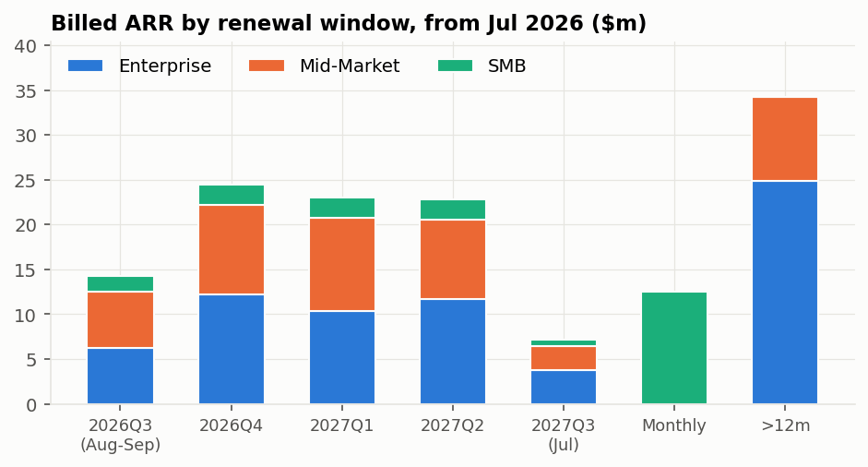
Figure 9. Billed ARR by renewal window and segment, from July 2026
Result. $91.8m of committed ARR, 66% of billed ARR, renews in the next twelve months, with the heaviest quarters in late 2026 and early 2027. Last year's non-renewal rates were 3.5% for Enterprise, 6.7% for Mid-Market and 10.4% for SMB (198, 688 and 695 contracts). Applied to the renewal schedule and the monthly book, they imply about $6.4m of ARR lost, 4.6% of billed ARR. One point of GRR on $145.4m of opening ARR is $1.45m of ARR, or $1.09m of annual gross profit at 75%.
Company | Quarter ending | Revenue ($m) | Revenue growth | Gross margin | Operating margin | FCF margin
NOW | 2026-06-30 | 3,987 | 24.0% | 70.7% | 4.1% | 11.9%
HUBS | 2026-06-30 | 912 | 19.8% | 82.4% | 4.8% | 22.3%
DDOG | 2026-06-30 | 1,121 | 35.6% | 78.6% | 0.5% | 27.3%
TWLO | 2026-06-30 | 1,499 | 22.0% | 48.4% | 5.6% | n/a
MDB | 2026-07-31 | 772 | 30.5% | 73.8% | 3.7% | 18.1%
CRM | 2026-07-31 | 11,345 | 10.8% | 76.7% | 20.5% | 9.7%
ESTC | 2026-07-31 | 478 | 15.1% | 74.5% | -4.9% | 27.5%
WDAY | 2026-07-31 | 2,649 | 12.8% | n/a | 11.8% | 17.4%
ASAN | 2026-07-31 | 216 | 9.9% | 86.0% | -19.0% | 20.6%
SNOW | 2026-07-31 | 1,547 | 35.1% | 67.0% | -17.0% | 5.4%
ZM | 2026-07-31 | 1,277 | 4.9% | 77.2% | 24.6% | 37.0%
Median |  |  | 19.8% | 75.6% | 4.1% | 19.3%

Source: SEC EDGAR company facts, latest reported quarter. Gross margin is not reported in a comparable tag for WDAY; FCF is missing for TWLO. Medians exclude missing values.
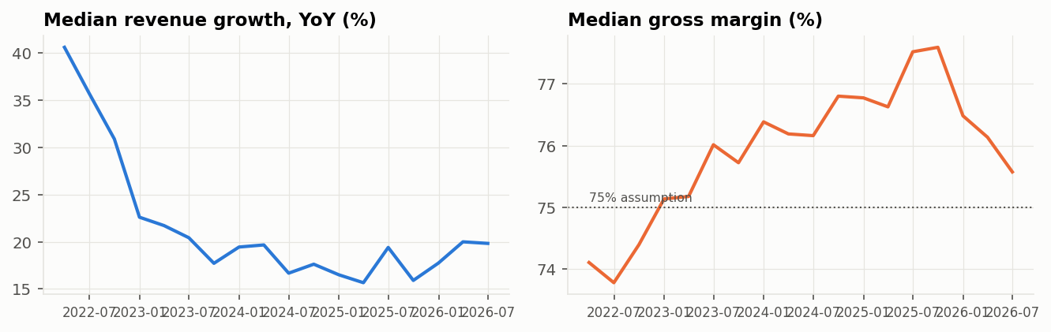
Figure 10. Median revenue growth and gross margin, 11 listed SaaS companies, fiscal quarters aligned to calendar quarters
GRR \ expansion rate | 6.9% | 8.9% | 10.9% (today) | 12.9% | 14.9%
84% | $150.4m | $153.3m | $156.2m | $159.2m | $162.1m
86% | $153.3m | $156.2m | $159.2m | $162.1m | $165.0m
88% | $156.2m | $159.2m | $162.1m | $165.0m | $167.9m
90% | $159.2m | $162.1m | $165.0m | $167.9m | $170.8m
92% (today 92.1%) | $162.1m | $165.0m | $167.9m | $170.8m | $173.7m
94% | $165.0m | $167.9m | $170.8m | $173.7m | $176.6m

Ending list ARR twelve months after June 2026 = opening ARR × (GRR + expansion rate) + trailing new-logo ARR. From the workbook's Sensitivity sheet; base case $168.1m.
Interpretation. The public median gross margin of 75.6% supports the 75% assumption. Per point, GRR and the expansion rate move ending ARR by the same $1.45m; what differs is the plausible range. Published GRR medians run from 84% (Benchmarkit, definition not disclosed) to 91% (SaaS Capital, all companies) and 92% (SaaS Capital, bootstrapped), a spread worth $10m to $12m of ARR within a year. As an illustration only, SEG's 2026 report puts the median SaaS M&A multiple at about 4.0 times trailing revenue, so one point of GRR sustained would be worth roughly $6m of enterprise value at that multiple. The multiple applies to revenue rather than ARR and to other companies, so the figure is an order of magnitude, not a valuation.

REFLECTION
Why might this be? The expected-loss estimate (4.6%) is below one minus GRR (7.9%) because it counts only non-renewal of committed contracts and the monthly book, and ignores down-sell at renewal and early terminations. The value of a point depends on the margin assumption because no P&L is simulated.
Did we resolve it? Partly. The expected loss is presented as a floor and the workbook exposes the rates so they can be stressed. The margin assumption is now anchored to public comparables. A simple P&L remains the next step for turning retention into Rule of 40 and valuation terms.

3.15 Churn-risk model
The model answers an operating question: each month, which accounts should customer success call first? It is built and tested in seven steps.

3.15.1 Design: target, split and leakage controls
Method. The target is three-month forward churn: whether an active account first appears as churned in any of the next three months. Each account-month is described using only its own last three months. A label is used only once all three following months have been observed. Training uses feature months 2022-03 to 2024-09, whose labels had all matured by the close. The holdout is every feature month after the close, 2025-01 to 2026-04; October to December 2024 is dropped because those labels straddle the close. Settings are tuned on four forward folds, in which each validation month is scored by a model trained only on months whose labels matured before it.
Sample | Feature months | Account-months | Churn events | Churn rate
Training | 2022-03 to 2024-09 | 66,904 | 1,533 | 2.29%
Purge gap | 2024-10 to 2024-12 | dropped
Holdout (post-close) | 2025-01 to 2026-04 | 48,800 | 1,059 | 2.17%

REFLECTION
Why might this be? A random split would put a customer's March in training and April in testing, and because neighbouring three-month labels overlap it would overstate accuracy. A post-close holdout is what a buyer actually faces: a model fitted on history and used on the future.
Did we resolve it? Yes, by construction. Tests check that training labels end before the holdout begins and that scrambling future months leaves current features unchanged.

3.15.2 Features and what distinguishes churners
Method. Sixteen features describe usage, product breadth, support friction, price, payment behaviour, satisfaction and contract mechanics. Before any model is fitted, the average of each feature is compared between account-months that churned in the next three months and those that did not, on the training sample.
Feature | What it captures | Stayed | Churned
Usage ratio | Share of licensed capacity used; most direct sign of value received | 0.649 | 0.571
Usage trend | Change in usage over the window | -0.002 | -0.015
Module adoption | Breadth of product use; raises switching costs | 0.638 | 0.575
Support tickets | Support friction; also scales with account size | 1.818 | 2.038
Ticket trend | Change in tickets over the window | 0.002 | 0.061
Severity-1 tickets | Serious incidents | 0.086 | 0.145
Average discount | Price concession | 0.050 | 0.053
Days late | Payment delay | 3.6 | 4.2
Failed payments | Payment failures | 0.054 | 0.060
List MRR change | Contraction or expansion under way | 0.017 | 0.005
NPS (latest) | Stated satisfaction | 6.6 | 6.0
NPS missing | Whether the customer answered the survey | 18% | 16%
Renewal within 3 months | A committed contract can end inside the window | 13% | 54%
Monthly contract | Can leave in any month | 31% | 33%
Promotion active | A discount is due to lapse | 3% | 4%
Tenure (months) | Time as a customer | 27.0 | 28.6

Training sample: 66,904 account-months, 1,533 followed by churn. Shares for yes/no features; three-month averages otherwise.
Result. The largest difference is contract timing: 54% of churning account-months had a committed renewal within three months, against 13% of the rest. Counting monthly contracts as always exposed (the renewal-window definition in Part 2), 45% of training account-months were inside a window and they carried about 87% of churn; the three-month churn rate was 4.4% inside and 0.56% outside. Churners also used less of what they bought (usage ratio 0.57 against 0.65), adopted fewer modules, raised more severe tickets and paid later. Discount, failed payments and monthly contracts differ little on average.

REFLECTION
Why might this be? Averages show each signal alone. Monthly contracts look harmless on average because monthly accounts are mostly small SMB customers whose individual-month churn rate is modest, even though they can leave in any month; the multivariate model gives them a large positive weight once renewal timing is held fixed. Tenure is slightly higher for churners because committed customers can only churn after a full term.
Did we resolve it? Yes. The univariate view is used to sense-check signs, not to choose features; the model and its stability tests make the selection (3.15.4).

3.15.3 Baselines: the rule and the operating rule
Method. Two baselines set the bar. The hand-set rule weights low usage, discount, days late, tickets and falling revenue. The operating rule, adopted in an earlier round and frozen before this holdout existed, multiplies the same score by renewal exposure, so accounts that cannot leave within the window are scored down to a quarter of their rule score. Two sensitivity tests check whether the baselines are fragile: each rule weight moved by 20% in either direction, and the early-exit multiplier varied from 0.1 to 1.
Test | Setting | Holdout ROC-AUC
Rule weight | Base weights | 0.754
Rule weight | usage −20% | 0.751
Rule weight | usage +20% | 0.756
Rule weight | discount −20% | 0.756
Rule weight | discount +20% | 0.752
Rule weight | late −20% | 0.755
Rule weight | late +20% | 0.753
Rule weight | tickets −20% | 0.754
Rule weight | tickets +20% | 0.755
Rule weight | growth −20% | 0.754
Rule weight | growth +20% | 0.754
Early-exit multiplier | 0.1 | 0.758
Early-exit multiplier | 0.25 | 0.754
Early-exit multiplier | 0.5 | 0.728
Early-exit multiplier | 1.0 (no renewal gating) | 0.603

Result. The hand-set rule scores 0.603; gating it by renewal exposure lifts it to 0.754. No single weight change moves AUC by more than 0.003. The early-exit multiplier matters: from 0.25 to 0.1 AUC barely moves, while removing the gate (1.0) returns the rule to 0.603.

REFLECTION
Why might this be? The rule's weights barely matter because its inputs are weak on their own; contract timing carries the signal, which is why the gate adds 0.15 of AUC.
Did we resolve it? Yes. The operating rule, not the hand-set rule, is the baseline every challenger must beat.

3.15.4 Logistic regression: choosing L1, L2 or Elastic Net
Method. Three penalties were compared at four strengths each on the forward folds: L1 (lasso), which can drop features; L2 (ridge), which shrinks all features smoothly and shares weight among correlated ones; and Elastic Net, an even mix. The choice depends on the data, so three diagnostics were computed first: pairwise correlations and VIFs for collinearity, the condition number for the design as a whole, and events per variable for overfitting risk. Each penalty was then refitted on 40 customer resamples to measure how often it keeps each feature and whether signs stay consistent. The one-standard-error rule picks the final setting: among settings within one standard error of the best score, prefer L2, then Elastic Net, then L1, and the strongest shrinkage.
Penalty | C | Forward-fold AUC | Std dev | Rank | Within one SE of best
L1 | 0.01 | 0.7853 | 0.0115 | 12 | No
L1 | 0.03 | 0.7915 | 0.0103 | 9 | Yes
L1 | 0.1 | 0.7932 | 0.0099 | 2 | Yes
L1 | 1.0 | 0.7931 | 0.0096 | 4 | Yes
L2 | 0.01 | 0.7909 | 0.0095 | 10 | Yes
L2 | 0.03 | 0.7925 | 0.0096 | 8 | Yes
L2 | 0.1 | 0.7931 | 0.0096 | 5 | Yes
L2 | 1.0 | 0.7933 | 0.0096 | 1 | Yes
Elastic Net (50/50) | 0.01 | 0.7893 | 0.0106 | 11 | Yes
Elastic Net (50/50) | 0.03 | 0.7929 | 0.0100 | 7 | Yes
Elastic Net (50/50) | 0.1 | 0.7931 | 0.0097 | 3 | Yes
Elastic Net (50/50) | 1.0 | 0.7930 | 0.0096 | 6 | Yes

Best forward-fold AUC 0.7933 (L2, C = 1); one standard error 0.0048; threshold 0.7885.
Diagnostic | Value | Reading
Strongest correlation | Usage ratio and module adoption, 0.90 | Two noisy measurements of the same underlying health
Next correlations | Usage and NPS 0.51; usage and tickets 0.50 | A correlated block of health proxies
VIF | Usage 5.8, module adoption 5.2; all others under 1.5 | Collinearity is concentrated in one pair
Condition number | 5.3 | Moderate; the design is not ill-conditioned overall
Events per variable | 96 | Too many features is not the problem; overfitting risk is low

Penalty (40 customer resamples) | Average share of fits keeping a feature | Features kept in 10% to 90% of fits (unstable) | Features kept in every fit
L1 | 51% | 8 of 16 | 4 of 16
Elastic Net | 70% | 9 of 16 | 6 of 16
L2 | 100% | 0 of 16 | 16 of 16

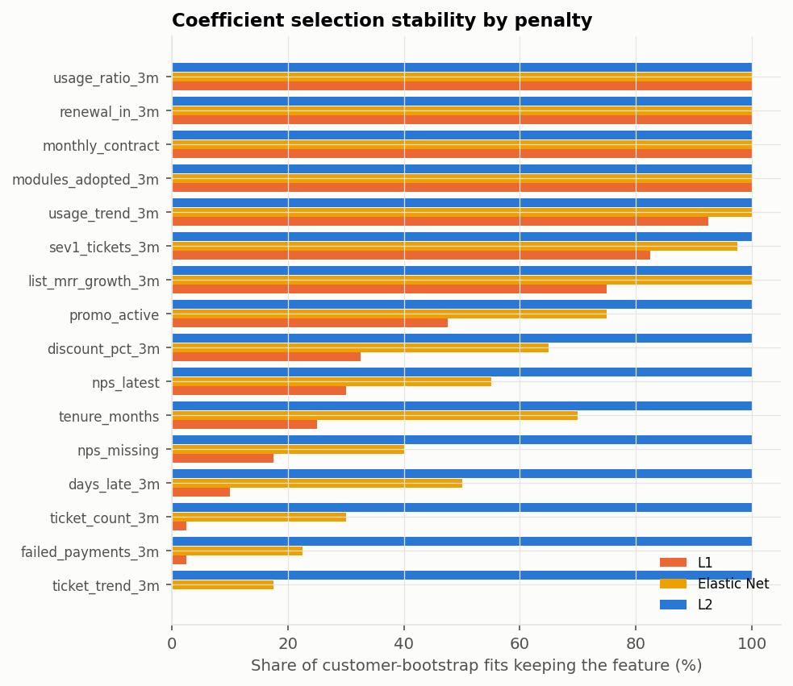
Figure 11. Share of customer-resampled fits in which each penalty keeps each feature
Result. All twelve settings score between 0.785 and 0.793, and 11 of them lie within one standard error of the best, including every penalty type. The design has one collinear pair (usage and module adoption, r = 0.90, VIFs near 5 to 6) inside an otherwise well-conditioned set, with about 96 churn events per feature. The strong features are stable under every penalty: renewal timing, monthly contract, usage, module adoption, usage trend, list MRR change, severity-1 tickets and promotion keep the same sign in at least 97% of L2 fits, and L1 keeps the four strongest in every fit, usage and module adoption together. The penalties differ on the eight weak features (days late, discount, failed payments, NPS, NPS missing, tenure, tickets and ticket trend). L1 keeps each of them in 0% to 33% of fits, so its selected list changes with the sample (8 features kept in 10% to 90% of fits). L2 keeps all sixteen but shrinks the weak ones towards zero, where their signs flip in 18% to 43% of fits. The chosen setting is L2 with C = 0.01, the strongest shrinkage within one standard error, at a forward-fold AUC of 0.791.
Interpretation. Neither accuracy nor collinearity decides the choice here. The correlated pair is strong enough that even L1 keeps both. The deciding facts are the events per variable and the weak features. With about 96 churn events per feature there is no need to cut features, which is the main reason to use L1. And L1's cut is not reproducible: it would present a clean feature list that changes with the sample. L2 keeps the weak features at near-zero weights whose signs flip, which reads correctly as no reliable effect. It also keeps correlated signals together if collinearity bites harder on new data. Elastic Net sits between the two and added neither accuracy nor stability. L2 is therefore chosen by a tie-break set in advance (L2, then Elastic Net, then L1), and the recorded diagnostics support that tie-break rather than force it.

REFLECTION
Why might this be? The penalties tie on accuracy because the signal sits in a few strong features (renewal window, monthly contract, usage and module adoption), so shrinkage changes the ranking very little. L1 is unstable only on the weak features, which trade places across resamples; under L2 the same weakness shows up as flipping signs.
Did we resolve it? Yes, for this data, with a caveat: the choice rests on a tie-break supported by recorded diagnostics, not on a measurable accuracy gain, and no weak feature should be read on its own. It would be re-examined if the feature set grew or the events per variable fell below about 20.

3.15.5 Gradient boosted trees and interaction effects
Method. The hypothesis to test is that falling usage, an approaching renewal and rising support tickets together carry more risk than the sum of their parts, and that trees capture such combinations where a linear model cannot. Three tests were run: boosted trees on the same sixteen features, tuned on the same forward folds over eight settings; the logistic with explicit renewal-exposure interaction terms (exposure times usage ratio, usage trend, ticket trend and ticket count); and a direct risk-cell table that cross-tabulates actual churn by renewal exposure, falling usage and rising tickets, beside each model's prediction.
Learning rate | Leaves per tree | Minimum account-months per leaf | Forward-fold AUC | Std dev | Rank
0.05 | 8 | 100 | 0.7907 | 0.0109 | 3
0.05 | 8 | 400 | 0.7912 | 0.0129 | 2
0.05 | 16 | 100 | 0.7847 | 0.0141 | 5
0.05 | 16 | 400 | 0.7797 | 0.0120 | 6
0.1 | 8 | 100 | 0.7945 | 0.0120 | 1
0.1 | 8 | 400 | 0.7850 | 0.0122 | 4
0.1 | 16 | 100 | 0.7753 | 0.0120 | 8
0.1 | 16 | 400 | 0.7774 | 0.0151 | 7

Each setting uses 200 trees. The selected setting (learning rate 0.1, 8 leaves, 100 accounts per leaf) scored 0.7945 on the forward folds, slightly above the best logistic (0.7933).
Renewal window | Usage | Tickets | Account-months | Actual churn | Logistic | Logistic + interactions | Trees
Outside | Not falling | Not rising | 11,565 | 0.52% | 0.69% | 0.60% | 0.62%
Outside | Not falling | Rising | 5,755 | 0.49% | 0.75% | 0.64% | 0.65%
Outside | Falling | Not rising | 4,258 | 0.49% | 0.82% | 0.69% | 0.73%
Outside | Falling | Rising | 4,592 | 0.48% | 0.83% | 0.67% | 0.73%
Inside | Not falling | Not rising | 9,958 | 3.89% | 4.02% | 4.11% | 3.78%
Inside | Not falling | Rising | 4,970 | 3.80% | 4.28% | 4.38% | 4.01%
Inside | Falling | Not rising | 3,962 | 4.77% | 4.71% | 4.83% | 4.24%
Inside | Falling | Rising | 3,740 | 4.36% | 4.84% | 5.02% | 4.37%

Holdout account-months. Three-month churn rates; model columns are average predicted probabilities.
Feature (trees) | AUC drop when shuffled | Std dev
Renewal within 3 months | 0.246 | 0.004
Monthly contract | 0.078 | 0.006
Module adoption | 0.022 | 0.002
Usage ratio | 0.009 | 0.002
Usage trend | 0.002 | 0.002
Average discount | 0.002 | 0.001
NPS (latest) | 0.001 | 0.001
Days late | 0.001 | 0.001

Interaction logistic, renewal terms | Standardised coefficient
Renewal-exposed | 0.356
Renewal-exposed x Usage ratio | 0.038
Renewal-exposed x Usage trend | −0.025
Renewal-exposed x Ticket trend | −0.001
Renewal-exposed x Support tickets | 0.243

Result. On the holdout the trees scored 0.800 against 0.809 for the L2 logistic; the paired difference is −0.009 (95% interval −0.017 to −0.001), and the trees were better in fewer than 1% of resamples. The interaction logistic scored 0.809, a difference of +0.001 (−0.002 to +0.003). Inside a renewal window, falling usage raises churn from 3.9% to 4.8%, but adding rising tickets lowers it to 4.4%; the three-way combination is not the riskiest cell. The trees rely almost entirely on renewal timing (AUC falls by 0.25 when it is shuffled) and monthly contracts (0.08); ticket trend contributes nothing. In the interaction model tickets carry a negative main effect (−0.18) and a positive interaction with the renewal window (+0.24), so tickets count for more inside the window than outside it; the ranking does not improve.
Interpretation. The interaction hypothesis is reasonable for real books and was tested rather than assumed. On this data it fails, and the reason is visible in the cells: risk inside the window is roughly additive, so there is no combination left for the trees to find. The trees won the forward folds by 0.001 and lost the holdout by 0.009, which is the pattern of a flexible model fitting pre-close noise.

REFLECTION
Why might this be? The simulated churn decision is additive on the log-odds scale apart from renewal gating, which both models already see, and rising tickets are mostly a symptom of low usage rather than a separate driver. The assumption register states this design choice.
Did we resolve it? The question is answered for this simulator and deliberately left open for real data. On a real book the same three tests (trees, interaction logistic, risk cells) should be rerun before a model is chosen, and the trees kept as a monitored challenger.

3.15.6 Holdout results and promotion decision
Method. All models are scored on the post-close holdout. Ranking is measured by ROC-AUC and average precision, probability quality by Brier skill, stability by the month-to-month spread of AUC, and the working list by churn rate, recall and F1 in the top 10% of each month. Uncertainty comes from a customer-cluster bootstrap, and model comparisons use paired differences on the same resampled customers. The promotion rule was fixed before the holdout was scored: a challenger must beat the operating rule by at least 0.02 AUC with an interval above zero, with Brier skill no worse and monthly stability no worse by more than 0.01.
Model | ROC-AUC | Avg precision | Brier skill | Monthly AUC sd | Top-10% churn | Lift | Recall | F1
Hand-set rule | 0.603 | 0.032 | n/a | 0.019 | 4.1% | 1.88 | 18.8% | 0.067
Rule x renewal exposure | 0.754 | 0.059 | 0.015 | 0.026 | 6.8% | 3.12 | 31.3% | 0.111
Logistic, L2 | 0.809 | 0.100 | 0.045 | 0.026 | 10.1% | 4.68 | 46.8% | 0.167
Logistic + interactions | 0.809 | 0.099 | 0.044 | 0.025 | 10.3% | 4.72 | 47.3% | 0.169
Gradient boosted trees | 0.800 | 0.091 | 0.038 | 0.020 | 9.8% | 4.51 | 45.1% | 0.161
Oracle (true probability) | 0.816 | 0.118 | 0.054 | 0.022 | 11.0% | 5.05 | 50.6% | 0.180

Accuracy is not reported: with 2.2% of account-months churning, predicting that nobody churns scores 97.8%. The hand-set rule is a score, not a probability, so it has no Brier skill.
Challenger | Baseline | AUC difference | 95% interval | Share of resamples better
Rule x renewal exposure | Hand-set rule | +0.151 | 0.133 to 0.168 | 100%
Logistic, L2 | Rule x renewal exposure | +0.054 | 0.039 to 0.068 | 100%
Logistic + interactions | Rule x renewal exposure | +0.055 | 0.039 to 0.071 | 100%
Gradient boosted trees | Rule x renewal exposure | +0.045 | 0.030 to 0.060 | 100%
Oracle (true probability) | Rule x renewal exposure | +0.062 | 0.045 to 0.077 | 100%
Logistic + interactions | Logistic, L2 | +0.001 | −0.002 to 0.003 | 70%
Gradient boosted trees | Logistic, L2 | −0.009 | −0.017 to −0.001 | 1%

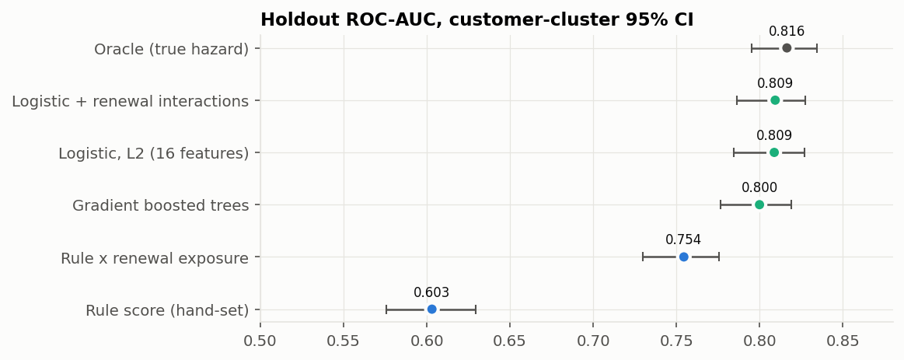
Figure 12. Holdout ROC-AUC with customer-cluster 95% intervals
Promotion check against the operating rule | L2 logistic | Logistic + interactions | Trees
AUC gain at least 0.02 | +0.054 | +0.055 | +0.045
Interval above zero | 0.039 to 0.068 | 0.039 to 0.071 | 0.030 to 0.060
Brier skill not worse | Pass | Pass | Pass
Stability not worse | Pass | Pass | Pass
Decision | Promote | Passes; no gain over L2 | Passes; loses to L2

Result. The L2 logistic ranks churners with AUC 0.809, 0.054 above the operating rule (interval 0.039 to 0.068) and within 0.008 of the oracle. Its top-10% list is 10.1% churners, 4.68 times the base rate, and catches 47% of all churners. It passes every promotion check.

REFLECTION
Why might this be? The oracle ceiling is only 0.816 because churn is partly random even given true health: two accounts with the same risk do not both leave. Most of the attainable signal is therefore already captured, and further model complexity has little room to help.
Did we resolve it? Yes. The L2 logistic is promoted; the trees remain a monitored challenger, rerun each quarter under the same rule.

3.15.7 Coefficients and calibration
Method. Coefficients are reported on standardised features, so their sizes are comparable: each shows the change in log-odds of churn for a one-standard-deviation change in the feature. Calibration compares average predicted and observed churn by decile of predicted risk.
Feature | Coefficient | Feature | Coefficient
Renewal within 3 months | +0.875 | Severity-1 tickets | +0.063
Monthly contract | +0.494 | Average discount | +0.037
Module adoption | −0.227 | NPS (latest) | −0.026
Usage ratio | −0.223 | Support tickets | −0.014
List MRR change | −0.121 | Days late | +0.010
Usage trend | −0.098 | NPS missing | +0.010
Tenure (months) | +0.072 | Ticket trend | +0.007
Promotion active | +0.065 | Failed payments | −0.004

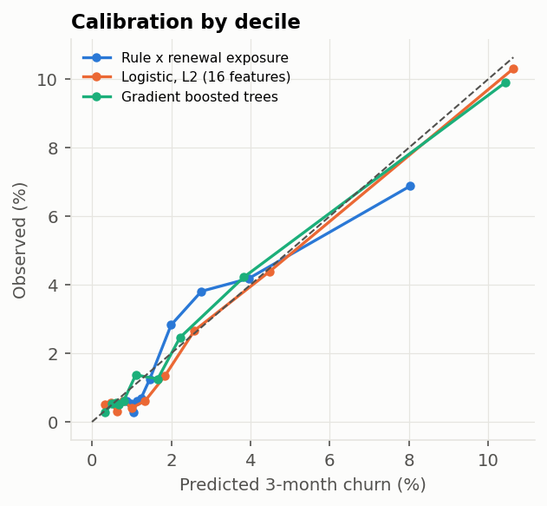
Figure 13. Predicted vs observed churn by decile of predicted risk
Result. Renewal within three months (+0.88) and monthly contract (+0.49) dominate; module adoption (−0.23), usage (−0.22), list MRR change (−0.12) and usage trend (−0.10) follow with the expected signs. Tickets come out slightly negative (−0.01). Predicted churn averaged 2.41% against 2.17% observed; the deciles lie close to the diagonal, and the excess sits mainly in account-months outside a renewal window, where the model predicts 0.7% to 0.8% against 0.5% observed.

REFLECTION
Why might this be? Churn was slightly lower after close than before (2.29% in training), and strong shrinkage pulls predictions toward the training average. Tickets come out negative because ticket volume scales with account size and larger accounts churn less.
Did we resolve it? Partly. Over-prediction does not change the ranking, so the work list is unaffected, but the retention economics use probabilities; monthly recalibration on recent outcomes would fix the level and is not yet implemented. Normalising tickets per seat is the suggested fix for the ticket sign.

3.16 Retention economics and pilot design
Question. Is it worth paying customer success to work the model's list, and how would we find out?
Method. The save rate, the share of at-risk accounts an intervention keeps, cannot be observed in this data, so the question is reversed: at what save rate does working a list pay for itself? Each list takes the top 10% of scored accounts each month; each account is worked once, in the month it first appears. The break-even save rate divides the outreach cost by the margin at risk. The value-ranked list orders accounts by probability times ARR, the expected loss, rather than by probability alone. Pilot size is the number of accounts per arm needed to detect a given save rate with 80% power at the 5% level, given the list's churn rate.
Assumption | Value | Basis
Outreach cost per account worked | $400 | Customer-success and executive time; assumption
Revenue preserved by a save | Twelve months | Assumption
Gross margin | 75% | Public SaaS median 75.6% (Section 3.14)
Concession to saved customers | 10% discount | Assumption; mirrors the generator's save offer

List (top 10% each month) | Accounts worked | Churners reached | Precision | Margin at risk | Outreach cost | Break-even save rate
Random 10% | 2,589 | 50 | 1.9% | $0.75m | $1.04m | 137%
Rule score | 1,066 | 50 | 4.7% | $0.63m | $0.43m | 67%
Rule x renewal | 1,259 | 103 | 8.2% | $1.36m | $0.50m | 37%
Logistic (L2) | 1,643 | 153 | 9.3% | $3.08m | $0.66m | 21%
Gradient boosted trees | 1,694 | 156 | 9.2% | $2.69m | $0.68m | 25%
Logistic, value-ranked | 1,300 | 108 | 8.3% | $3.02m | $0.52m | 17%

A break-even rate above 100% means the list cannot pay for itself at any save rate.
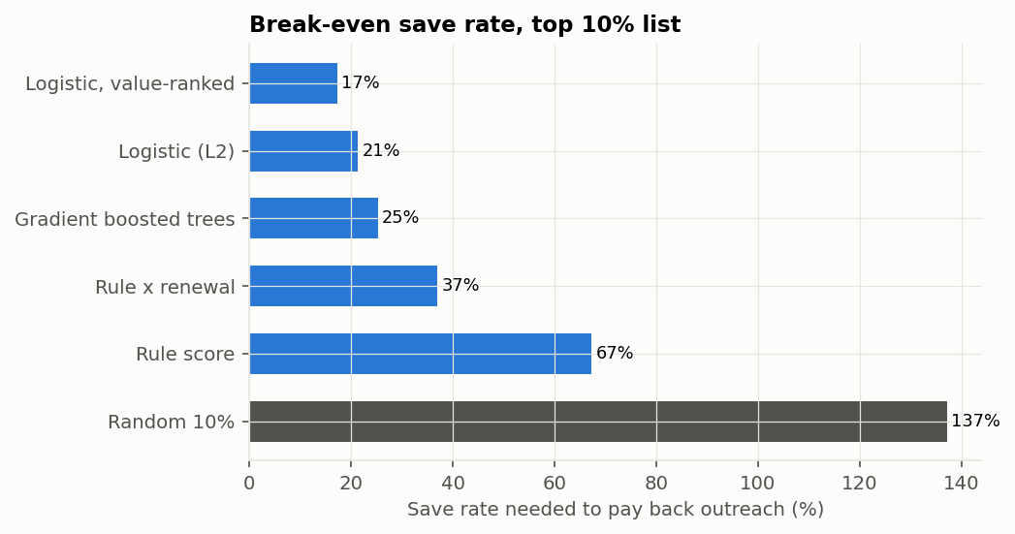
Figure 14. Break-even save rate by list
Save rate to detect | Accounts per arm | Months to fill both arms on one book
15% | 6,333 | 123
20% | 3,474 | 68
30% | 1,465 | 29

Sized on the L2 list: churn rate 9.3%; about 103 new accounts enter the list each month.
Result. A random 10% list cannot pay (break-even 137%). The hand-set rule needs 67% and the operating rule 37%. The L2 logistic needs 21%, the trees 25%, and the value-ranked logistic 17%: it works 1,300 accounts instead of 1,643 while protecting almost the same margin. Detecting a 20% save rate needs 3,474 accounts per arm, about 68 months of list flow on one book; the value-ranked list, with fewer accounts a month, would take longer.
Interpretation. A better list halves the hurdle a programme must clear, which is the economic value of the model. Whether real outreach saves one in six at-risk accounts is unknown, and one book cannot find out in a useful time.

REFLECTION
Why might this be? Churn is only about 2% a quarter, so even the best list is about 9% churners, and detecting a 20% relative drop in a 9% rate takes thousands of accounts. Value-ranking lowers the hurdle because it spends outreach on fewer, larger accounts, where each save is worth more.
Did we resolve it? Partly. The design answer is to pool the same protocol across several portfolio companies, or to restrict the pilot to accounts inside a renewal window where churn is higher. The save rate itself stays unknown until a randomised pilot runs.

3.17 Forward forecast, August 2026 to July 2027
Question. Where is ARR likely to be in twelve months, and how bad could it be?
Method. The base case applies the trailing twelve-month component rates from July 2026, as the underwriting forecast did at close. The band is built the same way, from resampled months. Scenarios apply multipliers to the base rates: the downside cuts new-logo and expansion revenue by 20% and raises contraction and churn by 30%; the upside moves them 15% the other way; run-off assumes no new logos, which isolates what the existing base does alone.
Month | Run-off | Downside | Base | Upside | 90% band
2026-08 | $146.9m | $147.3m | $148.5m | $149.3m | $147.8m to $149.4m
2027-01 | $148.6m | $150.5m | $158.0m | $163.0m | $155.4m to $160.3m
2027-07 | $150.6m | $154.4m | $169.6m | $180.0m | $165.5m to $172.7m

List ARR.
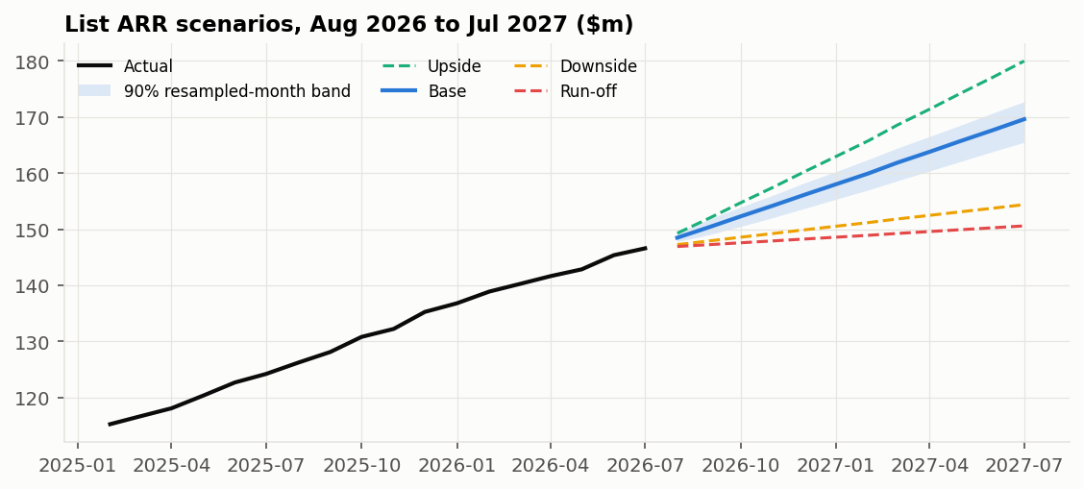
Figure 15. List ARR scenarios with the 90% resampled-month band
Result. The base case reaches $169.6m in July 2027, 15.7% above July 2026, with a band of $165.5m to $172.7m. The downside ends at $154.4m, the upside at $180.0m, and run-off at $150.6m, 2.7% above today. The workbook's sensitivity grid, built separately from quarterly figures, gives $168.1m for June 2027, a month earlier, which is consistent with the base case.
Interpretation. Growth of about 16% continues the deceleration seen since 2023. Even with no new customers the base would still grow about 3%, because NRR is above 100%; that is the floor the existing customers provide.

REFLECTION
Why might this be? The band is the same construction that covered only 70% to 79% of outcomes ten to twelve months ahead in Section 3.12, so it is too narrow at the far end. Scenario multipliers are judgement, not estimates.
Did we resolve it? No. The band at twelve months should be read as a lower bound on uncertainty; the downside scenario is the better guide to a bad year.

3.18 Quality-of-revenue workbook
Purpose. The workbook lets a reader audit every headline number without running code. It is built from the SQL marts, uses live formulas, and was recalculated with zero formula errors. Inputs are blue, formulas black, links to other sheets green, and key assumptions shaded yellow.
Sheet | Contents
Cover | Purpose, evidence boundary, units, colour legend and the checks that must read zero
Summary | Headline metrics, each linked to a working sheet, with its reference point
Inputs | Assumptions and every cited benchmark with source and window
Diligence | December 2023 to December 2024 cohort against SaaS Capital 2025 on matched cuts
Plan_vs_Actual | Underwriting forecast made at close against actual, January 2025 to July 2026, with band flags
ARR_Bridge | Quarterly ARR roll-forward, growth-quality ratios and a tie-out check
Retention | Twelve-month cohort GRR and NRR now, and the monthly-compounding comparison
Concentration | Top-N shares, HHI and trend
Revenue_to_Cash | Revenue, invoicing, collections, receivables and DSO with roll-forward checks
Renewals | ARR by renewal quarter and expected non-renewal
Sensitivity | Twelve-month ARR by GRR and expansion rate; value of a GRR point
Customer_ARR | Account-level ARR at July 2026
Monthly_Bridge | Monthly list-MRR bridge from SQL

REFLECTION
Why might this be? A workbook that repeats numbers from code can drift from it; one that recomputes them can disagree with it.
Did we resolve it? Yes. Every workbook figure is either linked to the SQL output or recomputed by formula, and the tie-out rows on ARR_Bridge and Revenue_to_Cash must read zero.

3.19 Corrections made during the project
Earlier versions contained errors or weak comparisons. They are listed because several changed conclusions.
Issue | What was wrong | Fix | Effect on conclusions
Benchmark mismatch | A $150m book was compared with bootstrapped medians for $3m to $20m companies from a different window | SaaS Capital 2025 cuts by ACV, term and funding over the same window | Diligence read moved from below peers to at the median
Circular validation | Benchmarks set the generator and were then cited as agreement | Calibrated window separated from the out-of-sample period | No evidence is claimed from the calibrated window
Monthly compounding | A monthly GRR was compounded as if annual in a comparison with another project | Compare monthly with monthly and cohort with cohort | In this book, compounded monthly GRR is 86.9% against cohort GRR of 92.1%
Double counting | Retention economics counted account-months as accounts | Each account worked once | Break-even rates restated per account
Assumed SMB churn | SMB churn was set at about 20% a year by assumption | Calibrated to benchmark | SMB no longer looks far worse than peers
SMB NRR inflation | Monthly contracts were treated as commercial reviews, receiving uplifts every month | Uplifts restricted to review months | SMB NRR fell to a realistic level
Recall above 100% | Future rows copied a missing industry, so one defect counted twice | Cleaning steps reordered | Recall is exactly 100%
Channel discount claim | Partner was said to discount most | Outbound leads for new logos (14.8%), partner for expansion (21.8%) | Deal-desk focus refined
Partner weakness | Attributed to discount or pricing mix | Checked: partner accounts carry the book's average discount (4.7% against 4.9%) and a similar pricing mix | Now reported as unexplained and tracked
Forecast band | Described as honest at short horizons | Coverage is 79% one month ahead and below 90% at ten of twelve horizons | Band described as too narrow at most horizons, most of all at ten to twelve months
Model menu | A shallow tree stood in for tree models; the penalty was fixed | Gradient boosted trees added; penalty chosen from L1, L2 and Elastic Net on diagnostics | L2 logistic promoted on evidence
Public comparables chart | Quarters grouped by raw fiscal period end, mixing different company sets each quarter | Fiscal quarters aligned to calendar quarters; partial quarters dropped | Apparent quarter-to-quarter margin swings of up to six points disappeared

3.20 Limitations and next steps
Limitation | Consequence | Next step
Customer-level effects are simulation parameters | Results test the method, not a company | Rerun the pipeline on real account data under the same data contract and tests
Benchmarks come from mostly smaller companies | Size mismatch that cannot be measured | Add retention data for larger private companies, for example lender or portfolio datasets
No interaction in the simulated churn process | The tree test says nothing about real books | Rerun the three-way interaction test on real data
Expansion rules do not depend on account size | The motion-versus-product question cannot be answered | Collect seat penetration, module whitespace and account coverage
No CAC, cost to serve or P&L | Segment strategy, Rule of 40 and valuation are out of scope | Add a simple P&L; request CAC, payback and support cost by segment
Forecast band too narrow, most of all beyond nine months | Forecast risk is understated | Add a trend term or widen bands by measured coverage shortfall
Monthly billing and assumed payment terms | DSO and deferred revenue are uninformative | Add annual upfront billing and receivables ageing
Save rate not identified | Economics give a hurdle, not a return | Run a pooled randomised pilot
Discount dependence is descriptive | No price elasticity | Use a pricing test or an approval-policy change as a natural experiment
Concentration low by design | The concentration test is inactive | Use a heavier-tailed customer-size distribution
Probabilities not recalibrated monthly | Slight over-prediction outside renewal windows | Recalibrate monthly on recent outcomes

Appendix Reproduction and file map
Item | Where
Full pipeline (data, models, reports) | make pipeline (python -m saas_growth_quality.pipeline --project-root .)
Reports only | make report
Tests (23) | make test
Public comparables from SEC EDGAR | make public-comps
SQL marts | sql/01_account_month.sql to sql/04_discount_dependence.sql
Model outputs | outputs/model/ (grids, coefficients, stability, interaction cells, comparison)
Uncertainty | outputs/uncertainty/ (customer-cluster bootstrap metrics and paired differences)
Deliverables | reports/project_report.docx, reports/quality_of_revenue.xlsx, reports/portfolio_monitoring_brief.pdf, dashboard/index.html

