A) A statement indicating if your program is working properly and generates the desired output.

This program worked

B) A copy of the output generated by your program.

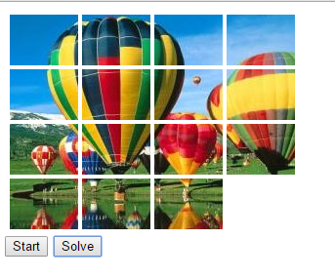

When opened the program

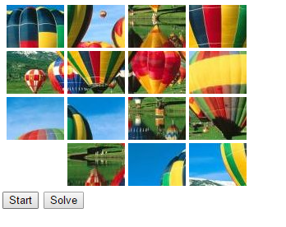

After click Start button(shuffled)

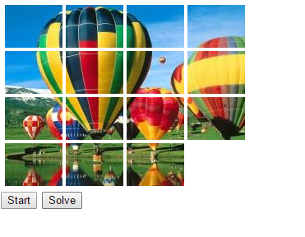

Clicked Solve button

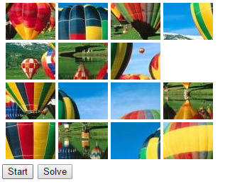

Another game