**Assignment #4**

Team 11 KYUNG WOO, HYUN (39324813)

HEE JEONG, HAN (83168505)

KYU SEON, YUM (71327945)

Our team, team 11, build the circuit to connect 3D Accelerometer to ESP board for collecting data of directions. We write a program to get data including X, Y, and Z axes directions. We read data from the sensor while performing Left, Right, Up, Down, and Circular motion. We collect 1000 data per each motion.[1] For Up motion, we move the circuit upward. When we do Down motion, we move the circuit downward. For Left motion, we turn the circuit anticlockwise while the circuit is on the table. For Right motion, we turn the circuit clockwise when the circuit is on the table. Also, for Circular motion, we rotate the circuit around.

After collecting data, we send the data to the server with each column corresponding to each respective direction like Figure 1[2]. and store the data in CSV format.[3]

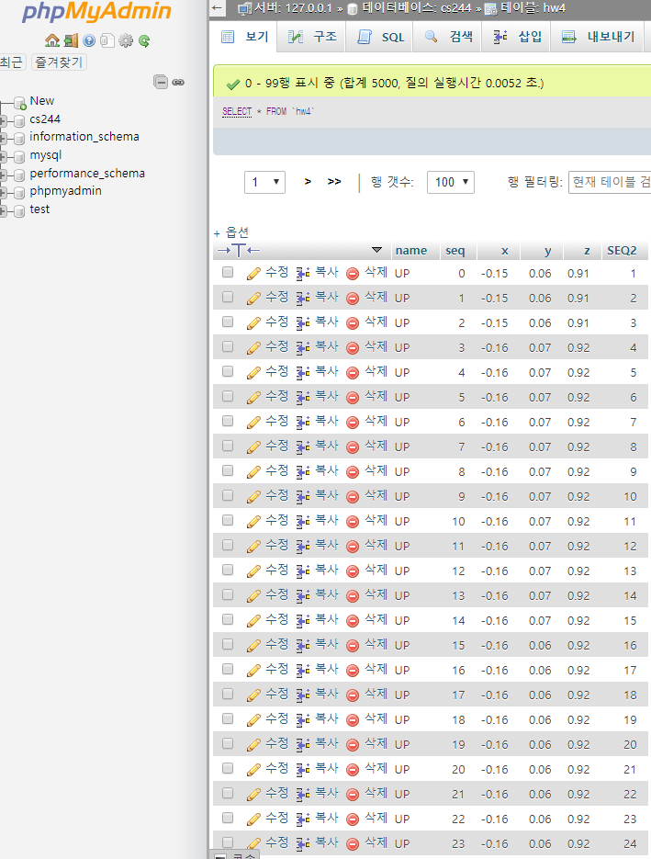

Figure 1.

Regarding our data, Z axes data change its values when the circuit moves Up or Down motion. Moving the circuit with Left or Right motion, X and Y axes data changes its values precipitously. The data by moving the circuit with the circular motion changes its values in all X, Y, Z axes direction.

1. https://github.com/kyungwoh/CS244Fall2017/blob/cs244_master/Assignment%234/main.cpp#L48-L55
2. https://github.com/kyungwoh/CS244Fall2017/blob/cs244_master/Assignment%234/hw4.php#L9-L21
3. https://github.com/kyungwoh/CS244Fall2017/blob/cs244_master/Assignment%234/hw4_csv.php#L8-L18