**Assignment #3**

Team 11 KYUNG WOO, HYUN (39324813)

HEE JEONG, HAN (83168505)

KYU SEON, YUM (71327945)

Our team, team 11, performs proper signal processing to filter the signal and extract three vital signs such as Heart Rate, Respiration Rate, and SPO2 using Matlab. First, our program read CSV file including three data which is time, IR, and RED. We will discuss three methods to calculate Heart Rate, Respiration, and SPO2 below. Before explaining methods, sampling frequency, Fs, is 50 Hz, length of signal, L, is 4501. Sampling period, T, is 1/50 measured on 1/Fs. Time vector, t, is measured on (0:L-1)*T. Nyquist frequency, Fn, is measured on Fs/2.

**Method to calculate Heart Rate**

For calculating Heart Rate, we apply Bandpass Butterworth Filter to IR data with a passband from 0.8 to 1.5 and convert to Second-Order-Section for stability.[1] Then, we find peaks from the filtered signals.[2] Using adjacent peak interval, we calculate Heart Rate[3]. In the Figure 1, the top line is IR data, the second line is filtered IR data.

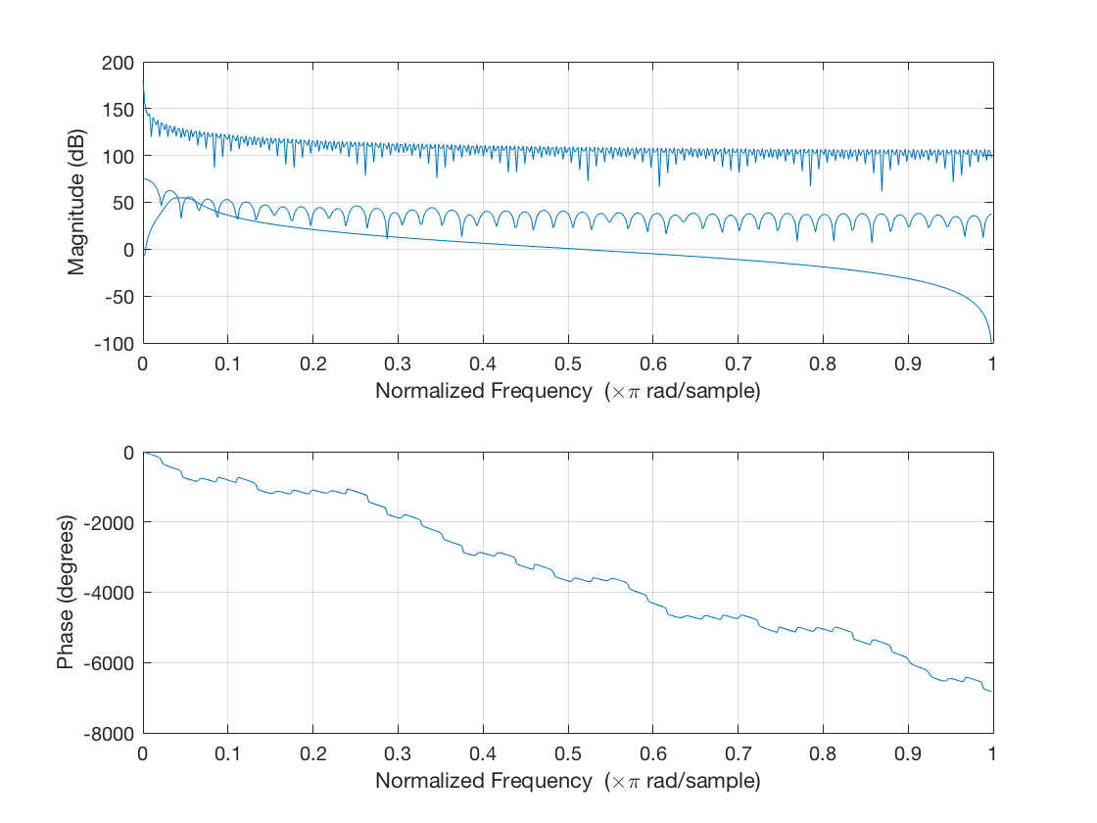

Figure 1.

**Method to calculate Respiration Rate**

For calculating Respiration Rate, we apply Bandpass Butterworth Filter to IR data with a passband from 0.16 to 0.33 and convert to Second-Order-Section for stability.[4] Then, we find peaks from the filtered signals.[5] Using adjacent peak interval, we calculate Respiration Rate.[6] In the Figure 2, the top line is IR data, the second line is filtered IR data.

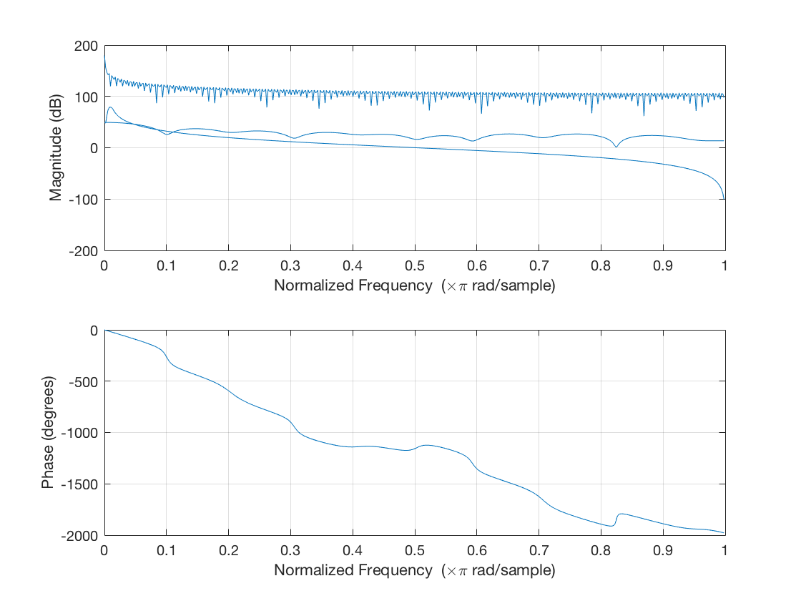

Figure 2.

**Method to calculate SPO2**

For calculating SPO2, we apply Bandpass Butterworth Filter to both IR and RED data with a passband from 0.8 to 1.5 and convert to Second-Order-Section for stability. Then we apply peak detection to find both maximum and minimum peaks for both IR and RED data, which are filtered. We apply interpolation on minimum peaks for both IR and RED data, which are filtered. We find values of index at maximum values. At that points, we find AC values using the difference with maximum values. Also, at that point, we find DC values. With both AC and DC values, we calculate SPO2.[7] In the Figure 3, the top line shows maximum and minimum peaks of filtered IR data and the second line shows maximum and minimum peaks of filtered RED data.

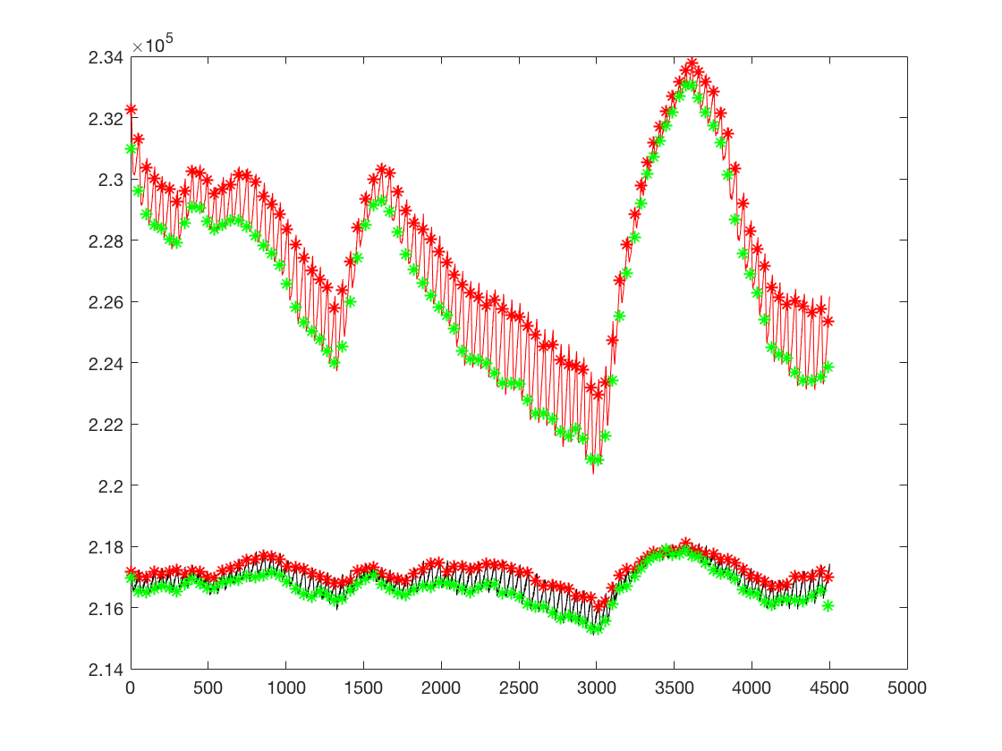

Figure 3.

As the result, the average of Heart Rate values is 60.89374078, the average of Respiration values is 13.31492573, and the average of SPO2 values is 99.29239913. All data seem in normal range.

1. https://github.com/kyungwoh/CS244Fall2017/blob/cs244_master/Assignment%233/hw3.m#L13-L15
2. https://github.com/kyungwoh/CS244Fall2017/blob/cs244_master/Assignment%233/hw3.m#L16-L17
3. https://github.com/kyungwoh/CS244Fall2017/blob/cs244_master/Assignment%233/hw3.m#L18
4. https://github.com/kyungwoh/CS244Fall2017/blob/cs244_master/Assignment%233/hw3.m#L26-L28
5. https://github.com/kyungwoh/CS244Fall2017/blob/cs244_master/Assignment%233/hw3.m#L29-L30
6. https://github.com/kyungwoh/CS244Fall2017/blob/cs244_master/Assignment%233/hw3.m#L31
7. https://github.com/kyungwoh/CS244Fall2017/blob/cs244_master/Assignment%233/hw3.m#L39-74