**Connect ESP wifi to the router**

There are lines for connecting WiFi, and ip address

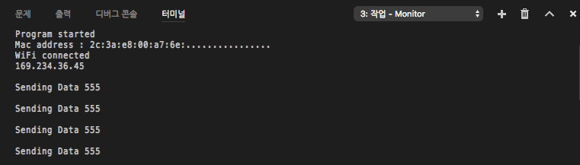

fig1. Connecting wifi

**Transmit data to the server**

The data are kept sending to the server



fig2. Sending data

those data are stored in DB of the server

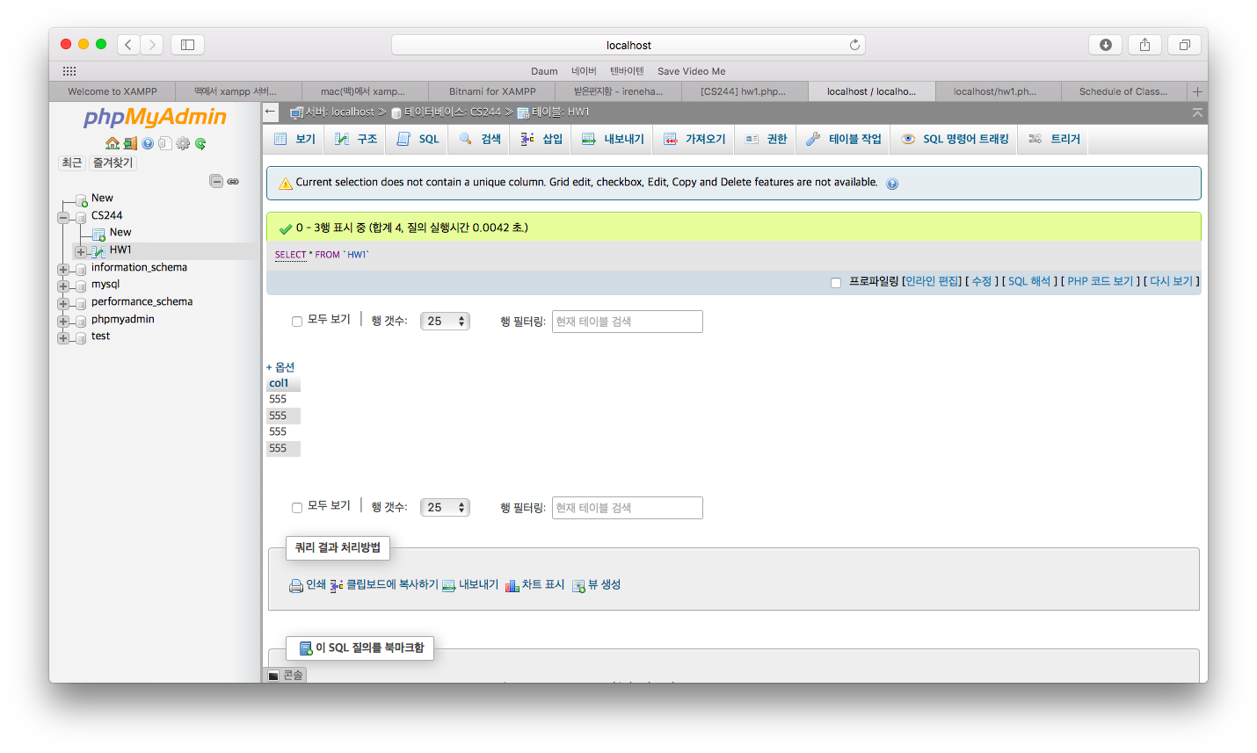

fig3. Storing data

**Handle data to the server**

1. Platform for server: Xampp

Xampp is the server platform that can manage Apache, mysql(db), and php

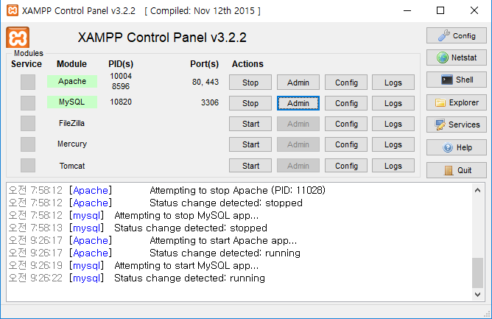

Fig4. Working server

1. Data management in the server

This is data that is stored in the table named hw1 from database named cs244

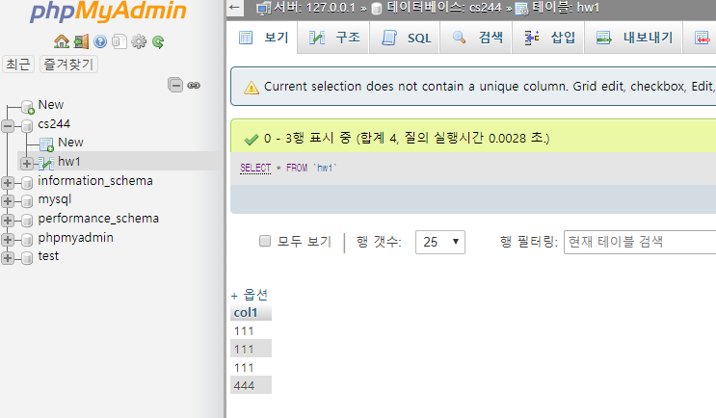

Fig5. Stored data in mysql

**Protocol team11 used in message transmission**

HTTP/1.1

**Process sequence**

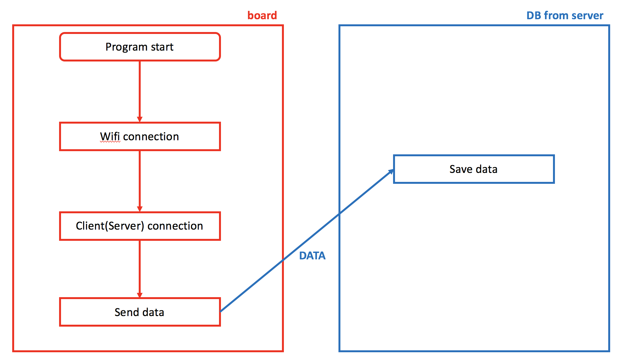

Fig6. Process sequence

**Github Link**

<https://github.com/kyungwoh/CS244Fall2017>