**Assignment #2**

Team 11 KYUNG WOO, HYUN (39324813)

HEE JEONG, HAN (83168505)

KYU SEON, YUM (71327945)

Chart1. Power level = 0.4mA

Chart2. Power lever = 6.4mA

Chart3. Power level = 25.4mA

Chart4. Power level = 50.0mA

Chart5. Power level

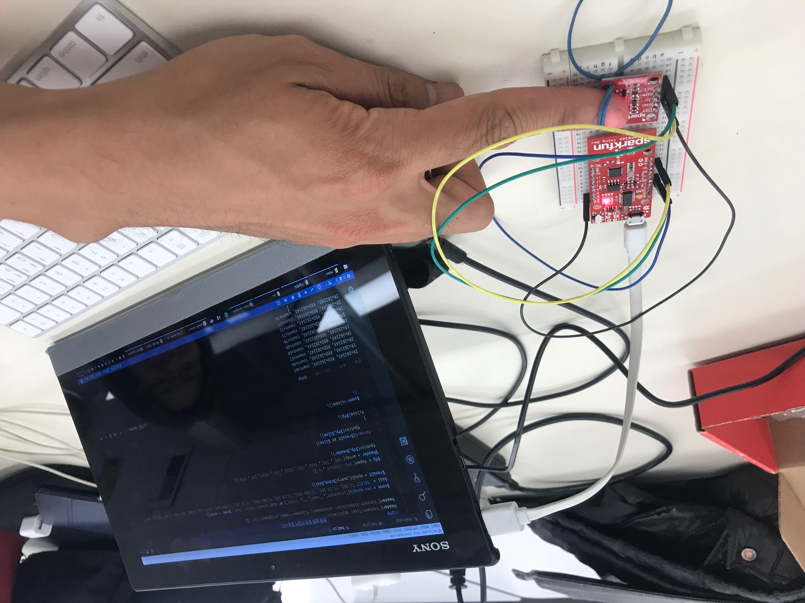

Figure 1

The statements above show the IR and RED data depending on power level for two minutes. From Chart1 to Chart4, the chart shows the pair of IR and RED data of each power level such as 0.4mA, 6.4mA, 25.4mA, and 50.0mA. The Chart5 shows all IR and RED data from all power levels.

For Chart3 and Chart4, every IR and RED value is the highest value for the unsigned long type value. We have been tested and concluded that when the power level is getting higher, values sending from the sensor go beyond the value that the unsigned long type value can express. Also, according to the guideline of MAX30105, *the IC is able to read up to 18-bits, which means there is limitation for reading some values.* [1]

Furthermore, we want to mention about our ways of data transmission. First, we failed to run the code when we were trying to store 6000 data from the sensor at once. It kept resetting software. We discussed that it might be the problem of memory limitation of ESP8266. So, we tried a different angle. We thought that collecting some data and sending them to server first instead of collecting whole data and sending to server. So, we tried to send 1000 data per each transmission, but data transmission was disconnected. We discussed that the server could not get that much of data. Therefore, when we sent 50 data per one second, we succeeded data transmission. The related code is attached below.

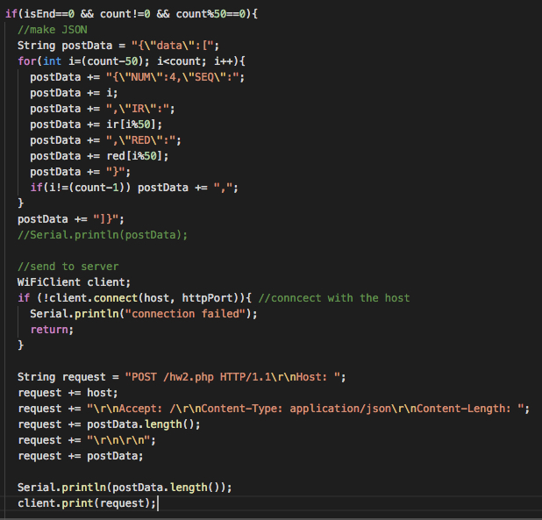

<https://github.com/kyungwoh/CS244Fall2017/blob/cs244_master/Assignment%232/main.cpp>

1. Guideline of MAX30105: reference from <http://bit.ly/2xeDf0R>