Assignment 4 – Code Document

1. Development Environment

· Operating System: **Windows 10 Pro**

· Language: **Python 3.6.5**

· Editor: Pycharm

2. How to run the rode

· This program is recommended to be executed in **Windows 10, with Pycharm IDE**.

· Please execute and ready the **receiver** program first, and then the **sender** program.

3. Code explanation

· There are **3 threads** in **receiver program**: status printing thread, ACK sending thread, and the main thread which receives packets from the multiple senders.

· If receiver gets the packet but the bottleneck queue is full, it immediately sends **queue full message** to the sender. Otherwise, if the bottleneck queue is not full yet, it enqueues the sender’s address into the queue.

· In ACK sending thread, it constantly dequeues the element from the bottleneck queue regarding the **bottleneck link rate**. With the dequeued element, which is the address of the sender, receiver simply sends the ACK message to the sender.

· Status printing thread calculates **average queue occupancy** for each 0.1 second. After calculating 20 times, when 2 seconds passed, it shows the status of receiver on the console.

· There are **3 threads** in **sender program**: status printing thread, ACK receiving thread, and the main thread which sends packets to the receiver.

· The sender constantly sends 1,000-byte packet to the receiver according to its sending rate.

· In ACK receiving thread, it gets the message from the receiver. The message could be either **queue full message** that receiver feedbacks, or **ACK message** that receiver successfully gets the packet.

· In ACK receiving thread, if the message is **queue full feedback**, sender shrink the sending rate to the **60%**.

· Else if the message is **ACK**, sender updates its sending rate by: $$sending_rate=sending_rate+\frac{1}{{sending_rate}^{3/2}}$$

· The implementation is **stateless**: it does not sends or receives messages about flow.

4. Screenshots of the test

A. Initial sending rate: 30, Bottleneck link rate: 30, Queue size: 100 (1 sender, 1 receiver)

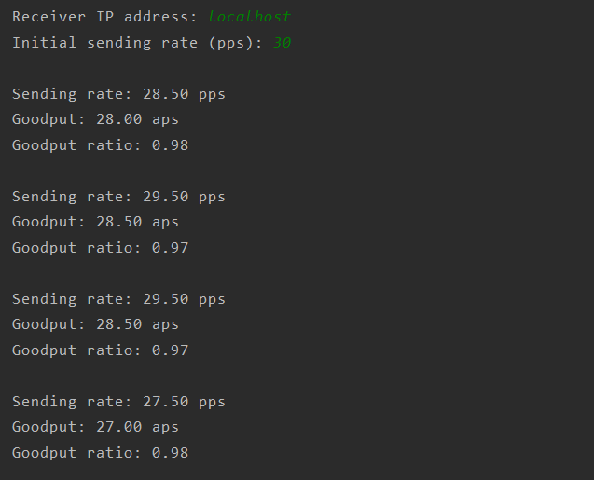 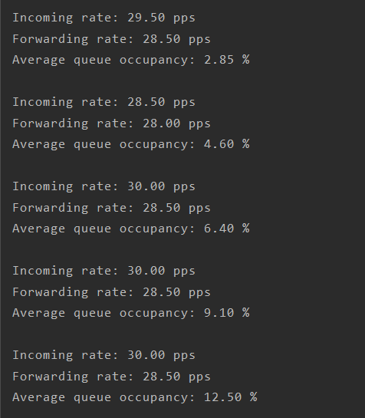

B. Initial sending rate: 30, Bottleneck link rate: 30, Queue size: 100 (3 senders, 1 receiver)

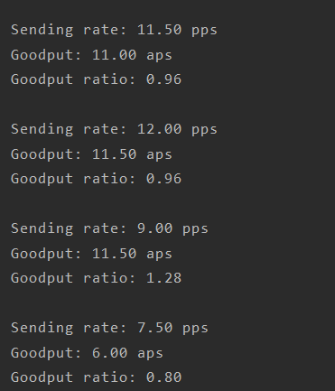 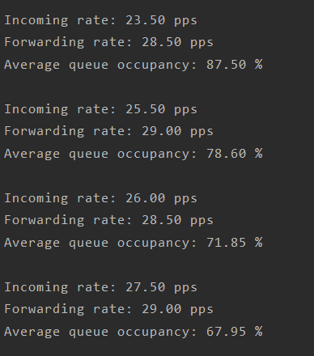

5. Graphs for extension goals

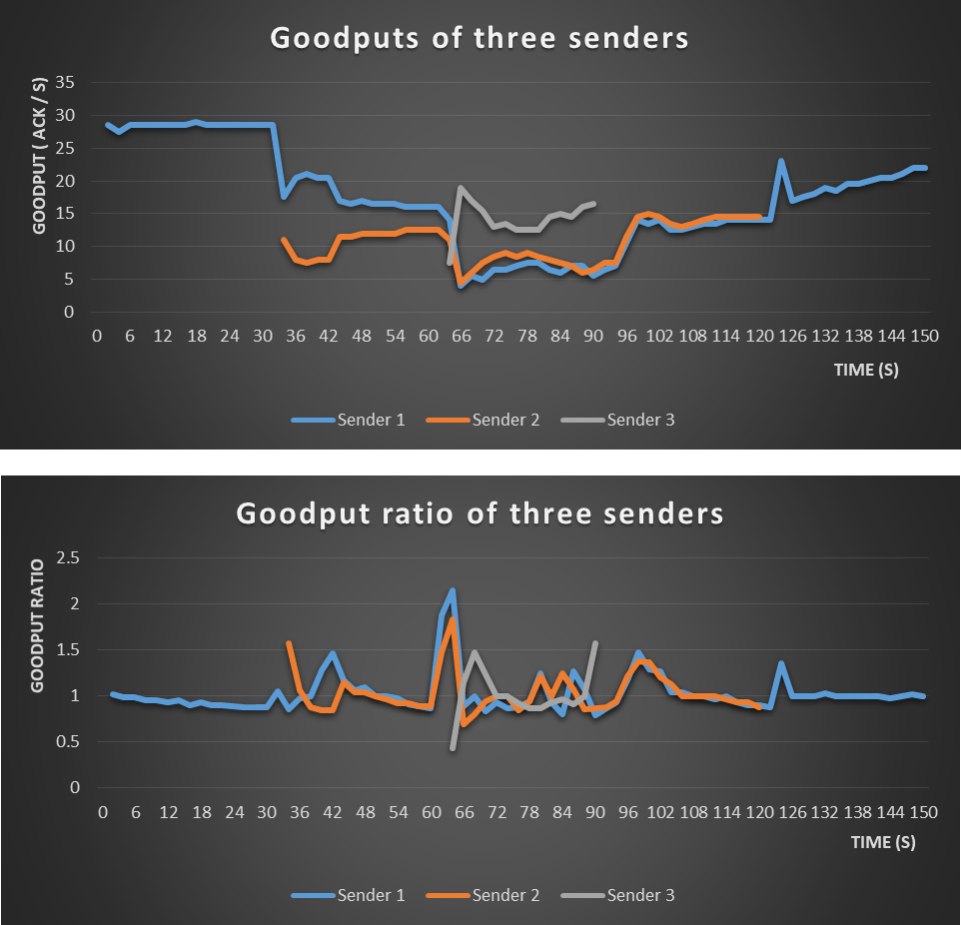

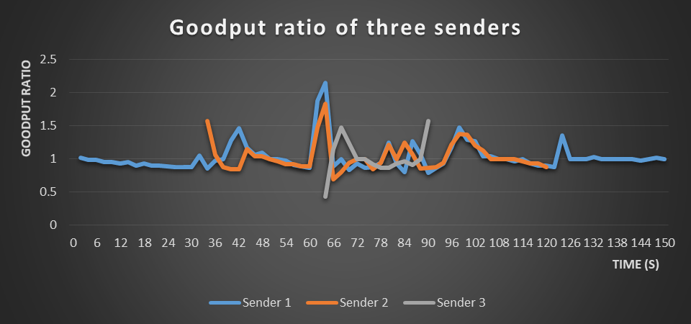

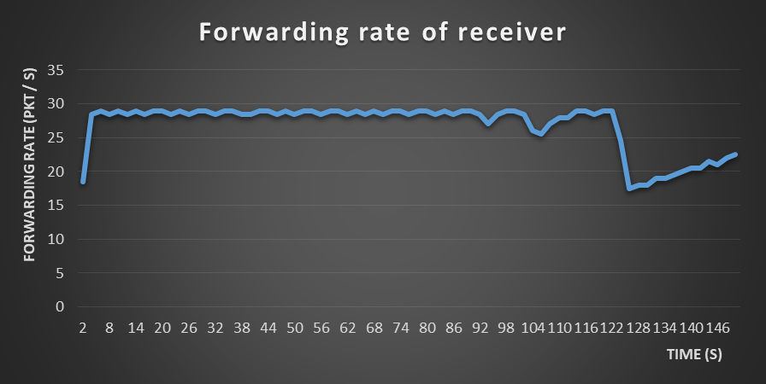  
 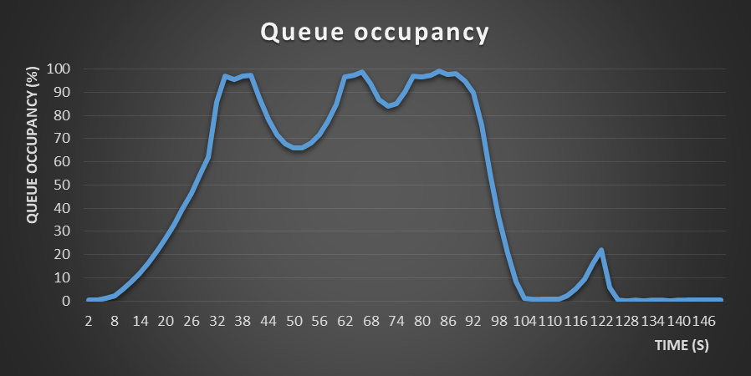

· You can see the data of graphs in each Excel file.

· On the first graph, all senders, especially sender 1 and sender 2 are having almost same bandwidth, which fits to the goal: multiple senders have fair bandwidth.

· On the second graph, the goodput ratio of three senders are always around 1.0, which fits to the goal: gootdput ratio gets close to 1.

· On the third graph, the forwarding rate almost gets close to 30 packets/s, which fits to the goal: maximize the utilization of the bottleneck link.

· On the last graph, the queue occupancy between 30~60 seconds time interval is about 60%~100%, and for 60~90 seconds time interval, is about 80%~100%. From 90 seconds point, the point when sender 2 leaves, the queue occupancy severely decreases to 0, and then goes around 0% ~ 25%.

· The emulator and sending rate calculation algorithm is implemented in stateless fashion: no such information is embedded in the packet between the sender and the receiver