DreamCatcher: A Predictive Analytics Framework for Sleep Disorder Screening in University Students

By:
Casuga, Jenard I.
Baliton, Floriza Mhae S.
Campos, Leticia Rose R.
Sobremonte, Earl Louie S.

October 2026

TABLE OF CONTENTS
Objectives 5
I. Data Understanding and Preparation 5
A. Dataset Description 5
Clinical Background and Why It Matters for the Model 6
B. Initial Exploratory Data Analysis (Raw Data) 7
C. Data Cleaning and Preprocessing 9
1. Handling Inconsistent Text, Missing Values and Outliers 9
2. Feature Engineering 12
3. Encoding and Scaling 12
D. Updated Exploratory Data Analysis (Cleaned Data) 13
Numerical Features by Class 15
Categorical and Ordinal Features by Class 17
Correlations 21
E. Train-Test Data Splitting 22
II. Model Implementation 22
A. Model Selection 22
B. Training Workflow and Handling Strategy 23
C. Hyperparameter Tuning 26
D. Feature Ranking and Feature Selection 28
III. Model Evaluation 32
A. Evaluation Metrics 32
B. Test-Set Results 32
C. Confusion Matrices 34
D. ROC Curves 37
E. Performance Comparison 39
F. Is the Signal Real? Permutation Test and Feature Importance 40
G. Screening Thresholds: Sensitivity and Specificity 41
H. Decision Rules: Ties and a Clinical Consistency Check 43
I. Final Model Selection 44
IV. Comparative Analysis and Discussion 44
A. Comparison of the Three Models 44
B. Why KNN May Perform Better on This Dataset 45
C. Implications of the Findings 45
D. Limitations 45
E. Potential Improvements 46
V. Model Deployment 46
A. Selecting, Training and Saving the Model 46
B. Folder Structure and Docker 47
C. API Endpoint (FastAPI) 49
D. Web Application Interface 54
VI. Conclusion and Recommendations 56
Conclusion 56
Recommendations 57
VII. References 57

LIST OF TABLES
Table 1. Where Each Requirement Is Addressed 5
Table 2. Dataset Variables, Descriptions and Types 6
Table 3. Cleaning Rules and the Number of Records Affected 9
Table 4. Examples of Raw Records and Their Cleaned Form 9
Table 5. Plausibility Ranges Used for Outlier Handling 10
Table 6. Departments Merged Into Each Final Group 11
Table 7. Feature Engineering from the Blood-Pressure Text 12
Table 8. Preprocessing Summary 13
Table 9. Summary Statistics of Numerical Variables 14
Table 10. Summary of Categorical and Ordinal Variables 14
Table 11. Class Distribution (Train vs Test) 22
Table 12. Key Functions and Parameters Used in the Training Workflow 26
Table 13. Hyperparameter Grid for Model Tuning 26
Table 14. Best Parameters and Cross-Validation Results (Training Set) 27
Table 15. Feature Ranking on the Training Set (Top 10 of 19 Encoded Features) 28
Table 16. Association of Each Original Feature with the Target (Training Set) 29
Table 17. Smallest Number of Features Within One Standard Error of the Best 30
Table 18. Comparison of Feature Sets 31
Table 19. Model Performance on the Held-Out Test Set (124 Students) 32
Table 20. Classification Report per Class (Precision / Recall / F1) 33
Table 21. One-vs-Rest ROC-AUC per Class (Test Set) 38
Table 22. Screening Thresholds on the Test Set 42
Table 23. Effect of the Decision Rules on the Test Set 44
Table 24. Strengths and Weaknesses of the Models 45
Table 25. Files of the Deployed Application 47
Table 26. API Endpoints 50
Table 27. Input Features of POST /predict 51
Table 28. Order and Codes of the 11 Values for POST /predict-features 52

LIST OF FIGURES
Figure 1. Raw Target Labels 7
Figure 2. Raw Department Spellings (Top 12 of 38) 7
Figure 3. Raw Sleep Duration Spellings 8
Figure 4. Raw Age Distribution 8
Figure 5. Department After Grouping 11
Figure 6. Target Class Distribution After Cleaning 13
Figure 7. Age by Class 15
Figure 8. Physical Activity by Class 15
Figure 9. Heart Rate by Class 16
Figure 10. Blood Pressure by Class 16
Figure 11. Sleep Duration: Class Mix per Answer 17
Figure 12. Sleep Quality: Class Mix per Answer 17
Figure 13. Stress Level: Class Mix per Answer 18
Figure 14. BMI Category: Class Mix per Answer 18
Figure 15. Daily Steps: Class Mix per Answer 19
Figure 16. Academic Level: Class Mix per Answer 19
Figure 17. Gender: Class Mix per Answer 20
Figure 18. Department: Class Mix per Answer 20
Figure 19. Spearman Correlation Heatmap of Predictors 21
Figure 20. Machine Learning Workflow 23
Figure 21. Structure of the Model Pipeline 24
Figure 22. Class Counts Before and After SMOTE (Training Set) 25
Figure 23. Cross-Validated Macro-F1 of the Tuned Models 27
Figure 24. Consensus Feature Ranking 28
Figure 25. Cross-Validated Macro-F1 versus Number of Top Features Kept 30
Figure 26. KNN Performance With Three Feature Sets 31
Figure 27. Confusion Matrix: Random Forest 34
Figure 28. Confusion Matrix: KNN 35
Figure 29. Confusion Matrix: SVM 36
Figure 30. ROC Curves: Random Forest (One-vs-Rest) 37
Figure 31. ROC Curves: KNN (One-vs-Rest) 37
Figure 32. ROC Curves: SVM (One-vs-Rest) 38
Figure 33. Model Performance Comparison on the Test Set 39
Figure 34. Permutation Test for KNN (Cross-Validated Macro-F1) 40
Figure 35. Permutation Importance of the KNN Model (Test Set) 41
Figure 36. Screening Decision Rules on the Test Set 42
Figure 37. Building and Running the Docker Container in Visual Studio Code 49
Figure 38. FastAPI Interactive Documentation (Swagger UI) 53
Figure 39. Testing POST /predict in the Swagger UI (Request and Response) 53
Figure 40. Testing POST /predict-features in the Swagger UI (Numeric Codes) 54
Figure 41. Web Form With Two Students Entered 55
Figure 42. Screening Results Shown to the User 56

Objectives
DreamCatcher is a predictive analytics framework that estimates the likelihood of two common sleep disorders, insomnia and sleep apnea, from everyday lifestyle, sleep and health indicators. It is a screening and awareness aid: it suggests who may benefit from a professional evaluation and which factors contribute most to that risk, so that people can seek care sooner. It does not diagnose any condition.
The objectives of this project are to (1) prepare and analyze a real-world survey dataset of university students; (2) build, tune and compare three machine learning models, Random Forest, K-Nearest Neighbors (KNN) and Support Vector Machine (SVM); (3) evaluate them with metrics that suit a health-screening purpose; and (4) deploy the best model as a web service with a user interface.
The table below shows where each part of the Final Term Requirement is addressed in this document and in the Jupyter notebook (DreamCatcher_Final_Project.ipynb).
Table 1. Where Each Requirement Is Addressed
Requirement | Section of this document | Notebook section
a. Data understanding and preparation | I. Data Understanding and Preparation | 1–4
b. Model implementation (Random Forest, KNN, SVM) | II. Model Implementation | 5, 7.2–7.3
c. Model evaluation | III. Model Evaluation | 6, 7
d. Comparative analysis and discussion | IV. Comparative Analysis and Discussion | 6, 7, 9
e. Model deployment | V. Model Deployment | 8 and the dreamcatcher_app folder

I. Data Understanding and Preparation

A. Dataset Description
The project uses the “BD-Uni Sleep Disorder Dataset” (Mendeley Data, 2026; DOI 10.17632/9djgjvtj8d.1). It contains 619 observations collected from students of five public universities in Bangladesh through Google Forms and in-person interviews. There are 12 predictor variables and one target variable, “Sleep Disorder”, with three classes: Insomnia (265 students), Sleep Apnea (241) and No Sleep Disorder (113). The task is therefore a multi-class classification problem. No values are missing in the raw file.
The dataset was selected because it is publicly available (so the study can be reproduced), it contains variables used in sleep research (sleep duration and quality, stress, BMI, blood pressure, heart rate, physical activity) and it describes a relevant population: insomnia symptoms are common among university students, with a pooled prevalence of 46.9% (95% CI 40.1–53.6) reported in a 2025 meta-analysis of 48 studies with 95,938 undergraduates (Global prevalence of insomnia symptoms in undergraduate university students, 2025).
Table 2. Dataset Variables, Descriptions and Types
Attribute / Feature | Description | Type
Department | Academic department of the student (38 different spellings in the raw file) | Nominal
Gender | Male or Female | Nominal
Age | Age in years | Numerical
Academic Level | Level-1 to Level-4 | Ordinal
Sleep Duration | Four bands: under 4 hours, 4–5, 6–7, 8 hours or more | Ordinal
Quality of Sleep | Very Poor, Poor, Average, Good, Excellent | Ordinal
Stress Level | Very Low, Low, Moderate, High, Very High | Ordinal
Physical Activity Level | Minutes of physical activity per day | Numerical
BMI Category | Underweight, Normal, Overweight, Obese | Ordinal
Blood Pressure | Text such as 120/80 (systolic/diastolic, mmHg), parsed into numbers | Text → Numerical
Heart Rate | Beats per minute | Numerical
Daily Steps | Five step-count bands (under 4,999 to over 16,000) | Ordinal
Sleep Disorder (target) | Insomnia, Sleep Apnea or No Sleep Disorder | Categorical (target)

Clinical Background and Why It Matters for the Model
Insomnia is a sleep disorder in which people struggle to fall asleep, stay asleep or sleep as long as they need, with daytime consequences. According to the European Insomnia Guideline (Riemann et al., 2023), it is assessed by clinical interview supported by sleep questionnaires and diaries, and polysomnography is reserved for suspected sleep-related breathing disorders such as sleep apnea. Insomnia is therefore diagnosed largely from what people report, and a person’s own sleep-quality rating is part of the condition itself, not a cause of it.
For sleep apnea, the standard screening instrument is the STOP-Bang questionnaire (snoring, tiredness, observed apnea, blood pressure, BMI, age, neck size, gender). It is designed to be sensitive rather than specific: in surgical patients it showed a pooled sensitivity of 85%, 88% and 90% for any, moderate-to-severe and severe sleep apnea, but a pooled specificity of only 47%, 29% and 27% (Hwang et al., 2022). A meta-analysis of 47 studies concluded that it has adequate sensitivity for detecting moderate-to-severe sleep apnea across geographic regions (Pivetta et al., 2021). The lesson for this project is that screening accepts false alarms to avoid missing real cases, so recall (sensitivity) is emphasized in the evaluation.
What the data cannot provide: The dataset has no snoring, observed-apnea, daytime-tiredness or neck-size items, which are the strongest clinical clues, and the students are young with mostly normal BMI and blood pressure. In addition, “No Sleep Disorder” means that no symptoms were reported, and the method used to determine a disorder is not stated, so the labels are symptom-based and not clinically confirmed. These facts limit how accurate any model can be (Section IV).

B. Initial Exploratory Data Analysis (Raw Data)
EDA was done twice: an initial EDA on the raw file to find data-quality problems, and an updated EDA on the cleaned data to understand patterns. EDA is descriptive only; no tuning or selection decision uses the test labels, and the statistical feature ranking in Section II.D uses the training set only.
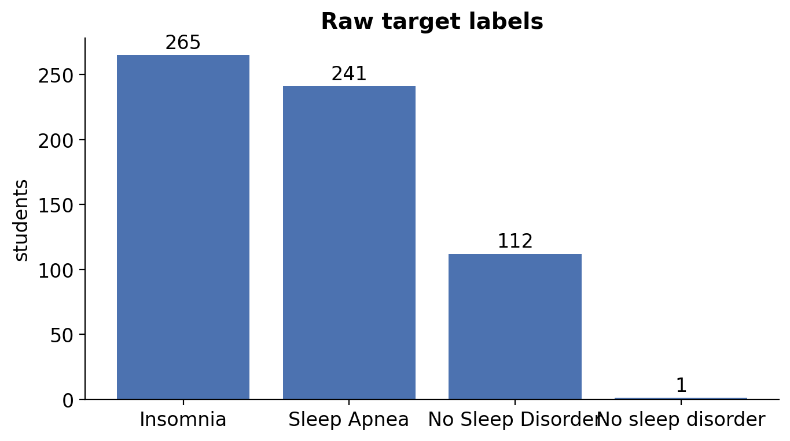
Figure 1. Raw Target Labels
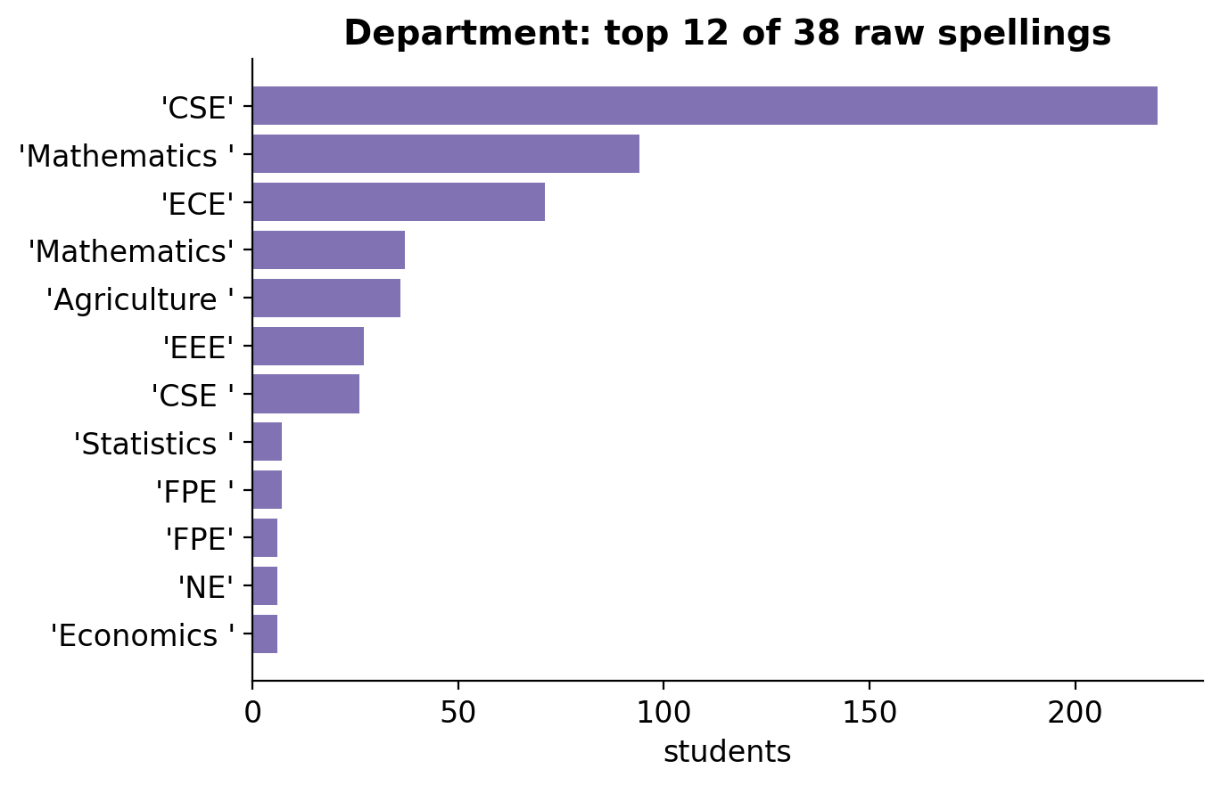
Figure 2. Raw Department Spellings (Top 12 of 38)
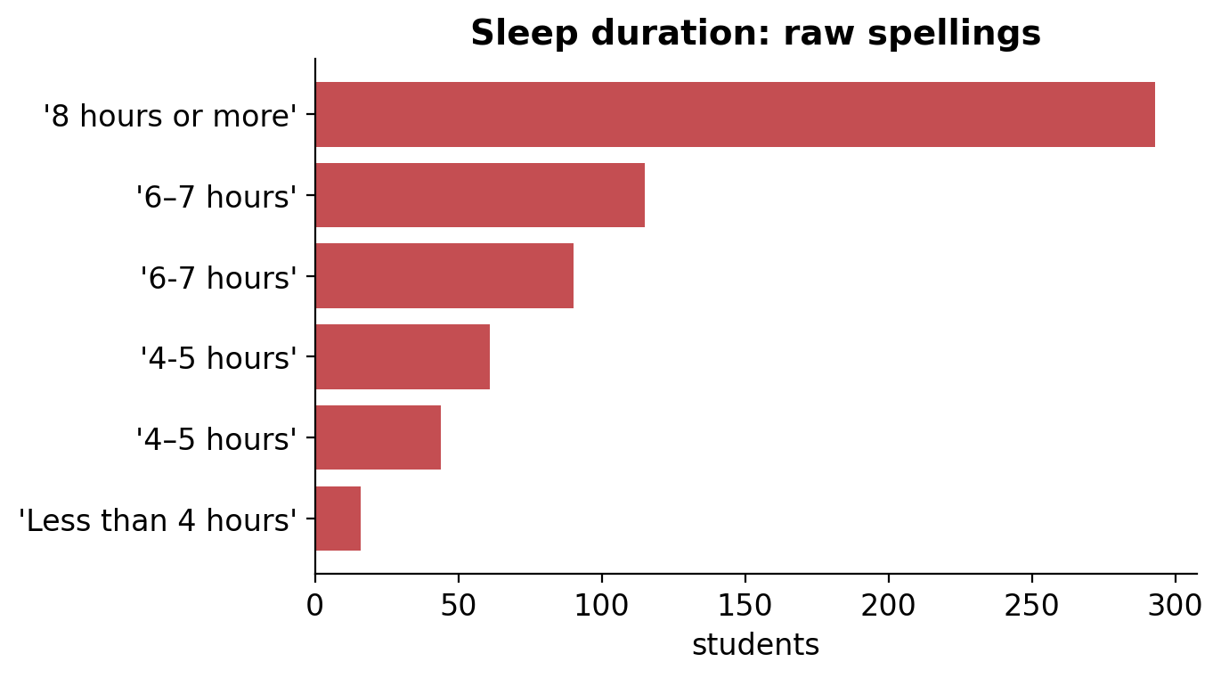
Figure 3. Raw Sleep Duration Spellings
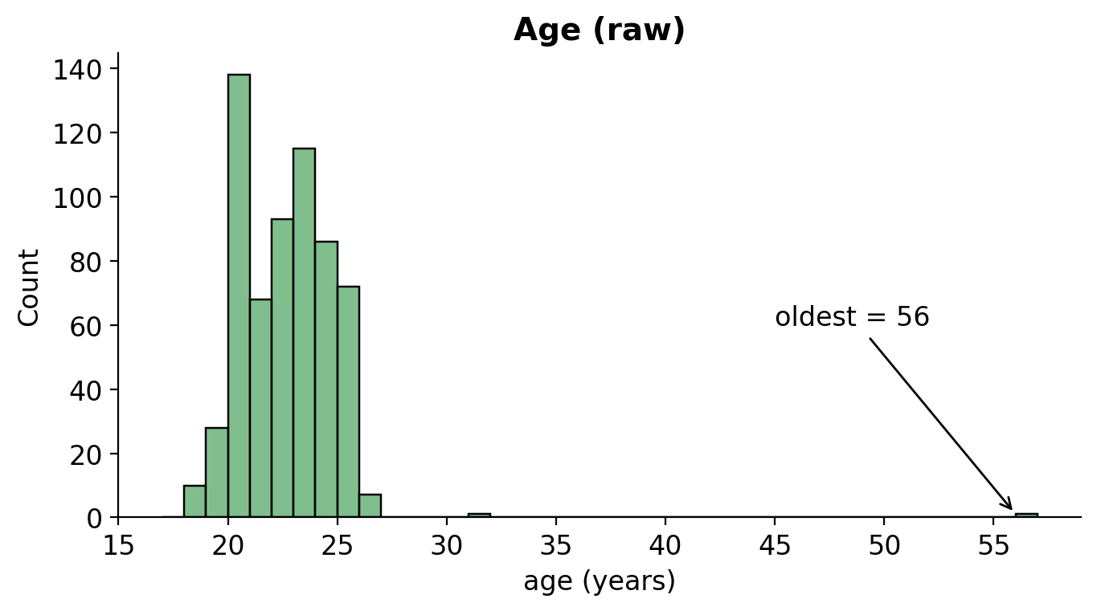
Figure 4. Raw Age Distribution
Figures 1–4 show four data-quality problems in the raw file. In Figure 1, the target contains 265 Insomnia, 241 Sleep Apnea, 112 “No Sleep Disorder” and one “No sleep disorder” (different capital letter), which would be treated as a separate class if left alone. Figure 2 shows that the Department field has 38 spellings for what are really a few departments: “Mathematics ” (with a trailing space, 94 students) and “Mathematics” (37) are counted separately, as are “CSE” (220) and “CSE ” (26). Figure 3 shows the same problem in sleep duration: “6–7 hours” (en dash, 115) and “6-7 hours” (hyphen, 90) are the same answer, and so are the two spellings of “4–5 hours” (44 and 61). Without cleaning, a model would learn from artificial categories that split the same group of students in two. Figure 4 shows that age is concentrated between 18 and 26 for most students (mean 22.2, standard deviation 2.4), with two extreme values (31 and 56 years) in a population of students. Further checks found three physiologically impossible blood-pressure readings (118/26, 80/90 and 80/120), 8 students with heart rates above 105 bpm (plausible and therefore kept) and physical-activity answers that are heavily rounded (36% are multiples of ten), which is typical of self-reported data.

C. Data Cleaning and Preprocessing
Cleaning follows one principle: rule-based steps that learn nothing from the data (text normalization, fixed plausible ranges, parsing, ordinal coding) are applied once to the whole file and stored in a shared module (dreamcatcher_utils.py) that the web service reuses, while statistics-based steps (imputation, scaling, one-hot encoding, oversampling and feature selection) are placed inside a pipeline, so they are fitted on training data only. This avoids data leakage, which occurs when information from the test set influences preprocessing.

1. Handling Inconsistent Text, Missing Values and Outliers
Listing every cleaned record would take 619 rows and add little, so the cleaning is documented in two ways: the next table counts how many of the 619 records each rule changed, and the table after it shows representative before-and-after examples. The complete row-by-row transformation can be reproduced by running the notebook.
Table 3. Cleaning Rules and the Number of Records Affected
Field | Rule | Records affected | Result
Department | Trim extra spaces and unify case; group small departments | 213 with extra spaces; 118 grouped into “Other” | 38 spellings → 24 departments → 5 groups
Sleep duration | Unify the en dash (–) and hyphen (-) | 159 | One spelling per answer
Sleep disorder (target) | Case-insensitive label match | 1 | Three clean classes
Blood pressure | Impossible reading set to missing (118/26, 80/90, 80/120) | 3 | 616 valid readings
Age | Capped to 18–30 | 2 (ages 31 and 56) | No student removed
Heart rate | Limited to 40–200 bpm | 0 | Unchanged
Physical activity | Limited to 0–180 min/day | 0 | Unchanged
Six ordinal columns | Converted to ordered integer codes | 619 (all) | Order preserved

Table 4. Examples of Raw Records and Their Cleaned Form
Record | Field | Raw value | Cleaned value | Rule applied
10 | Department | “Mathematics ” | Mathematics | Trim spaces, group
1 | Sleep duration | “4–5 hours” (en dash) | Code 1 (4-5 hours) | Unify dashes, ordinal code
86 | Blood pressure | 118/26 | missing | Impossible reading; imputed later
467 | Age | 31 | 30 | Capped to plausible range 18–30
(any) | Target | “No sleep disorder” | No Sleep Disorder | Case-insensitive label match

Table 4 shows real examples. Text was normalized by lower-casing, unifying dashes and collapsing spaces, which reduced the 38 department spellings to 24 departments and then to five groups (Section I.C, Department grouping below). Impossible blood-pressure readings were set to missing and are imputed with the training median inside the pipeline. Outliers were not removed; instead, fixed plausible ranges were applied, so no student is lost and no statistic from the test set is used. The next table explains where these ranges come from.
Table 5. Plausibility Ranges Used for Outlier Handling
Variable | Observed range | Tukey fences (Q1 − 1.5·IQR, Q3 + 1.5·IQR) | Range applied | Records changed
Age (years) | 18 – 56 | 14 – 30 | 18 – 30 | 2
Heart rate (bpm) | 50 – 120 | 29.5 – 121.5 | 40 – 200 | 0
Physical activity (min/day) | 10 – 120 | −51.8 – 166.2 | 0 – 180 | 0
Blood pressure (mmHg) | Systolic 90 – 150; diastolic 50 – 97 | Not used (physiological rule) | Systolic 70 – 220; diastolic 40 – 130; systolic above diastolic | 3 set to missing

How the ranges were chosen: The ranges are plausibility rules, not statistical trimming. Each combines domain knowledge about who the respondents are with a check against Tukey’s fences (the usual box-plot rule for unusual values, shown in Table 5).
Age 18–30: the respondents are university students and nobody in the data is younger than 18; the upper fence from the data is exactly 30, and only two students (31 and 56 years) lie above it. They are likely mature or part-time students, so their records are kept but capped at 30, which stops two values from pulling distance-based models such as KNN and SVM.
Heart rate 40–200 bpm: a measured heart rate below 40 or above 200 beats per minute is not credible for a young adult (200 is close to the commonly used estimate of maximum heart rate for a 20-year-old, 220 minus age). The observed values (50–120) are all inside and sit within the statistical fences (29.5–121.5), so no value was changed.
Physical activity 0–180 min/day: activity cannot be negative, and 180 minutes (3 hours) per day is above both the observed maximum (120) and the upper fence (166), so the limit only catches typing errors and never touches a real answer. Because the heart-rate and activity limits changed nothing in this dataset, they act as safeguards for future data and for values typed into the web form.
Blood pressure: a reading is treated as impossible when the systolic value is outside 70–220 mmHg, the diastolic value is outside 40–130 mmHg, or the systolic value is not higher than the diastolic value. Three readings failed this rule (118/26, 80/90 and 80/120). They are set to missing, not capped, because a wrong reading cannot be repaired by clipping, and they are filled in later inside the pipeline.
Where the rules are applied: all limits are fixed numbers, not learned from the data. They are implemented in the shared module dreamcatcher_utils.py (functions build_features and parse_bp), which the notebook runs before the train-test split and which the web service reuses, so training and deployment apply exactly the same rules. The observed ranges and Tukey fences in Table 5 were calculated from the raw data to justify the limits and are reported here for documentation.
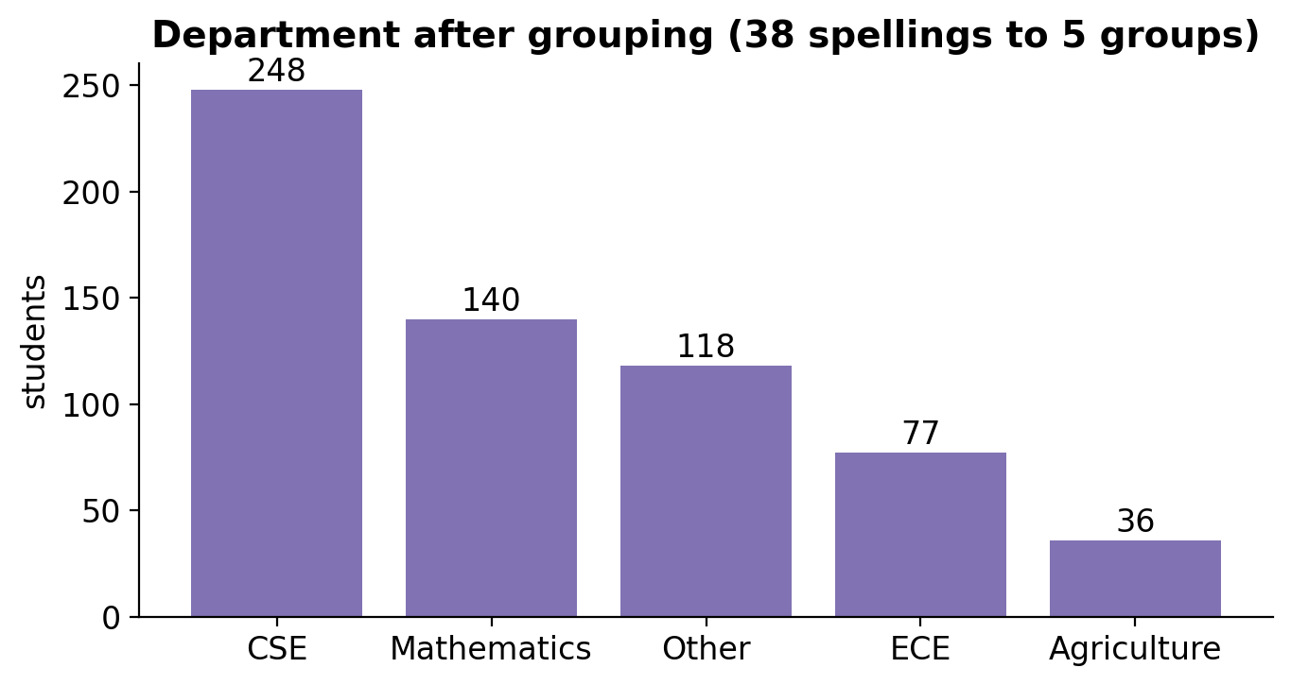
Figure 5. Department After Grouping
Figure 5 shows the result of grouping: CSE has 248 students, Mathematics 140, “Other” (EEE, Statistics and small departments) 118, ECE 77 and Agriculture 36. The groups are unbalanced, but every group is large enough to be estimated, and the smallest (Agriculture) still has 36 students. Department is later shown to be an administrative variable that does not help the model (Section II.D).
Table 6. Departments Merged Into Each Final Group
Final group | Raw spellings merged | Departments included (students) | Students
CSE | 3 | CSE | 248
Mathematics | 5 | Mathematics | 140
ECE | 2 | ECE | 77
Agriculture | 1 | Agriculture | 36
Other | 27 | EEE (30), FPE (13), Statistics (10), Economics (9), Chemistry (6), NE (6), Civil Engineering (5), DVM (5), English (5), AIE (3), BBA Professional (3), DS (3), GDS (3), ME (3), Physics (3), Social Work (3), GE (2), Software Engineering (2), SWE (2), URP (2) | 118

Table 6 shows exactly which departments were combined. The raw file contains 38 spellings, but many differ only by a trailing space or letter case (for example “CSE” and “CSE ”), so trimming and lower-casing leaves 24 real departments. The rule for the final groups is size: departments with at least 35 students (CSE, Mathematics, ECE and Agriculture) keep their own group, and the 20 departments with 30 students or fewer are combined into “Other”. Keeping tiny departments separate would create one-hot columns with only a handful of students, which the models cannot learn from reliably. Software Engineering and “SWE” are different spellings of the same department, but together they have only 4 students, so they remain in “Other”.

2. Feature Engineering
Table 7. Feature Engineering from the Blood-Pressure Text
New feature | Formula | Worked example (120/80) | Meaning
Systolic | first number of the text | 120 mmHg | Pressure when the heart beats
Diastolic | second number of the text | 80 mmHg | Pressure between beats
MAP (mean arterial pressure) | (Systolic + 2 × Diastolic) / 3 | (120 + 2 × 80) / 3 = 93.33 | Average pressure over a heartbeat; reflects blood supply to organs
Pulse pressure | Systolic − Diastolic | 120 − 80 = 40 | Gap between the two pressures; reflects arterial stiffness

The blood-pressure text cannot be used by a model, so it was split into systolic and diastolic values and two clinically meaningful features were derived (Table 7). Both relate to cardiovascular risk, which is linked to sleep apnea. Showing the values for all 616 students would take many pages and add no insight; instead, the distribution of the four blood-pressure variables is summarized in the numerical statistics table in Section I.D (mean MAP 90.0, mean pulse pressure 46.1), and the full engineered table can be reproduced in the notebook.

3. Encoding and Scaling
Ordered answers (sleep duration, sleep quality, stress level, BMI category, daily steps and academic level) were converted to integer codes that keep their order, which one-hot encoding would discard. Gender and department were one-hot encoded. The target was converted with a LabelEncoder (Insomnia = 0, No Sleep Disorder = 1, Sleep Apnea = 2; the codes follow alphabetical order and are only internal labels with no meaning of size). Numerical and ordinal columns were standardized with StandardScaler, so that columns with large values (such as physical-activity minutes) do not dominate distance-based models such as KNN and SVM. Imputation, scaling and one-hot encoding are fitted on training folds only.
Table 8. Preprocessing Summary
Step | Method | Where applied
Text normalization | Lower-case, unified dashes and spaces; 38 department spellings grouped into 5 | Rules, before the split
Missing / impossible values | Impossible blood pressure set to missing; median (numeric) or most-frequent (ordinal) imputation | Imputation in the pipeline
Outliers | Fixed plausible ranges (age 18–30, heart rate 40–200, activity 0–180); no rows removed | Rules, before the split
Feature engineering | Systolic, diastolic, MAP and pulse pressure from blood-pressure text | Rules, before the split
Encoding | Ordinal codes; one-hot for gender and department; LabelEncoder for the target | Rules and pipeline
Scaling | StandardScaler on numerical and ordinal columns | Pipeline
Class imbalance | Optional SMOTE (tuned by the grid search) | Pipeline, training folds only
Feature selection | SelectKBest with ANOVA F-test; k tuned | Pipeline
Train-test split | Stratified 80/20, random_state = 42 | Section I.E

D. Updated Exploratory Data Analysis (Cleaned Data)
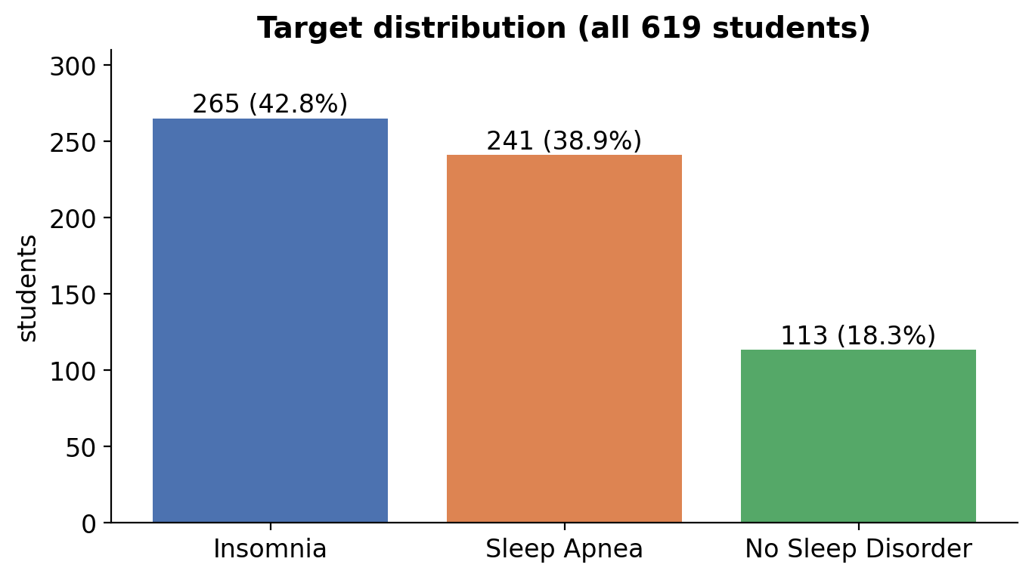
Figure 6. Target Class Distribution After Cleaning
Figure 6 shows that, after cleaning, Insomnia accounts for 42.8% of the students, Sleep Apnea for 38.9% and No Sleep Disorder for only 18.3%. The imbalance is mild, but “No Sleep Disorder” is clearly the smallest class. Two consequences follow. First, a model that always answers “Insomnia” would already be right 43% of the time, so accuracy alone is a poor measure and macro-averaged metrics are used. Second, the share of students with a disorder (82%) is far higher than in the general population, which is a property of this sample (students who answered a sleep survey) and means that predictive values from this study should not be generalized.
Table 9. Summary Statistics of Numerical Variables
Variable | n | Mean | Std | Min | 25% | 50% | 75% | Max
Age | 619 | 22.13 | 1.96 | 18.00 | 20.00 | 22.00 | 24.00 | 30.00
Physical activity (min/day) | 619 | 56.39 | 33.49 | 10.00 | 30.00 | 50.00 | 84.50 | 120.00
Heart rate (bpm) | 619 | 75.48 | 14.49 | 50.00 | 64.00 | 75.00 | 87.00 | 120.00
Systolic BP (mmHg) | 616 | 120.74 | 9.38 | 90.00 | 115.00 | 120.00 | 126.00 | 150.00
Diastolic BP (mmHg) | 616 | 74.63 | 9.19 | 50.00 | 68.00 | 75.00 | 80.00 | 97.00
Mean arterial pressure | 616 | 90.00 | 8.55 | 66.67 | 83.33 | 90.67 | 95.00 | 112.33
Pulse pressure | 616 | 46.11 | 7.51 | 2.00 | 40.00 | 47.00 | 51.00 | 70.00

About the counts (n): Most variables have n = 619, but systolic pressure, diastolic pressure, mean arterial pressure and pulse pressure have n = 616. The difference is the three impossible blood-pressure readings (118/26, 80/90 and 80/120) that were set to missing during cleaning, so these four statistics are computed from the 616 valid readings. The three missing values are not deleted: the students stay in the dataset and the missing values are filled with the training median inside the pipeline.
Table 10. Summary of Categorical and Ordinal Variables
Variable | Type | Categories | Most common answer | Share
Sleep duration | Ordinal | 4 | 8 hours or more | 47.3%
Quality of sleep | Ordinal | 5 | Average | 35.4%
Stress level | Ordinal | 5 | High | 26.0%
BMI category | Ordinal | 4 | Normal | 34.9%
Daily steps | Ordinal | 5 | 12,000–15,999 | 20.8%
Academic level | Ordinal | 4 | Level-1 | 39.9%
Gender | Nominal | 2 | Male | 53.0%
Department | Nominal | 5 (after grouping) | CSE | 40.1%

The summary statistics describe a young, fairly homogeneous group: the average student is 22 years old, does about 56 minutes of physical activity a day, has a resting heart rate of 75 bpm and a blood pressure of about 121/75 mmHg, all within normal ranges. Almost half of the students (47%) report sleeping eight hours or more, and the most common stress level is “High”, which already hints that self-reported sleep amount does not tell the whole story. The BMI distribution is concentrated in the normal group, so there are few students whose BMI would clinically raise sleep-apnea risk.

Numerical Features by Class
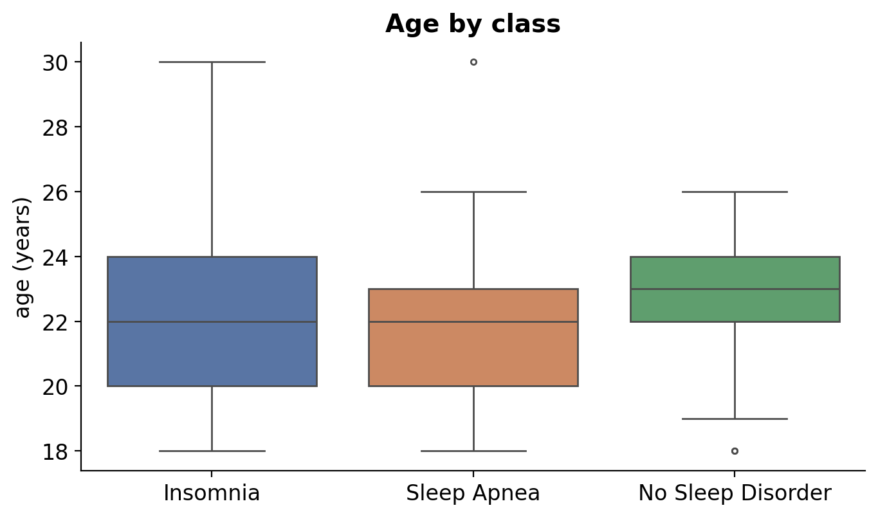
Figure 7. Age by Class
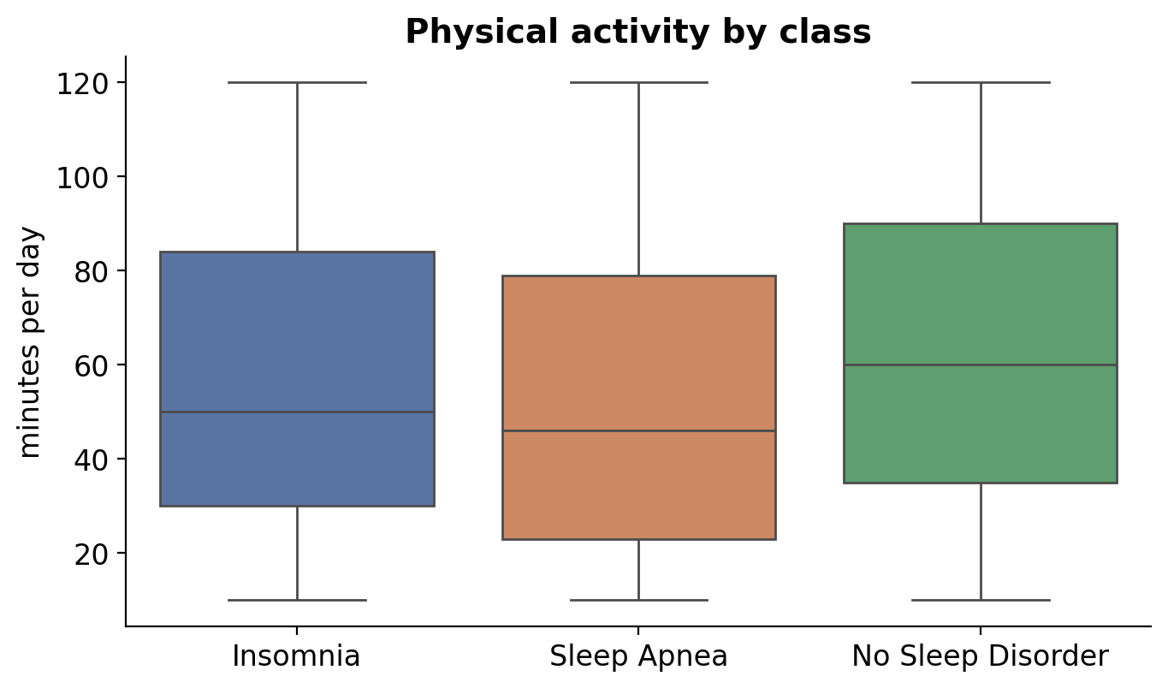
Figure 8. Physical Activity by Class
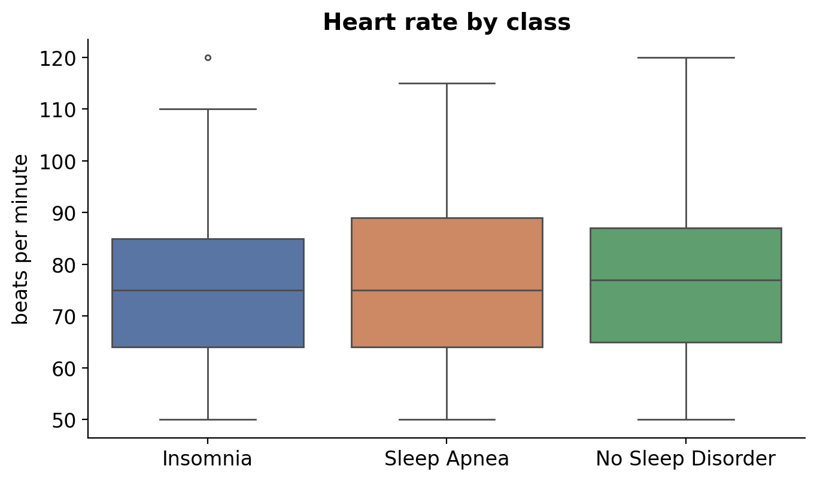
Figure 9. Heart Rate by Class
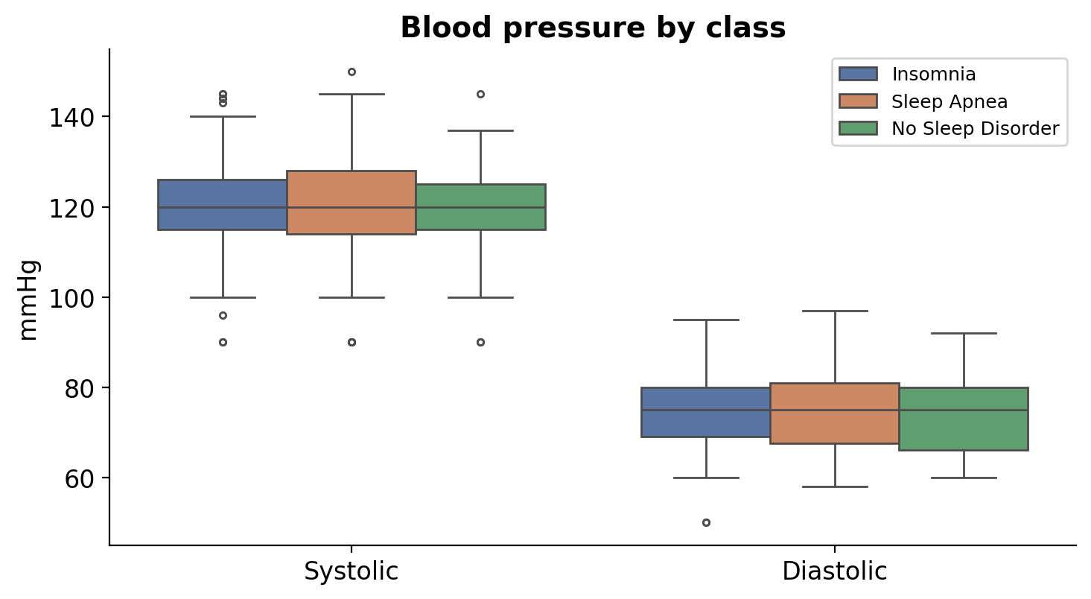
Figure 10. Blood Pressure by Class
Figures 7–10 compare the distributions of the numerical variables across the three classes (the line is the median; the box covers the middle 50% of students and the dots are unusual values). The boxes overlap heavily in every figure, so no numerical variable separates the classes clearly. Age (Figure 7) differs only slightly: students with no disorder are marginally older (mean 22.8 years) than students with insomnia (22.2) or sleep apnea (21.7). This small difference is statistically detectable in 619 students but is not a meaningful biological difference in a group spanning only 18 to 30 years. Physical activity (Figure 8) shows the clearest pattern: students with no disorder are more active (median 60 minutes per day) than students with insomnia (50) or sleep apnea (46), which agrees with the clinical idea that regular activity supports sleep. Heart rate (Figure 9) is almost identical (medians 75, 77 and 75 bpm). Systolic and diastolic pressure (Figure 10) have identical medians in all classes (120 and 75 mmHg), so, in this young group, blood pressure carries no visible information about the disorder, in contrast to the clinical expectation for sleep apnea in older adults.

Categorical and Ordinal Features by Class
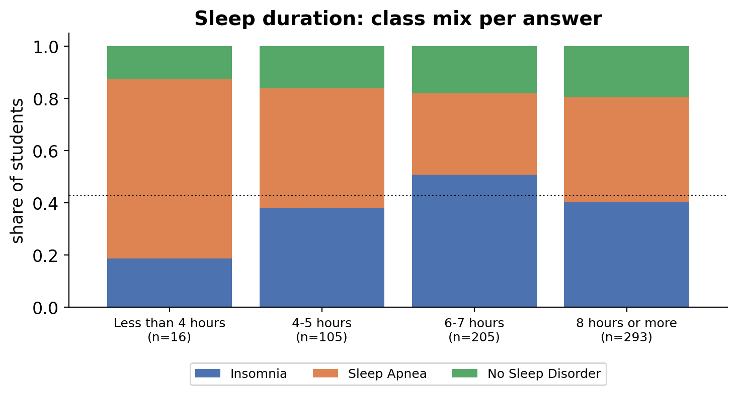
Figure 11. Sleep Duration: Class Mix per Answer
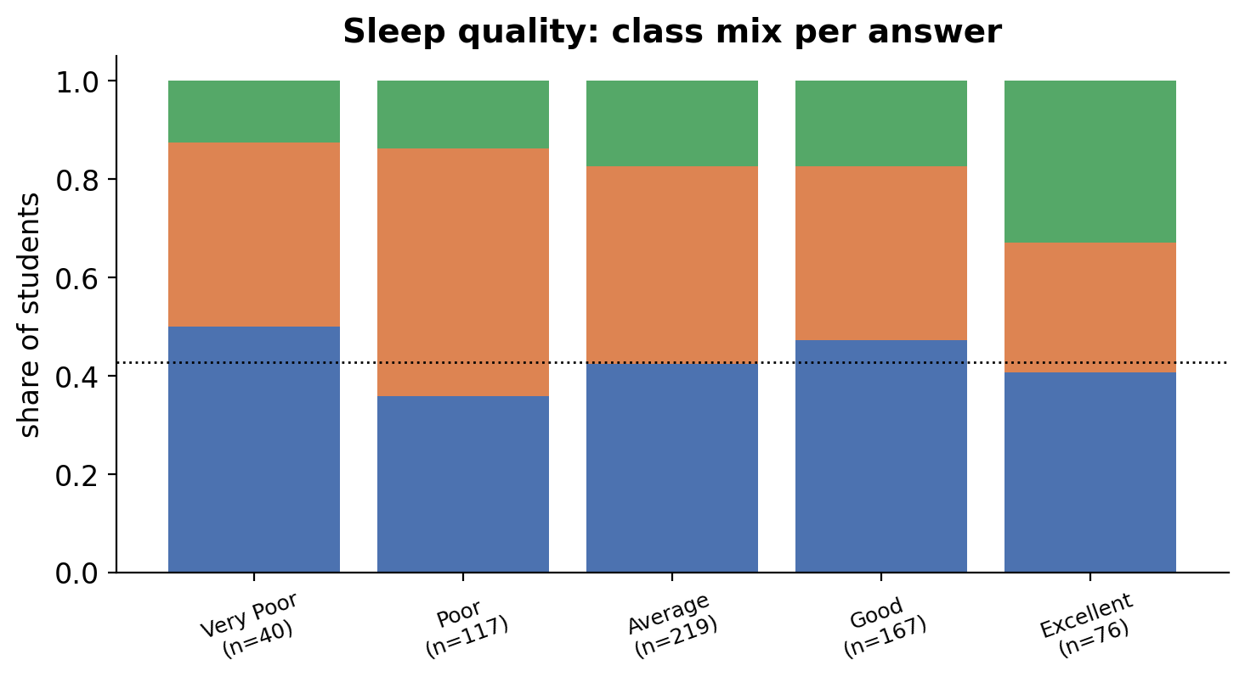
Figure 12. Sleep Quality: Class Mix per Answer
Figures 11–18 show, for each answer, how the three classes are mixed (the dotted line marks 42.8%, the overall share of insomnia). Sleep duration (Figure 11) shows an interesting non-linear pattern. Among the 16 students sleeping under four hours, 69% belong to the sleep-apnea class and only 19% to insomnia; for 4–5 hours the apnea share is still high (46%), whereas students sleeping 6–7 hours are mostly in the insomnia class (51%). This does not follow the common assumption that short sleepers have insomnia, but it fits the clinical picture that sleep apnea fragments and shortens sleep. The 8-hours-or-more group is split evenly (40% insomnia, 40% apnea, 19% none), which shows that long reported sleep does not protect against either condition. Sleep quality (Figure 12) is the most informative variable for the “No Sleep Disorder” class: among the 76 students who rate their sleep as excellent, 33% have no disorder, compared with 12–17% in every other group, and their share of sleep apnea (26%) is the lowest. At the other end, half of the students with “very poor” quality are in the insomnia class (50%). Quality is an intuitive marker because poor sleep satisfaction is part of the definition of insomnia (Riemann et al., 2023), but the effect is modest: even in the best group two-thirds of students still report a disorder.
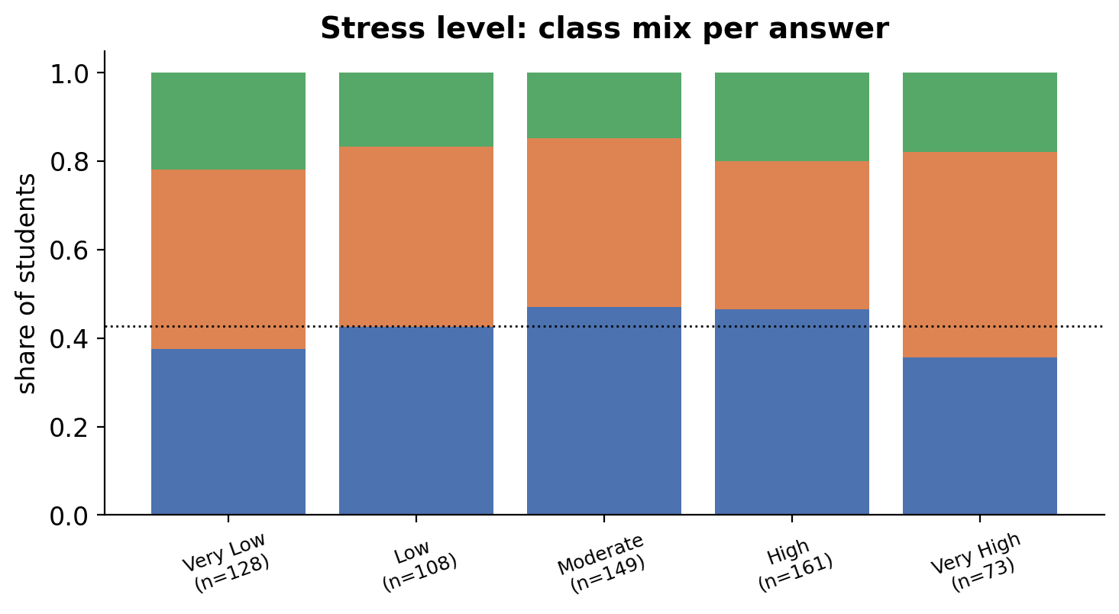
Figure 13. Stress Level: Class Mix per Answer
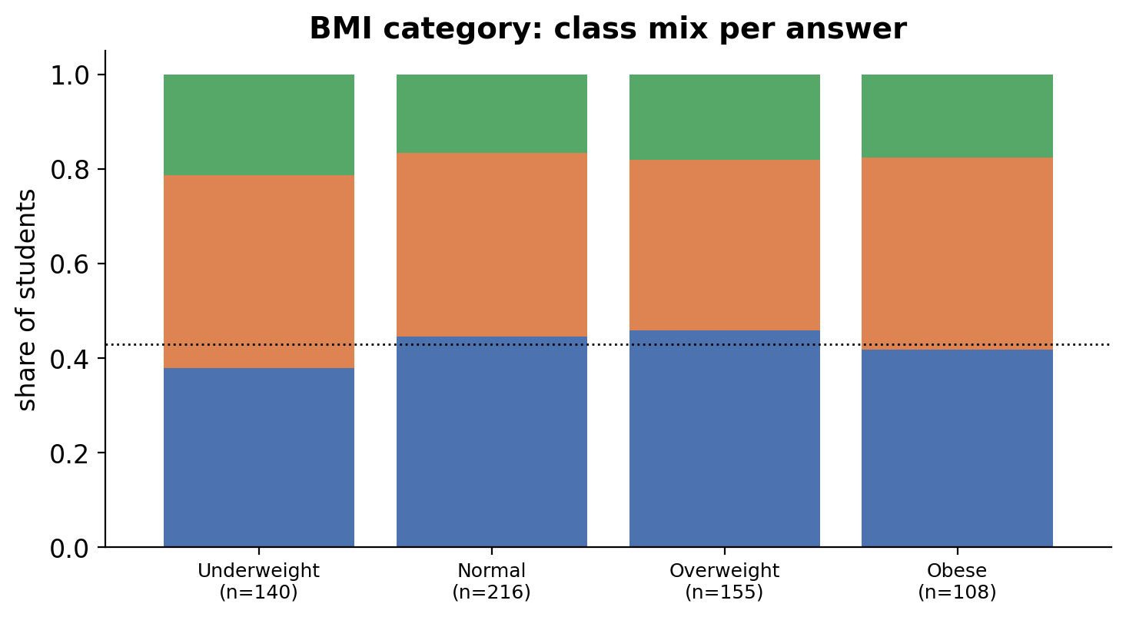
Figure 14. BMI Category: Class Mix per Answer
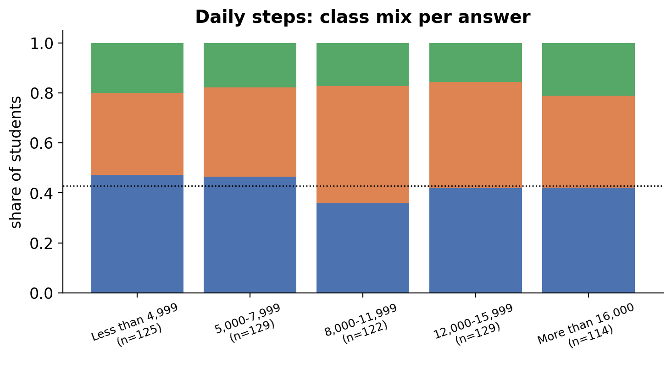
Figure 15. Daily Steps: Class Mix per Answer
Stress level (Figure 13) shows no consistent trend: the insomnia share rises from 38% (very low stress) to 47% (moderate and high stress), but falls to 36% in the “very high” group, whose apnea share jumps to 47%. Because the pattern is not monotonic, stress behaves more like noise than like the strong driver reported in the literature, and the thin “very high” group (73 students) makes it unreliable. BMI (Figure 14) is unexpectedly flat: the sleep-apnea share is 41% for underweight, 39% for normal, 36% for overweight and 41% for obese students. Obesity is a leading risk factor for sleep apnea in clinical populations, so this flat pattern is another sign that the labels in this survey are weakly linked to physiology. Daily steps (Figure 15) show a small dip in the insomnia share for the 8,000–11,999 band (36%) but otherwise the bars look alike, which means that step count is not a useful separator on its own.
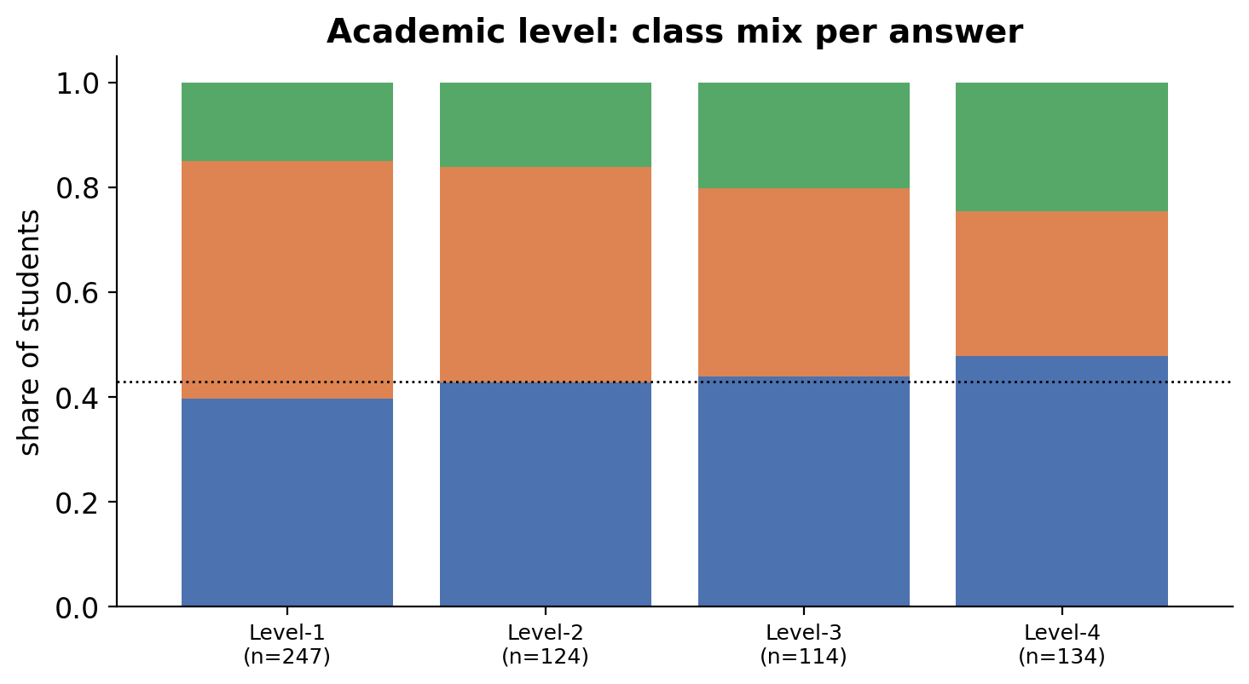
Figure 16. Academic Level: Class Mix per Answer
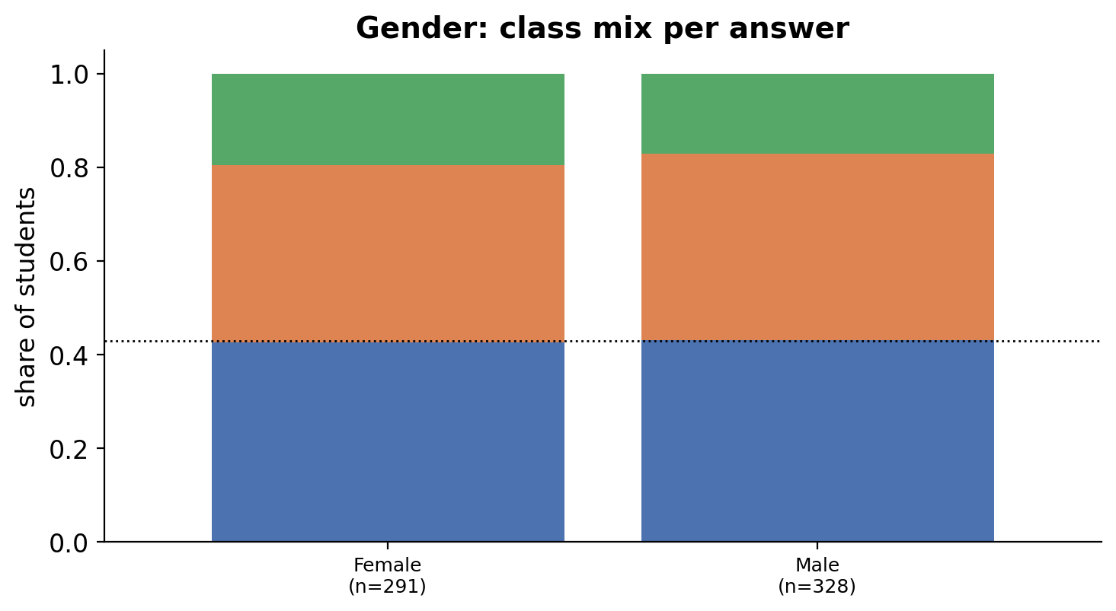
Figure 17. Gender: Class Mix per Answer
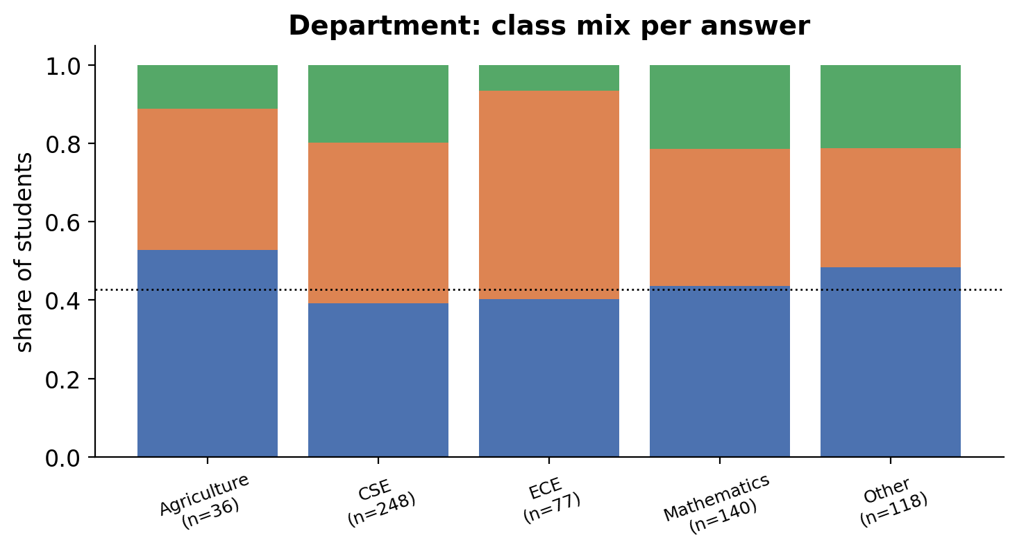
Figure 18. Department: Class Mix per Answer
Academic level (Figure 16) has a visible gradient: the share of “No Sleep Disorder” rises from 15% in Level-1 to 25% in Level-4, while the apnea share falls from 45% to 28%. It is tempting to read this as “older students sleep better”, but academic level is an administrative variable, not a physiological one, and it is correlated with age (Spearman 0.39), so the gradient most likely reflects how the sample was collected (for example, which classes were surveyed) rather than a biological effect. Gender (Figure 17) shows virtually identical mixes for women (43% / 38% / 20%) and men (43% / 40% / 17%), so gender does not help. Department (Figure 18) has the largest differences between groups: ECE students are 53% sleep apnea and only 6% “no disorder”, while Agriculture students are 53% insomnia and 11% “no disorder”. Department is not a plausible cause of either condition; the differences more likely come from small groups answering the survey in different settings, which is why department is excluded from the final feature set (Section II.D).

Correlations
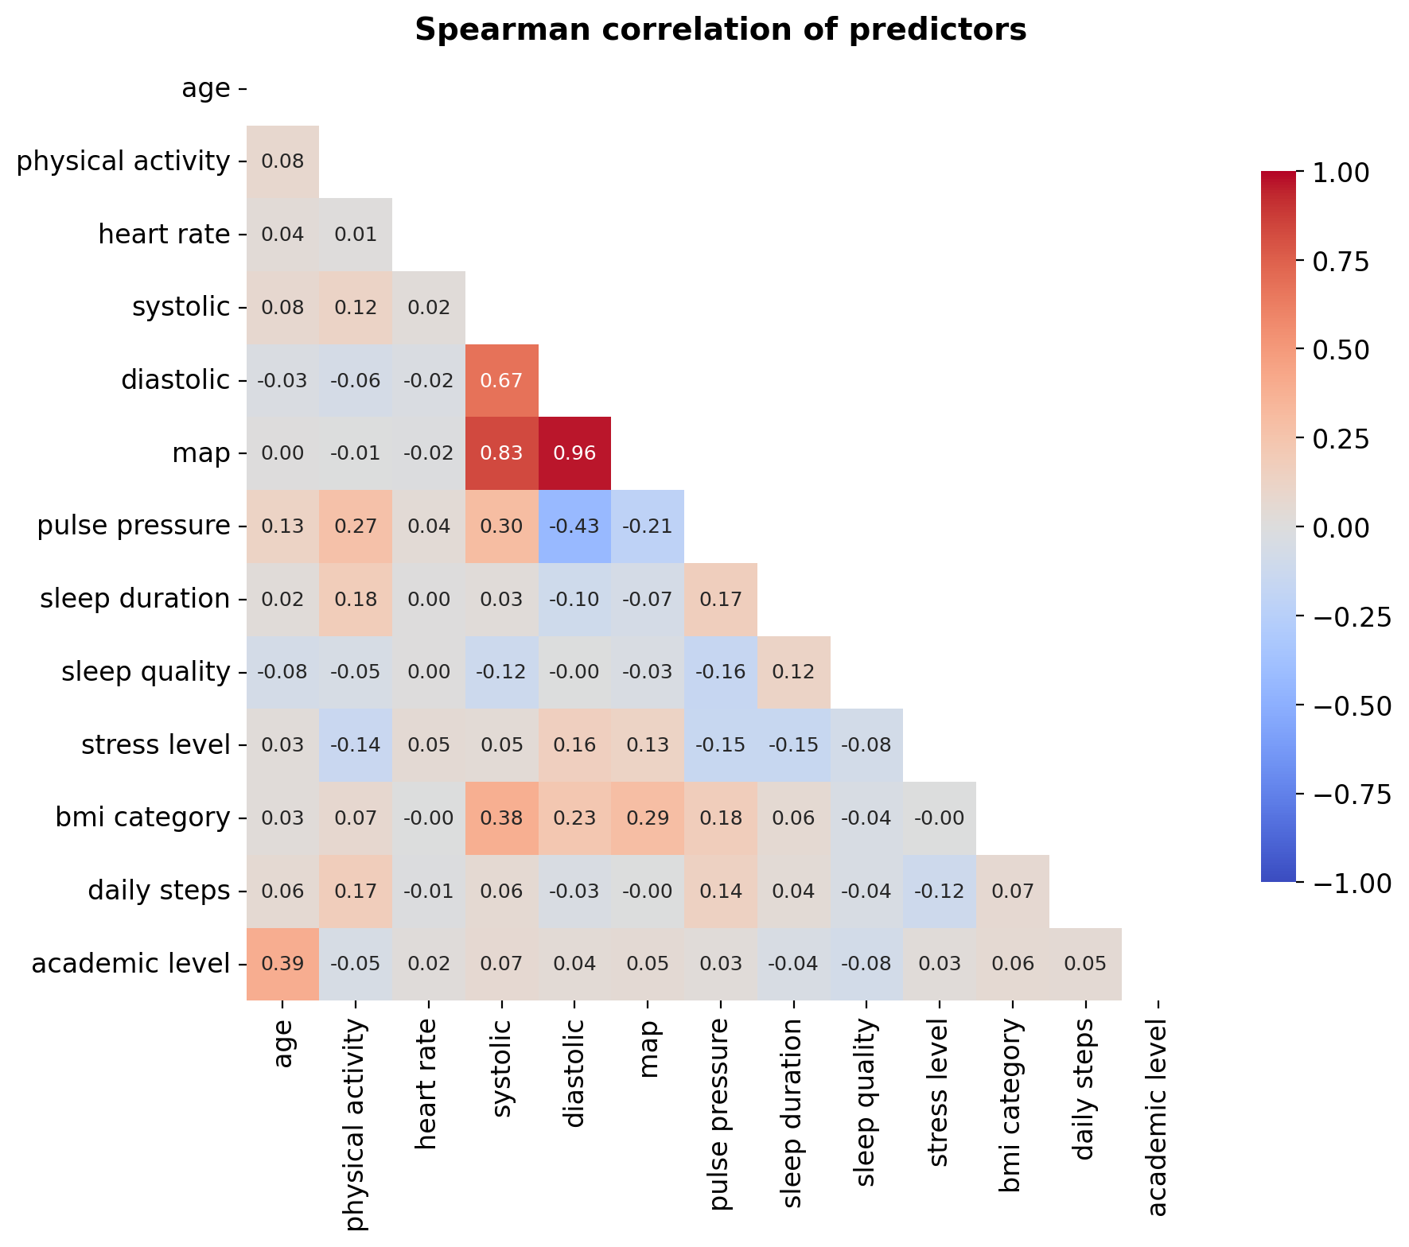
Figure 19. Spearman Correlation Heatmap of Predictors
Figure 19 shows pairwise Spearman correlations between predictors (values near +1 or −1 mean a strong relationship; near 0, none). Spearman is used instead of Pearson because it works on ranks, which suits ordinal survey answers and is less sensitive to outliers. Three findings stand out. (1) The strongest correlations are structural: mean arterial pressure (MAP) is almost determined by diastolic pressure (0.96) and systolic pressure (0.83), simply because MAP is calculated from them, so these three columns are largely redundant. (2) Some relationships are clinically sensible: systolic pressure rises with BMI category (0.38), and older students are in higher academic levels (0.39). (3) The self-reported sleep items are surprisingly weakly related: sleep duration and sleep quality correlate at only 0.12, and stress is only weakly related to sleep quality (−0.08) and sleep duration (−0.15). In genuine sleep data one would expect much stronger links, so this suggests substantial noise in the self-reported answers. This noise, together with the weak differences between classes, foreshadows the modest model performance reported in Section III.

E. Train-Test Data Splitting
The data was divided into 80% training (495 students) and 20% testing (124 students) with a stratified split and a fixed random seed, so that every class keeps nearly the same share in both parts. The test set was not touched until the final evaluation.
Table 11. Class Distribution (Train vs Test)
Class | Train count | Train % | Test count | Test %
Insomnia | 212 | 42.8 | 53 | 42.7
Sleep Apnea | 193 | 39.0 | 48 | 38.7
No Sleep Disorder | 90 | 18.2 | 23 | 18.5
Total | 495 | 100 | 124 | 100

Table 11 confirms that stratification worked: the class shares differ by less than one percentage point between training and test sets. The test set is small (only 23 students without a disorder), which is why all test results are reported with confidence intervals and interpreted cautiously.

II. Model Implementation

A. Model Selection
The target has three classes, so classification models are required. The three algorithms required by the course were implemented and compared with a no-skill baseline. Similar lifestyle-based sleep-disorder studies have also compared Random Forest, SVM and boosting models with cross-validated tuning (Sari et al., 2025; Rahardian & Rakasiwi, 2026), which supports this choice.
- Random Forest builds many decision trees on random subsets of students and features and votes. It models non-linear effects and interactions and is insensitive to scaling, but it can fit noise when the signal is weak.
- K-Nearest Neighbors (KNN) classifies a student by the most common class among the k most similar students. It is simple and a large k smooths noisy data, but it is sensitive to irrelevant features and to scaling.
- Support Vector Machine (SVM) with an RBF kernel finds a margin-maximizing boundary between classes. It is regularized and works well on small datasets, but needs scaling and careful tuning of C and gamma.
- Baseline (majority class) always predicts the most frequent class. Any useful model must beat it.

B. Training Workflow and Handling Strategy
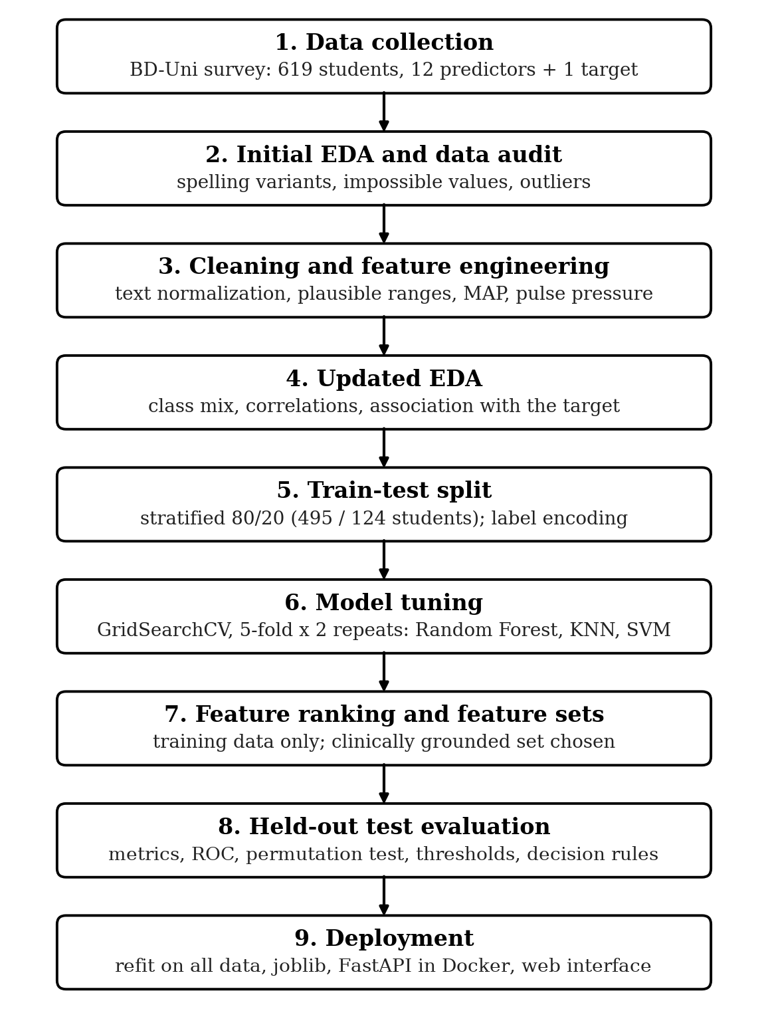
Figure 20. Machine Learning Workflow
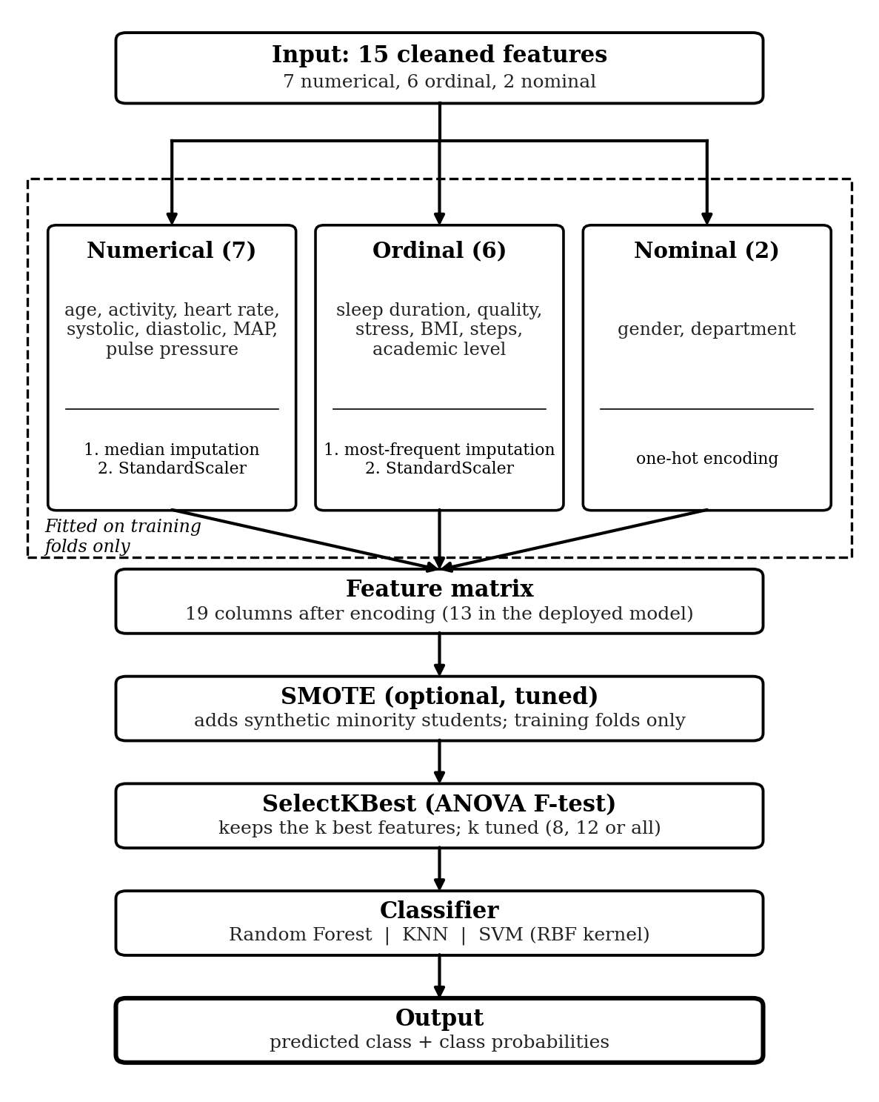
Figure 21. Structure of the Model Pipeline
Figure 20 summarizes the nine stages of the study from data collection to deployment, and Figure 21 shows what happens inside each model. The pipeline processes the three kinds of variables in parallel (numerical and ordinal columns are imputed and standardized, nominal columns are one-hot encoded), joins them into one feature matrix of 19 columns (13 in the deployed model, where academic level and department are excluded), and then applies optional SMOTE, SelectKBest and the classifier. The key design choice is that everything that learns from data is inside the pipeline, so during cross-validation each step is fitted only on the training part of each fold and applied unchanged to the validation part. This prevents leakage and makes the validation scores honest. Model selection uses 5-fold stratified cross-validation repeated twice (10 fits per setting) and the macro-averaged F1-score, which treats the three classes equally so that a model cannot score well by ignoring the smaller “No Sleep Disorder” class. The final model is chosen from cross-validation results only, never from the test score.
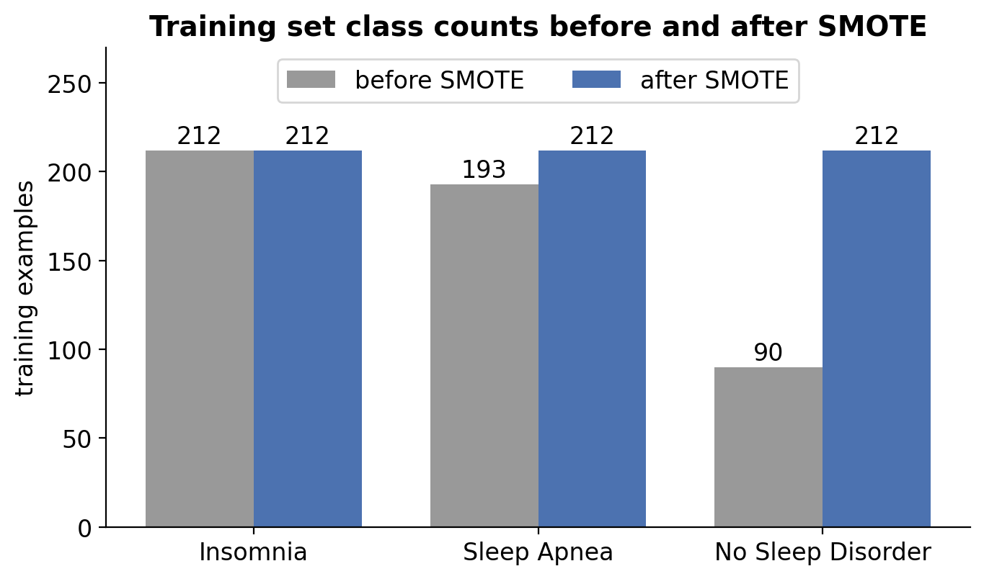
Figure 22. Class Counts Before and After SMOTE (Training Set)
SMOTE (Synthetic Minority Oversampling Technique; Elreedy et al., 2024) creates new minority-class examples by interpolating between a student and that student’s nearest neighbors in the same class. Figure 22 shows the effect on the 495 training students: “No Sleep Disorder” grows from 90 to 212 (122 synthetic students) and Sleep Apnea from 193 to 212 (19 synthetic students), so all classes end with 212. SMOTE is applied only inside the training part of each cross-validation fold; validation folds and the test set keep their real class mix, so the reported scores are not inflated by artificial students. It is treated as a tunable option because it can also create unrealistic points when classes overlap, as they do here.
Key functions and parameters: Table 12 lists the functions and parameters used in the training workflow (notebook Sections 4–5). The same pipeline is built for all three models, so they receive identical preprocessing and differ only in the classifier and its tuning grid.
Table 12. Key Functions and Parameters Used in the Training Workflow
Step | Function (library) | Key parameters used
Train-test split | train_test_split (scikit-learn) | test_size=0.2, stratify=y, random_state=42
Target encoding | LabelEncoder | Insomnia = 0, No Sleep Disorder = 1, Sleep Apnea = 2
Missing values | SimpleImputer | strategy="median" (numerical), "most_frequent" (ordinal)
Scaling | StandardScaler | default (mean 0, standard deviation 1)
Nominal encoding | OneHotEncoder | drop="if_binary", handle_unknown="ignore"
Column routing | ColumnTransformer | separate steps for numerical, ordinal and nominal columns
Class imbalance | SMOTE (imbalanced-learn) | random_state=42; on or off chosen by the grid search
Feature selection | SelectKBest | score_func=f_classif; k = 8, 12 or all (tuned)
Leakage-safe chaining | Pipeline (imbalanced-learn) | SMOTE applied to training folds only
Random Forest | RandomForestClassifier | n_estimators=300, random_state=42; depth, leaf size, class weight tuned
KNN | KNeighborsClassifier | n_neighbors, weights and distance metric p tuned
SVM | SVC | kernel="rbf", random_state=42; C, gamma, class weight tuned; probability=True for the final fit
Cross-validation | RepeatedStratifiedKFold | n_splits=5, n_repeats=2, random_state=42
Tuning | GridSearchCV | scoring = macro-F1 (refit), balanced accuracy, accuracy, macro recall; n_jobs=-1
Saving | joblib.dump | dreamcatcher_model.joblib and label_encoder.pkl (Section V)

C. Hyperparameter Tuning
Hyperparameters were tuned with GridSearchCV. The grid for each model also contains the pipeline choices (SMOTE on or off and the number of features kept by SelectKBest), so these are tuned together with the model’s own parameters.
Table 13. Hyperparameter Grid for Model Tuning
Model | Hyperparameter | Values tested | Combinations
Random Forest | smote; select__k; max_depth; min_samples_leaf; class_weight; n_estimators (fixed) | [none, SMOTE]; [8, 12, all]; [5, 10, None]; [2, 5]; [None, balanced]; 300 | 72
KNN | smote; select__k; n_neighbors; weights; p (distance metric) | [none, SMOTE]; [8, 12, all]; [5, 9, 15, 25]; [uniform, distance]; [1, 2] | 96
SVM (RBF) | smote; select__k; C; gamma; class_weight | [none, SMOTE]; [8, 12, all]; [0.1, 1, 10]; [scale, 0.01, 0.1]; [None, balanced] | 108

The last column is the number of different settings tried for each model, which is the product of the number of values in each row (for Random Forest: 2 × 3 × 3 × 2 × 2 = 72). Every setting is trained and validated 10 times (5 folds × 2 repeats), so the search trained 720 Random Forest, 960 KNN and 1,080 SVM models before the best setting of each was chosen.
Table 14. Best Parameters and Cross-Validation Results (Training Set)
Model | Best parameters | CV macro-F1 | CV bal. acc. | CV acc. | F1 std
Baseline | – | 0.200 | 0.333 | 0.428 | 0.002
Random Forest | max_depth = 5, min_samples_leaf = 5, class_weight = None, k = 12, SMOTE | 0.384 | 0.399 | 0.407 | 0.058
KNN | n_neighbors = 25, p = 1 (Manhattan), weights = uniform, k = all, SMOTE | 0.399 | 0.414 | 0.415 | 0.074
SVM | C = 1, gamma = scale, class_weight = None, k = 12, SMOTE | 0.389 | 0.399 | 0.406 | 0.044

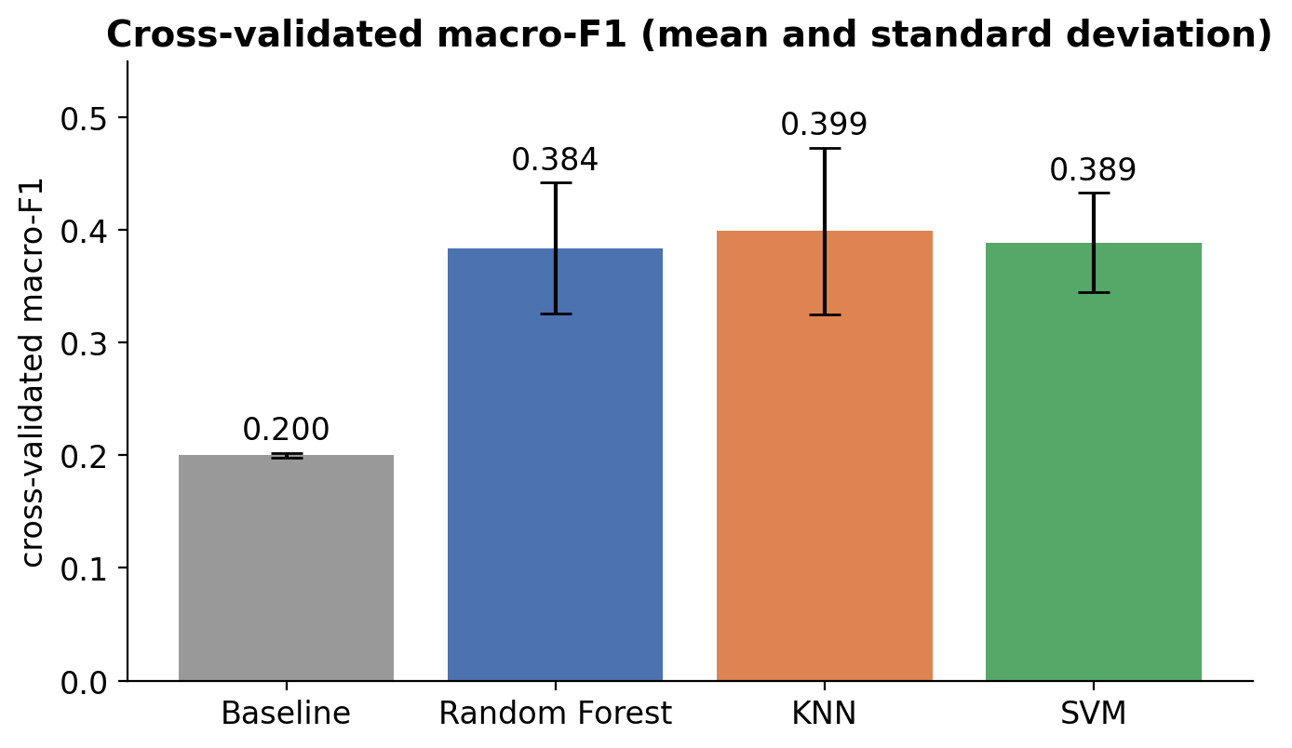
Figure 23. Cross-Validated Macro-F1 of the Tuned Models
Figure 23 compares the tuned models with the baseline (bars show the mean over 10 validation folds, whiskers one standard deviation). All three models are clearly above the baseline (0.200), but they are almost tied: KNN 0.399, SVM 0.389 and Random Forest 0.384, with fold-to-fold standard deviations (0.04 to 0.07) larger than the differences between models. The tuned KNN uses a large neighborhood (k = 25) with Manhattan distance, which averages over many students and therefore smooths noise. All three best configurations use SMOTE, but its effect was small (best macro-F1 with versus without SMOTE: Random Forest 0.384 / 0.383, KNN 0.399 / 0.383, SVM 0.389 / 0.388), consistent with a mild class imbalance. KNN has the highest cross-validated macro-F1 and is therefore the selected model.

D. Feature Ranking and Feature Selection
The study tests which features matter most and whether only a few are needed. SelectKBest with the ANOVA F-test is part of the pipeline, so ranking is repeated inside every fold. In addition, features were ranked on the training data with three independent methods (ANOVA F, mutual information and Random Forest importance) and combined into a consensus rank.
Table 15. Feature Ranking on the Training Set (Top 10 of 19 Encoded Features)
Feature | Consensus rank | ANOVA F | Mutual information | RF importance
age | 3.00 | 16.524 | 0.004 | 0.090
sleep_quality | 5.00 | 2.663 | 0.051 | 0.052
academic_level | 5.33 | 5.293 | 0.045 | 0.043
diastolic | 6.67 | 0.602 | 0.013 | 0.079
physical_activity | 7.00 | 1.852 | 0.000 | 0.107
daily_steps | 7.33 | 0.570 | 0.049 | 0.054
heart_rate | 7.67 | 0.687 | 0.000 | 0.115
sleep_duration | 9.00 | 0.679 | 0.002 | 0.041
systolic | 9.67 | 0.127 | 0.001 | 0.082
department_CSE | 10.00 | 1.051 | 0.001 | 0.018

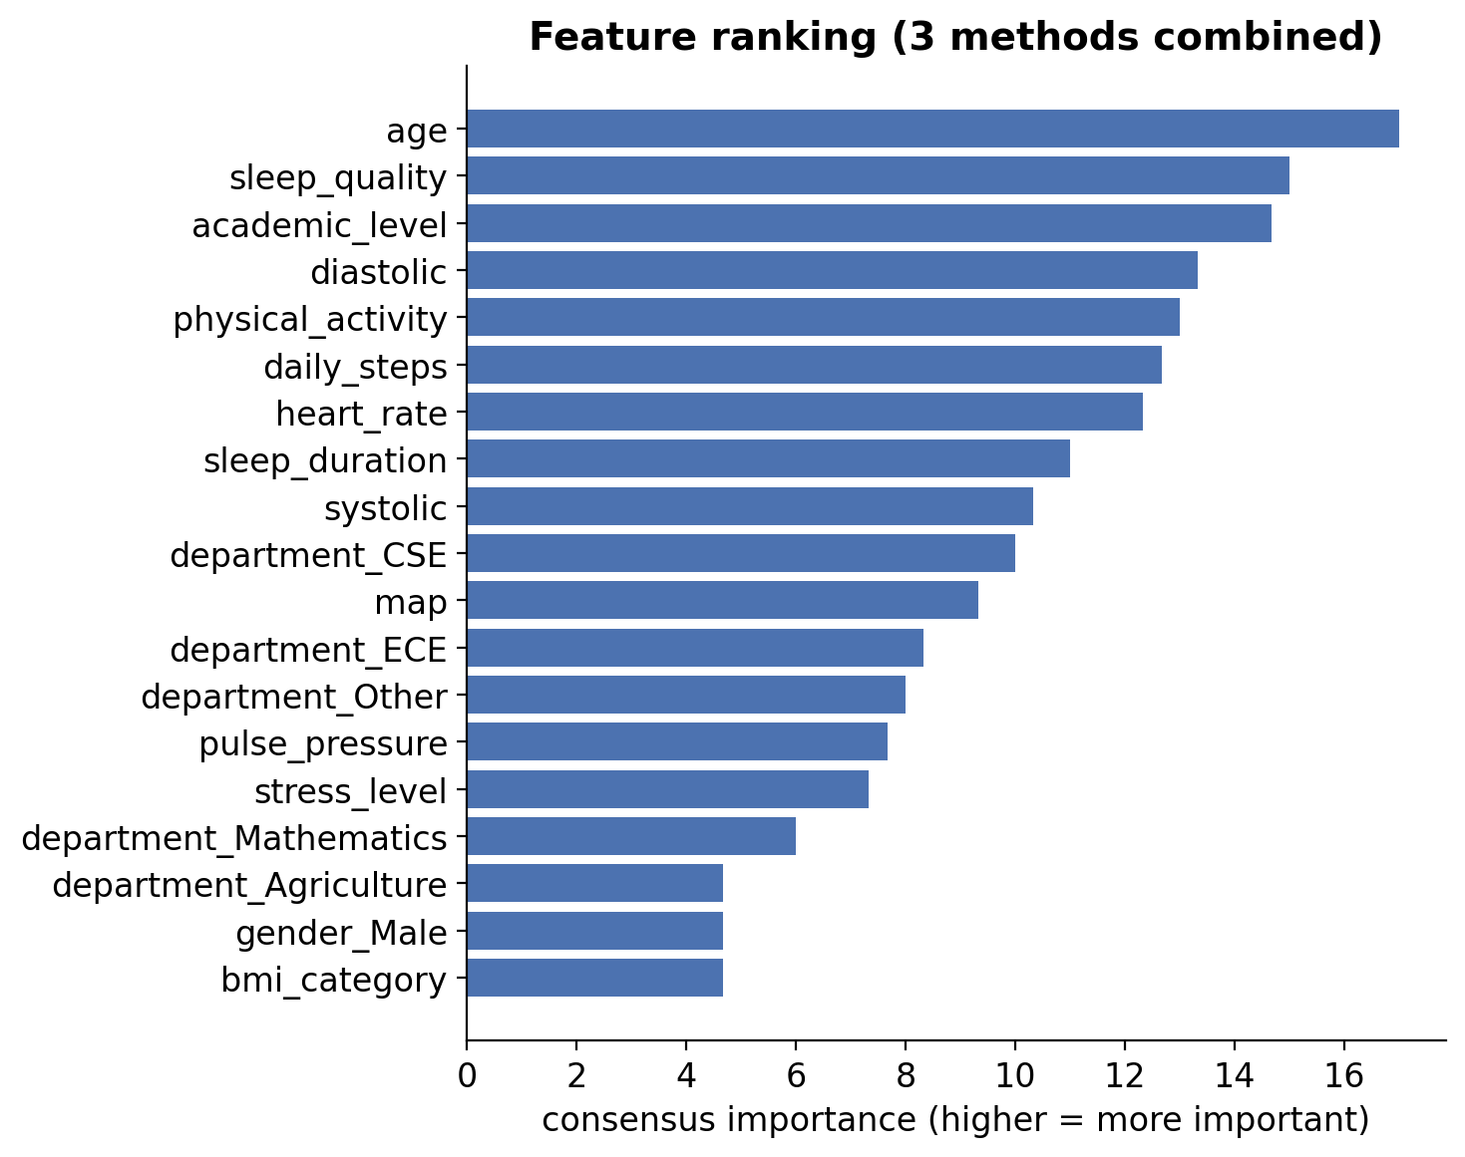
Figure 24. Consensus Feature Ranking
Figure 24 and the table above show that the three methods disagree: age ranks first because of a large ANOVA F value (16.5), sleep quality ranks highly on mutual information, and heart rate and physical activity rank highly on Random Forest importance. A high rank is not a clinical explanation. Age ranks first although the students span only 18 to 30 years, and academic level ranks third although it is an administrative label. A formal test on the original features (see the association table below; Kruskal–Wallis for numerical and chi-square for categorical variables, with Benjamini–Hochberg correction for multiple testing) confirms that only age and sleep duration are significantly related to the target after correction, and both effects are small.
What the next table is for: The rankings above only put the features in order. The association table asks a different question: for each original feature, is the difference between the three classes larger than we would expect by chance? Numerical features are tested with the Kruskal–Wallis test and categorical features with the chi-square test. The effect size says how large the difference is (closer to 0 means smaller; every value here is small, 0.14 at most) and the p-value says how surprising the difference would be if the feature had no real link to the target. Because 15 features are tested at once, a few would look significant by luck alone, so the p-values are adjusted with the Benjamini–Hochberg false-discovery-rate method; a feature counts as significant only when the adjusted p-value is below 0.05.
Table 16. Association of Each Original Feature with the Target (Training Set)
Feature | Test | Effect size | p-value | p (FDR-adjusted) | Significant
age | Kruskal–Wallis | 0.0679 | <0.0001 | <0.0001 | Yes
sleep_duration | Chi-square | 0.1352 | 0.0060 | 0.0450 | Yes
academic_level | Chi-square | 0.1108 | 0.0588 | 0.2224 | No
sleep_quality | Chi-square | 0.1231 | 0.0593 | 0.2224 | No
physical_activity | Kruskal–Wallis | 0.0057 | 0.0908 | 0.2725 | No
department | Chi-square | 0.1096 | 0.1562 | 0.3905 | No
daily_steps | Chi-square | 0.0986 | 0.2923 | 0.6264 | No
heart_rate | Kruskal–Wallis | −0.0015 | 0.5306 | 0.8437 | No
diastolic | Kruskal–Wallis | −0.0023 | 0.6424 | 0.8437 | No
bmi_category | Chi-square | 0.0654 | 0.6446 | 0.8437 | No
map | Kruskal–Wallis | −0.0027 | 0.7097 | 0.8437 | No
pulse_pressure | Kruskal–Wallis | −0.0028 | 0.7303 | 0.8437 | No
stress_level | Chi-square | 0.0728 | 0.7312 | 0.8437 | No
gender | Chi-square | 0.0177 | 0.9257 | 0.9350 | No
systolic | Kruskal–Wallis | −0.0038 | 0.9350 | 0.9350 | No

What the next figure is for: The ranking raises a practical question: do we need all the features, or would a few be enough? To test this, only the k best-ranked features are kept (k from 1 to 19) and the cross-validated macro-F1 is measured for each model. The horizontal axis is k and the vertical axis is the score; if a few features carried most of the information, the curve would climb quickly and then level off. The table that follows summarizes the curve: the best k is the one with the highest score, and the smallest k within one standard error is the simplest model whose score cannot be told apart from the best.
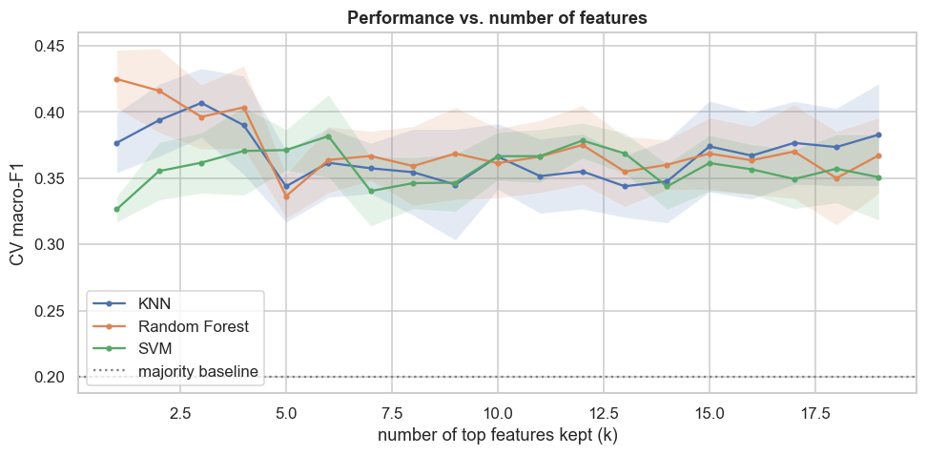
Figure 25. Cross-Validated Macro-F1 versus Number of Top Features Kept
Table 17. Smallest Number of Features Within One Standard Error of the Best
Model | Best k | CV macro-F1 at best k | Smallest k within 1 SE | CV macro-F1 at that k
KNN | 3 | 0.407 | 2 | 0.394
Random Forest | 1 | 0.425 | 1 | 0.425
SVM | 6 | 0.382 | 2 | 0.355

How few features are enough? Figure 25 keeps only the top k features (k from 1 to 19) and re-runs cross-validation. The curves are flat and noisy (shaded bands show one standard error), they cross each other, and the best k differs by model (Table 17), so there is no stable small subset. Random Forest even scores highest with a single feature, which is a sign of random variation, not of one feature being sufficient. On the test set, keeping only the two top-ranked features (age and academic level) lowered the macro-F1 of KNN from 0.454 to 0.324 and its balanced accuracy from 0.479 to 0.357. In this dataset, therefore, a few statistically top-ranked features do not identify sleep disorder on their own.
Clinically grounded feature sets: Because age and academic level are unlikely to be clinical drivers, three feature sets were compared with each model’s tuned hyperparameters: (1) all features; (2) clinically grounded, which drops academic level and department (administrative variables); and (3) clinical without demographics, which also drops age and gender. The rule was to deploy the clinically grounded set unless it was worse than all features by more than one standard error.
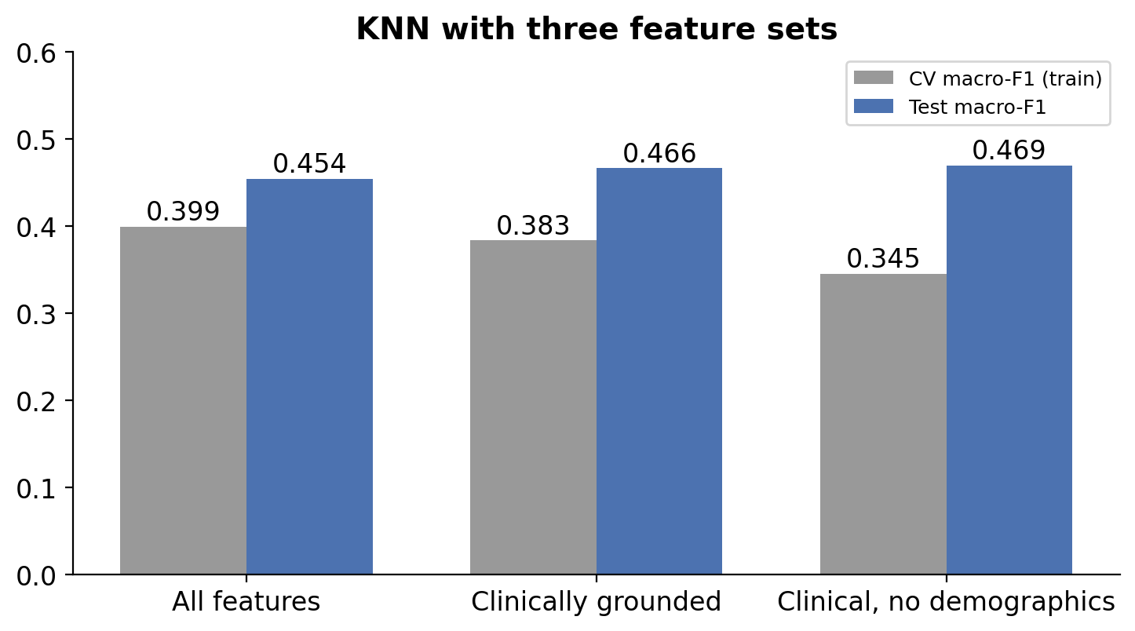
Figure 26. KNN Performance With Three Feature Sets
Table 18. Comparison of Feature Sets
Measure | All features | Clinically grounded | Clinical, no demographics
CV macro-F1: KNN | 0.399 | 0.383 | 0.345
CV macro-F1: Random Forest | 0.382 | 0.385 | 0.343
CV macro-F1: SVM | 0.365 | 0.381 | 0.341
Test accuracy (KNN) | 0.452 | 0.476 | 0.476
Test balanced accuracy (KNN) | 0.479 | 0.477 | 0.498
Test macro-F1 (KNN) | 0.454 | 0.466 | 0.469

Figure 26 and Table 18 show that removing academic level and department did not hurt: cross-validated macro-F1 for KNN moved from 0.399 to 0.383, a change smaller than one standard error, and the test macro-F1 rose slightly from 0.454 to 0.466. Removing age and gender as well lowered the cross-validated score (0.345), so the demographic variables carry a little information in cross-validation even though the test score did not fall. The clinically grounded set was therefore selected: it performs at least as well as all features, avoids two variables that cannot be justified medically, and requires fewer questions from the user.
Features used by the deployed model (13): age, physical activity, heart rate, systolic pressure, diastolic pressure, mean arterial pressure, pulse pressure, sleep duration, sleep quality, stress level, BMI category, daily steps and gender. Academic level and department are excluded. In the notebook, SelectKBest is part of the tuned pipeline (Section 5), the rankings, association tests and top-k curve use the training set only (Section 7.2), the feature-set comparison decides the final set (Section 7.3), and that set is applied when the final model is trained (Section 8).

III. Model Evaluation

A. Evaluation Metrics
- Accuracy is the share of correct predictions. It can mislead here because the majority baseline already reaches 0.427.
- Precision is the share of predicted cases of a class that are correct. Recall (sensitivity) is the share of real cases of a class that are found. F1-score is their harmonic mean. Macro averages treat the three classes equally.
- Balanced accuracy is the average recall over classes, and the Matthews correlation coefficient (MCC) summarizes the confusion matrix in one number (0 = no better than chance).
- ROC-AUC (one-vs-rest) measures how well a class is separated from the others across all thresholds (0.5 = guessing, 1 = perfect).
- Confusion matrix counts, for every true class, which class the model predicted. Sensitivity (the same quantity as recall) is the share of students who truly have a disorder that the model flags; specificity is the share of students without a disorder that the model correctly clears. They are used for the screening thresholds in Section III.G.

Why is recall emphasized? In a screening setting a false negative (a student with a disorder labelled as having none) is worse than a false alarm, because it can delay care. Established screening tools make the same trade: STOP-Bang accepts a specificity as low as 27–47% to reach a sensitivity of 85–90% (Hwang et al., 2022). Macro-F1 is used for model selection, and per-class recall, any-disorder sensitivity and specificity are reported in addition.

B. Test-Set Results
Table 19. Model Performance on the Held-Out Test Set (124 Students)
Model | Accuracy | Balanced acc. | Precision (macro) | Recall (macro) | F1 (macro) | F1 95% CI | MCC
Random Forest | 0.379 | 0.378 | 0.362 | 0.378 | 0.362 | [0.28, 0.45] | 0.055
KNN | 0.452 | 0.479 | 0.450 | 0.479 | 0.454 | [0.35, 0.54] | 0.165
SVM | 0.427 | 0.432 | 0.419 | 0.432 | 0.416 | [0.33, 0.50] | 0.137
Baseline (majority) | 0.427 | 0.333 | 0.142 | 0.333 | 0.200 | [0.17, 0.23] | 0.000

Table 19 shows that KNN has the best result on every summary metric (macro-F1 0.454, balanced accuracy 0.479, MCC 0.165), followed by SVM and then Random Forest, whose MCC (0.055) is barely above zero. All three clearly beat the baseline in macro-F1 (0.200), although SVM only matches the baseline in plain accuracy (0.427), which shows once more why accuracy alone is misleading. The 95% confidence intervals from 1,000 bootstrap resample of the test set (KNN 0.35–0.54, SVM 0.33–0.50, Random Forest 0.28–0.45) overlap, so KNN is slightly better but not significantly better.
Table 20. Classification Report per Class (Precision / Recall / F1)
Model | Class | Precision | Recall | F1-score | Support
Random Forest | Insomnia | 0.378 | 0.264 | 0.311 | 53
 | No Sleep Disorder | 0.235 | 0.348 | 0.281 | 23
 | Sleep Apnea | 0.472 | 0.521 | 0.495 | 48
KNN | Insomnia | 0.460 | 0.434 | 0.447 | 53
 | No Sleep Disorder | 0.389 | 0.609 | 0.475 | 23
 | Sleep Apnea | 0.500 | 0.396 | 0.442 | 48
SVM | Insomnia | 0.450 | 0.340 | 0.387 | 53
 | No Sleep Disorder | 0.263 | 0.435 | 0.328 | 23
 | Sleep Apnea | 0.543 | 0.521 | 0.532 | 48

The classification report breaks the results down by class (precision: how often a predicted label is correct; recall: how many real cases are found; F1: their combination; support: how many test students belong to the class). No model is best for every class. KNN is best for “No Sleep Disorder” (F1 0.475) and Insomnia (F1 0.447), whereas SVM is best for Sleep Apnea (F1 0.532, precision 0.543, the highest in the table) and Random Forest is close behind for apnea (F1 0.495).
Sleep Apnea is the class the models recognize best. Random Forest and SVM both find 52% of apnea students and are right about half the time when they predict apnea. This agrees with the ROC results (AUC 0.68–0.70) and with the EDA, where very short sleep was strongly linked to this class.
A “No Sleep Disorder” prediction is not reassuring. KNN has the best recall for this class (0.609), but its precision is only 0.389: it labelled 36 students as having no disorder and only 14 of them were really healthy, while 22 had a disorder. Precision is even lower for Random Forest (0.235) and SVM (0.263). For a screening aid this means that a “no disorder” result should never be used to tell someone they can ignore their symptoms.
Insomnia is the hardest class even though it is the largest. Its F1 is below 0.45 for every model and its recall ranges from 0.26 to 0.43. Insomnia is defined by symptoms and distress (trouble falling or staying asleep) that this survey captures only indirectly, which matches the near-chance AUC for this class.
Caution about small classes. Only 23 test students have no disorder, so one student changes that class’s recall by 4.3 percentage points. A difference such as 0.435 (SVM) versus 0.348 (Random Forest) is only two students. The patterns across classes are therefore more trustworthy than individual decimals.

C. Confusion Matrices
In the following figures rows are the true class and columns the predicted class; each cell shows the number of students and the percentage of that true class, so the diagonal gives the recall of each class.
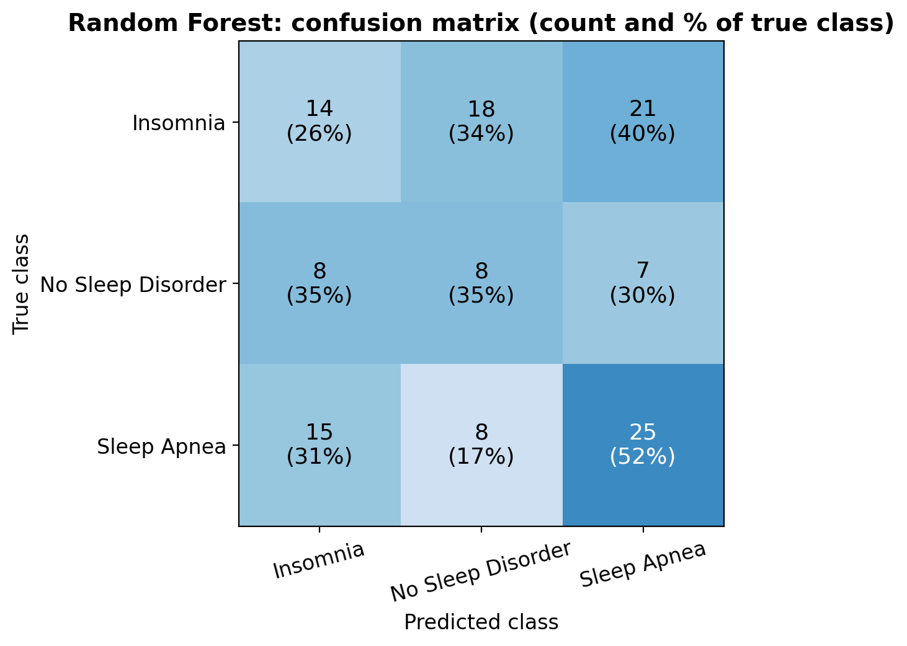
Figure 27. Confusion Matrix: Random Forest
Random Forest (Figure 27) is the weakest model. It finds only 14 of 53 insomnia students (26% recall) and sends 21 of them (40%) to sleep apnea and 18 (34%) to “no disorder”. It performs best for sleep apnea (25 of 48, 52%), but 15 apnea students (31%) are labelled as insomnia. Its recognition of “No Sleep Disorder” is poor: only 8 of 23 (35%) are found, and as many healthy students are labelled insomnia (8) as are labelled healthy. With a shallow forest (depth 5) and a weak signal, the trees split on noise and spread their predictions almost evenly over the three classes.
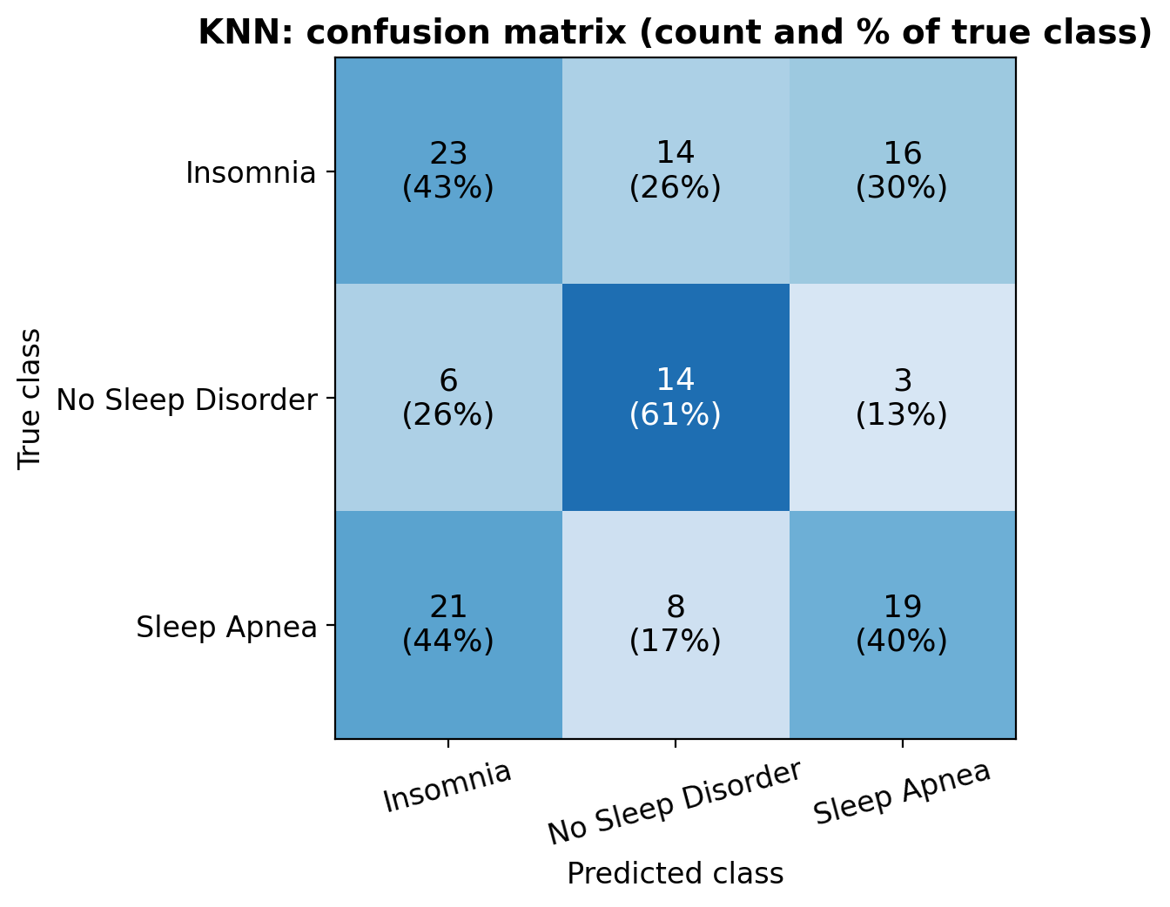
Figure 28. Confusion Matrix: KNN
KNN (Figure 28) has the best balance. It finds 23 of 53 insomnia students (43%) and, notably, 14 of 23 students with no disorder (61%, the best of all models), which means that when KNN says “no disorder” it is more often right than the others. Its weakness is sleep apnea: only 19 of 48 (40%) are found, and 21 apnea students are labelled insomnia. For referral purposes, the error that matters most is a disorder labelled as “no disorder”: KNN makes it for 22 of the 101 students with a disorder (14 insomnia and 8 apnea), Random Forest for 26 (18 and 8) and SVM for 28 (19 and 9), so KNN also misses the fewest real cases.
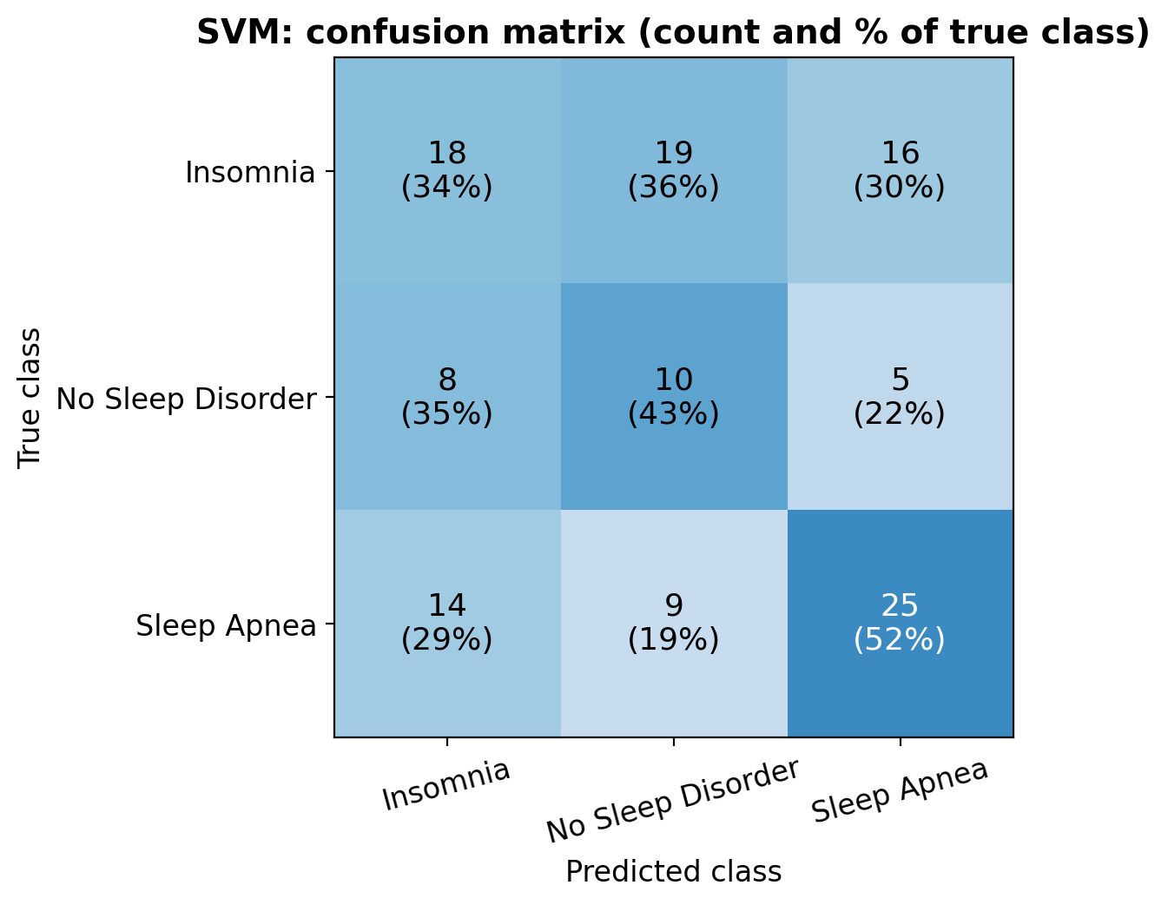
Figure 29. Confusion Matrix: SVM
SVM (Figure 29) sits between the two. It matches Random Forest on sleep apnea (25 of 48, 52%) with the highest precision for that class (0.543), finds 10 of 23 healthy students (43%) and 18 of 53 insomnia students (34%). Across all three matrices the same pattern appears: the dominant confusion is between Insomnia and Sleep Apnea, not between a disorder and no disorder. This is expected from the clinical side, because the two conditions overlap (poor and fragmented sleep, daytime tiredness) and the dataset lacks the symptoms that separate them, such as snoring and observed breathing pauses. Insomnia is the hardest class for every model (recall 26–43%).

D. ROC Curves
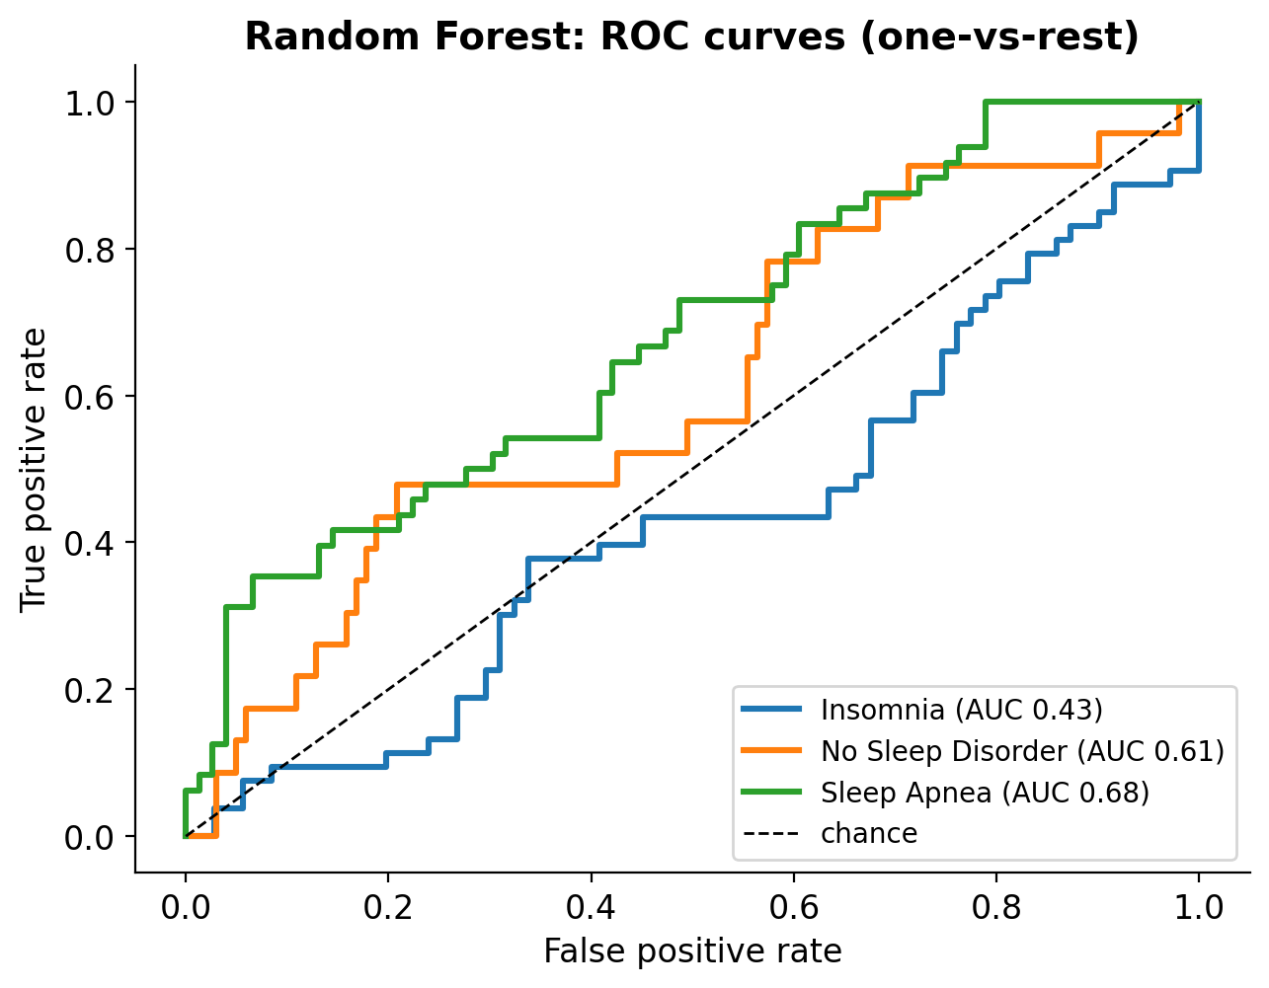
Figure 30. ROC Curves: Random Forest (One-vs-Rest)
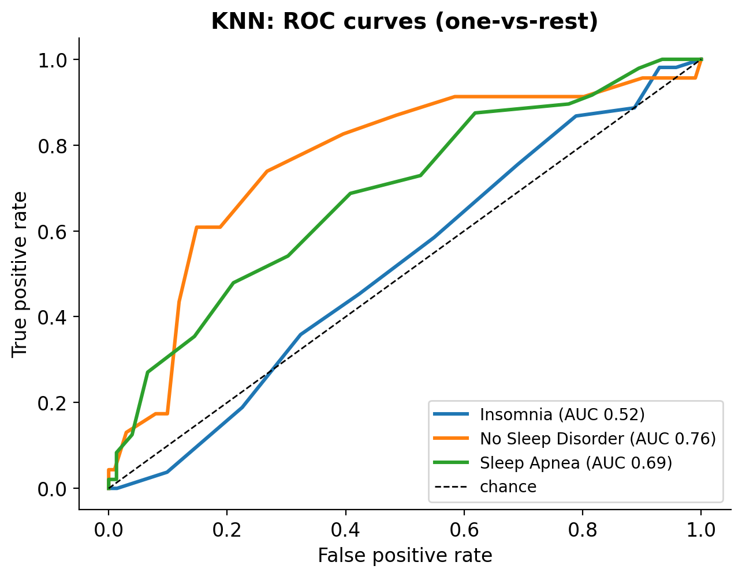
Figure 31. ROC Curves: KNN (One-vs-Rest)
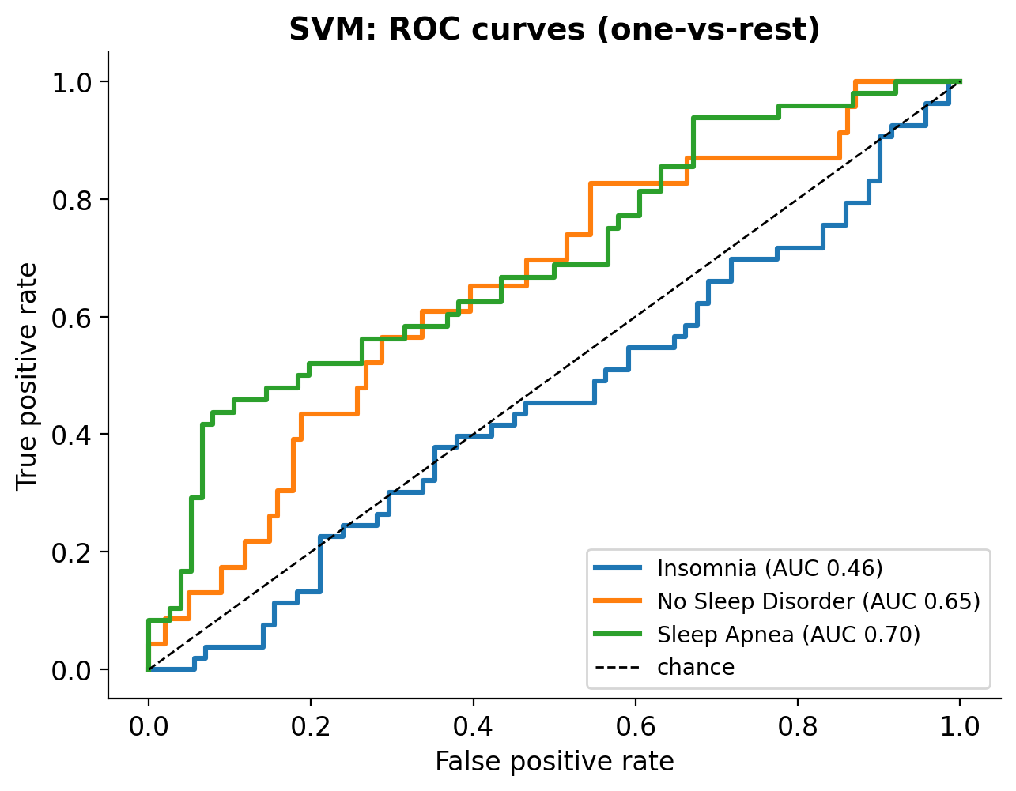
Figure 32. ROC Curves: SVM (One-vs-Rest)
Table 21. One-vs-Rest ROC-AUC per Class (Test Set)
Model | Insomnia | No Sleep Disorder | Sleep Apnea | Macro average
Random Forest | 0.43 | 0.61 | 0.68 | 0.57
KNN | 0.52 | 0.76 | 0.69 | 0.66
SVM | 0.46 | 0.65 | 0.70 | 0.60

A ROC curve plots the share of real cases found (true positive rate) against the share of false alarms (false positive rate) as the decision threshold moves; the dashed diagonal is guessing (AUC 0.5) and the top-left corner is perfect (AUC 1). Figures 30–32 and Table 21 show curves that rise only modestly above the diagonal, in line with the small effect sizes found in the EDA. KNN separates “No Sleep Disorder” best (AUC 0.76) and has the highest macro-AUC (0.66). Sleep Apnea is the class that all models separate reasonably well (AUC 0.68–0.70), and the steep start of the Random Forest and SVM curves shows that a small group of apnea students can be identified with few false alarms, probably those with short sleep (Figure 11). For Insomnia, the AUC of Random Forest (0.43) and SVM (0.46) is at or below chance, meaning these models cannot rank insomnia students above others from the available features; insomnia is defined by symptoms and distress that the lifestyle questions do not capture.

E. Performance Comparison
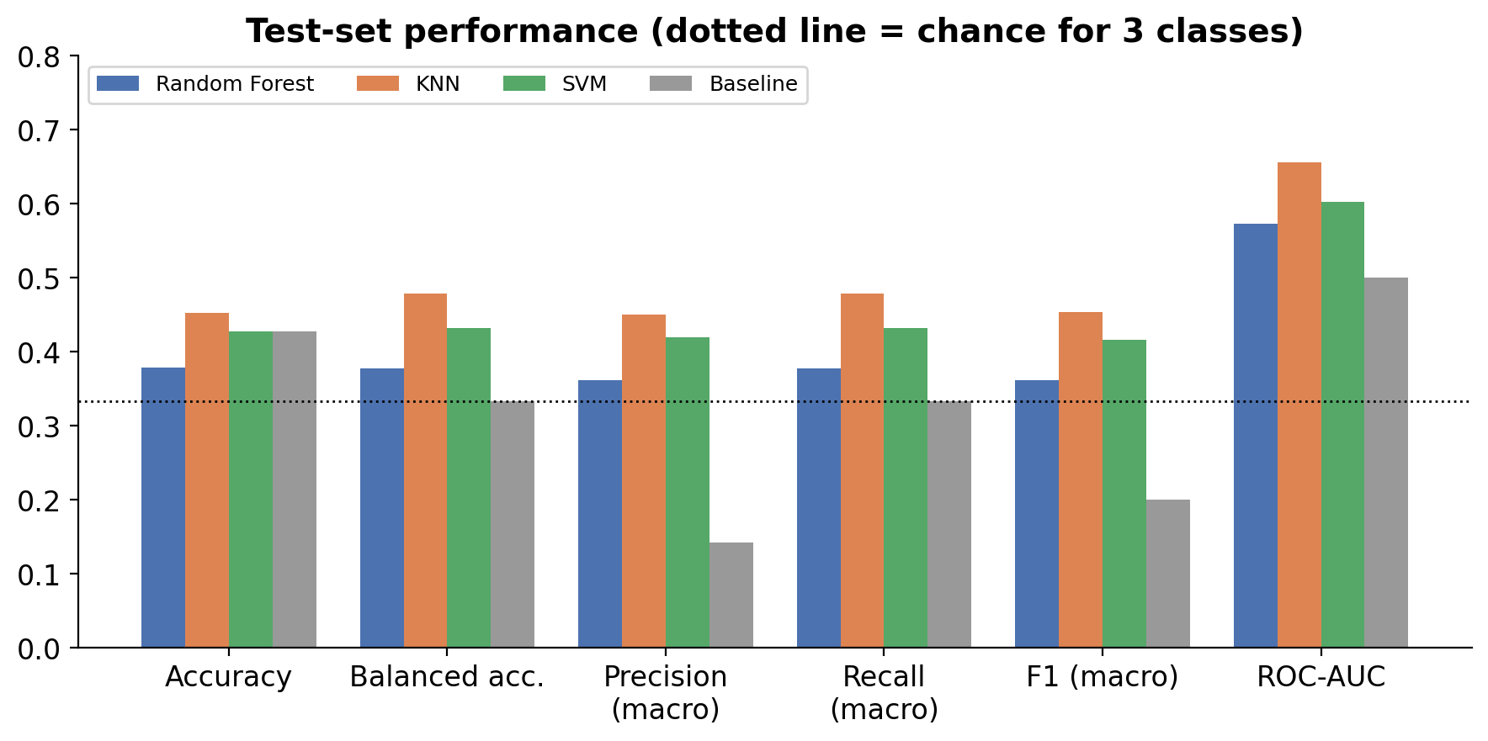
Figure 33. Model Performance Comparison on the Test Set
Figure 33 places all metrics side by side; the dotted line marks chance level for three classes (0.33). Four observations stand out.
1. Accuracy hides most of the story. The baseline already reaches an accuracy of 0.427, SVM only matches it, and Random Forest (0.379) is actually below it. KNN is only 0.025 above. This is why macro-averaged metrics and the baseline are essential in this problem.
2. Balanced accuracy and macro recall are the same number. Macro-averaged recall is by definition the average of the recall of each class, which is also balanced accuracy, so those two bars are identical for every model. Against the 0.333 chance level, KNN gains 0.146, SVM 0.099 and Random Forest 0.045.
3. Precision of the baseline is very low (0.142) because it never predicts two of the three classes, so their precision counts as zero. For the real models, precision (0.36–0.45) is close to recall, which means that they do not trade one for the other.
4. The ranking is consistent: KNN, then SVM, then Random Forest on balanced accuracy, precision, recall, macro-F1, ROC-AUC and MCC (Table 19). Agreement across metrics makes the ordering more credible, but the differences are small compared with the uncertainty (overlapping 95% intervals on a test set of 124 students), so the conclusion is “KNN is a little better”, not “KNN is clearly better”. A ROC-AUC of 0.66 means that if one student from a given class and one from another class are picked at random, KNN ranks them correctly about two times out of three: better than guessing (0.5), but far from the near-perfect separation (0.9 or more) seen with clean data.

F. Is the Signal Real? Permutation Test and Feature Importance
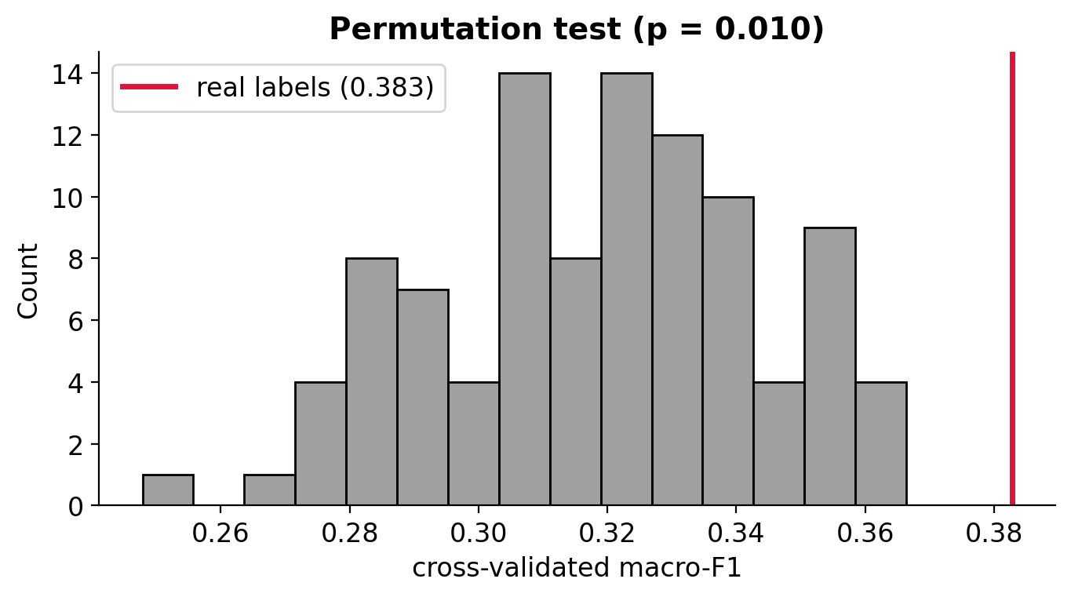
Figure 34. Permutation Test for KNN (Cross-Validated Macro-F1)
With weak signals it is necessary to confirm that the model is better than chance. In a permutation test the labels are shuffled randomly 100 times and the model is re-scored each time. Figure 34 shows the scores obtained with shuffled labels (grey bars, mean 0.318) and the score with the real labels (red line, 0.383). The real score lies outside the entire grey distribution; only about 1% of shuffled runs reached it (permutation p-value = 0.010). The signal is therefore real but modest: the model does learn something about sleep disorder from these answers, but not much. Note that the shuffled-label mean (0.318) is above 0.2 because macro-F1 of a model that guesses among three classes is higher than that of the baseline.
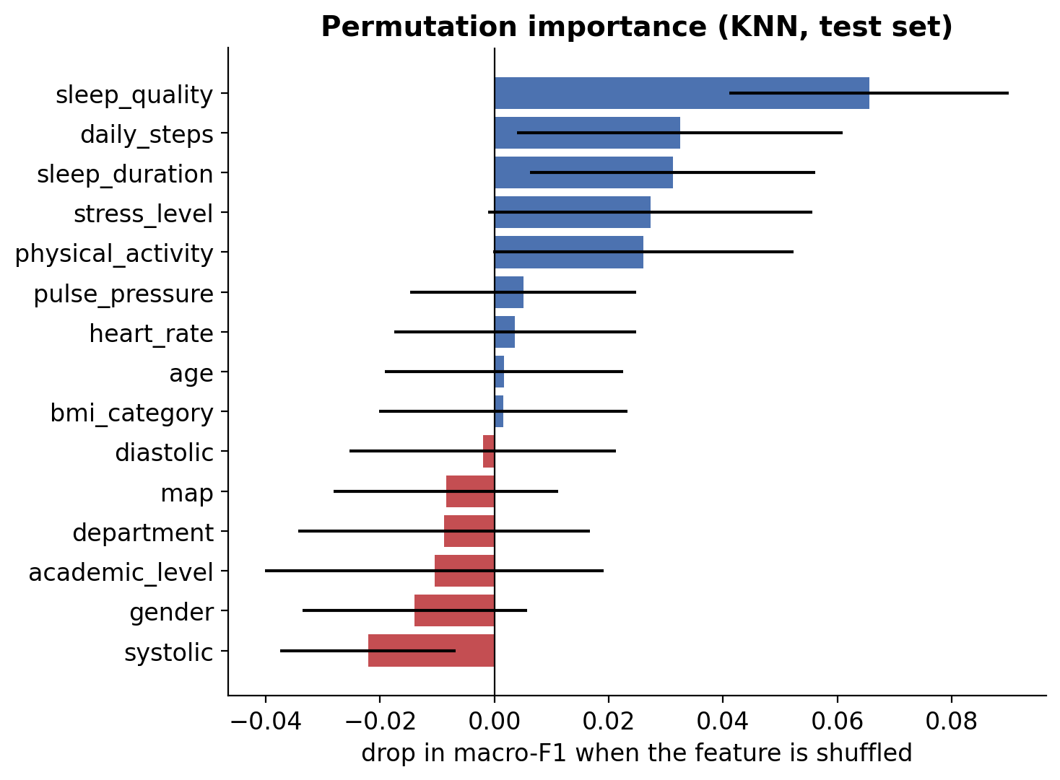
Figure 35. Permutation Importance of the KNN Model (Test Set)
Permutation importance (Figure 35) shuffles one feature at a time in the test set and measures how much the macro-F1 drops; longer bars mean the model relies on the feature more, and bars at or below zero mean it does not help (the whiskers show variation over 30 shuffles). Sleep quality is the most important feature (drop of 0.066), followed by daily steps (0.032), sleep duration (0.031), stress level (0.027) and physical activity (0.026): the model relies on exactly the sleep and lifestyle answers that make clinical sense. In contrast, systolic pressure (−0.022), gender (−0.014), academic level (−0.010), department (−0.009) and MAP (−0.009) have negative values, meaning that the model does slightly better when they are scrambled, so they only add noise. This supports the choice of the clinically grounded feature set and shows that age, which the statistical rankings placed first, is not what KNN uses. Because the test set is small, the error bars are wide and this is read as a ranking hint, not proof.

G. Screening Thresholds: Sensitivity and Specificity
Besides the most likely pattern, the web application gives screening advice: “Higher likelihood”, “Possible” or “Lower likelihood”. This advice answers a simpler yes-or-no question: might the student have any sleep disorder? Two measures describe how good such a yes-or-no decision is.
Sensitivity is the share of students who really have a disorder that the tool flags. High sensitivity means few missed cases.
Specificity is the share of students without a disorder that the tool correctly clears. High specificity means few false alarms.
The model gives every student a probability of having any disorder, P(any) = 1 − P(No Sleep Disorder), computed after the clinical consistency rule of Section III.H. A student is flagged when P(any) is at or above a cut-off called the threshold. The two measures pull in opposite directions: a lower threshold flags more students, so fewer real cases are missed (higher sensitivity) but more healthy students are flagged as well (lower specificity). Two thresholds were chosen on the training data only and checked once on the test set: a balanced threshold of 0.69, which gives the best combination of the two measures, and a high-sensitivity threshold of 0.44, which catches at least 90% of disorder cases in the training data.
Worked example: The test set has 101 students with a disorder and 23 without. With the high-sensitivity threshold, the tool flagged 87 of the 101 students with a disorder (sensitivity 87/101 = 86%) but cleared only 5 of the 23 healthy students (specificity 5/23 = 22%).
How the web application uses the thresholds: P(any) of 0.69 or more is shown as “Higher likelihood”, 0.44 up to 0.69 as “Possible”, and below 0.44 as “Lower likelihood”.
Table 22. Screening Thresholds on the Test Set
Decision rule | Sensitivity | Specificity | Precision | Missed cases | False alarms
Default (reported class) | 0.752 | 0.522 | 0.874 | 25 | 11
Balanced (threshold 0.69) | 0.515 | 0.826 | 0.929 | 49 | 4
High sensitivity (threshold 0.44) | 0.861 | 0.217 | 0.829 | 14 | 18

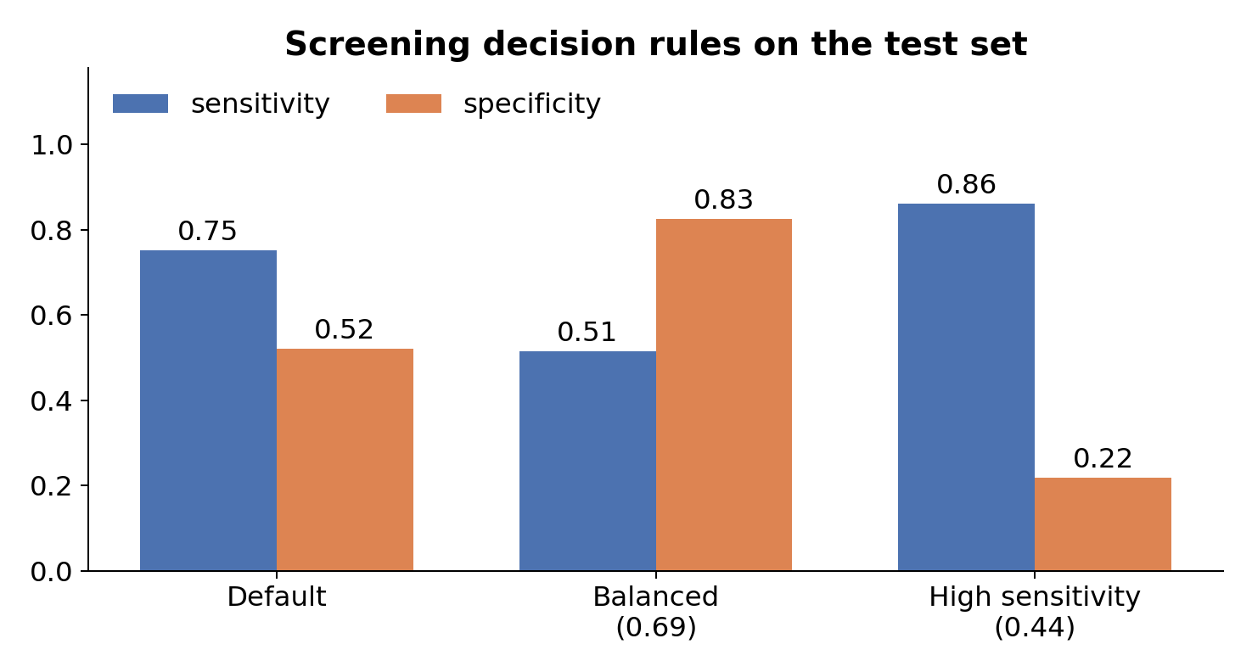
Figure 36. Screening Decision Rules on the Test Set
Table 22 and Figure 36 give the test results for the three decision rules among 101 students with a disorder and 23 without. The default rule (the class reported by the web page) finds 75% of disorder cases (25 missed) and clears 52% of healthy students. The balanced threshold clears most healthy students (83%) but misses 49 of 101 real cases (sensitivity 51%), which is unacceptable if missing a case is the worst error. The high-sensitivity threshold catches 86% of students with a disorder (14 missed) but clears only 22% of those without (18 false alarms), the same trade-off made by STOP-Bang. It was set to reach 90% sensitivity on the training data; reaching 86% on 101 new students is within the variation expected from a small test set. For a screening aid whose message is “consider a professional evaluation”, the high-sensitivity rule is the most defensible, whereas the balanced rule suits situations where evaluation capacity is limited. Both thresholds are stored with the model so the choice remains a policy decision. Because the 82% disorder rate of this sample is not a population rate, precision values do not transfer to other groups.

H. Decision Rules: Ties and a Clinical Consistency Check
The model returns three probabilities, but the user sees one “most likely pattern”. Testing the web application revealed two situations in which simply taking the class with the highest probability gave a misleading answer, so two decision rules were added. Both are implemented once in dreamcatcher_utils.py and used by the notebook (Section 7.4) and by the web service, so the evaluation below is exactly what users receive.
Ties: KNN with k = 25 estimates each probability as the share of the 25 nearest students in a class, so probabilities move in steps of 4% and two classes can share the top value. The standard argmax then silently picks the class that comes first alphabetically: a student with 36% Sleep Apnea and 36% No Sleep Disorder was told “No Sleep Disorder”. Ties are not rare: 5 of the 124 test students had one, and about 5% of random form inputs produced a tie involving “No Sleep Disorder”. Because a missed case is the worse error in screening, a tie is now reported as the disorder; between the two disorders, Insomnia (the more common class in training) is reported first. The web page states the tie explicitly (for example, “Tied with No Sleep Disorder, 36% each”).
Clinical consistency: Insomnia requires dissatisfaction with sleep quantity or quality (Riemann et al., 2023; Section I.A). A student who sleeps 8 hours or more and rates sleep quality as Good or Excellent reports neither, yet the model sometimes predicted Insomnia for such students. The reason is in the data: of the 119 students with these answers, 49 (41.2%) are labelled Insomnia, 42 (35.3%) Sleep Apnea and only 28 (23.5%) No Sleep Disorder, so the nearest neighbors of a good sleeper are often labelled Insomnia. For these students the deployed service sets the probability of Insomnia to zero and rescales the other two classes so that they sum to one, which is the model’s estimate given that the disorder is not insomnia. The original probabilities are still returned by the API (model_probabilities), and the web page explains when the rule was applied.
Table 23. Effect of the Decision Rules on the Test Set
Reported class | Accuracy | Balanced acc. | Macro-F1 | Recall: Insomnia | Recall: No Sleep Disorder | Recall: Sleep Apnea
Highest probability only (first class wins a tie) | 0.476 | 0.477 | 0.466 | 0.453 | 0.478 | 0.500
+ tie rule | 0.484 | 0.484 | 0.474 | 0.453 | 0.478 | 0.521
+ tie rule + clinical rule (deployed) | 0.444 | 0.461 | 0.438 | 0.340 | 0.522 | 0.521

Table 23 shows the effect on the held-out test set (KNN with the clinically grounded features, trained on the training set only). The tie rule slightly improves every summary measure (macro-F1 0.466 → 0.474; Sleep Apnea recall 0.500 → 0.521). The clinical rule lowers macro-F1 to 0.438 and insomnia recall to 0.340, while recall for No Sleep Disorder rises to 0.522. This is a deliberate trade-off: the rule disagrees with the survey labels exactly where those labels contradict the clinical definition of insomnia, which is further evidence that the labels are symptom-based rather than clinically confirmed. The rule was kept because a screening aid that tells a well-rested, satisfied sleeper that they have insomnia would not be credible, and its cost is reported openly. The screening thresholds in Section III.G were chosen on probabilities after this rule.

I. Final Model Selection
The final model was chosen from the cross-validation results: KNN had the highest cross-validated macro-F1 (0.399) and was also the best model on the untouched test set (macro-F1 0.454, balanced accuracy 0.479, MCC 0.165, macro-ROC-AUC 0.66). It is trained with the clinically grounded feature set (academic level and department excluded), which performed at least as well as all features and is easier to justify. The choice carries the caveat that differences between the models lie within statistical uncertainty. In the deployed service the two decision rules of Section III.H are applied on top of the model; with them, test macro-F1 is 0.438 (0.466 for the model alone).

IV. Comparative Analysis and Discussion

A. Comparison of the Three Models
In cross-validation the models are almost tied (macro-F1: KNN 0.399, SVM 0.389, Random Forest 0.384). On the held-out test set KNN is best (macro-F1 0.454), followed by SVM (0.416) and Random Forest (0.362). All three beat the majority baseline (macro-F1 0.200), and the permutation test (p = 0.010) shows the signal is real but modest. In overall accuracy KNN reaches 45.2%, SVM 42.7% and Random Forest 37.9%, against 42.7% for the baseline, which shows how little accuracy reveals in this problem.

B. Why KNN May Perform Better on This Dataset
The selected KNN uses a large neighborhood (k = 25) with Manhattan distance and uniform weights. When the signal is weak and spread across many noisy, self-reported features, averaging over many neighbors reduces variance, whereas trees can fit noise (Random Forest has the lowest test MCC, 0.055). Manhattan distance is also less dominated by a single large difference than Euclidean distance, which helps with ordinal answers. This is a plausible explanation, not a proven one, because the confidence intervals overlap.
Table 24. Strengths and Weaknesses of the Models
Model | Strengths | Weaknesses observed here
Random Forest | Captures interactions and non-linear effects; robust to scaling; gives feature importance | Lowest test score (MCC 0.055); fits noise when the signal is weak; insomnia AUC 0.43
KNN | Simple; large k smooths noise; best balanced accuracy and best recognition of “No Sleep Disorder” (61%) | Sensitive to irrelevant features; coarse probabilities (steps of 4% with k = 25) that can tie; weaker apnea recall (40%)
SVM | Regularized margin; highest precision for Sleep Apnea (0.543) | Needs scaling and tuning of C and gamma; probabilities need extra calibration; low precision for “No Sleep Disorder” (0.263)

C. Implications of the Findings
- Lifestyle answers and basic vital signs in a survey are not enough to separate insomnia from sleep apnea; DreamCatcher should be used only as a screening aid, not as a diagnostic tool.
- A smaller, clinically sensible feature set costs nothing: test macro-F1 was 0.454 with all features and 0.466 without academic level and department, whereas a purely statistical top-2 subset was clearly worse (0.324).
- A recall-first threshold (0.44) catches 86% of disorder cases on the test set, but with many false alarms (specificity 22%); this mirrors the trade-off of established screening tools.
- Two decision rules (ties reported as a disorder; insomnia ruled out for students who sleep 8 hours or more with good or excellent quality) keep the output clinically coherent, at a measurable cost in agreement with the survey labels (test macro-F1 0.474 → 0.438).
- The modest scores (macro-F1 about 0.45 against 0.20 for the baseline) are normal for real, self-reported survey data: labels that follow no clean rule cannot be predicted almost perfectly, and an accuracy near 0.9 on such data would be suspicious.

D. Limitations
- Self-reported, categorized and rounded answers; labels are symptom-based and not clinically confirmed.
- No snoring, observed-apnea, tiredness or neck-size items (core STOP-Bang items); young students with mostly normal BMI and blood pressure leave little variation to learn from.
- One survey in one country (619 students, five universities), no external validation and a small test set (124 students).
- The 82% disorder rate is a property of the sample, not of the population.

E. Potential Improvements
The analysis points to concrete ways to make DreamCatcher more accurate and more useful. They are ordered from the largest expected gain to the smallest.
- Better inputs: add validated questionnaire items such as the Insomnia Severity Index and the STOP-Bang items (snoring, observed breathing pauses, daytime tiredness, neck circumference). These target the main confusion between insomnia and sleep apnea and would replace the single clinical rule with measured symptoms.
- Clinically confirmed labels: train on diagnoses confirmed by a clinician or a sleep study, so that the model learns the disorders rather than self-reported symptom labels.
- Two-stage model: first predict any disorder versus none, then insomnia versus sleep apnea, with features and thresholds tuned for each stage.
- Finer probabilities: distance-weighted KNN or calibrated models (for example CalibratedClassifierCV) give smoother probabilities, fewer ties and more meaningful screening thresholds.
- Other algorithms and explanations: try gradient boosting (XGBoost or LightGBM) and show SHAP explanations so that users see which answers drove their result.
- External validation: test the model on students from another university or country before any real use, and report its performance there.

V. Model Deployment
Deployment turns the trained model into a service that anyone can use. The selected model is saved with joblib, served by a FastAPI application, packaged as a Docker image, tested through the automatically generated Swagger UI and finally used through a web interface. Each step is described below.

A. Selecting, Training and Saving the Model
The best model was selected on cross-validated macro-F1, with preprocessing, SMOTE, feature selection and hyperparameters tuned by GridSearchCV, and evaluated on the held-out test set as described above. For deployment, the selected configuration (KNN with the clinically grounded features) was refit on all 619 labelled students and saved with the joblib library. The model is a single pipeline object that already contains imputation, scaling and one-hot encoding, so the web service cannot apply different preprocessing than training. The label encoder is saved separately. The notebook saves these files directly into the deployment folder dreamcatcher_app/app/models, so the web service always serves the model trained in the notebook.
At the end of the notebook (Section 8) the trained pipeline, the label encoder and a model card are saved with joblib and JSON (Table 25). No separate scaler file is needed: the StandardScaler, the imputers and the one-hot encoder are stored inside the saved pipeline, so the web service cannot apply preprocessing that differs from training.
Table 25. Files of the Deployed Application
File | Location | Purpose
dreamcatcher_model.joblib | app/models | Trained pipeline (preprocessing, SMOTE, SelectKBest, KNN classifier)
label_encoder.pkl | app/models | Converts predicted integers back to Insomnia / No Sleep Disorder / Sleep Apnea
model_card.json | app/models | Model name, metrics, feature set, class names, decision rules, screening thresholds (0.69 and 0.44) and disclaimer
BD-Uni. Sleep Disorder Dataset.xlsx | app/dataset | The dataset; the notebook reads it from here
dreamcatcher_utils.py | project folder and app | Shared cleaning, feature-engineering and decision rules (the same code in training and serving)
server.py | app | FastAPI web service
index.html | app/static | Web page (input form and results)
Dockerfile, requirements.txt | dreamcatcher_app | Container build instructions and the exact package versions used for training

B. Folder Structure and Docker
The deployment folder dreamcatcher_app follows the standard structure required for the project: an app directory that holds the dataset, the serialized model files and server.py, plus a Dockerfile and requirements.txt at the top level. DreamCatcher adds three small items to that structure: static/index.html, the web interface; dreamcatcher_utils.py, which applies the same cleaning and decision rules as the notebook; and __init__.py, an empty file that marks app as a Python package so that server.py can import dreamcatcher_utils.py.
dreamcatcher_app/
├── app/
│ ├── dataset/
│ │ └── BD-Uni. Sleep Disorder Dataset.xlsx
│ ├── models/
│ │ ├── dreamcatcher_model.joblib
│ │ ├── label_encoder.pkl
│ │ └── model_card.json
│ ├── static/
│ │ └── index.html
│ ├── __init__.py
│ ├── dreamcatcher_utils.py
│ └── server.py
├── Dockerfile
└── requirements.txt
The Dockerfile defines the image: a slim Python 3.13 base (the Python version used to train the model), the working directory, installation of the pinned packages, the application files and the start-up command for the Uvicorn server.
FROM python:3.13-slim
WORKDIR /code
COPY ./requirements.txt /code/requirements.txt
RUN pip install --no-cache-dir -r /code/requirements.txt
COPY ./app /code/app
EXPOSE 8000
CMD ["uvicorn", "app.server:app", "--host", "0.0.0.0", "--port", "8000"]
requirements.txt pins the exact package versions of the training environment. Pinning matters because a model saved with one scikit-learn version is not guaranteed to load correctly in another.
fastapi==0.142.2
uvicorn==0.54.0
pydantic==2.10.3
scikit-learn==1.6.1
imbalanced-learn==0.13.0
pandas==2.2.3
numpy==2.1.3
scipy==1.15.3
joblib==1.4.2
The image is built and the container is started from a terminal opened in the dreamcatcher_app folder:
docker build -t dreamcatcher_img .
docker run --name dreamcatcher -p 8000:8000 dreamcatcher_img
A container name can be used only once, so a container left from an earlier run must be removed first with docker rm -f dreamcatcher. After any change to the code or the model the image must be rebuilt; otherwise the old version keeps running.
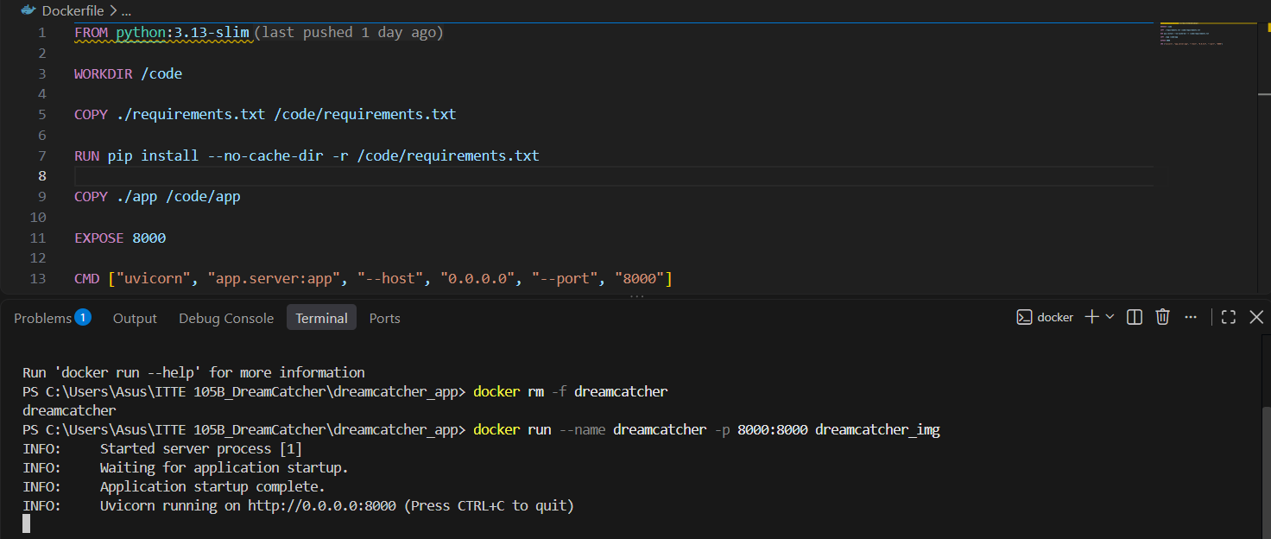
Figure 37. Building and Running the Docker Container in Visual Studio Code
Figure 37 shows the Dockerfile and the terminal output of docker run: Uvicorn reports “Application startup complete” and listens on port 8000. The root endpoint http://localhost:8000 then returns {"message": "DreamCatcher API"}, which confirms that the deployment is active.

C. API Endpoint (FastAPI)
The model is served with FastAPI. The service loads the saved pipeline, validates the input with Pydantic, applies the same cleaning and decision rules as in training, and returns the predicted class, class probabilities and screening flags as JSON. Interactive documentation is generated automatically at /docs (Swagger UI).
The prediction endpoint, simplified from server.py, shows how one request is processed:
@app.post("/predict")
def predict(p: SleepInput): # Pydantic validates the input
X = build_features(pd.DataFrame([p.model_dump()])) # same cleaning as training
raw = model.predict_proba(X) # KNN probabilities
proba, ruled = apply_clinical_rule(raw, X, classes) # Section III.H
i = decide(proba, classes)[0] # ties go to a disorder
return {"predicted_class": classes[i],
"confidence": round(proba[0][i], 2), ...}
Table 26. API Endpoints
Method and path | Description
GET / | Connection test; returns {"message": "DreamCatcher API"}
GET /health | Returns the model name and training date
GET /options | Allowed answers for every form field (used to build the web form)
GET /model-card | Model details, metrics, feature set, decision rules and thresholds
POST /predict | One student’s answers written out (Table 27); returns predicted_class, confidence, screening_advice, tied_with, ranking, probabilities (after the clinical rule), model_probabilities (before it), clinical_rule_applied, any_disorder_probability, the screening flags and a disclaimer
POST /predict-batch | Same as /predict for up to 20 people at once (used by the web page)
POST /predict-features | Numbers only: up to 20 rows of 11 numeric codes (Table 28); returns predicted_class, confidence, screening_advice and any_disorder_probability for each row

The API accepts the answers exactly as a student would give them (for example “8 hours or more”) and encodes them itself with the same rules as the notebook. Table 27 lists the input features of POST /predict.
Table 27. Input Features of POST /predict
Feature | Description | Allowed values | Example
gender | Gender of the student | Male, Female | Female
age | Age in years (the model was trained on ages 18–30) | 16 to 60 | 22
sleep_duration | Usual sleep per night | Less than 4 hours; 4-5 hours; 6-7 hours; 8 hours or more | 8 hours or more
sleep_quality | Self-rated sleep quality | Very Poor, Poor, Average, Good, Excellent | Good
stress_level | Usual stress level | Very Low, Low, Moderate, High, Very High | Low
physical_activity | Minutes of physical activity per day (values above 180 are treated as 180) | 0 to 1440 | 60
bmi_category | BMI category | Underweight, Normal, Overweight, Obese | Normal
blood_pressure | Systolic/diastolic pressure in mmHg | text "sys/dia"; systolic 70–220, diastolic 40–130, systolic higher | 120/80
heart_rate | Resting heart rate in beats per minute | 40 to 200 | 72
daily_steps | Usual number of steps per day | Less than 4,999; 5,000-7,999; 8,000-11,999; 12,000-15,999; More than 16,000 | 8,000-11,999
department, academic_level | Optional; accepted but not used by the deployed model | any / Level-1 to Level-4 | –

For a numbers-only request, POST /predict-features takes each student as one row of 11 numeric codes in the order of Table 28, for example [1, 21, 0, 0, 3, 20, 2, 130, 85, 88, 0]. Up to 20 rows can be sent at once. The service turns the codes back into the answers of Table 27 before predicting, so both endpoints give exactly the same result for the same student.
Table 28. Order and Codes of the 11 Values for POST /predict-features
# | Feature | Code or unit | Example
1 | gender | 0 = Female, 1 = Male | 1
2 | age | years (16 to 60) | 21
3 | sleep_duration | 0 = Less than 4 hours, 1 = 4-5 hours, 2 = 6-7 hours, 3 = 8 hours or more | 0
4 | sleep_quality | 0 = Very Poor, 1 = Poor, 2 = Average, 3 = Good, 4 = Excellent | 0
5 | stress_level | 0 = Very Low, 1 = Low, 2 = Moderate, 3 = High, 4 = Very High | 3
6 | physical_activity | minutes per day (0 to 1440) | 20
7 | bmi_category | 0 = Underweight, 1 = Normal, 2 = Overweight, 3 = Obese | 2
8 | systolic | mmHg (70 to 220) | 130
9 | diastolic | mmHg (40 to 130, lower than systolic) | 85
10 | heart_rate | beats per minute (40 to 200) | 88
11 | daily_steps | 0 = Less than 4,999, 1 = 5,000-7,999, 2 = 8,000-11,999, 3 = 12,000-15,999, 4 = More than 16,000 | 0

Step 1: Open a web browser at http://localhost:8000/docs. The Swagger UI (Figure 38) lists every endpoint of the API.
Step 2: Expand POST /predict and click “Try it out”. A valid example request is already filled in; change any answer if you like (Figure 39 uses a student who sleeps 8 hours or more with good quality) and click “Execute”.
Step 3: Read the server response below the request: code 200 and a JSON body with the prediction. An invalid answer (for example, sleep quality = “Terrible”, or a blood pressure of 80/120) returns code 422 with a message that names the wrong field.
Step 4: To demonstrate the numbers-only format, expand POST /predict-features, click “Try it out” and “Execute”: the pre-filled example sends three students as rows of codes (Figure 40).
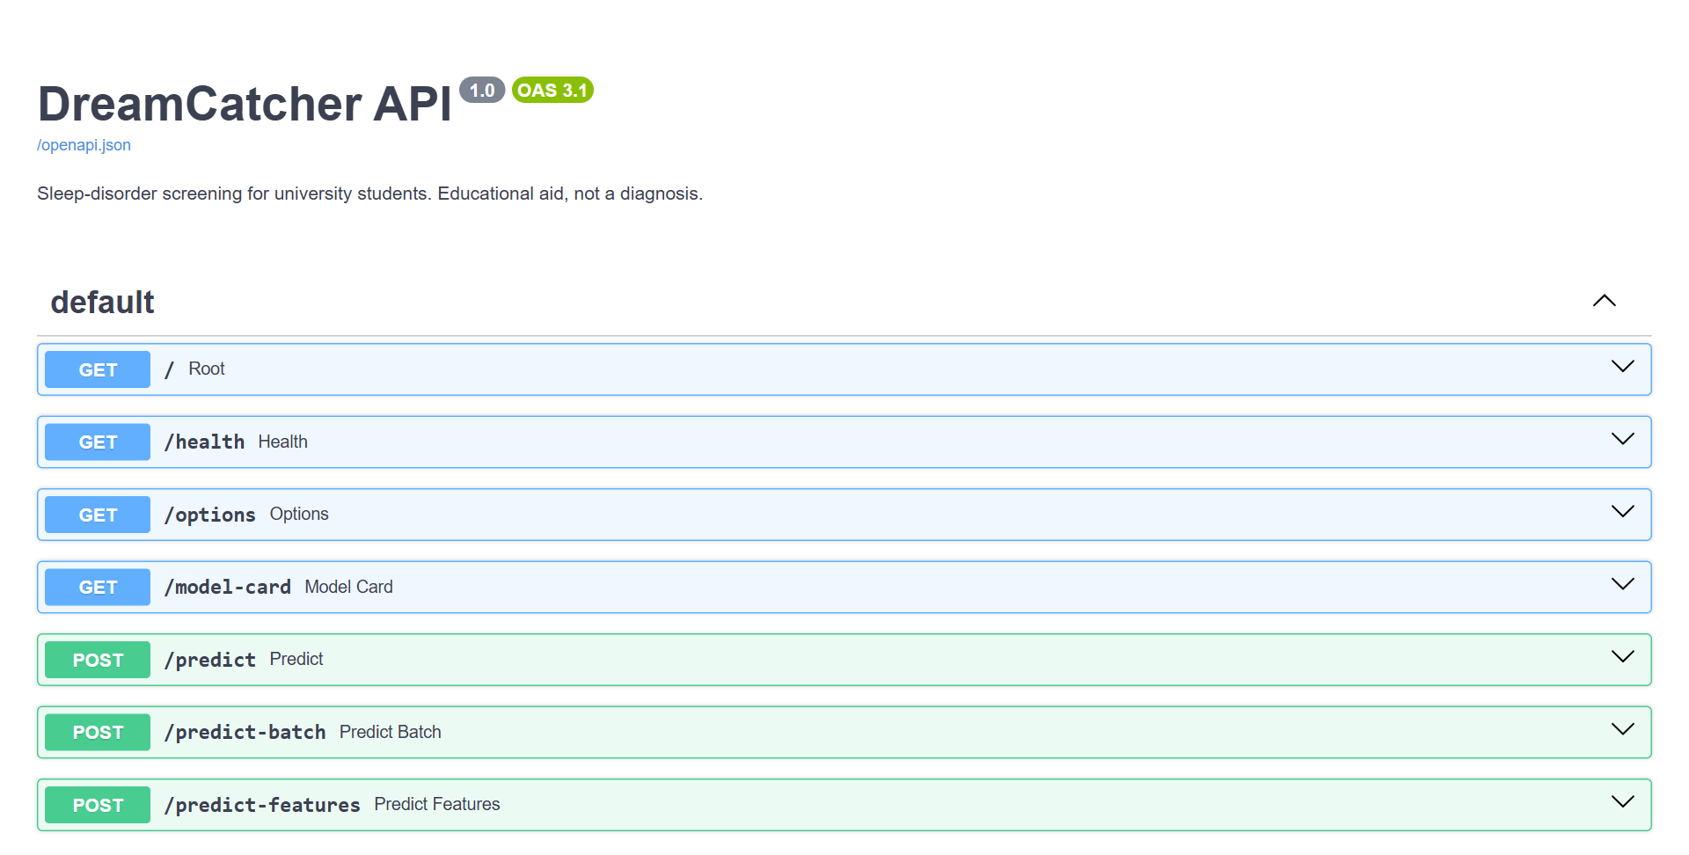
Figure 38. FastAPI Interactive Documentation (Swagger UI)
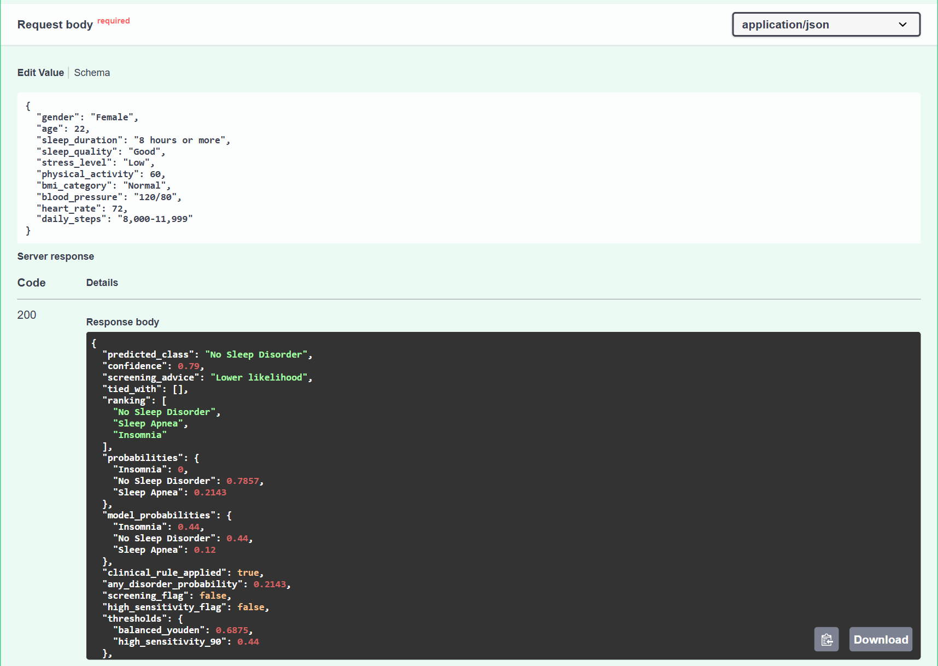
Figure 39. Testing POST /predict in the Swagger UI (Request and Response)
In Figure 39 the student sleeps 8 hours or more with good quality, so clinical_rule_applied is true. model_probabilities shows the model’s raw estimate (Insomnia 0.44, No Sleep Disorder 0.44, Sleep Apnea 0.12), probabilities shows the values after Insomnia is ruled out, and predicted_class is No Sleep Disorder with a confidence of 0.79. The probability of any disorder (0.21) is below both thresholds, so both screening flags are false and screening_advice is “Lower likelihood”.
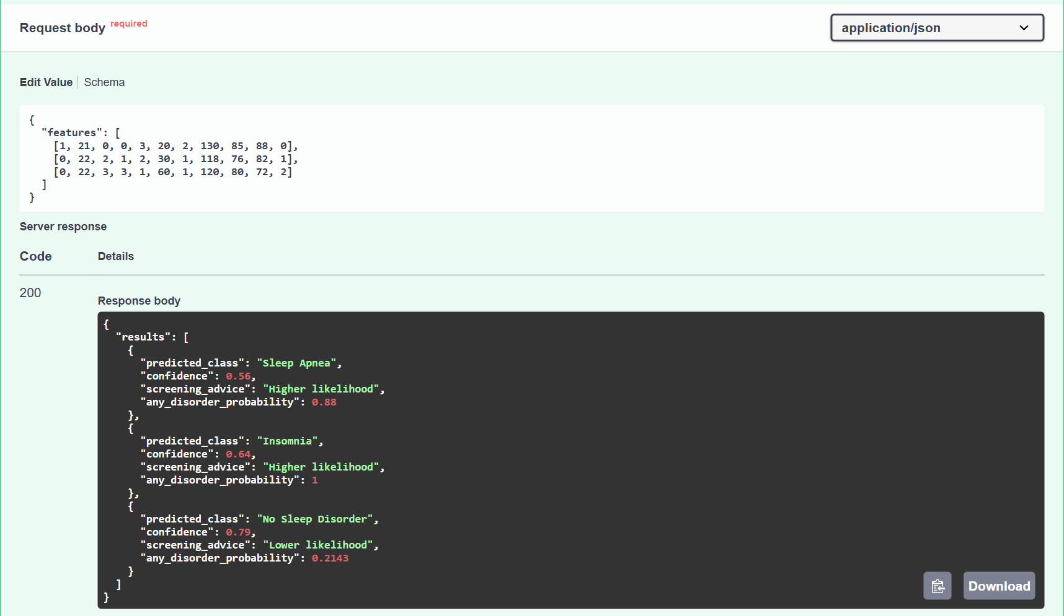
Figure 40. Testing POST /predict-features in the Swagger UI (Numeric Codes)
In Figure 40 the three rows are a student who sleeps less than 4 hours with very poor quality (reported as Sleep Apnea, confidence 0.56), a student who sleeps 6–7 hours with poor quality (Insomnia, 0.64) and the good sleeper of Figure 39 (No Sleep Disorder, 0.79). Each result gives the most likely pattern, its confidence and the screening advice.
The service was tested with FastAPI’s TestClient inside the notebook: a valid request returned a prediction; a student sleeping 8 hours or more with excellent quality received “No Sleep Disorder” with the clinical rule applied; the numeric endpoint returned the same results as the named one; and an invalid answer (for example, sleep quality = “Terrible”) was rejected with HTTP status 422.

D. Web Application Interface
A single-page web interface (http://localhost:8000/web/) lets a user screen one or several people (up to 20) at once. Answers are chosen from dropdown lists that the page loads from the /options endpoint, numbers are checked before sending (for example, systolic pressure must be higher than diastolic), and invalid fields are marked in red next to the field. The page sends the answers to /predict-batch and shows, for every person, the most likely pattern with its confidence, the screening advice based on the probability of any disorder and, on request, the probability of each class. Ties and the clinical rule are explained in plain language.
Step 1: Open http://localhost:8000/web/ while the container is running.
Step 2: Fill in the form for the first person (Figure 41). A name or initials is optional; every other field is required. Dropdowns contain only the allowed answers and number fields accept digits only.
Step 3: Click “+ Add person” to screen several people at once (up to 20), or “Clear” and “Remove” to edit the list.
Step 4: Click “Run screening”. Any answer that needs attention is marked in red next to its field; otherwise the results appear below the form (Figure 42).
Step 5: Read the most likely pattern, its confidence and the screening advice, and click “Details” to see the probability of each class and any note about a tie or the clinical rule.
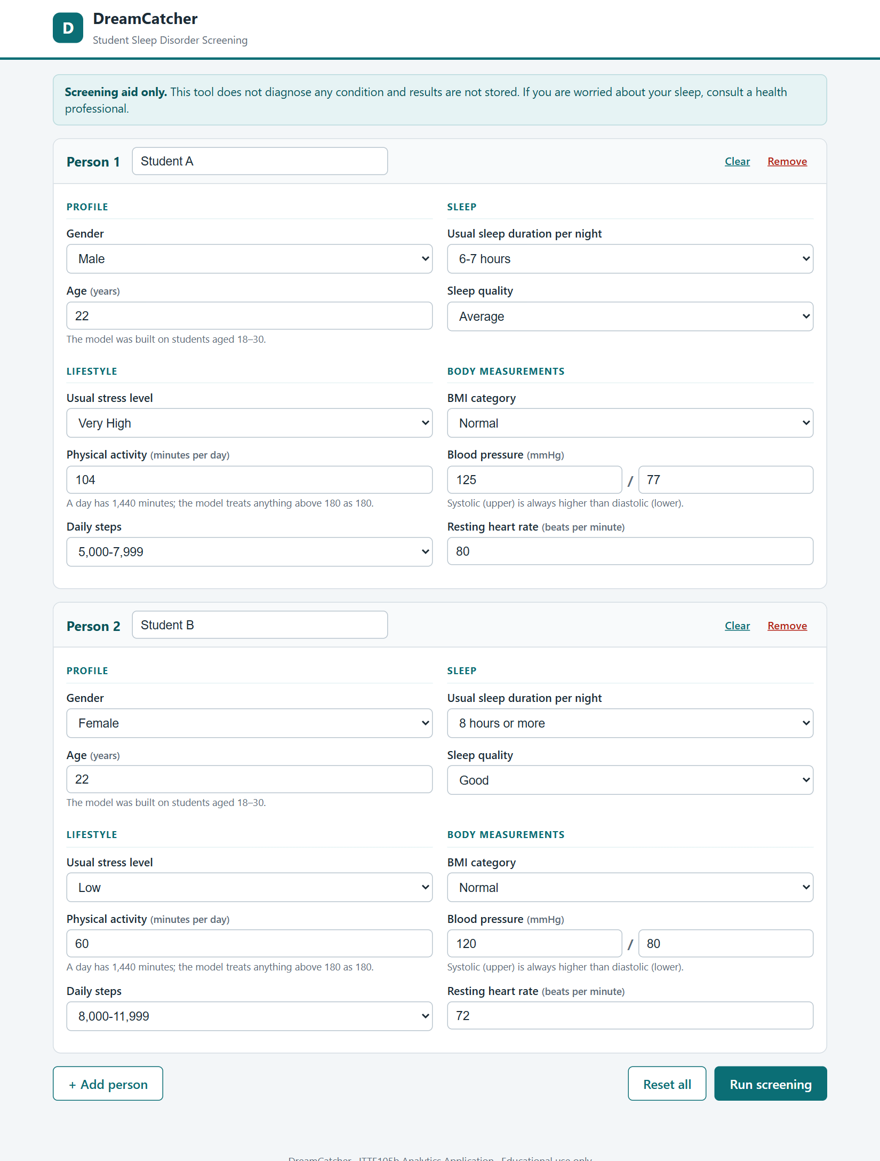
Figure 41. Web Form With Two Students Entered
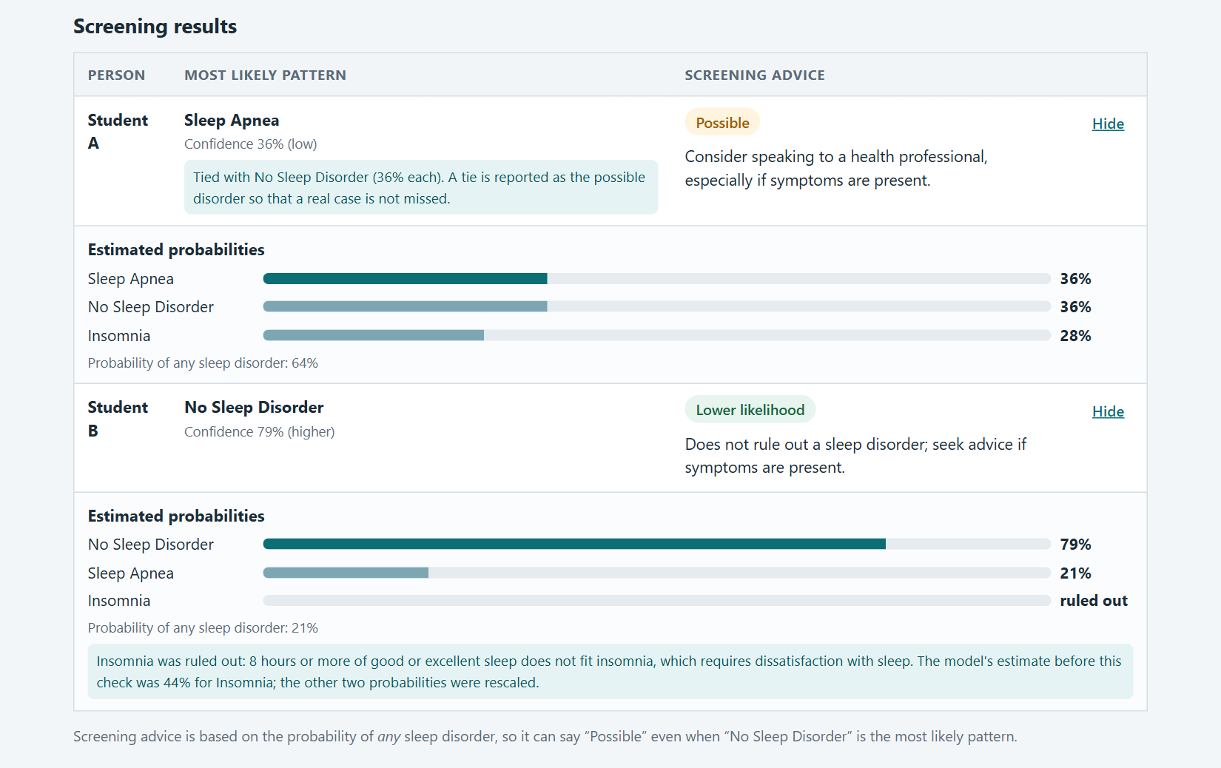
Figure 42. Screening Results Shown to the User
Figure 42 shows both decision rules in action. Student A’s probabilities are tied at 36% for Sleep Apnea and No Sleep Disorder; the page reports Sleep Apnea and says so explicitly. Student B sleeps 8 hours or more with good quality; the model’s raw estimate was 44% Insomnia and 44% No Sleep Disorder, but Insomnia is ruled out, so the page reports No Sleep Disorder (79%) and explains why. Because the screening advice uses the probability of any disorder, Student A receives “Possible” (64%, above the high-sensitivity threshold of 0.44) and Student B “Lower likelihood” (21%).

VI. Conclusion and Recommendations

Conclusion
This study built and compared Random Forest, KNN and SVM classifiers for screening insomnia and sleep apnea in university students using the real-world BD-Uni Sleep Disorder Dataset. A leakage-safe pipeline (imputation, scaling, encoding, optional SMOTE and feature selection), grid search with repeated cross-validation and an untouched test set were used. KNN was selected (cross-validated macro-F1 0.399; test macro-F1 0.454, balanced accuracy 0.479), but the three models are statistically close, and all perform only modestly better than a no-skill baseline (macro-F1 0.200). The permutation test confirmed that the signal is real (p = 0.010).
Feature analysis showed that age and sleep duration were the only individually significant predictors, that most errors occur between Insomnia and Sleep Apnea, and that no small subset of top-ranked features suffices. A clinically grounded feature set without academic level and department performed at least as well as all features and was deployed. Two screening thresholds were provided so that sensitivity can be prioritized, in line with how clinical screening tools work. Two decision rules were added to the deployed service: ties are reported as a disorder, and Insomnia is ruled out for students who sleep 8 hours or more with good or excellent quality, which keeps the output clinically coherent at a reported cost in agreement with the survey labels. The modest scores reflect weak signal in self-reported data lacking core clinical items, not an implementation fault.

Recommendations
- Better data: add validated items (STOP-Bang, Insomnia Severity Index, PSQI), such as snoring, observed apnea, tiredness and neck circumference, and use clinically confirmed labels.
- More and different students: collect more responses and validate the model at another university or in another country.
- Two-stage modelling: first predict disorder versus none, then Insomnia versus Sleep Apnea, because most errors are between the two disorders.
- Calibration and explanation: calibrate the probabilities, explore SHAP explanations and try gradient boosting (for example XGBoost or LightGBM).
- Responsible use: present results as “consider a professional evaluation”, never as a diagnosis.

VII. References
Elreedy, D., Atiya, A. F., & Kamalov, F. (2024). A theoretical distribution analysis of synthetic minority oversampling technique (SMOTE) for imbalanced learning. Machine Learning. https://doi.org/10.1007/s10994-022-06296-4
Global prevalence of insomnia symptoms in undergraduate university students: A systematic review and meta-analysis. (2025). PubMed Central, PMC12687938. https://www.ncbi.nlm.nih.gov/pmc/articles/PMC12687938/
Hwang, M., Nagappa, M., Guluzade, N., Saripella, A., Englesakis, M., & Chung, F. (2022). Validation of the STOP-Bang questionnaire as a preoperative screening tool for obstructive sleep apnea: A systematic review and meta-analysis. BMC Anesthesiology, 22(1), 366. https://doi.org/10.1186/s12871-022-01912-1
A cross-sectional dataset of sleep disorder indicators among Bangladeshi university students. (2026). Mendeley Data. https://doi.org/10.17632/9djgjvtj8d.1
Pivetta, B., et al. (2021). Use and performance of the STOP-Bang questionnaire for obstructive sleep apnea screening across geographic regions: A systematic review and meta-analysis. JAMA Network Open, 4(3). https://pmc.ncbi.nlm.nih.gov/articles/PMC7941199/
Rahardian, F., & Rakasiwi, S. (2026). Interpretable ensemble models for lifestyle-based sleep disorder prediction. Journal of Applied Informatics and Computing (JAIC), 10(1). https://jurnal.polibatam.ac.id/index.php/JAIC/article/view/12125
Riemann, D., Espie, C. A., Altena, E., Lancee, J., et al. (2023). The European Insomnia Guideline: An update on the diagnosis and treatment of insomnia 2023. Journal of Sleep Research, 32(6), e14035. https://doi.org/10.1111/jsr.14035
Sari, H. K., Shoelarta, S., Pratama, T. O., Sajida, G. N., Krista, G. M., Ferawati, Y. F., & Taufiqurrahim, T. (2025). Machine learning-based prediction of sleep disorders from lifestyle and physiological data: A cross-occupational study. Jurnal Teknologi. https://e-jurnal.pnl.ac.id/teknologi/article/view/7507

