StatEase: A Laravel MVC-Based Survey Data Analysis Tool for Students and Researchers

Upload your survey. Get your results chapter.

A Final Project Presented to
Sir Manny R. Hortizuela

In Partial Fulfillment of the Requirements in
System Integration and Architecture
Bachelor of Science in Information Technology – Business Analytics

By:
Sobremonte, Earl Louie S.
Baliton, Floriza Mhae S.
Campos, Leticia Rose R.
Casuga, Jenard I.

October 2026

TABLE OF CONTENTS
B. Introduction 3
C. Objectives 3
D. Application Description 4
E. Features 4
F. Tools and Technologies Used 6
G. MVC Implementation 7
Models (app/Models) 7
Controllers (app/Http/Controllers) 8
Views (resources/views, Blade) 8
Routes (routes/web.php) 9
Supporting classes 10
H. Program Flow 11
I. User Interface and Screenshots 12
J. Testing 20
K. Limitations and Future Improvements 21
Appendix: Installation and Setup 22

B. Introduction
StatEase turns raw survey responses into the tables, charts and written interpretations that a thesis or research paper needs, in minutes instead of hours.
Surveys with Likert-scale questionnaires are the most common instrument in student research and capstone projects. After collecting responses, usually through Google Forms, students must compute the weighted mean of every item, interpret it against a scale, rank the items, count the profile of the respondents, test the reliability of the questionnaire, and run tests such as chi-square or ANOVA.
This work is usually done by hand or in spreadsheets. It is slow, easy to get wrong, and hard to check. Interpretation ranges are often mistyped, blank answers are counted by mistake, and statistical tests need software such as SPSS that students rarely have. Writing the interpretation paragraph for every table takes even more time.
StatEase addresses this need. It is a web-based utility application built with Laravel and the Model-View-Controller (MVC) architecture. It reads the response file, computes every result with verified formulas, and writes the interpretation of each table in thesis style.

C. Objectives
General objective: to develop a web-based utility application, using Laravel and the MVC architecture, that automates the statistical analysis and interpretation of Likert-scale survey data for students and researchers.
Specific objectives:
- Import survey responses from CSV and Excel (.xlsx) files, and automatically identify Likert items, profile questions and columns to ignore.
- Compute the weighted mean, verbal interpretation and rank of each item, the overall weighted mean, and the frequency and percentage of each respondent group.
- Support any Likert scale from 2 to 10 points, with custom answer labels and interpretations, and accept answers given as numbers or as label text.
- Measure the reliability of a questionnaire with Cronbach’s alpha and item analysis.
- Recommend and run hypothesis tests: chi-square test of independence, Pearson’s r and one-way ANOVA, with p-values and decisions.
- Write a thesis-style interpretation for every table and test, and export the results as a Word report or a printed document.
- Validate every input and explain every error in plain language, so that the computed results can be trusted.
- Protect the privacy of research data with user accounts, so that each user can see only the surveys they uploaded.

D. Application Description
Purpose. StatEase is a utility application that analyzes questionnaire data. It replaces manual computation in spreadsheets with one workflow: upload the responses, confirm the columns, and read the results with their interpretations.
Intended users.
- Undergraduate and graduate students writing a thesis, capstone or research paper
- Faculty and researchers who run evaluation or satisfaction surveys
- Offices that conduct service or system evaluations, such as ISO 25010 software evaluations
How it works.
- Log in. The user creates an account or logs in. Every survey belongs to the user who uploaded it.
- Upload. The user uploads a CSV or Excel file, such as a Google Forms export, and chooses the Likert scale used. StatEase reads every row as one respondent.
- Confirm column types. StatEase guesses whether each column is a Likert item, a profile question (such as sex or year level), or a column to ignore (timestamps, names, comments). The user corrects any guess. StatEase checks that every Likert answer fits the chosen scale.
- View results. StatEase computes the profile tables, the weighted mean table, charts and the response distribution, each with a written interpretation.
- Go further. The user tests reliability with Cronbach’s alpha, runs statistical tests through a guided advisor, computes a sample size with Slovin’s formula, and downloads a Word report or prints the results.

E. Features
StatEase has eleven major features. All computations are written in the application’s own PHP code, without a statistics library.
Feature | What it does | How it works
1. User accounts | Register, log in and log out; each user sees only their own surveys | Passwords are stored as hashes; a policy checks that the survey belongs to the logged-in user
2. CSV and Excel import | Reads .csv and .xlsx files up to 5 MB and 5,000 respondents | Each row is one respondent; Excel files are read directly from their XML parts
3. Automatic column detection | Guesses the type of each column so the user only corrects mistakes | Answers that all fit the scale = Likert item; few different answers = profile question; names, timestamps and comments are ignored
4. Custom Likert scales | 2 to 10 points, custom labels and interpretations; six built-in scales | Answers can be the number or the label; a scale in use cannot be deleted
5. Weighted mean and interpretation | Weighted mean, verbal interpretation and rank of every item | Weighted mean = Σ(f × w) ÷ N; blank answers are left out
6. Profile of the respondents | Frequency and percentage of each group | Percentage = f ÷ N × 100
7. Charts | Weighted mean, response distribution and profile charts | Red for disagree, gray for neutral, blue for agree
8. Written interpretation | A thesis-style paragraph under every table and test | Sentence templates filled with the computed numbers
9. Reliability | Cronbach’s alpha and item analysis | Shows which items lower the reliability
10. Statistical test advisor | Recommends and runs chi-square, Pearson’s r or one-way ANOVA | Gives the p-value, the decision and the effect size
11. Sample size, report and printing | Slovin’s formula, a Word report and an A4 print layout | n = N ÷ (1 + N e²), rounded up

F. Tools and Technologies Used
StatEase runs on a standard XAMPP setup with Laravel 12; no paid software or external statistics package is used.
Tool / technology | Version | Used for
Laravel | 12.69.3 | PHP framework: routing, MVC structure, Eloquent ORM, validation, migrations, Blade
PHP | 8.2.12 | Server-side language; all computations are written in PHP
MariaDB (MySQL), via XAMPP | 10.4.32 | Database statease_db
Composer | 2.10.3 | Installs Laravel and its packages
Blade | Laravel | Templates for every page and for the Word report
HTML5, CSS3 | – | Page structure; a custom stylesheet with design tokens and an A4 print layout
JavaScript | – | Charts, the confirmation dialog, copy buttons, live counters and the section menu
Bootstrap | 5.3.3 | Responsive layout, forms, tables, modal dialog, scroll spy
Bootstrap Icons | 1.11.3 | Icons
Chart.js | 4.4.1 | Bar charts, stacked distribution charts and scatter plots
PHP ZipArchive and SimpleXML | Built in | Reading Excel .xlsx files without an extra library
PHPUnit | 11.5.57 | 48 automated tests
Code editor, terminal, phpMyAdmin | – | Writing code, running commands and managing the database

G. MVC Implementation
StatEase follows Laravel’s MVC structure: 6 Models hold the data, 9 Controllers handle the 26 routes, and Blade Views display the pages. All computation lives in separate Service classes, and all input checks live in Form Request classes, so the controllers stay short.

Models (app/Models)
Model | Table | Holds | Relationships
User | users | Name, email and hashed password of an account | has many Survey and LikertScale
Survey | surveys | Owner, title, description, scale, file name, respondent count, whether columns are confirmed | belongs to User and LikertScale; has many SurveyColumn and Respondent
SurveyColumn | survey_columns | One CSV/Excel column: position, header text, type (likert, profile, ignore) | belongs to Survey
Respondent | respondents | One row of the file: row number and all answers as JSON | belongs to Survey
LikertScale | likert_scales | Owner (empty for built-in scales), name, description, number of points (2 to 10) | belongs to User; has many LikertScaleLevel and Survey
LikertScaleLevel | likert_scale_levels | Value, answer label and optional interpretation of one point | belongs to LikertScale

Answers are stored as JSON because every survey has a different number of questions. Deleting a survey deletes its columns and respondents through the database (cascade on delete); a scale in use cannot be deleted (restrict on delete).

Controllers (app/Http/Controllers)
Controller | Methods | Purpose
AuthController | showLogin, login, showRegister, register, logout | User accounts
SurveyController | index, create, store, show, destroy | List, upload, view and delete the user’s surveys
ColumnMappingController | edit, update | Confirm the type of each column and the scale
ResultsController | show | Weighted mean, profile tables, charts and interpretations
ReliabilityController | show | Cronbach’s alpha and item analysis
StatisticalTestController | index, run | Test advisor; chi-square, Pearson’s r and ANOVA
ReportController | word | Download the results as a Word (.doc) report
LikertScaleController | index, create, store, edit, update, destroy | Manage Likert scales
SlovinController | index, calculate | Sample size calculator

Views (resources/views, Blade)
- layouts/app – the shared page: navigation bar with the account menu, messages, confirmation dialog, footer and print header
- auth/ – login and register
- surveys/ – index, create, columns, show, results, reliability
- tests/ – index (advisor) and result; scales/ – index and form; slovin/ – index; reports/ – word
- errors/ – friendly 403, 404, 419, 429 and 500 pages
- partials/ – reusable pieces: survey tabs, step indicator, scale dropdown, interpretation box, colored level chip

Routes (routes/web.php)
Each row lists the routes of one controller as method, URL and controller method. Survey routes use the {survey} parameter, which Laravel turns into the Survey model (route model binding).
Controller | Routes (method, URL → controller method)
AuthController | GET /login → showLogin  POST /login → login  GET /register → showRegister  POST /register → register  POST /logout → logout
SurveyController | GET /surveys → index  GET /surveys/create → create  POST /surveys → store  GET /surveys/{survey} → show  DELETE /surveys/{survey} → destroy
ColumnMapping­Controller | GET /surveys/{survey}/columns → edit  PUT /surveys/{survey}/columns → update
ResultsController | GET /surveys/{survey}/results → show
Reliability­Controller | GET /surveys/{survey}/reliability → show
StatisticalTest­Controller | GET /surveys/{survey}/tests → index  GET /surveys/{survey}/tests/run → run
ReportController | GET /surveys/{survey}/report.doc → word
LikertScale­Controller | GET /scales → index  GET /scales/create → create  POST /scales → store  GET /scales/{scale}/edit → edit  PUT /scales/{scale} → update  DELETE /scales/{scale} → destroy
SlovinController | GET /slovin → index  POST /slovin → calculate

Middleware protects the routes in four checks. guest keeps logged-in users away from the login and register pages, and auth sends visitors who are not logged in to the login page. On every survey and scale route, can:view,survey (or update, delete) asks the policy whether the survey belongs to the user; if not, the answer is 403 Forbidden. Finally, EnsureSurveyIsMapped sends the user back to the column types page until the columns are confirmed.

Supporting classes
Layer | Classes | Role
Services (app/Services) | SurveyImportService, XlsxReader, StatisticsService, ReliabilityService, InferentialService, NarrativeService, ResponseMatrix | File import, all computations and the written interpretations
Policies (app/Policies) | SurveyPolicy, LikertScalePolicy | Who may view, change or delete a survey or scale
Support (app/Support) | Distributions, DivergingPalette | P-values (chi-square, F, t) and the chart colors
Form Requests (app/Http/Requests) | LoginRequest, RegisterRequest, StoreSurveyRequest, UpdateColumnMappingRequest, LikertScaleRequest, RunTestRequest, SlovinRequest | Validation rules and error messages
Middleware (app/Http/Middleware) | EnsureSurveyIsMapped | Blocks analysis pages until columns are confirmed
Exception (app/Exceptions) | SurveyImportException | A readable message when a file cannot be read
Database (database/) | 10 migrations (7 for StatEase, 3 from Laravel), LikertScaleSeeder, statease_db.sql | Tables, the six built-in scales, and an export with sample data

H. Program Flow
A survey reaches the results page only after two checks pass: the uploaded file must be readable and valid, and every Likert answer must fit the chosen scale.
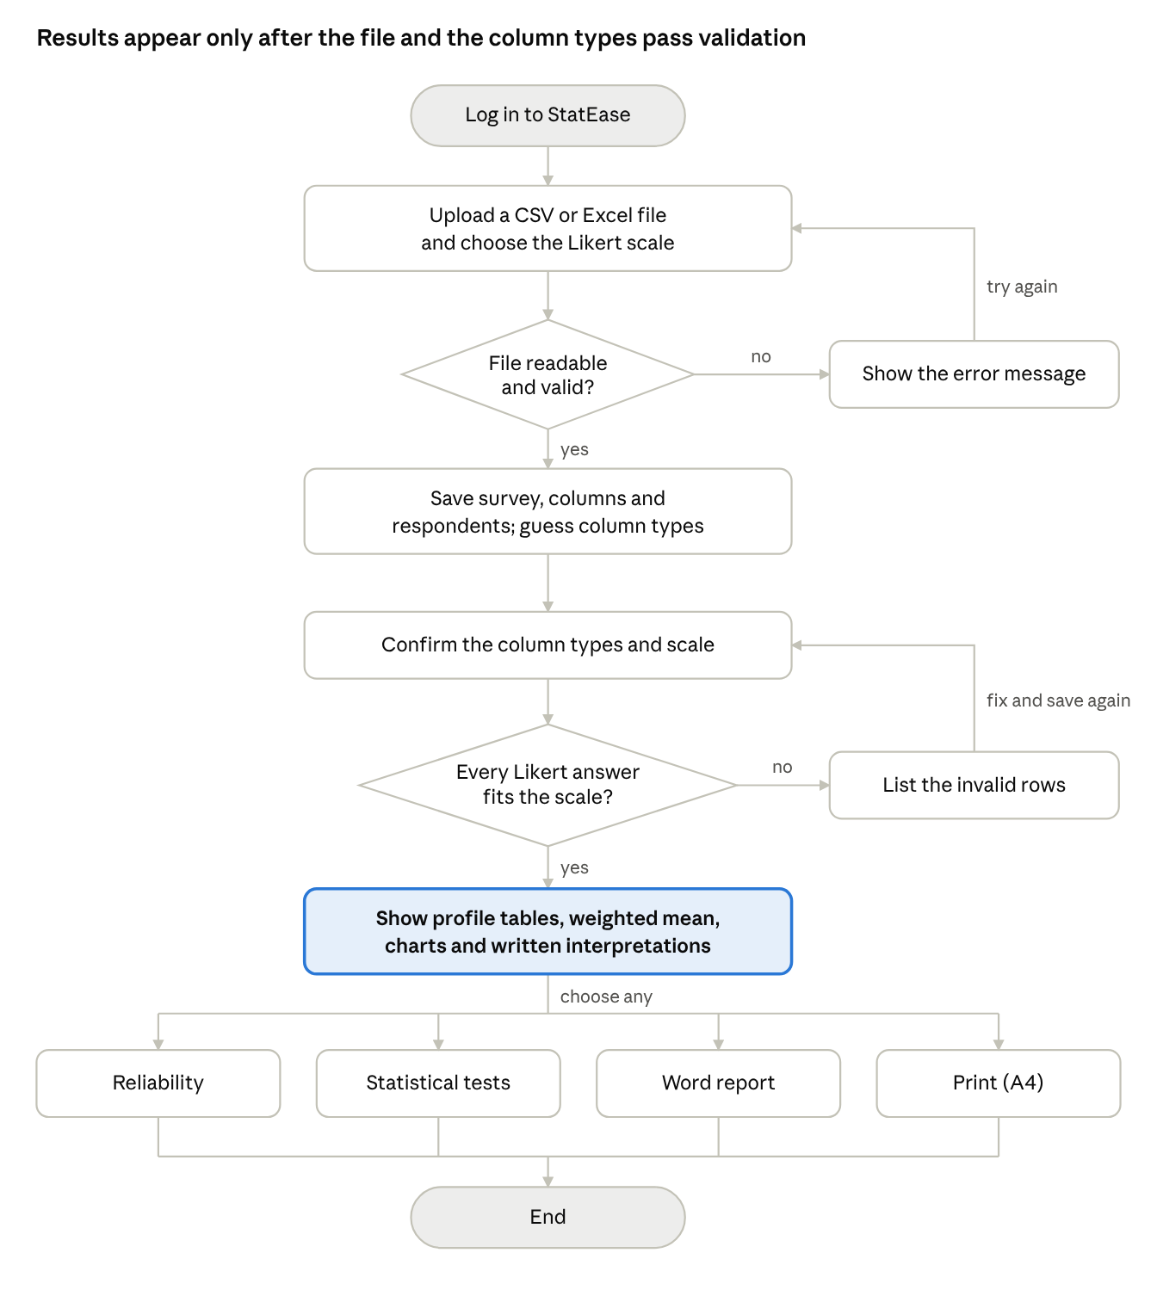
Figure 1. Program flow. Each failed check returns the user to the step before it with a message that says what to fix; from the results page the user can open any of the four analysis options.
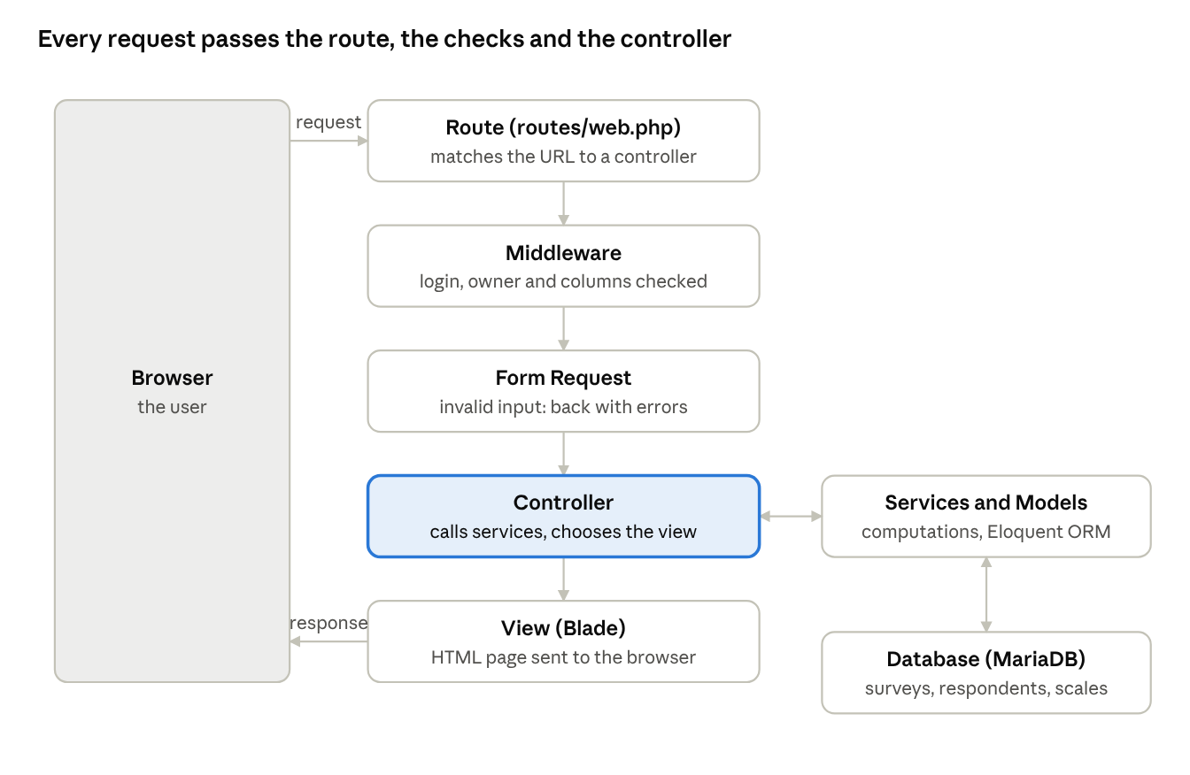
Figure 2. Laravel MVC request flow. Every request follows the same path: the route picks a controller, middleware and the Form Request check the request, and the controller uses services and models to build the view that is sent back.

I. User Interface and Screenshots
The interface follows the workflow from upload to analysis; a sticky navigation bar and a sticky tab bar keep every page one click away. The screenshots use the 420-respondent sample survey.
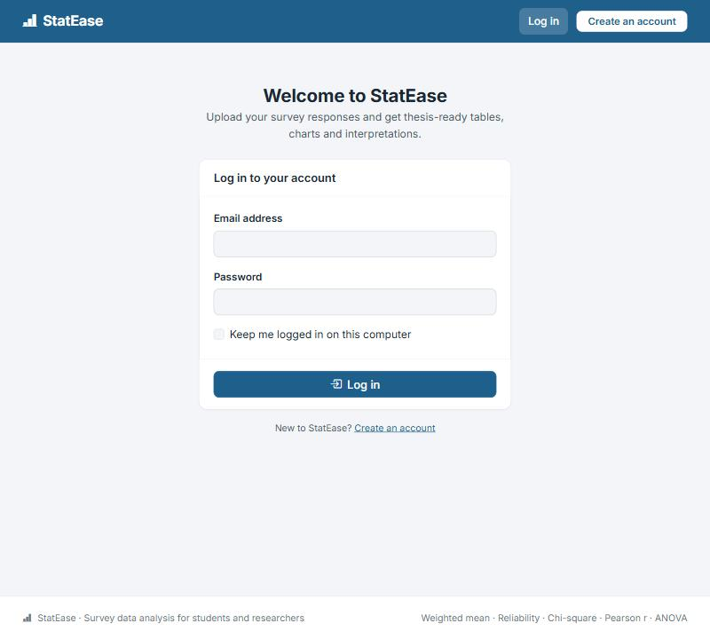
Figure 3. Log in. Every user logs in first; new users create an account. Each user sees only the surveys they uploaded, which keeps research data private.
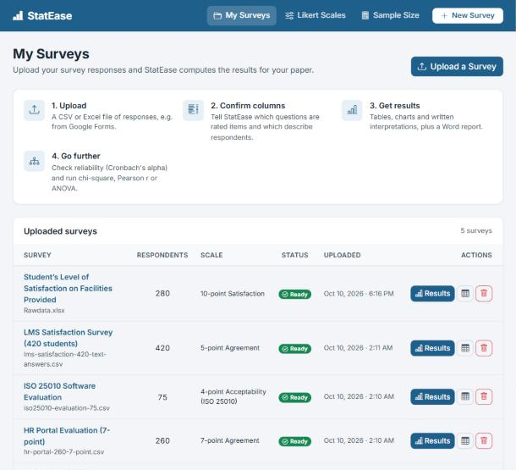
Figure 4. My Surveys (home page). Explains the four steps of StatEase and lists every uploaded survey with its number of respondents, scale and status. Each row opens the results, the raw data, or a delete confirmation.
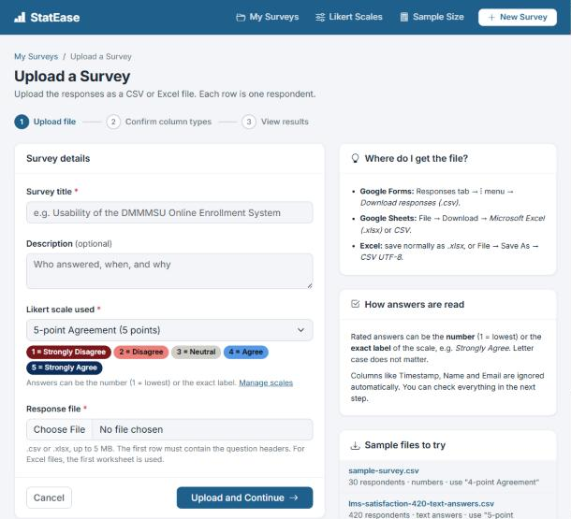
Figure 5. Upload a Survey. Step 1 of 3. The user enters a title, picks a Likert scale (its levels are previewed in color) and chooses a CSV or Excel file. The right side explains where to get the file and offers sample files.
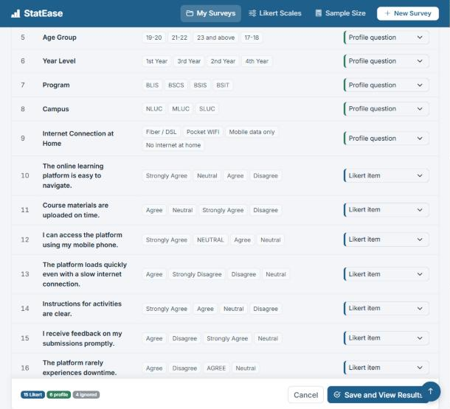
Figure 6. Confirm the column types. Step 2 of 3. Each column shows sample answers and StatEase’s guess, color-coded by type. The save bar stays at the bottom with a live count of Likert items, profile questions and ignored columns.
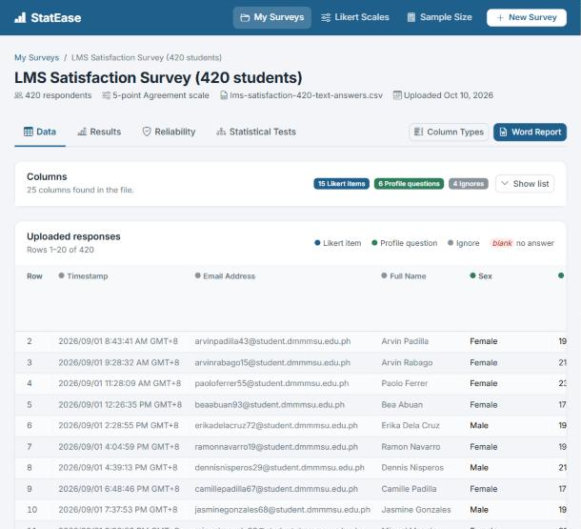
Figure 7. Survey data. All uploaded responses, 20 rows per page, with the type of each column marked by a colored dot and blank answers highlighted.
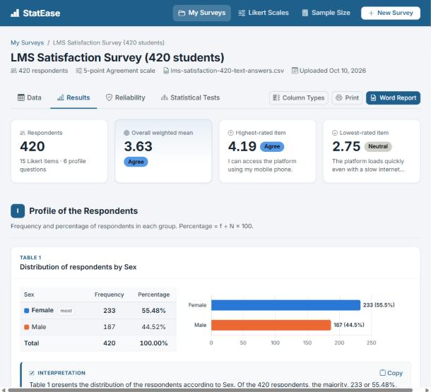
Figure 8. Results: summary and profile of the respondents. Summary cards show the respondents, the overall weighted mean, and the highest- and lowest-rated items. Each profile question gets a numbered table, a chart and an auto-written interpretation.
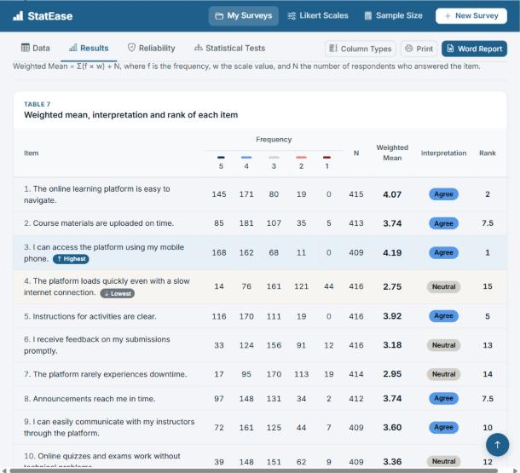
Figure 9. Weighted mean per item. The frequency of each scale value, N, weighted mean, color-coded interpretation and rank of every item. The highest and lowest items are highlighted.
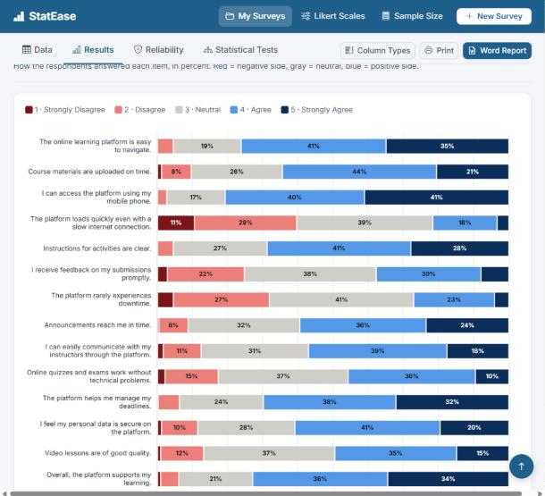
Figure 10. Response distribution. The percentage of each answer per item, from red (disagree) through gray (neutral) to blue (agree).
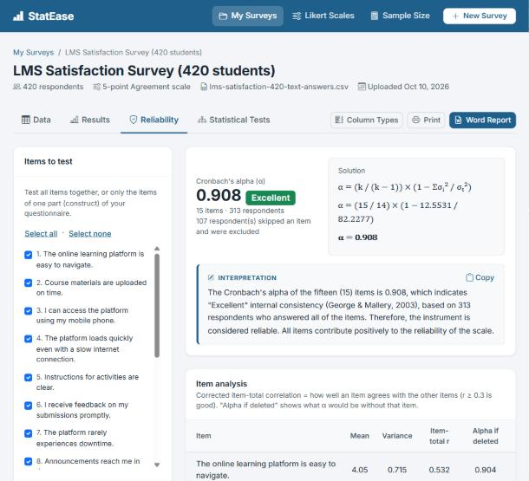
Figure 11. Reliability. Cronbach’s alpha of the selected items with its rating, the formula worked out with the actual numbers, an interpretation, and the item analysis.
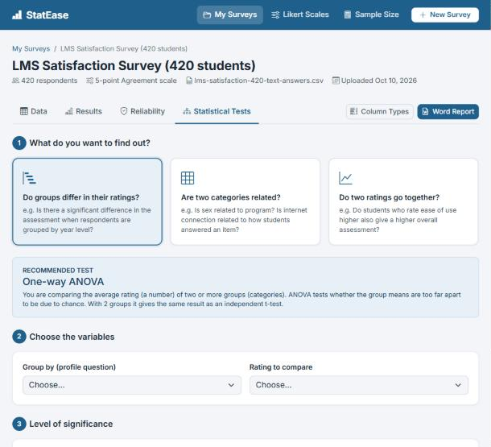
Figure 12. Statistical test advisor. The user chooses what to find out; StatEase recommends the test and explains why, then asks for the variables and the level of significance.
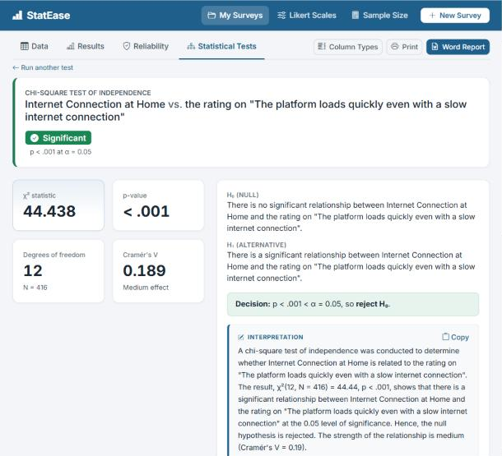
Figure 13. Test result. The decision (significant or not), the test statistic, p-value, degrees of freedom and effect size, the hypotheses, the decision rule and the written conclusion.
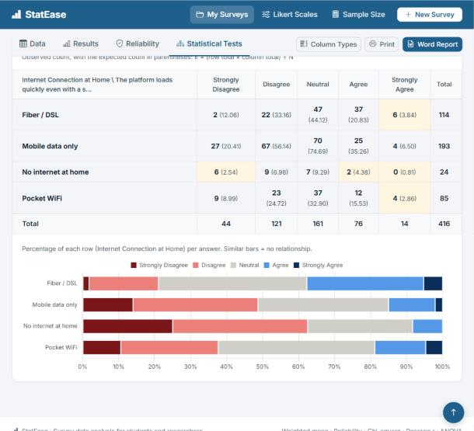
Figure 14. Chi-square details. Observed counts with expected counts in parentheses; cells with an expected count below 5 are highlighted and explained in a warning.
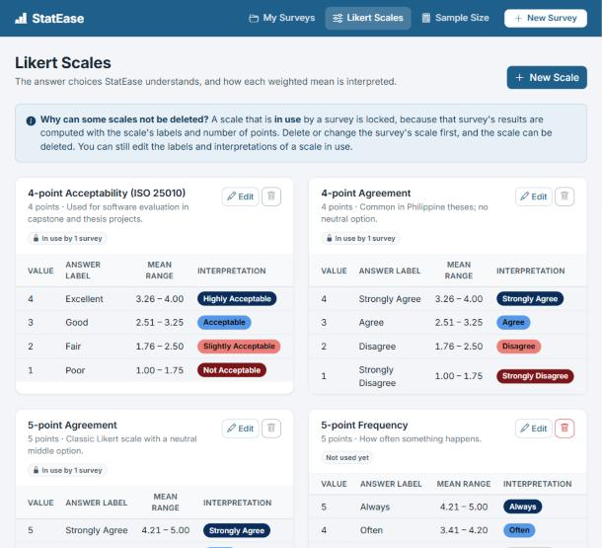
Figure 15. Likert Scales (settings). Every scale with its labels, computed mean ranges and interpretations. Built-in scales are read-only, and a scale in use by a survey cannot be deleted.
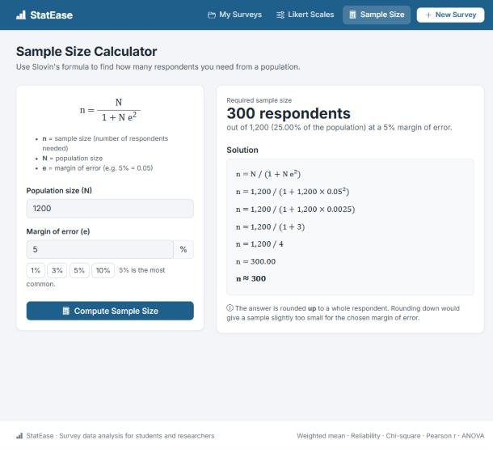
Figure 16. Sample Size Calculator. Slovin’s formula with the required sample size and the step-by-step solution.
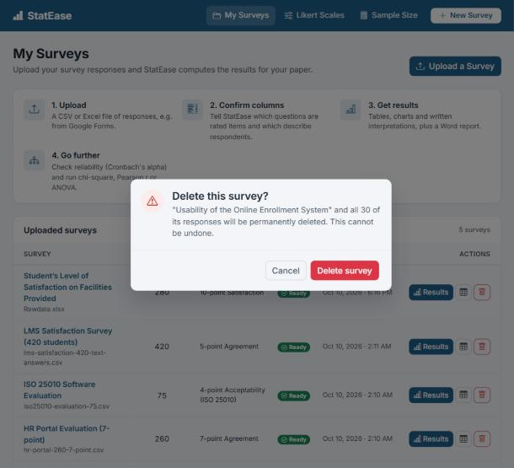
Figure 17. Delete confirmation. Every delete asks for confirmation in a dialog that states exactly what will be removed.

J. Testing
All 48 automated tests pass. They run with php artisan test on a temporary database, so real data is never changed. The main test cases are below; every statistic was also checked against an independent calculation.
ID | Test case | Input | Expected result | Actual result
TC-01 | Register and log in | Name, email, password secret123 (twice) | Account created and logged in; password stored as a hash | Pass
TC-02 | Log in with a wrong password | Correct email, wrong password | “The email or password is incorrect.”; not logged in | Pass
TC-03 | Open another user’s survey | User B opens and deletes user A’s survey | 403 Forbidden; survey not deleted | Pass
TC-04 | Upload a valid CSV | 4 respondents; columns Timestamp, Name, Sex, Q1, Q2 | Survey saved; types guessed as ignore, ignore, profile, likert, likert | Pass
TC-05 | Upload with missing or wrong input | Empty form; a .pdf file | Error on each missing field; “The file must be a .csv or .xlsx file” | Pass
TC-06 | Mark a text column as a Likert item | Sex (Male/Female) set to Likert | Error naming the column and the invalid rows; not saved | Pass
TC-07 | Weighted mean with a blank answer | Q1 = 4, 3, 4, 2; Q2 = 3, 3, 2, blank | Q1 = 3.25; Q2 = 2.67 (blank left out) | Pass
TC-08 | Open results before confirming columns | Results, reliability, tests and report pages | Sent back to the column types page | Pass

K. Limitations and Future Improvements
The current version covers a full survey analysis for one scale per survey; these are its known limits and the planned next steps.
Current limitation | Planned improvement
One Likert scale per survey | A scale per section, for questionnaires that mix agreement and satisfaction items
A significant ANOVA does not show which groups differ | Tukey HSD post hoc test
No separate t-test option (one-way ANOVA with two groups gives the same result) | Independent and paired t-tests, and non-parametric tests
Files are uploaded by hand | Live import from a linked Google Sheet
A survey has one owner; there is no password reset by email | Shared surveys for research teams, and password reset by email
Up to 5,000 respondents and 100 columns per file | Background processing for larger datasets
Bootstrap, Chart.js and fonts load from the internet | Bundle them with the app so it works fully offline

Appendix: Installation and Setup
StatEase needs PHP 8.2 or newer, Composer and MySQL/MariaDB (XAMPP), plus an internet connection for the Bootstrap, Chart.js and font files.
- In C:\xampp\php\php.ini, make sure the line extension=zip has no semicolon in front of it.
- Start MySQL (and Apache, for phpMyAdmin) in the XAMPP Control Panel, then create an empty database named statease_db.
- Open a terminal in the project folder and run: composer install, then copy .env.example .env, then php artisan key:generate.
- Create the tables with one of these: php artisan migrate (fresh start with the six built-in scales), or in phpMyAdmin select statease_db → Import → database/statease_db.sql (with the sample surveys).
- Start the app with php artisan serve and open http://127.0.0.1:8000.
- Click Create an account. If you imported the sample data, the first account you register becomes the owner of the sample surveys.
- Optional: run php artisan test to confirm that all 48 tests pass.
Sample files for the demonstration are in public/samples/ (CSV) and test-files/library-satisfaction-40.xlsx (Excel).

