Kyveriqx
AI Tools Platform — Architecture & Build Plan
A multi-tenant SaaS marketplace of reconciliation & outreach tools
6 platforms · one monorepo · one subdomain per tool

1. Architecture at a glance
The whole platform on one page. One repository (a monorepo) holds a shared /core and one folder per tool under /tools. It deploys as a single Next.js app on Vercel behind the *.kyveriqx.com wildcard, and the subdomain decides which tool folder loads. Underneath sit the three shared backend services.
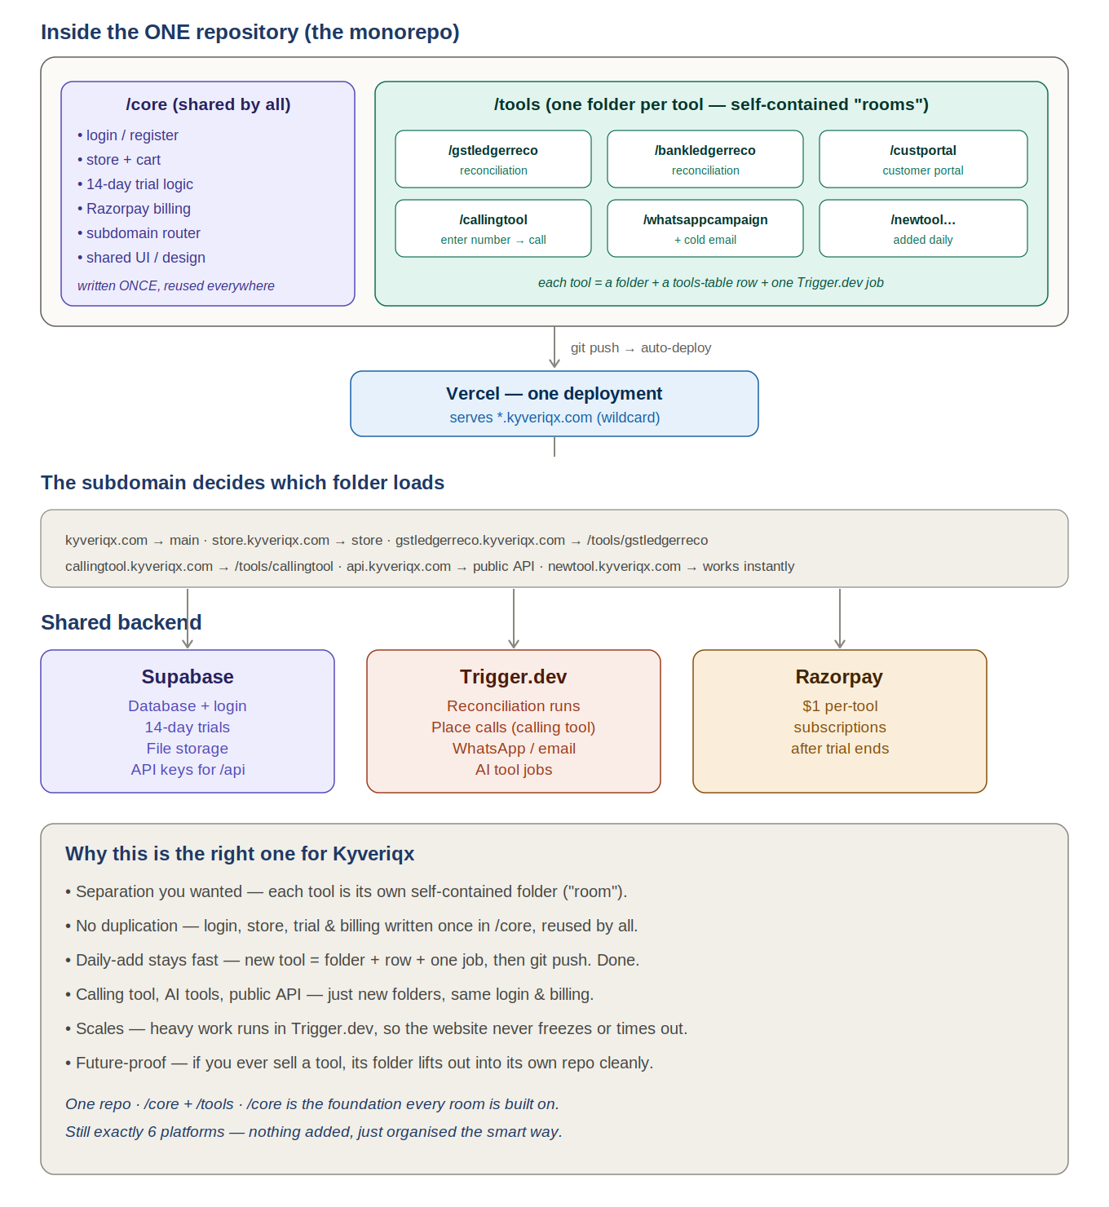

2. What you are building
Stripped of jargon, Kyveriqx is a multi-tenant SaaS with a marketplace of AI tools, per-tool subscriptions, and a 14-day free trial per tool. A visitor registers with their email, gets a 14-day trial on each tool, and after the trial pays roughly $1 per tool to keep using it. New tools (GST, TDS, bank, vendor and customer reconciliation, WhatsApp campaigns, cold email outreach) are added over time — ideally one at a time without rebuilding the whole site.
Everything lives in one repository organised as a monorepo: a shared /core and one folder per tool under /tools. Each tool is served on its own subdomain (gstledgerreco.kyveriqx.com and so on) via a wildcard, all sitting on a single shared backend. The same structure cleanly hosts richer tools too — a calling tool where someone enters a number and a call is placed, AI-powered tools, and a public API — each just another folder reusing the shared login and billing. You build it on your laptop with Claude Code and four managed services do the rest.

3. The repository structure — one monorepo
Use one repository, organised internally as a monorepo: a shared /core plus one self-contained folder per tool under /tools. This is the single right structure for Kyveriqx, and here is the honest reasoning.
You are adding a tool a day, by yourself, and all tools share one login, one store, one cart, one trial system and one billing system. That rules out separate repos per tool: each new tool would mean a new repo, new Vercel project, and re-wiring login and billing every time — an hour of plumbing per tool, plus keeping every copy in sync forever. It also rules out one flat tangled app, where tools bleed into each other. The monorepo gives all three things you need at once: clean separation per tool, no duplication of shared code, and a five-minute daily add.
/core — written once, reused everywhere: login & register, the store and cart, the 14-day trial logic, Razorpay billing, the subdomain router, and shared UI.
/tools — one folder per tool (each its own “room”): gstledgerreco, bankledgerreco, custportal, callingtool, whatsappcampaign, and a new folder each day. Each tool is a folder + a row in the tools table + one Trigger.dev job.
Future-proof: if you ever sell or spin off a single tool, its folder lifts cleanly out of /tools into its own repository — because it was already self-contained. You get the option of separation later without paying its cost every day now.

How you add a tool each day
- Create a new folder under /tools (e.g. /tools/callingtool).
- Insert one row in the tools table: name, subdomain, price.
- Write one Trigger.dev job for the heavy part.
- git push — Vercel redeploys; callingtool.kyveriqx.com is instantly live with login, trial and billing already working from /core.

Building your specific tools on this structure
Calling tool (enter a number, place a call): the page lives in /tools/callingtool; the call itself is placed by a Trigger.dev job talking to a telephony provider such as Twilio, Plivo or Exotel (Plivo/Exotel are often cheaper and simpler for India). The browser never dials directly — it asks your backend, which runs the job. Calls are slow and need retries, which is exactly what Trigger.dev handles.
AI tools: any tool needing AI (summarising, extracting, classifying) calls the Anthropic API (Claude) from inside that tool’s folder or its Trigger.dev job — folder for the UI, job for the heavy AI work.
Public API: expose your tools programmatically as one more room — a folder answering on api.kyveriqx.com that checks an API key stored in Supabase and runs the same logic your tools use. Because the logic already lives in /core and /tools, the API is reuse, not a rebuild.

4. The platforms — how many and what each does
You will use 6 digital platforms in total. Two carry your code from your laptop to the internet; four run the live product underneath all the subdomains.
# | Platform | Category | Role
1 | Laptop + Claude Code | Delivery | Where you build the whole app
2 | GitHub | Delivery | One repo holding all the code; source of truth
3 | Vercel | Live product | Hosts the site; serves all subdomains via *.kyveriqx.com
4 | Supabase | Live product | Database, login, 14-day trials, file storage
5 | Trigger.dev | Live product | Heavy background jobs (reconciliation, campaigns)
6 | Razorpay | Live product | $1 per-tool subscriptions after the trial
Note on Razorpay: chosen over Stripe because your customers are Indian businesses (GST, TDS) billing in INR.

5. One subdomain per tool, on a wildcard
Every tool gets its own subdomain — orgledgerreco.kyveriqx.com, bankledgerreco.kyveriqx.com, gstledgerreco.kyveriqx.com, custportal.kyveriqx.com, and a new one each day. The trick that makes this painless is a wildcard: *.kyveriqx.com points at one Vercel deployment. So all of these subdomains are still the same Next.js app — the app simply reads which subdomain was used and loads the matching tool. They are not separate websites and do not have separate backends.
Subdomain | Weight | What lives there
kyveriqx.com | Light | Main site — about you, what you have built
store.kyveriqx.com | Light | Cart, catalogue, register, login, checkout
orgledgerreco.kyveriqx.com | Heavy on run | Org ledger reconciliation tool
bankledgerreco.kyveriqx.com | Heavy on run | Bank ledger reconciliation tool
gstledgerreco.kyveriqx.com | Heavy on run | GST ledger reconciliation tool
custportal.kyveriqx.com | Heavy on run | Customer portal
…one per tool, added daily | Heavy on run | Each new tool gets its own subdomain automatically
Why the wildcard matters: because *.kyveriqx.com is set up once, a brand-new tool subdomain works the moment you deploy — no new DNS record, no new Vercel project, no new repo. The main site and store stay light; only a tool subdomain does heavy work, and only while a tool is actually running.
Note: tool subdomains drop the www prefix — gstledgerreco.kyveriqx.com, not www.gstledgerreco.kyveriqx.com — which is cleaner and standard.

6. Domain, DNS & email (Hostinger + Vercel + Office 365)
The domain kyveriqx.com is registered at Hostinger. You keep it there — Hostinger owns the name and holds your DNS. Vercel hosts and runs the site. Microsoft 365 runs your email. All three coexist in one Hostinger DNS panel because website records and email records are different record types that never collide.
Key principle: the website uses A and CNAME records; email uses MX plus a few CNAME and TXT records. The only shared name is @, and there it is an A record for the web versus an MX record for mail — two different types that sit side by side without conflict.

Website records (point the site at Vercel)
Type | Name / Host | Points to | Purpose
A | @ | Vercel IP (shown in Vercel dashboard, e.g. 76.76.21.21) | Main site
CNAME | www | cname.vercel-dns.com | www site
CNAME | * | cname.vercel-dns.com | All tool subdomains
Add kyveriqx.com and *.kyveriqx.com inside the Vercel dashboard first; Vercel then shows the exact target values to paste into Hostinger. SSL for every subdomain, including the wildcard, is automatic.

Email records (Office 365)
Add and verify kyveriqx.com in the Microsoft 365 admin center first. Microsoft then generates the precise records below — use the values it gives you. The wildcard CNAME does not interfere: an explicit record like autodiscover always wins over the * wildcard.
Type | Name / Host | Value | Purpose
MX | @ | kyveriqx-com.mail.protection.outlook.com (priority 0) | Receive mail
CNAME | autodiscover | autodiscover.outlook.com | Outlook auto-setup
TXT | @ | v=spf1 include:spf.protection.outlook.com -all | SPF (one only)
CNAME | selector1._domainkey | (value from Microsoft 365 admin center) | DKIM signing
CNAME | selector2._domainkey | (value from Microsoft 365 admin center) | DKIM signing
Two rules that protect your email: (1) Only ever one SPF TXT record — if one already exists, edit it to add the Microsoft value; never publish a second, or mail authentication silently breaks. (2) When pointing the site to Vercel, leave all MX and email TXT/CNAME records alone — only touch the website A/CNAME records.
Recommended order: verify the domain in Microsoft 365 and enter the mail records, then add the three Vercel website records. Email and website end up working independently, with no downtime.

7. How the platforms connect
The flow in one sentence: you build locally, push to GitHub, GitHub auto-deploys to Vercel, Vercel serves the site, and the site talks to Supabase (data), Trigger.dev (jobs) and Razorpay (billing).
Delivery chain: Laptop + Claude Code → git push → GitHub → auto-deploy → Vercel.
Shared backend: Every subdomain reads/writes the same Supabase. The app hands heavy work to Trigger.dev, which writes results back to Supabase. Razorpay records subscriptions into Supabase.

What happens when someone runs a tool
- At the store they register — Supabase starts a 14-day trial for that tool.
- They open the tool's subdomain (e.g. gstledgerreco.kyveriqx.com) — the app reads the subdomain and loads that tool.
- They upload a file — it lands in Supabase storage.
- The app hands the heavy matching to Trigger.dev — a progress bar shows.
- The result is written back to Supabase — the user downloads it.
- When the trial ends, Razorpay charges $1 and Supabase marks the user subscribed.

8. What to do first — the build order
Each step depends on the one before it, so follow this order. At every stage you will have something working rather than a half-built mess.

Step 1 — Set up your laptop
Install Node.js and Claude Code, then create one Next.js project laid out as a monorepo — a /core folder for the shared login, store and billing, and a /tools folder that will hold one folder per tool. This is your only workspace. Everything lives here.

Step 2 — Create the GitHub repo
Make one repository, connect your local project, and push. From now on every change goes up with git push. GitHub is the holding place Vercel watches.

Step 3 — Connect Vercel
Link Vercel to your GitHub repo so it deploys automatically. Add the main domain and the wildcard *.kyveriqx.com (see Section 6 for the exact Hostinger DNS records), keeping your Office 365 mail records untouched. SSL is automatic. With the wildcard in place, every future tool subdomain works without any further DNS work. Do this early so you always have a live site to look at.

Step 4 — Set up Supabase (the heart)
Create the database tables (users, orgs, tools, subscriptions), turn on email login, and create a storage bucket for uploaded files. This is where the 14-day trial logic lives. Nothing else works until this exists.

Step 5 — Add Trigger.dev (the muscle)
Now wire up the heavy jobs. For each tool folder, write its Trigger.dev job — reconciliation matching, placing a call via Twilio/Plivo/Exotel, sending a WhatsApp/email campaign, or running an AI task via the Anthropic API — and have it write results back to Supabase. Add one job per tool over time; this is your one-tool-a-day rhythm.

Step 6 — Connect Razorpay (the till)
Last, because billing only matters once a tool works and a trial can end. Set up a per-tool subscription, and connect it so that when a trial ends, Razorpay charges and Supabase flips the user to subscribed.

9. The one rule that makes “add a tool a day” work
Make every tool a row in a database table — never hardcoded. Each row stores the subdomain that tool answers to (e.g. gstledgerreco). Adding a tool should mean inserting a row, adding a tool folder, and defining one Trigger.dev job — not editing and redeploying everything by hand. Combined with the wildcard, the new subdomain just works. If you hardcode tools, the plan collapses within a week; if each tool is just data, adding one becomes a five-minute task.
That is the entire system: 6 platforms, 3 subdomains, 1 codebase, connected in the chain above. The recommended next step is to design the Supabase tables (Step 4) in detail, since that shared database is what everything else plugs into.

