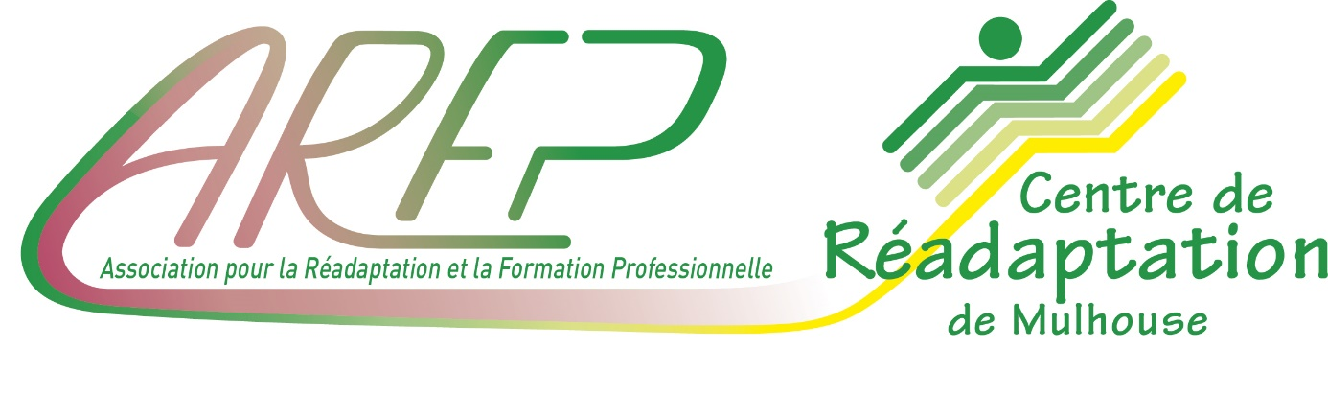

Tim BROWN, Sylvain TORRENTI, Aurélien BOUDIER

Project tracking

**API ON SAIT PAS**

CDA 2005 - From 2020/05/04 au 2021/09/2021

**SUMMARY**

1. TEAM 3

2. PROJECT 3

3. MEETING REPORTS 3

# TEAM

# PROJECT

# MEETING REPORTS