**Programming environment**: Java

**Brief description**:

(1)class description

Proj1.java :this class is to call function in SearchCSV.java

SearchCSV.java:

|  |  |
| --- | --- |
| Function | Description |
| doLoadingCSV() | This function load csv into different lists |
| doSortlist() | This is for sorting different lists according to firstname, lastname, phonenumber and compayname by rewriting comparator |
| getCol(String) | Accept input and decide which to search in address book |
| doBinarySearch(String,List,int) | The is preparation for binary search |
| doBinarySearch(String,int ,int,List,int) | This does binarySearch for firstname, lastname, compayname |
| doPhoneBinarySearch() | This is preparation for phone’s binary search |
| doPBS() | This search phone numbers by binary search dealing with”(””)””-” |
| printout() | This print out output of search from all inputs |
| ComparatorFN[LN][PN][PN][CN] | This is rewrite of comparator for comparing list according to firstname, lastname,phonenumber and companyname |

(2)process description

Firstly the Java this load CSV into four lists which is colListFN, colListLN, colListPN, colListCN and then call doSortlist() to sort list according to FirstName, LastName, PhoneNumber and CompanyName using time complexity of nlogn. But this is loading and just one time. Here I rewrite comparator because the compare is to deal certain string, firstname, lastname etc. in the List. Because here I want to realizing that input certain words of first name and JAVA will ouput all results including whole FirstName, LastName, PhoneNumber and CompanyName. doBinarySearch(String,int,int,List,int) and doPBS realize binary search using time complexity of O(logn)!

**Test result:**

Here I just want output results including FirstName, LastName, PhoneNumber and CompanyName. This will make the addressbook more functionable.At the same time it will be sorted according to your input string. You don’t need to input () or – when you search phone number! This is have been deal in function.

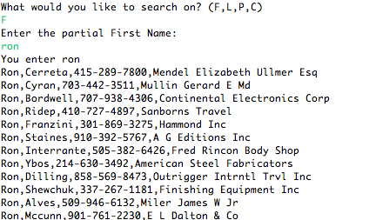

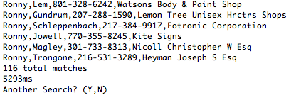

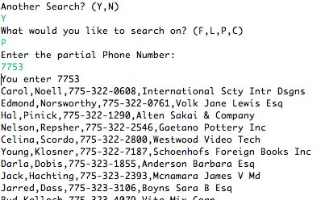

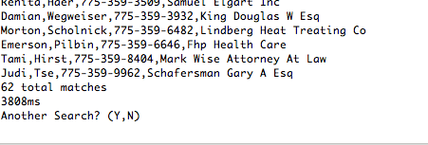

The output of LastName and CompanyName is the same with FirstName.

Here I output all results is just for clearing reading of addressBook.It has been sorted according to the input of ”F”or”L”or”P”or”C”! The time complexity will be O(logn)!