Employee Management Screenshots

Application Interface
- Login page
- Sign-up page
- Employee directory
- Add employee form
- Manage employees page
- Manage employees in edit mode

API Testing
- Postman — retrieve all employees
- Postman — retrieve one employee
- Postman — create employee
- Postman — update employee
- Postman — delete employee

Automated Testing
- Cypress test results

Application Interface
- Login page 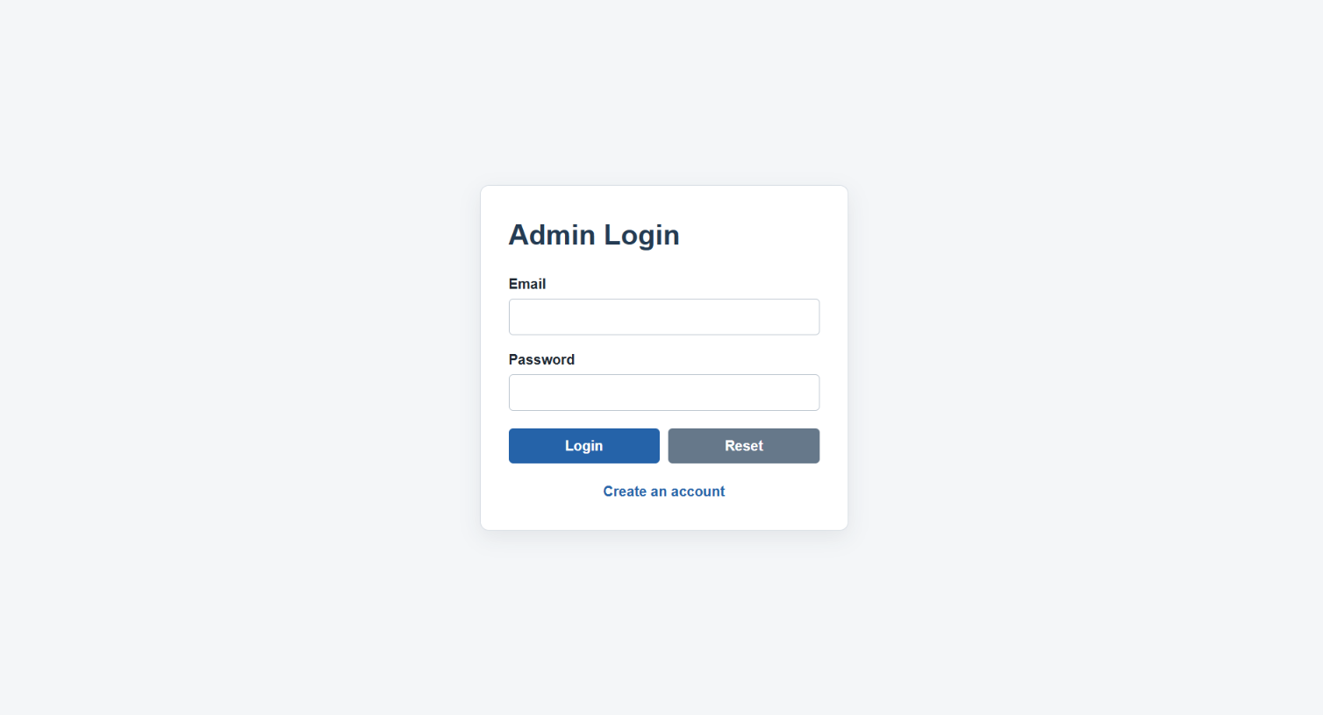
- Sign-up page
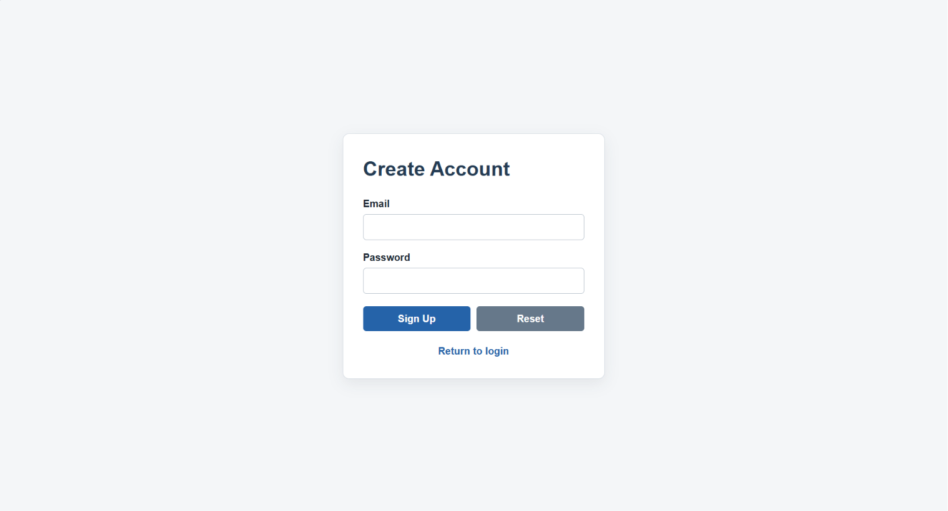
- Employee directory
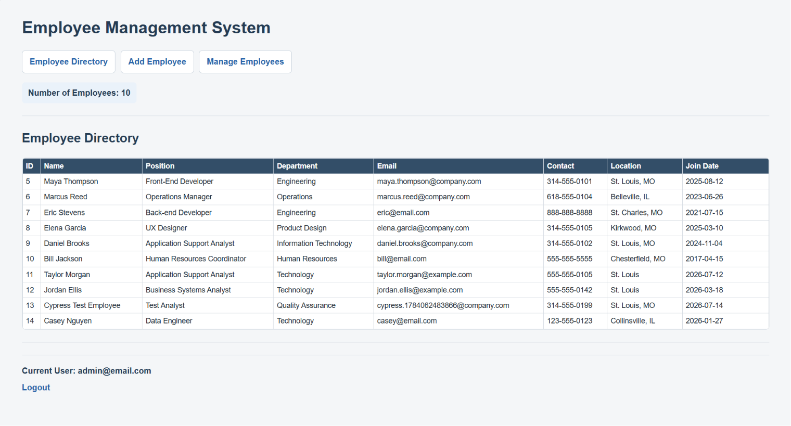

- Add employee form
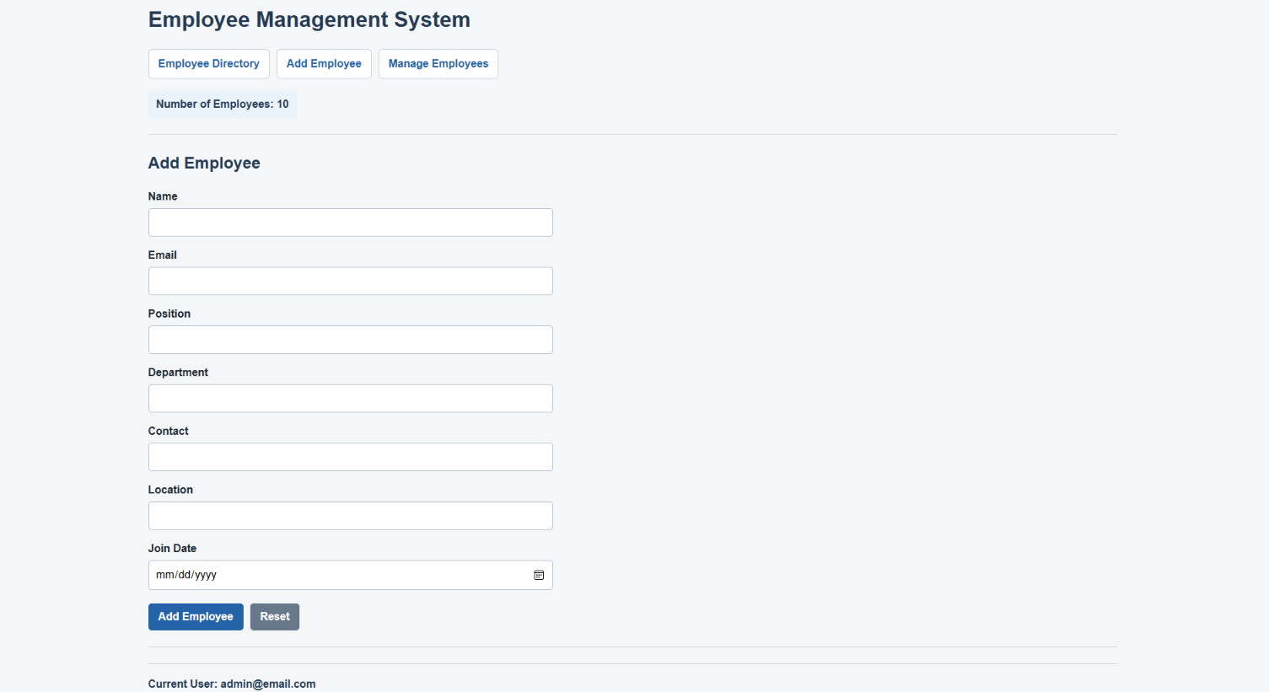
- Manage employees page
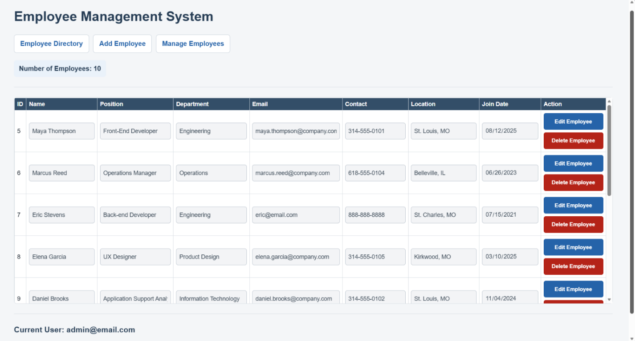

- Manage employees in edit mode
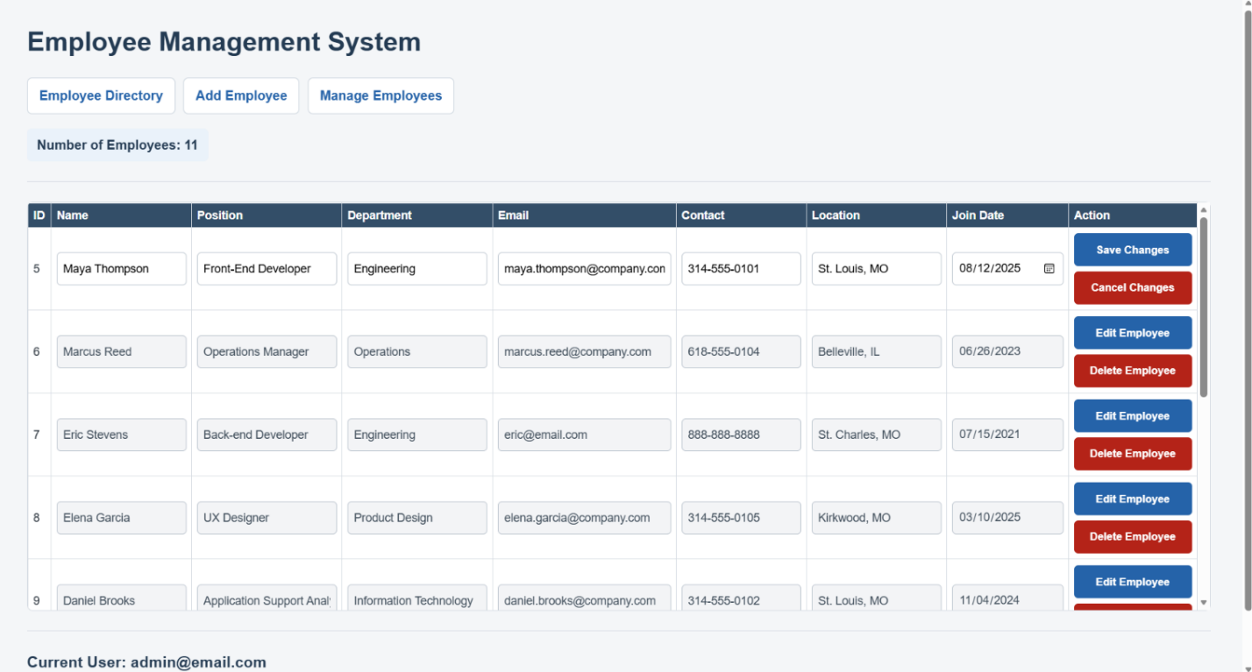
API Testing
- Postman — retrieve all employees
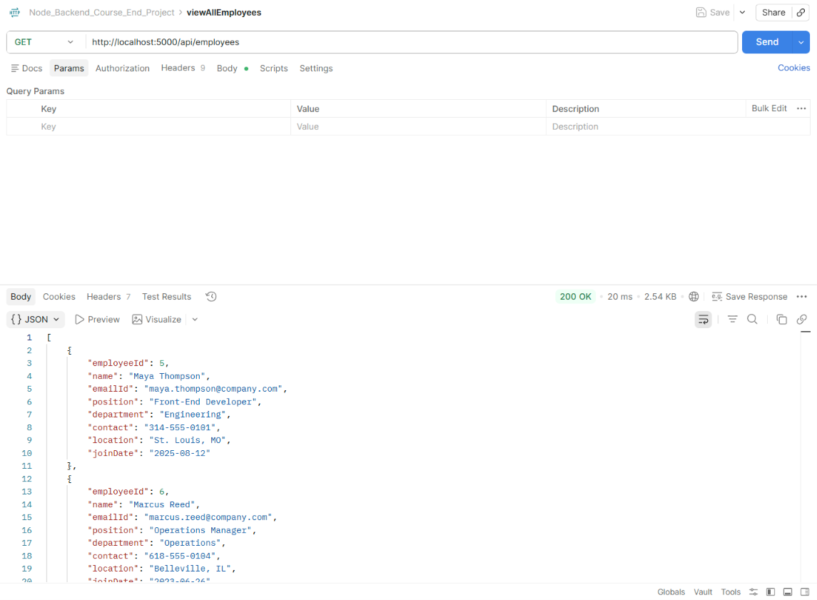

- Postman — retrieve one employee
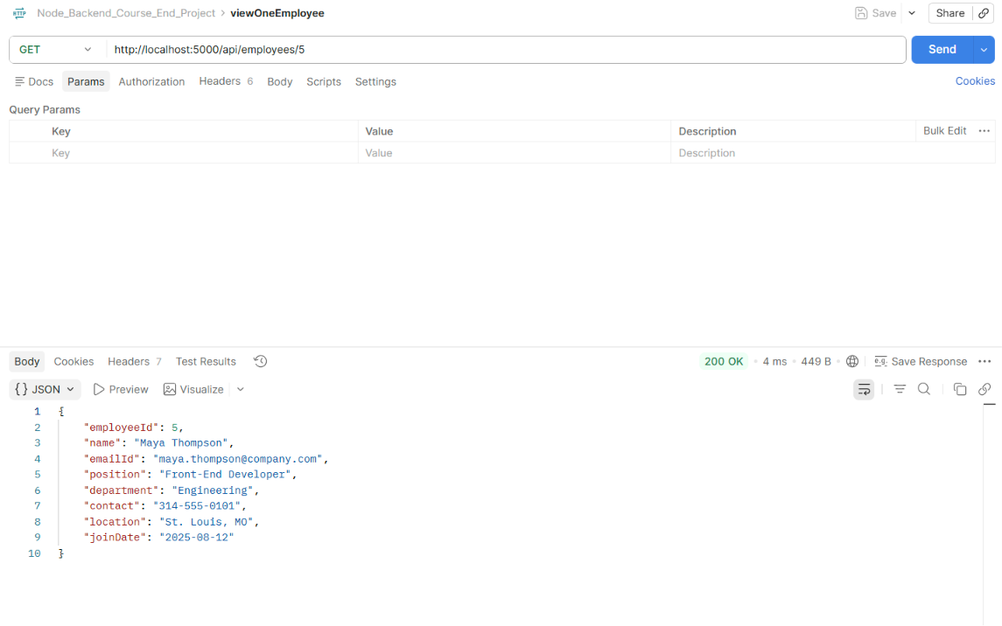
- Postman — create employee
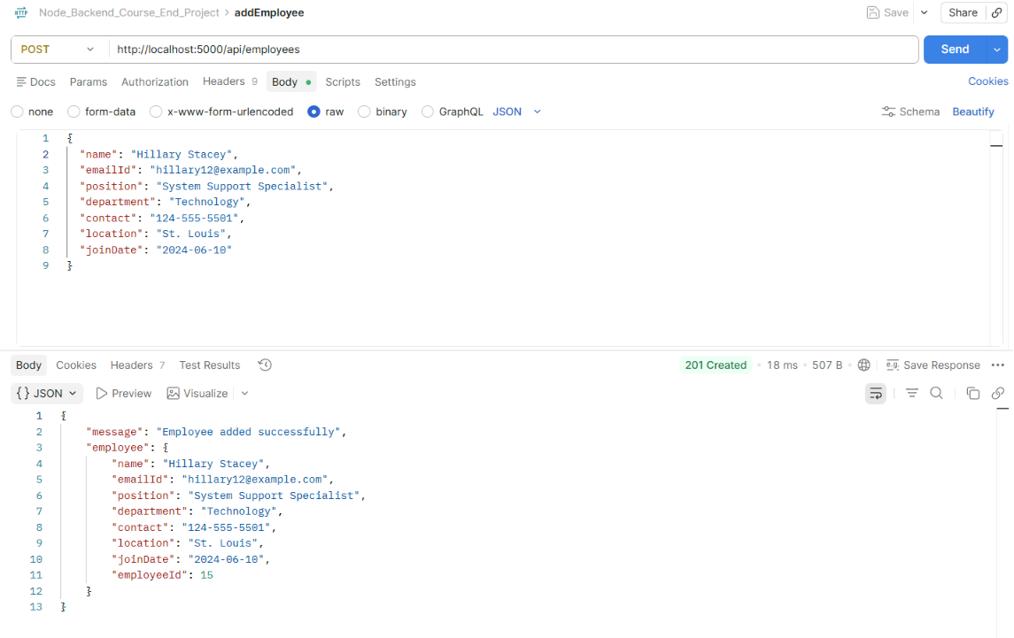

- Postman — update employee
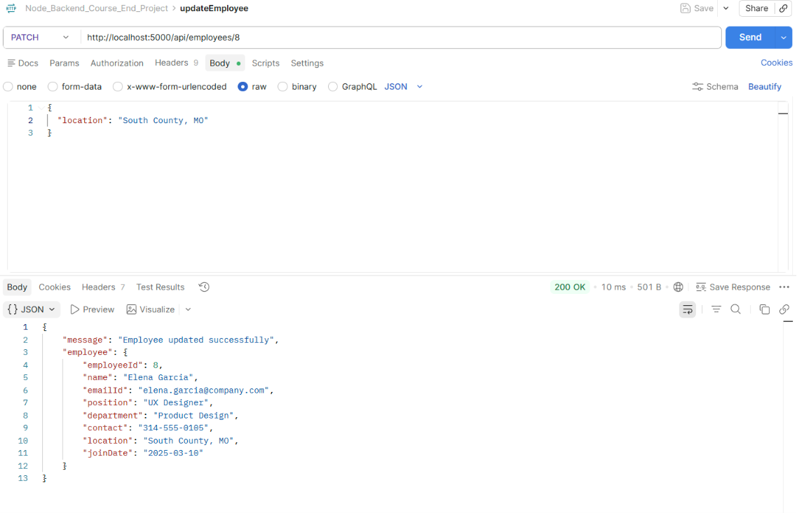
- Postman — delete employee
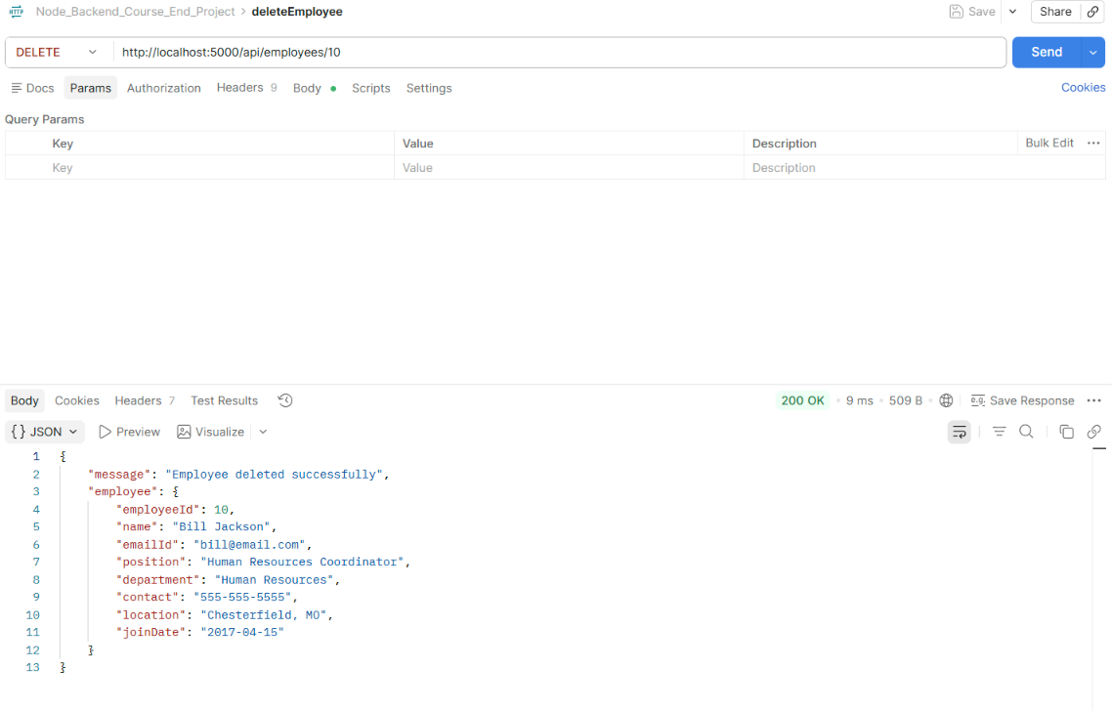

Automated Testing
- Cypress test results
