Software Project Management Plan

SPMP

For

State Park Educational Website

Group 4

**Table of Contents**

1. Revision Sheet
2. Introduction
3. Project Overview
4. Project Deliverables
5. Process Model
6. Management Objectives and Priorities
7. Risk Management
8. Methods, Tools, and Techniques
9. Software Requirements Specification
10. Softare Design Description
11. Software Test Plan

Revision Sheet (Update History)

Introduction

For this project, we have been asked by the client to create an educational website for a states park. This website will include a math-based game and it will incline the student to go outside and enjoy the summer weather. The purpose of this website is to have a fun and interactive way for students to learn during the summer and provide an easy way for teachers and parents to monitor students progress. A large incentive that can be used since this educational website is linked to the given states park, is giving discounted tickets to those who perform exceptionally well.

Project Overview

This website will contain a mathgame that will allow students to improve their math skills over the summer. The site will allow parents and teachers to purchase tickets to local state parks and provide free/discounted tickets for students who perform exceptionally well on the math game or those who complete any outdoor bonus activities. The site itself will include a way for teachers and parents to monitor students behavior and see if they are improving in their math skills. This website will include common website functions such as social media sharing, user reviews for park rides, and donations. This website will be hosted during the development phase on google firebase, once it is time to deploy we will host the website on our servers unless the client decides they would like to host it.

Project Deliverables

* Use Case
* Sequence Diagram
* High Level Architechture Diagram
* Class Diagram
* Interface Specification Chart
* Test Skeleton
* Deployment Plan
* Requirements Chart

Process Model

The development plan that our product will follow is the incremental development plan. We will develop one feature of the website fully and push that for users use, upon user feedback we can make alterations to the given feature and get it to a point where it satisfies the client. This process model is good because it allows our small team to focus on mainly one task and make sure that we are getting that task done to the best of our ability. This model will start with the most important features of the website, namely the login system, the math game, and the ability to purchase tickets. This will allow us to build the foundation for the website and then over time, increment in all of the other features that the client desires.

Management Objectives and Priorities

Project Dimension Fixed Constrained Flexible

Cost X

Schedule X

Scope (functionality) X

Risk Management

With this project, there is not too much risk involved. Since we are dealing with a website that does not hold much sensitive information, our risk is rather low. Some of the risks that we do face include the website not working, or the server being overloaded. This is an issue that can happen to any website, and it is something we will need to keep ourselves aware of, in order to take preventative measures. Additionally, there is the potential that someones credit card could be compromised when attempting to purchase tickets. We do not store any credit card information on our website, nor do we personally process credit card information. We will utilize third-party credit card vendors in order to purchase tickets, to try and prevent any credit card fraud that could happen.

Methods, Tools, and Techniques

This website will utilize, JavaScript, CSS, and HTML5. We are using Google Firebase as our server for the website. The team structure itself includes four coders and one PM (Project Manager). There are no specific computing systems/operating systems required for the development of this product.

Software Requirements Specification

1. Educational game covering basic topics

A game where the kid has to complete a math riddle online, if they complete it correctly then they receive a place that they must go outside and take a picture of the place, if the picture is verified then they receive credit for the problem.

Or use a QR code that when scanned randomly generates a code that they must enter on the website.

Or use a leveling system that as the kid completes math riddles correctly they earn “quest rewards” these rewards could give them coupons to free treats or places in their area.

Incorporate a high scoreboard that the highest students get a free ticket.

2. Incorporates the state’s amusement park

Answering enough math riddles correctly will earn free entry to the park.

Include a tab for the given states park that provides information about the park and allows the purchase of tickets.

Park can be chosen via zip code, city, state, or county.

Ads for the given state park can be displayed around the kids game as long as they are age and school appropriate.

3. Support submission of images, park, descriptions, reviews etc.

Incorporate a user review that system that will allow the users to review, post images, and descriptions of the park and rides.

For verification use a captcha to prevent spam.

Utilize reviews under the park tab so that the user can review specific rides or the park as a whole.

Utilize reviews under the game itself so that the user can review the game.

4. Incorporate Online & Mobile Ticketing support

Include debit card and credit card transactions.

Purchase a ticket through the website with a simple form entry.

Utilize API calls so that the user can pay via PayPal or credit card - No information stored.

5. Integrate with popular social media platforms.

If the user reaches an achievement then they can share it on a social media platform.

Allow the user to share the website as a whole.

Social media platforms integrated into the website itself.

6. Allow parents to view basic info on their child(ren)’s activities in the game

A parent should be able to view information such as how much they have played what games they have been playing how good they have been doing and how well they are at the math piece

The student can have a unique code on their account and the parent can utilize that code to link to their child’s account. While the teacher can have a teacher code that the student must use to sign up on the website allowing the teacher to have access to all of her students.

*Does the client want a system that incorporates a hierarchy of “roles” that controls the level of permissions and access that a specific user group has access to? For example, a parent role giving parent access to their child's information for viewing and accessing their child's grades and recent activity. *

The teacher should be able to see how good their student is doing in the given math problems, and what students potentially need extra help in school practice.

7. Support Donations

A button on the webpage for the users to support the website.

They can donate using a web form that calls an API to process the card information

Every week the top donator will receive a spotlight banner to show appreciation for their donation.

8. All data in a centralized location

School may want to put the information in their database so store all info in a generalized database

Use a general database to contain all of the codes and student, teacher, parent information.

Software Design Description

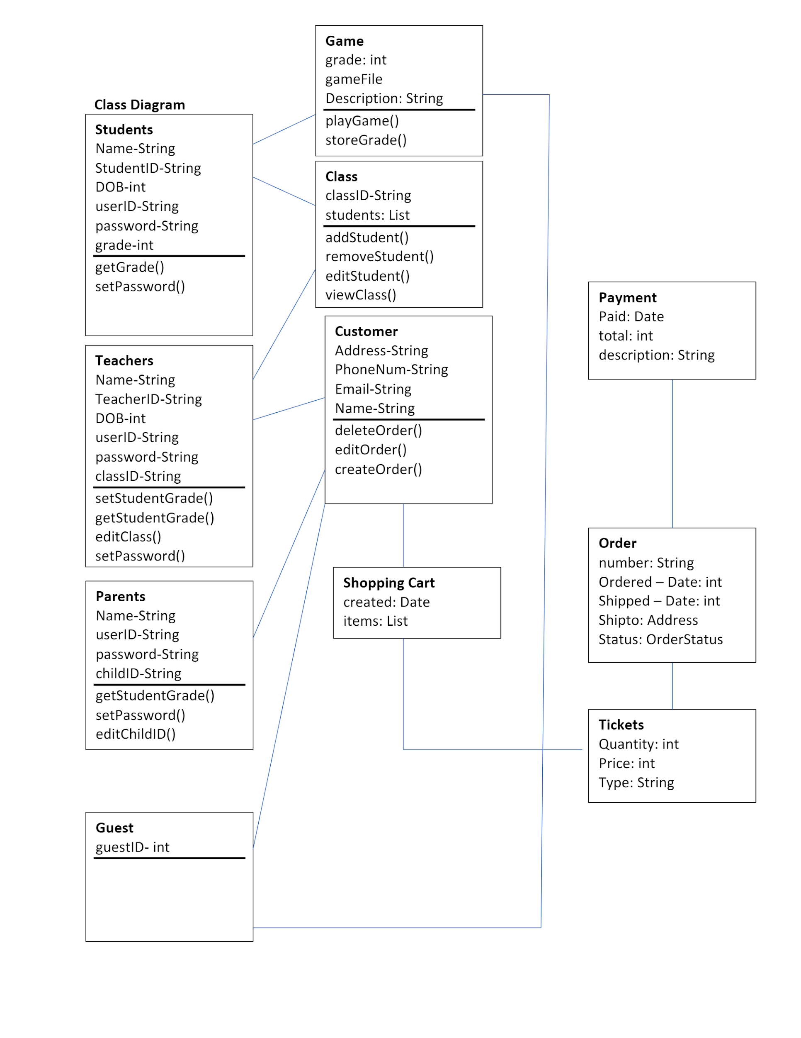

Software Test Plan

Unit Testing Test Skeleton

[TestGame]

Public class newTest

{

[SetUp]

public void loadGame()

{

// Loads the game to play and test

}

Public void startGame()

{

//Starts the game to be played and tested by the user

}

Public void test1()

{

//Test the mechanics of the math game under a light load

}

Public void test2()

{

//Test the mechanics of the math game under a heavy load

}

Public void unload()

{

//Clean up the test and finish running

}

}

[TestSite]

Public class newSiteTest

{

Public void loadSite()

{

//Load the website for various testing

}

Public void pageTest()

{

//Test the various page hyperlinks and reroutes of the site

}

Public void objectTest()

{

//Test all of the internal of the site such as login, embedded game function, donations, and ticket purchases

}

Public void stressTest()

{

//Test the sites performance under a high load force

}

Public void unload()

{

//Clean up the test and finish up

}

}