互動程式設計三 期中專案

資工四110590034楊榮鈞

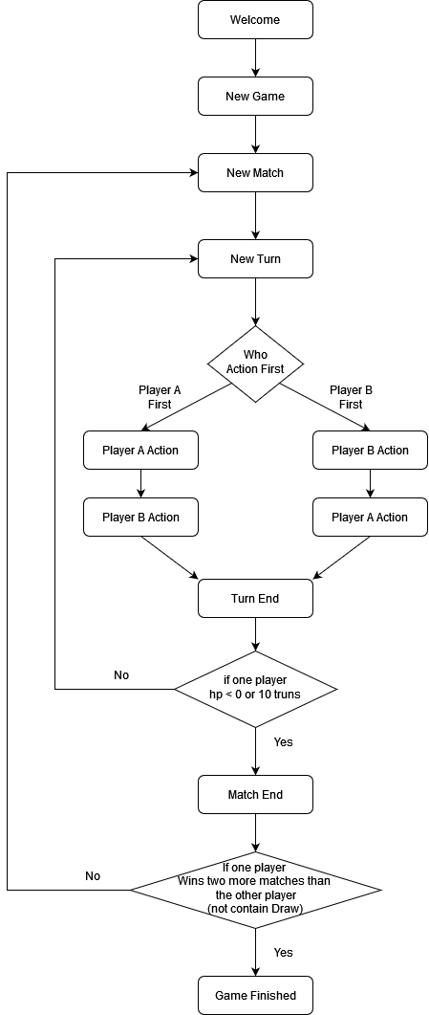期中專案的Repo：<https://github.com/kyynk/RPG_mid>

Flowchart

Class Diagram

如想看放大圖片可至

https://raw.githubusercontent.com/kyynk/RPG_mid/refs/heads/main/SomeGraph/class_diagram.png

