1. K-Means

Given 8 dots: A (4, 9) B (2, 10) C (1, 2) D (2, 5) E (6, 4) F (8, 4) G (7, 5) H (5, 8)

3 centroids: α (2, 10) β (1, 2) γ (5, 8)

1)

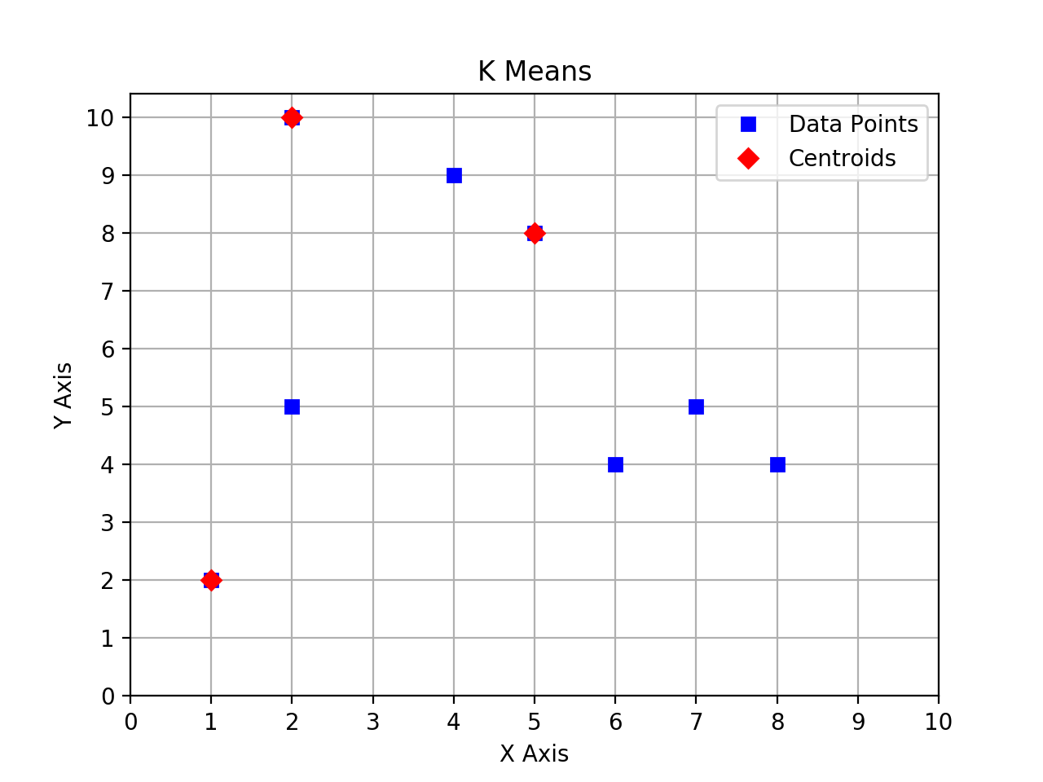

Compute the Euclidian distance

A -> α = This is the rendered form of the equation. You can not edit this directly. Right click will give you the option to save the image, and in most browsers you can drag the image onto your desktop or another program. B -> α = 0 C -> α = This is the rendered form of the equation. You can not edit this directly. Right click will give you the option to save the image, and in most browsers you can drag the image onto your desktop or another program. D -> α = 5

A -> β = This is the rendered form of the equation. You can not edit this directly. Right click will give you the option to save the image, and in most browsers you can drag the image onto your desktop or another program. B -> β = This is the rendered form of the equation. You can not edit this directly. Right click will give you the option to save the image, and in most browsers you can drag the image onto your desktop or another program. C -> β = 0 D -> β = This is the rendered form of the equation. You can not edit this directly. Right click will give you the option to save the image, and in most browsers you can drag the image onto your desktop or another program.

A -> γ = This is the rendered form of the equation. You can not edit this directly. Right click will give you the option to save the image, and in most browsers you can drag the image onto your desktop or another program. B -> γ = This is the rendered form of the equation. You can not edit this directly. Right click will give you the option to save the image, and in most browsers you can drag the image onto your desktop or another program. C -> γ = This is the rendered form of the equation. You can not edit this directly. Right click will give you the option to save the image, and in most browsers you can drag the image onto your desktop or another program. D -> γ = This is the rendered form of the equation. You can not edit this directly. Right click will give you the option to save the image, and in most browsers you can drag the image onto your desktop or another program.

E -> α = This is the rendered form of the equation. You can not edit this directly. Right click will give you the option to save the image, and in most browsers you can drag the image onto your desktop or another program. F -> α = This is the rendered form of the equation. You can not edit this directly. Right click will give you the option to save the image, and in most browsers you can drag the image onto your desktop or another program. G -> α = This is the rendered form of the equation. You can not edit this directly. Right click will give you the option to save the image, and in most browsers you can drag the image onto your desktop or another program. H -> α = This is the rendered form of the equation. You can not edit this directly. Right click will give you the option to save the image, and in most browsers you can drag the image onto your desktop or another program.

E -> β = This is the rendered form of the equation. You can not edit this directly. Right click will give you the option to save the image, and in most browsers you can drag the image onto your desktop or another program. F -> β = This is the rendered form of the equation. You can not edit this directly. Right click will give you the option to save the image, and in most browsers you can drag the image onto your desktop or another program. G -> β = This is the rendered form of the equation. You can not edit this directly. Right click will give you the option to save the image, and in most browsers you can drag the image onto your desktop or another program. H -> β =This is the rendered form of the equation. You can not edit this directly. Right click will give you the option to save the image, and in most browsers you can drag the image onto your desktop or another program.

E -> γ = This is the rendered form of the equation. You can not edit this directly. Right click will give you the option to save the image, and in most browsers you can drag the image onto your desktop or another program. F -> γ = 5 G -> γ = This is the rendered form of the equation. You can not edit this directly. Right click will give you the option to save the image, and in most browsers you can drag the image onto your desktop or another program. H -> γ = 0

Centroid Assignment

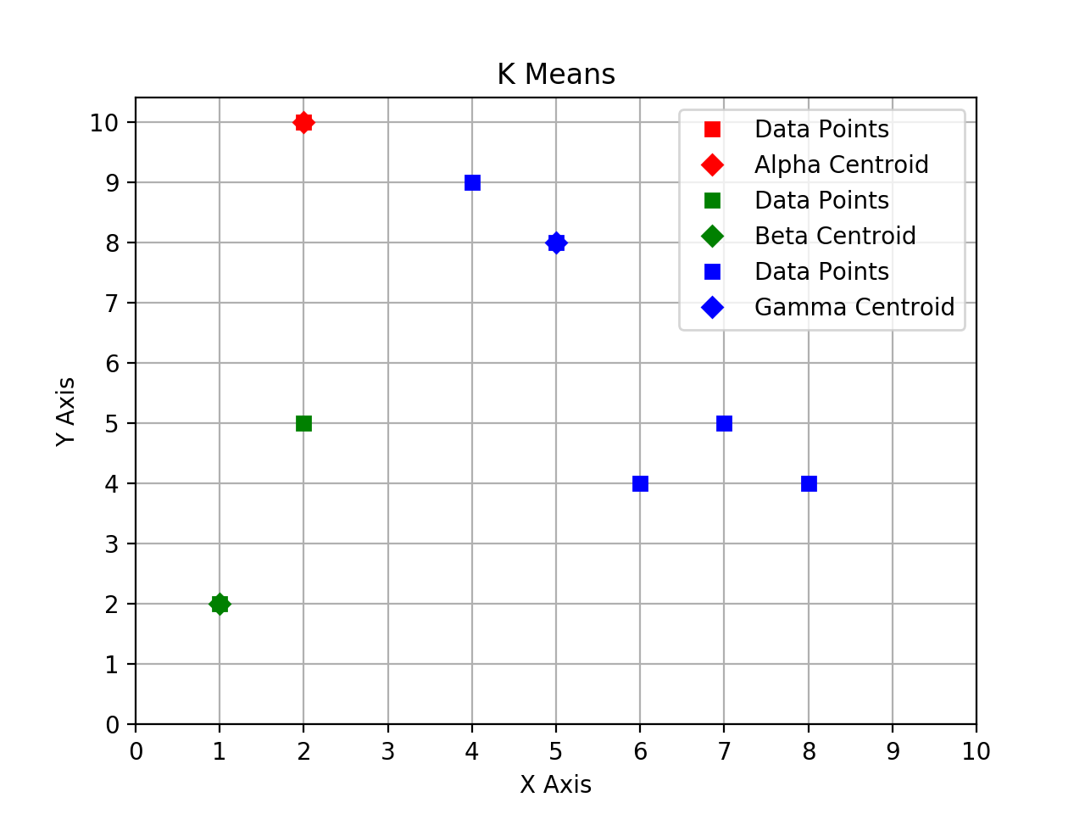

2) Recompute centroids for each cluster

Given 8 dots: A (4, 9) B (2, 10) C (1, 2) D (2, 5) E (6, 4) F (8, 4) G (7, 5) H (5, 8)

New centroids: α (2, 10) β (1.5, 3.5) γ (6, 6)

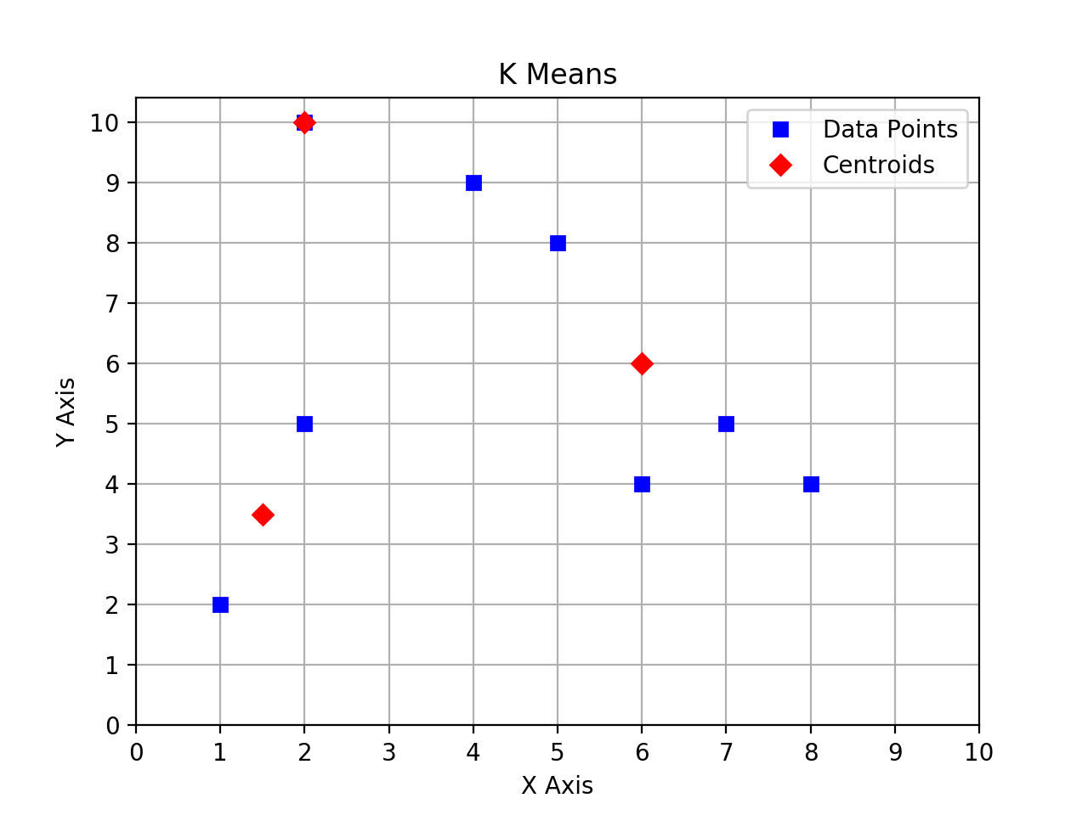

Compute the Euclidian distance

A -> α = This is the rendered form of the equation. You can not edit this directly. Right click will give you the option to save the image, and in most browsers you can drag the image onto your desktop or another program. B -> α = 0 C -> α = This is the rendered form of the equation. You can not edit this directly. Right click will give you the option to save the image, and in most browsers you can drag the image onto your desktop or another program. D -> α = 5

A -> β = This is the rendered form of the equation. You can not edit this directly. Right click will give you the option to save the image, and in most browsers you can drag the image onto your desktop or another program. B -> β = This is the rendered form of the equation. You can not edit this directly. Right click will give you the option to save the image, and in most browsers you can drag the image onto your desktop or another program. C -> β = This is the rendered form of the equation. You can not edit this directly. Right click will give you the option to save the image, and in most browsers you can drag the image onto your desktop or another program. D -> β = This is the rendered form of the equation. You can not edit this directly. Right click will give you the option to save the image, and in most browsers you can drag the image onto your desktop or another program.

A -> γ = This is the rendered form of the equation. You can not edit this directly. Right click will give you the option to save the image, and in most browsers you can drag the image onto your desktop or another program. B -> γ = This is the rendered form of the equation. You can not edit this directly. Right click will give you the option to save the image, and in most browsers you can drag the image onto your desktop or another program. C -> γ = This is the rendered form of the equation. You can not edit this directly. Right click will give you the option to save the image, and in most browsers you can drag the image onto your desktop or another program. D -> γ = This is the rendered form of the equation. You can not edit this directly. Right click will give you the option to save the image, and in most browsers you can drag the image onto your desktop or another program.

E -> α = This is the rendered form of the equation. You can not edit this directly. Right click will give you the option to save the image, and in most browsers you can drag the image onto your desktop or another program. F -> α = This is the rendered form of the equation. You can not edit this directly. Right click will give you the option to save the image, and in most browsers you can drag the image onto your desktop or another program. G -> α = This is the rendered form of the equation. You can not edit this directly. Right click will give you the option to save the image, and in most browsers you can drag the image onto your desktop or another program. H -> α = This is the rendered form of the equation. You can not edit this directly. Right click will give you the option to save the image, and in most browsers you can drag the image onto your desktop or another program.

E -> β = This is the rendered form of the equation. You can not edit this directly. Right click will give you the option to save the image, and in most browsers you can drag the image onto your desktop or another program. F -> β = This is the rendered form of the equation. You can not edit this directly. Right click will give you the option to save the image, and in most browsers you can drag the image onto your desktop or another program. G -> β = This is the rendered form of the equation. You can not edit this directly. Right click will give you the option to save the image, and in most browsers you can drag the image onto your desktop or another program. H -> β =This is the rendered form of the equation. You can not edit this directly. Right click will give you the option to save the image, and in most browsers you can drag the image onto your desktop or another program.

E -> γ = 2 F -> γ = This is the rendered form of the equation. You can not edit this directly. Right click will give you the option to save the image, and in most browsers you can drag the image onto your desktop or another program. G -> γ = This is the rendered form of the equation. You can not edit this directly. Right click will give you the option to save the image, and in most browsers you can drag the image onto your desktop or another program. H -> γ = This is the rendered form of the equation. You can not edit this directly. Right click will give you the option to save the image, and in most browsers you can drag the image onto your desktop or another program.

3) Recompute centroids for each cluster

Given 8 dots: A (4, 9) B (2, 10) C (1, 2) D (2, 5) E (6, 4) F (8, 4) G (7, 5) H (5, 8)

New centroids: α (3, 9.5) β (1.5, 3.5) γ (6.5, 5.25)

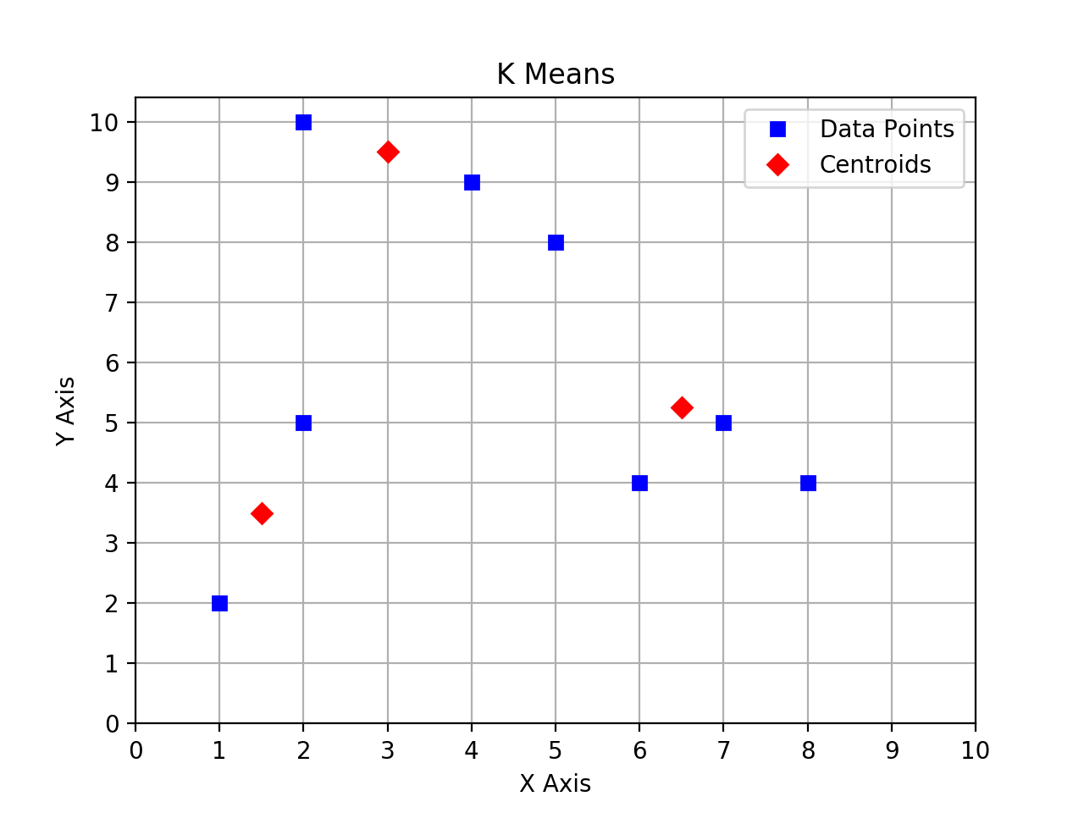

Compute the Euclidian distance

A -> α = This is the rendered form of the equation. You can not edit this directly. Right click will give you the option to save the image, and in most browsers you can drag the image onto your desktop or another program. B -> α = This is the rendered form of the equation. You can not edit this directly. Right click will give you the option to save the image, and in most browsers you can drag the image onto your desktop or another program. C -> α = This is the rendered form of the equation. You can not edit this directly. Right click will give you the option to save the image, and in most browsers you can drag the image onto your desktop or another program. D -> α = This is the rendered form of the equation. You can not edit this directly. Right click will give you the option to save the image, and in most browsers you can drag the image onto your desktop or another program.

A -> β = This is the rendered form of the equation. You can not edit this directly. Right click will give you the option to save the image, and in most browsers you can drag the image onto your desktop or another program. B -> β = This is the rendered form of the equation. You can not edit this directly. Right click will give you the option to save the image, and in most browsers you can drag the image onto your desktop or another program. C -> β = This is the rendered form of the equation. You can not edit this directly. Right click will give you the option to save the image, and in most browsers you can drag the image onto your desktop or another program. D -> β = This is the rendered form of the equation. You can not edit this directly. Right click will give you the option to save the image, and in most browsers you can drag the image onto your desktop or another program.

A -> γ = This is the rendered form of the equation. You can not edit this directly. Right click will give you the option to save the image, and in most browsers you can drag the image onto your desktop or another program. B -> γ = This is the rendered form of the equation. You can not edit this directly. Right click will give you the option to save the image, and in most browsers you can drag the image onto your desktop or another program. C -> γ = This is the rendered form of the equation. You can not edit this directly. Right click will give you the option to save the image, and in most browsers you can drag the image onto your desktop or another program. D -> γ = This is the rendered form of the equation. You can not edit this directly. Right click will give you the option to save the image, and in most browsers you can drag the image onto your desktop or another program.

E -> α = This is the rendered form of the equation. You can not edit this directly. Right click will give you the option to save the image, and in most browsers you can drag the image onto your desktop or another program. F -> α = This is the rendered form of the equation. You can not edit this directly. Right click will give you the option to save the image, and in most browsers you can drag the image onto your desktop or another program. G -> α = This is the rendered form of the equation. You can not edit this directly. Right click will give you the option to save the image, and in most browsers you can drag the image onto your desktop or another program. H -> α = This is the rendered form of the equation. You can not edit this directly. Right click will give you the option to save the image, and in most browsers you can drag the image onto your desktop or another program.

E -> β = This is the rendered form of the equation. You can not edit this directly. Right click will give you the option to save the image, and in most browsers you can drag the image onto your desktop or another program. F -> β = This is the rendered form of the equation. You can not edit this directly. Right click will give you the option to save the image, and in most browsers you can drag the image onto your desktop or another program. G -> β = This is the rendered form of the equation. You can not edit this directly. Right click will give you the option to save the image, and in most browsers you can drag the image onto your desktop or another program. H -> β =This is the rendered form of the equation. You can not edit this directly. Right click will give you the option to save the image, and in most browsers you can drag the image onto your desktop or another program.

E -> γ = This is the rendered form of the equation. You can not edit this directly. Right click will give you the option to save the image, and in most browsers you can drag the image onto your desktop or another program. F -> γ = This is the rendered form of the equation. You can not edit this directly. Right click will give you the option to save the image, and in most browsers you can drag the image onto your desktop or another program. G -> γ = This is the rendered form of the equation. You can not edit this directly. Right click will give you the option to save the image, and in most browsers you can drag the image onto your desktop or another program. H -> γ = This is the rendered form of the equation. You can not edit this directly. Right click will give you the option to save the image, and in most browsers you can drag the image onto your desktop or another program.

4) Recompute centroids for each cluster

Given 8 dots: A (4, 9) B (2, 10) C (1, 2) D (2, 5) E (6, 4) F (8, 4) G (7, 5) H (5, 8)

New centroids: α (11/3, 9) β (1.5, 3.5) γ (7, 13/3)

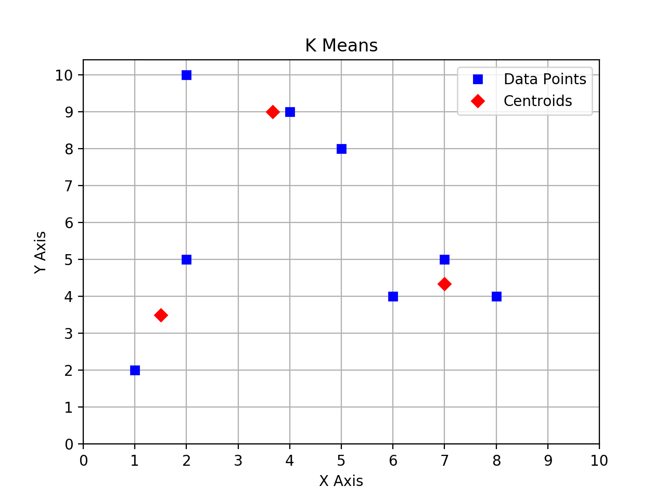

Compute the Euclidian distance

A -> α = 1/3 B -> α = 1.94 C -> α = 7.49 D -> α = 4.33

A -> β = This is the rendered form of the equation. You can not edit this directly. Right click will give you the option to save the image, and in most browsers you can drag the image onto your desktop or another program. B -> β = This is the rendered form of the equation. You can not edit this directly. Right click will give you the option to save the image, and in most browsers you can drag the image onto your desktop or another program. C -> β = This is the rendered form of the equation. You can not edit this directly. Right click will give you the option to save the image, and in most browsers you can drag the image onto your desktop or another program. D -> β = This is the rendered form of the equation. You can not edit this directly. Right click will give you the option to save the image, and in most browsers you can drag the image onto your desktop or another program.

A -> γ = 5.55 B -> γ = 7.56 C -> γ = 6.44 D -> γ = 5.04

E -> α = 5.52 F -> α = 6.62 G -> α = 5.21 H -> α = 1.67

E -> β = This is the rendered form of the equation. You can not edit this directly. Right click will give you the option to save the image, and in most browsers you can drag the image onto your desktop or another program. F -> β = This is the rendered form of the equation. You can not edit this directly. Right click will give you the option to save the image, and in most browsers you can drag the image onto your desktop or another program. G -> β = This is the rendered form of the equation. You can not edit this directly. Right click will give you the option to save the image, and in most browsers you can drag the image onto your desktop or another program. H -> β =This is the rendered form of the equation. You can not edit this directly. Right click will give you the option to save the image, and in most browsers you can drag the image onto your desktop or another program.

E -> γ = 1.05 F -> γ = 1.05 G -> γ = 0.67 H -> γ = 4.18

Realizing that the centroids are not changing this time. K-Means converges. The plot is drawn as below.

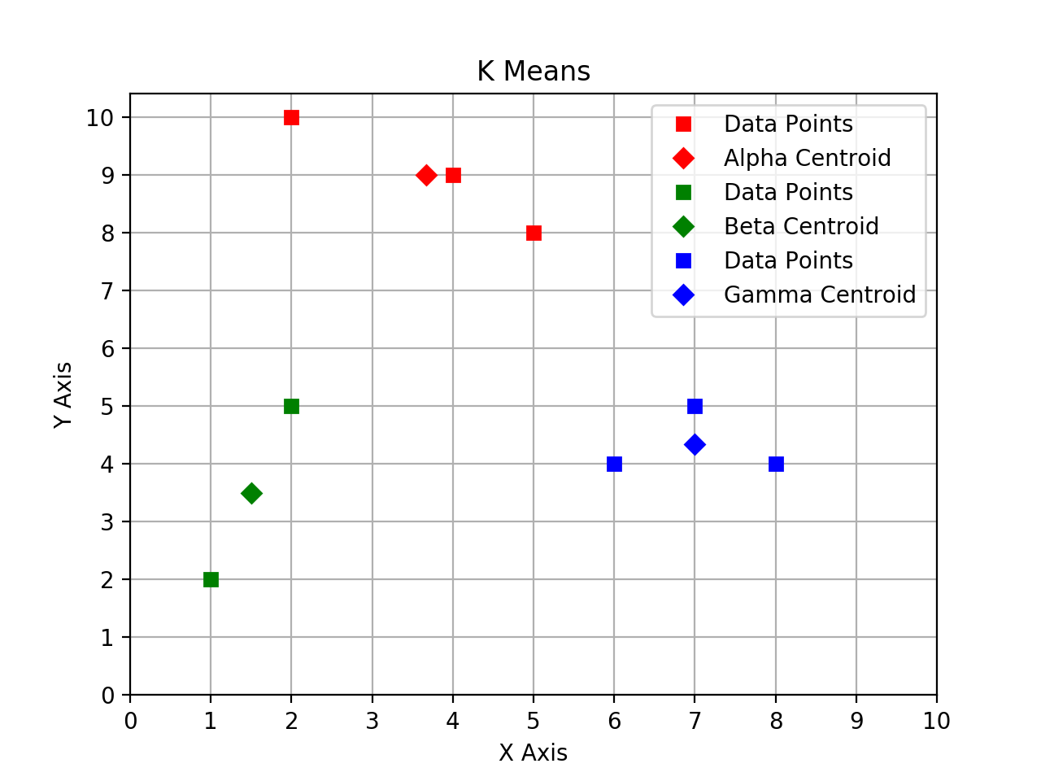

2. Agglomerative Hierarchical

MIN Link:

|  |  |  |
| --- | --- | --- |
|  | x | y |
| p1 | 0.40 | 0.53 |
| p2 | 0.21 | 0.38 |
| p3 | 0.35 | 0.32 |
| p4 | 0.26 | 0.19 |
| p5 | 0.08 | 0.41 |
| p6 | 0.45 | 0.30 |

|  |  |  |  |  |  |  |
| --- | --- | --- | --- | --- | --- | --- |
|  | p1 | p2 | p3 | p4 | p5 | p6 |
| p1 |  |  |  |  |  |  |
| p2 | 0.242074 |  |  |  |  |  |
| p3 | 0.21587 | 0.152315 |  |  |  |  |
| p4 | 0.367696 | 0.196469 | 0.158114 |  |  |  |
| p5 | 0.34176 | 0.133417 | 0.284605 | 0.284253 |  |  |
| p6 | 0.235372 | 0.252982 | 0.10198 | 0.219545 | 0.386005 |  |

First Cluster: {3, 6}

d({1},{3,6}) = min( d({1},{3}), d({1},{6}) ) = d({1},{3})

d({2},{3,6}) = min( d({2},{3}), d({2},{6}) ) = d({2},{3})

d({4},{3,6}) = min( d({4},{3}), d({4},{6}) ) = d({4},{3})

d({5},{3,6}) = min( d({5},{3}), d({5},{6}) ) = d({5},{3})

Merge two closest clusters for MIN:

|  |  |  |
| --- | --- | --- |
|  | x | y |
| p1 | 0.40 | 0.53 |
| p2 | 0.21 | 0.38 |
| p3 | 0.35 | 0.32 |
| p4 | 0.26 | 0.19 |
| p5 | 0.08 | 0.41 |
| p6 | 0.45 | 0.30 |

|  |  |  |  |  |  |  |
| --- | --- | --- | --- | --- | --- | --- |
|  | p1 | p2 | p3 | p4 | p5 | p6 |
| p1 |  |  |  |  |  |  |
| p2 | 0.242074 |  |  |  |  |  |
| p3 | 0.21587 | 0.152315 |  |  |  |  |
| p4 | 0.367696 | 0.196469 | 0.158114 |  |  |  |
| p5 | 0.34176 | 0.133417 | 0.284605 | 0.284253 |  |  |
| p6 | ~~0.235372~~ | ~~0.252982~~ | ~~0.10198~~ | ~~0.219545~~ | ~~0.386005~~ |  |

Second Cluster: {2, 5}

d({1},{2,5}) = min( d({1},{2}), d({1},{5}) ) = d({1},{2})

d({3},{2,5}) = min( d({2},{3}), d({3},{5}) ) = d({2},{3})

d({4},{2,5}) = min( d({4},{2}), d({4},{5}) ) = d({4},{2})

Merge two closest clusters for MIN:

|  |  |  |
| --- | --- | --- |
|  | x | y |
| p1 | 0.40 | 0.53 |
| p2 | 0.21 | 0.38 |
| p3 | 0.35 | 0.32 |
| p4 | 0.26 | 0.19 |
| p5 | 0.08 | 0.41 |
| p6 | 0.45 | 0.30 |

|  |  |  |  |  |  |  |
| --- | --- | --- | --- | --- | --- | --- |
|  | p1 | p2 | p3 | p4 | p5 | p6 |
| p1 |  |  |  |  |  |  |
| p2 | 0.242074 |  |  |  |  |  |
| p3 | 0.21587 | 0.152315 |  |  |  |  |
| p4 | 0.367696 | 0.196469 | 0.158114 |  |  |  |
| p5 | ~~0.34176~~ | ~~0.133417~~ | ~~0.284605~~ | ~~0.284253~~ |  |  |
| p6 | ~~0.235372~~ | ~~0.252982~~ | ~~0.10198~~ | ~~0.219545~~ | ~~0.386005~~ |  |

Third Cluster: {2, 3}

d({1},{2, 3}) = min( d({1},{2}), d({1},{3}) ) = d({1},{3})

d({4},{2, 3}) = min( d({2},{4}), d({3},{4}) ) = d({3},{4})

Merge two closest clusters for MIN:

|  |  |  |
| --- | --- | --- |
|  | x | y |
| p1 | 0.40 | 0.53 |
| p2 | 0.21 | 0.38 |
| p3 | 0.35 | 0.32 |
| p4 | 0.26 | 0.19 |
| p5 | 0.08 | 0.41 |
| p6 | 0.45 | 0.30 |

|  |  |  |  |  |  |  |
| --- | --- | --- | --- | --- | --- | --- |
|  | p1 | p2 | p3 | p4 | p5 | p6 |
| p1 |  |  |  |  |  |  |
| p2 | ~~0.242074~~ |  |  |  |  |  |
| p3 | 0.21587 | ~~0.152315~~ |  |  |  |  |
| p4 | 0.367696 | ~~0.196469~~ | 0.158114 |  |  |  |
| p5 | ~~0.34176~~ | ~~0.133417~~ | 0.284605 | ~~0.284253~~ |  |  |
| p6 | ~~0.235372~~ | ~~0.252982~~ | ~~0.10198~~ | ~~0.219545~~ | ~~0.386005~~ |  |

Fourth Cluster: {3, 4}

Therefore, {1} and {2, 3, 4, 5, 6}

MAX Link:

|  |  |  |
| --- | --- | --- |
|  | x | y |
| p1 | 0.40 | 0.53 |
| p2 | 0.21 | 0.38 |
| p3 | 0.35 | 0.32 |
| p4 | 0.26 | 0.19 |
| p5 | 0.08 | 0.41 |
| p6 | 0.45 | 0.30 |

|  |  |  |  |  |  |  |
| --- | --- | --- | --- | --- | --- | --- |
|  | p1 | p2 | p3 | p4 | p5 | p6 |
| p1 |  |  |  |  |  |  |
| p2 | 0.242074 |  |  |  |  |  |
| p3 | 0.21587 | 0.152315 |  |  |  |  |
| p4 | 0.367696 | 0.196469 | 0.158114 |  |  |  |
| p5 | 0.34176 | 0.133417 | 0.284605 | 0.284253 |  |  |
| p6 | 0.235372 | 0.252982 | 0.10198 | 0.219545 | 0.386005 |  |

Merge two closest clusters for MAX:

|  |  |  |
| --- | --- | --- |
|  | x | y |
| p1 | 0.40 | 0.53 |
| p2 | 0.21 | 0.38 |
| p3 | 0.35 | 0.32 |
| p4 | 0.26 | 0.19 |
| p5 | 0.08 | 0.41 |
| p6 | 0.45 | 0.30 |

|  |  |  |  |  |  |  |
| --- | --- | --- | --- | --- | --- | --- |
|  | p1 | p2 | p3 | p4 | p5 | p6 |
| p1 |  |  |  |  |  |  |
| p2 | 0.242074 |  |  |  |  |  |
| p3 | ~~0.21587~~ | ~~0.152315~~ |  |  |  |  |
| p4 | 0.367696 | 0.196469 | ~~0.158114~~ |  |  |  |
| p5 | 0.34176 | 0.133417 | ~~0.284605~~ | 0.284253 |  |  |
| p6 | 0.235372 | 0.252982 | ~~0.10198~~ | 0.219545 | 0.386005 |  |

First Cluster: {3, 6}

d({1},{3,6}) = max( d({1},{3}), d({1},{6}) ) = d({1},{6})

d({2},{3,6}) = max( d({2},{3}), d({2},{6}) ) = d({2},{6})

d({4},{3,6}) = max( d({4},{3}), d({4},{6}) ) = d({4},{6})

d({5},{3,6}) = max( d({5},{3}), d({5},{6}) ) = d({5},{6})

Merge two closest clusters for MAX:

|  |  |  |
| --- | --- | --- |
|  | x | y |
| p1 | 0.40 | 0.53 |
| p2 | 0.21 | 0.38 |
| p3 | 0.35 | 0.32 |
| p4 | 0.26 | 0.19 |
| p5 | 0.08 | 0.41 |
| p6 | 0.45 | 0.30 |

|  |  |  |  |  |  |  |
| --- | --- | --- | --- | --- | --- | --- |
|  | p1 | p2 | p3 | p4 | p5 | p6 |
| p1 |  |  |  |  |  |  |
| p2 | ~~0.242074~~ |  |  |  |  |  |
| p3 | ~~0.21587~~ | ~~0.152315~~ |  |  |  |  |
| p4 | 0.367696 | ~~0.196469~~ | ~~0.158114~~ |  |  |  |
| p5 | 0.34176 | ~~0.133417~~ | ~~0.284605~~ | 0.284253 |  |  |
| p6 | 0.235372 | ~~0.252982~~ | ~~0.10198~~ | 0.219545 | 0.386005 |  |

Second Cluster: {2, 5}

d({1},{2,5}) = max( d({1},{2}), d({1},{5}) ) = d({1},{5})

d({4},{2,5}) = max( d({2},{4}), d({4},{5}) ) = d({4},{5})

d({6},{2,5}) = max( d({2},{6}), d({5},{6}) ) = d({5},{6})

Merge two closest clusters for MAX:

|  |  |  |
| --- | --- | --- |
|  | x | y |
| p1 | 0.40 | 0.53 |
| p2 | 0.21 | 0.38 |
| p3 | 0.35 | 0.32 |
| p4 | 0.26 | 0.19 |
| p5 | 0.08 | 0.41 |
| p6 | 0.45 | 0.30 |

|  |  |  |  |  |  |  |
| --- | --- | --- | --- | --- | --- | --- |
|  | p1 | p2 | p3 | p4 | p5 | p6 |
| p1 |  |  |  |  |  |  |
| p2 | ~~0.242074~~ |  |  |  |  |  |
| p3 | ~~0.21587~~ | ~~0.152315~~ |  |  |  |  |
| p4 | 0.367696 | ~~0.196469~~ | ~~0.158114~~ |  |  |  |
| p5 | 0.34176 | ~~0.133417~~ | ~~0.284605~~ | ~~0.284253~~ |  |  |
| p6 | ~~0.235372~~ | ~~0.252982~~ | ~~0.10198~~ | ~~0.219545~~ | 0.386005 |  |

Third Cluster: {4, 6}

d({1},{4,6}) = max( d({1},{4}), d({1},{6}) ) = d({1},{4})

d({5},{4,6}) = max( d({4},{5}), d({5},{6}) ) = d({5},{6})

Merge two closest clusters for MAX:

|  |  |  |
| --- | --- | --- |
|  | x | y |
| p1 | 0.40 | 0.53 |
| p2 | 0.21 | 0.38 |
| p3 | 0.35 | 0.32 |
| p4 | 0.26 | 0.19 |
| p5 | 0.08 | 0.41 |
| p6 | 0.45 | 0.30 |

|  |  |  |  |  |  |  |
| --- | --- | --- | --- | --- | --- | --- |
|  | p1 | p2 | p3 | p4 | p5 | p6 |
| p1 |  |  |  |  |  |  |
| p2 | ~~0.242074~~ |  |  |  |  |  |
| p3 | ~~0.21587~~ | ~~0.152315~~ |  |  |  |  |
| p4 | 0.367696 | ~~0.196469~~ | ~~0.158114~~ |  |  |  |
| p5 | 0.34176 | ~~0.133417~~ | ~~0.284605~~ | ~~0.284253~~ |  |  |
| p6 | ~~0.235372~~ | ~~0.252982~~ | ~~0.10198~~ | ~~0.219545~~ | 0.386005 |  |

Fourth Cluster: {1, 5}

Therefore, {1, 2, 5} and {3, 4, 6}

AVG:

|  |  |  |
| --- | --- | --- |
|  | x | y |
| p1 | 0.40 | 0.53 |
| p2 | 0.21 | 0.38 |
| p3 | 0.35 | 0.32 |
| p4 | 0.26 | 0.19 |
| p5 | 0.08 | 0.41 |
| p6 | 0.45 | 0.30 |

|  |  |  |  |  |  |  |
| --- | --- | --- | --- | --- | --- | --- |
|  | p1 | p2 | p3 | p4 | p5 | p6 |
| p1 |  |  |  |  |  |  |
| p2 | 0.242074 |  |  |  |  |  |
| p3 | 0.21587 | 0.152315 |  |  |  |  |
| p4 | 0.367696 | 0.196469 | 0.158114 |  |  |  |
| p5 | 0.34176 | 0.133417 | 0.284605 | 0.284253 |  |  |
| p6 | 0.235372 | 0.252982 | **0.10198** | 0.219545 | 0.386005 |  |

First Cluster: {3, 6}

|  |  |  |  |  |  |
| --- | --- | --- | --- | --- | --- |
|  | p1 | p2 | p4 | p5 | p3,p6 |
| p2 | 0.242074 |  |  |  |  |
| p4 | 0.367696 | 0.196469 |  |  |  |
| p5 | 0.34176 | **0.133417** | 0.284253 |  |  |
| p3, p6 | 0.225621 | 0.2026485 | 0.1888295 | 0.335305 |  |

Second Cluster: {2,5}

|  |  |  |  |  |
| --- | --- | --- | --- | --- |
|  | p1 | p4 | p2, p5 | p3, p6 |
| p4 | 0.367696 |  |  |  |
| p2, p5 | 0.291917 | 0.240361 |  |  |
| p3, p6 | 0.225621 | **0.1888295** | 0.26897675 |  |

Third Cluster: {3,4,6}

Therefore, {1}, {2, 3, 4, 5, 6}

3.

Condition: (ε = 7.5, MinPts = 3).

pt 0: 2 < MinPts, so cluster=-1

pt 1: 3 ≥ MinPts, so cluster=0, to visit=[40, 75], visited={1}

• pt 40: cluster=0, 3 ≥ MinPts, so adding neighbors to_visit=[75, 28], visited={1, 40}

• pt 75: cluster=0, 3 ≥ MinPts, so adding neighbors to_visit=[28, 4], visited={1, 40, 75}

• pt 28: cluster=0, 3 ≥ MinPts, so adding neighbors to_visit=[4, 12], visited={1, 28, 40, 75}

• pt 4: cluster=0, 3 ≥ MinPts, so adding neighbors to_visit=[12, 56], visited={1, 4, 28, 40, 75}

• pt 12: cluster=0, 2 < MinPts, to_visit=[56], visited={1, 4, 12, 28, 40, 75}

• pt 56: cluster=0, 3 ≥ MinPts, so adding neighbors to_visit=[66], visited={1, 4, 12, 28, 40, 56, 75}

• pt 66: cluster=0, 2 < MinPts to_visit=[], visited={1, 4, 12, 28, 40, 56, 66, 75}

pt 2: 1 < MinPts, so cluster=-1

pt 3: 2 < MinPts, so cluster=-1

pt 4: cluster=0, so skip

pt 5: 3 ≥ MinPts, so cluster=1 to visit=[70, 74], visited={5}:

• pt 70: cluster=1, 5 ≥ MinPts, so adding neighbors to_visit=[74, 32, 69, 72], visited={5, 70}

• pt 74: cluster=1, 4 ≥ MinPts, so adding neighbors to_visit=[32, 69, 72, 19, 54], visited={5, 70, 74}

• pt 32: cluster=1, 5 ≥ MinPts, so adding neighbors to_visit=[69, 72, 19, 54, 63, 69], visited={5, 32, 70, 74}

• pt 69: cluster=1, 4 ≥ MinPts, so adding neighbors to_visit=[72, 19, 54, 63], visited={5, 32, 69, 70, 74}

• pt 72: cluster=1, 7 ≥ MinPts, so adding neighbors to_visit=[19, 54, 63, 8, 60], visited={5, 32, 69, 70, 72, 74}

• pt 19: cluster=1, 3 ≥ MinPts, so adding neighbors to_visit=[54, 63, 8, 60], visited={5, 19, 32, 69, 70, 72, 74}

• pt 54: cluster=1, 4 ≥ MinPts, so adding neighbors to_visit=[63, 8, 60, 25], visited={5, 19, 32, 54, 69, 70, 72, 74}

• pt 63: cluster=1, 7 ≥ MinPts, so adding neighbors to_visit=[8, 60, 25], visited={5, 19, 32, 54, 63, 69, 70, 72, 74}

• pt 8: cluster=1, 5 ≥ MinPts, so adding neighbors to_visit=[60, 25, 11], visited={5, 8, 19, 32, 54, 63, 69, 70, 72, 74}

• pt 60: cluster=1, 6 ≥ MinPts, so adding neighbors to_visit=[25, 11, 50, 68], visited={5, 8, 19, 32, 54, 60, 63, 69, 70, 72, 74}

• pt 25: cluster=1, 4 ≥ MinPts, so adding neighbors to_visit=[11, 50, 68, 26, 67], visited={5, 8, 19, 25, 32, 54, 60, 63, 69, 70, 72, 74}

• pt 11: cluster=1, 3 ≥ MinPts, so adding neighbors to_visit=[50, 68, 26, 67, 14], visited={5, 8, 11, 19, 25, 32, 54, 60, 63, 69, 70, 72, 74}

• pt 50: cluster=1, 5 ≥ MinPts, so adding neighbors to_visit=[68, 26, 67, 14, 39], visited={5, 8, 11, 19, 25, 32, 50, 54, 60, 63, 69, 70, 72, 74}

• pt 68: cluster=1, 5 ≥ MinPts, so adding neighbors to_visit=[26, 67, 14, 39], visited={5, 8, 11, 19, 25, 32, 50, 54, 60, 63, 68, 69, 70, 72, 74}

• pt 26: cluster=1, 3 ≥ MinPts, so adding neighbors to_visit=[67, 14, 39, 34], visited={5, 8, 11, 19, 25, 26, 32, 50, 54, 60, 63, 68, 69, 70, 72, 74}

• pt 67: cluster=1, 2 < MinPts, to_visit=[14, 39, 34], visited={5, 8, 11, 19, 25, 26, 32, 50, 54, 60, 63, 67, 68, 69, 70, 72, 74}

• pt 14: cluster=1, 3 ≥ MinPts, so adding neighbors to_visit=[39, 34, 6], visited={5, 8, 11, 14, 19, 25, 26, 32, 50, 54, 60, 63, 68, 69, 70, 72, 74}

• pt 39: cluster=1, 3 ≥ MinPts, so adding neighbors to_visit=[34, 6, 10, 71], visited={5, 8, 11, 14, 19, 25, 26, 32, 39, 50, 54, 60, 63, 68, 69, 70, 72, 74}

• pt 34: cluster=1, 4 ≥ MinPts, so adding neighbors to_visit=[6, 10, 71, 29, 46], visited={5, 8, 11, 14, 19, 25, 26, 32, 34, 39, 50, 54, 60, 63, 68, 69, 70, 72, 74}

• pt 6: cluster=1, 3 ≥ MinPts, so adding neighbors to_visit=[10, 71, 29, 46, 42], visited={5, 6, 8, 11, 14, 19, 25, 26, 32, 34, 39, 50, 54, 60, 63, 68, 69, 70, 72, 74}

• pt 10: cluster=1, 3 ≥ MinPts, so adding neighbors to_visit=[71, 29, 46, 42, 22], visited={5, 6, 8, 10, 11, 14, 19, 25, 26, 32, 34, 39, 50, 54, 60, 63, 68, 69, 70, 72, 74}

• pt 71: cluster=1, 4 ≥ MinPts, so adding neighbors to_visit=[29, 46, 42, 22], visited={5, 6, 8, 10, 11, 14, 19, 25, 26, 32, 34, 39, 50, 54, 60, 63, 68, 69, 70, 71, 72, 74}

• pt 29: cluster=1, 4 ≥ MinPts, so adding neighbors to_visit=[46, 42, 22, 16], visited={5, 6, 8, 10, 11, 14, 19, 25, 26, 29, 32, 34, 39, 50, 54, 60, 63, 68, 69, 70, 71, 72, 74}

• pt 46: cluster=1, 4 ≥ MinPts, so adding neighbors to_visit=[42, 22, 16], visited={5, 6, 8, 10, 11, 14, 19, 25, 26, 29, 32, 34, 39, 46, 50, 54, 60, 63, 68, 69, 70, 71, 72, 74}

• pt 42: cluster=1, 4 ≥ MinPts, so adding neighbors to_visit=[22, 16, 17, 20], visited={5, 6, 8, 10, 11, 14, 19, 25, 26, 29, 32, 34, 39, 42, 46, 50, 54, 60, 63, 68, 69, 70, 71, 72, 74}

• pt 22: cluster=1, 3 ≥ MinPts, so adding neighbors to_visit=[16, 17, 20], visited={5, 6, 8, 10, 11, 14, 19, 22, 25, 26, 29, 32, 34, 39, 42, 46, 50, 54, 60, 63, 68, 69, 70, 71, 72, 74}

• pt 16: cluster=1, 4 ≥ MinPts, so adding neighbors to_visit=[17, 20, 48], visited={5, 6, 8, 10, 11, 14, 16, 19, 22, 25, 26, 29, 32, 34, 39, 42, 46, 50, 54, 60, 63, 68, 69, 70, 71, 72, 74}

• pt 17: cluster=1, 3 ≥ MinPts, so adding neighbors to_visit=[20, 48], visited={5, 6, 8, 10, 11, 14, 16, 17, 19, 22, 25, 26, 29, 32, 34, 39, 42, 46, 50, 54, 60, 63, 68, 69, 70, 71, 72, 74}

• pt 20: cluster=1, 4 ≥ MinPts, so adding neighbors to_visit=[48, 38], visited={5, 6, 8, 10, 11, 14, 16, 17, 19, 20, 22, 25, 26, 29, 32, 34, 39, 42, 46, 50, 54, 60, 63, 68, 69, 70, 71, 72, 74}

• pt 48: cluster=1, 2 < MinPts, to_visit=[38], visited={5, 6, 8, 10, 11, 14, 16, 17, 19, 20, 22, 25, 26, 29, 32, 34, 39, 42, 46, 48, 50, 54, 60, 63, 68, 69, 70, 71, 72, 74}

• pt 38: cluster=1, 5 ≥ MinPts, so adding neighbors to_visit=[30, 37, 45], visited={5, 6, 8, 10, 11, 14, 16, 17, 19, 20, 22, 25, 26, 29, 32, 34, 38, 39, 42, 46, 48, 50, 54, 60, 63, 68, 69, 70, 71, 72, 74}

• pt 30: cluster=1, 4 ≥ MinPts, so adding neighbors to_visit=[37, 45, 52], visited={5, 6, 8, 10, 11, 14, 16, 17, 19, 20, 22, 25, 26, 29, 30, 32, 34, 38, 39, 42, 46, 48, 50, 54, 60, 63, 68, 69, 70, 71, 72, 74}

• pt 37: cluster=1, 4 ≥ MinPts, so adding neighbors to_visit=[45, 52, 53], visited={5, 6, 8, 10, 11, 14, 16, 17, 19, 20, 22, 25, 26, 29, 30, 32, 34, 37, 38, 39, 42, 46, 48, 50, 54, 60, 63, 68, 69, 70, 71, 72, 74}

• pt 45: cluster=1, 4 ≥ MinPts, so adding neighbors to_visit=[52, 53], visited={5, 6, 8, 10, 11, 14, 16, 17, 19, 20, 22, 25, 26, 29, 30, 32, 34, 37, 38, 39, 42, 45, 46, 48, 50, 54, 60, 63, 68, 69, 70, 71, 72, 74}

• pt 52: cluster=1, 4 ≥ MinPts, so adding neighbors to_visit=[53, 49, 64], visited={5, 6, 8, 10, 11, 14, 16, 17, 19, 20, 22, 25, 26, 29, 30, 32, 34, 37, 38, 39, 42, 45, 46, 48, 50, 52, 54, 60, 63, 68, 69, 70, 71, 72, 74}

• pt 53: cluster=1, 3 ≥ MinPts, so adding neighbors to_visit=[49, 64, 47], visited={5, 6, 8, 10, 11, 14, 16, 17, 19, 20, 22, 25, 26, 29, 30, 32, 34, 37, 38, 39, 42, 45, 46, 48, 50, 52, 53, 54, 60, 63, 68, 69, 70, 71, 72, 74}

• pt 49: cluster=1, 4 ≥ MinPts, so adding neighbors to_visit=[64, 47, 31, 76], visited={5, 6, 8, 10, 11, 14, 16, 17, 19, 20, 22, 25, 26, 29, 30, 32, 34, 37, 38, 39, 42, 45, 46, 48, 49, 50, 52, 53, 54, 60, 63, 68, 69, 70, 71, 72, 74}

• pt 64: cluster=1, 2 < MinPts, to_visit=[47, 31, 76], visited={5, 6, 8, 10, 11, 14, 16, 17, 19, 20, 22, 25, 26, 29, 30, 32, 34, 37, 38, 39, 42, 45, 46, 48, 49, 50, 52, 53, 54, 60, 63, 64, 68, 69, 70, 71, 72, 74}

• pt 47: cluster=1, 2 < MinPts, to_visit=[31, 76], visited={5, 6, 8, 10, 11, 14, 16, 17, 19, 20, 22, 25, 26, 29, 30, 32, 34, 37, 38, 39, 42, 45, 46, 47, 48, 49, 50, 52, 53, 54, 60, 63, 64, 68, 69, 70, 71, 72, 74}

• pt 31: cluster=1, 2 < MinPts, to_visit=[76], visited={5, 6, 8, 10, 11, 14, 16, 17, 19, 20, 22, 25, 26, 29, 30, 31, 32, 34, 37, 38, 39, 42, 45, 46, 47, 48, 49, 50, 52, 53, 54, 60, 63, 64, 68, 69, 70, 71, 72, 74}

• pt 76: cluster=1, 3 ≥ MinPts, so adding neighbors to_visit=[21], visited={5, 6, 8, 10, 11, 14, 16, 17, 19, 20, 22, 25, 26, 29, 30, 31, 32, 34, 37, 38, 39, 42, 45, 46, 47, 48, 49, 50, 52, 53, 54, 60, 63, 64, 68, 69, 70, 71, 72, 74}

• pt 21: cluster=1, 3 ≥ MinPts, so adding neighbors to_visit=[], visited={5, 6, 8, 10, 11, 14, 16, 17, 19, 20, 21, 22, 25, 26, 29, 30, 31, 32, 34, 37, 38, 39, 42, 45, 46, 47, 48, 49, 50, 52, 53, 54, 60, 63, 64, 68, 69, 70, 71, 72, 74}

pt 5: cluster=1, so skip

pt 6: cluster=1, so skip

pt 7: 1 < MinPts, so cluster=-1

pt 8: cluster=1, so skip

pt 9: 3 ≥ MinPts, so cluster=2, to visit=[33, 78], visited={9}

• pt 33: cluster=2, 3 ≥ MinPts, so adding neighbors to_visit=[78], visited={9, 33}

• pt 78: cluster=2, 3 ≥ MinPts, so adding neighbors to_visit=[], visited={9, 33, 78}

pt 10: cluster=1, so skip

pt 11: cluster=1, so skip

pt 12: cluster=0, so skip

pt 13: 2 < MinPts, so cluster=-1

pt 14: cluster=1, so skip

pt 15: 1 < MinPts, so cluster=-1

pt 16: cluster=1, so skip

pt 17: cluster=1, so skip

pt 18: 1 < MinPts, so cluster=-1

pt 19: cluster=1, so skip

pt 20: cluster=1, so skip

pt 21: cluster=1, so skip

pt 22: cluster=1, so skip

pt 23: 1 < MinPts, so cluster=-1

pt 24: 1 < MinPts, so cluster=-1

pt 25: cluster=1, so skip

pt 26: cluster=1, so skip

pt 27: 2 < MinPts, so cluster=-1

pt 28: cluster=0, so skip

pt 29: cluster=1, so skip

pt 30: cluster=1, so skip

pt 31: cluster=1, so skip

pt 32: cluster=1, so skip

pt 33: cluster=2, so skip

pt 34: cluster=1, so skip

pt 35: 2 < MinPts, so cluster=-1

pt 36: 1 < MinPts, so cluster=-1

pt 37: cluster=1, so skip

pt 38: cluster=1, so skip

pt 39: cluster=1, so skip

pt 40: cluster=0, so skip

pt 41: 1 < MinPts, so cluster=-1

pt 42: cluster=1, so skip

pt 43: 2 < MinPts, so cluster=-1

pt 44: 1 < MinPts, so cluster=-1

pt 45: cluster=1, so skip

pt 46: cluster=1, so skip

pt 47: cluster=1, so skip

pt 48: cluster=1, so skip

pt 49: cluster=1, so skip

pt 50: cluster=1, so skip

pt 51: 2 < MinPts, so cluster=-1

pt 52: cluster=1, so skip

pt 53: cluster=1, so skip

pt 54: cluster=1, so skip

pt 55: 2 < MinPts, so cluster=-1

pt 56: cluster=0, so skip

pt 57: 1 < MinPts, so cluster=-1

pt 58: 1 < MinPts, so cluster=-1

pt 59: 2 < MinPts, so cluster=-1

pt 60: cluster=1, so skip

pt 61: 1 < MinPts, so cluster=-1

pt 62: 2 < MinPts, so cluster=-1

pt 63: cluster=1, so skip

pt 64: cluster=1, so skip

pt 65: 1 < MinPts, so cluster=-1

pt 66: cluster=0, so skip

pt 67: cluster=1, so skip

pt 68: cluster=1, so skip

pt 69: cluster=1, so skip

pt 70: cluster=1, so skip

pt 71: cluster=1, so skip

pt 72: cluster=1, so skip

pt 73: 1 < MinPts, so cluster=-1

pt 74: cluster=1, so skip

pt 75: cluster=0, so skip

pt 76: cluster=1, so skip

pt 77: 2 < MinPts, so cluster=-1

pt 78: cluster=2, so skip

pt 79: 1 < MinPts, so cluster=-1

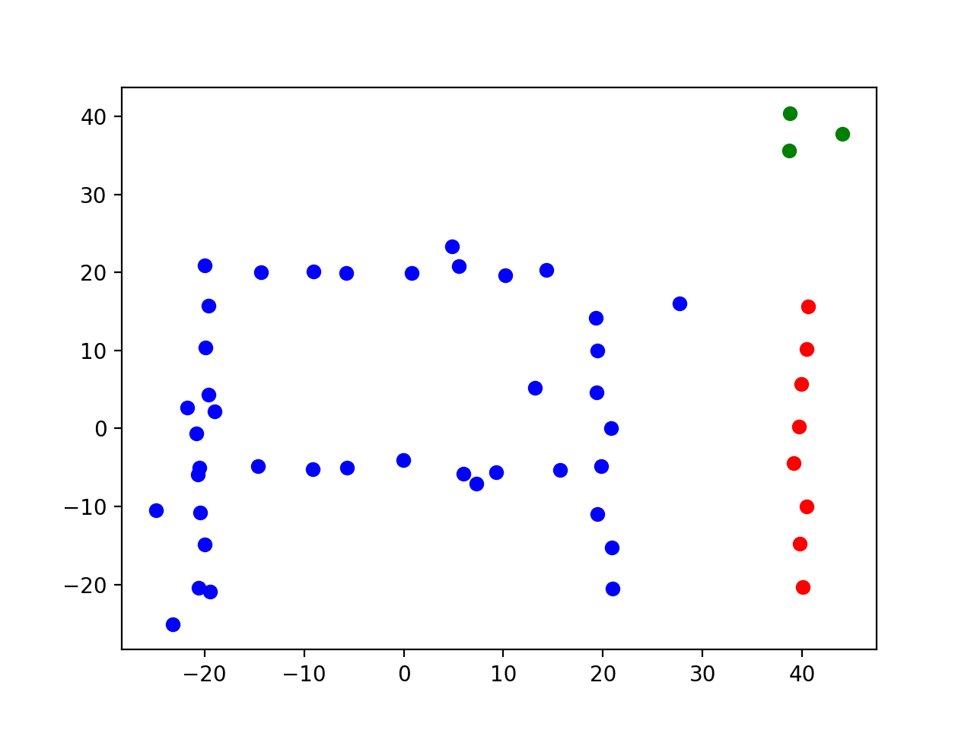

Extra credit:

Name: Thomas G. Dietterich

Employer: Oregon State University

3 interesting facts:

Born in South Weymouth MA

Known for Executive Editor of Machine Learning (92-98), founder of field machine learning

Honored Distinguished Professor by Oregon State in spring of 2013