ORIGINAL REFERENCE CONVERSATION – using VouchMe as the test case:

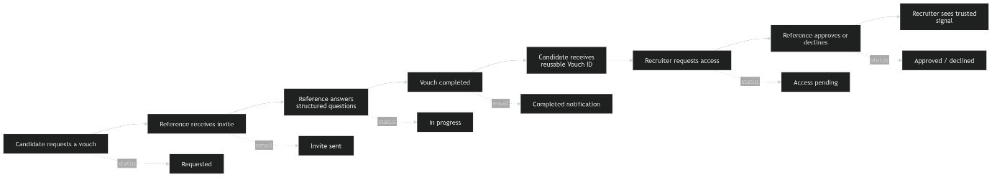
The top of each major page becomes a ringfenced Journey Header:
You are here: Candidate → Requesting a Vouch → Waiting for Reference
Next: Reference receives invite email
That instantly tells the user:
- who they are in the process
- where they are
- what has already happened
- what happens next
- who is responsible for the next action
This would make the product feel much clearer.
The core design pattern
I would call the reusable component something like:
JourneyMapHeader
or
VouchJourneyHeader
It would sit at the top of role pages and transactional pages.

Element | Purpose
Role badge | Candidate, Referee, Recruiter
“You are here” marker | Current stage in the process
Mini journey map | 4–6 steps, not every backend detail
Status chips | Requested, Opened, In Progress, Completed, Shared
Notification indicators | Email sent, reminder sent, access requested
Next action | The single clearest thing the user should do now

Simplified master journey
This is probably the version that should drive the whole site:
Then each page highlights one node in that journey.
Route-to-journey mapping
Based on the current app structure, I’d map it roughly like this:
Page / route | Role | Journey stage | Header message
/for-candidates | Candidate | Learn | “You can request a vouch before you need it.”
/candidate/request | Candidate | Request | “You are creating a vouch request.”
/candidate/request/[reference]/track | Candidate | Track | “Your request is with your referee.”
/vouches/[id]?view=candidate | Candidate | Review/share | “Your vouch is ready to manage or share.”
/for-references or /write-reference | Referee | Learn | “You can give a better reference once.”
/public-reference/respond | Referee | Respond | “You are answering a structured vouch request.”
/referee/access | Referee | Access control | “A recruiter wants to view a vouch you gave.”
/for-recruiters | Recruiter | Learn | “You can request access to trusted reference evidence.”
/recruiter/request | Recruiter | Create request | “You are requesting a structured reference.”
/request-access/[reference] | Recruiter | Request access | “You are asking to view an existing vouch.”
/recruiter/access/[accessRequestId] | Recruiter | View outcome | “Your access request has an outcome.”
How the header should feel visually
Not a huge complex diagram every time. More like a compact, tactile process strip.
Example:
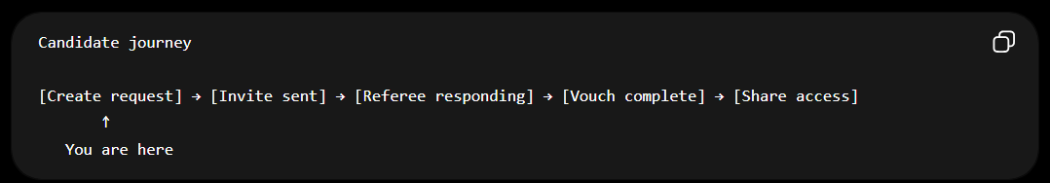
Or for a Referee page:
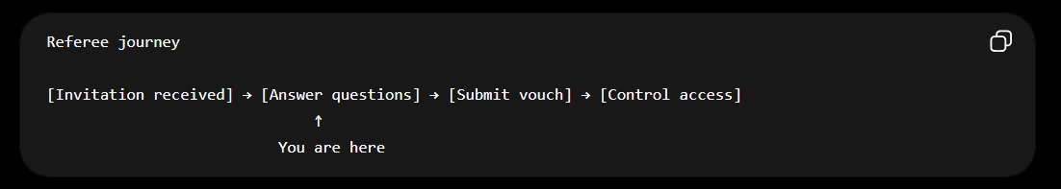
Or for a Recruiter page:
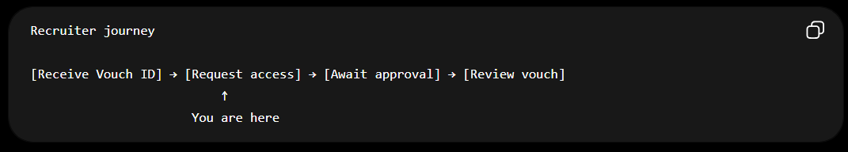
Kauri – human – Clarification to ChatGPT:
okay - we just need to consider - each historical vouchme record is saved with a page location context, Si if I jump into my dashboard and go from a vouch as a candidate I made a year ago and click into it, the map orients to that journey location and role context. When I jump back into my dashboard and then go to today's reference request from a recruiter I am now recording, the header will be a new location and role on the map. Does that make sense?
Yes — that makes complete sense.
The key idea is: the Journey Header is not a fixed site header. It is a contextual map that re-orients itself every time the user opens a specific VouchMe record, route, or task.
So the dashboard becomes a neutral launchpad. Each card in the dashboard carries the user into a different role + journey location.
Example:
Dashboard
→ Old vouch I requested as Candidate
Header shows:
Candidate journey
You are here: Completed vouch / Ready to share

Dashboard
→ New reference request from Recruiter
Header shows:
Referee journey
You are here: Answering structured questions

Dashboard
→ Recruiter access request I made
Header shows:
Recruiter journey
You are here: Waiting for referee approval
This is exactly the right product logic.
The important principle
A user is not permanently one role.
A single person can be:
- a candidate on one record
- a referee on another record
- a recruiter/requester on another record
- potentially more than one role across the platform over time
So the journey map should answer:
In this specific record, from this specific page, wearing this specific hat, where am I?
Not:
“What type of user is this account?”
That distinction is really important.
How I’d define the logic
Each page should resolve a journeyContext.
Something like:
journeyContext = {
recordId: "vouch_123",
viewerRole: "candidate" | "referee" | "recruiter",
journeyStage: "request_created" | "invite_sent" | "responding" | "completed" | "access_pending" | "access_approved",
status: "requested" | "opened" | "in_progress" | "completed" | "shared" | "declined" | "revoked" | "expired",
nextAction: "Share vouch" | "Answer questions" | "Wait for referee" | "Review vouch",
sourceRoute: "/vouches/[id]?view=candidate"
}

Then the header renders from that context.
This means the header should be record-aware
The header should not just ask:
What page am I on?
It should ask:
What record am I viewing?
What role am I in for this record?
What status is this record currently in?
What is the next meaningful action?
That solves the historical-record problem.
A completed vouch from a year ago would not show the user at the beginning of the journey. It would orient them to where that record now sits:
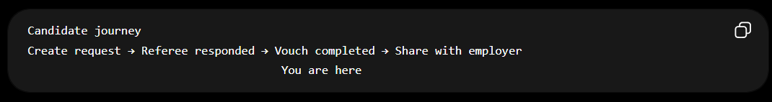
A live reference request from today would show a different journey:
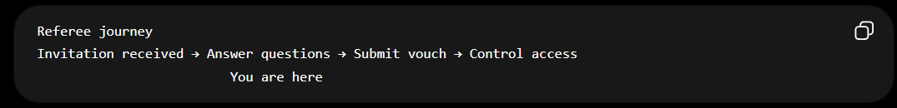
Dashboard behaviour
The dashboard should probably become a set of journey cards, not just records.
Each dashboard item should show:
Role: Candidate
Status: Completed
Next action: Share this vouch
Last activity: 1 year ago
OR
Role: Referee
Status: In progress
Next action: Finish your response
Last activity: Today

So when the user clicks into a card, the destination page already knows which map to render.
One warning
Do not let the Journey Header rely only on global session state.
For example, this would be risky:

User last selected Candidate mode
Therefore all pages show Candidate journey
That would break the experience you just described.
Instead, every route should resolve the journey fresh from:
- the current route,
- the record being viewed,
- the viewer’s relationship to that record,
- the record/access status.
Cleaner mental model
I’d describe it like this:
Every VouchMe record has a journey location. Every viewer has a role context. The Journey Header combines both to show “You are here.”
That gives you exactly what you want:
- historical records orient correctly
- dashboard jumps feel clear
- users can wear different hats across different records
- each transactional page explains itself
- the site becomes much less confusing
This is a really strong product architecture shift.
HUMAN – Kauri – validation:
very good - we can use the mermaids to map and either repurpose what was set up in the logical site map folder or blitz it but use its intent, as a clean way to map processes and tie them to pages as the framework diagrams, living arcitectural diagrams. That means that we should have the operational and architectural schematics included in the user journeys but not exposed on the public surfaces. So we are logically applying IDs to each step and the ID infrastructure is written in levels to show layering tied to visibility. The layers at the very top 0 are surface layers and public, and then descend to lower layers that would include supabase, vercel, and logical/AI layers that include you and codex and claude, and then shop layers for stripe and gelato, landing page layers, basically every surface x and y, and then z down - does that make sense - topological user journeys, processes, architecture all in one.

Yes — that makes sense. What you’re describing is bigger than a sitemap. It is a topological map of VouchMe where user journeys, page routes, statuses, emails, database records, integrations, and AI/dev/ops layers all share the same underlying step IDs.
The important distinction is:
Public users only see the surface journey.
The repo contains the full layered architecture behind that journey.
So the public page might show:
Candidate → Request a vouch → Reference responds → Vouch completed → Share
But internally, that same journey node links downward into:
Page route
Status state
Email notification
Supabase tables
Vercel function / API route
Stripe / Gelato if relevant
Claude / Codex / test coverage / operational notes
The model
I would define this as a Layered Journey Architecture.
Think of it like:
X axis = journey sequence / process step
Y axis = role or surface context
Z axis = depth layer / implementation layer
So every “thing” in VouchMe has coordinates.
Example:
X: Request a vouch
Y: Candidate journey
Z0: Public explanation
Z1: App page
Z2: Status and email workflow
Z3: Supabase data
Z4: Vercel/API/runtime
Z5: AI/dev/test/ops notes
That lets the same product process be visible at different depths depending on audience.
Suggested layer structure
I’d keep the layers simple and stable:
Layer | Visibility | Meaning
L0 — Surface / Public | Public | Marketing journey, landing page copy, simple “You are here” map
L1 — App / Page | User-facing app | Actual routes, dashboards, forms, role views
L2 — Workflow / Operational | Internal product | Statuses, notifications, reminders, access states
L3 — Data / Supabase | Internal technical | Tables, records, RLS, storage, auth links
L4 — Platform / Integrations | Internal technical | Vercel, Stripe, Gelato, Resend, webhooks
L5 — Agent / Delivery / AI Ops | Internal delivery | Claude, Codex, Playwright, UAT, prompts, test harnesses
Then each diagram can choose which layers to expose.
Public page: L0 only
Authenticated user header: L0 + L1 + some L2 status language
Internal architecture docs: L0 to L5
Example ID pattern
I’d avoid random IDs and use readable, hierarchical IDs.
Something like:
VM.J.CAN.010
VM.J.CAN.020
VM.J.REF.010
VM.J.REC.030
Where:
VM = VouchMe
J = Journey
CAN = Candidate
REF = Referee
REC = Recruiter
010 = Step order
Example:
id: VM.J.CAN.020
role: candidate
surface_label: Request a vouch
route: /candidate/request
public_visible: true
journey_header_visible: true
layers:
L0:
copy: Candidate requests a vouch
L1:
page: /candidate/request
component: CandidateRequestForm
L2:
status_created: pending_referee
email_triggered: reference_invite_sent
L3:
tables:
- vouch_requests
- reference_invites
- notification_dispatches
L4:
services:
- Supabase Auth
- Resend
L5:
tests:
- candidate-request-flow.spec.ts

That means the same node can power:
- the public landing page journey
- the authenticated “You are here” header
- Mermaid diagrams
- internal architecture maps
- QA/UAT checklists
- Claude/Codex implementation briefs
Mermaid as living diagrams
Yes — the Mermaid files become living architectural diagrams, not one-off illustrations.
You could have:
docs/
logical-site-map/
README.md
journey-register.yaml
page-context-map.yaml
diagrams/
L0-public-master-journey.mmd
L1-app-route-journey.mmd
L2-status-email-workflow.mmd
L3-supabase-data-flow.mmd
L4-integrations-flow.mmd
L5-agent-ops-flow.mmd
The public site does not expose the L2-L5 diagrams, but the repo keeps them as source-of-truth.
Example layered Mermaid idea

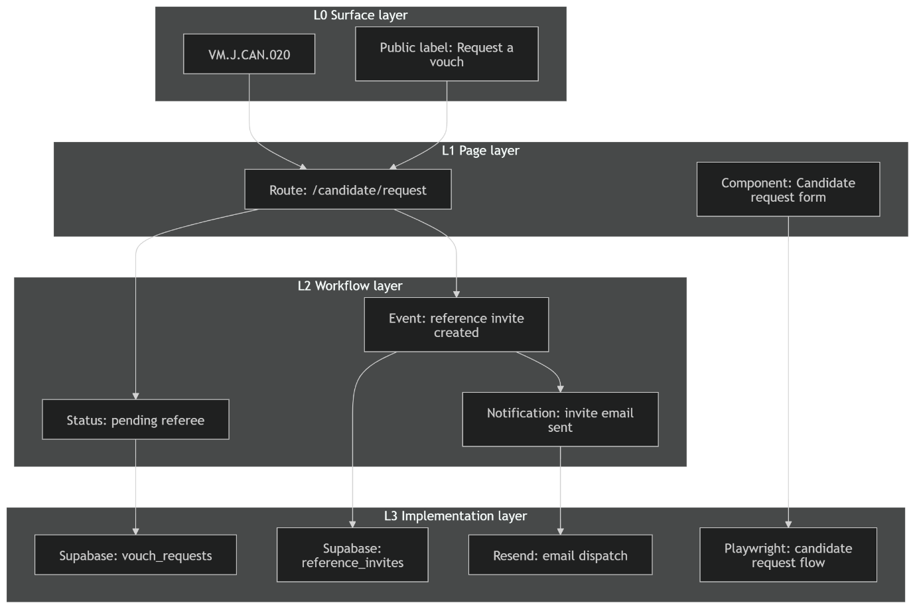
L0 Surface / public user meaning
↓
L1 Page / route / component
↓
L2 Workflow / status / notification logic
↓
L3 Data / services / tests / ops

You are Here

For internal architecture, the same IDs expand downward.
Why this is powerful
This gives VouchMe a proper operating map.
Instead of having:
- landing pages over here
- app routes over there
- database schema somewhere else
- UAT issues in another doc
- Claude prompts in chat history
- Stripe/Gelato flows in separate notes
You get one connected framework:
Every page, process, record, status, email, integration, and test maps back to a journey node.
That is exactly how you stop the product from becoming confusing as it grows.
Best implementation principle
The journey header should consume only a safe, public-facing slice of the map.
Something like:
getJourneyContext({
route,
recordId,
viewerRole,
status
})
returns:
{
role: "candidate",
currentStepId: "VM.J.CAN.040",
publicLabel: "Your vouch is complete",
nextAction: "Share with an employer",
visibleSteps: [
"Request a vouch",
"Reference responds",
"Vouch complete",
"Share"
]
}
But internally, VM.J.CAN.040 can still point to statuses, Supabase tables, notifications, access rules, and tests.
So yes — topological user journeys, processes, and architecture all in one is the right mental model.
The next practical step is to define the first register:
VM.JOURNEY.REGISTER.v1
Starting with the three role journeys:
- Candidate journey
- Referee journey
- Recruiter journey
Then we attach routes, statuses, email events, tables, and visibility layers to each step.

So for a full journey, we’d use:
X axis = journey sequence
Y axis = role context
Z axis = architecture depth
And for a single record/page, the header only exposes the top slice:
L0: You are here — Request a vouch
But internally that same ID points downward into:
L1: /candidate/request
L2: pending_referee, reference_invite_created, invite_email_sent
L3: vouch_requests, reference_invites, notification_dispatches, Resend, Playwright

The unique part is not just “journey mapping” or “architecture diagrams”.
The unique part is:
Every visible user journey step has a stable ID, and that ID vertically maps down through page, status, notification, database, integration, test, and AI/dev-ops layers.
That is more specific than a normal service blueprint.
Your model is basically:
X axis = journey sequence
Y axis = role or surface
Z axis = implementation depth
So a candidate sees only:
You are here: Vouch completed
Next: Share with employer
But internally that same point maps to:
VM.J.CAN.040
L0: Public journey label
L1: Route and component
L2: Workflow status and notification events
L3: Supabase tables and storage
L4: Vercel, Resend, Stripe, Gelato, APIs
L5: Playwright, UAT, Claude/Codex prompts, operational notes
That combination feels more like a topological product operating system than a normal sitemap.
Best comparison
I’d compare it like this:
Existing thing | What it gives you | What it does not fully give you
Service blueprint | Frontstage/backstage journey map | Usually static, not code-linked
Miro/Smaply/UXPressia | Visual journey/service maps | Not naturally tied to repo, routes, tests, live state
Mermaid | Version-controlled diagrams | No built-in journey registry or app context engine
Structurizr/C4 | Model-based architecture views | Focuses on software architecture, not user journeys
Backstage | Software catalog and ownership metadata | Not user-journey-first
EventCatalog/AsyncAPI-style docs | Event/service documentation | Not public journey/header oriented

HUMAN – Kauri – clarification:
Very agreed. Ideally what we want is to then have the architecture go to the code itself, and have every reference to what the user is experiencing listed in the touched code elements so vibe coders get teh overview of the interdependencies, without needing to view the code itself - while having the links to do so should they. We're looking at token burn efficiencies where a vibe coder can narrrow down an area and Claude or Codex can use the co-oridintes instead of vacuuming the entire codebase for context. Meaning its context inversion. You only go wider, if the narrow co-ordinates don't offer the immediate detail to solve or refernce an issue or potential enhancement area.
Yes. That is exactly the value of this.
You’re describing context inversion:
Instead of asking Claude/Codex to read the whole codebase and infer the product context, the product architecture tells the coder exactly where to look first.
So the journey map becomes a context-routing system.
A vibe coder sees:
VM.J.CAN.040
Candidate journey
Stage: Vouch completed / ready to share
Surface: Candidate sees completed Vouch and can share it
Then underneath that, the architecture map tells them:
Relevant routes:
- /vouches/[id]?view=candidate
- /candidate/request/[reference]/track

Relevant components:
- VouchHub
- CandidateVouchSummary
- ShareVouchPanel

Relevant statuses:
- completed
- shared
- revoked

Relevant tables:
- vouches
- vouch_access_requests
- notification_dispatches

Relevant notifications:
- someone-has-vouched-for-you
- recruiter-access-requested

Relevant tests:
- candidate-vouch-hub.spec.ts
- access-request-flow.spec.ts
So Claude or Codex does not begin by vacuuming the repo. It begins from the coordinate.

The principle
The new workflow becomes:
Issue or enhancement
↓
Identify journey coordinate
↓
Load only the mapped files, states, routes, and tests
↓
Patch narrowly
↓
Only expand context if the coordinate map is insufficient

That is much more efficient.
It also reduces the risk of AI agents touching unrelated areas because they have a bounded map of what this feature actually depends on.
What this becomes
I’d call this a:
Journey-to-Code Context Map
or more strongly:
VouchMe Context Inversion Layer
It sits between:
- user experience
- product architecture
- technical implementation
- AI-assisted development
The map answers:
“When a user experiences this thing, what code, state, data, events, tests, and integrations are actually involved?”
Recommended structure
The source of truth should probably be repo-native and machine-readable:
docs/logical-site-map/
journey-register.yaml
page-context-map.yaml
code-context-map.yaml
status-event-map.yaml
notification-map.yaml
diagrams/
L0-public-journey.mmd
L1-page-route-map.mmd
L2-workflow-status-map.mmd
L3-data-service-map.mmd
L4-integration-map.mmd
L5-ai-ops-map.mmd
The most important file would be something like:
id: VM.J.CAN.040
title: Candidate receives completed vouch
role: candidate
surface_layer:
label: Your vouch is complete
user_meaning: The candidate can review the completed vouch summary and share it with employers.
public_visible: true
page_layer:
routes:
- /vouches/[id]?view=candidate
- /candidate/request/[reference]/track
components:
- app/vouches/[id]/page.tsx
- components/vouches/CandidateVouchSummary.tsx
- components/vouches/ShareVouchPanel.tsx
workflow_layer:
statuses:
- completed
- shared
- revoked
events:
- vouch_completed
- vouch_shared
- access_requested
notifications:
- someone-has-vouched-for-you
- organisation-wants-to-review-a-vouch-you-made
data_layer:
tables:
- vouches
- vouch_access_requests
- notification_dispatches
storage:
- vouch-audio-answers
integration_layer:
services:
- Supabase
- Resend
test_layer:
tests:
- tests/e2e/candidate-vouch-hub.spec.ts
- tests/e2e/recruiter-access-request.spec.ts
ai_context:
safe_starting_scope:
- app/vouches/[id]/page.tsx
- components/vouches/
- lib/vouches/
expand_only_if:
- status mismatch
- RLS failure
- notification dispatch failure
- access control failure
That gives Claude/Codex a narrow starting packet.
Code references without polluting the codebase
I would not put huge architecture comments throughout the code. That gets messy.
But I would use small anchors where useful:
// VMCTX: VM.J.CAN.040 candidate completed vouch share surface
Then the YAML map can point to that symbol or file.
That gives you two benefits:
- The docs know which code belongs to which journey node.
- The code has just enough breadcrumbing for future agents to orient themselves.
The killer feature
The biggest benefit is that every future bug report or enhancement can be framed like this:
Issue:
Candidate says they cannot share an old completed vouch.
Coordinate:
VM.J.CAN.040
Expected surface:
Completed vouch should show share CTA.
Initial context scope:
Load only VM.J.CAN.040 mapped files and tests.
Do not inspect unrelated recruiter-pro, store, Stripe, Gelato, or onboarding code unless the mapped context proves insufficient.
That is exactly the kind of prompt discipline that reduces token burn and reduces random breakage.
This also makes diagrams operational
The Mermaid diagrams are no longer just documentation.
They become the visual form of the same register:
Diagram node VM.J.CAN.040
↓
YAML register entry
↓
Routes/components/statuses/tables/tests
↓
Claude/Codex implementation scope
So the architecture is not separate from the code. It is a navigation layer over the code.
The practical next step
The next sprint should not rebuild the site immediately.
I’d do this first:
Create VM.JOURNEY.REGISTER.v1 from the existing app.
Start with:
- Candidate journey
- Referee journey
- Recruiter journey
- Shared access journey
- Store/Gelato journey later as separate commerce topology
Then add code references only for the most important routes/components first.
Once that register exists, the Journey Header can consume the same IDs for the user-facing “You are here” experience.
That gives you one framework serving two audiences:
User sees: You are here.
Vibe coder sees: Here is the exact system area behind that moment.
HUMAN – Validation and project scope expansion:
I actually think we create a Github project and this becomes its own product and the first customer is VouchMe. So we build how you would install and implement this into active sites - a diagnostic and scanning tool, basically a mapping tool (call it something awesome), that then generates the .md and single folder where the map resides in any repo. Then we have the visual renderer that can be applied into the header of a site and turned on/off controlled by admins, or exposed to users and controlled at that layer as well.

<THIS IS WHERE I THINK THE CORE LAYER 0 PRODUCT DIVERGES SLIGHTLY>
Not that this is a bad thing – but there two products emerging now. Where we want the Layer 0 orientation for user journey product embedded in the header – distinct from the footer and layer 1-x which could be an add-on and paid version.
Here’s the rest of the conversation:
Here it is as a writing block:
Instead of Claude/Codex searching the whole codebase, you ask:
Instead of needing to struggle with co-ordinates the user would be at Level 0 and provide the url and ask what are the co-ordinates of this page... OR each page has a tiny co-0rdinate (which would be branded awesomely) they can simply copy and paste

I added the note but this is a new feature and not sure how to use it properly: Instead of Claude/Codex searching the whole codebase, you ask: Instead of needing to struggle with co-ordinates the user would be at Level 0 and provide the url and ask what are the co-ordinates of this page... OR each page has a tiny co-0rdinate (which would be branded awesomely) they can simply copy and paste
Explained feature usage
Yes — that note is pointing to an important UX layer.
The user should not have to understand coordinates first. The product should let them start from the thing they already know:
“I’m on this page.”
or
“This is the issue I’m seeing.”
or
“Here’s the page URL.”
Then ContextAtlas resolves the coordinate.
There should be two ways to use it:
- URL lookup
The user gives Claude/Codex a URL and asks:
“What are the coordinates for this page?”
- Copyable page marker
Each mapped page has a small branded context marker, something like:
  - Atlas Pin
  - Waypoint
  - Context Pin
  - Journey Pin
  - AhoPoint
  - Threadmark
My favourite is probably Waypoint for general users, or Atlas Pin if the product is called ContextAtlas.
A page might show a tiny admin/dev-only control:
Atlas Pin: VM.J.CAN.040
Copy context
When copied, it gives a useful context packet, not just the raw ID:
ContextAtlas Pin
Coordinate: VM.J.CAN.040
Role: Candidate
Journey stage: Completed vouch / ready to share
Route: /vouches/[id]?view=candidate
Status: completed
Suggested scope: candidate vouch hub, share panel, access request flow
That means the user can say to Claude:
“Use this Atlas Pin and help me improve the page.”
Or:
“Here’s the URL. Find the coordinate and generate the right context pack.”
Here’s a cleaner version of the note as a writing block:
Instead of Claude or Codex searching the whole codebase, ContextAtlas lets the user begin from Level 0: the page, journey moment, or user-facing issue they are actually looking at.
The user should not need to understand the coordinate system first. They can simply provide the current URL and ask, “What are the coordinates of this page?” ContextAtlas resolves the route, role, journey stage, status, and mapped implementation layers behind that page.
For a smoother workflow, each mapped page can also expose a tiny branded copyable marker, such as an Atlas Pin, Waypoint, Journey Pin, or Context Pin. The user can copy this marker and paste it into Claude, Codex, GitHub, Linear, or a support ticket.
The copied marker should include the coordinate plus a safe context snapshot:
- Coordinate
- Role context
- Journey stage
- Route or route pattern
- Current visible status
- Relevant page/component scope
- Suggested tests
- Expansion rules
This means users do not have to say, “Search the repo for the vouch sharing problem.” They can say, “Use this Atlas Pin.” The AI agent starts from the narrow mapped context and only expands outward if the coordinate does not contain enough information to solve the issue.
This is the core context inversion model: start from the visible user experience, resolve the coordinate, load only the mapped context, and widen only when necessary.

Absolutely — that should be a core feature as well.
Here it is as a writing block:
Another core feature is that the diagrams themselves should be shareable at each level, or as a complete layered view.
This means a user could export or share only Layer 0 with a marketing team, strategist, founder, or ChatGPT, and it would present a clean, beautiful process diagram focused only on the surface user journey. That version should be ideal for generating copy, refining messaging, understanding user flows, or inferring the right narrative for a landing page or campaign.
At the same time, deeper layers should also be individually shareable for product, engineering, operations, or AI-assisted development. A product manager might share Layer 1 or Layer 2 to discuss routes, statuses, and notifications. An engineer or AI coding agent might receive Layer 3 and below to understand code, data, integrations, and dependencies.
The system should also support sharing the full stacked view, where all layers remain connected through the same coordinates. This allows one source of truth to serve different audiences without exposing unnecessary complexity.
In practice, this means every mapped journey should support:
- share Layer 0 only
- share Layer 1 only
- share Layer 2 only
- share full layered view
- export as Markdown
- export as Mermaid
- export as image or presentation-ready diagram
- generate audience-specific summaries from the selected layer
This is powerful because it turns the map into a communication tool as well as a technical tool. The same journey can be used to brief marketing, align product, guide engineering, or give ChatGPT enough structured context to generate accurate copy and user-facing explanations.

