**Bangladesh Seed Association**

**User Manual**

**Prepared by: KGeCom Ltd.**



**Introduction:**

BSA was formed in 2002 at government behest. The association is registered with the Registrar of Joint Stock Companies and Farms (RJSC). Its Executive Committee comprises 20 members, elected to two-year terms, divided into two groups, Seed Industry and Seed Dealers. The President is Mr Abdul Awal Mintoo (also on APSA’s EC), elected in October 2019. Membership types are Seed Dealer; Seed Industry; and Associate. The latter lack voting rights. The seven Technical Committees are Membership and Finance; Hybrid Rice Seed; Vegetable Seed; Maize Seed; Potato Seed; Export and Import; and Discipline and Vigilance. BSA strategies include: defining seed business groups by sector; partnering with government; building public – private partnerships; short and long term plans for food production and seed import estimates related thereto; introducing mechanized agriculture; creating a seed supply and demand database; seed processing and storage; business promotion; and enhancing the BSA Secretariat’s capabilities. The BSA added some 170 new members last year and opened three new district chapters. A training manual is in preparation for dealers, retailers and sales personnel. Agriculture accounts for 20 percent of Bangladesh GDP. There are 1.4 million farm households and nine million hectares of land capable of cultivation.

**Objective:**

BSA Tracking system is customer level verification.

**Login Page**

Open the browser and type the following address: <http://103.132.94.84:99/> then a page similar to the one shown in the image below will be displayed whereby a user will be required to type in their correct **Member ID and Password.** This system works best with Google Chrome, Mozilla Firefox, Microsoft Edge or Opera browsers. From here on, the use of the word “browser” will refer to above mentioned web browsers only.

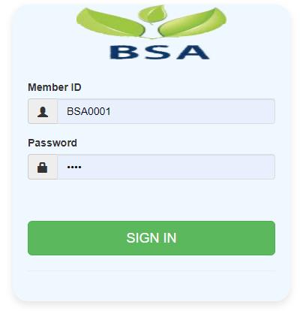

**Dashboard**

On successful login, a user is directed to the Home Page which consists of the main menu on the left side named dashboard. At the top most part of the system you will have on your left a home icon to denote the home page, a help button- which contains this help manual and the Member Id of the user currently accessing the system.

