Dissertation Project Proposal

Comparative Analysis of Security Vulnerabilities
in RESTful and GraphQL APIs
Through Automated Testing

Table of Contents
1. Introduction 3
1.1. Background and Rationale 3
1.2. Aim 3
1.3. Objectives 4
2. Literature Review 6
2.1. API Security Landscape and Threats 6
2.2. Vulnerabilities and Testing Approaches for RESTful API 6
2.3. Vulnerabilities and Testing Approaches for GraphQL API 7
2.4. Existing Security Testing Tools and Limitations 8
2.5. Research Gap 9
2.6. Critical Evaluation Table 9
3. Methodology 12
3.1. Research Methodology 12
3.2. Target Population, Sampling Strategy and Data Collection 12
3.3. Framework Development 13
3.4. Data Analysis 13
3.5. Evaluation Methodology 14
3.6. Prototype Development 15
3.7. Testing Targets 15
4. Architectural Design 17
5. Ethical Considerations 20
6. Project Plan 22
7. References 25

Introduction

Background and Rationale
Organisations have increasingly utilised both RESTful and GraphQL API architectures as the backbones of their digital ecosystems to drive their business operations. This growth is increasing and expected to accelerate in the future with the increasing use of AI technologies. Due to fast adoption of AI-related API, the usage of it has surged to 807% since 2023 (Simpson, 2025).

Along with the popularity of API consumptions, the cyber attacks related to API have also risen. In February 2025 alone, 99% of organisations using API technologies have experienced API-related security issue mainly from injection attacks and Broken Object Level Authorization followed by sensitive data exposure and broken authentication (Traynor, 2025).

To document and raise global awareness for security breach and risks related to API, the Open Web Security Project (OWASP) has maintained and highlighted the API Security Top 10 which identifies the most critical API vulnerabilities (OWASP, 2023). Many academic studies have also conducted security studies for API architectures especially RESTful and GraphQL APIs, and most of these studies are carried out for one specific architecture. Therefore, deep exploration into the studies of both architectures at the same time to make comparative analysis regarding security concerns is still limited. This project aims to addresses such critical gap in making critical comparative studies and investigations between RESTful and GraphQL API vulnerabilities by implementing the automated testing framework.

Aim
The aim of the project is to implement an automated and lightweight testing framework by using mainly open-sourced libraries and resources to investigate, compare, and critically evaluate security vulnerabilities in RESTful and GraphQL architectures.

Objectives
- Foundational Studies and Literature Review
  - To thoroughly study ecosystems of APIs and security landscapes of the architectures to have strong foundational knowledge of API technologies and related vulnerabilities.
  - To conduct critical literature review to investigate theoretical and practical research projects concerning security vulnerabilities by systematically studying the documents, examine critical architectural differences that implicate vulnerabilities, and learn the best API-related security best practices in testing from professional industry practices.
- Framework Implementation
  - To design, develop, and implement lightweight security testing framework that can systematically identify the vulnerabilities of both architectures. The framework will be modular enough to have both architecture-agnostic and architecture-dependent testing. The automated test cases will mainly target on vulnerabilities defined by OWASP API Security Top 10.
- Empirical Evaluation and Comparative Analysis
  - To test the performance of the developed framework and its effectiveness will against intentionally vulnerable applications such as DVGA and VAmPI where all the testing will be controlled environments with systematic segmentations using containers or virtual environment. When applicable, open-sourced API end points or self-developed end points will be utilised to have more accurate result evaluations.
  - To perform quantitative evaluations with the metrics such as accuracy, precision, and false positive rates, and performance metrics such as execution time and raw numbers of vulnerabilities detected will be employed to empirically perform comparative critical analysis between two architectures
  - To benchmark against existing testing tools such as OWASP ZAP, Burp Suite, and GraphQL Cop will be conducted to determine the testing framework’s strengths and weaknesses, and to draw the framework’s effectiveness baseline
- Discussion and Contribution
  - To document and discuss unique and overlapped vulnerabilities of both API architectures to highlight the implications in vulnerability patterns.
  - Comprehensive findings of framework results, performance, strengths, and limitations will be included to broaden the security testing landscape.
  - Recommendations for general API security testing practices and organisational API security strategies will be made based on empirical findings.

Literature Review

API Security Landscape and Threats
Along with the popularity of API, the growth of threats taking advantage of expanding the attack surfaces has also emerged. To document and raise global awareness for API developers, the Open Web Security Project (OWASP) maintains and highlights the API Security Top 10 which identifies the most critical vulnerabilities that are affecting current API implementations (OWASP, 2023). This 2023 edition highlights the prevalent vulnerabilities such as Broken Object Level Authorisation (BOLA), Broken Authentication, Server-Side Request Forgery (SSRF), and other risks. One research project that worked on development and evaluation of API security testing platform also have indicated that modern applications that consume APIs face persistent vulnerabilities such as injection attacks, authentication failures, and data breaches (Idris, Syarif, and Winarno, 2022). The Capital One data breach, where the attacker exploited misconfiguration to have access to API credentials by using Server-Side Request Forgery (SSRF) costing Capital One 300 million USD in losses and penalties, have underscored the importance of systematic vulnerability assessment and robust security solutions (Danielson, 2025).

Vulnerabilities and Testing Approaches for RESTful API
REST (Representational State Transfer) API was introduced in 2000, and has become a standard such as statelessness, uniform interface, layered system, and capability to cache for World Wide Web (Fielding, 2000). While it has been widely used, security vulnerabilities such as authorisation and authentication issues, injection attacks, and configurations and assets management issues have also become apparent. As utilising of complex API architectures can potentially expose varieties of attack surfaces, many of the issues still result from validation issue because the security of APIs depends significantly on input sanitisation. When there are not enough validations in processing users’ or third parties’ inputs, the APIs endpoints become vulnerable to common injection attacks such as SQL Injection, Cross-Site Scripting (XSS), and Regular Expression Denial of Service (ReDoS) which can result in data losses and system outages (Tanveer, Iradat, Iqbal, and Ahmad, 2025).

Testing the vulnerabilities also involve several challenges in areas such as input validation, authentication, and authorisation because there are complexities in dependencies and layers, limitations in testing tools, lack of expertise in RESTful APIs-focused testing, and there is no single standardised methodology for the development and testing (Alharbi and Moulahi, 2023). While many testing methodologies have been applied, state-of-the-art methodologies include static code analysis to analyse the code without executing, dynamic analysis to test at runtime, penetration testing to simulate cyber-attacks, and fuzz testing to test with random data (Tanveer, Iradat, Iqbal, and Ahmad, 2025).

Vulnerabilities and Testing Approaches for GraphQL API
GraphQL, a data query language for API, was introduced as an open source by Facebook in 2015, and it is currently being managed by GraphQL Foundation. This architecture has its own many unique features comparing to REST and other API technologies. Furthermore, it also has different security profiles. After scanning over 1,500 GraphQL endpoints, one research project has reported that there are over 46,000 security issues and data breaches, and 10% are of those were classified as critical (Carossio and Tristan Kalos, 2023).

While REST has many endpoints, GraphQL has only one that can be worked with queries and mutations specified by schema. However, this can also complicate security controls such as rate limiting and role-based access control. To exploit such feature, attackers can execute thousands of queries within one HTTP request to overload the server (Yerushalmi, 2023). Furthermore, another unique GraphQL’s introspection feature, when it is enabled in the production environments, attackers can learn about the schema and data models which can help them with exploitations and data breaches.

Due to GraphQL single-endpoint structure and nested queries, there are many complexities in security testing. This has required the specialised testing methods instead of traditional approaches. To meet the requirement, one study has introduced evolutionary-based fuzzing that include white-box and black-box testing techniques (Belhadi, Zhang, and Arcuri, 2024). White-box testing is used, when source code is available, to utilise evolutionary search to intelligently explore the test space. This technique can maximise the code coverage and fault-finding capabilities. Without accessing the code, black-box testing is used with random search technique to generate the queries based on the schema. White-box testing achieved 90.3% line coverage with 71 additional errors detection while black-box testing identified errors in 77.8% of endpoints.

Existing Security Testing Tools and Limitations
There are many tools available in the industry to test security in RESTful and GraphQL APIs. Among these, two of the most widely adopted tools are OWASP ZAP (Zed Attack Proxy) and Burp Suite. OWASP ZAP is an open-source application that has YAML framework, and it has a focus on automation, CI/CD integration, and strong community support. For Burp Suite, it has both enterprise and community editions. It offers automation and advanced manual testing capabilities, and extensive documentation (Shneider, 2024). In terms of performance, according to one study that examined both static and dynamic testing tools, OWASP ZAP outperformed Burp Suite in identifying vulnerabilities in three categories of OWASP Top 10 2021 which are Broken Access Control, Insecure Design, and Security Misconfiguration. However, Burp Suite was found to be exceled in identifying outdated web API components, and in detecting Cross-Site Scripting (XSS) (Qadir, Waheed, Khanum, and Jehan, 2025).

While both tools have many strong features in security testing, there are also limitations. For instance, when testing against vulnerabilities documented by OWASP, both tools could not detect vulnerabilities in security logging and monitoring failures category. Moreover, these tools did not outperform other lesser-known tools in finding raw number of vulnerabilities as well (Qadir, Waheed, Khanum, and Jehan, 2025). Another academic study has stated that existing tools for GraphQL security testing focus on one-time server analysis instead of performing real-time analysis of each coming query (Perera, Abeyrathne, Malalgoda, and Ifthikar, 2025). While GraphQL is new compared to REST architecture, inadequate number of security testing tools can make it contributes to increasing number of vulnerabilities and exploitations.

Research Gap
As Restful and GraphQL APIs came out in 2000 and 2015, many academic studies and professional industries have experimented and documented security and related practices regarding each API architecture. While security studies for RESTful API are abundant and for GraphQL API are emerging, numbers of studies focusing on systematic and comparative analysis between these two APIs in the context of security and vulnerabilities are still limited. There are indeed many researches in comparison between the two APIs, but many of them address performance such as finding out GraphQL outperforms REST mainly in queries requiring multiple parameters (Brito and Valente, 2020) instead of addressing security risks.

Thus, the absence of the systematic research and projects to employ comparative analysis of vulnerabilities, detection performance and accuracy, severity distribution, and automated detection of risks across both API architectures represents a significant gap in literature studies. As the organisations have been implementing both architectures increasingly, this literature gap is particularly relevant. Without the data obtained from empirical testing and experiment, it will be extremely hard for organisations to employ evidence-based security approaches and develop a strategy for accident response for their business operations which depend on API security, workflows, and processes. Therefore, this identified gap in limitations of comparative security analysis establishes the foundation and justification for the proposed dissertation project.

Critical Evaluation Table
Following table discusses about testing methods, evaluation criteria, and limitations of existing research described in the sections that are parts of the literature review.
Study | Target | Testing Method | Evaluation Criteria | Limitations
Alharbi, S.J. and Moulahi, T. (2023) API Security Testing: The Challenges of Security Testing for Restful APIs | REST | Dynamic and static testing, manual, and black-box testing | API is evaluated based on authentication and authorisation, input and output validation | Limited to specific vulnerability types and inaccuracy results
Tanveer, F., Iradat, F., Iqbal, W. and Ahmad, Awais. (2025) Towards Secure APIs: A Survey on RESTful API Vulnerability Detection | REST | Dynamic and static testing, penetration, and fuzz testing | Precision, recall, F1-Score, and false positives | Real-world testing is limited, and some tests failed at complex operations
Saito, K., Tahara, Y., Ohsuga, A. and Sei, Y. (2025) Proposal of an Automated Testing Method for GraphQL APIs Using Reinforcement Learning | GraphQL | API request generation and learning mechanism | Schema coverage and error response rate | Use of random values instead of intelligent data generation and lack of depth in schema exploration
Belhadi, A., Zhang, M. and Arcuri, A. (2024) Random Testing and Evolutionary Testing for Fuzzing GraphQL API | GraphQL | White-box and black-box testing | HTTP status code coverage, fault detection, and schema validation | Testing difficulties due to structural complexity, lack of constraints in GraphQL, and limited scope of APIs
Qadir, S., Waheed, E., Khanum, A. and Jehan, S. (2025) Comparative evaluation of approaches and tools for effective security testing of Web applications | General web app securities | Static and dynamic application security testing | Number of vulnerabilities with severity level, and effectiveness of the approaches | Limited categories of vulnerability detection and other limitations in testing tools
Perera, I., Abeyrathne, H., Malalgoda, S. and Ifthikar, A. (2025) Enhancing GraphQL security by detecting malicious queries using large language models, sentence transformers, and convolutional neural networks | GraphQL | Machine Learning model testing for GraphQL, and load testing for the systems | Metrics such as accuracy, precision, recall, and f1-score | Constraints on computations and datasets, and not being able to validate LLM-generated rules
Brito, G. and Valente, M.T. (2020) REST vs GraphQL: A Controlled Experiment | REST and GraphQL | Controlled experiment asking to do both API implementations to different participants who are students | Task completion times, correctness, ease of use, and other statistical data such as effect sizes | Participants limited to students only, and evaluation criteria does not include API usability

Methodology

Research Methodology
The primary research categories include applied experimentation for developing automated testing framework in controlled environments and applied observational study for analysing real-world API to understand real-world security vulnerabilities (Easterbrook, Singer, Storey, and Damian, 2008). For the secondary category, it includes hypothetico-deductive experimental research for testing hypotheses regarding vulnerabilities in both API architectures.

These chosen methodologies have many strengths such as validity enhancement and individual method bias reduction with multiple methods, and enhanced efficiency at vulnerability detection with controlled experiments. However, limitations such as built API not representing fully complex natures of production or prioritisation of vulnerabilities due to time constraints may exist.

Alternate methods that emphasise only for theoretical and qualitative approach are rejected as the project needs to be experimental and practical where many quantitative metrics are applied.

Target Population, Sampling Strategy and Data Collection
API Architecture Populations
- RESTful APIs with HTTP methods such as GET, POST, PUT, and DELETE and JSON/XML format.
- GraphQL APIs with data schema and queries.
Both architectures will include purposely built and publicly available API endpoints
Sampling Strategy
- Purposive Sampling: for specific vulnerabilities which are mainly from OWASP API Security Top 10 (OWASP, 2023) such as Broken Object Level Authorisation (BOLA), Excessive Data Exposure, and Security Misconfiguration.
- Convenient sampling: for publicly accessible API. For example, 5-8 REST API and 5-8 GraphQL API from domains such as e-commerce, social media, and entertainment
Data Collection Size
- Specific number of experimental testings will be carried out for each vulnerable category (as mainly defined by OWASP) for both architectures. For example, up to 600 total test executions for 8-10 vulnerabilities times 2 architectures times 10-20 runs.
- Detection metrics such as counts, false positive or negative rates, and CVSS scores
- Performance metrics such as detection times, and resource utilisation

Framework Development
The security testing framework will be developed using hybrid approach which is a combination of waterfall and agile methodologies. By using waterfall, the project can have well defining and clear structure while agile approach will provide the flexibility to revise and review the project implementation. The development cycle will have following seven phases:
- Initiation and Literature Review
- Design
- Implementation
- Testing and Data Collection
- Evaluation and Data Analysis
- Documentation
- Review
For testing environments, controlled experimentations will be utilised for both API architectures
- RESTful API will be developed with CRUD operations to work with deliberate target of vulnerabilities from OWASP Top 10
- GraphQL API will be developed with query-based using the server such as Apollo Server or similar services to test OWASP Top 10 vulnerabilities

Data Analysis
Following types of analysis will be employed for efficient statistics and comparative analysis:

- Descriptive statistics with mean, median, and standard deviation to obtain the results such as detection frequencies, timing, and severity distribution of each API architecture
- Inferential analysis to test the hypotheses by using following effect sizes (Wikipedia, 2011):
  - Mann-Whitney U test to compare detection rate
  - Chi-square tests to examine the differences in vulnerability frequency of each category of risk
  - Cohen’s d to quantify the architectural differences
- Statistical analysis to make quantitative conclusions for comparative analysis between RESTful and GraphQL API architectures (Vandever, 2020)

Evaluation Methodology
To evaluate effectively to each API architecture, the followings metrics will be employed:
- Detection rate or recall
  - True positives / (True positives + False negatives)
  - To measure framework’s capabilities in identifying vulnerabilities
- Precision
  - True Positives / (True positives + False positives)
  - To measure framework’s accuracy in vulnerability prediction
- F1-score
  - Harmonic mean of precision and recall
  - To balance the effectiveness in measurements
- False positive rate
  - False positives / (False positives + True negatives)
  - To measure how often the framework incorrectly flag as vulnerable to APIs that are not harmful

Moreover, further validation will be carried out by benchmarking against existing framework such as OWASP ZAP and Burp Suite in scenarios such as reliability in detection.

Prototype Development
At the proposal stage, a prototype is still not available due to the following reasons:
- Building prototype will need extensive reading and more critical literature review of both academic and industry documentations to have a deep understanding of building a framework.
- Studying take beyond understanding of vulnerabilities in each API architecture, and it will involve understanding of how each architecture works, learning how to build controlled environments using container or virtual environment, and planning to work with purposely vulnerability APIs which are not feasible within current timeline.

Testing Targets
The following table represents the intentionally vulnerable applications that will be treated as testing targets along with documented vulnerability counts.
Application | Type | Vulnerability  Count | Categories
DVGA (Damn Vulnerable GraphQL Application) | GraphQL | 23 | DoS (5), Information Disclosure (5), Injection (4), Auth Bypass (3), Code Execution (2), Recon (2), Miscellaneous (2)
VAmPI | REST | 9 | SQLi Injection, Unauthorized Password Change, Broken Object Level Authorization, Mass Assignment, Excessive Data Exposure through debug endpoint, User and Password Enumeration, RegexDOS (Denial of Service), Lack of Resources & Rate Limiting, and  JWT authentication bypass via weak signing key
crAPI (Completely ridiculous API) | REST | 21 | BOLA (2), Broken User Authentication (1), Excessive Data Exposure (2), Rate Limiting (1), BFLA (1), Mass Assignment (3), SSRF (1), NoSQL Injection (1), SQL Injection (1), Unauthenticated Access (1), JWT Vulnerabilities (1), LLM Vulnerabilities (3), and 3 other secret challenges
OWASP Juice Shop | REST | 111 | BOLA/IDOR, Broken Auth, Excessive Data Exposure, Rate Limiting, XSS via API

The following figure displays how these vulnerabilities will be employed in the testing environments.
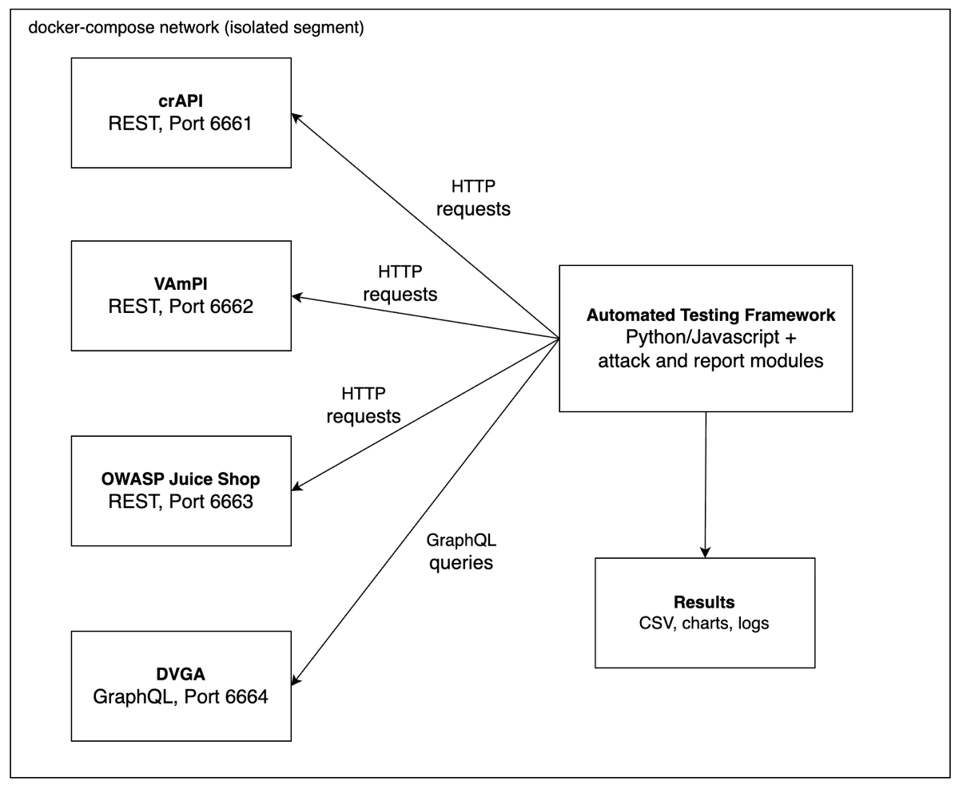
Figure 3.1: Vulnerability Environments Setup within Docker

Architectural Design
The Automated API Testing Framework will fundamentally have three layers where each serve different purposes.
- Input Layer: API Under Test
The framework accepts two API architectures as inputs
  - REST Endpoints: Paths and resources associated with RESTful APIs.
  - GraphQL Schema: Query based API with data modelling and introspection.
- Process Layer: Testing Framework
The framework will be built around four main modules with subcomponents.
  - API Discovery Module
    - Endpoint Mapping: For REST, this will systematically include all relevant API endpoints and resources with HTTP methods such as GET, POST, PUT, and DELETE, and URL patterns. For GraphQL, it will be query and mutation points.
    - Schema Introspection: For REST, this will involve analysing OpenAPI/Swagger specifications. For GraphQL, it has introspection capabilities to query the complete schema.
  - Security Testing Module
REST Component
    - Authentication Testing: Manages tokens, sessions, OAuth/JWT, and credentials.
    - Rate Limiting: Validates the implementation of request throttling, and for brute-force attacks.
    - Injection Attacks: Probes for injections in the context of SQL, NoSQL, command, and XML/JSON.
    - Authorisation Checks: Validates access control systems to test vulnerabilities such as Broken Object Level Authorisation (BOLA), and privilege escalation.
GraphQL Component
- Query Depth Analysis: Tests for deeply nested and complex queries that can trigger DOS risk.
- Introspection Abuse: Identifies exposed introspection that can reveal sensitive schema information to attackers.
- Batch Query Testing: Evaluates batch query for any possible vulnerabilities.
- Field-Level Authorisation: Validates that authorisation is enforced at the field level.
Vulnerability Analysis Module
- Severity Scoring (CVSS): Common Vulnerability Scoring System to determine the impact and exploitability of the identified vulnerabilities.
- False Positive Filtering: Verification of actual vulnerabilities from false alarm.
- OWASP Mapping: Maps identified vulnerabilities to OWASP API Security TOP 10 to be in compliance with industrial security standards.
Comparative Analysis Module
- Aggregate Metrics: Categorises the vulnerabilities by API architecture type, severity level, and OWASP category.
- Detection Metrics: Produces metrics such as detection rate, precision, false positive/negative rate, and F1-score
- Performance Differences: Displays difference performances such as resource such as CPU/memory consumption and throughput between two API architectures
- Comparative Statistics: Different statistic data between two API architectures e.g. Hypothesis testing such as t-tests and chi-square to validate the detection rate
- Output Layer: Report Generation
  - Detailed Findings: Documentations for vulnerabilities and framework performance for each API architectures
  - Remediation Steps: Guides and recommendations regarding testing practices, codes, and configuration management
  - OWASP Compliance: Documentations aligning with OWASP API Security Top 10 standards

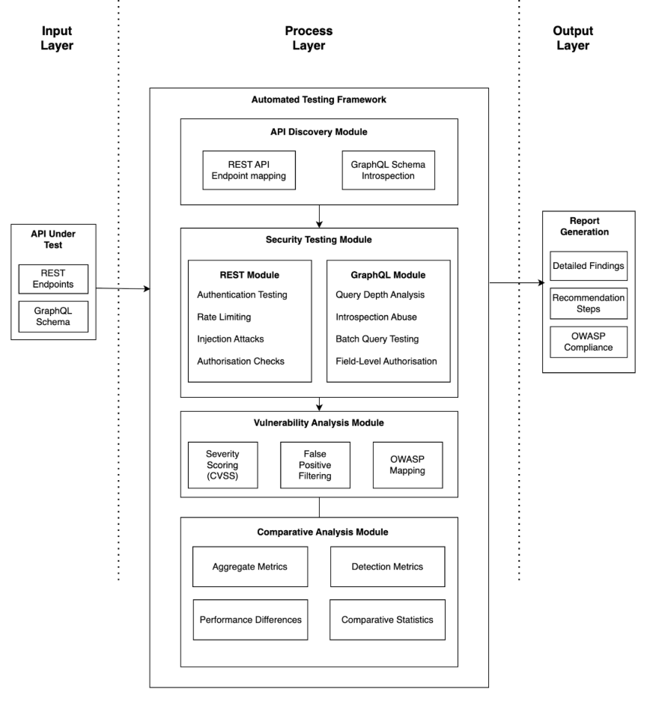
Figure 4.1: High-level Framework Architectural Diagram

Ethical Considerations
The project involves security vulnerability testing that needs to address the ethical considerations to ensure compliance with legal and regulatory codes of practice.

Initiation after Approval
The project will be initiated only after the formal approval is obtained from the designated supervisor.

Controlled Environment for Testing
The security testing will be carried out only in the controlled lab setups. The environments will be in either containerised or virtualised where careful segmentation will be done. API endpoints to test will be either self-developed or explicitly authorized. All the testing will not be performed on production systems or third-party APIs without the formal and explicit approval to be in accordance with the Computer Misuse Act 1990.

Data Protection and Privacy
The research will utilize only the synthetic data such as fictional or specifically generated information of person, groups, and places to be in accordance with data handling guidelines and compliance with Data Protection Act 2018.

Responsible Research and Standardised Documentation
The findings from the vulnerability testing and comparative analysis result will be well documented and presented responsibly to ensure that the knowledge of the project contributes from the positive perspective to security improvement rather than exploring opportunity to exploitation.

Software Licensing
Code sources, tools, and libraries used in implementing the testing framework will be in accordance with open-source guidelines and license terms as defined by the Open-Source Initiative (OSI) to ensure the compliance with licenses such as MIT, and Apache 2.0. If there are any commercial products involved, all the usage will also be in accordance with license and free-trial terms.

No Human Participants
The research will not include any interaction with human participants, which is by means of surveys, interviews, or any form of data collection.

Project Plan
The project will be implemented based on the hybrid approach which utilise both waterfall and agile, particularly scrum methodologies. According to waterfall, project phases, initial planning to project completion, will be carried out in a sequence while sprints will be employed to make the project more manageable and flexible to make changes with incremental review.

Timeline is based on the 12 weeks period. Each individual item needs one to several days to complete. Number of days taken to complete those items in a week are to not be added together. According to similarities in nature, items are grouped into each sprint which generally represents a week period. Items in each sprint depends on the completion of items from the previous sprint. Each sprint will be reviewed, and items will be made necessary changes in the following sprints. However, detailed items dependency in each sprint are not included due to complex nature of the detailed planning of steps to be taken.

After every week or two or depending on discussion time given with supervisor (intermittently or regularly), feedback will be incorporated.

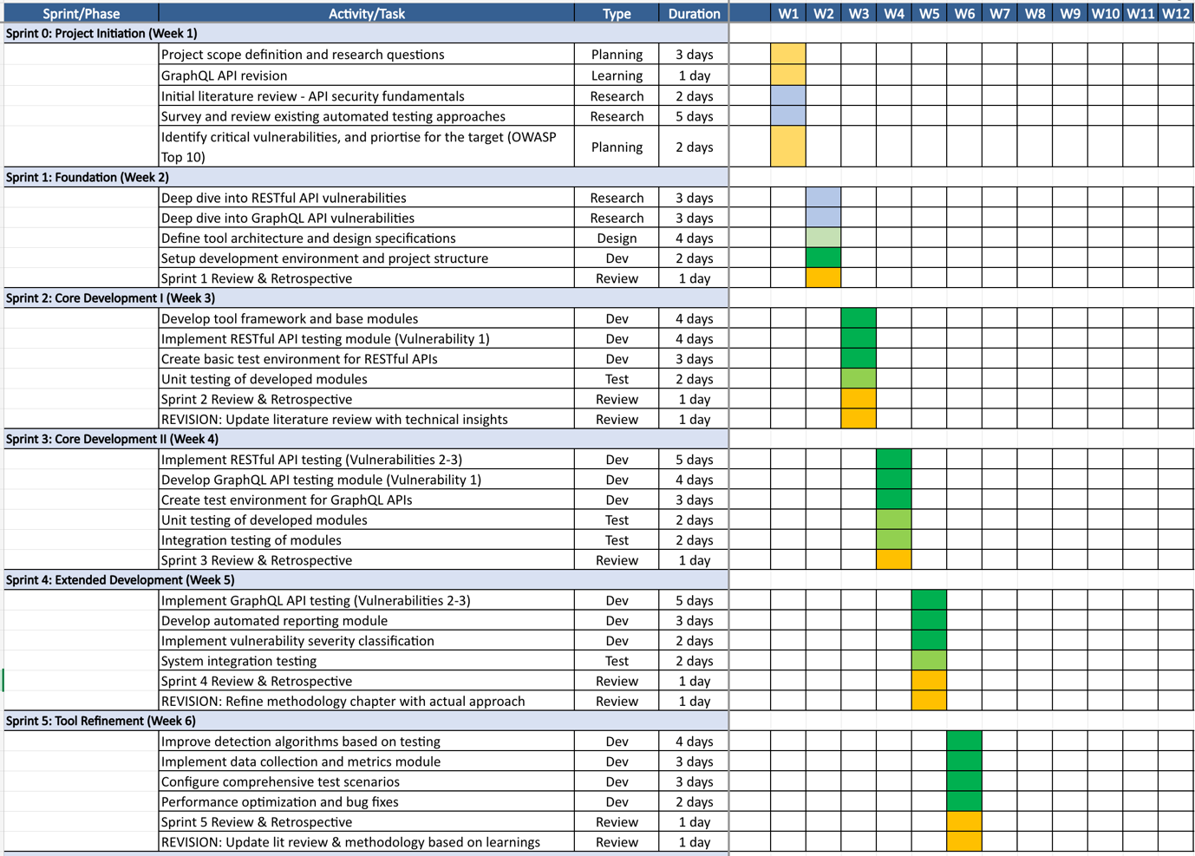
Figure 6.1: Project Plan from Week 1 to Week 6
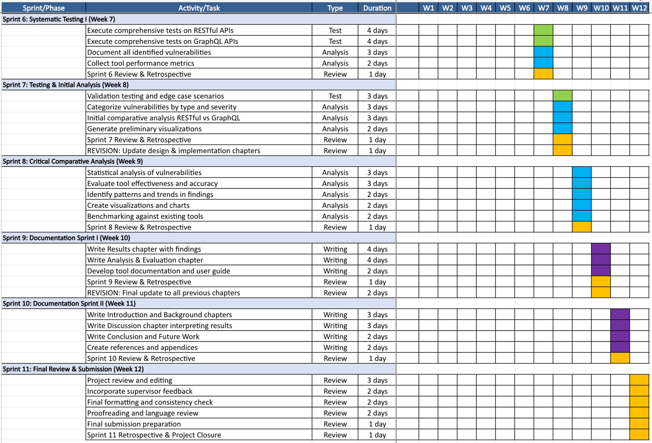
Figure 6.2: Project Plan from Week 7 to Week 12
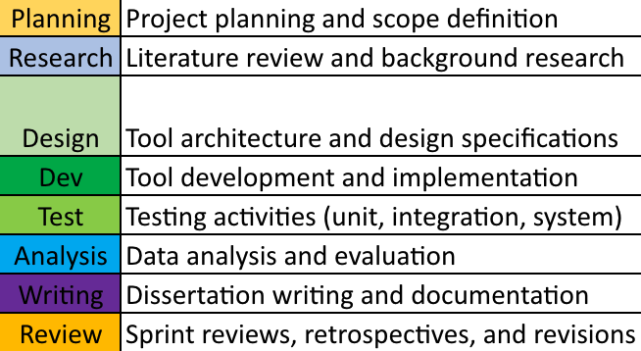
Figure 6.3: Legends for Project Activities

References
- Simpson (2025) Shift to AI Exploded API Usage in 2024. Available from: <https://nordicapis.com/shift-to-ai-exploded-api-usage-in-2024/> [Accessed 12 December 2025].
- Traynor (2025) The API Threat Report: What 2025 Has Taught Us So Far. Available from: <https://cybelangel.com/blog/the-api-threat-report-2025/> [Accessed 12 December 2025].
- Easterbrook, S., Singer, J., Storey, M.A. and Damian, D. (2008) Selecting Empirical Methods for Software Engineering Research. In: Shull, F., Singer, J., and Sjoberg, D. ed. Guide to Advanced Empirical Software Engineering. London: Springer-Verlag London Limited, pp. 285-311. doi: 10.1007/978-1-84800-044-5_11.
- Wikipedia (2014) Effect size. Available from: <https://en.wikipedia.org/wiki/Effect_size> [Accessed 23 December 2025].
- Vandever, C. (2020) Introduction to Research Statistical Analysis: An Overview of the Basics. HCA Healthcare Journal of Medicine, pp. 71-74. doi: 10.36518/2689-0216.1062.
- Open Worldwide Application Security Project (2023) OWASP Top 10 API Security Risks – 2023. Available from: <https://owasp.org/API-Security/editions/2023/en/0x11-t10/> [Accessed 10 December 2025].
- Idris, M., Syarif, I. and Winarno, I. (2022) Web Application Security Education Platform Based on OWASP API Security Project. EMITTER International Journal of Engineering Technology, 10 (2) December, pp. 246-261. doi: 10.24003/emitter.v10i2.705.
- Danielson (2025) Capital One Data Breach. Available from: <https://www.huntress.com/threat-library/data-breach/capital-one-data-breach> [Accessed 26 December 2025].
- Fielding, R.T. (2000) Architectural Styles and the Design of Network-based Software Architectures. PhD thesis, University of California, Irvine, 2000. Available from: < https://roy.gbiv.com/pubs/dissertation/fielding_dissertation.pdf> [Accessed 24 December 2025].
- Alharbi, S.J. and Moulahi, T. (2023) API Security Testing: The Challenges of Security Testing for Restful APIs. International Journal of Innovative Science and Research Technology, 8 (5) May, pp. 1485-1493. Available from: < https://ijisrt.com/assets/upload/files/IJISRT23MAY1879.pdf> [Accessed 26 December 2025].
- Tanveer, F., Iradat, F., Iqbal, W. and Ahmad, Awais. (2025) Towards Secure APIs: A Survey on RESTful API Vulnerability Detection. Computers, Materials & Continua (CMC), 84 (3) July, pp. 4223-4246. doi: 10.32604/cmc.2025.067536.
- Carossio and Kalos (2023) GraphQL Security Vulnerabilities in the Wild. Available from: <https://graphql.org/conf/2023/sessions/5bf24cd6483a63e62a2276fe38effb82/> [Accessed 27 December 2025].
- Yerushalmi (2023) GraphQL Vulnerabilities and Common Attacks: What You Need to Know. Available from: <https://www.imperva.com/blog/graphql-vulnerabilities-common-attacks/> [Accessed 27 December 2025].
- Saito, K., Tahara, Y., Ohsuga, A. and Sei, Y. (2025) Proposal of an Automated Testing Method for GraphQL APIs Using Reinforcement Learning. 17th International Conference on Agents and Artiﬁcial Intelligence, 3 (3) May, pp. 1101-1107. doi : 10.5220/0013263100003890.
- Belhadi, A., Zhang, M. and Arcuri, A. (2024) Random Testing and Evolutionary Testing for Fuzzing GraphQL API. ACM Transactions on the Web. 18 (1), pp. 1–41. doi: 10.1145/3609427.
- Yosef (2024) Burp Suite vs. ZAP: Features, Key Differences & Limitations. Available from: <https://www.pynt.io/learning-hub/burp-suite-guides/burp-suite-vs-zap-features-key-differences-limitations> [Accessed 29 December 2025].
- Qadir, S., Waheed, E., Khanum, A. and Jehan, S. (2025) Comparative evaluation of approaches and tools for effective security testing of Web applications. PeerJ Computer Science, 11, e2821 May. doi: 10.7717/peerj-cs.2821.
- Perera, I., Abeyrathne, H., Malalgoda, S. and Ifthikar, A. (2025) Enhancing GraphQL security by detecting malicious queries using large language models, sentence transformers, and convolutional neural networks arXiv:2508.11711. Available from: <https://arxiv.org/abs/2508.11711> [Accessed 30 December 2025].
- Brito, G. and Valente, M.T. (2020) REST vs GraphQL: A Controlled Experiment. arXiv:2003.04761. Available from: <https://arxiv.org/abs/2003.04761> [Accessed 1 January 2026].
- UK Government (1990) Computer Misuse Act 1990. Available from: <https://www.legislation.gov.uk/ukpga/1990/18/contents> [Accessed 15 December 2025].
- UK Government (2018) Data Protection Act 1990. Available from: <https://www.legislation.gov.uk/ukpga/2018/12/contents> [Accessed 15 December 2025].
- Open Source Initiative (n.d.) The Open Source Definition. Available from: <https://opensource.org/osd> [Accessed 16 December 2025].
- Farhi (2021) Damn-Vulnerable-GraphQL-Application. Available from: <https://github.com/dolevf/Damn-Vulnerable-GraphQL-Application> [Accessed 23 April 2026].
- erev0s (2020) VAmPI. Available from: <https://github.com/erev0s/VAmPI> [Accessed 23 April 2026].
- OWASP (n.d.) crAPI. Available from: <https://owasp.org/crAPI/docs/challenges.html> [Accessed 23 April 2026].
- Pwning OWASP Juice Shop (n.d.) OWASP Juice Shop Integration. Available from: <https://pwning.owasp-juice.shop/companion-guide/latest/part4/integration.html> [Accessed 23 April 2026].

