### **Define the Purpose & Audience**

**Purpose**: Document the design, development, and usage of the online clothing store.

**Audience**: Developers, administrators, and end users

**Document Structure**.

**Project Name**: Online Shopping System with COD for Clothing

* **Frontend**: HTML, CSS, JavaScript (Bootstrap)
* **Backend**: PHP
* **Database**: MySQL
* **Payment**: COD (Cash on Delivery)

**System Features**

**User Authentication & Profile**

* Register/Login
* Profile management

**Product Catalog**

* Clothing categories
* Product details

**Shopping Cart & Checkou**

* Add/remove items

**Cash on Delivery (COD) Option**

* Select COD during checkout
* Order confirmation message

**Admin Panel**

* **Manage inventory**
* **Track orders**
* **Handle customer queries**

#### **Product Management**

On one hand, an admin has full access to managing products for the website. There is a number of required fields under this section. It includes the name of the product, its categories, pricing, size, color, description, features, images, and more. Also, there are no such limits while uploading image files for each product. And at last, the system provides an option to feature the product. Where the administrator can simply check on to the featured product section in order to list it out as a featured one on to the client-side. As mentioned earlier, an administrator has full control to manage all the featured items for the website. Besides, the user can simply activate and deactivate each product. Also, the quantity section gets automatically updated as soon as someone purchases it.

#### **Order Management**

On the other hand, all the orders from the customers are listed under this section. The system lists out order details with proper mention of customer and product details with payment information, paid amount, and status. All the orders are automatically set to pending status under shipping and payment status by default. Here, an admin has to verify each order manually and change the status of each order. Starting from the payment status to shipping status, an admin has to mark it as complete as soon as it gets. Additionally, the admin can also send personal messages to the customers regarding any product-related issues or a simple thank you message. This section is directly connected to the customer’s order history as the results depend upon the admin side of things. Besides, the user can delete orders, search orders by product name, customer name, or pricing details.

##### Available Features:

* Client-Side Interaction
* Admin Panel
* Customer Registration
* Add to Cart System
* Checkout System
* Update Billing Address
* Search, Filter Products
* Product Categories
* Featured Products
* Latest Products
* Popular Products
* View Order History
* Update Customer Profile
* Manage Website Settings
* Manage Shop Settings
* Product Management
* Order Management
* Pending Orders, Shippings
* Set up Image Sliders
* Set Shipping Charges
* Page Settings
* Set Social Media Links
* Subscribers
* View Registered Customers

| **Project Name:** | Ecommerce Website PHP Project |
| --- | --- |
| **Language/s Used:** | PHP |
| **PHP version (Recommended):** | 5.6, 7.4 |
| **Database:** | MySQL |
| **Type:** | Website |
| **Developer:** | Your Name |
| **Updates:** | 0 |

#### **Instructions: How to Run?**

* [unzip](https://www.win-rar.com/start.html?&L=0) the project file and head over to your XAMPP directory.
* There you’ll find a folder naming “c:/xammp /htdocs”.
* Inside the “htdocs” folder, paste the project folder (not the .zip one, but the extracted one).
* Open your favorite browser; we recommend using Google Chrome or Mozilla Firefox.
* Then, go to URL “*http://localhost/phpmyadmin*“.
* Create a Database with a name “[db_shop](http://localhost/phpmyadmin/index.php?route=/database/structure&db=db_shop)”
* Click on the “Import” tab and choose the database file (.sql) which is provided under the folder naming “[db_shop](http://localhost/phpmyadmin/index.php?route=/database/structure&db=db_shop)” form zip file .

And there you have it, a full setup of the eCommerce site Project in PHP MySQL. For this particular PHP project, PHP Version 5.6 or 7.4 is required because the project does not operate with the oldest PHP version. So, users with the oldest PHP version (older than 5.6) might face various problems while operating it. As a result, you’ll need to manage your PHP version (only if you’re using the old version) at the moment. Also, Download Free eCommerce Site Project in PHP MySQL Source Code. So, this eCommerce Website PHP project is a fully functional project for all the intermediate levels that broads vast knowledge into such PHP web applications. In conclusion, this whole PHP project with free source code is an absolute project and a meaningful way for the users to learn and explore more about it.

**Use Case Digrame**

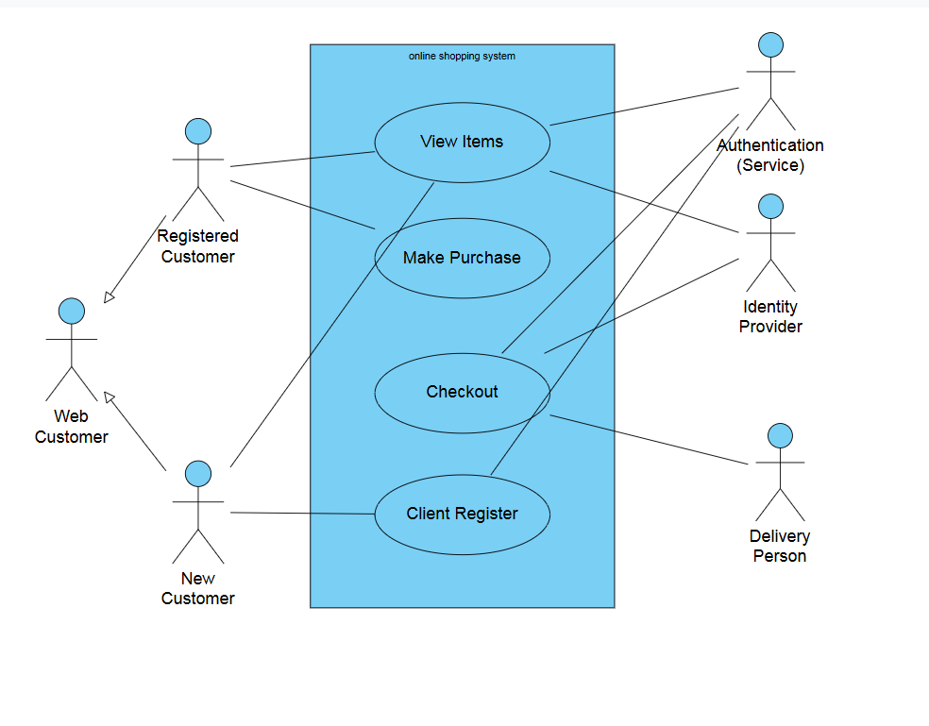**Installation & Setup Guide**