Author: Karen Bourgeois
SYstem Requirement Specification
Karen Bourgeois Portfolio
Abstract
This SRS details the Functional requirements for the Karen Bourgeois Portfolio website. This document is for educational purposes only. Sharing of this document is not permissible.

Contents
1. Travel the World – Main Page 2
2. Reserve Page 2
3. Purchase Page 3
4. Confirmation Page 4

Home Section

  - There is a welcome message on the page: a salutation, name, title, expiration of who Karen is.
  - It has a logo of a Robot designed by Karen.
  - There is a menu.
    - Clicking on the menu items take you to the appropriate sections.
  - There are pop out sections for social media and resume.
    - Menu listed on the upper right of page when full-screen.
    - The mobile menu is expandable.
  - There is a .
    - The destination cities available are: Buenos Aires, Rome, London, Berlin, New York, Dublin, and Cairo.
    - The default destination is Buenos Aires.

    - The option is a button with the verbiage “Find Flights”.

Reserve Page

  - There is an option to return the user to the Travel the World – Main Page.
    - The option is a link with the verbiage: Travel The World
  - There is verbiage to note the departure and destination cities: Flights from <departure city> to <destination city>
  - There is an option to choose a flight from a list of available flights.
    - The option is a button with the text “Choose This Flight”
    - Selecting the option Choose This Flight advances the user to the Purchase page.
  - The information listed for each flight is: Flight #, Airline, Departs: <city name>, Arrives: <city name>, and the Price
    - The Departs time in in regular, not military time
    - The Arrives time is in regular time, not military time
    - The Price is in USD dollars
Sample Data for the Reserve Page
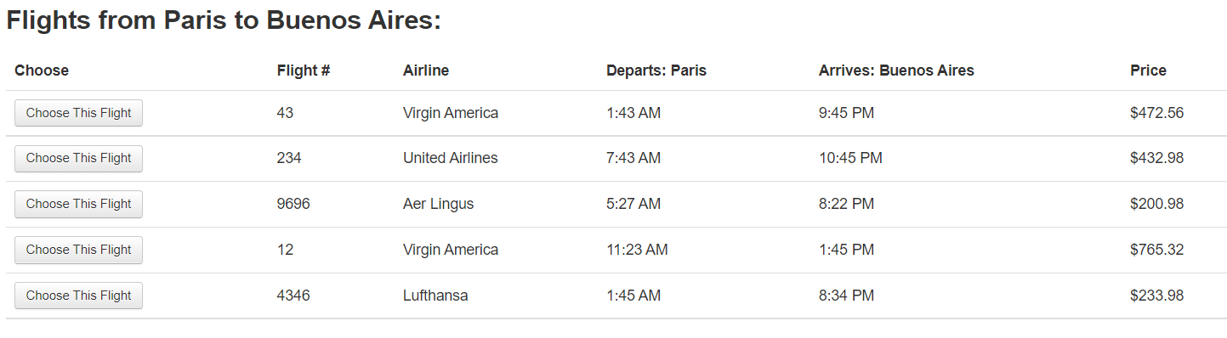

Purchase Page

  - Static information is displayed on the page.
    - A message clarifying the flights: Your flight from <airline code> to <airline code> has been reserved.
    - The airline name. Ex. Airline: United
    - The flight number. Ex. Flight Number: UA954
    - The Price before taxes. Ex. Price: 400
    - The Arbitrary Fees and taxes. Ex. Arbitrary Fees and Taxes: 514.76
    - The total cost is displayed. Ex. 914.76
    - The comment field is a required field.
  - There is a message indicating to the user to enter their information in the form to purchase the flight.
  - There is an option for the User to enter their first and last name.
      - This is a required field
  - There is an option to enter the civic address.
    - This is a required field.
  - There is an option to enter the City.
    - This is a required field.
  - There is an option to enter the State.
    - This is a required field
  - There is an option to enter the Zip Code.
    - This is a required field
  - There is an option to select a card type.
    - Card options in the list are: Visa, American Express, Diner’s Club
  - There is an option to enter the card number.
    - This is a required field.
  - There is an option to enter the Month.
    - The month is numeric
    - The max character length is 2 digits
    - This is a required field.
  - There is an option to enter the Year
    - The year is numeric
    - The character length is 4 digits.
    - This is a required field.
  - There is an option to enter the Name on Card
    - The max character length is 50 characters
    - This is a required field.
  - There is a checkbox to allow the system to remember the information.
    - The verbiage next to the check box indicates: Remember me
  - There is a button to Purchase the Flight once all required fields are filled in.
    - The button states: Purchase Flight
    - If any required fields are not completed an appropriate error message appears on the screen indicating which information the user needs to complete.
    - If all required fields are completed properly the user advance to the Confirmation page on click.
  - There is an option to return the user to the Travel the World – Main Page.
  - The option is a link with the verbiage: Travel The World

Confirmation Page

  - There is an option to return the user to the Travel the World – Main Page.
    - The option is a link with the verbiage: Travel The World
  - There is a message thanking the user for their purchase: Thank you for your purchase today!
  - There is static information displaying on the page for the user:
    - Id – order id number, 13 digits, numeric
    - Status – initial status is Pending
    - Amount – Total dollar amount in USD. Ex. $560 USD
    - Card Number – credit card number with all fields as X’s except the final 4 characters
    - Expiration – the expiration dates entered. Appears as month/year. Ex. 11/2025
    - Auth Code – authentication code, 6 numeric digits
    - Date – date and time of the purchase. Ex. Thu, 02 Jun 2022 18:15:04 +0000

