# Abstract

The USGS Soil-Water-Balance (SWB) model was developed as a tool to enable scientists and engineers to estimate the distribution and timing of groundwater recharge relatively quickly and easily. The original SWB 1.0 model calculates recharge (or more accurately, net infiltration) by use of commonly available geographic information system (GIS) data layers in combination with tabular climatological data. The code is based on a modified Thornthwaite-Mather soil-water-balance approach, with components of the soil-water balance calculated at a daily timestep. Recharge calculations are made on a rectangular grid of computational elements that may be easily imported into a regional groundwater-flow model. Recharge estimates calculated by the code may be output as daily, monthly, or annual values. The code described in this document (SWB 2.0) extends the original work by adding new process options and data input output capabilities.

# Introduction

Accurate estimates of the spatial and temporal distribution of recharge are important for many types of hydrologic assessments, including those that concern water-quality protection, streamflow and riparian ecosystem management, aquifer replenishment, groundwater-flow modeling, and contaminant transport; these recharge estimates are often key to understanding the effects of development in urban, industrial, and agricultural regions. With increasing demand for hydrologic assessments in support of management decisions comes an increased need for practical methods to quantify recharge rates and delineate zones of similar recharge (Scanlon and others, 2002).

The code calculates components of the water balance at a daily timestep by means of a modified version of the Thornthwaite-Mather soil-moisture-balance approach (Thornthwaite, 1948; Thornthwaite and Mather, 1957). Data requirements include several commonly available tabular and gridded data types: (1) precipitation and temperature, (2) land-use classification, (3) hydrologic soil group, (4) flow direction and (5) soil-water capacity. The data and formats required are designed to take advantage of widely available GIS datasets and file structures.

There is often a tradeoff between a modeling package's ease of use and its ability to simulate detail in a problem. SWB is no exception. The Soil-Water-Balance code can be easily used to estimate potential recharge in a wide variety of environmental settings. The inputs to the model are flexible; the user may define as many classes of soils as needed in order to capture important features.

Two versions of the Soil-Water-Balance code now exist (versions 1.0 and 2.0). Version 2.0 simulates all of the processes that Version 1.0 does.

# Background

A note regarding nomenclature: Healy (2010) gives clear definitions for a number of recharge-related terms:

* potential recharge: water that has infiltrated into the root zone; this water may leave the bottom of the root zone, eventually becoming recharge, or it may be removed from the soil column by means of evaporation and transpiration.
* deep percolation or net infiltration: water that has escaped the root zone and will eventually find its way to the groundwater table.

In this and the previous documentation of SWB, potential recharge is defined as water that leaves the bottom of the root zone and may become groundwater recharge after transiting the remainder of the unsaturated zone. The reason for using the term potential recharge in this manner was to emphasize the point that SWB does not simulate any processes beneath the root zone, and reflects the fact that there may be a considerable delay between the time the water leaves the bottom of the root zone and the time it meets the groundwater table. The term potential recharge as used in this document is the same as Healy's (2010) deep percolation or net infiltration.

Groundwater recharge can vary greatly over time and space. Site-specific data, when available, are not applicable to regional-scale problems. Groundwater modelers often assume that a fraction of precipitation is converted to recharge, or they instead use recharge as a calibration parameter. In transient groundwater-modeling problems, use of a physically based, spatially variable recharge boundary condition has been found to improve model performance (Jyrkama and Sykes, 2007).

Numerical modeling is one technique sometimes used to supply a spatially varied, transient recharge boundary condition on a regional scale (Scanlon and others, 2002). Simple soil-water-balance models are a category of numerical models commonly applied to groundwater recharge estimation problems. There perhaps are hundreds of soil-water-balance models described in the literature. Many soil-water-balance models were developed in order to evaluate crop irrigation requirements and impacts (Kendy and others, 2003), crop yield prediction (Akinremi and others, 1996), and landfill cover design (Schroeder and others, 1994).

Similarly, there are many examples of groundwater recharge estimation by means of a soil-water-balance. For example, the U.S. Environmental Protection Agency (U.S. EPA) HELP model, a soil-water-balance code used in landfill design (Schroeder and others, 1994), has been linked to commercial geographic information system (GIS) software (Jyrkama and Sykes, 2007). WetSpass calculates long-term recharge by means of a soil-water-balance model within a commercial GIS software package (Batelaan and De Smedt, 2001). (Finch, 2001) describes a distributed daily soil-water-balance model, but does not specify the computing platform.

Within the USGS, water balance models have long been used as a means to estimate potential groundwater recharge. The Yucca Mountain Project of the 1980s and 1990s produced the INFIL 3.0 model (U.S. Geological Survey, 2008). The Basin Characterization Model (BCM) has been applied to significant tracts of the southwestern United States (Flint and Flint, 2007; Flint and Flint, 2007). A similar model was developed and applied in Montana, Idaho, and Washington State (Bauer and Vaccaro, 1987; Bauer and Vaccaro, 1990). A custom water balance model has been applied to the Hawaiian Islands for decades (Izuka and others, 2010, Engott (2011)). Another custom water balance model was applied to the central Midwest regional aquifer system, with special emphasis on estimating consumptive use of water and the resulting impact on recharge (Dugan and Peckenpaugh, 1985). These models have generally been developed with specific environmental settings in mind (Yucca Mountain, Hawaiian Islands), are known well to only their authors, or would be difficult to apply to other more general use cases. However, these previous works also represent a significant body of work aimed at generating improved recharge estimates, and as time permits the good ideas and process implementations in those codes will be adapted to the SWB code.

For reasons of ease of use, non-reliance on proprietary software, and in the interest of general applicability, the U.S. Geological Survey (USGS) translated the original soil-water-balance code from Visual Basic to modern Fortran 95 (Westenbroek and others, 2010). This code was derived from work completed as part of a doctoral dissertation at the University of Wisconsin-Madison (Dripps, 2003). The SWB code has evolved since the original release, with crop water demand calculations and addition of some of the functionality of the Hawaiian Water Budget Code (Izuka and others, 2010).

# Scope and Purpose

This report documents changes made to the SWB 1.0 code since the original publication was issued, and use and operation of the SWB 2.0 code. Every effort has been made to ensure that control file statements operate in an identical fashion between the two codes. Features that exist in only one of the two codes are labeled as such.

The theoretical basis, data requirements for use, and limitations and assumptions relating to the two SWB codes are presented in this report. In addition, two test cases are provided. The first test case (Maui, Hawaii) confirms the performance of the SWB code relative to the Hawaii Water Budget code. The second test case demonstrates the application of the SWB code to the Little Plover River in Wisconsin, and compares the output of the two codes. Appendixes to this document contain a complete listing of control file directives and a description of input and output files use with SWB 1.0 and 2.0.

# Changes from Previous Versions

The core functionality of SWB has not changed since its initial release (Westenbroek and others, 2010). The code still performs a modified Thornthwaite-Mather soil water balance at each grid point within the model domain. However, the scope of recent process module additions and modifications of the input and output file structures are significant enough to warrant a new major SWB release along with a new publication.

Many of the changes to SWB have been "under the hood"; most users will never appreciate the difference between the initial and the current codes. Some of these changes will be very apparent to anyone familiar with the original SWB code. These changes have to do with model input and output, and include:

1. Elimination of swbstats,
2. Elimination of internally generated graphics,
3. Elimination of the custom swb binary output files,
4. Addition of PROJ.4 library (allows SWB to read grids with differing geographic projections),
5. Upgrading NetCDF input and output to NetCDF version 4,
6. Modification of internal structure to make adding new modules easier,
7. Addition of facility allowing for more flexible tabular data and parameter input, and
8. Rearrangement of internal data structures to more efficiently simulate non-rectangular model domains.

Many of the changes outlined above were made in response to frustrations relating to the difficulty of aligning and resampling input grids; SWB 1.0 required that every grid supplied to it be in exactly the same geographic projection, cover the same extents as the SWB project grid, at the same gridcell resolution. This requirement resulted in much needless data manipulation and consumed project time that would better have been spent on more worthwhile project tasks. In addition, SWB 1.0 stored results in a custom-programmed binary file format. Following a SWB 1.0 model run, a little program called ‘swbstats’ could be run to extract daily, monthly, annual, or period grids as well as generate grids and plots.

When the opportunity to modify SWB 1.0 came, the authors decided to overhaul some of the input and output code. SWB 2.0 stores all gridded output in a common gridded and widely used format: NetCDF (Unidata, 2014). The NetCDF file format is in common use amongst climate scientists and meteorologists, and has been slowly gaining favor in other scientific fields. The benefit of switching to a well-known binary file format is that rather than relying on a single program, swbstats, to handle post-processing, there are dozens of active, maintained open-source tools designed to make post-processing of NetCDF files easier.

Other changes since the initial SWB release add or modify the actual hydrologic processes simulated by SWB. These changes include the addition of the following modules:

1. Irrigation demand,
2. FAO-56 soil-moisture retention,
3. Interception: a) Horton, b) Gash,
4. Fog interception,
5. Rainfall: method of fragments,
6. Pervious/impervious subgrid characterization, and
7. Runoff: monthly runoff ratio.

# Model Description

Accurate estimates of the spatial and temporal distribution of recharge are important for many types of hydrologic assessments, including those that concern water-quality protection, streamflow and riparian ecosystem management, aquifer replenishment, groundwater-flow modeling, and contaminant transport; these recharge estimates are often key to understanding the effects of development in urban, industrial, and agricultural regions. With increasing demand for hydrologic assessments in support of management decisions comes an increased need for practical methods to quantify recharge rates and delineate zones of similar recharge (Scanlon and others, 2002).

The Soil-Water-Balance code has been developed to allow estimates of recharge to be made quickly and easily. The code calculates components of the water balance at a daily timestep by means of a modified version of the Thornthwaite-Mather soil-moisture-balance approach (Thornthwaite, 1948; Thornthwaite and Mather, 1957). Data requirements include several commonly available tabular and gridded data types: (1) precipitation and temperature, (2) land-use classification, (3) hydrologic soil group, (4) flow direction and (5) soil-water capacity. The data and formats required are designed to take advantage of widely available GIS datasets and file structures.

## Overview and Capabilities

SWB capabilities at version 2.0 are largely the same as they were in version 1.0. A simple soil-moisture balance calculation is made on a daily timestep for each active cell within the model domain. Potential recharge (or deep drainage) is considered to occur only when the daily soil-moisture balance generates soil-moisture values that exceed the soil’s field capacity. In this event, the soil-moisture value is reset to the soil’s field capacity, and the excess water is considered to become potential recharge.

## Model Theory

The SWB code uses a modified Thornthwaite-Mather soil-moisture accounting method (Thornthwaite and Mather, 1957) to calculate recharge; recharge is calculated separately for each grid cell in the model domain. Sources and sinks of water within each grid cell are determined on the basis of input climate data and landscape characteristics; recharge is calculated as the difference between the change in soil moisture and these sources and sinks.

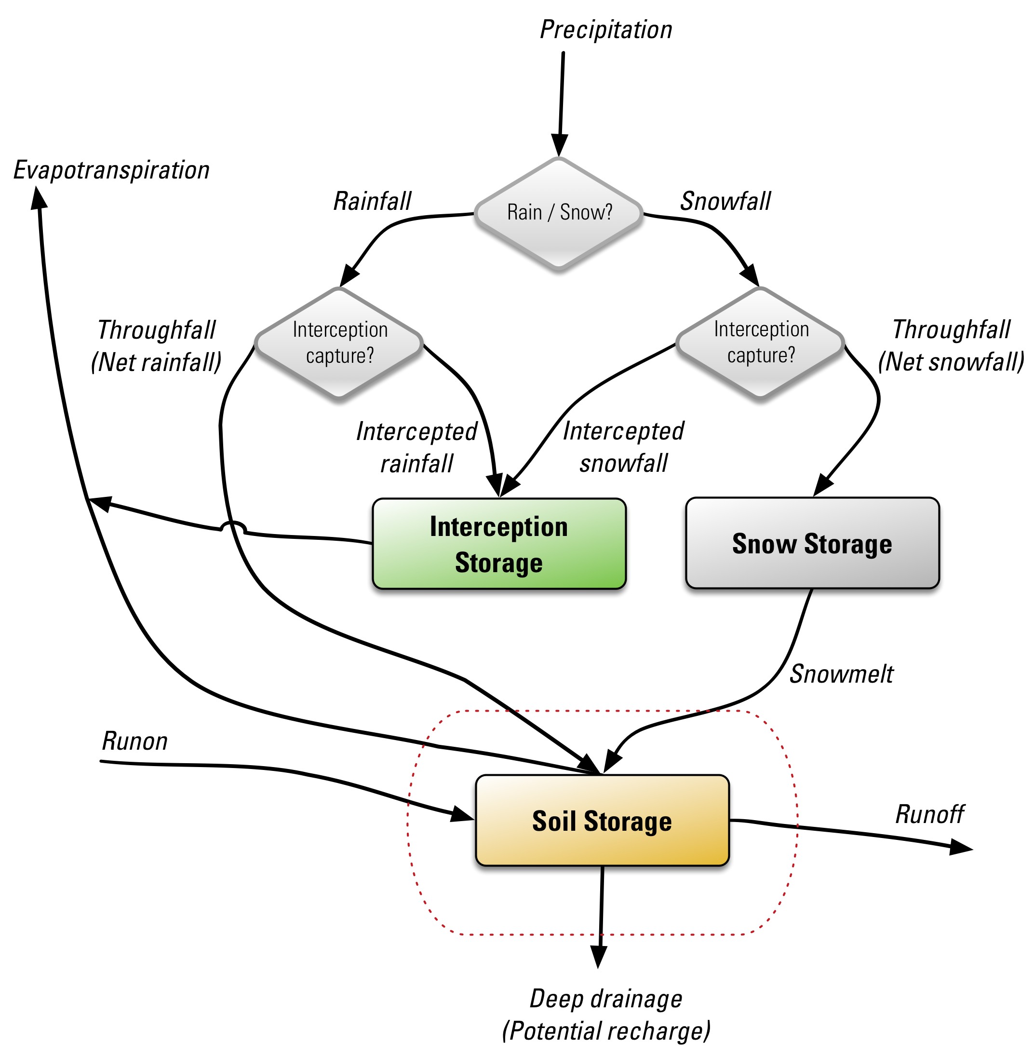

Figure 1. Conceptual_diagram_SWB_simplified.png

The water balance components used to calculate potential recharge amounts are shown schematically in Fig. 1.

The calculation proceeds as follows:

1. Precipitation is partitioned into gross rainfall and/or gross snowfall,
2. Intercepted rain or snow is added to the interception storage reservoir,
3. Net snowfall is added to the snow storage reservoir,
4. Snowmelt (if any) is calculated,
5. Potential evapotranspiration (PET) is calculated,
6. Interim soil moisture is calculated as ,
7. Interim soil moisture fraction is calculated as: ,
8. Actual evapotranspiration (AET) is calculated as some function of and ,
9. Updated soil moisture is calculated as ,
10. If the updated soil moisture () exceeds the field capacity of the soil, the updated soil moisture is set to , making the change in soil moisture ,
11. If the updated soil moisture is less than the field capacity, potential recharge is considered to be zero,
12. Otherwise, potential recharge is calculated as: .

In some cases it might be useful to simulate recharge in urban areas in a more detailed manner. This option is triggered in SWB 2.0 when a percent or fraction impervious area grid is supplied to the code (Fig. 2). When this option is active, an additional storage reservoir is created: "impervious surface storage". In addition, it is possible to take storm drains into account by supplying the fraction of impervious surface storage that is intercepted by storm drains.

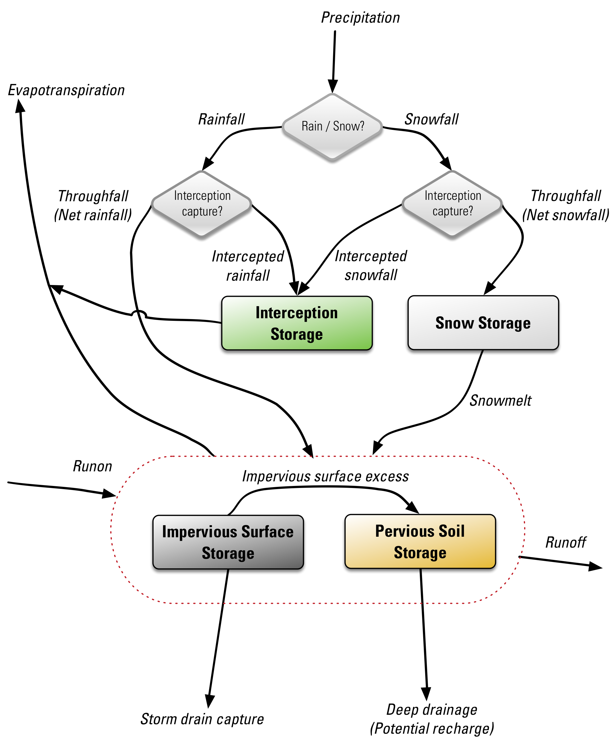

Figure 2. Conceptual_diagram_SWB.png

Implementation details regarding the storage reservoirs and process options are discussed in the next section.

## Process Options

### Precipitation

Several options exist for supplying SWB with precipitation data. The most straightforward involves simply reading a set of interpolated values from a gridded data file. If gridded data do not exist, the method of fragments may be used to disaggregate monthly grids into a set of distributed daily precipitation values.

#### Gridded / Tabular

#### Method of Fragments

The method of fragments creates synthetic sequences of daily rainfall from monthly rainfall by imposing the rainfall pattern from selected rain gages with daily data (see, for example, Srikanthan and McMahon (1999)). The synthesized daily rainfall data approximate the long-term average character of daily rainfall, such as frequency, duration, and intensity, but may not necessarily reproduce the actual historical daily rainfall record. Rain gages should be selected on the basis of location, and the length and completeness of daily records. Thiessen polygons are drawn around each of the selected rain gages, and the daily rainfall pattern within each Thiessen polygon is assumed to be the same as the pattern at the rain gage.

Daily rainfall fragments are calculated by dividing each daily rainfall measurement for a particular month by the total rainfall measured at the gage for that month. This results in a set of fragments for that particular month in which the total number of fragments is equal to the number of days in the month. Fragment sets are compiled for every selected gage for every month in which complete daily rainfall measurements are available. Fragment sets are grouped by month of the year and by rain gage. In the water-balance calculation, the fragment set used for a given gage for a given month is selected randomly from among all available sets for that gage for that month. Daily rainfall for a given month is synthesized by multiplying total rainfall for that by each fragment in the set.

### Interception

#### Bucket

The "bucket" model of interception is the original interception process module that was coded into SWB. The bucket model simply assumes that a set and constant amount of rainfall or snowfall must fall before the soil will receive any precipitation.

#### Gash

Another option in SWB for calculating canopy interception is a modified version of the model described by Gash and others (1979), herein referred to as the Gash model. Using this approach, canopy evaporation for a given day and location depends on precipitation, forest structure, and the mean rates of evaporation and precipitation. The Gash model was modified so that (1) precipitation includes rainfall and fog interception, instead of rain only, and (2) water cannot be stored on the forest canopy for more than a day. The forest structure is characterized in terms of canopy cover, canopy capacity, trunk-storage capacity, and the proportion of precipitation diverted to stemflow. Canopy cover, , is the fraction of a forested area that is covered by leaves, stems, and branches of trees. Canopy capacity, , is the depth of water left on the canopy when rainfall and throughfall have ceased (Gash and Morton, 1978). Evaporation of water from tree trunks is accounted for using the proportion of precipitation that is diverted to stemflow, , and trunk-storage capacity, , which is considered in terms of an equivalent depth of precipitation. The last parameter needed for the Gash model is the ratio of the mean evaporation rate to the mean precipitation rate during saturated conditions, .

To calculate canopy interception, the first step is to determine the minimum depth of precipitation necessary to saturate the forest canopy, , which is calculated on the basis of equation 2 in Gash and others (1995) as:

where

= precipitation necessary to saturate the canopy [L],

= canopy capacity per unit of ground area [L] (a constant),

= canopy cover per unit of ground area [dimensionless], and

= ratio of mean evaporation rate to mean precipitation rate during saturated conditions [dimensionless].

On the basis of the revised analytical form of the Gash model presented in table 1 of Gash and others (1995), canopy interception for a given day, (CE)i, is calculated for three canopy conditions as follows:

for ,

,

for and ,

,

for and ,

,

where:

= trunk-storage capacity [L] (a constant), and

= proportion of precipitation diverted to stemflow [dimensionless].

Advantages of the Gash model are: (1) it accounts for gaps in the forest canopy, which allows for a sparse canopy to be differentiated from a dense canopy; (2) canopy interception during a period of precipitation is dependent on the amount of precipitation during that period; and (3) the Gash model can account for spatial differences in climate. Disadvantages of the Gash model are that it is theoretical and may be difficult to adequately parameterize.

#### Horton

Robert Horton made countless observations at his hydrologic laboratory in the early 1900's. One of the hydrologic processes to receive his attention is that of canopy interception. The Horton model begins with a "bucket" that must be filled regardless of total storm volume, and adds a linear relation that produces an increasing canopy interception value proportional to increasing storm volume (Horton, 1919).

Table 1. Horton's working equations for estimating intercepted rainfall.

|  |  |
| --- | --- |
| Vegetation Type | Working Equation |
| Orchard |  |
| Chestnut, hedge and open |  |
| Chestnut, in woods |  |
| Ash, hedges and open |  |
| Ash, in woods |  |
| Beech, hedges and open |  |
| Beech, woods |  |
| Oak, hedges and open |  |
| Oak, woods |  |
| Maple, hedges and open |  |
| Maple, woods |  |
| Willow shrubs |  |
| Elm, hedges and open |  |
| Elm, woods |  |
| Basswood, hedges and open |  |
| Basswood, woods |  |
| Hemlock and pine, hedges and open |  |
| Hemlock and pine, woods |  |
| Clover and meadow grass |  |
| Forage, alfalfa, vetch, millet, etc. |  |
| Beans, potatoes, cabbage, and other small-hilled crops |  |
| Tobacco |  |
| Cotton |  |
| Buckwheat |  |
| Corn, planted in hills or rows |  |
| Fodder corn, sorghum, Kaffir corn, etc., sowed in drills |  |

In order to use Horton’s working equations in a SWB simulation, the user must supply the constant, slope, and exponent as given in the table above. No attempt is made to incorporate plant height; the user must modify the equation with the approximate plant height. Thus, the equation for 8-foot tall corn would be ; the constant, slope, and exponent supplied to SWB would be 0.04, 0.04, and 1.0, respectively.

### Snowfall

Snow is allowed to accumulate and/or melt on a daily basis. The daily mean, maximum, and minimum air temperatures are used to determine whether precipitation takes the form of rain or snow. Precipitation that falls on a day when the mean temperature minus one-third the difference between the daily high and low temperatures is less than or equal to the freezing point of water is considered to fall as snow (Dripps and Bradbury, 2007).

$$T_{\mean} - \frac{1}{3}\left( {{T_{\max }} - {T_{\min }}} \right) < 32\qquad(2)$$

where $T_{\mean}$ is the mean daily air temperature, in degrees Fahrenheit, and , are the daily maximum and minimum air temperatures, in degrees Fahrenheit.

### Snowmelt

#### Original SWB Process

Snowmelt is based on a temperature-index method. In the SWB code it is assumed that 1.5 mm (0.059 in.) of water-equivalent snow melts per day per average degree Celsius that the daily maximum temperature is above the freezing point (Dripps and Bradbury, 2007).

#### PRMS Snowmelt Process (actually Army COE)

Lorem ipsum dolor sit amet, consectetuer adipiscing elit. Aenean commodo ligula eget dolor. Aenean massa. Cum sociis natoque penatibus et magnis dis parturient montes, nascetur ridiculus mus. Donec quam felis, ultricies nec, pellentesque eu, pretium quis, sem. Nulla consequat massa quis enim. Donec pede justo, fringilla vel, aliquet nec, vulputate eget, arcu. In enim justo, rhoncus ut, imperdiet a, venenatis vitae, justo. Nullam dictum felis eu pede mollis pretium.

Etiam rhoncus. Maecenas tempus, tellus eget condimentum rhoncus, sem quam semper libero, sit amet adipiscing sem neque sed ipsum. Nam quam nunc, blandit vel, luctus pulvinar, hendrerit id, lorem. Maecenas nec odio et ante tincidunt tempus.

### Fog Interception

#### Fog

Fog interception is not explicitly modeled within SWB 2.0, but estimates of fog interception may e supplied by means of externally generated grid files. For pilot application of the new code to Maui, Hawaii (discussed elsewhere in this document), a set of external grids were developed. These grids express the intercepted fog amounts as a fraction of the monthly observed rainfall amounts. The process involves a grid computation using the aspect, elevation, and mean monthly rainfall combined with table values of estimated annual fog interception rates to yield monthly fog interception grids expressed as a fraction of monthly rainfall amounts.

### Runoff

#### Soil Conservation Service Curve Number {#curve_number}

The curve number method defines runoff in relation to the difference between precipitation and an initial abstraction term. Conceptually, this initial abstraction term represents the summation of all processes that might act to reduce runoff, including interception by plants and fallen leaves, depression storage, and infiltration [(Woodward and others, 2003). Eq. 3 is used to calculate runoff volumes (Woodward and others, 2002):

where is runoff, is daily precipitation, is the maximum soil-moisture holding capacity, and is initial abstraction, the amount of precipitation that must fall before runoff is generated.

The initial abstraction () term is related to a maximum storage term () as follows:

The maximum storage term is defined by the curve number for the land-cover type under consideration:

Curve numbers are adjusted upward or downward depending on how much precipitation has occurred in the previous 5-day period. The amount of precipitation that has fallen in the previous 5-day period is used to describe soil-moisture conditions; three classes of moisture conditions are defined and are called antecedent runoff condition I, II, and III, defined as shown in table tbl. 2.

Table 2. Antecedent Runoff Conditions.

|  |  |  |  |
| --- | --- | --- | --- |
| Runoff condition number | Description | Nongrowing Season | Growing Season |
| I | Dry | 0.05 | 1.4 |
| II | Average | 0.5 -- 1.1 | 1.4 -- 2.1 |
| III | Near Saturation | 1.1 | 2.1 |

#### Monthly Runoff Fraction Grid {#monthly_runoff_grid}

### Impervious surface runoff

Runoff from impervious surfaces may be simulated in a more detailed manner by including a gridded dataset defining the proportion of each gridcell that is comprised of impervious materials. Data may be supplied as either a fraction (0.0-1.0) or percentage (0-100%) of either pervious or *im*pervious surface area.

Any cell that is assigned an impervious surface fraction or percent that is greater than zero will operate in a fundamentally different way than the original SWB code did; in these cells, mass balance calculations will be performed on an additional "impervious surface storage" reservoir (Fig. 3).

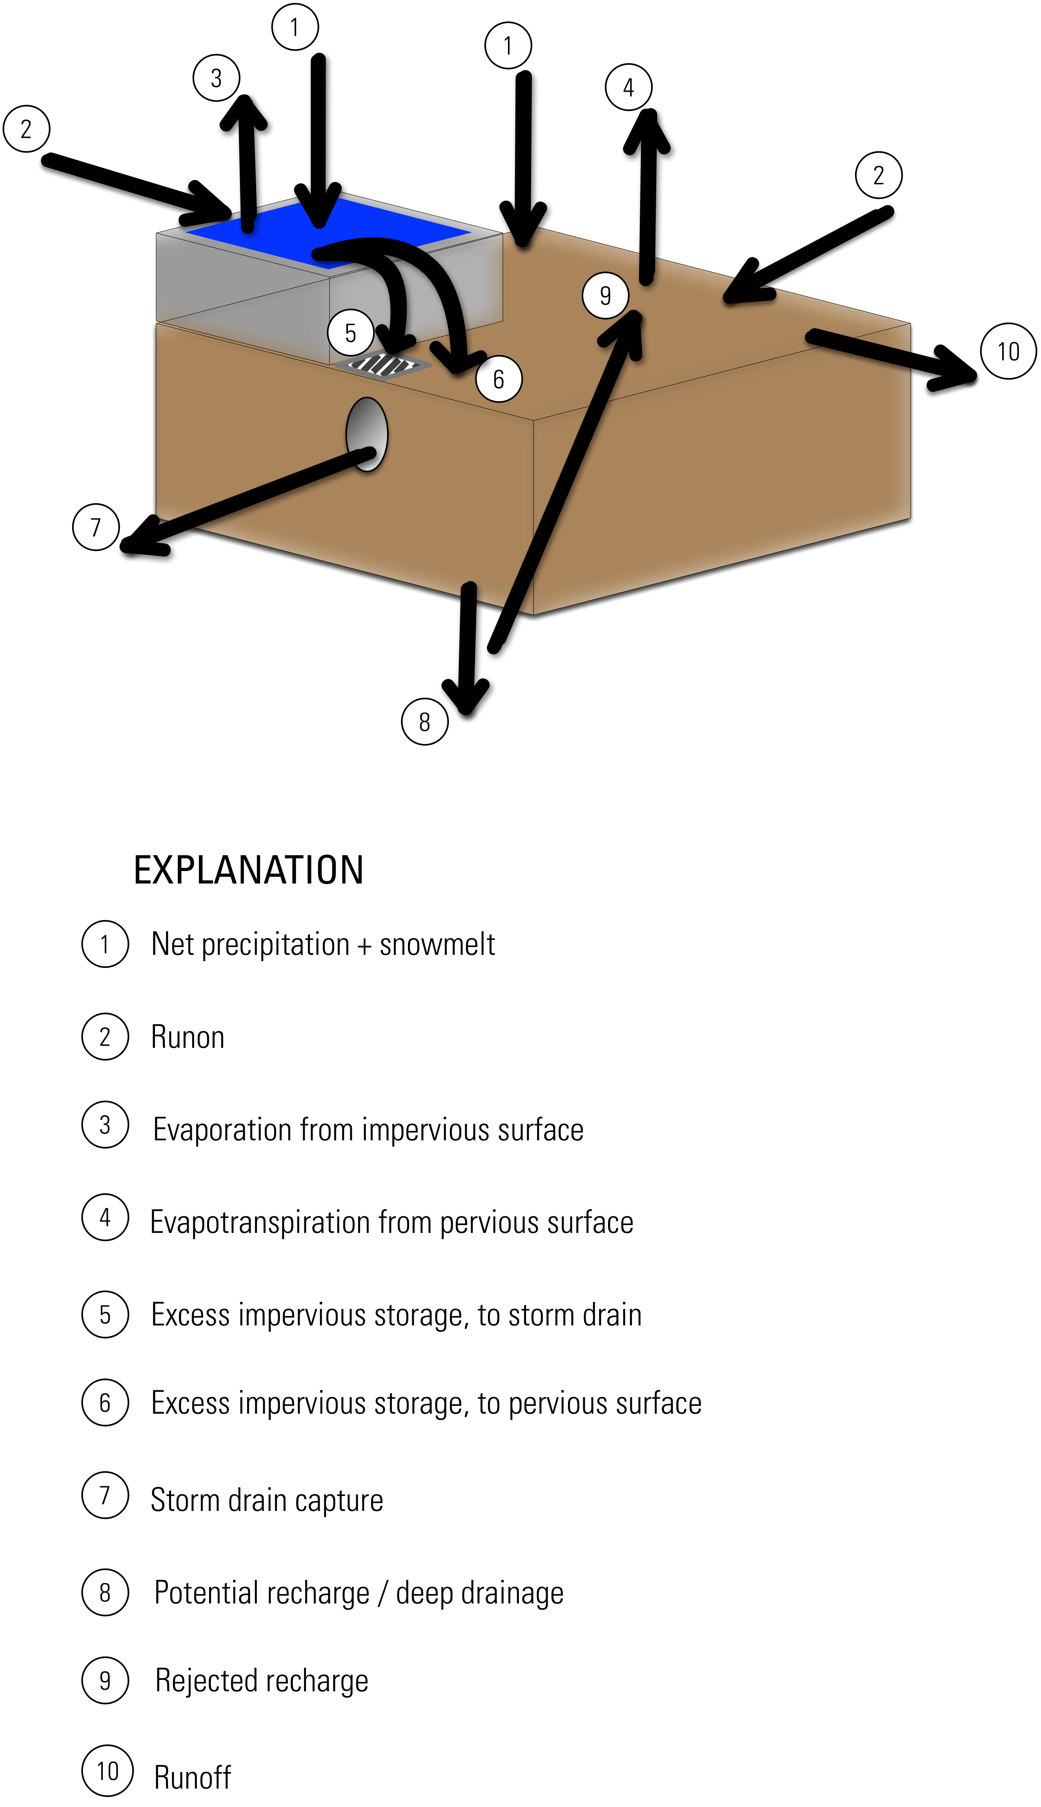

Figure 3. Detailed_soil_reservoir_schematic.png

### Runoff Routing

#### No Routing

Downhill routing may be disabled altogether. Cell-to-cell routing becomes increasingly hard to imagine in a meaningful way as gridcell sizes exceed 1km or so; in any system with a well-developed drainage system, overland flow would almost certainly encounter some type of surface water feature over that distance. With flow routing disabled, all cell runoff is assumed to reach a surface water feature and leave the model domain.

#### Downhill Routing

Activation of the overland flow-routing module within SWB allows runoff from one or more cells to become runon to downslope cells. All runoff from a cell is assumed to infiltrate in downslope cells or be routed out of the model domain on the same day in which it originated as rainfall or snowmelt.

During model initialization, SWB examines the connectivity between each active cell. On the basis of this connectivity, SWB creates a master list of cell IDs and sorts them from upslope to downslope. When the model solution is calculated each day, the code begins with the cell furthest upslope, performs all mass-balance calculations, and then proceeds to perform the same calculation on the next cell in the list.

Connectivity is defined on the basis of an input D8 flow-direction grid; this is a scheme by which connections between cells are encoded as an integer value within the flow-direction grid (O’Callaghan and Mark, 1984). Fig. **??** shows the direction encoding; the arrow shown in the figure shows a hydrologic connection from the central cell to the cell immediately to the southwest of the central cell, resulting in a flow direction value of 8. 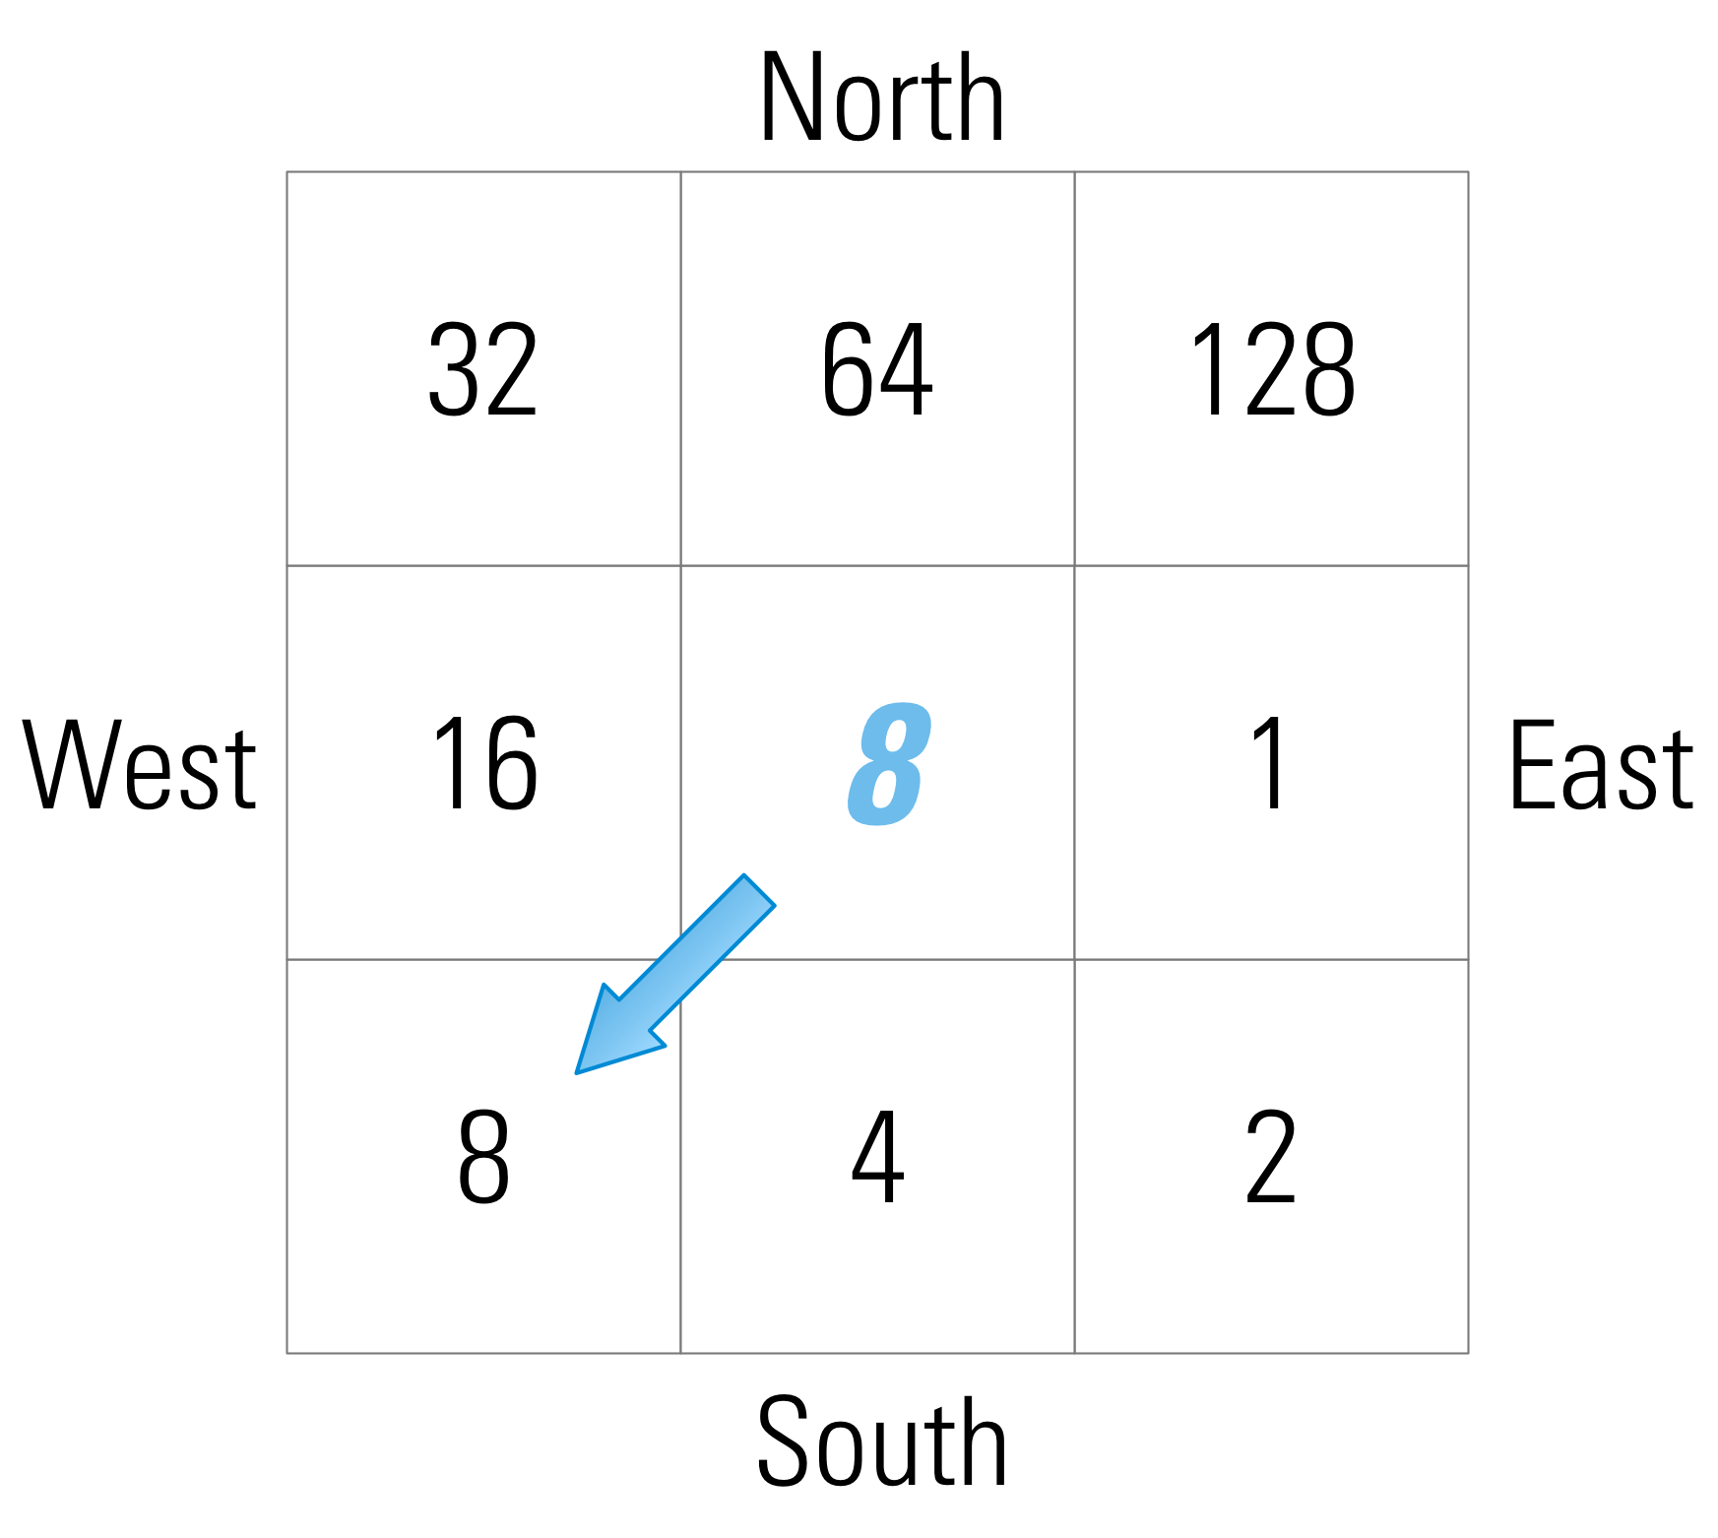

Once water is routed to a closed surface depression and evapotranspiration and soil-moisture demands are met, the only loss mechanism is recharge. This results in cases where maximum recharge values of hundreds or thousands of inches per year are calculated. These extremely high values are unrealistic and likely result from surface storage of water not being accounted for. The code described here allows the user to enter a maximum recharge rate for each land-cover and soil-group combination. This feature offers a way to restrict the estimated recharge values to a more reasonable range; however, the rejected recharge is nonetheless removed from the model domain on the same day in which it originated as precipitation or snowmelt.

### Potential / Reference Evapotranspiration

#### Jensen-Haise

where:

is an air temperature coefficient, and constant for a given area,

is the daily mean air temperature in degrees Fahrenheit,

is a constant for a given area,

is the daily solar radiation, expressed as equivalent depth of evaporation in inches,

is

is a humidity index given by , and

, are the maximum and minimum saturation vapor pressures for the warmest month.

#### Hargreaves-Samani

where:

is the grass-reference evapotranspiration, in mm per day,

is the (minimum/mean/maximum) air temperature in degrees Celcius, and

is extraterrestrial solar radiation, in mm per day.

Extraterrestrial solar radiation is calculated using the latitude and longitude of each grid cell for each day of the year. The equations used to calculate solar radiation may be found in Meeus (1991).

#### Monthly Potential Evapotranspiration Grid

Lorem ipsum dolor sit amet, consectetuer adipiscing elit. Aenean commodo ligula eget dolor. Aenean massa. Cum sociis natoque penatibus et magnis dis parturient montes, nascetur ridiculus mus. Donec quam felis, ultricies nec, pellentesque eu, pretium quis, sem. Nulla consequat massa quis enim. Donec pede justo, fringilla vel, aliquet nec, vulputate eget, arcu. In enim justo, rhoncus ut, imperdiet a, venenatis vitae, justo. Nullam dictum felis eu pede mollis pretium.

Etiam rhoncus. Maecenas tempus, tellus eget condimentum rhoncus, sem quam semper libero, sit amet adipiscing sem neque sed ipsum. Nam quam nunc, blandit vel, luctus pulvinar, hendrerit id, lorem. Maecenas nec odio et ante tincidunt tempus.

#### Turc

#### Thornthwaite-Mather

### Soil-Moisture Retention / Actual Evapotranspiration

Actual evapotranspiration is the soil moisture that can be extracted from a soil of a given soil moisture condition; by definition, actual evapotranspiration will be equal to or less than the potential evapotranspiration. In the days following a rainstorm, soil moisture is close to field capacity, and moisture is evaporated from bare soil and transpired by plants at rates close to the maximum rate sustainable given climatic conditions. Assuming no further precipitation, in subsequent days the evaporation and transpiration rates decrease as remaining soil-moisture is held more tightly within the soil matrix (Dunne and Leopold, 1978).

One simple way of simulating decreasing rates of soil-moisture evapotranspiration is to assume that the actual evapotranspiration is some function of the potential or reference evapotranspiration and the current soil-moisture amount (eq. 6).

where is the actual evapotranspiration, is the potential evapotranspiration, is the current soil-moisture amount [L], and is the soil field-capacity.

This section discusses the two soil-moisture retention functions implemented in SWB, one developed by Thornthwaite (1948) and the other included in the FAO-56 approach (1998).

#### Thornthwaite-Mather

In the late 1940s and early 1950s, C.W. Thornthwaite and his associates studied plant growth, and water utilization. As a result of this work, Thornthwaite observed that the relation between the actual ET to potential ET ratio and the soil moisture was linear Fig. **??**.

The first versions of SWB included full tabularized versions of the soil-moisture retention function, along with methods to interpolate between the various table values. The original published Thornthwaite-Mather (1957) method also introduces a variable (accumulated potential water loss, APWL) to track the cumulative unmet potential evapotranspiration; this term was developed in an age before easy access to computers and calculators, and, when used with the table values, made calculation of the daily water balance simpler.

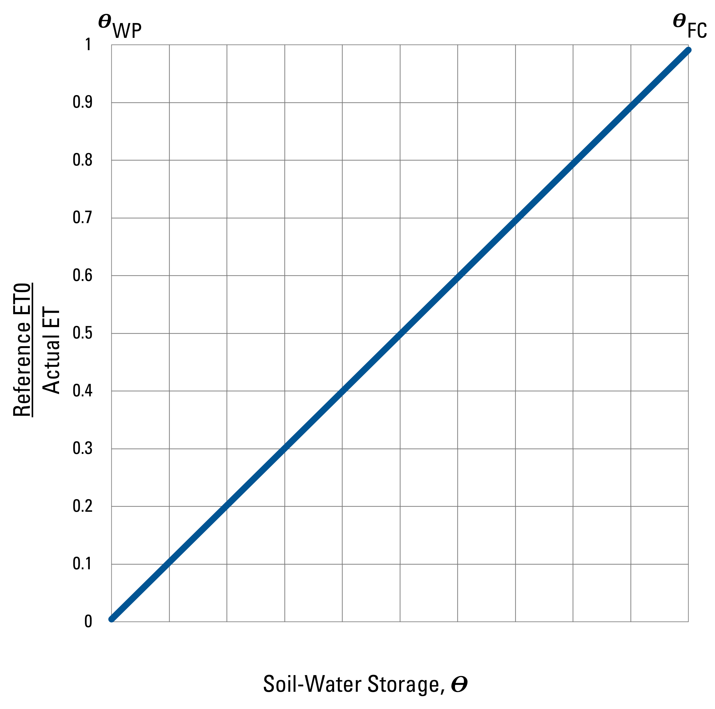 {#fig:aet_to_pet_thornthwaite width=4.5in}

The process of calculating daily soil moisture by means of tabular values and by use of fitted equations is given in the appendix. Current versions of the code update the soil moisture value by means of the relation derived below. Daily soil moisture may be estimated from this relation by first defining the instantaneous soil evapotranspiration as equal to the change in storage:

where is the instantaneous actual evapotranspiration, and is the rate of change in soil moisture relative to time.

The relation shown in Fig. **??** can be used to define a function relating actual and potential evapotranspiration as:

where is the instantaneous actual evapotranspiration, is the instantaneous potential evapotranspiration, is the soil moisture, and is the soil moisture value at field capacity.

eq. 7 and eq. 8 can be set equal to one another, the terms rearranged and integrated to yield an estimate of the current daily soil moisture:

The integral of the instantaneous potential ET over the course of a day is just the daily value. The integral of soil moisture is evaluated from to , with , where and represent the soil moisture on the current and previous days, respectively:

#### FAO-56

The FAO-56 method for determining actual evapotranspiration considers the process in two phases Fig. **??**. In the first phase, soil moisture levels are between a threshold soil moisture level and field capacity, and the actual ET is assumed to be equal to the potential ET. At soil moisture levels below the threshold level, the ratio between actual and potential ET is assumed to decrease linearly, with the ratio having a value of zero as the soil moisture reaches the permanent wilting point.

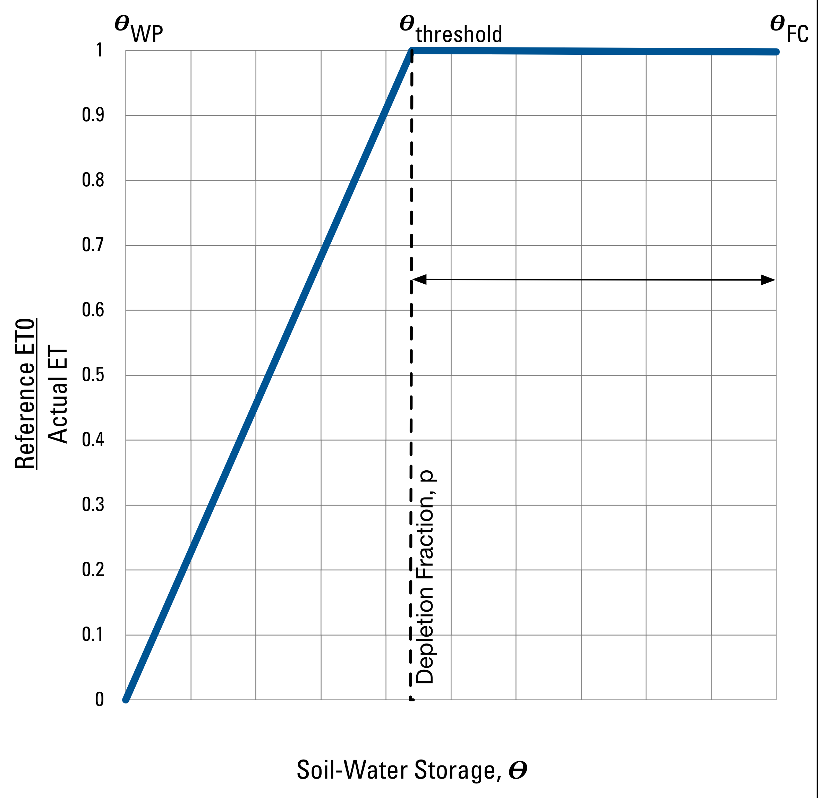 {#fig:fao56_soil_moisture width=4.5in}

The relation shown in figure 6 may be used to update the current soil moisture by considering three cases:

1. and are both greater than the threshold soil moisture ,
2. exceeds , but is less than , or
3. and are both less than .

In the first case where both the previous days’ and interim soil moistures lie on the horizontal portion of the line in figure 6, evapotranspiration proceeds at the rate of the potential ET value, and soil moisture is calculated:

In the third case, both the previous days’ and interim soil moistures lie on the sloped portion of the line in Fig. **??**, and evapotranspiration is some fraction of the potential ET value. The derivation of the equation describing this case is similar to that shown in the previous section, except that replaces :

The second case is simply a linear combination of the first and third cases. We can define as the fraction of the soil moisture band between and that exceeds the threshold soil moisture:

The new soil moisture for the second case can then be found as:

### Crop Coefficients

When the irrigation demand is simulated in SWB, the underlying soil-moisture module is automatically changed to the FAO-56 The calculation under 'nonstandard' conditions includes the transpiration-limiting effects of soil water stress on plants. When this option is invoked in swb, the Thornthwaite-Mather soil moisture retention tables are **not** consulted. Rather, the crop evapotranspiration amount is adjusted by incorporation of a water stress factor whose value may range between 0.0 and 1.0:

is defined by the doil moisture deficit relative to two soil moisture amounts: the Readily Available Water (RAW) and Total Available Water (TAW) amounts. At soil moisture deficits less than the RAW amount, it is assumed that plants have adequate available moisture for growth; plants are assumed to be under no water stress. The value of is one under these conditions.

Once soil moisture deficit increases beyond the RAW amount, decreases linearly, reaching a value of zero as the soil moisture deficit approaches the TAW value.

Total Available Water is defined as the **maximum** amount of water that can be present within the root zone, and is calculated in swb as:

where

is the Available Water Capacity, in inches per foot, and  
 is the current rooting depth of vegetation in feet.

Readily Available Water is defined as the amount of water that can be withdrawn by a plant from soil moisture storage without the plant suffering water stress. may be defined as some fraction of the Total Available Water:

where

is the fraction of Total Available Water that can be removed from soil moisture storage before a plant begins suffering from water stress.

is called the "plant stress depletion fraction" in the swb irrigation lookup table.

The figure below, taken from FAO-56 (Allen and others, 1998), shows how the water stress factor changes with changing soil moisture deficit amounts.

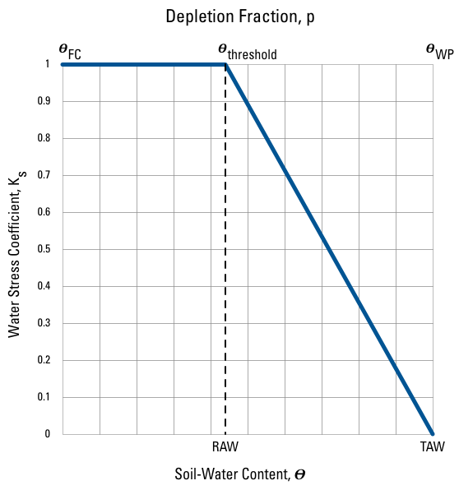

Figure 4. Parameters__Depletion_Fraction.png

As shown in +Fig. 4, the depletion parameter defines the soil moisture conditions below which the actual to potential ET ratio drops toward zero.

### Irrigation Demand

#### FAO-56

### Rejected recharge

Specification of maximum daily recharge amounts is a crude but effective way of preventing SWB from calculating unreasonably high potential recharge values. With flow routing enabled, downslope cells can have significant amounts of water diverted to them. The resulting calculated potential recharge values sometimes greatly exceed the values that might be reasonable given the soils and underlying geology. Setting a maximum daily recharge value will prevent these cells from taking on unrealistic recharge values.

In cases where the calculated daily potential recharge is greater than the cell's maximum daily recharge limit, the potential recharge for the cell is set to the maximum daily recharge value, and the remaining water is converted to "rejected recharge". This rejected recharge is then routed to the next downslope cell, where the water becomes available for runoff, recharge, or evapotranspiration.

In previous SWB applications, the maximum recharge values were set to values approximating the vertical hydraulic conductivity values for the underlying MODFLOW application.

# Potential Limitations to Application of the SWB Code

The original concept behind the SWB code was to allow for the spatial distribution of groundwater recharge to be quickly and easily calculated on the basis of readily available data and a standardized set of parameters (Dripps, 2003). The version of the SWB model described here retains most of the features that made the original model attractive from the standpoint of practical application (Dripps, 2003; Dripps and Bradbury, 2007). Despite the possible limitations given below, the SWB model approach is capable of generating reasonable annual or monthly mean groundwater recharge estimates at the scale of a small catchment (Dripps and Bradbury, 2007). In order to do so, however, the user will have to upscale the daily results offered by the SWB model and average or filter the results over a larger area. The relative spatial variability and pattern of recharge between catchments should also be of great value, particularly if these estimates can be corroborated with recharge estimates generated from streamgages or observation wells. Comparing SWB-calculated recharge estimates to those estimated from streamflow records, or from a groundwater model calibrated to stream fluxes is recommended.

As with any numerical model, the burden is on the user to preprocess the input grids in the most appropriate manner. If the user has not done this, then SWB will generally halt after giving the user a description of the problem it detects for an input grid. Although the SWB code can certainly be applied using only available data and a standard set of curve numbers, it would be prudent to treat the results with caution, as one should with any model output. In addition, certain underlying theoretical limitations should be kept in mind when interpreting SWB model output. These limitations are discussed below.

**Runoff routing.** The inclusion of overland-flow routing in the code ensures that runoff from an upslope grid cell has one or more opportunities to contribute to infiltration in the cells that are downslope from it. However, all runoff from a cell is assumed to infiltrate in downslope cells or be routed out of the model domain on the same day in which it originated as rainfall or snowmelt.

In addition, once water is routed to a closed surface depression and evapotranspiration and soil-moisture demands are met, the only loss mechanism is recharge. This results in cases where maximum recharge values of hundreds or thousands of inches per year are calculated. These extremely high values are unrealistic and likely result from surface storage of water not being accounted for. The code described here allows the user to enter a maximum recharge rate for each land-cover and soil-group combination. This feature offers a way to restrict the estimated recharge values to a more reasonable range; however, the rejected recharge is nonetheless removed from the model domain on the same day in which it originated as precipitation or snowmelt.

**Groundwater/surface-water interaction.** Interactions between surface-water and groundwater features are not simulated in the SWB code and could not be without significantly increasing the complexity of the model. In locations where the water table is beneath the bottom of the root-zone, the SWB code should be capable of producing reasonable annual or monthly values. The depth from the bottom of the root zone to the top of the water table is not considered in the estimation of recharge; there may be a significant time of travel through the unsaturated zone. Coupling the SWB code with an unsaturated-zone code that could route water to the water table, such as the MODFLOW UZF Package (Niswonger and others, 2006), would be one way to address this limitation.

In areas with wetlands, springs, lakes, or other landscape features where the water table is close to the land surface, the SWB code can be expected to perform poorly; there is currently no provision for recharge rejection via saturation excess other than by specifying a maximum recharge rate for a particular combination of land use and soil type.

**Curve number method.** In the current version of the SWB model, it is assumed that infiltration is the sum of net precipitation, snowmelt, and inflow, minus the runoff calculated by means of the NRCS curve number method. Runoff calculation at a plot or field scale in a continuous simulation by means of the curve number method may be beyond the limits of the method. The list of perceived limitations associated with the curve number method includes the following (Garen and Moore, 2005):

* method cannot be used to identify runoff processes, source areas, or flow paths;
* method is a watershed-scale method that should not be applied at a plot or field (or grid cell) scale; and
* method was developed to evaluate floods and was not designed to simulate daily flows of ordinary magnitude.

In addition, it has been suggested that the curve number itself is not constant but varies from event to event and that the antecedent-runoff condition explains only some of this variability (Hjelmfelt, 1991). Given variability in the curve numbers themselves, as well as the other limitations of the curve number method, it is reasonable to treat the standard curve number table values merely as starting points; ideally, the curve numbers should be verified by use of observed paired precipitation-runoff data (Hawkins, 1993).

The SWB code contains an alternative method for calculating runoff that incorporates a much smaller initial abstraction term. Use of this alternative method for calculating the initial abstraction may be more appropriate for continuous simulation (Woodward and others, 2003). Users of the SWB code have the option of defining the initial abstraction term as , compared to . The use of this smaller initial abstraction term results in more runoff generation for areas with low curve numbers and for storms of smaller magnitude. If the smaller initial abstraction term is used, curve numbers are automatically scaled by the SWB code to maintain an appropriately shaped rainfall-runoff curve (Woodward and others, 2003).

The modular design of the SWB code makes it feasible to add new process modules relatively easily. Although there are no immediate plans to do so, future versions of SWB could include an implementation of the Green-Ampt infiltration method (Green and Ampt, 1911), and an enhanced ability to route and store overland flow.

**Snowmelt and infiltration.** For temperate areas that experience snowfall and snowmelt, the SWB model is sensitive to snowmelt, and in particular, to how snowmelt translates into surface runoff. The addition of a continuous frozen ground index (CFGI) to the SWB code offers a simple way to approximate the effects of frozen ground. Spring runoff may be increased by lowering the setpoints at which the ground is considered to change from unfrozen to frozen; lowering the CFGI setpoints has the effect of increasing the amount of time that the runoff curve numbers are shifted toward antecedent runoff condition III.

Other modelers have altered the curve number in an attempt to simulate runoff from frozen ground. For example, Carroll and others (2005) assigned a separate set of curve numbers to soils considered to be frozen and another set of curve numbers to soils considered to be unfrozen. Despite this, there is no theoretical basis supporting the derivation of a frozen-ground curve number, so its use in the SWB code is primarily for expediency and consistency with other model input considerations.

Because the CFGI is based on air temperatures, the SWB code is unable to resolve differences in snowmelt timing between grid cells with differing ground-surface orientation relative to the sun (aspect).

**Climate variability.** Year-to-year climate variability causes corresponding variability in calculated recharge values. Use of multiple years of climate data should help to minimize the effect of year-to-year climate variability on estimated recharge values.

# Model Application

Accurate estimates of the spatial and temporal distribution of recharge are important for many types of hydrologic assessments, including those that concern water-quality protection, streamflow and riparian ecosystem management, aquifer replenishment, groundwater-flow modeling, and contaminant transport; these recharge estimates are often key to understanding the effects of development in urban, industrial, and agricultural regions. With increasing demand for hydrologic assessments in support of management decisions comes an increased need for practical methods to quantify recharge rates and delineate zones of similar recharge (Scanlon and others, 2002).

The Soil-Water-Balance code has been developed to allow estimates of recharge to be made quickly and easily. The code calculates components of the water balance at a daily timestep by means of a modified version of the Thornthwaite-Mather soil-moisture-balance approach (Thornthwaite, 1948; Thornthwaite and Mather, 1957). Data requirements include several commonly available tabular and gridded data types: (1) precipitation and temperature, (2) land-use classification, (3) hydrologic soil group, (4) flow direction and (5) soil-water capacity. The data and formats required are designed to take advantage of widely available GIS datasets and file structures.

## Overview of Input and Output Files

The Soil-Water-Balance Code must be supplied with at least three gridded datasets in order to run:

1. Available water capacity, in inches per foot [real valued grid]
2. Landuse classification [integer grid]
3. Hydrologic Soils Group [integer grid]

A fourth grid must be supplied if flow routing is enabled in the simulation. This grid is an integer-valued grid of "D8" flow directions, wherein 1 signifies flow from the cell to the east, 2 to the southeast, 4 to the south, 8 to the southwest, 16 to the west, 32 to the northwest, 64 to the north, and 128 to the northeast.

If flow routing is not enabled, the flow direction grid may be specified in the control file as something like:

FLOW_DIRECTION CONSTANT 1

This specification will satisfy SWB's requirement for flow direction data by simply supplying a grid of constant values.

## General Discussion of Gridded Datasets

SWB can ingest gridded data in three formats: Surfer, ESRI Arc ASCII, or netCDF.

### Supported File Types

#### Surfer ASCII Grid

Golden Software’s ASCII grid format consists of a 5-line header followed by the data values arranged in a matrix.

DSAA  
14 5  
0.5 7.0  
-0.4 0.0  
0.0 7.0  
0.5 1. 1.5 2. 2.5 3. 3.5 4. 4.5 5. 5.5 6. 6.5 7.0  
0.45 0.9 1.4 1.9 2.4 2.9 3.4 3.9 4.4 4.9 5.4 5.9 6.4 6.9  
0.4 0.8 1.3 1.8 2.3 2.8 3.3 3.8 4.3 4.8 5.3 5.8 6.3 6.8  
0.36 0.72 1.21 1.7 2.2 2.7 3.2 3.7 4.2 4.7 5.2 5.7 6.2 6.7  
0.32 0.64 1.13 1.6 2.1 2.6 3.1 3.6 4.1 4.6 5.1 5.6 6.1 6.6

The header values contain:

1. “DSAA”, a label identifying the file format as a Golden Software ASCII grid,
2. Number of columns (number of X values), number of rows (number of Y values),
3. Minimum X value, maximum X value,
4. Minimum Y value, maximum Y value,
5. Minimum Z value, maximum Z value.

As one might expect, the matrix of values is arranged such that the “x” coordinates increase from lower to higher values as one moves left to right over the columns. The “y” coordinates correspond to the rows of data and decrease from higher values to lower values as one moves down the rows.

#### ESRI ASCII Grid

The publishers of ArcMap and ArcView software, the Environmental Systems Research Institute (ESRI), developed one of the most commonly used raster data formats in use. ESRI’s ASCII grid format is a simple matrix representation of the gridded dataset with a short header tacked to the top of the file.

ncols 34  
nrows 4  
xllcorner 739475.000000000000  
yllcorner 2314000.000000000000  
cellsize 10.000000000000  
NODATA_value -9999  
9 9 9 9 9 9 9 9 9 9 9 8 8 8 8 8 8 8 9 9 9 9 9 9 8 8 8 8 8 8 8 8 9 9  
7 7 7 7 7 7 7 7 7 7 7 7 7 7 7 6 6 6 7 7 7 6 6 6 6 6 6 6 6 6 6 6 6 6  
7 7 7 7 6 6 6 7 7 7 6 6 6 6 6 6 6 6 6 6 6 6 6 6 6 6 6 6 6 6 6 6 6 6  
7 7 7 7 7 7 7 7 7 7 6 6 6 7 7 7 6 6 6 6 6 6 6 6 6 6 6 6 6 6 6 6 6 6

Note that SWB does not really handle the NODATA_value codes as given in the ESRI ASCII grid files; missing values should be handled through the use of user-supplied control file directives, discussed later in this section.

#### NetCDF

NetCDF, or Network Common Data File, is a file format commonly used by researchers in atmospheric and oceanic sciences. One of the key benefits of NetCDF files is that they are designed to be platform-independent; in other words, a NetCDF file generated on a Macintosh by an application compiled with the PGI compiler should be able to be read by an application compiled with the Intel compiler and running on Windows. In addition, NetCDF files are able to store arbitrary combinations of data. This allows for substantial metadata to be stored in the NetCDF file along with the variable of interest.

A set of conventions, known as the Climate and Forecast Metadata Conventions, gives recommendations regarding the kind and nature of metadata to be included along with the primary variable within a NetCDF file (Eaton and others, 2011). SWB outputs written to NetCDF files attempt to adhere to the Climate and Forecast Metadata Conventions version 1.6 (CF 1.6) in order to maximize the number of third-party NetCDF tools that will work with SWB output.

In addition to these benefits of NetCDF file use, the fact that there are dozens of open-source tools available to read, write, and visualize NetCDF files makes them a good candidate for use with SWB. One of the most basic tools, distributed by Unidata, the maintainer of NetCDF file format, is called ncdump—a program to “dump” the contents of a NetCDF file. If we take a recent Daymet file containing daily precipitation values for 2014, we can see the stored metadata in the file:

> ncdump -h prcp_2014.nc4  
The following metadata is returned:  
netcdf prcp_2014 {  
dimensions:  
 x = 5268 ;  
 y = 4823 ;  
 time = UNLIMITED ; // (365 currently)  
 nv = 2 ;  
variables:  
 float x(x) ;  
 x:units = "m" ;  
 x:long_name = "x coordinate of projection" ;  
 x:standard_name = "projection_x_coordinate" ;  
 float y(y) ;  
 y:units = "m" ;  
 y:long_name = "y coordinate of projection" ;  
 y:standard_name = "projection_y_coordinate" ;  
 float lat(y, x) ;  
 lat:units = "degrees_north" ;  
 lat:long_name = "latitude coordinate" ;  
 lat:standard_name = "latitude" ;  
 float lon(y, x) ;  
 lon:units = "degrees_east" ;  
 lon:long_name = "longitude coordinate" ;  
 lon:standard_name = "longitude" ;  
 float time(time) ;  
 time:long_name = "time" ;  
 time:calendar = "standard" ;  
 time:units = "days since 1980-01-01 00:00:00 UTC" ;  
 time:bounds = "time_bnds" ;  
 short yearday(time) ;  
 yearday:long_name = "yearday" ;  
 yearday:valid_range = 1s, 365s ;  
 float time_bnds(time, nv) ;  
 short lambert_conformal_conic ;  
 lambert_conformal_conic:grid_mapping_name = "lambert_conformal_conic" ;  
 lambert_conformal_conic:longitude_of_central_meridian = -100. ;  
 lambert_conformal_conic:latitude_of_projection_origin = 42.5 ;  
 lambert_conformal_conic:false_easting = 0. ;  
 lambert_conformal_conic:false_northing = 0. ;  
 lambert_conformal_conic:standard_parallel = 25., 60. ;  
 float prcp(time, y, x) ;  
 prcp:_FillValue = -9999.f ;  
 prcp:cell_methods = "area: sum time: sum" ;  
 prcp:coordinates = "lat lon" ;  
 prcp:grid_mapping = "lambert_conformal_conic" ;  
 prcp:long_name = "daily total precipitation" ;  
 prcp:missing_value = -9999.f ;  
 prcp:units = "mm/day" ;  
 prcp:valid_range = 0.f, 200.f ;  
  
// global attributes:  
 :start_year = 2014s ;  
 :source = "Daymet Software Version 2.0" ;  
 :Version_software = "Daymet Software Version 2.0" ;  
 :Version_data = "Daymet Data Version 2.1" ;  
 :Conventions = "CF-1.4" ;  
 :citation = "Please see http://daymet.ornl.gov/ for current Daymet data citation information" ;  
 :references = "Please see http://daymet.ornl.gov/ for current information on Daymet references" ;  
}

This particular file contains three classes of metadata: dimensions, variables, and global attributes. As can be seen above, the file contains data about 4 “dimensions”: x, y, time, and nv. Nine variables are defined, each of which is references in terms of the dimensions. The key variable in the file is “prcp”—the daily precipitation value. prcp is defined at each time (day) in the file for all values of x and y. Note the way that dates and times are specified in the NetCDF file: as a real-valued number of days since 1980-01-01 00:00:00 UTC.

SWB does not have the ability to make sense of much of this metadata. It is the user’s responsibility to be aware of the physical units that each of the datasets is stored in. Control file directives may be used to convert precipitation in metric units (mm/day) to inches per day. We recommend examining the output values of air temperature and precipitation in order to verify that any such unit conversions have been done correctly.

In addition, SWB cannot parse the variables and attributes associated with any map projection that may have been used when the NetCDF file was created. The user needs to be aware of the geographic projection (if any) that was used. If the gridded data do not match the SWB project bounds exactly, a “PROJ4 string” must be provided to enable SWB to translate between project coordinates and the NetCDF file coordinates.

### Geographic Projections

Later versions of SWB are linked to the PROJ4 library, originally written by a USGS scientist (Evenden, 1990). PROJ4 is used by many commonly used mapping applications, both open source and proprietary. The library provides a set of routines that may be used to calculate forward and backward coordinate transformations. SWB make use of this library in order to translate coordinates found in external data files to the coordinates in use by the SWB project.

### Treatment of Missing Values

## Required Gridded Datasets

SWB can ingest gridded data in three formats: Surfer, ESRI Arc ASCII, or netCDF.

### Hydrologic Soils Group

### Available Water Capacity

### Landuse Code

### D8 Flow Direction

## Tabular data

In addition to the gridded data, one or more lookup tables must be provided in order to supply parameter values to the SWB modules. Many parameters are specified for specific combinations of landuse categories and hydrologic soils groups. A list of the required parameters for each SWB module may be found in the appendices.

The required parameters for the Lake Michigan Pilot Water Availability Project SWB application used as an example case in Westenbroek and others (2010) are given in the table below.

|  |  |  |  |
| --- | --- | --- | --- |
| Module Type | Module Name | Specified By | Parameters |
| precipitation gridded | -- |
| potential evapotranspiration | Hargreaves-Samani | control file |  |
| runoff | SCS curve number | landuse and soil type | curve number |
| actual evapotranspiration | Thornthwaite | landuse and soil type | rooting depth |
| canopy interception | bucket | landuse | growing and nongrowing season interception values |
| -- | -- | landuse and soil type | maximum recharge rate |

In the original version of the SWB model, the parameters given above were “hard-wired”; in other words, SWB required the lookup table to be structured such that the parameters were supplied in a non-flexible column order. In this way, parameter values for curve numbers would be supplied in the first columns, followed by the maximum recharge rates, interception values, and rooting depths. In addition, the original version of SWB required that the number of soil types and landuses be specified, and did not allow nor require a table header.

The new version of SWB uses keywords to identify parameter values within the table; the new lookup tables allow parameters to be supplied in any arbitrary column order. A separate column of parameter values must be supplied for each soil type. A snippet of the new table format is given below.

|  |  |  |  |  |  |  |
| --- | --- | --- | --- | --- | --- | --- |
| LU code | Description | Surface Storage Max | CN 1 | CN 2 | CN 3 | CN 4 |
| 0 | Background | 0 | 100 | 100 | 100 | 100 |
| 2 | Pineapple | 0 | 42 | 64 | 76 | 81 |
| 3 | Coffee | 0 | 52 | 70 | 80 | 84 |
| 4 | Diversified Agriculture | 0 | 55 | 72 | 82 | 85 |
| 5 | Macadamia | 0 | 44 | 65 | 77 | 82 |
| 6 | Fallow_grassland | 0 | 37 | 61 | 74 | 79 |
| 7 | Developed Open Space | 0 | 37 | 61 | 74 | 79 |
| 8 | Developed Low intensity | 0 | 60 | 75 | 84 | 87 |
| 9 | Developed Medium intensity | 0.25 | 70 | 82 | 88 | 91 |
| 10 | Developed High intensity | 0.25 | 81 | 88 | 92 | 94 |

In SWB 2.0, it is critical that each column be clearly identified so that the proper parameters may be linked to their respective process modules.

# Example Applications

Two applications are included here. The first example application forms the base test case for our incorporation of some of the Hawaii Water Budget code features: the Hawaiian Island of Maui. The second example application demonstrates the application of SWB’s crop water demand / irrigation estimation capabilities to the Little Plover River in central Wisconsin. The Little Plover River example is also designed to demonstrate that the SWB 2.0 code generates very similar estimates to those produced by SWB 1.0.

## Maui, Hawaii

SWB 2.0 was used to estimate potential recharge for the Island of Maui, Hawai‘i. These estimates were compared to the potential recharge estimates generated for a previous USGS study (Johnson and others, 2014) using the Hawai‘i Water Budget code.

### Description of Maui

The Island of Maui has an area of about 728 square miles () and is the second largest island in the Hawaiian archipelago. Maui is composed of two shield volcanoes. The older volcano, the West Maui Mountain, rises to an altitude of 5,788 ft at Pu‘u Kukui, and the younger volcano, the East Maui Volcano (commonly referred to as Haleakalā), rises to an altitude of 10,023 ft at Pu‘u ‘Ula‘ula (Red Hill). The two volcanoes are connected by an isthmus that is covered with terrestrial and marine sedimentary deposits that are as much as 5 miles wide (Stearns and Macdonald, 1942). Erosion of the West Maui Mountain has carved deep valleys and sharp-crested ridges that radiate from near the summit. On Haleakalā, the rainy eastern slope has valleys that are separated by broad areas and ridges. The drier western slope of Haleakalā is less incised and retains the broad, shield shape of the volcano.

Steep gradients in mean annual rainfall patterns on Maui reflect the influence of persistent trade winds and orographic rainfall (Giambelluca and others, 2013). On an island-wide basis, mean rainfall on Maui is about 81 inches per year (in/yr). Mean rainfall is more than 360 in/yr at Pu‘u Kukui. About 5 mi southwest of Pu‘u Kukui, mean rainfall is less than 15 in/yr. Mean rainfall exceeds 100 in/yr for much of the interior uplands of the West Maui Mountain. On Haleakalā, mean rainfall exceeds 200 in/yr on mid-altitude windward slopes. At a rain gage (not shown) near 5,400 ft altitude on windward Haleakalā, mean rainfall is about 404 in/yr, which is among the highest values in the Hawaiian Islands and the world during 1978–2007 (Giambelluca and others, 2013). Leeward slopes in the rain shadow of Haleakalā are much drier. Mean rainfall is less than 25 in/yr for most leeward areas along the coastline and the isthmus. The summit area of Haleakalā is also relatively dry, with mean rainfall between about 35 and 50 in/yr.

### Application of the Models

Gridded SWB 2.0 model input was generated using the polygon-based model input for the Hawaii Water Budget code used in Johnson and others (2014). The model-grid size for SWB 2.0 is 25 meters by 25 meters. For both models, the monthly rainfall time series used is 1978–2007 and the land cover is representative of 2010.

## Little Plover River, Wisconsin

Lorem ipsum dolor sit amet, consectetuer adipiscing elit. Aenean commodo ligula eget dolor. Aenean massa. Cum sociis natoque penatibus et magnis dis parturient montes, nascetur ridiculus mus. Donec quam felis, ultricies nec, pellentesque eu, pretium quis, sem. Nulla consequat massa quis enim. Donec pede justo, fringilla vel, aliquet nec, vulputate eget, arcu. In enim justo, rhoncus ut, imperdiet a, venenatis vitae, justo. Nullam dictum felis eu pede mollis pretium.

Lorem ipsum dolor sit amet, consectetuer adipiscing elit. Aenean commodo ligula eget dolor. Aenean massa. Cum sociis natoque penatibus et magnis dis parturient montes, nascetur ridiculus mus. Donec quam felis, ultricies nec, pellentesque eu, pretium quis, sem. Nulla consequat massa quis enim. Donec pede justo, fringilla vel, aliquet nec, vulputate eget, arcu. In enim justo, rhoncus ut, imperdiet a, venenatis vitae, justo. Nullam dictum felis eu pede mollis pretium.

Lorem ipsum dolor sit amet, consectetuer adipiscing elit. Aenean commodo ligula eget dolor. Aenean massa. Cum sociis natoque penatibus et magnis dis parturient montes, nascetur ridiculus mus. Donec quam felis, ultricies nec, pellentesque eu, pretium quis, sem. Nulla consequat massa quis enim. Donec pede justo, fringilla vel, aliquet nec, vulputate eget, arcu. In enim justo, rhoncus ut, imperdiet a, venenatis vitae, justo. Nullam dictum felis eu pede mollis pretium.

Lorem ipsum dolor sit amet, consectetuer adipiscing elit. Aenean commodo ligula eget dolor. Aenean massa. Cum sociis natoque penatibus et magnis dis parturient montes, nascetur ridiculus mus. Donec quam felis, ultricies nec, pellentesque eu, pretium quis, sem. Nulla consequat massa quis enim. Donec pede justo, fringilla vel, aliquet nec, vulputate eget, arcu. In enim justo, rhoncus ut, imperdiet a, venenatis vitae, justo. Nullam dictum felis eu pede mollis pretium.

# Example Setup of a New SWB Application

This section presents development of a complete SWB 2.0 application for the state of Wisconsin. The tasks involved in setting up a new SWB application are:

1. Determine geographic area of application;
2. Decide on projection system (if any) to be used;
3. Determine which process options within SWB are most appropriate;
4. Locate and possibly download the required climate and GIS datasets;
5. Perform GIS operations, especially if flow routing is to be used;
6. Examine the metadata for each of the climate and GIS datasets, and add directives to the control file as appropriate.
7. Create one or more lookup tables to supply all needed parameters for the process options in use.

# Geographic Area of Application

For this example we're targeting the entire state of Wisconsin, USA. 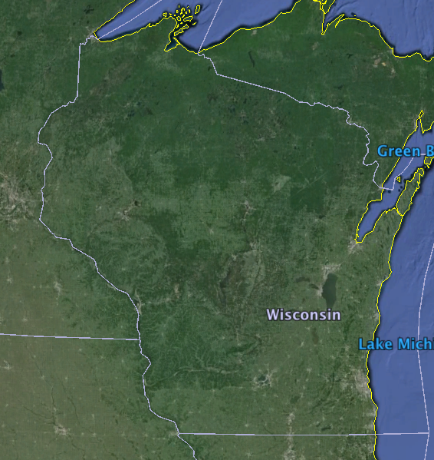

# Climate Data

New sources of gridded climate data come online every day. Many of these gridded datasets can be used to provide SWB with the needed precipitation and air temperature data. Making use of these new gridded datasets, however, requires the user to research the ways in which these new data were encoded into the netCDF file format. In this section we document the steps taken in order to generate the control file statements needed to make SWB understand a new data source.

The Global Precipitation Climatology Project (GPCP) generates estimates of precipitation for the entire globe on a daily basis by merging microwave, infrared, and sounder datasets with precipitation gage data. The resolution is 1-degree by 1-degree, far too coarse for many SWB applications, but entirely suitable for this example. The datasets may be found at https://climatedataguide.ucar.edu/climate-data/gpcp-daily-global-precipitation-climatology-project. The remainder of this example assumes that the new netCDF datasets ave been downloaded and placed in a local subdirectory, and that the required software drivers for netCDF files have been downloaded and installed on the user's machine. The netCDF C libraries and utility programs demonstrated in this example may be obtained [here] (http://www.unidata.ucar.edu/software/netcdf/docs/winbin.html).

The first step to take when attempting to use a new data source is to determine the structure, naming conventions, and geographic projection used in packaging the data into the netCDF file format. The program "ncdump" is a utility distributed along with the netCDF C language library. ncdump -h will comb through the netCDF file and return only header information:

ncdump -h GPCP_1DD_v1.2_201306.nc

The ncdump program produces the following output:

netcdf GPCP_1DD_v1.2_201306 {  
dimensions:  
 time = UNLIMITED ; // (30 currently)  
 lon = 360 ;  
 lat = 180 ;  
variables:  
 double time(time) ;  
 time:long_name = "time" ;  
 time:calendar = "standard" ;  
 time:units = "days since 1990-01-01 00:00:00" ;  
 float lat(lat) ;  
 lat:long_name = "latitude" ;  
 lat:units = "degrees_north" ;  
 float lon(lon) ;  
 lon:long_name = "longitude" ;  
 lon:units = "degrees_east" ;  
 int date(time) ;  
 date:long_name = "gregorian date" ;  
 date:units = "yyyymmdd" ;  
 int yyyyddd(time) ;  
 yyyyddd:units = "yyyyddd" ;  
 yyyyddd:long_name = "yyyy and day_of_year" ;  
 float PREC(time, lat, lon) ;  
 PREC:long_name = "GPCP: daily precipitation" ;  
 PREC:units = "mm/day" ;  
 PREC:_FillValue = -99999.f ;  
 PREC:missing_value = -99999.f ;  
 PREC:version = "v1.2" ;  
  
// global attributes:  
 :title = "GPCP ONE-DEGREE DAILY PRECIPITATION DATA SET" ;  
 :GSFC = "http://precip.gsfc.nasa.gov/" ;  
 :information = "http://precip.gsfc.nasa.gov/gpcp_daily_comb.html" ;  
 :Source = "ftp://rsd.gsfc.nasa.gov/pub/1dd-v1.2/" ;  
 :Acknowledgement = "\n",  
 "Please cite the original source of the data.\n",  
 "Please email the citation to george.j.huffman@nasa.gov or david.t.bolvin@nasa.gov\n",  
 "" ;  
 :Convention = "CF-1.0" ;  
 :comment = "netCDF version of original binary file(s)" ;  
 :Conversion = "NCL: http://www.ncl.ucar.edu/" ;  
 :ref_1 = "\n",  
 "Huffman, G.J., R.F. Adler, M.M. Morrissey, S. Curtis \n",  
 "R. Joyce, B. McGavock, and J. Susskind, 2001: \n",  
 "Global precipitation at one-degree daily resolution from multi-satellite observations\n",  
 "J. Hydrometeor., 2, 36-50\n",  
 "" ;  
 :ref_2 = "\n",  
 "Bolvin, David T., Robert F. Adler, George J. Huffman \n",  
 "Eric J. Nelkin, Jani P. Poutiainen, 2009: \n",  
 "Comparison of GPCP Monthly and Daily Precipitation Estimates with High-Latitude Gauge Observations\n",  
 "J. Appl. Meteor. Climatol., 48, 1843-1857\n",  
 "http://dx.doi.org/10.1175/2009JAMC2147.1\n",  
 "" ;  
 :ref_3 = "\n",  
 "Adler, Robert F., Guojun Gu, George J. Huffman, 2012: \n",  
 "Estimating Climatological Bias Errors for the Global Precipitation Climatology Project (GPCP)\n",  
 "J. Appl. Meteor. Climatol., 51, 84-99\n",  
 "http://dx.doi.org/10.1175/JAMC-D-11-052.1\n",  
 "" ;  
 :creation_date = "Mon Nov 3 09:01:45 MST 2014" ;  
}

# Best Practices

The Soil-Water-Balance code has been applied to dozens of sites around the world since its initial release (Westenbroek and others, 2010). In this section we attempt to summarize a set of best practices for application of the SWB model. These best practices really amount to what any good modeler would do when applying a modeling framework in a new environmental setting:

1. Begin with reasonable parameter values--be wary of recycling parameter values left over from previous studies.
2. Compare SWB output to other applicable regional and point estimates of potential recharge.

## Initial Parameter Values

# Curve Numbers

< INSERT TR55 TABLE HERE>

## Curve Number Aligner

One of the developers of curve number methodology developed a graphical method whereby curve numbers for soil hydrologic group A, C, and D may be estimated from the curve number assigned to soil hydrologic group B. Use of the curve number aligner is encouraged as it will maintain reasonable differences in curve number value between the various soil hydrologic groups for a given landuse.

The curve number aligner has been expressed in equation form as given below (Woodward and others, 2003):

## Calibration Strategy

Actual recharge rates for a study area are generally unknown; none of the methods available to us offer recharge estimates of known accuracy. Healy (2010) suggests that because of the uncertainty inherent in all current recharge estimation methods, there "are no standards that can be used to evaluate the accuracy of recharge estimates."

# Glossary

**APWL:** *Accumulated Potential Water Loss.* Represents the running sum of unmet potential evapotranspiration () over days for which evapotranspiration is greater than precipitation. On days where the precipitation exceeds evapotranspiration, the positive value of is 7added to the previous day's soil moisture to calculate the current day's soil moisture; the soil moisture retention tables (Thornthwaite and Mather, 1957) can then be used to back-calculate a new APWL value for ongoing calculations.

# SWB Technical Reference

Lorem ipsum dolor sit amet, consectetuer adipiscing elit. Aenean commodo ligula eget dolor. Aenean massa. Cum sociis natoque penatibus et magnis dis parturient montes, nascetur ridiculus mus. Donec quam felis, ultricies nec, pellentesque eu, pretium quis, sem. Nulla consequat massa quis enim. Donec pede justo, fringilla vel, aliquet nec, vulputate eget, arcu. In enim justo, rhoncus ut, imperdiet a, venenatis vitae, justo. Nullam dictum felis eu pede mollis pretium.

Lorem ipsum dolor sit amet, consectetuer adipiscing elit. Aenean commodo ligula eget dolor. Aenean massa. Cum sociis natoque penatibus et magnis dis parturient montes, nascetur ridiculus mus. Donec quam felis, ultricies nec, pellentesque eu, pretium quis, sem. Nulla consequat massa quis enim. Donec pede justo, fringilla vel, aliquet nec, vulputate eget, arcu. In enim justo, rhoncus ut, imperdiet a, venenatis vitae, justo. Nullam dictum felis eu pede mollis pretium.

Lorem ipsum dolor sit amet, consectetuer adipiscing elit. Aenean commodo ligula eget dolor. Aenean massa. Cum sociis natoque penatibus et magnis dis parturient montes, nascetur ridiculus mus. Donec quam felis, ultricies nec, pellentesque eu, pretium quis, sem. Nulla consequat massa quis enim. Donec pede justo, fringilla vel, aliquet nec, vulputate eget, arcu. In enim justo, rhoncus ut, imperdiet a, venenatis vitae, justo. Nullam dictum felis eu pede mollis pretium.

Lorem ipsum dolor sit amet, consectetuer adipiscing elit. Aenean commodo ligula eget dolor. Aenean massa. Cum sociis natoque penatibus et magnis dis parturient montes, nascetur ridiculus mus. Donec quam felis, ultricies nec, pellentesque eu, pretium quis, sem. Nulla consequat massa quis enim. Donec pede justo, fringilla vel, aliquet nec, vulputate eget, arcu. In enim justo, rhoncus ut, imperdiet a, venenatis vitae, justo. Nullam dictum felis eu pede mollis pretium.

# Appendix 1. Data, Parameter, and Control File Requirements by Process Option {#appendix_1_data_and_param_requirements}

SWB 2.0 was designed so that parameters may be supplied to the model on an as-needed basis. The original SWB 1.0 input requirements grew ever larger as more possible calculations methods were added. For this reason, we created a flexible table-based format that allows for parameters to be supplied in any order convenient to the user.

For table-based parameter entry, the crucial detail is to enter the proper parameter name in the header of the file. Case does not matter for these heading entries: "DEPLETION_FRACTION" will work as well as "depletion_fraction" or "Depletion_Fraction". For some modules, multiple heading values are recognized as equivalent to one another. For example, to identify a particular table column as holding landuse / land cover codes, SWB 2.0 recognizes any of the following: "LU_Code", "Landuse_Code", or "Landuse Lookup Code". Note also that SWB will fill any blank spaces in the header with underscores before evaluating the values therein. Thus, "Landuse Lookup Code" will be treated as "Landuse_Lookup_Code" by SWB. The idea is that whatever identification makes sense to the modeler should be recognized by SWB and acted upon.

This section describes in detail the data, parameter, and control file requirements for each module currently implemented in the SWB 2.0 code.

## Process: Actual Evapotranspiration

Three actual ET modules are available. The actual ET modules are responsible for determining how much soil moisture can be extracted given the climate and soil moisture conditions being simulated. The Thornthwaite-Mather actual ET modules should provide equivalent results and should provide identical performance.

### FAO-56

*Control File Entry*

SOIL_MOISTURE_METHOD FAO-56

|  |  |
| --- | --- |
| Parameter Description | Allowable Lookup Table headers |
| Depletion fraction | Depletion_Fraction |

### Thornthwaite-Mather

*Control File Entry*

SOIL_MOISTURE_METHOD THORNTHWAITE-MATHER

|  |  |
| --- | --- |
| Parameter Description | Allowable Lookup Table headers |
| * | * |

### Thornthwaite-Mather Equations

*Control File Entry*

SOIL_MOISTURE_METHOD THORNTHWAITE-MATHER_EQUATIONS  
 -or-  
SOIL_MOISTURE_METHOD THORNTHWAITE_MATHER_EQUATIONS

|  |  |
| --- | --- |
| Parameter Description | Allowable Lookup Table headers |
| * | * |

## Process: Available Water Capacity / Available Water Content

### Gridded Values

*Control File Entry*

AVAILABLE_WATER_CONTENT GRIDDED  
 -or-  
AVAILABLE_WATER_CAPACITY GRIDDED

|  |  |
| --- | --- |
| Parameter Description | Allowable Lookup Table headers |
| * | * |

### Table Values

*Control File Entry*

AVAILABLE_WATER_CONTENT TABLE  
 -or-  
AVAILABLE_WATER_CAPACITY TABLE

|  |  |
| --- | --- |
| Parameter Description | Allowable Lookup Table headers |
| Available water capacity, in inches per foot | AWC |

### Table Values, Depth-Integrated

*Control File Entry*

AVAILABLE_WATER_CONTENT DEPTH_INTEGRATED  
 -or-  
AVAILABLE_WATER_CAPACITY DEPTH_INTEGRATED

|  |  |  |
| --- | --- | --- |
| Parameter Description | Allowable Lookup Table headers | Note |
| Landuse code | LU_Code Landuse_Code Landuse_Lookup_Code |  |
| Soils code | Soils_Code Soils_Lookup_Code Soil_Code Soils_Lookup_Code |  |
| Soils horizon | Soils_Horizon Soils_Horizon_Number Soil_Horizon Soil_Horizon_Number |  |
| Soils top depth | Soils_Top_Depth Soil_Top_Depth Soils_Z_Top Soils_Top_of_Horizon |  |
| Soils bottom depth | Soils_Bottom_Depth Soil_Bottom_Depth Soils_Z_Bottom Soils_Bottom_of_Horizon |  |
| Soils component | Soils_Component Soils_Component_Number Soil_Component Soil_Component_Number |  |
| Soils component fraction | Soils_Component_Fraction Soil_Component_Fraction |  |
| Available water content | Soils_Available_Water_Content Soils_AWC Soil_Available_Water_Content Soil_AWC Available_Water_Content AWC |  |

## Process: Soil Storage Maximum / Plant Available Water

The original way to parameterize the total volume of soil moisture storage (or plant available water) was to specify an available water capacity grid, plus a set of effective plant rooting depths in the lookup table. SWB would multiply these two values to come up with the size of the soil storage reservoir.

In some cases it may be useful to calculate the size of the soil moisture reservoir outside of the SWB framework. This may be accomplished by specifying that the soil storage maximum will be read into SWB from an external grid file. *Specifying the soil storage maximum this way will cause the rooting depths and available water capacity values to be ignored.*

*Control File Entry*

SOIL_STORAGE_MAXIMUM GRIDDED  
 -or-  
PLANT_AVAILABLE_WATER GRIDDED  
 ...  
SOIL_STORAGE_MAX ARC_GRID Common_Data/input/soil_moisture_storage__10m.asc  
SOIL_STORAGE_MAX_PROJECTION_DEFINITION +proj=utm +zone=4 +ellps=WGS84 +datum=WGS84 +units=m +no_defs

## Process: Runoff

### Soil Conservation Service Curve Number

*Control File Entry*

RUNOFF_METHOD CURVE_NUMBER  
 -or-  
RUNOFF_METHOD C-N

### Monthly Runoff Ratio

*Control File Entry*

RUNOFF_METHOD RUNOFF_RATIO  
 -or-  
RUNOFF_METHOD MONTHLY_GRID

## Process: Runoff from Impervious surfaces

Runoff from impervious surfaces may be simulated in a more detailed manner by including a gridded dataset defining the proportion of each gridcell that is comprised of impervious materials. Data may be supplied as either a fraction (0.0-1.0) or percentage (0-100%) of either pervious or *im*pervious surface area.

## Process: Crop Coefficients (FAO-56)

This module handles all processes associated with simulating the growth and senescence of plants and their effect on soil moisture. There are three ways in which crop coefficient curves may be specified; each landuse code may use one of the three methods. The three methods that may be used to specify the crop coefficient curves are:

1. Time-based: specified in terms of the number of days that have elapsed since planting;
2. Growing degree-day based: specified in terms of the number of growing degree-days that have passed since planting;
3. Monthly: specific crop coefficients may be supplied with a single value per month.

*Control File Entry*

CROP_COEFFICIENT_METHOD FAO-56

|  |  |  |
| --- | --- | --- |
| Parameter Description | Allowable Lookup Table headers | Note |
| Landuse code | LU_Code Landuse_Code Landuse_Lookup_Code |  |
|  | Planting_date |  |
| Inflection points on the Kcb curve, defined in terms of time (days) elapsed since the start of plant growth. | L_ini L_dev L_mid L_late L_fallow | Day values may be specified as the integer number of days elapsed since planting, *or* may be specified as a date in mm/dd format. |
| Inflection points on the Kcb curve, defined in terms of growing degree-days. | GDD_plant GDD_ini GDD_dev GDD_mid GDD_late |  |
| These values are typically used along with the GDD or day length values to define a simple K_{cb} curve. | Kcb_ini Kcb_mid Kcb_end Kcb_min |  |
| Mean plant height is used to determine how much bare soil might be exposed to evaporation at various growth stages. | Mean_plant_height |  |
| Monthly values to define the Kcb curve more completely. This may be useful for a crop that has multiple plantings and harvests in the course of a year. | Kcb_Jan Kcb_Feb Kcb_Mar Kcb_Apr Kcb_May Kcb_Jun Kcb_Jul Kcb_Aug Kcb_Sep Kcb_Oct Kcb_Nov Kcb_Dec |  |

## Process: Direct Additions

External estimates for important components of the water budget may be supplied as supplemental grids or as table values. These additional water sources may be applied to the soil storage reservoir or added directly as potential recharge (deep percolation).

For both direct addition types, either gridded or table data may be supplied. SWB will always look for gridded data first. If no gridded data are found, SWB will look for table values. Table values are expected to correspond to the landuse codes contained in the main landuse grid.

### Direct Additions to Potential Recharge

The grid or table values supplied as direct recharge may represent any source of water that is not simulated as part of SWB's normal water budget accounting. For convenience, a number of data types are defined:

* cesspool leakage
* disposal well injection
* storm drain leakage
* water body or reservoir leakage
* water main leakage
* other direct recharge
* Control File Entry *

CESSPOOL_LEAKAGE ARC_GRID Common_Data/input/cesspool_effluent_inches_day.asc  
CESSPOOL_LEAKAGE_PROJECTION_DEFINITION +proj=utm +zone=4 +ellps=WGS84 +datum=WGS84 +units=m +no_defs

|  |  |  |
| --- | --- | --- |
| Parameter Description | Allowable Lookup Table headers | Note |
| Landuse code | LU_Code Landuse_Code Landuse_Lookup_Code |  |
| Generic direct recharge | Annual_direct_recharge_rate Annual_recharge_rate Annual_direct_recharge | direct recharge expressed as an *ANNUAL SUM* |
| Cesspool leakage | Cesspool_direct_recharge Cesspool_recharge Cesspool_discharge Cesspool_leakage | direct recharge expressed as a *DAILY SUM* |
| Storm drain leakage | Storm_drain_discharge Storm_drain_recharge Storm_drain_leakage | direct recharge expressed as a *DAILY SUM* |
| Water body / reservoir leakage | Water_body_recharge Water_body_discharge Water_body_leakage | direct recharge expressed as a *DAILY SUM* |
| Water main leakage | Water_main_recharge Water_main_discharge Water_main_leakage | direct recharge expressed as a *DAILY SUM* |
| Disposal well | Disposal_well_recharge Disposal_well_discharge | direct recharge expressed as a *DAILY SUM* |

### Direct Additions to Soil Moisture

Additional sources of water may also be supplied directly to the soil moisture reservoir. Currently the named data types include daily and annual septic system discharge.

## Process: Potential evapotranspiration

### Gridded

*Control File Entry*

POTENTIAL_EVAPOTRANSPIRATION_METHOD GRIDDED  
 -or-  
REFERENCE_EVAPOTRANSPIRATION_METHOD GRIDDED  
  
 ...  
  
POTENTIAL_ET ARC_GRID Common_Data/input/gr0_in_month_ascii/gr0_in_%b.asc  
POTENTIAL_ET_PROJECTION_DEFINITION +proj=lonlat +datum=WGS84 +no_defs

### Jensen-Haise

*Control File Entry*

POTENTIAL_EVAPOTRANSPIRATION_METHOD JENSEN-HAISE  
 -or-  
REFERENCE_EVAPOTRANSPIRATION_METHOD JENSEN-HAISE  
 -or-  
POTENTIAL_EVAPOTRANSPIRATION_METHOD JENSEN_HAISE  
 -or-  
REFERENCE_EVAPOTRANSPIRATION_METHOD JENSEN_HAISE

### Hargreaves-Samani

SWB 1.0 required that the northern and southern latitudes of the project area be supplied by the user. Since SWB 2.0 requires that a project grid is established along with a PROJ.4 string, the northern and southern latitudes can be calculated by SWB 2.0; the user need not enter these values in the control file.

*Control File Entry*

POTENTIAL_EVAPOTRANSPIRATION_METHOD HARGREAVES_SAMANI  
 -or-  
REFERENCE_EVAPOTRANSPIRATION_METHOD HARGREAVES_SAMANI  
 -or-  
POTENTIAL_EVAPOTRANSPIRATION_METHOD HARGREAVES-SAMANI  
 -or-  
REFERENCE_EVAPOTRANSPIRATION_METHOD HARGREAVES-SAMANI

## Process: Fog Interception

*Control File Entry*

FOG_METHOD MONTHLY_GRID  
 -or-  
FOG_METHOD GRIDDED  
 ...  
FOG_RATIO ARC_GRID ../../Maui_Common_Data/input/fog_fraction_grids/maui_fog_ratio_monthly_%0m.asc  
FOG_RATIO_PROJECTION_DEFINITION +proj=utm +zone=4 +ellps=WGS84 +datum=WGS84 +units=m +no_defs

## Process Support: Growing Degree-Day

*Control File Entry*

*

## Process Support: Growing Season

*Control File Entry*

*

## Process: Interception

### Bucket

*Control File Entry*

INTERCEPTION_METHOD BUCKET

### Horton

*Control File Entry*

INTERCEPTION_METHOD HORTON

### Gash

*Control File Entry*

INTERCEPTION_METHOD GASH  
 ...  
FRACTION_CANOPY_COVER ARC_GRID Common_Data/input/CANOPY_COVER_FRACTION.asc  
FRACTION_CANOPY_COVER_PROJECTION_DEFINITION +proj=utm +zone=4 +ellps=WGS84 +datum=WGS84 +units=m +no_defs  
  
EVAPORATION_TO_RAINFALL_RATIO ARC_GRID Common_Data/input/EVAPORATION_TO_RAINFALL_RATIO.asc  
EVAPORATION_TO_RAINFALL_RATIO_PROJECTION_DEFINITION +proj=utm +zone=4 +ellps=WGS84 +datum=WGS84 +units=m +no_defs

## Process: Irrigation

*Control File Entry*

IRRIGATION_METHOD FAO-56

## Process Support: Precipitation

### Table Values

*Control File Entry*

PRECIPITATION_METHOD TABLE

### Gridded Values

*Control File Entry*

PRECIPITATION_METHOD NORMAL  
 -or-  
PRECIPITATION_METHOD GRIDDED

### Method of Fragments

PRECIPITATION_METHOD METHOD_OF_FRAGMENTS  
 ...  
RAINFALL_ZONE ARC_GRID Common_Data/input/maui_RAIN_ZONE__10m.asc  
RAINFALL_ZONE_PROJECTION_DEFINITION +proj=utm +zone=4 +ellps=WGS84 +datum=WGS84 +units=m +no_defs  
  
RAINFALL_ADJUST_FACTOR ARC_GRID Common_Data/input/Maui_RF_adj_factors/maui_RF_adj_%b.asc  
RAINFALL_ADJUST_FACTOR_PROJECTION_DEFINITION +proj=utm +zone=4 +ellps=WGS84 +datum=WGS84 +units=m +no_defs

## Process: Storm Drain Capture

|  |
| --- |
| Parameter Allowable Lookup Note |
| Description Table headers |

Landuse code LU_Code Landuse_Code Landuse_Lookup_Code

Storm_drain_capture  
 Storm_drain_capture_fraction

# Appendix 2. Control File Directives

This section provides a complete list of the control file statements understood by SWB.

## Control File Directives

This section provides a complete list of the control file statements understood by SWB, version 1.x.

### Project Setup and Grid Specification

GRID *NX* *NY* *X0* *Y0* *Cell_size*

-or-

GRID *NX* *NY* *X0* *Y0* *X1* *Y1* *Cell_size*

### Gridded Datasets

For each of the three major climate datasets (precipitation, minimum and maximum air temperature), a standard set of suffixes may be added to the dataset name to control how SWB treats the dataset. The list of suffixes understood by SWB is long:

|  |  |  |  |
| --- | --- | --- | --- |
| Suffix | Argument | Description | Default |
| _SCALE_FACTOR | *real value* | amount to multiply raw grid value by prior to use | 1.0 |
| _ADD_OFFSET | *real value* | amount to add to the raw grid value following application of the scale factor, if any | 0.0 |
| _NETCDF_X_VAR | *string* | name of the variable to be used as the "x" axis | x |
| _NETCDF_Y_VAR | *string* | name of the variable to be used as the "y" axis | y |
| _NETCDF_Z_VAR | *string* | name of the variable to be used as the "z" (value) axis | prcp |
| _NETCDF_TIME_VAR | *string* | name of the variable to be used as the "time" axis | time |
| _NETCDF_VARIABLE_ORDER | "xyt or txy" | description of the order in which the gridded data were written | tyx |
| _NETCDF_FLIP_VERTICAL | **none** | if present, all gridded data will be "flipped" around the vertical axis. | NA |
| _NETCDF_FLIP_HORIZONTAL | **none** | if present, all gridded data will be "flipped" around the horizontal axis |  |
| _NETCDF_MAKE_LOCAL_ARCHIVE |  |  |  |
| _PROJECTION_DEFINITION |  | PROJ.4 string describing the geographic projection of the dataset |  |
| _MINIMUM_ALLOWED_VALUE | *real value* | ceiling to be applied to the data; data above this value will be reset to this amount |  |
| _MAXIMUM_ALLOWED_VALUE | *real value* | floor to be applied to the data; data beneath this value will be reset to this amount |
| _MISSING_VALUES_CODE | *real or integer value* | value |  |
| _MISSING_VALUES_OPERATOR | "<", "<=", ">", ">=" | trigger missing values action if the data value meets this condition |  |
| _MISSING_VALUES_ACTION | "mean" or "zero" | "mean" will substitute the mean value calculated over the remaining valid cells; "zero" will substitute a value of 0.0 in place of missing values |

## Control File Directives

This section provides a complete list of the control file statements understood by SWB, version 2.0.

## Control File Directives: Gridded Datasets

SWB has a set of common control file directives that may be used with any input gridded dataset. The types of data recognized by SWB (as of July 2015) includes:

|  |
| --- |
| Gridded Dataset Name |
| PRECIPITATION |
| TMIN |
| TMAX |
| AVAILABLE_WATER_CONTENT |
| POTENTIAL_ET |
| SOLAR_RADIATION |
| WIND_SPEED |
| RAINFALL_ZONE |
| FLOW_DIRECTION |
| FOG_RATIO |
| LAND_USE |
| SOILS_GROUP |
| INITIAL_PERCENT_SOIL_MOISTURE |
| INITIAL_SNOW_COVER_STORAGE |
| CANOPY_COVER_FRACTION |
| PERVIOUS_SURFACE_FRACTION |
| IMPERVIOUS_SURFACE_FRACTION |
| STEMFLOW_FRACTION |
| EVAPORATION_TO_RAINFALL_RATIO |
| RAINFALL_ADJUST_FACTOR |
| CESSPOOL_LEAKAGE |
| STORM_DRAIN_LEAKAGE |
| WATER_BODY_LEAKAGE |
| WATER_MAIN_LEAKAGE |
| DISPOSAL_WELL_DISCHARGE |
| ANNUAL_DIRECT_RECHARGE_RATE |
| RUNOFF_ZONE |
| IRRIGATION_MASK |
| RELATIVE_HUMIDITY |

For each of the gridded datasets listed above, a standard set of suffixes may be added to the dataset name to control how SWB treats the dataset. The list of suffixes understood by SWB is long:

|  |  |  |
| --- | --- | --- |
| Suffix | Argument | Description |
| _SCALE_FACTOR | *real value* | amount to multiply raw grid value by prior to use |
| _ADD_OFFSET | *real value* | amount to add to the raw grid value following application of the scale factor, if any |
| _NETCDF_X_VAR | *string* | name of the variable to be used as the "x" axis |
| _NETCDF_Y_VAR | *string* | name of the variable to be used as the "y" axis |
| _NETCDF_Z_VAR | *string* | name of the variable to be used as the "z" (value) axis |
| _NETCDF_TIME_VAR | *string* | name of the variable to be used as the "time" axis |
| _NETCDF_VARIABLE_ORDER | "xyt or txy" | description of the order in which the gridded data were written |
| _NETCDF_FLIP_VERTICAL | **none** | if present, all gridded data will be "flipped" around the vertical axis. |
| _NETCDF_FLIP_HORIZONTAL | **none** | if present, all gridded data will be "flipped" around the horizontal axis |
| _NETCDF_MAKE_LOCAL_ARCHIVE |  |  |
| _PROJECTION_DEFINITION |  | PROJ.4 string describing the geographic projection of the dataset |
| _MINIMUM_ALLOWED_VALUE | *real value* | ceiling to be applied to the data; data above this value will be reset to this amount |
| _MAXIMUM_ALLOWED_VALUE | *real value* | floor to be applied to the data; data beneath this value will be reset to this amount |
| _MISSING_VALUES_CODE | *real or integer value* | value |
| _MISSING_VALUES_OPERATOR | "<", "<=", ">", ">=" |  |
| _MISSING_VALUES_ACTION | "mean" or "zero" | "mean" will substitute the mean value calculated over the remaining valid cells; "zero" will substitute a value of 0.0 in place of missing values |

# Appendix 3. Parameter Definitions

This section provides a complete list of all required and optional parameters used by SWB.

## Depletion Fraction

The soil water depletion fraction is defined in FAO-56 (Allen and others, 1998) as the average fraction of total available water (TAW) that can be removed from the root zone without causing plant stress. Soil water content () is assumed to be bounded by the field capacity () at a maximum, and by the permanent wilting point () at a minimum. Plant evapotranspiration will proceed at maximum values until soil water depletion exceeds the readily availible water (RAW) content for the crop under consideration. As depletion of soil water continues beyond the readily available water content, plant evapotranspiration is reduced until it reaches zero as the soil water content reaches field capacity.



Figure placeholder: Parameters__Depletion_Fraction.png

Lorem ipsum dolor sit amet, consectetuer adipiscing elit. Aenean commodo ligula eget dolor. Aenean massa. Cum sociis natoque penatibus et magnis dis parturient montes, nascetur ridiculus mus. Donec quam felis, ultricies nec, pellentesque eu, pretium quis, sem. Nulla consequat massa quis enim. Donec pede justo, fringilla vel, aliquet nec, vulputate eget, arcu. In enim justo, rhoncus ut, imperdiet a, venenatis vitae, justo. Nullam dictum felis eu pede mollis pretium.

# Appendix 4. Example of control file setting selection for a new climate data source.

New sources of gridded climate data are continuing to come online. Inevitably, these new climate data sources will require that the SWB control file directives be modified in order to work properly. This example shows the process used to configure SWB control file parameters for a set of downscaled climate model results produced by a consortium of agencies including USGS, BLM, NCAR, U.S. Army Corps. of Engineers, and others (Brekke and others, 2013), available here:

http://gdo-dcp.ucllnl.org/downscaled_cmip_projections/dcpInterface.html.

For this example, we downloaded model results for a single climate scenario, for a subset of the national grid. As will be shown later, sometimes the tools employed in creating the data subset end up changing the output NetCDF file in a way that prevents it from being used with SWB. Once the necessary NetCDF files have been downloaded to a local hard drive, the metadata they contain should be examined. A simple command-line tool that can accomplish this is called “ncdump”, distributed by Unidata. As of February, 2016, it is available as part of the NetCDF C library for Windows, which may be obtained here: http://www.unidata.ucar.edu/software/netcdf/docs/winbin.html. Once the library is installed, ncdump may be run at the command line to extract the metadata.

>C:\”Program Files\netCDF 4.4.0”\bin\ncdump –h Extraction_pr.nc

The output from running this command is shown below.

netcdf Extraction_pr {  
dimensions:  
 longitude = 129 ;  
 latitude = 64 ;  
 time = 2557 ;  
 projection = UNLIMITED ; // (1 currently)  
variables:  
 float longitude(longitude) ;  
 longitude:standard_name = "longitude" ;  
 longitude:long_name = "Longitude" ;  
 longitude:units = "degrees_east" ;  
 longitude:axis = "X" ;  
 float latitude(latitude) ;  
 latitude:standard_name = "latitude" ;  
 latitude:long_name = "Latitude" ;  
 latitude:units = "degrees_north" ;  
 latitude:axis = "Y" ;  
 double time(time) ;  
 time:standard_name = "time" ;  
 time:long_name = "time" ;  
 time:units = "days since 1950-01-01 00:00:00" ;  
 time:calendar = "standard" ;  
 float pr(projection, time, latitude, longitude) ;  
 pr:standard_name = "precipitation_flux" ;  
 pr:long_name = "Precipitation" ;  
 pr:units = "mm/d" ;  
 pr:_FillValue = 1.e+020f ;  
 pr:missing_value = 1.e+020f ;  
 pr:typeConversion_op_ncl = "double converted to float" ;  
 pr:cell_methods = "time: mean" ;  
 pr:interp_method = "conserve_order1" ;  
 pr:original_units = "kg/m2/s" ;  
 pr:original_name = "precip" ;  
 pr:associated_files = "baseURL: http://cmip-pcmdi.llnl.gov/CMIP5/dataLocation areacella: areacella_fx_GFDL-CM3_rcp26_r0i0p0.nc" ;  
 pr:time = 38716.5 ;  
  
// global attributes:  
 :CDI = "Climate Data Interface version 1.6.2 (http://code.zmaw.de/projects/cdi)" ;  
 :Conventions = "CF-1.4" ;  
 :history = "12/2014 corrected the historical bias in the mean" ;  
 :institution = "NOAA GFDL(201 Forrestal Rd, Princeton, NJ, 08540)" ;  
 :institute_id = "NOAA GFDL" ;  
 :model_id = "GFDL-CM3" ;  
 :frequency = "day" ;  
 :experiment = "RCP2.6" ;  
 :experiment_id = "rcp26" ;  
 :parent_experiment_id = "historical" ;  
 :parent_experiment_rip = "r1i1p1" ;  
 :creation_date = "Mon Sep 10 22:41:18 PDT 2012" ;  
 :references = "Daily BC method: modified version of Maurer EP, Hidalgo HG, Das T, Dettinger MD, Cayan DR, 2010, Hydrol Earth Syst Sci 14:1125-1138\n",  
 "CA method: Hidalgo HG, Dettinger MD, Cayan DR, 2008, California Energy Commission technical report CEC-500-2007-123\n",  
 "Reference period obs: updated version of Maurer EP, Wood AW, Adam JC, Lettenmaier DP, Nijssen B, 2002, J Climate 15(22):3237ΓÇô3251, \n",  
 "provided via http://www.engr.scu.edu/~emaurer/gridded_obs/index_gridded_obs.html" ;  
 :contacts = "Bridget Thrasher: bridget@climateanalyticsgroup.org or Ed Maurer: emaurer@scu.edu" ;  
 :documentation = "http://gdo-dcp.ucllnl.org" ;  
 :NCO = "4.0.8" ;  
 :CDO = "Climate Data Operators version 1.6.2 (http://code.zmaw.de/projects/cdo)" ;  
 :Projections = "gfdl-cm3.1.rcp26, " ;  
}

There is a lot of useful information in this particular set of metadata. NetCDF files of this sort typically have a number of dimensions and variables defined in the first part of the file description. In this example, four dimensions are defined: longitude, latitude, time, and projection. In addition, the file contains four variables: longitude, latitude, time, and pr (precipitation). Three of the variable names are also names of dimensions. The dimension “longitude” in this case refers to a set of index values ranging from 0 to 128. The variable “longitude” contains the actual longitudinal value associated with each of the indices contained in the longitude dimension.

C:\"Program Files\netCDF 4.4.0"\bin\ncdump -v longitude Extraction_pr.nc

Running ncdump with the “-v” option and a variable name returns a list of all variable values:

longitude = 251.9375, 252.0625, 252.1875, 252.3125, 252.4375, 252.5625,  
 252.6875, 252.8125, 252.9375, 253.0625, 253.1875, 253.3125, 253.4375,  
 253.5625, 253.6875, 253.8125, 253.9375, 254.0625, 254.1875, 254.3125,  
 254.4375, 254.5625, 254.6875, 254.8125, 254.9375, 255.0625, 255.1875,  
 255.3125, 255.4375, 255.5625, 255.6875, 255.8125, 255.9375, 256.0625,  
 256.1875, 256.3125, 256.4375, 256.5625, 256.6875, 256.8125, 256.9375,  
 257.0625, 257.1875, 257.3125, 257.4375, 257.5625, 257.6875, 257.8125,  
 257.9375, 258.0625, 258.1875, 258.3125, 258.4375, 258.5625, 258.6875,  
 258.8125, 258.9375, 259.0625, 259.1875, 259.3125, 259.4375, 259.5625,  
 259.6875, 259.8125, 259.9375, 260.0625, 260.1875, 260.3125, 260.4375,  
 260.5625, 260.6875, 260.8125, 260.9375, 261.0625, 261.1875, 261.3125,  
 261.4375, 261.5625, 261.6875, 261.8125, 261.9375, 262.0625, 262.1875,  
 262.3125, 262.4375, 262.5625, 262.6875, 262.8125, 262.9375, 263.0625,  
 263.1875, 263.3125, 263.4375, 263.5625, 263.6875, 263.8125, 263.9375,  
 264.0625, 264.1875, 264.3125, 264.4375, 264.5625, 264.6875, 264.8125,  
 264.9375, 265.0625, 265.1875, 265.3125, 265.4375, 265.5625, 265.6875,  
 265.8125, 265.9375, 266.0625, 266.1875, 266.3125, 266.4375, 266.5625,  
 266.6875, 266.8125, 266.9375, 267.0625, 267.1875, 267.3125, 267.4375,  
 267.5625, 267.6875, 267.8125, 267.9375 ;

An interesting this to note about the values of longitude is that they seem unusual relative to the longitudes we are used to working with in North America. Indeed, this example dataset is centered on the state of Nebraska, USA; we commonly would see the longitude values range from about 108° to 93° West longitude, perhaps expressed as -108° to -93°. Many of the downscaled climate model datasets refer to longitude as ranging from 0° to 360°, with the longitude of 0°/360° centered on the parallel running through Greenwich, England. If we subtract 360° from the longitude values above, the range looks more familiar: 251°-360°=-108°; 267°-360°=-93°. Presumably the reason for defining longitudes this way is because it is easier to have model grid for which all longitude values are greater than zero!

One item we need to look at first is the organization of the data of interest on the disk file. SWB expects climate data files to be arranged in such a way that the data may be accessed by referencing a specific datetime, y-coordinate, and x-coordinate value. The precipitation variable we are interested in is dimensioned as follows:

float pr(projection, time, latitude, longitude) ;

SWB is written under the assumption that the variable of interest will be referenced by just three dimensions: time, x, and y. The fourth dimension listed above, projection, was added apparently to allow results for more than one climate emissions scenario to be stored in a single NetCDF file. In order to use this file with SWB we must get rid of this fourth dimension. To remove the fourth dimension, we can use a third-party tool called NCO, NetCDF Climate Operators, to calculate an “average” over the fourth dimension. Because there is only a single projection contained in the file, the resulting file will be the same as the input file *without* the projection dimension. NCO as available at: http://nco.sourceforge.net/. As of February, 2016, a Windows executable for NCO may be found here: http://nco.sourceforge.net/src/nco-4.5.4.windows.mvs.exe.

The NCO package is not overly user friendly. Luckily, it has a helpful discussion page, which suggests that to eliminate a “degenerate” dimension (a dimension with only a single value), the “averaging” tool may be used:

ncwa -a projection Extraction_pr.nc Extraction_pr_3d.nc

ncwa stands for “NetCDF Weighted Averager”. The “-a” flag allows one to specify a dimension over which to average (“projection”). The last two entries are the input and output filenames, respectively. Once this command-line utility is run, the NetCDF files are rendered usable by SWB. With all of the metadata available we can finally generate the SWB control file statements to make this file work with SWB:

# 001: specify the filename containing precipitation data  
PRECIPITATION NETCDF Extraction_pr_3D.nc  
  
# 002: define PRECIPITATION projection and NetCDF variable names  
PRECIPITATION_GRID_PROJECTION_DEFINITION +proj=lonlat +ellps=GRS80 +datum=NAD83 +lon_wrap=180 +no_defs  
NETCDF_PRECIP_X_VAR longitude  
NETCDF_PRECIP_Y_VAR latitude  
NETCDF_PRECIP_Z_VAR pr  
  
# 003: define PRECIPITATION missing values action  
PRECIPITATION_MISSING_VALUES_CODE 1.0E+20  
PRECIPITATION_MISSING_VALUES_OPERATOR >=  
PRECIPITATION_MISSING_VALUES_ACTION ZERO  
  
# 004: PRECIPITATION is given in mm/day; need to convert to inches/day  
PRECIPITATION_SCALE_FACTOR 0.03937008

The first line of the control file snippet above specifies the name of the NetCDF file that contains the precipitation data we wish to use.

The commands under group 002 define the geographic projection and specify the variable names. In this case, the exact projection of the data is unknown; in any event climate models rarely seem to reflect anything other than a global (unprojected) coordinate system. It is not clear from the metadata what datum was used in defining the latitude and longitude. We’ll guess NAD83 with an ellipsoid specified by GRS80. Downscaled climate model cells are generally far larger than the error we would incur by selecting the wrong datum and ellipsoid. Note that this dataset requires the “+lon_wrap=180” addition to the projection definition. This is required in order to convert the longitude values to +/- 180°. The variable names are found in the metadata and must be supplied in the control file in order for SWB to find them: x=> “longitude”, y=>”latitude”, z=”pr”.

The commands under group 003 specify what actions SWB should take in the event it encounters missing values within the file. The first line defines the numeric value associated with a missing value. The second line defines the operator, which can be one of “<”, “<=”, “>”, “>=”. The third line specifies what should be done with the missing value. In this case, we’ve specified that any values >= 1.0E+20 will be treated as 0.0.

The command under group 004 informs SWB how the values in the file are to be converted to inches per day. The PRECIPITATION_SCALE_FACTOR of 0.03937 = 1.0 / 25.4, or one over the number of millimeters per inch.

# Appendix 5. Earlier implementations of soil moisture retention relations.

SWB has evolved over time, incorporating additional and improved process formulations whenever possible. This is how SWB and SWB 2.0 ended up with no less than three ways by which to update soil moisture values by means of the Thornthwaite-Mather approach (Thornthwaite, 1948; Thornthwaite and Mather, 1955; Thornthwaite and Mather, 1957). The direct solution method is now the method of choice; the other two methods are included here to document the functioning of earlier versions of the code.

##### Table Values

The original version of the SWB model reads in digitized versions of the Thornthwaite-Mather soil-moisture retention tables and follows the original instructions for calculation faithfully. In order to track changes in soil moisture, several intermediary values are calculated, including precipitation minus potential evapotranspiration (), accumulated potential water loss (), actual evapotranspiration, soil-moisture surplus, and soil-moisture deficit. These terms are described below.

*P minus PE* . The first step in calculating a new soil moisture value for any given grid cell is to subtract potential evapotranspiration from the daily precipitation (). Negative values of represent a potential deficiency of water, whereas positive values represent a potential surplus of water.

*Soil moisture*, . The soil-moisture term represents the amount of water held in soil storage for a given grid cell. Soil moisture has an upper bound that corresponds to the soil's maximum water-holding capacity (roughly equivalent to the field capacity); soil moisture has a lower bound that corresponds to the soil's permanent wilting point.

When is positive, the new soil-moisture value is found by adding this term directly to the preceding soil-moisture value. If the new soil-moisture value is still below the maximum water-holding capacity, the Thornthwaite-Mather soil-moisture tables are consulted to back-calculate a new, reduced accumulated potential water-loss value. If the new soil-moisture value exceeds the maximum water-holding capacity, the soil-moisture value is capped at the value of the maximum water-holding capacity, the excess moisture is converted to recharge, and the accumulated potential water-loss term is reset to zero.

When is negative, the new soil-moisture term is found by looking up the soil-moisture value associated with the current accumulated potential water-loss value in the Thornthwaite-Mather tables.

*Actual ET*. When is positive, the actual evapotranspiration equals the potential evapotranspiration. When is negative, the actual evapotranspiration is equal only to the amount of water that can be extracted from the soil ( soil moisture).

During the course of a model run, the soil layer is considered to be in one of three states:

Table 3. Soil moisture states.

|  |  |  |  |  |  |
| --- | --- | --- | --- | --- | --- |
|  | Soil Status |  |  |  | Excess (potential recharge) |
| < 0 | drying | SM from T-M tables |  |  | 0.0 |
| > 0 | wetting *and* |  | from tables |  | 0.0 |
| > 0 | wetting *and* |  | 0.0 |  |  |

##### Fitted Equations

The amount of computing involved in negotiating the lookup tables and interpolating a result was significant enough to warrant generalization; in addition, small roundoff errors were accumulated in the course of repeated conversions between accumulated potential water loss and the corresponding soil moisture values. In order to avoid the use of lookup tables altogether a generalized equation was developed, using the Thornthwaite and Mather (1957) table values as the basis for the equations.

Two equations were fitted and implemented in the SWB 1.0 code. The first equation relates the current soil moisture to an equivalent accumulated potential water loss +eq. 9:

$$soil\,moisture = {10^{({{\log }_{10}}\theta }}^{ - APWL\, \cdot \,0.4788{\kern 1pt} {\theta ^{ - 1.037}})}\qquad(9)$$

The second equation is used to back-calculate the equivalent accumulated potential water loss value for a given soil moisture amount:

Akinremi, O.O., McGinn, S.M., and Barr, A.G., 1996, Simulation of soil moisture and other components of the hydrological cycle using a water budget approach: Canadian Journal of Soil Science, v. 76, no. 2, p. 133–142.

Allen, R.G., Pereira, L.S., Raes, D., and Smith, M., 1998, Crop evapotranspiration-guidelines for computing crop water requirements-FAO irrigation and drainage paper 56: Food; Agriculture Organization of the United Nations, Rome.

Batelaan, O., and De Smedt, F., 2001, WetSpass: A flexible, GIS based, distributed recharge methodology for regional groundwater modelling: IAHS PUBLICATION, p. 11–18.

Bauer, H.H., and Vaccaro, J.J., 1987, Documentation of a deep percolation model for estimating ground-water recharge: US Geological Survey,

Bauer, H.H., and Vaccaro, J.J., 1990, Estimates of ground-water recharge to the columbia plateau regional aquifer system, washington, oregon, and idaho, for predevelopment and current land-use conditions: US Geological Survey; Books; Open-File Reports Section,

Carroll, R., Pohll, G., Tracy, J., Winter, T., and Smith, R., 2005, Simulation of a semipermanent wetland basin in the cottonwood lake area, east-central north dakota: Journal of Hydrologic Engineering, v. 10, no. 1, p. 70–84.

Dripps, W.R., 2003, The spatial and temporal variability of groundwater recharge within the trout lake basin of northern wisconsin:

Dripps, W.R., and Bradbury, K.R., 2007, A simple daily soil–water balance model for estimating the spatial and temporal distribution of groundwater recharge in temperate humid areas: Hydrogeology Journal, v. 15, no. 3, p. 433–444.

Dugan, J.T., and Peckenpaugh, J.M., 1985, Effects of climate, vegetation, and soils on consumptive water use and ground-water recharge to the central midwest regional aquifer system, mid-continent united states: US Geological Survey,

Dunne, T., and Leopold, L.B., 1978, Water in environmental planning: Macmillan.

Eaton, B., Gregory, J., Drach, B., Taylor, K., Hankin, S., Caron, J., Signell, R., Bently, P., Rappa, G., Heinke, H., Pamment, A., and Juckes, M., 2011, NetCDF climate and forecast (CF) metadata conventions. NetCDF climate and forecast (CF) metadata conventions, version 1.6, accessed 2/08/2016 at <http://cfconventions.org/cf-conventions/v1.6.0/cf-conventions.html>.

Engott, J.A., 2011, A water-budget model and assessment of groundwater recharge for the island of hawaiʻi: US Geological Survey.

Evenden, G.I., 1990, Cartographic projection procedures for the UNIX environment; a user’s manual: 90-284.

Finch, J.W., 2001, Estimating change in direct groundwater recharge using a spatially distributed soil water balance model: Quarterly Journal of Engineering Geology and Hydrogeology, v. 34, no. 1, p. 71–83.

Flint, A.L., and Flint, L.E., 2007, Application of the basin characterization model to estimate in-place recharge and runoff potential in the basin and range carbonate-rock aquifer system, white pine county, nevada, and adjacent areas in nevada and utah:

Garen, D.C., and Moore, D.S., 2005, Curve number hydrology in water quality modeling: Uses, abuses, and future directions: Journal of the American Water Resources Association, v. 41, no. 2, p. 377–388.

Gash, J.H.C., 1979, An analytical model of rainfall interception by forests: Quarterly Journal of the Royal Meteorological Society, v. 105, no. 443, p. 43–55.

Gash, J.H.C., and Morton, A.J., 1978, An application of the rutter model to the estimation of the interception loss from thetford forest: Journal of Hydrology, v. 38, no. 1, p. 49–58.

Giambelluca, T.W., Chen, Q., Frazier, A.G., Price, J.P., Chen, Y.-L., Chu, P.-S., Eischeid, J.K., and Delparte, D.M., 2013, Online rainfall atlas of hawai’i: Bulletin of the American Meteorological Society, v. 94, no. 3, p. 313–316.

Green, W.H., and Ampt, C.A., 1911, Studies on soil physics, i. flow of water and air through soils: Journal of Agricultural Science, v. 4, p. 1–24.

Hawkins, R.H., 1993, Asymptotic determination of runoff curve numbers from data: Journal of Irrigation and Drainage Engineering, v. 119, no. 2, p. 334–345.

Healy, R.W., 2010, Estimating groundwater recharge: Cambridge University Press, 245 p.

Hjelmfelt, A.T., Jr., 1991, Investigation of curve number procedure: Journal of Hydraulic Engineering, v. 117, no. 6, p. 725–737.

Horton, R.E., 1919, Rainfall interception: Monthly Weather Review, v. 47, no. 9, p. 603–623.

Izuka, S.K., Oki, D.S., and Engott, J.A., 2010, Simple method for estimating groundwater recharge on tropical islands: Journal of Hydrology, v. 387, no. 1, p. 81–89.

Johnson, A.G., Engott, J.A., and Bassiouni, M., 2014, Spatially distributed groundwater recharge estimated using a water-budget model for the island of maui, hawai ‘i, 1978-2007: US Geological Survey.

Jyrkama, M.I., and Sykes, J.F., 2007, The impact of climate change on spatially varying groundwater recharge in the grand river watershed (ontario): Journal of Hydrology, v. 338, no. 3, p. 237–250.

Kendy, E., Gerard-Marchant, P., Walter, M.T., Zhang, Y., Liu, C., and Steenhuis, T.S., 2003, A soil-water-balance approach to quantify groundwater recharge from irrigated cropland in the north china plain: Hydrological Processes, v. 17, no. 10, p. 2011–2031.

Meeus, J.H., 1991, Astronomical algorithms: Willmann-Bell, Incorporated.

Niswonger, R., Prudic, D., and Regan, R., 2006, Documentation of the unsaturated-zone flow (UZF1) package for modeling unsaturated flow between the land surface and the water table with MODFLOW-2005: Techniques and methods, U.S. Geological Survey, 74 p.

O’Callaghan, J.F., and Mark, D.M., 1984, The extraction of drainage networks from digital elevation data: Computer vision, graphics, and image processing, v. 28, no. 3, p. 323–344.

Scanlon, B.R., Healy, R.W., and Cook, P.G., 2002, Choosing appropriate techniques for quantifying groundwater recharge: Hydrogeology Journal, v. 10, no. 1, p. 18–39.

Schroeder, P.R., Dozier, T.S., Zappi, P.A., McEnroe, B.M., Sjostrom, J.W., and Peyton, R.L., 1994, The hydrologic evaluation of landfill performance (HELP) model: Engineering documentation for version 3: Army Engineer Waterways Experiment Station, Vicksburg, MS. in cooperation with Clemson Univ., SC. Dept. of Civil Engineering. 128p.

Srikanthan, R., and McMahon, T.A., 1999, Stochastic generation of annual, monthly and daily climate data: A review: Hydrology and Earth System Sciences, v. 5, no. 4, p. 653–670.

Stearns, H.T., and Macdonald, G.A., 1942, Geology and ground-water resources of the island of maui, hawaii: Division of Hydrography, Territory of Hawaii 7, 344 p.

Thornthwaite, C.W., 1948, An approach toward a rational classification of climate: Geographical Review, v. 38, no. 1, p. 55.

Thornthwaite, C.W., and Mather, J.R., 1955, The water balance: Publications in Climatology, v. 8, no. 1, p. 185–311.

Thornthwaite, C.W., and Mather, J.R., 1957, Instructions and tables for computing potential evapotranspiration and the water balance: Publications in Climatology, v. 10, no. 3, p. 1–104.

U.S. Geological Survey, 2008, Documentation of computer program INFIL3.0-a distributed-parameter watershed model to estimate net infiltration below the root zone: Scientific investigations report, U.S. Geological Survey.

Unidata, 2014, NetCDF: Network common data format: UCAR/Unidata Program Center, Boulder, Colorado.

Westenbroek, S.M., Kelson, V.A., Dripps, W.R., Hunt, R.J., and Bradbury, K.R., 2010, SWB—A modified thornthwaite-mather soil-water-balance code for estimating groundwater recharge: 6-A31, 1–61 pp.

Woodward, D.E., Hawkins, R.H., Hjelmfelt, A.T., Jr., Van Mullem, J.A., and Quan, Q.D., 2002, Curve number method: Origins, applications, and limitations:

Woodward, D.E., Hawkins, R.H., Jiang, R., HJELMFELT Jr, A., Van Mullem, J., and Quan, Q.D., 2003, Runoff curve number method: Examination of the initial abstraction ratio, *in* Conference proceeding paper, world water and environmental resources congress: