**Use Case UC-（10）Close own cabinet**

|  |
| --- |
| Use Case UC-（10）Close own cabinet |
| Related Requirement’s: REQ8, REQ9, table1-2  Initiating Actor: Any of: recipients  Actor’s Goal: close the own cabinet  Participating Actors: cabinet, door of the cabinet, data processing center  Preconditions: Recipients got the food or takeout successfully.  Post conditions: The door is closed.  Flow of Events for Main Success Scenario: The recipients got the food and takeout. The system confirmed the behavior. The recipients need to close the door. |

**Use Case UC-（11） Tag occupation of self-contained cabinets**

|  |
| --- |
| Use Case UC-（11） Tag occupation of self-contained cabinets |
| Related Requirement’s: REQ6, REQ7, table1-2  Initiating Actor: Any of: senders, recipients, system  Actor’s Goal: the senders and recipients finished the behavior.  Participating Actors: data processing center, cabinets  Preconditions: The senders finished the behavior and close the door.  Post conditions: The cabinets tag the occupation.  Flow of Events for Main Success Scenario: The senders and recipients finished the process and close the door. The system confirmed the behavior and tag occupation of the cabinets |

**Use Case UC-（12）System sending the fetch code**

|  |
| --- |
| Use Case UC-（12）System sending the fetch code |
| Related Requirement’s: REQ9, table1-2  Initiating Actor: System, fetching code  Actor’s Goal: Let users see their food or take-out information  Participating Actors: recipients, system, data processing center  Preconditions: System has received the successful order information, and sent the fetch code.  Post conditions: Recipients received the fetch code.  Flow of Events for Main Success Scenario: System saw the information and sent the fetch code; the recipients got the fetch code. |

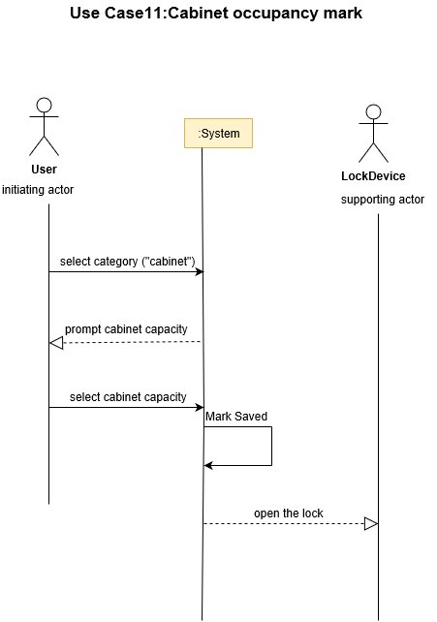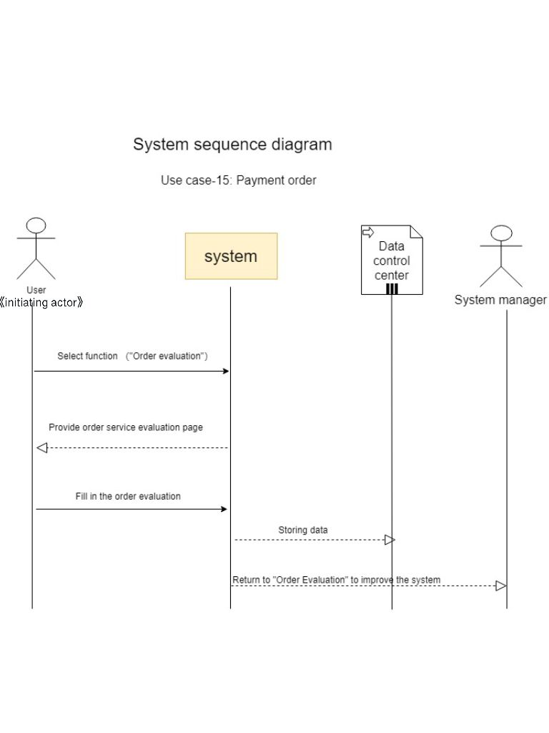

**UC-10:Close cabinet:** The depositor puts the package and closes the door

**UC-11:Cabinet occupancy mark:** The data processing center marks that the cabinet has been used.

**UC-12:Send pick-up code:** The system receives the order information, and sends the pickup QR code to the id according to the order information.