Name | Value
Today’s Date | 6/27/2018
Youtube Source | https://www.youtube.com/watch?v=PBTYxXADG_k
Youtube Title | Learn The MERN Stack
Starter files/Github | https://github.com/bradtraversy/mern_shopping_list
Thumnail

Things Learned:
Category | Skill
MERN | MongoDB, Express, React, Node.js
JavaScript
CSS

HTML

NPM | >npm install express body-parser mongoose concurrently  >npm install –g create-react-app  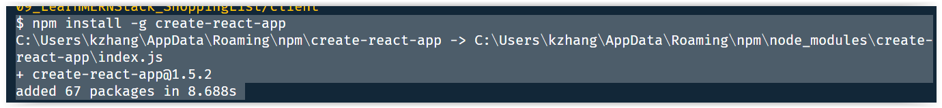  CD to client folder before run below installation  >npm install bootstrap reactstrap uuid react-transition-group  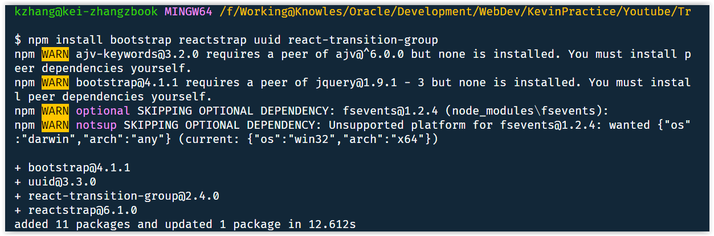  To run your application  >npm run dev

MLab – MongoDB:

DBName: kevin_shopping
Username: kevin
Password: welcome1

