Deploy “ComingSoonCruise” application to Netify.com

# Create a new repository on Github.com for this project

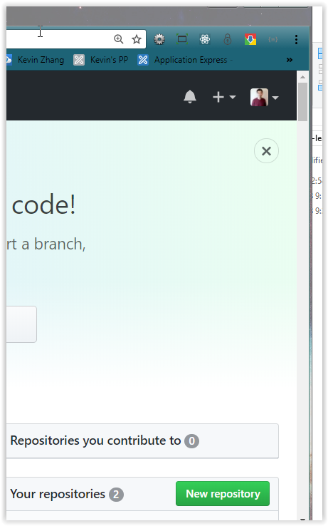

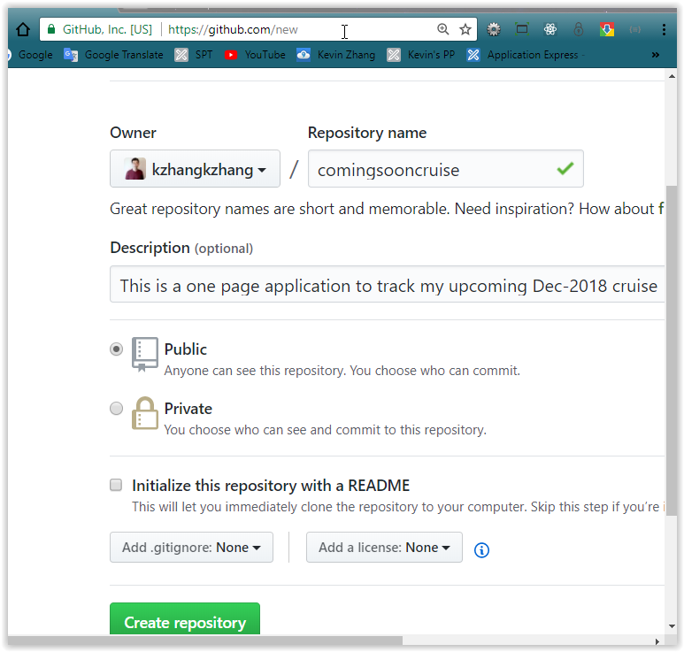

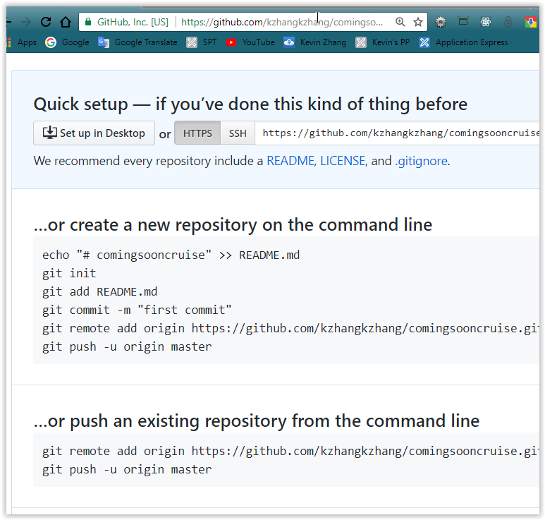

|  |
| --- |
| **…or create a new repository on the command line**  echo "# comingsooncruise" >> README.md  git init  git add README.md  git commit -m "first commit"  git remote add origin https://github.com/kzhangkzhang/comingsooncruise.git  git push -u origin master |
| …or push an existing repository from the command line git remote add origin https://github.com/kzhangkzhang/comingsooncruise.git  git push -u origin master |
|  |

# Setup local Github repository on your PC

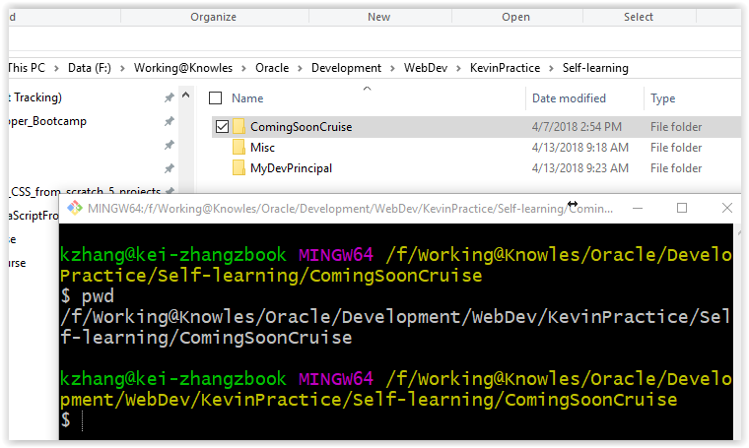

## >git init

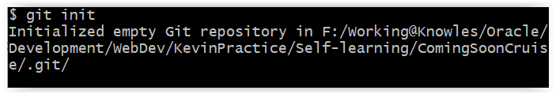

## >Create a .gitignore file

I don’t want to deploy my document (*.docx) file to github so I need create .gitignore file

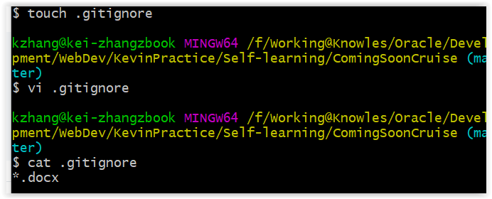

## >git add .

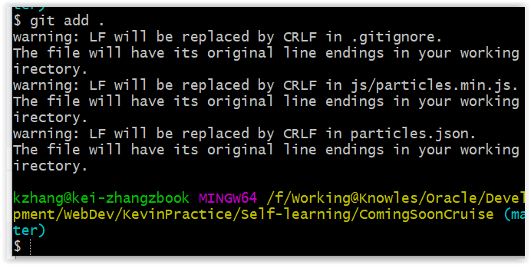

## >git commit –am ‘initial creation’

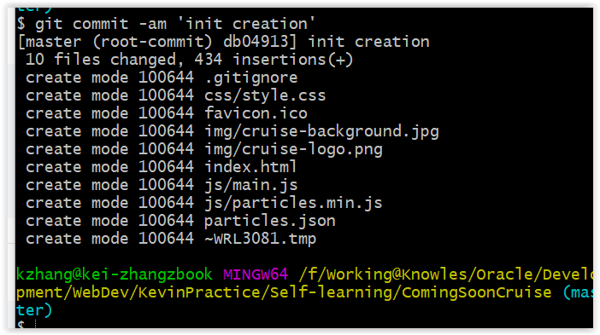

## >git remote add origin https://github.com/kzhangkzhang/comingsooncruise.git

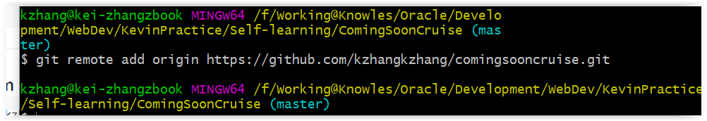

## >git push –u origin master

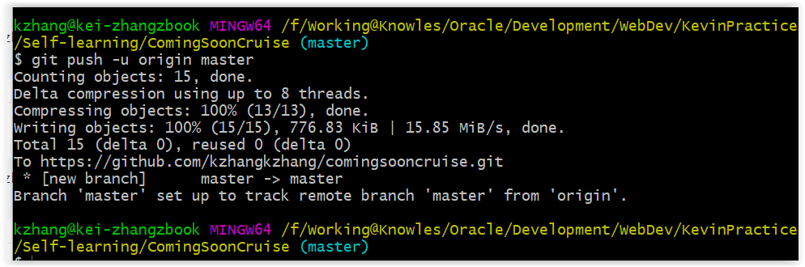

Check the Github to verify result

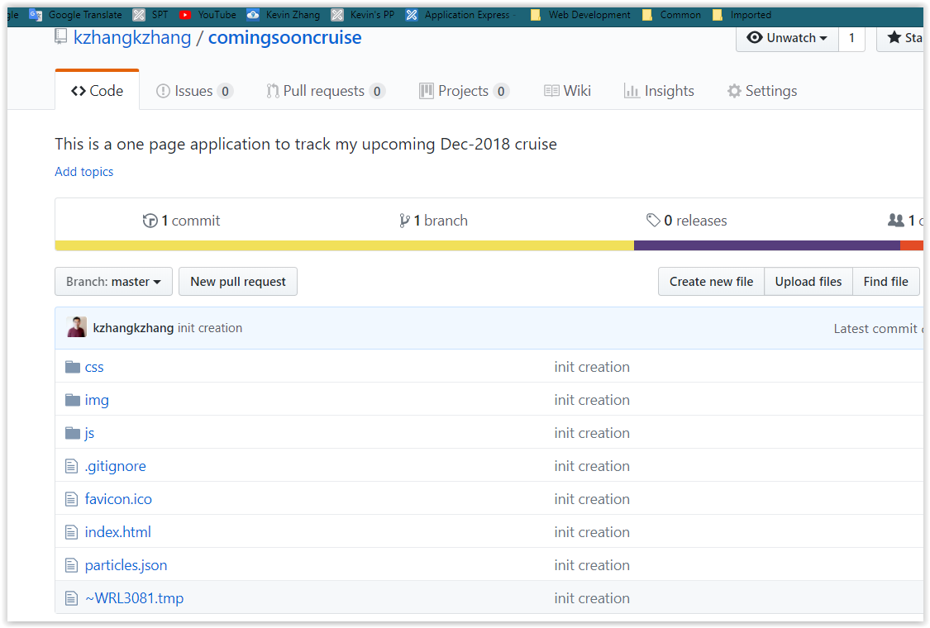

# Upload your github project to netlify.com

<https://www.netlify.com/>



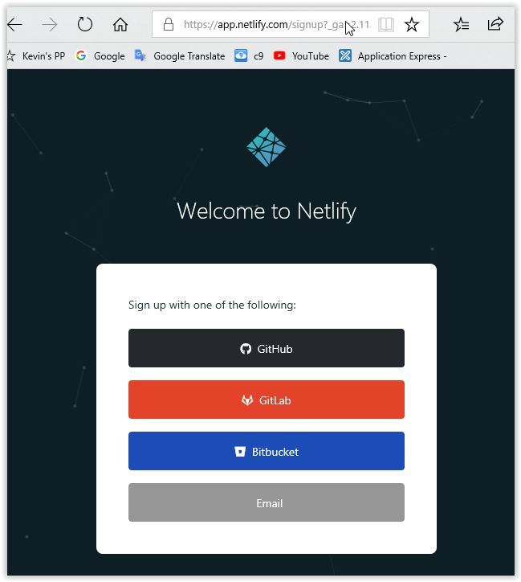

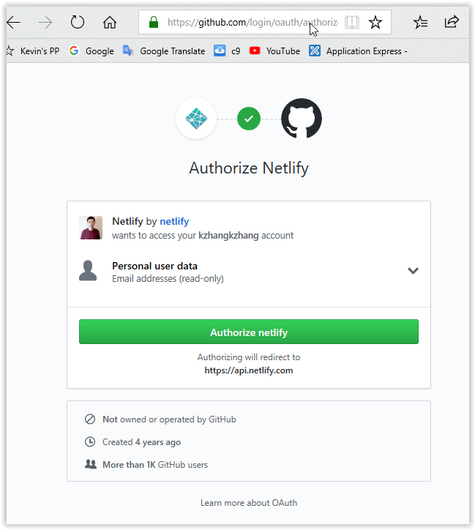

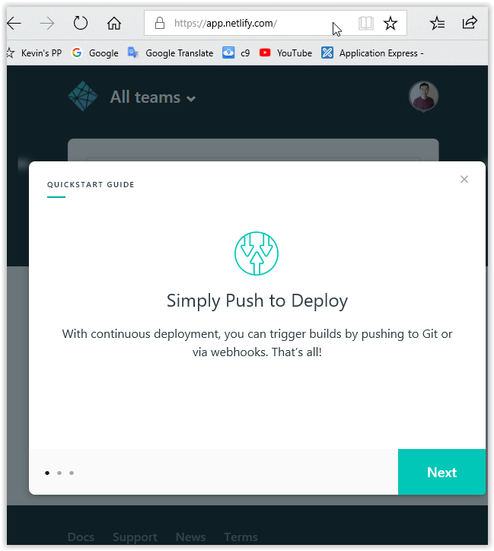

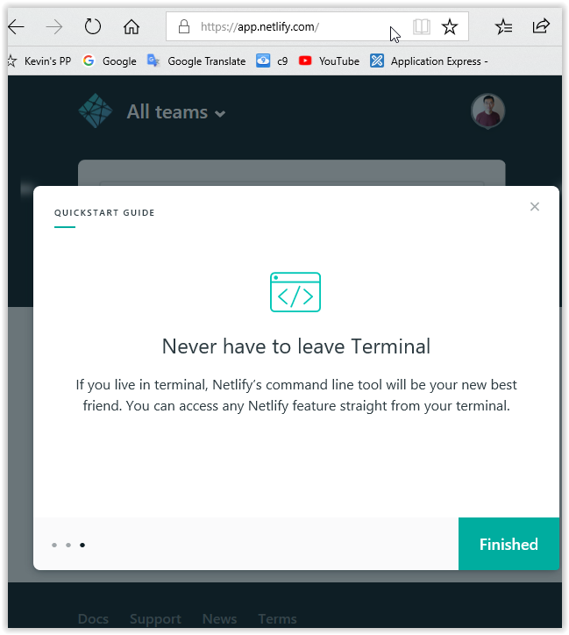

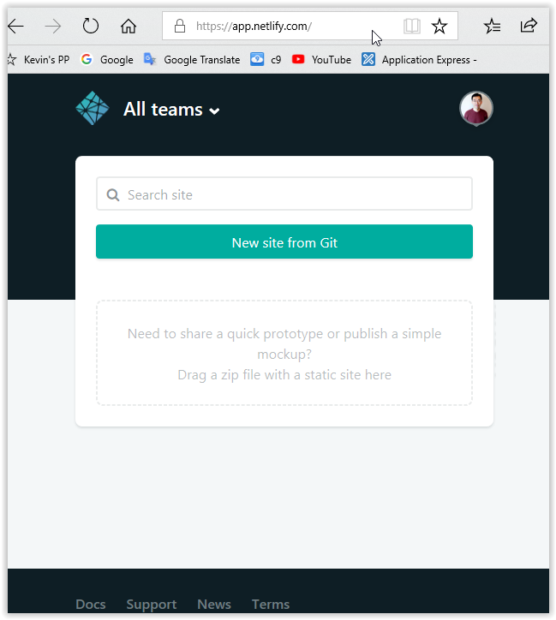

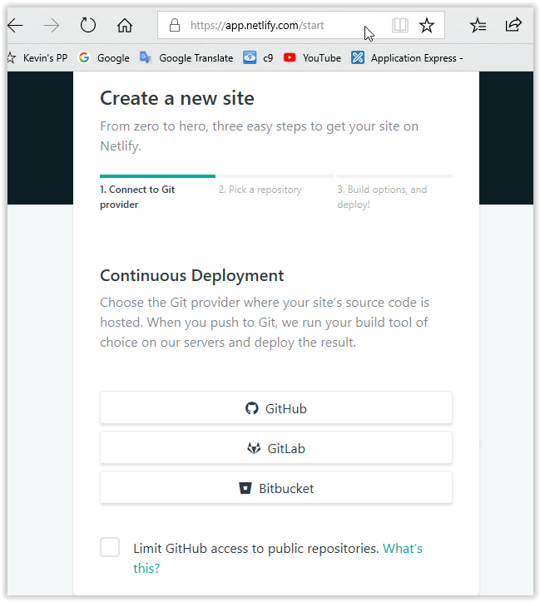

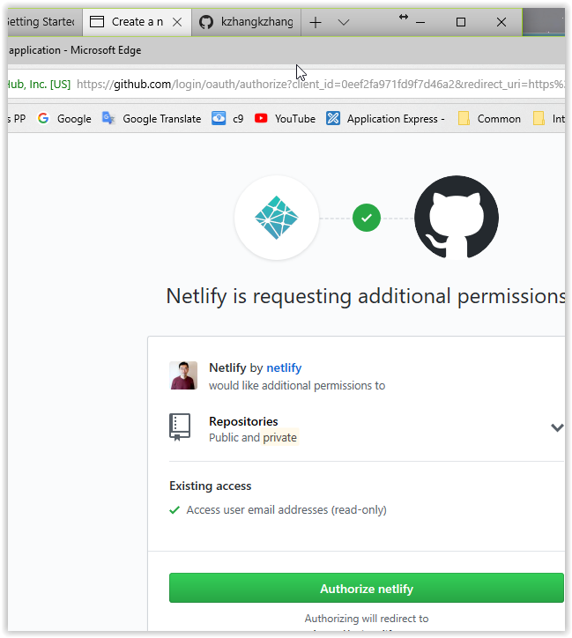

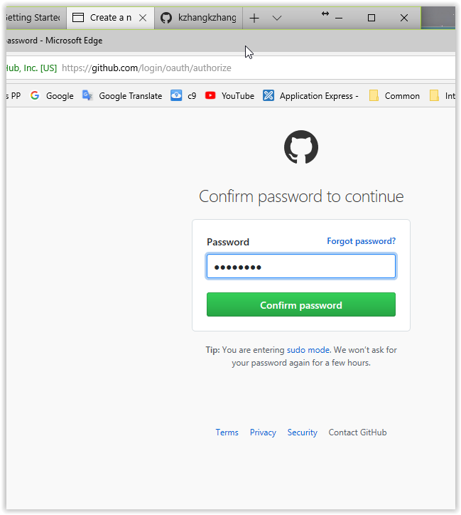

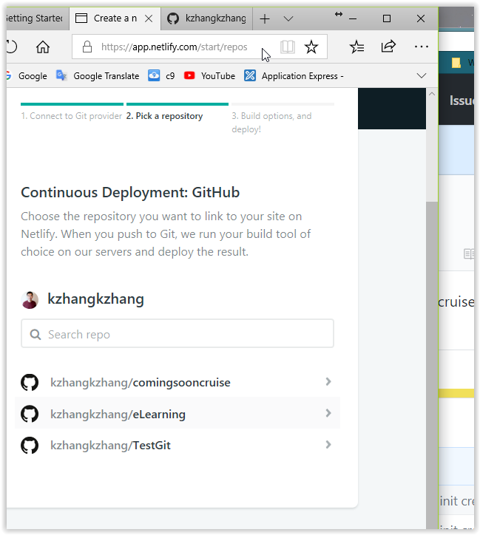

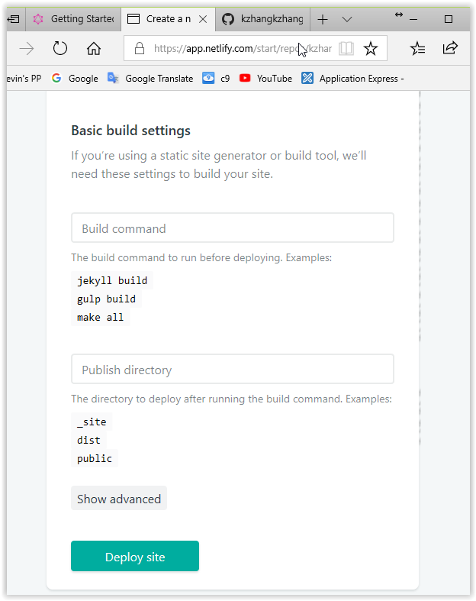

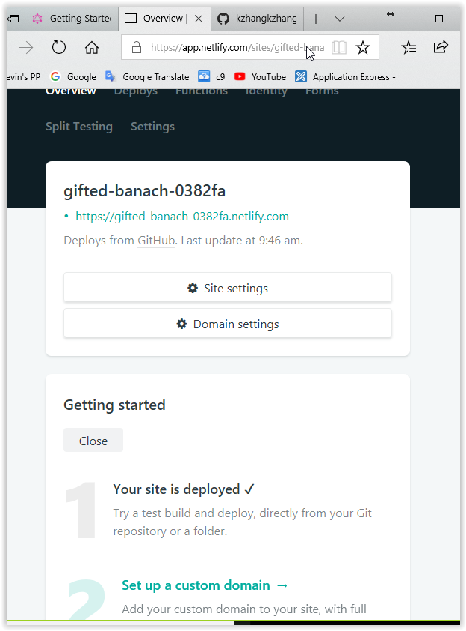

Final link is: [https://gifted-banach-0382fa.netlify.com](https://gifted-banach-0382fa.netlify.com/)



There are other options you can do (setup a custom domain etc). I will reach this in another day.

