I am following codebasics from youtube

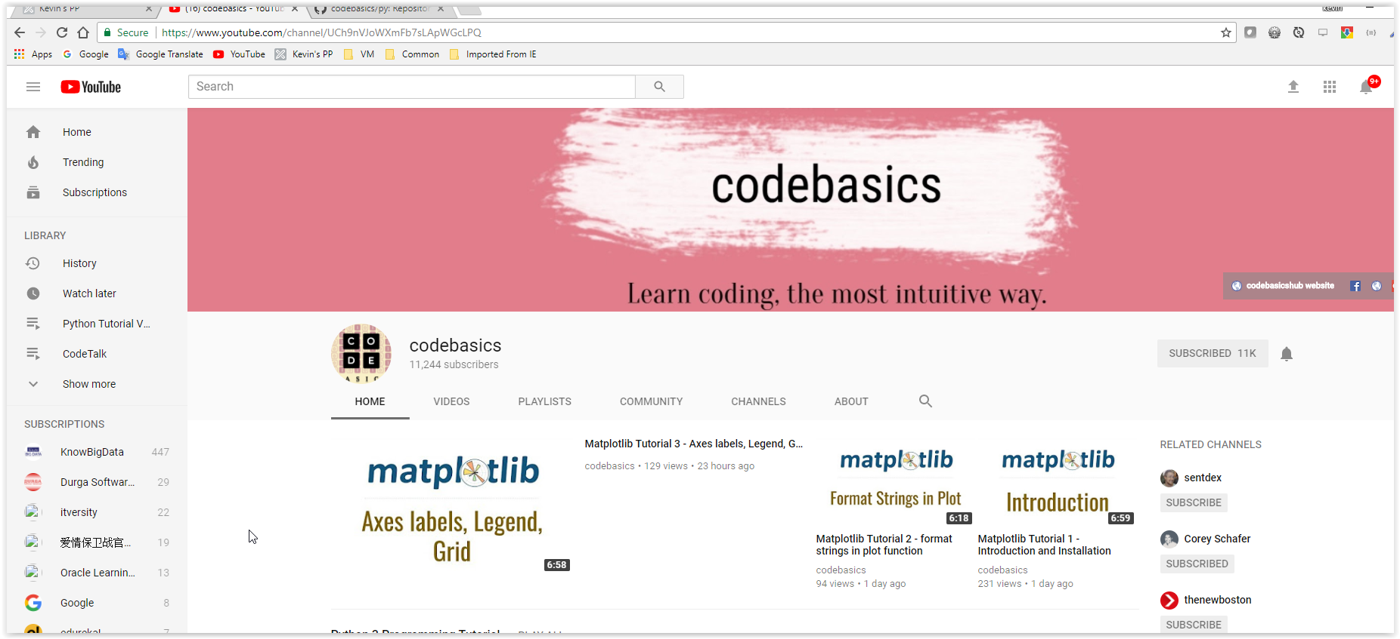

The github for codebasics:

<https://github.com/codebasics>

For Python: <https://github.com/codebasics/py>