|  |  |
| --- | --- |
| Name | Value |
| Youtube Source | <https://www.youtube.com/watch?v=9Hz3P1VgLz4>  <https://www.youtube.com/watch?v=lvzekeBQsSo> |
| Youtube Title | Machine Learning Totorial for Beginners – USING JASASCRIPT |
| Github | <https://github.com/BrainJS/brain.js> |
| NPM | <https://www.npmjs.com/package/brain.js> |
| Brain.js | <https://brain.js.org/> |
|  |  |

Things Learned:

|  |  |
| --- | --- |
| Category | Skill |
| Javascript |  |
|  |  |
|  |  |

> npm install brain.js

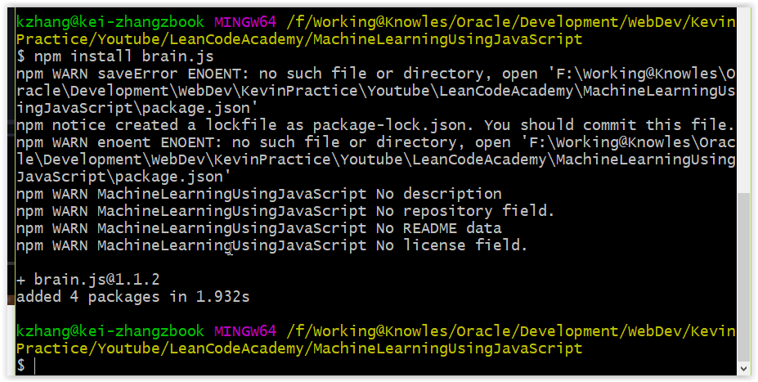

> npm init

