Youtube is:

<https://www.youtube.com/watch?v=hMxGhHNOkCU&index=1&list=PLoYCgNOIyGABdI2V8I_SWo22tFpgh2s6_>

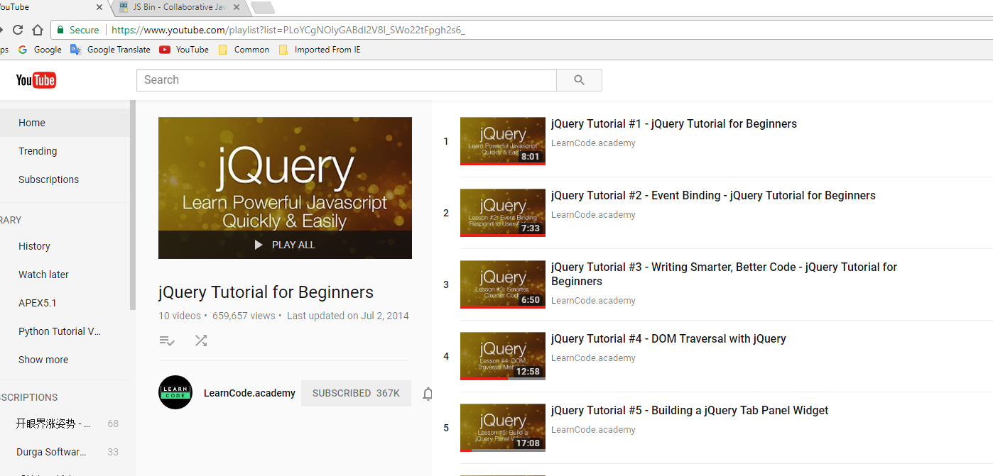

Source Code can be download from:

<http://jsbin.com/pojeni/1/edit?html,output>

# I created one tutorial_x.html for each Youtube clip. For example, tutorial_3.html is for the Youtube “jQuery Tutorial #3 - Writing Smarter, Better Code - jQuery Tutorial for Beginners” (https://www.youtube.com/watch?v=Cc3K2jDdKTo)

“

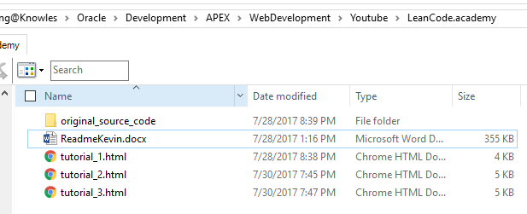

*** You can download all the source code from below.

<https://github.com/kaileeagray/learn_code_academy_jquery>

